Detecting Depression Risk from Social Media Text Through
Interpretable Machine Learning
FIT5145 Foundations of Data Science | Assignment 3 Report
Student: SUN ZHEN
Student ID: 36446874
Submission files: PDF report and RMD demonstration file

Required Assignment 3 Question
Have you selected a topic for Assignment 3 that is different from the one that you used for Assignment 1?
Answer: No. This report continues the Assignment 1 topic and rewrites the first three sections in a more focused academic form. The project remains an interpretable machine learning system for detecting depression-related risk signals from Reddit mental health text, now extended with data characterisation, R-based demonstration, model evaluation, business value analysis, and data governance.

Abstract
Depression is a major public health problem and many people at risk are not identified early enough to receive timely support. Social media communities can contain early expressions of distress, but any automated use of this text must be transparent, privacy-aware and framed as decision support rather than diagnosis. This report proposes a human-reviewed triage system that classifies Reddit posts as depression-related or ADHD-related using interpretable natural language processing. A public Reddit mental health dataset was analysed in R by combining titles and post bodies, removing deleted or empty records, examining class balance and text length, extracting word-frequency and TF-IDF patterns, and comparing Logistic Regression with Naive Bayes. The cleaned sample contained 34,282 posts, with 13,884 depression-related posts and 20,398 ADHD comparison posts. Logistic Regression achieved strong discrimination in the demonstration (accuracy = 0.9024; AUC = 0.9577), while its coefficients provided term-level explanations useful for human review. The proposed contribution is a narrower and more governable early-risk workflow: posts are prioritised for trained human reviewers, not automatically labelled as clinical cases. The report also specifies data sources, 4V characteristics, platform requirements, evaluation criteria, and governance safeguards for responsible deployment.
Keywords: depression detection; Reddit; NLP; Logistic Regression; interpretable machine learning; data governance

Assignment 1 Feedback and Response
Grade: D (11.33). Marker feedback from Assignment 1:
- Problem Clarity: The problem is understandable, but the scope and goals remain too broad.
- Business Model Analysis: The business case is reasonable with stakeholders identified, though the value creation pathway could be developed further.
- Problem Importance: The importance is clear and socially relevant, but supporting evidence is not well integrated with in-text citations.
- Novelty: The idea may be useful, but novelty is not established through comparison with existing work.
- Peer grading: Well done.

How the feedback was incorporated
I incorporated the feedback by narrowing the scope from general depression detection to a human-reviewed early-risk triage workflow for Reddit posts. The goals are now measurable: data characterisation, interpretable classification, threshold-aware evaluation, and governance planning. The business model was expanded into a clear value pathway linking model scores, reviewer prioritisation, earlier support, and reduced manual workload for wellbeing teams and moderators. I also strengthened the problem importance with in-text citations from WHO and prior computational mental health research. Novelty is now argued through comparison with existing work: instead of presenting another accuracy-focused classifier, the project emphasises an ADHD comparison group, interpretable Logistic Regression coefficients, privacy-safe reporting, and cautious non-diagnostic deployment.
(Response length: approximately 117 words.)

1. Introduction
Depressive disorder is a major social and public health challenge. The World Health Organization estimates that it affects 5.7% of adults worldwide and can disrupt education, work, family and community life (World Health Organization, 2025). Because many people express distress in online communities before seeking formal help, Reddit provides a useful but sensitive source of long-form text about symptoms, medication, stigma and daily functioning.
This project addresses how depression-related risk signals can be detected from large-scale Reddit text while remaining transparent, ethical and non-diagnostic. It proposes a decision-support workflow that assigns each post a depression-related probability, identifies influential terms, and prioritises uncertain or high-risk posts for trained human review. To keep the scope manageable, the study focuses on post-level triage using public Reddit data and an ADHD comparison group.
The project objectives are to analyse linguistic differences between depression-related and ADHD-related posts, build an interpretable R-based text classification pipeline, evaluate performance using accuracy, precision, recall, F1-score and AUC, and propose governance controls for privacy, security, ethics and human oversight.

2. Related Work
Prior research shows that social media text can contain useful mental health signals. De Choudhury, Gamon, Counts and Horvitz (2013) showed that online language and behavioural cues can help estimate depression risk, while Guntuku, Yaden, Kern, Ungar and Eichstaedt (2017) reviewed evidence that linguistic features are useful for detecting depression and related mental health states. However, many recent approaches emphasise prediction accuracy, including complex embedding or transformer-based models, without always explaining how results can be trusted or used in practice.
The key gap is therefore operational and ethical, not only technical. Platform-based labels are not clinical diagnoses, and false positives or false negatives can cause harm in a sensitive support context. This project addresses the gap by using interpretable machine learning as a triage layer rather than a diagnostic tool. Its novelty lies in combining an ADHD comparison group, explainable Logistic Regression coefficients, threshold-aware evaluation and privacy-safe reporting to support human review instead of automated clinical judgement.

3. Business Model and Value Creation
The application area is digital mental health support and online community safety. The main stakeholders are post authors, community moderators, university or workplace wellbeing teams, mental health service providers, and data governance staff. The value creation pathway is: public or consent-based text is processed into risk scores; risk scores are converted into a ranked triage queue; human reviewers inspect high-priority or uncertain cases; and supportive resources or escalation pathways are offered according to organisational policy. This pathway creates operational value by reducing manual searching across large volumes of text, and social value by improving the chance that distress signals receive timely attention.
The business model can be evaluated with measurable indicators. For moderators, the key metric is reduction in time spent manually scanning posts. For wellbeing services, the key metric is the proportion of high-risk posts reviewed within a target response window. For governance teams, the key metric is whether every prediction can be traced to a model version, feature pipeline and documented decision rule. These indicators make the value pathway more concrete: the model does not create value merely by producing labels; it creates value only when labels support faster, explainable and accountable human action.

Table 1. Stakeholder value pathway
Stakeholder | Need | Value created by the project
Post authors and community members | Respectful support without exposure of identity | Earlier human review of posts that may otherwise be missed
Moderators and wellbeing staff | Prioritisation tools and interpretable alerts | Lower manual workload and more consistent triage decisions
Mental health services | Efficient allocation of limited resources | Risk-ranked queues that support preventive outreach
Platform or institution | Safe and accountable use of user-generated text | Improved community care with reduced ethical and reputational risk

A possible implementation would be an internal dashboard rather than a public-facing diagnostic app. The dashboard would show a post identifier, predicted probability, key contributing terms, confidence band and recommended review status. A mental health charity or university wellbeing unit could fund it as a triage analytics module, but the business model should be evaluated by service quality, response time, transparency and harm reduction rather than profit alone.

4. Characterising and Analysing Data

4.1 Data sources, 4Vs and technology requirements
The R demonstration uses the public Hugging Face dataset solomonk/reddit_mental_health_posts, specifically depression.csv from r/depression and adhd.csv from r/ADHD. The repository lists fields including author, body, created_utc, id, num_comments, score, subreddit, title, upvote_ratio and url, and contains multiple mental health subreddit files. The final report must include a dataset download link; the direct source is https://huggingface.co/datasets/solomonk/reddit_mental_health_posts.

Table 2. Data characteristics using the 4V framework
4V dimension | Interpretation for this project
Volume | After removing deleted, removed, empty and missing posts, the demonstration uses 34,282 posts: 20,398 ADHD comparison posts and 13,884 depression-related posts.
Variety | The data is mainly unstructured text but also includes titles, bodies, subreddit labels and metadata. Posts vary in length, slang, spelling, emotional tone and sensitive content.
Velocity | The demonstration is static, but a deployed system would process new posts through approved APIs or scheduled batch exports.
Veracity | Subreddit membership is not a clinical diagnosis. Labels are useful for feasibility testing but introduce noise, bias and ethical limits.

For the current scale, R, tidytext, tm, ggplot2, e1071 and pROC are sufficient. If the project expanded, secure object storage would be required for raw text, a relational database for metadata and review status, version-controlled model artefacts, and scheduled data pipelines. Distributed processing such as Spark would only be justified if the volume increased substantially and if platform terms and ethics approval permitted ongoing collection.
The data pipeline should also separate research artefacts from operational artefacts. Raw CSV files would remain in restricted storage; processed feature matrices and model outputs would use pseudonymous post IDs; and public reporting would use aggregate statistics and figures only. This separation is important because the strongest evidence for model performance comes from text features, but the highest privacy risk also comes from the raw text itself. Versioning the data cleaning rules, stop-word lists, train-test split and model dictionary is necessary for reproducibility, especially because changes to preprocessing can change both performance and interpretability.
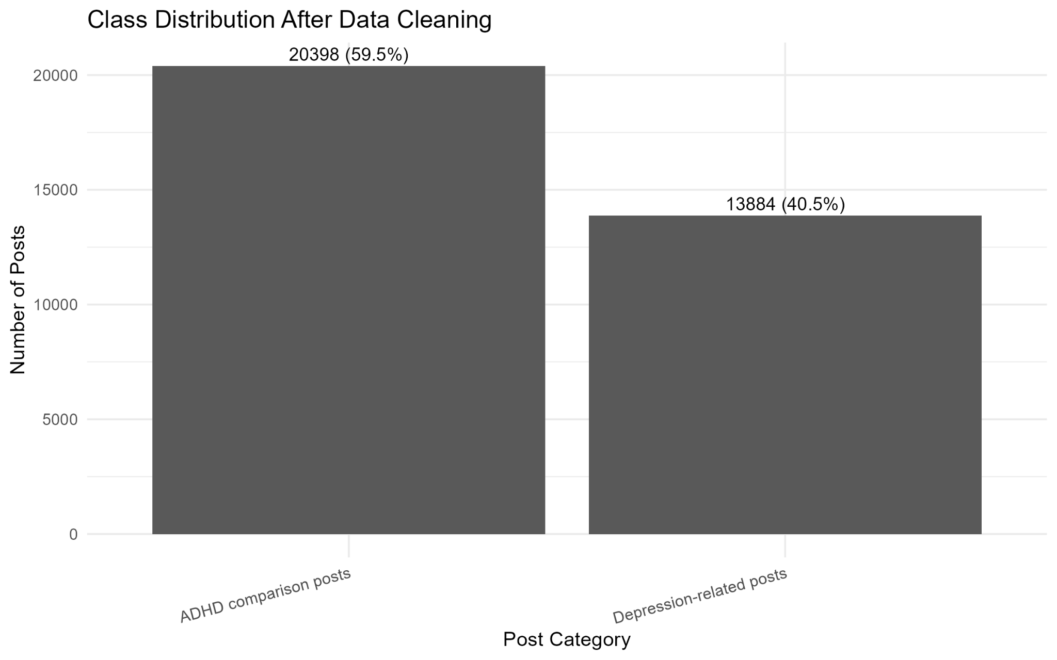
Figure 1. Cleaned class distribution used in the R demonstration.

4.2 Analysis techniques and rationale
The proposed analytical strategy has two levels. At the project level, exploratory data analysis should describe class distribution, text length, missingness, deleted content, frequent terms and post-level TF-IDF. Statistical comparison of post length, term frequency and model errors can reveal whether one class is easier to detect because of style rather than meaning. At the modelling level, Logistic Regression with DTM or TF-IDF features should be the primary model because its coefficients are interpretable. Naive Bayes is a useful baseline for text classification, while support vector machines or gradient boosting could be tested as secondary models. Transformer embeddings could improve performance, but they should not be the starting point because their decision logic is harder to explain and governance requirements are higher.
Evaluation must reflect the triage context. Recall is important because false negatives represent depression-related posts that the model failed to identify. Precision is also important because false positives create unnecessary work for human reviewers. Therefore the project should report precision, recall, F1-score, AUC, confusion matrices and threshold analysis. A practical deployment would tune the threshold according to review capacity: a wellbeing team with limited capacity may prioritise precision, while a crisis-oriented service may prioritise recall and accept more false positives.
The expected high-level outputs are threefold. The first is a descriptive profile of the dataset, including post length, class balance and distinctive language patterns. The second is a deployable scoring pipeline that produces a probability, predicted class and explanation terms for each post. The third is an error profile that tells stakeholders where the system is most likely to fail. These outcomes are deliberately broader than a single accuracy score because an early-risk triage system must be judged by feasibility, interpretability and workflow fit, not by prediction performance alone.
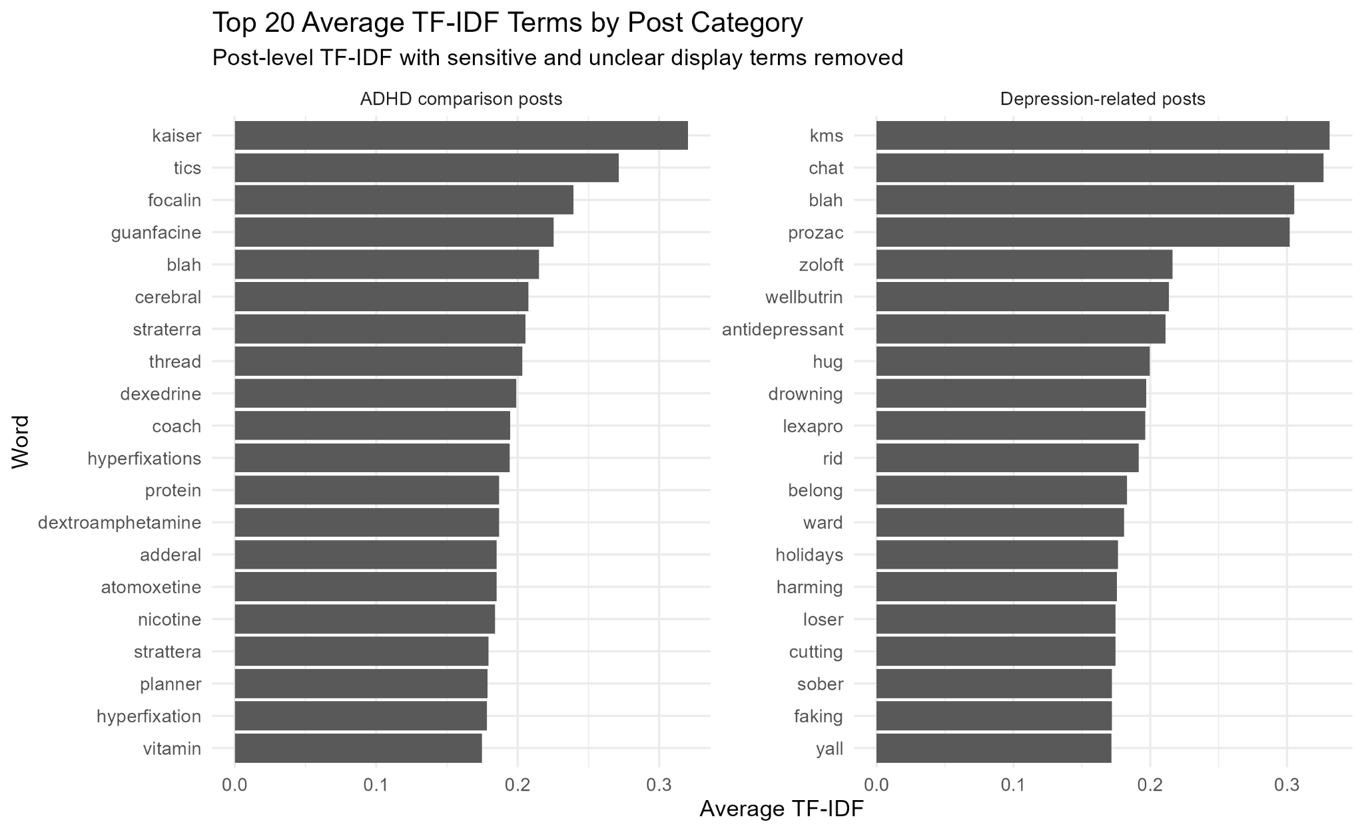
Figure 2. Post-level average TF-IDF terms after removal of sensitive or unclear display terms.

4.3 R demonstration and results
The supplied RMD implements the feasibility demonstration. It combines title and body fields into one text variable, removes [removed], [deleted], empty and missing posts, and labels depression-related posts as the positive class. The RMD then tokenises text, removes stop words, removes direct label words such as “adhd” and “depression”, stems terms, constructs a Document-Term Matrix and removes sparse features. The train-test split is created before fixing the vocabulary, which reduces data leakage because the test set is transformed using terms learned from the training set only.
Exploratory results show that the sample is moderately imbalanced but still usable for supervised learning. TF-IDF and word-frequency analysis indicate that ADHD comparison posts are more associated with medication, diagnosis and attention-related language, while depression-related posts include terms linked with emotional distress, social disconnection and negative experiences. These findings support feasibility, but they also reinforce the need for careful interpretation because the model is learning community-language differences rather than verified clinical status.
The demonstration compares Logistic Regression and Naive Bayes. Logistic Regression is the preferred model because it provides both strong predictive performance and interpretable coefficients. In the held-out test set, Logistic Regression correctly classified 6,188 posts, with 304 false negatives and 365 false positives. This corresponds to 90.24% accuracy. The ROC analysis reports AUC = 0.9577 for Logistic Regression and AUC = 0.8248 for Naive Bayes, showing substantially stronger discrimination for the interpretable model. The error analysis also shows that model outputs should be reviewed by humans: even a strong classifier can miss depression-related posts or flag ADHD-related posts incorrectly.
The coefficient plot should be read as an explanation of the statistical model, not as a psychological theory. Stemmed terms with positive coefficients push a post toward the depression-related class, while negative coefficients push it toward the ADHD comparison class. Some terms are clinically suggestive, but others may reflect subreddit norms, medication names or artefacts of community language. For this reason, the demonstration supports the feasibility of interpretable triage, but it does not prove that the system can identify depression in individual people. A stronger future study would require consent-based data, validated screening measures, clinician-reviewed labels and subgroup performance checks.
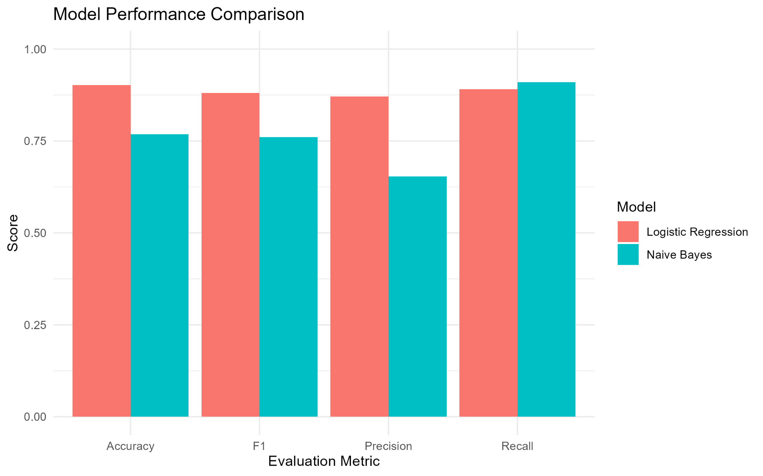
Figure 3. Model performance comparison from the R demonstration.
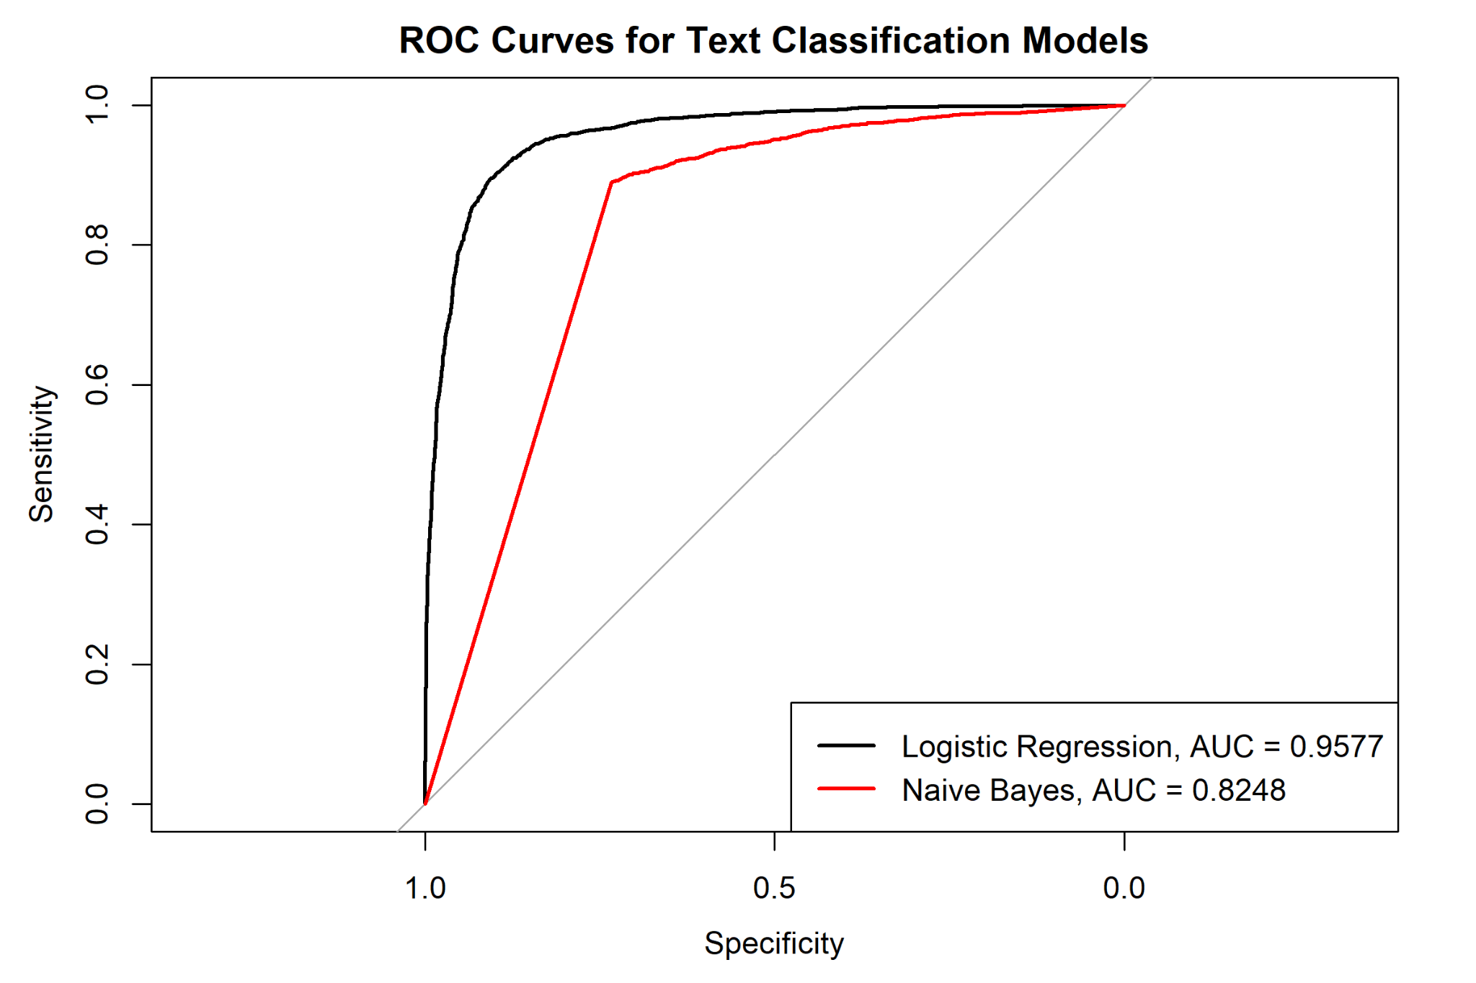
Figure 4. ROC curves for Logistic Regression and Naive Bayes.
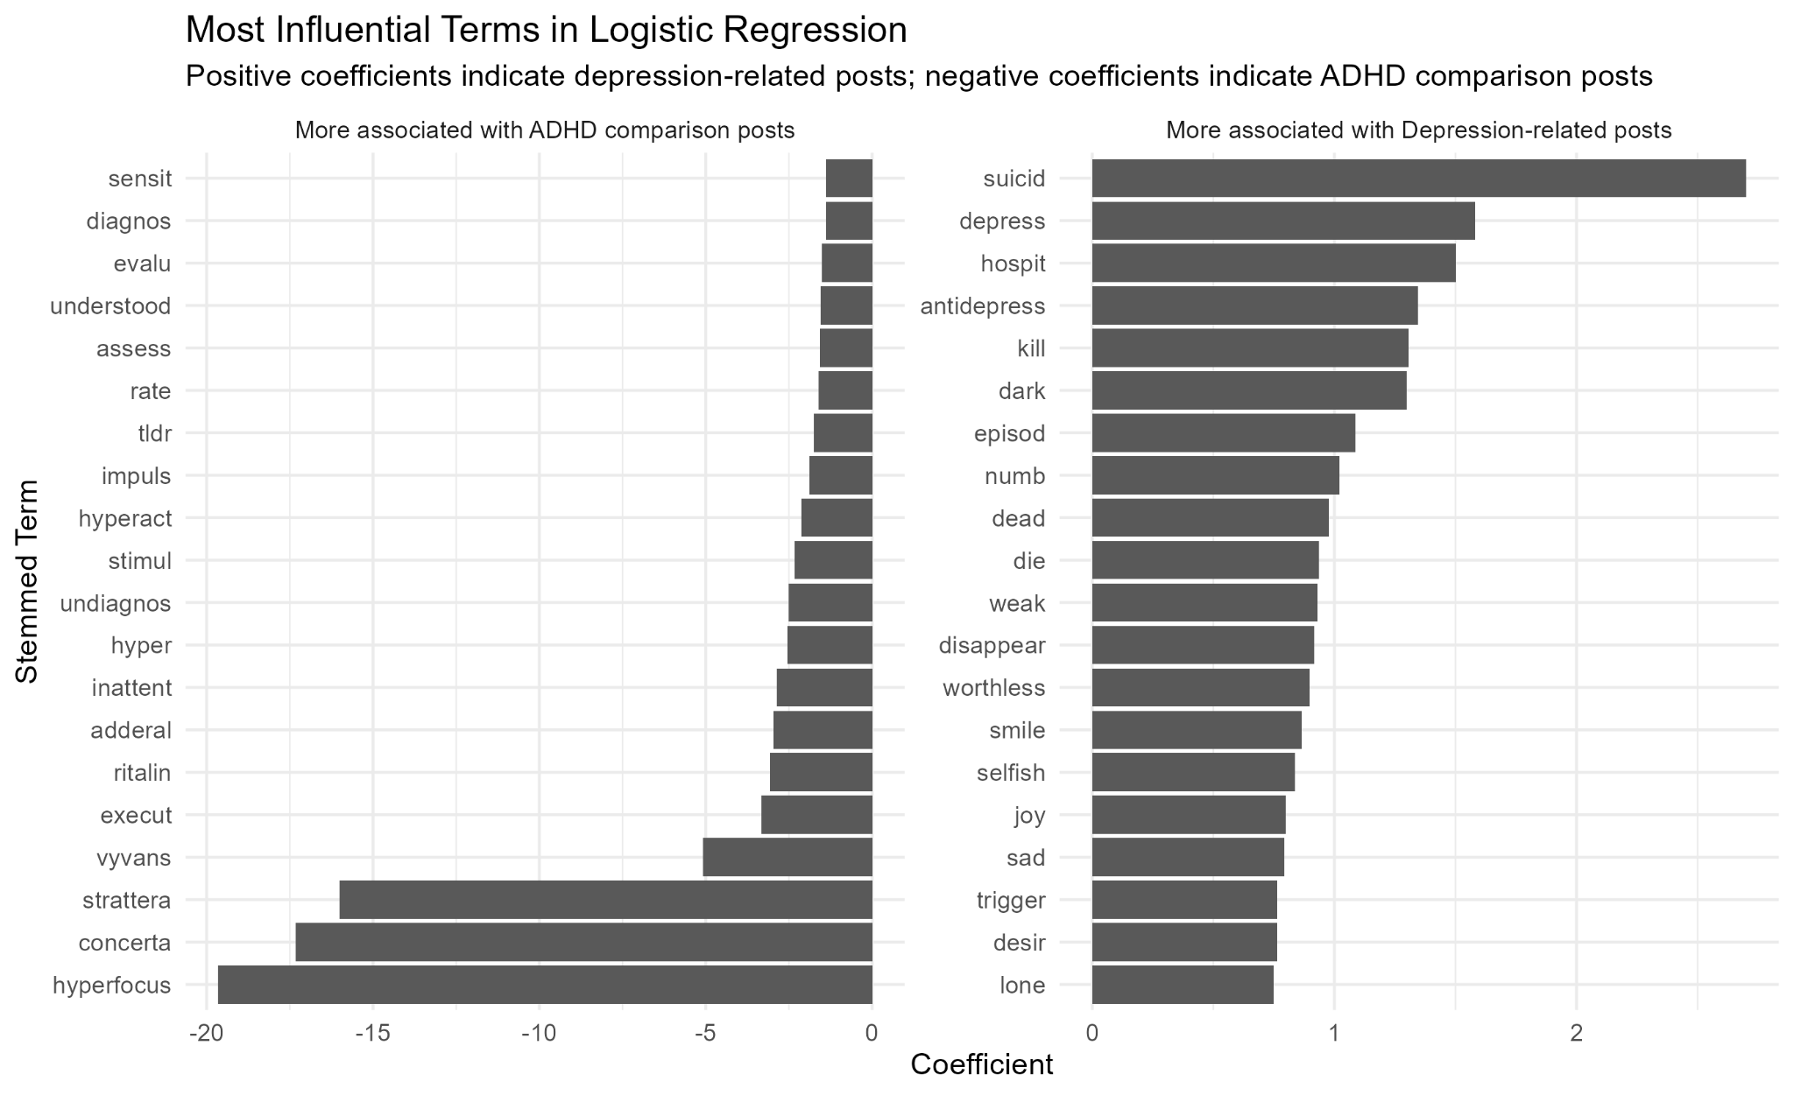
Figure 5. Most influential stemmed terms in the Logistic Regression model.
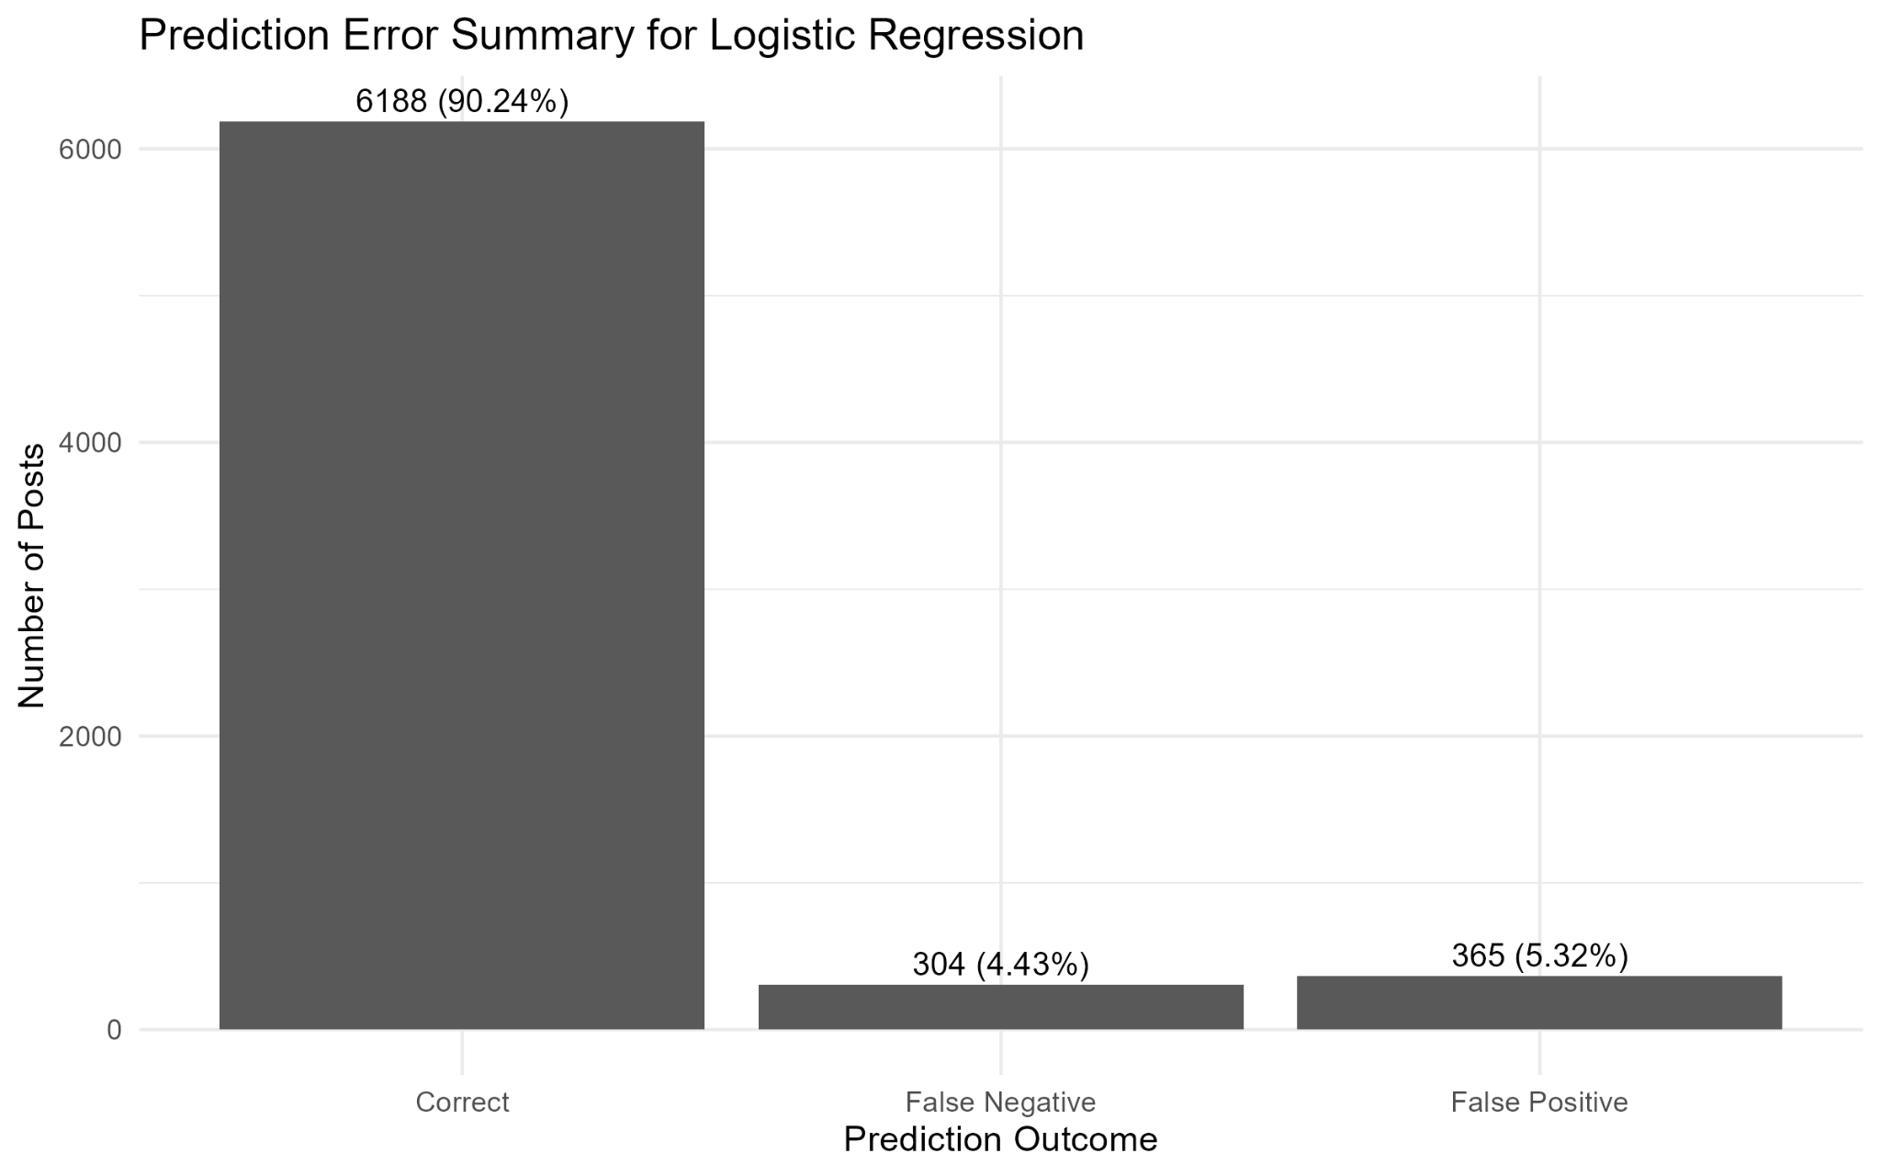
Figure 6. Logistic Regression prediction error summary.

5. Standards, Data Governance and Management
The project follows the CRISP-DM process: business understanding, data understanding, data preparation, modelling, evaluation and deployment planning. This standard is suitable because the project begins with a stakeholder problem, explores and cleans the data, builds interpretable models, evaluates them with multiple metrics, and considers deployment constraints before recommending use (IBM, n.d.).
Data governance is essential because the dataset contains sensitive mental health language. Access to raw text should be limited to approved project members, stored securely, encrypted where possible, and excluded from public outputs. The RMD supports this principle by creating a safer metadata version without raw post text. Any future collection should comply with Reddit’s Data API Terms, privacy requirements and applicable law.
Data management should follow a least-privilege model. Researchers should only access fields needed for the current task, while author names, URLs and other identifiers should be removed or hashed early. Retention periods should be defined, and deleted or removed posts should not be redisplayed. In an operational system, audit logs should record who reviewed a post and why.
Ethically, the system must not identify, diagnose or punish users. Outputs should be framed as “posts requiring review” rather than “depressed users”. A deployed version would require ethics approval, a model card, access logs, threshold monitoring and human oversight to prevent mental health prediction from becoming surveillance.

6. Conclusion
This report extends the Assignment 1 proposal into a focused, evidence-based and governable data science project. The R demonstration shows that depression-related Reddit posts can be distinguished from ADHD comparison posts using interpretable NLP features, and that Logistic Regression provides strong performance while remaining explainable. More importantly, the report clarifies the project’s real contribution: a transparent early-risk triage workflow that connects data analysis to human support, stakeholder value and governance. The main limitation is that subreddit labels are not clinical diagnoses, so future work should validate the model with ethically sourced labels, calibrate thresholds with reviewers, and assess fairness before any real-world deployment.

References
De Choudhury, M., Gamon, M., Counts, S., & Horvitz, E. (2013). Predicting depression via social media. Proceedings of the International AAAI Conference on Web and Social Media, 7(1), 128-137. https://doi.org/10.1609/icwsm.v7i1.14432
Guntuku, S. C., Yaden, D. B., Kern, M. L., Ungar, L. H., & Eichstaedt, J. C. (2017). Detecting depression and mental illness on social media: An integrative review. Current Opinion in Behavioral Sciences, 18, 43-49. https://doi.org/10.1016/j.cobeha.2017.07.005
IBM. (n.d.). CRISP-DM help overview. IBM Documentation. https://www.ibm.com/docs/pt-br/spss-modeler/saas?topic=dm-crisp-help-overview
Reddit. (2023). Data API Terms. https://redditinc.com/policies/data-api-terms
Reddit. (2026). Reddit Privacy Policy. https://www.reddit.com/policies/privacy-policy
solomonk. (n.d.). Reddit posts about mental health [Dataset]. Hugging Face. https://huggingface.co/datasets/solomonk/reddit_mental_health_posts
World Health Organization. (2025). Depressive disorder (depression). https://www.who.int/news-room/fact-sheets/detail/depression

