‘Rapid Bushfire Response’ UAV System

summary

Due to the drought of southeast Australia, forest fires burn across the country, impacting New South Wales and eastern Victoria. To help the Victorian government respond to future wildfire disasters, we established the ‘Rapid Bushfire Response’ system and evaluate drone arrangements with three models.

**For model 1,** to address irregular fire regions and diverse SSA drone detection patterns, we used **regional** **discretization** method, turning fire data and multi-drone cooperation in to constraint equations. We then divide the information in discreated area into different layers. The drone layer and information layer indicate an SSA drone’s search mode and search zone. The flame layer represents the severity of wildfire, which could be obtained from model 2. Finally, balancing information detection revenue and SSA drone numbers while considering constrains on EOC position, we optimized the SSA drone search pattern and EOC position.

**For model 2,** we discussed the changes in fire under global warming circumstances. We first formed a two-level function that maps temperature to ignition probability, and ignition probability to burned area size. To obtain ignition probability and burned area size correlations, we used **cellular automata** model to simulate ignition probability’s effect on burned area and fitted their relation. We then estimated the temperature change due to climate factors consulting further studies, and assessed the ignition probability of this year and the next decade. Finally, we simulated average fire scenes and estimated their fire severity.

**For model 3,** We first evaluated the influence of terrain on communication, and measures a regions’ communication shielding effect with the terrain’s second gradient. Then we optimized the number and location of radio repeater drones referring to the position of SSA drones obtained in model 1. We further considered the continuity of communication and calculated the final radio repeater drone numbers under shifting conditions.

Based on the above three models, we estimated that 10 SSA drones and 2 radio repeater drones is required to build the ‘Rapid Bushfire Response’ system. For next decade, the cost of imaging cameras and telemetry sensors (for SSA drones) will increase. We also suggest that fire zone area plays a major role influence on drone arrangements and the topographical condition has little influence.

**Keyword:** Drone, Optimization, Regional Discretization, Fire Dynamic Models, Cellular Automata

Content

summary 1

1 Introduction 2

1.1 Problem Background 2

1.2 Restatement of the Problem 2

1.3 Model Framework 3

Assumptions and Justifications 4

2 Notations 4

2.1 Notations used in this paper 4

3 Model Derivation 5

3.1 Model Preparation 5

3.2 Model 1: SSA Drones and EOC Optimization Model 7

3.3 Model 2: CA Fire Prediction model 9

3.4 Model 3: Ratio-Repeater Drones Optimization Model 14

4 Test the Model 16

4.1 Model 1 Sensitivity Analysis 16

4.2 Model 2 Sensitivity Analysis 17

4.3 Model 3 Sensitivity Analysis 18

5 Conclusion 18

5.1 Summary of Results 18

6 Model Evaluation and Further Discussion 20

6.1 Strengths 20

6.2 Possible Improvements 20

7 References 20

Budget Request 22

1. Introduction
   1. Problem Background

Since September 2019, mountain fires in Australia have been burning for more than 200 days, covering 6 million hectares, 7 times the burnt area of Amazon rainforest fire. Victorian state, located in the southeast coast of Australia, suffers from a $700 million lost.

Drone-detection system was widely used in aerial photography, environmental detection and other fields, and has a huge industrial prospect [1]. Due to the great lost, we brought in the UAV system to detect fire data and establish real-time communication.

* 1. Restatement of the Problem

We need to develop a wildfire disaster relief response system named “Rapid Bushfire Response” and improve its response capabilities based on the situations of Victoria, Australia.

* **What we Know:**
* Historian wildfire data in Australia and countries
* Geographic information of Southeast Australia
* **What we Have:**
* **2 kinds of drones.** SSA drones are used for video & telemetry and Radio Repeater drones are used to extend the range of low power radios on the front lines.
* **1 mobile EOC.** central command and control point for emergency related operations and activities, and for requests for activation and deployment of resources
* **What we Should Do:**
* **Determine the type and number of UAV.** The UAV fleet should satisfy and balance the need of capability, safety and economics.
* **Identify the most-demanded locations for SSA drones.** SSA drones has the capability of video & telemetry and act as the main part of UAV fleet to guarantee the safety of firefighters and the data of the most serious fire areas.
* **Identify the best hovering locations for radio-repeater drones.** Radio-repeater drones are the core of several SSA drones to transmit information to EOC.
* **Propose dispatching schedule.** Assign flight plan to each type of drones to ensure the Continuous information transmission.

The simple structure of the “Rapid Bushfire Response” UAV system is shown in figure 1.

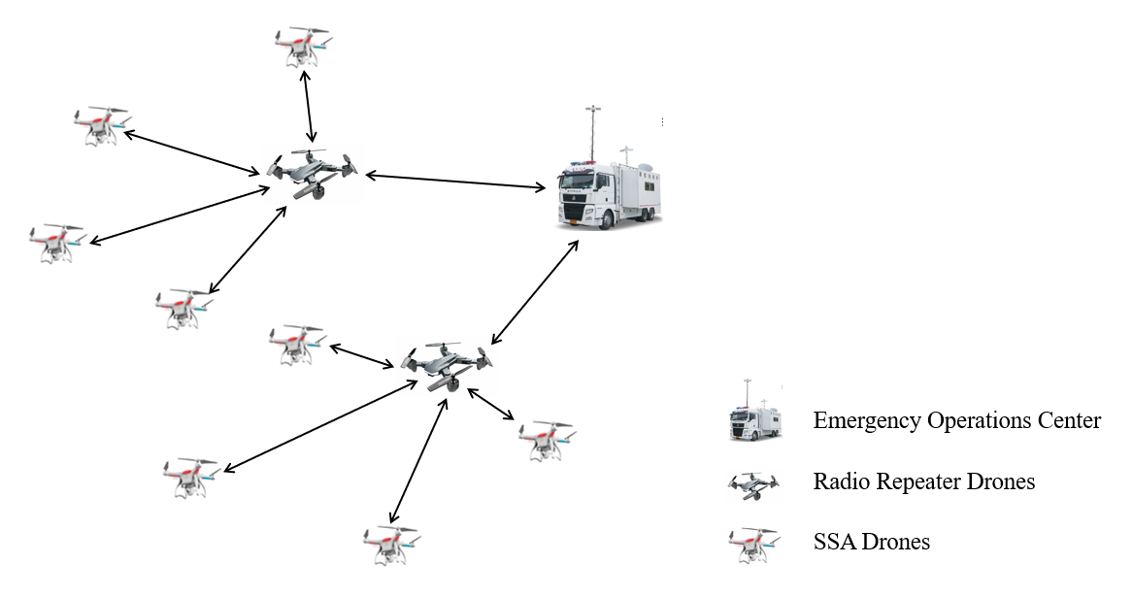

* + - * 1. “Rapid Bushfire Response” UAV System
  1. Model Framework

We separate the problem into three chained sub-problems, and established three models to solve them respectively.

The **CA fire prediction model** predicts the size and scale of the possible wildfires. It estimates the relation between temperature and wild fire and predicts the fire field based with Cellular Automata model.

The **SSA drones optimization model** uses the wild fire estimation and generates SSA drone distribution. To balance the observation revenue of UAV and cost, we defined a variable to determine the observation revenue of UAV in a certain area in a certain period.

The **radio-repeater drones optimization model** refers to the SSA drone distribution and optimizes radio-repeater distribution and EOC location. The model optimizes radio-repeater drones referring to radio communication restrains.

The overall algorithm flow chart of the model is shown in the figure 2:

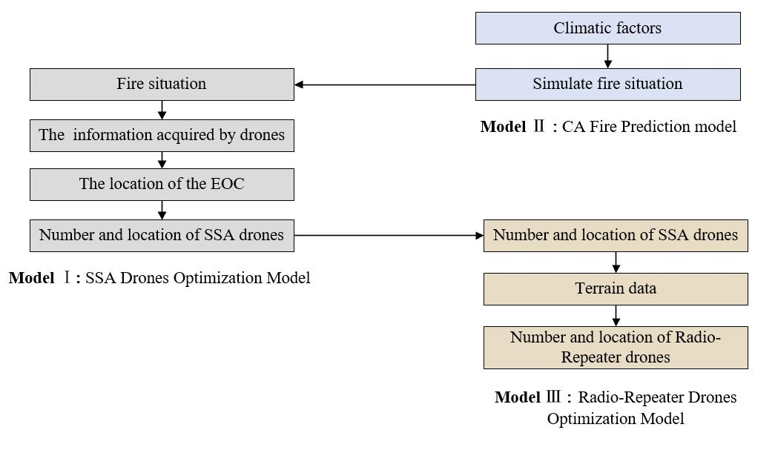

* + - * 1. Model Overview

Assumptions and Justifications

1. Of all fire effecting factors, only temperature changes in the next decade.

**Justification:** Considering global warming as the main factor of climate change, temperature will increase slowly in the next decade while the change in humidity and wind speed is unpredictable hence could be regarded as constant.

1. Fire fields and flying patterns could be discretized.

**Justification:** While discretizing the fire field into ** areas, the minimum transmit area of 5-watt transmitters, the distance unit is smaller than one fifth of the maximum communication distance, and the size unit is reasonable for drones traveling at 20km/s with a maximum battery life of 2.5hrs. Hence the discretize method bring only little error into the result.

1. The observation revenue in each space unit obeys the law of diminishing marginal utility.

**Justification:** As the observation time in each space unit increase, the marginal observation revenue decreases.

1. Drones can only be recharged at the Emergency Operations Center and are fully charged when leaving.

**Justification:** Drones could only be recharged at EOCs due to equipment requirements, and they should be fully recharged to ensure maximum efficiency.

1. Drones fly at the maximum speed of 20m/s until they reach the designated location.

**Justification:** Due to the limitation of flight time, flying at the maximum speed can minimize the time consumed on the road.

1. Terrain only influences communication distances.

**Justification:** As drones hovers well above the ground, terrain has little effect on traveling distances. Meanwhile, the uneven terrain and altitude difference hinders radio signals.

1. Notations
   1. Notations used in this paper

Notations Used in This Paper

|  |  |  |
| --- | --- | --- |
| Symbol | Description | Unit |
|  | Maximum speed of drones | *km/hr* |
|  | The size of discretion space unit | *km2* |
|  | The total number of unit area on landscape and portrait direction | *-* |
|  | The location of m, SSA for SSA drones, RRD for radio repeater drones, EOC for EOC. | *-* |
|  | Monitoring types of SSA drones | *-* |
|  | State variable indicating whether the SSA drone is in this area.  means the drone is in this area;  means the drone is not in this area. | *-* |
|  | The docking time of the drone in this area in detection pattern k | *hr* |
|  | Maximum flight time drones | *hr* |
|  | Remaining flight time after SSA drones traveling from EOC to | *hr* |
|  | UAV detection performance index | *-* |
|  | The amount of information acquired by UAV in this area | *-* |
|  | Detection range of UAV | *km* |
|  | The severity of the fire in this area. | *-* |
|  | The boundary contribution of SSA drones | - |
|  | The state value of each unit area’s fire state in the cellular automata. | *-* |
| *T* | Ground temperature in fire area (before fire) | *℃* |
|  | Critical ignition and extinguish probability in the cellular automata model. | *-* |
|  | The size of fire zone | *km2* |
|  | Terrain matrix | - |
|  | Transmit range ratio | - |
|  | The shifting parameter for radio repeater drone r | - |
|  | Recharge time for the built-in battery of drones | *hr* |
|  | The time drones spend on road | *hr* |
|  | hovering time for radio repeater drones | *hr* |

1. Model Derivation
   1. Model Preparation
      1. The Data
2. Data Collection

The data we used mainly include Elevation data of southwest Australia, Australian wildfire data set, Forest fire areas in Australia_ 2019-2020 and Global Forest Watch. The data sources are summarized in Table 2.

Data Source Collation

|  |  |  |
| --- | --- | --- |
| Database Names | Database Websites | Data Type |
| Elevation data of southwest Australia | https://topex.ucsd.edu/cgi-bin/get_data.cgi | Geography |
| Australian wildfire data set | https://www.kesci.com/mw/dataset/5e21588a2823a10036b575bf | Geography |
| Forest fire areas in Australia_ 2019-2020 | https://www.datafountain.cn/datasets/5395 | Geography |
| Global Forest Watch | https://www.globalforestwatch.org/ | Geography |
| FW_Veg_Rem_Combined | https://github.com/varunr89/smokey/blob/master/Wildfire_att_description.txt | Climate |

1. Data Cleaning

According to the latitude and longitude range and the administrative boundary of Victoria, Australia, we extracted data of terrain and fire details of Victoria from all the data. The topographical data in Victoria is shown in the figure 3 below.

|  |  |
| --- | --- |
|  | C:\Users\96547\Documents\Tencent Files\965475717\Image\Group\[N9F]`}B{0B{NF($3R](BQS.jpg |
| * + - * 1. Topographical Map and Brief Contour of Southeast Australia | |

* + 1. Geographic Coordinate System

To find the true distance between any two points with geographic coordinates, we map the spherical coordinate system to the plane rectangular coordinate system. With the latitude and longitude range of the fire area, a rectangular fire field area can be obtained in a rectangular coordinate system. The linear distance between any two points in the rectangular coordinate system is the actual distance between the two places.

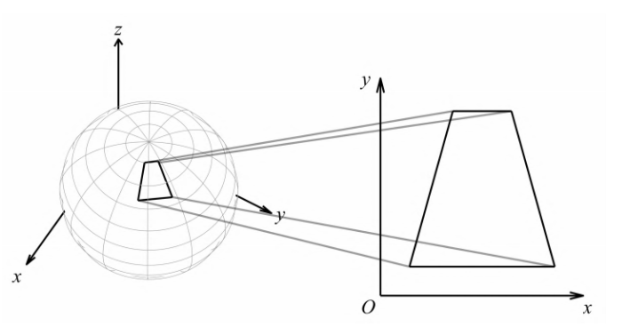

* + - * 1. Spherical Coordinate Transformation
  1. Model 1: SSA Drones and EOC Optimization Model

Due to area detection requirements, UAVs continuously monitor fire regions. However, limited by power and communication, it is impossible to detect all regions of interest. Therefore, We optimized the detection time of different regions according to their importance. [2]

* + 1. Regional Discretization

We first discretize the area into a M×N matrix, each unit area is . We then divide the matrix in to 4 layers to analyze different information, **the drone layer** (*x*, a 0-1 state variable matrix representing a drone’s hovering zone), **the time layer** (*t*, a matrix representing the hover time of the unit), **the information layer** (*I*, a matrix representing the information SSA drones collected form the unit) and **the flame layer** (*h* a matrix representing the severity of wildfire). We combine these four layers to optimize the number of SSA drones and balance the capability and economics.

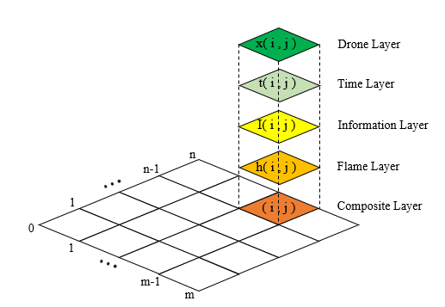

* + - * 1. Different Levels in The Optimization Model

Considering a SSA drone’s power limitations, we hypothesize that a drone detects one or two block at once, hence a SSA drones has 5 different detection patterns:

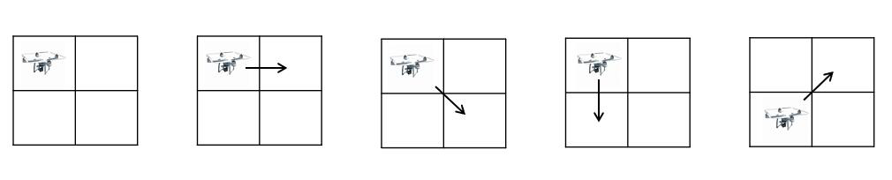

* + - * 1. Detection Patterns of SSA Drones

Representing five drone detection behavior by dividing the drone layer into 5 sub-layers , we could put together drones with the same detection pattern in the same layer, and identify each drone with the upper left corner of its detection pattern.

While hypnotizing drones flying towards the final observation destination straight forward, we could have the total observation time as max battery life minus time spend on the road:



Assuming an even split in observation time for each block in a two-block detection, we could have the observation time derived by the five patterns  as:



Considering the diminishing marginal observation revenue, we could presume the amount of information acquired by UAV in a certain area  as:



In multiple-goods-condition, we consider the drones optimization problem as a Multiple-objective

integer programming problem, and set objective function of the optimization model as:



Here  represents the detection revenue of SSA drones.  is the severity of the fire area (*i*,*j*), As “Boots-on-the-ground” Teams faces more danger in severe areas, The higher the value of , the more valuable the information of this fire unit is.  is calculated with emulations methods and will be further discussed in the next section.  represents the total number of SSA UAVs,  serves as an threshold, It prevents the algorithm from adding drones when a new drone’s contribution is smaller than , balancing economic needs and fire zone detection.

To sum up, the structure of SSA drones optimization model structure could be visualized as follows:

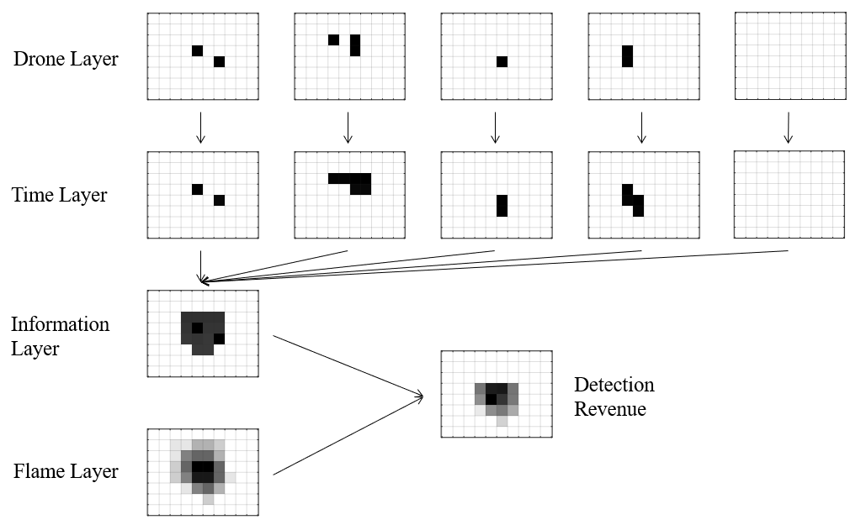

* + - * 1. SSA Drones Optimization Model Structure
    1. EOC Position Constrains

To ensure EOC position reasonability, we may hypothesis that EOC locates inside the discrete zone.



What’s more, we have EOCs locating outside the fire zone:



To introduce Equation 6 to programming problems, we could rewrite it as:



Equation 7 casts no effect when  is zero, yet when  is bigger than zero which indicates fire, it restrains  from being zero, hence EOC will not be optimized into fire zone.

* 1. Model 2: CA Fire Prediction model

Considering the lack of spatial distribution data of fire field, we use cellular automata model to simulate the fire field distribution in a rectangular area. We set a temperature related ignition probability to bring global warming factors to the area and distribution of fire field. Then we estimated the temperature change due to climate factors from further studies, and assessed the ignition probability of this year and the next decade. Here we formed a two-level function that maps temperature to ignition probability, and ignition probability to fire field size. The resulting model can be used to generate fire field distribution at present as well as in the next decade.

* + 1. Simulation of the Wildfire

1. Simulation Preparation

We set up three states for unit areas: burned, burning and unburned. Considering the duration of combustion, this model defines a life for the fire of each point. If burning, the state value  of this point decreases by 1 as time increases by 1. Here we set the state value .  represents the unburned state;  represents the burning state, whose value equals to residual life of the unit;  represents the burned state of the unit. Note that the fire field is of the same size as the previous model, yet the ‘unit area’ of this model is 100 times smaller to achieve higher accuracy.

Traditional forest fire models produce regular fire zone shapes and fails to converge. Here, to generate natural fire zone which converges to irregular shapes and varies according meteorology factors. We improved the traditional forest fire model by bringing random ignition and extinguishing events. The critical ignition probability is set as a function of temperature to consider weather factors, while the extinguish probability is set as an increasing function of time to simulates the growing forces put into firefighting as well as ensuring convergence.

We consider the ignition of trees as a random event whose probability depends on its neighbors in the  region, which better fits actual events than considering only the adjacent trees and brings more randomness. Here we consider the probability of whether a certain tree ignites as a linear superposition of all neighbors in the  region, and each tree’s contribution depends on its distance from the tree. Hence, we obtain ignition probability by applying gaussian filters to the burning trees matrix multiplying the critical ignition probability . Note that here, critical ignition probability  is a tree’s probability of ignition when all its neighbors in the  region is burning.

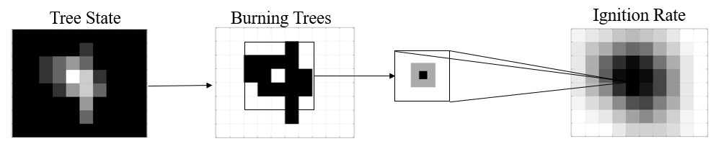

* + - * 1. Ignition Rate Calculation

To simulate ignition and extinguishment, we could generate random matrixes. When the random number is larger than the probability the tree ignites or extinguishes. We could then calculate the burning trees of current status with the matrix of ignited trees, extinguished trees and the burning trees of previous status.

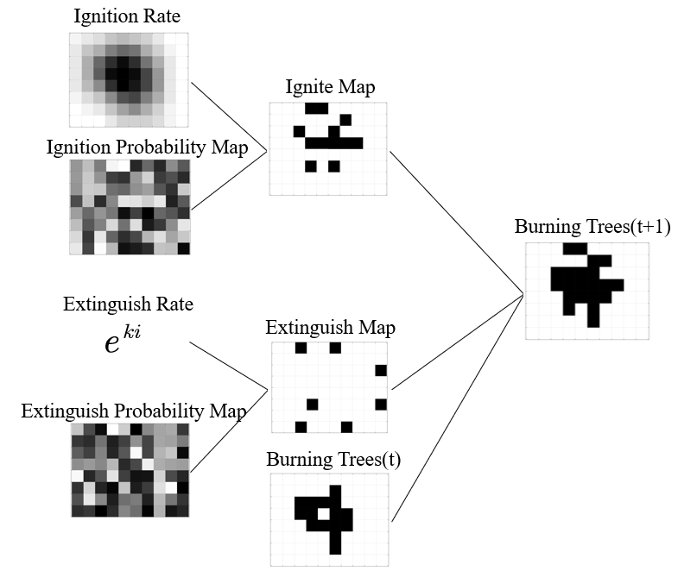

* + - * 1. Burn Trees Calculation

We could obtain the current tree status by decreasing the state value  by 1.

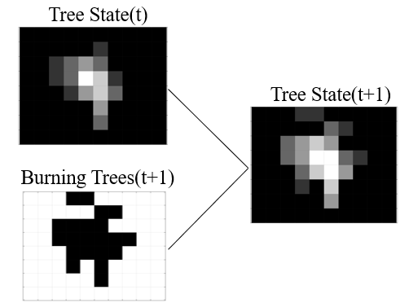

* + - * 1. Tree State Calculation

1. Simulation Method

The simulation algorithm is as follows: **Firstly,** the four points in the center of the fire site are set as fire, namely setting . **Secondly,** calculate the ignition probability for the next moment and compare with a random matrix get the location of the new fire point. **Thirdly,** the state variable of ignition point, that is, the unit state value , minus one. **Fourthly,** calculate the extinguish probability for the next moment and compare with a random matrix to get the newly extinguished tree and set . **Fifthly,** update the burning-time matrix for judgment of flame severity. **At last,** recalculate the ignition probability of all points.The specific algorithm flow chart is as follows.

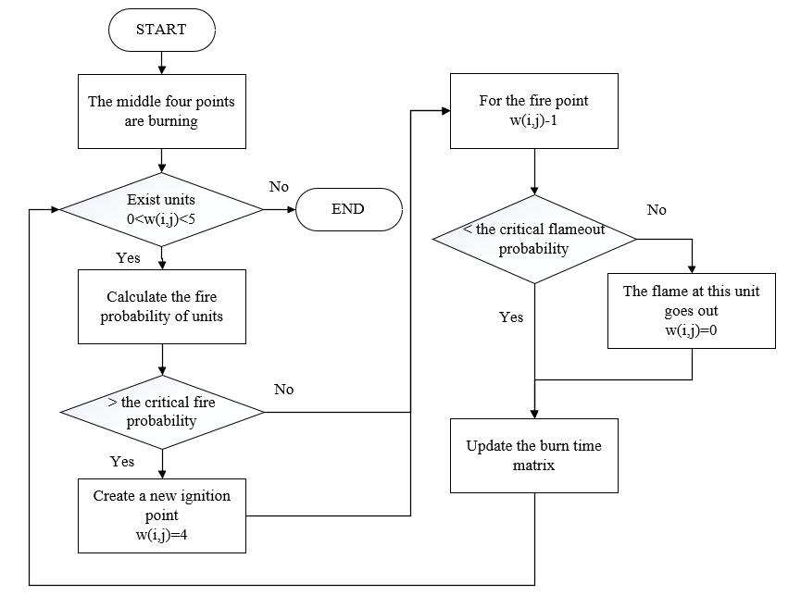

* + - * 1. Fire Simulation Model Based on Cellular Automata

The simulation results under this year’s condition are as follows:

图表, 散点图

已生成极高可信度的说明

* + - * 1. Simulation Result Under this Year’s Condition

After the model converged, we accumulate the time each point has been burned to determine the severity of the fire, namely assuming model converged at , and tree r was ignited at , we have . This indicates the center and spread of fire. We rescaled all  to 0-1 and transforms it into a M×N dimensional matrix with average pooling to characterize the spatial severity distribution of the fire, which is the value ** we used for the last model.

We can visualize this matrix as follows:

图示

已生成高可信度的说明

图示

已生成高可信度的说明

* + - * 1. Fire Severity Matrix (5 Simulations)

The lighter the color in the figure, the higher the flame severity of the unit.

* + 1. The Influence of Global Warming on Wildfire Simulation

To analyze the impact of global warming on this model, we established the following relationships. Firstly, by traversing the critical ignition probability from 0.7 to 0.95, we get the simulation results between the critical ignition probability and the fire area size. Then the relationship between the two variables is determined by curve fitting tool of MATLAB, which is shown as below.



We could speculate the critical ignition probability with fire area by using the above formula. With the fire zone size and average temperature of previous forest fire, we can get the relationship between the critical ignition probability and average temperature of the area.



When analyzing the relationship between time and temperature, we find that the change of temperature includes seasonal periodic change and long-term growth. For the annual temperature prediction, we can ignore the seasonal periodic change of temperature. Therefore, the temperature in this area increases exponentially with time. Due to an average temperature rise of 1.5 degrees Celsius over the past 50 years, their relationship is as follows



图表, 散点图

已生成极高可信度的说明

|  |  |  |
| --- | --- | --- |
| 1. The Relationship Between Critical Ignition Probability and Fire zone size | 1. The Relationship Between Average Temperature and Critical Ignition Probability | 1. Average Temperature Change Due to Global Warming |

* + - * 1. Fitting Results

We estimated the critical ignition probability of this year and ten years later as . Taking them into the simulation model, we can get respective average fire distribution and determine the demand change of UAV system.

* 1. Model 3: Ratio-Repeater Drones Optimization Model

We first evaluated the influence of terrain on communication, and measures a regions’ communication shielding effect with the terrain’s second gradient. Then we considered communication continuity requirements, which requires radio repeater drones to hover at a certain position continuously. According to the location and number of the SSA drones from model 1. We can get the location and number of radio repeater drones by optimization model.

* + 1. Influence of Terrain on Radio Range

Considering the influence of terrain on drone communication, we extract terrain data  from a fire region in Victoria. Then we use Laplacian operator to obtain the second gradient of terrain, which indicates the amplitude of altitude change. We then converted second gradient into signal transmission range. The specific transformation methods are as follows.



 enforces value range to. This matrix represents the transmit range of SSA drone at the fire region for each unit. The transmit limit between SSA drone or EOC and repeater is the sum of SSA drone transmit range and radio repeater drones transmit range.

图表, 直方图

已生成极高可信度的说明

* + - * 1. The Transmit Range for Each Space Unit
    1. Radio Repeater Drones Optimization Model

To adapt signal limits into programming problems, we could first discretize transmit range and calculate the transmit limit for each SSA drone and EOC. Then we could constrain radio repeater drone position by comparing spatial distance with transmit limits.

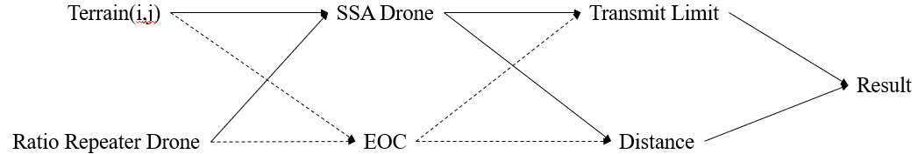

* + - * 1. Signal Transmit Limit Constrains Considering Terrain Factors

As we hypothesis that SSA drones can communicate with at least one radio repeater drone and EOC can communicate with all radio repeater drones, we have:



However, as we couldn’t optimize the total number of radio repeater drones in a programming problem directly, we could set the number of radio repeater drones and find feasible results that fits constrains manually. To adopt the question to programming, we could set the optimization object as the sum of distance between ratio repeater and EOC.



* + 1. Radio repeater drones scheduling scheme

For radio repeater drones, the reliability of communication needs to be considered, so we need to ensure that there is a ratio repeater drones at the calculated position throughout the wildfire course. Therefore, when the drone needs to return for charging, another drone needs to replace it.

For the WileE–15.2X hybrid drone, hovering time and charging time of UAV determine how many UAVs are needed in this position as follow.



For the formula 13, we know that



To sum up, we can know the total number of radio repeater drones, namely, .

1. Test the Model
   1. Model 1 Sensitivity Analysis
2. UAV detection performance index sensitivity analysis

For the model 1, UAV detection performance index depends on the detection range of the UAV. Different detectors have different detection capabilities, and we can find out how different detection range will affect the number and distribution of UAVs in this model by solving different parameters in its neighborhood range to testify the sensitivity analysis.

For the UAV detection performance index, we take 0.005 as the step size within the range of [0.01,0.03], and observe the effect of the change of the value on the model solution result. The results are shown in the following table:

The Relationship Between UAV Detection Performance Index and Drone Number

|  |  |  |
| --- | --- | --- |
|  | Drone number | * + - * 1. The Relationship Between UAV Detection Performance Index and Drone Number |
| 0.010 | 3 |
| 0.015 | 5 |
| 0.020 | 6 |
| 0.025 | 5 |
| 0.030 | 5 |

It can be seen from the results that when the value of λ is greater than a certain threshold, the number of UAVs solved by the model stabilizes at 5. It can be seen that the stability of the parameter is robust.

1. The boundary parameter sensitivity analysis

The boundary parameter balances the cost increase of adding SSA drones. It adds SSA drones when the detection revenue contributes more than the increased cost.

For the boundary parameter𝛼, we use 0.1 as the step size in the range of [0.3, 0.7] to observe it’s influence on the result. The results are shown in the table 4 below

The Relationship Between Boundary Contribution and Drone Number

|  |  |  |
| --- | --- | --- |
| α | Drone number | 图表, 折线图  已生成极高可信度的说明   * + - * 1. The Relationship Between Boundary Contribution and Drone Number |
| 0.3 | 7 |
| 0.4 | 6 |
| 0.5 | 6 |
| 0.6 | 4 |
| 0.7 | 3 |

It can be seen from the table that this parameter has a great influence on the result of UAV, which shows that this parameter has high sensitivity and poor stability. This is reasonable considering its physical meaning.

* 1. Model 2 Sensitivity Analysis

For cellular automata, due to the random simulation process involved in the model, different tests with the same parameter value may result in different fire field distributions. Therefore, we change the value of a certain parameter and solve the model twice for each value to verify the sensitivity.

For the critical ignition probability , we use 0.03 as the step size in the range of [0.74, 0.83] to observe the influence of the change of its value on the model solution result. The results are shown in the table 5 below:

The Relationship Between Critical Ignition Probability  and Drone Number

|  |  |  |
| --- | --- | --- |
|  | Drone number  simulation 1 | Drone number  simulation 2 |
| 0.74 | 10 | 10 |
| 0.77 | 6 | 6 |
| 0.80 | 6 | 5 |
| 0.83 | 4 | 4 |

图表, 折线图

已生成极高可信度的说明

* + - * 1. Sensitivity Analysis for Critical Ignition Probability

It can be deduced that the change of value k has a great influence on the solution result of the model, indicating that the sensitivity of parameter  is high. Therefore, it is necessary to accurately simulate the value of k in the process of model building, otherwise the solution result will produce errors.

* 1. Model 3 Sensitivity Analysis

We further applied the model 2 sensitivity analysis results to test the influence of Critical ignition probability on radio repeater drone location.

Location of Radio Repeater Drone Under Two Independent Simulations

|  |  |  |
| --- | --- | --- |
| Critical ignition probability | Location of radio repeater drone simulation 1 | Location of radio repeater drone simulation 2 |
| 0.74 | (3,4) | (2,5) |
| 0.77 | (0,3) | (0,3) |
| 0.80 | (0,3) | (2,5) |
| 0.83 | (2,4) | (2,4) |

Results showed that the Location of radio repeater drone tends to stay close to the EOC and varies less during different simulations or under different fire zone situations.

1. Conclusion
   1. Summary of Results
      1. Result of Problem 1

Through cellular automata, according to the fire data of the Australian fire, we can get the distribution of one of the fires as follows, where the critical ignition probability is . We ran five simulations. Then we got the flame severity distribution matrix. We visualize it as shown in the figure 10.

图示

已生成高可信度的说明

图示

已生成高可信度的说明

* + - * 1. Flame Severity Distribution Matrix

Bring the fire severity data to the optimization model 1 we have:



Through lingo, the matrix for 5 kinds of SSA drones monitoring mode and the location of EOC is obtained, and the total number of SSA UAVs is . The location of EOC is (1,6).

Bringing EOC and SSA locations to optimization model 3, we have:



Here we could solve the optimization model when setting the total number of radio repeater drones in the programming problem to one. we could further calculate the total number of radio repeater drones under shifting conditions with its traveling distance: . Hence the total number of 2 kinds of drones is 10.

* + 1. Result of Problem 2

Due to global warming, the surface temperature of Victoria will increase, which will affect the ignition probability of the region. The critical ignition probability after ten years is . Through cellular automata. Following the same optimization process of problem 1. The number of SSA drones is . The number of radio repeater drones is known as.

Therefore, for the next decade, due to global warming, the cost of thermal imaging cameras and telemetry sensors increases.

* + 1. Result of Problem 3

We choose 3 different area to simulate the results, yet the location of radio repeater remains the same. We believe that as the average fire zone and SSA drone hovering area is small, most constrains on transmit limit are loose constrains. Also, the terrain’s influence on transmit limit is too small and the repeater drone’s robust tendency of staying close to the EOC weakens the influence. This is reasonable as terrain usually have minor influence on aircrafts.

1. Model Evaluation and Further Discussion
   1. Strengths

* By using simulation and history data, the model is robust and wide applicable. The deployment position of EOC and UAV can be quickly solved knowing the fire situation, which can improve the efficiency of fire rescue.
* The model follows the encapsulation principle, each of the three sub models could be independently modified according to actual needs.
  1. Possible Improvements
* The impact of weather and terrain factors on the flight of the UAV is not considered.
* The fire field prediction model assumes isotropy fire diffusion, yet the vegetation coverage is inconsistent, we could further bring terrain factors to the cellular automata model.

1. References

[1] W. Wei, M. Hao, X. Jin-qi, and S. Chang-yin, “Research on standardized design method of air-frame for multi-rotor uav,” no. 5, pp. 147150, 2014.

[2]Xiang Tingli, Wang Hongjun, Shi Yingchun. Multi-aircraft cooperative detection task allocation strategy for area coverage[J]. Journal of Air Force Engineering University (Natural Science Edi-tion), 2019, 20(06): 33-38+71.

[3] Niu Ruoyun, Zhai Panmao, Sun Minghua. Review of Forest Fire Risk Meteorological Index and Its Construction Method[J]. Meteorology, 2006(12): 3-9.

[4] Zhang Wenwen, Wang Qiuhua, Wang Ruichen, Long Tengteng, Wei Jianheng, Gao Zhongliang. Research progress on Australian eucalyptus forest fires[J/OL]. World Forestry Re-search:1-10[2021-02-07].https://doi.org/10.13348/j.cnki.sjlyyj.2021.0004.y.

[5] Li Chengxin, Zhao Liangchen, Li Dongyun, Ma Jiahui. Australian forest fire spread prediction model based on CA system and application of emergency supplies dispatching [J]. Forestry In-vestigation and Planning, 2020, 45(05): 62-69+89.

[6] Liu Jiachang, Tang Bin, Zou Yuan. Using GIS to analyze the factors affecting the occurrence of forest fires and their temporal and spatial distribution characteristics: Taking California as an example [J]. Journal of Northeast Forestry University, 2020, 48(07): 70-74.

[7] Li Binghua, Zhu Jiping, Xiaodezhi, Peng Chen. A method for estimating the frequency of major fires based on the information diffusion of small sample data[J]. Fire Science, 2010, 19(02): 82-88.

[8] Liu Chang. Research and simulation of forest fire spread model based on cellular automata[D]. Dalian University of Technology, 2012.

[9] Yang Fulong. Three-dimensional simulation of forest fire spread based on cellular automata[D]. Beijing Forestry University, 2016.

[10] Zhou Peiheng. Research on the evolution model of regional disaster consequences based on cellular automata [D]. Dalian University of Technology, 2015.

Budget Request

|  |  |
| --- | --- |
| To: CFA | From: MCM/ICM Team #2104673 |
| Date: Friday, February 5, 2021 | |
| Subject: Budget request for establishing ‘Rapid Bushfire Response’ UAV system for Victoria state government | |

Dear Sir or Madam:

Knowing that CFA is preparing to set up a new department called “Rapid Bushfire Response” and recently developing a drone system to deal with forest fires. We are more than glad to share our mathematical model to give some recommendations.

From 2019 to 2020, Australia has suffered from devastating forest fires, causing serious damage to the environment in every state and seriously affecting people's normal lives. In order to curb the spread of fire and reduce property losses, emergency systems must be designed to better help the Victorian government to rescue fires.

Since the drones are not restricted by road conditions, they can observe the situation in the disaster area, transport relief supplies. Therefore, it is widely used in the rescue of natural disasters such as fires, earthquakes and hurricanes. Our team has developed an drone system for fire detection and information transmission. The system can be used to observe forest fires and provide communication services between firefighters and the command center.

First, we built a fire prediction model based on climate data. By collecting climate data from Victoria and combining with future climate change trends, we can predict the probability and magnitude of fires in this area in the next ten years. Then by discretizing the fire area, we constructed an SSA drone deploy model considering fire severity. Through the number and location of SSA drones, we can obtain the number and location of Radio Repeater drones considering influence of Victoria's terrain on the signal transmission.

In order to reduce the government's financial burden, we propose to purchase rechargeable drones and find the minimum number of drones that can meet the rescue requirements. We recommend that you purchase 10 SSA drones and 2 radio repeater drones to deal with forest fires in Victoria in the next ten years, otherwise it may not be able to cover the entire fire scene and ensure the communication safety of all firefighters.

We hope that our model can help CFA improve the efficiency of fire rescue, ensure the safety of firefighters and reduce the loss caused by fire.

Yours Sincerely,

Team # 2104673

P.S. The attached table for the budget request is on the next page.

|  |  |  |  |  |
| --- | --- | --- | --- | --- |
| **Budget Request** | | | | |
| **Project for Requesting Department** | | | **Effective Date** | |
| ‘Rapid Bushfire Response’ UAV system | | | Friday, February 5, 2021 | |
| **Title:** UAV system for fire detection and information transmission | | | | |
| **Purpose:**  Detect fire conditions to improve fire rescue efficiency and reduce losses caused by fire. Provide  communication services between firefighters and rescue centers to ensure the safety of firefighters. | | | | |
| **How are funds used：**  The money is mainly used to purchase WileE–15.2X Hybrid Drones, handheld two-way radios, thermal imaging cameras and telemetry sensors and repeaters. | | | | |
| Estimated Expenditures | Price | Number | | Comments |
| WileE–15.2X Hybrid Drone | $12000 | 12 | | An UVA equipped with radio repeaters or video and telemetry functions. |
| thermal imaging cameras and telemetry sensors | $1000 | 10 | | Portable communication equipment between firefighters and EOC. |
| radio repeater | $1000 | 2 | | Transceivers that automatically rebroadcast signals at higher powers. |
| **Reporting Department:** Team #2104673 MCM/ICM | | | | |
| Requested by: CFA | | | | |
| Date: Friday, February 5, 2021 | | | | |