EE533 - Laboratory 2

Xilinx ISE 10.1 In-depth Tutorial

Screen capture of schematics
Since the original tutorial’s “stopwatch.sch” was no longer compilable, I use the ise_tutorial.mkv video for the tutorial section. The following is a 4-bit adder, which uses 4 1-bit full adders as components.
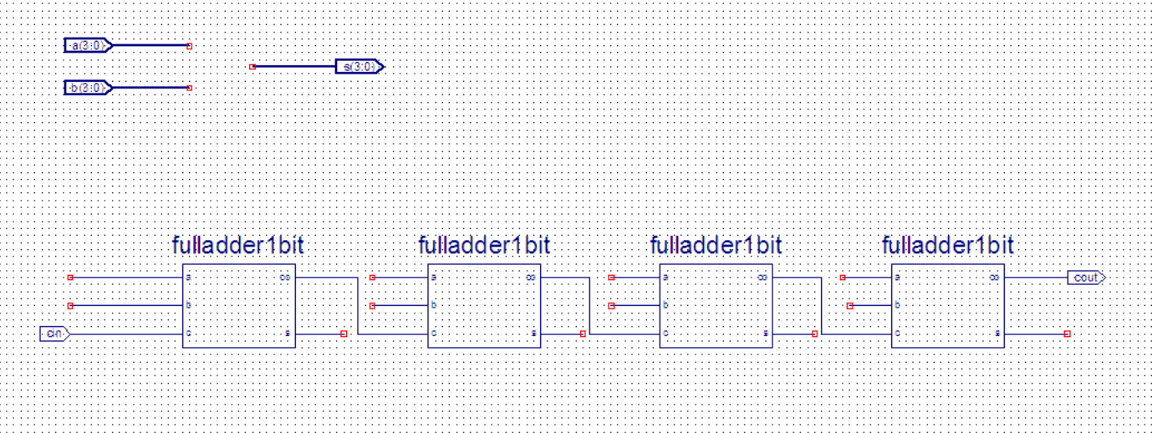
Inside the 1-bit full adder:
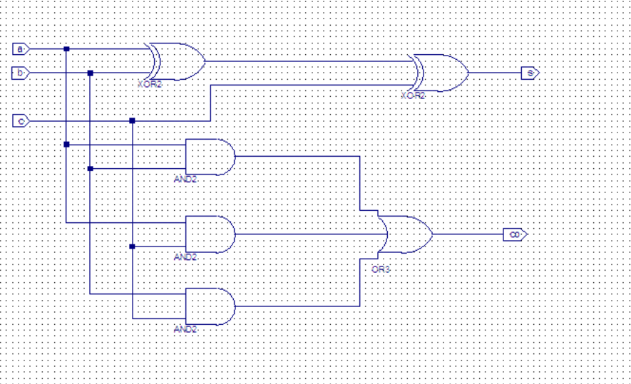

Waveform
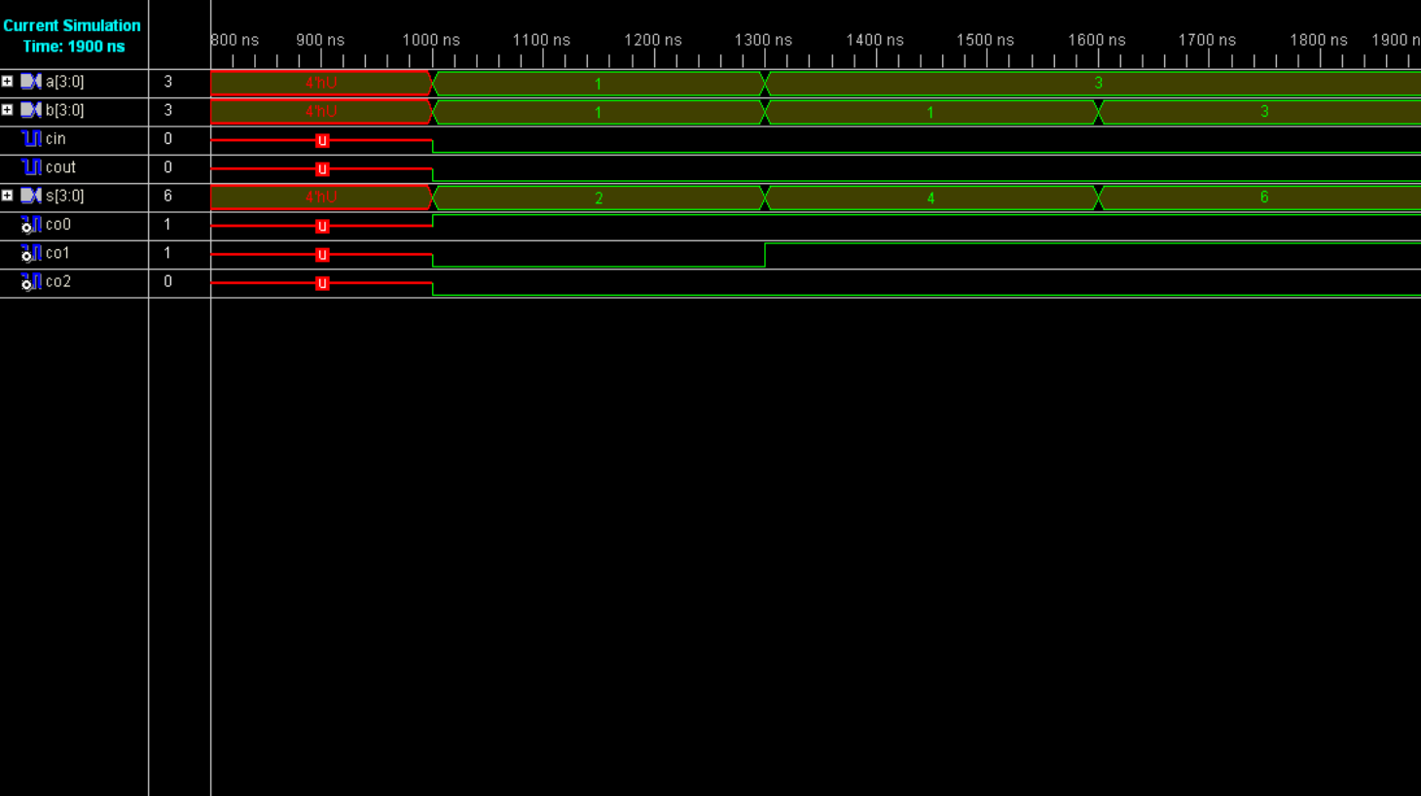

Designing and Simulating a Synchronous 8-bit Adder

Designing and Simulating a Synchronous 8-bit Adder
A synchronous 8-bit Adder uses 8 1-bit full adders in a sequential manner. To have the synchronous functionality, I use DFFs in front of inputs and after the outputs. So that when the positive edge of the clock comes, the input of the adder changes.
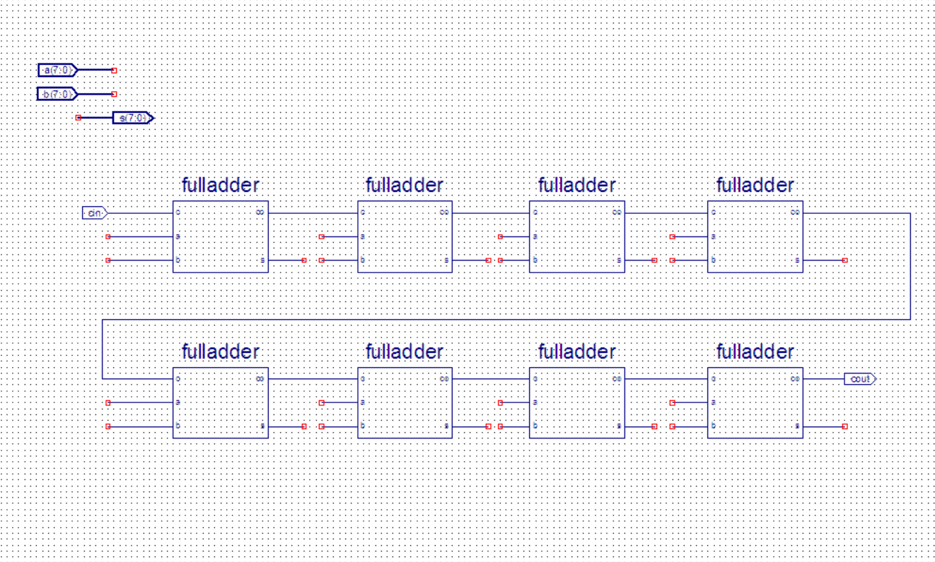
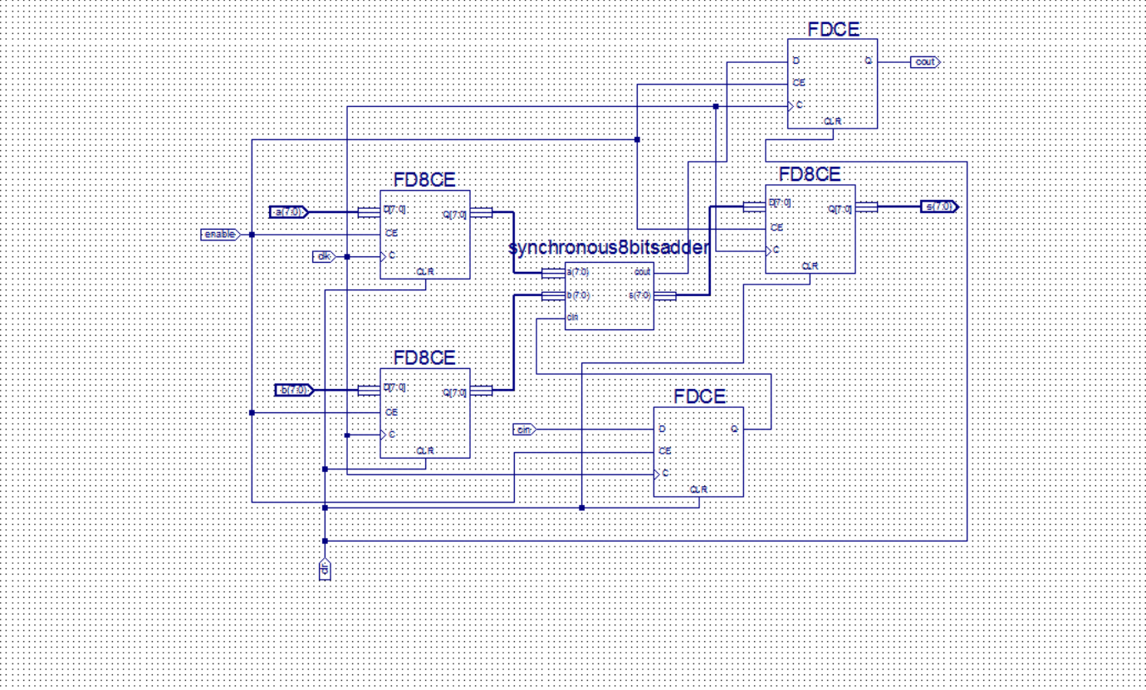

Waveforms
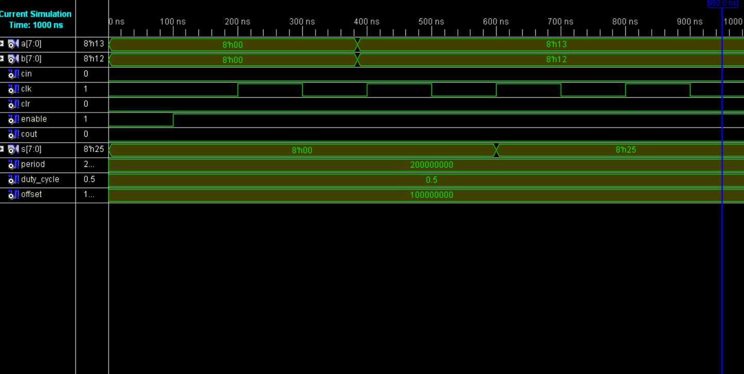

Extending Adder into 32-bit ALU

32-bit Adder

Screen capture of schematics
Same as the 32-bit adder, but without 32-bit DFFs, I use 2 16-bit DFFs combined to a 32-bit DFF.
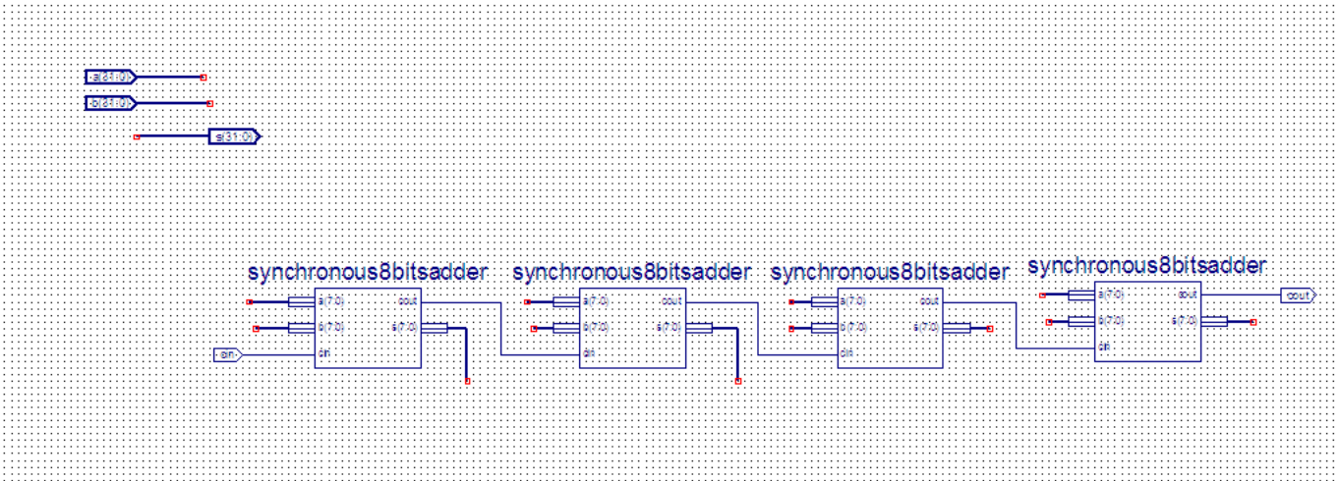
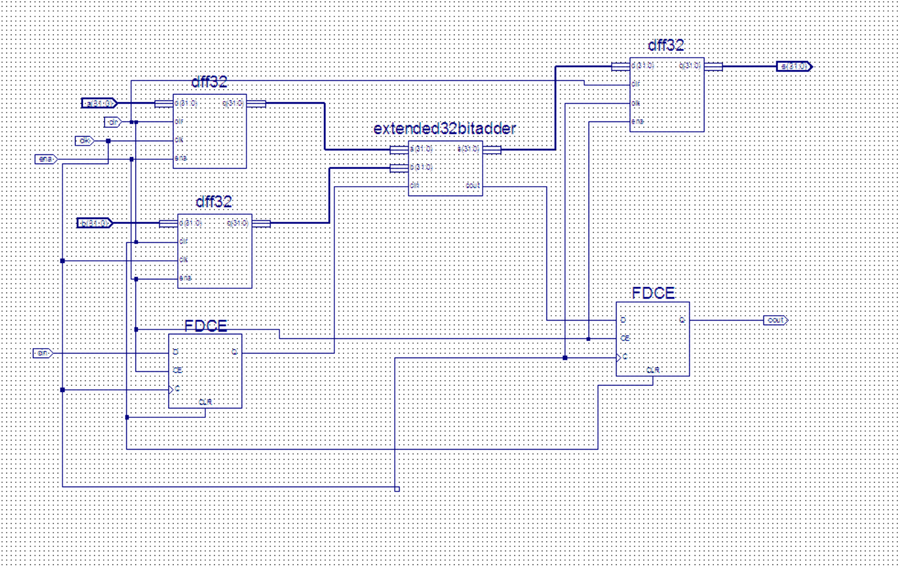

Waveforms
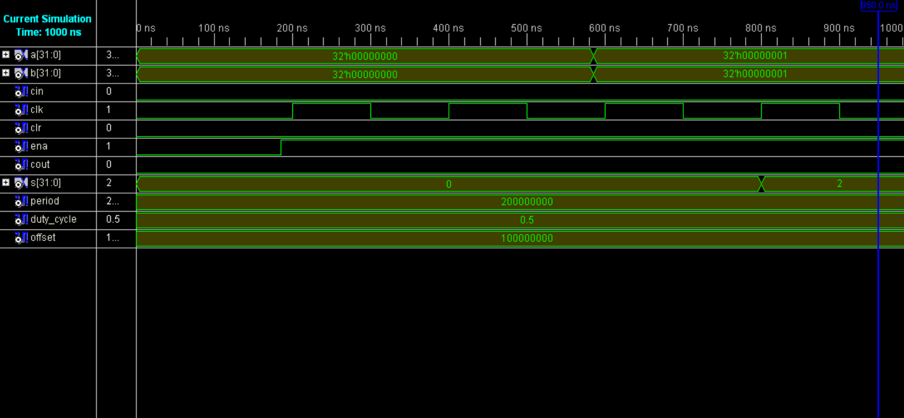

ALU

Brief description of the functions
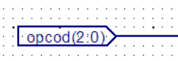
In this section,
When the opcode is 000, the ALU does add calculation.
When the opcode is 001, the ALU does sub calculation.
When the opcode is 010, the ALU does and calculation.
When the opcode is 011, the ALU does or calculation.
When the opcode is 100, the ALU does SHL calculation.

Screen capture of schematics
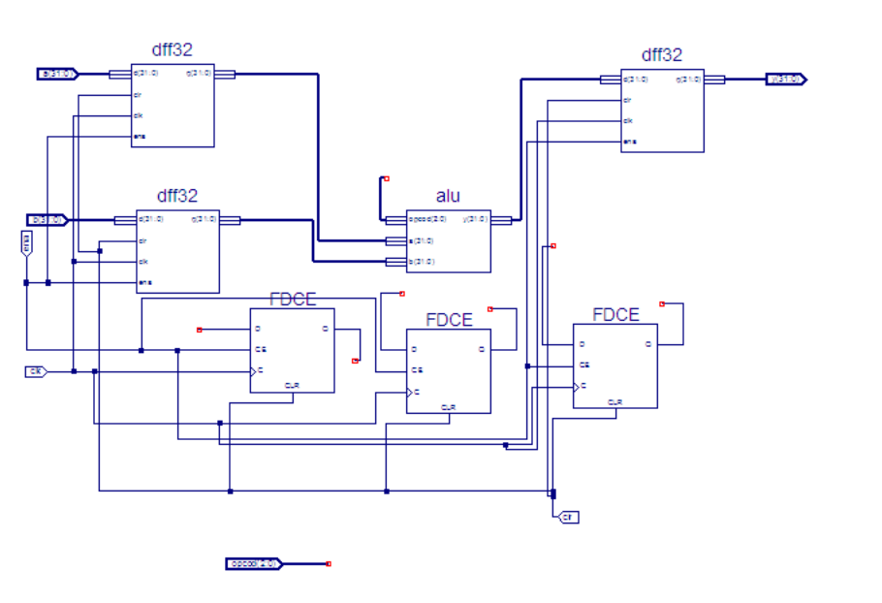

Waveforms
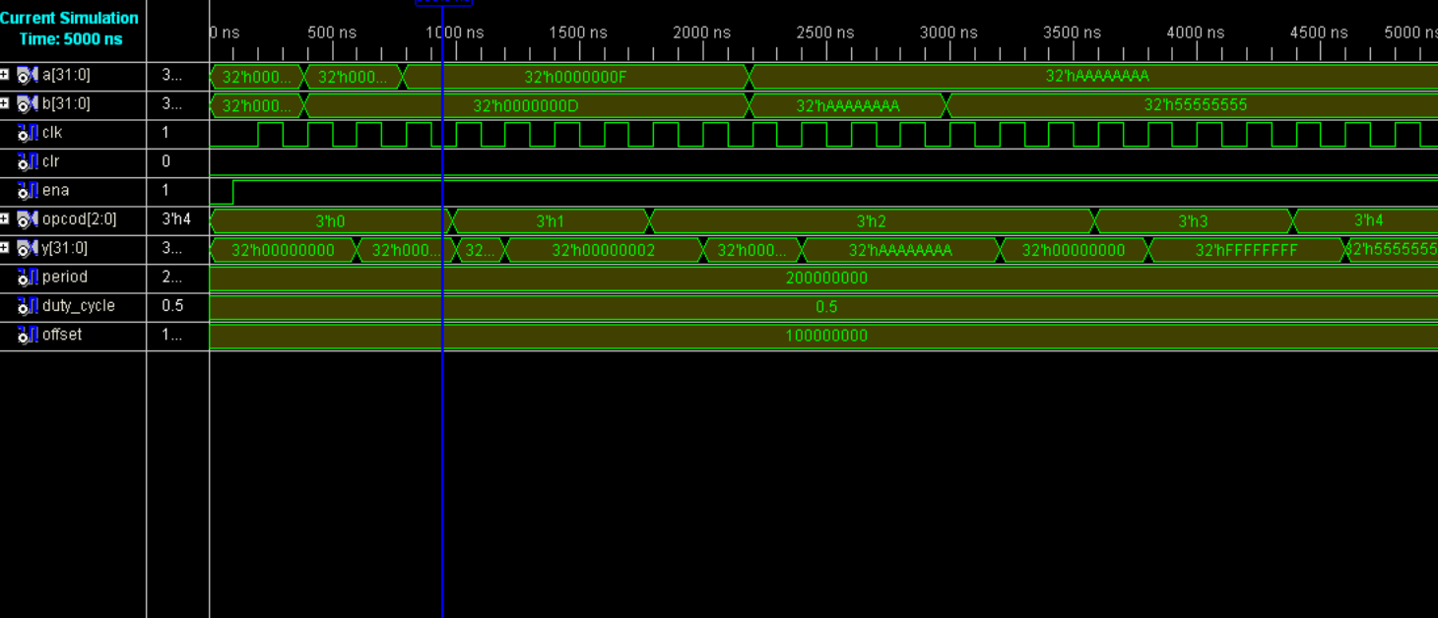

Log file of the mapper
Release 10.1 Map K.31 (nt)
Xilinx Mapping Report File for Design 'tb_syn_alu'

Design Information
------------------
Command Line : map -ise "C:/Documents and
Settings/student/Desktop/ee533/ee533_lab2/ee533_lab2.ise" -intstyle ise -p
xc2v1000-bg575-6 -cm area -pr off -k 4 -c 100 -tx off -o tb_syn_alu_map.ncd
tb_syn_alu.ngd tb_syn_alu.pcf
Target Device : xc2v1000
Target Package : bg575
Target Speed : -6
Mapper Version : virtex2 -- $Revision: 1.46 $
Mapped Date : Fri Jan 23 20:13:09 2026

Design Summary
--------------
Number of errors: 0
Number of warnings: 0
Logic Utilization:
Number of Slice Flip Flops: 99 out of 10,240 1%
Number of 4 input LUTs: 160 out of 10,240 1%
Logic Distribution:
Number of occupied Slices: 114 out of 5,120 2%
Number of Slices containing only related logic: 114 out of 114 100%
Number of Slices containing unrelated logic: 0 out of 114 0%
*See NOTES below for an explanation of the effects of unrelated logic.
Total Number of 4 input LUTs: 160 out of 10,240 1%
Number of bonded IOBs: 102 out of 328 31%
Number of BUFGMUXs: 1 out of 16 6%

Peak Memory Usage: 146 MB
Total REAL time to MAP completion: 0 secs
Total CPU time to MAP completion: 0 secs

NOTES:

Related logic is defined as being logic that shares connectivity - e.g. two
LUTs are "related" if they share common inputs. When assembling slices,
Map gives priority to combine logic that is related. Doing so results in
the best timing performance.

Unrelated logic shares no connectivity. Map will only begin packing
unrelated logic into a slice once 99% of the slices are occupied through
related logic packing.

Note that once logic distribution reaches the 99% level through related
logic packing, this does not mean the device is completely utilized.
Unrelated logic packing will then begin, continuing until all usable LUTs
and FFs are occupied. Depending on your timing budget, increased levels of
unrelated logic packing may adversely affect the overall timing performance
of your design.

Table of Contents
-----------------
Section 1 - Errors
Section 2 - Warnings
Section 3 - Informational
Section 4 - Removed Logic Summary
Section 5 - Removed Logic
Section 6 - IOB Properties
Section 7 - RPMs
Section 8 - Guide Report
Section 9 - Area Group and Partition Summary
Section 10 - Modular Design Summary
Section 11 - Timing Report
Section 12 - Configuration String Information
Section 13 - Control Set Information
Section 14 - Utilization by Hierarchy

Section 1 - Errors
------------------

Section 2 - Warnings
--------------------

Section 3 - Informational
-------------------------
INFO:MapLib:562 - No environment variables are currently set.
INFO:LIT:244 - All of the single ended outputs in this design are using slew
rate limited output drivers. The delay on speed critical single ended outputs
can be dramatically reduced by designating them as fast outputs.

Section 4 - Removed Logic Summary
---------------------------------
4 block(s) removed
3 block(s) optimized away
3 signal(s) removed

Section 5 - Removed Logic
-------------------------

The trimmed logic report below shows the logic removed from your design due to
sourceless or loadless signals, and VCC or ground connections. If the removal
of a signal or symbol results in the subsequent removal of an additional signal
or symbol, the message explaining that second removal will be indented. This
indentation will be repeated as a chain of related logic is removed.

To quickly locate the original cause for the removal of a chain of logic, look
above the place where that logic is listed in the trimming report, then locate
the lines that are least indented (begin at the leftmost edge).

Loadless block "XLXI_1/XLXI_1/XLXI_1/XLXI_4/XLXI_9/XLXI_6" (OR) removed.
The signal "XLXI_1/XLXI_1/XLXI_1/XLXI_4/XLXI_9/XLXN_15" is loadless and has been
removed.
Loadless block "XLXI_1/XLXI_1/XLXI_1/XLXI_4/XLXI_9/XLXI_5" (AND) removed.
The signal "XLXI_1/XLXI_1/XLXI_1/XLXI_4/XLXI_9/XLXN_14" is loadless and has been
removed.
Loadless block "XLXI_1/XLXI_1/XLXI_1/XLXI_4/XLXI_9/XLXI_4" (AND) removed.
The signal "XLXI_1/XLXI_1/XLXI_1/XLXI_4/XLXI_9/XLXN_13" is loadless and has been
removed.
Loadless block "XLXI_1/XLXI_1/XLXI_1/XLXI_4/XLXI_9/XLXI_3" (AND) removed.

Optimized Block(s):
TYPE BLOCK
AND2 XLXI_1/XLXI_10/XLXI_2/XLXI_1/XLXI_1/XLXI_1/I_36_9
BUF XLXI_1/XLXI_5/XLXI_34
GND XST_GND

To enable printing of redundant blocks removed and signals merged, set the
detailed map report option and rerun map.

Section 6 - IOB Properties
--------------------------

+----------------------------------------------------------------------------------------------------------------------------------------+
| IOB Name | Type | Direction | IO Standard | Drive | Slew | Reg (s) | Resistor | IOB |
| | | | | Strength | Rate | | | Delay |
+----------------------------------------------------------------------------------------------------------------------------------------+
| a<0> | IOB | INPUT | LVTTL | | | | | |
| a<1> | IOB | INPUT | LVTTL | | | | | |
| a<2> | IOB | INPUT | LVTTL | | | | | |
| a<3> | IOB | INPUT | LVTTL | | | | | |
| a<4> | IOB | INPUT | LVTTL | | | | | |
| a<5> | IOB | INPUT | LVTTL | | | | | |
| a<6> | IOB | INPUT | LVTTL | | | | | |
| a<7> | IOB | INPUT | LVTTL | | | | | |
| a<8> | IOB | INPUT | LVTTL | | | | | |
| a<9> | IOB | INPUT | LVTTL | | | | | |
| a<10> | IOB | INPUT | LVTTL | | | | | |
| a<11> | IOB | INPUT | LVTTL | | | | | |
| a<12> | IOB | INPUT | LVTTL | | | | | |
| a<13> | IOB | INPUT | LVTTL | | | | | |
| a<14> | IOB | INPUT | LVTTL | | | | | |
| a<15> | IOB | INPUT | LVTTL | | | | | |
| a<16> | IOB | INPUT | LVTTL | | | | | |
| a<17> | IOB | INPUT | LVTTL | | | | | |
| a<18> | IOB | INPUT | LVTTL | | | | | |
| a<19> | IOB | INPUT | LVTTL | | | | | |
| a<20> | IOB | INPUT | LVTTL | | | | | |
| a<21> | IOB | INPUT | LVTTL | | | | | |
| a<22> | IOB | INPUT | LVTTL | | | | | |
| a<23> | IOB | INPUT | LVTTL | | | | | |
| a<24> | IOB | INPUT | LVTTL | | | | | |
| a<25> | IOB | INPUT | LVTTL | | | | | |
| a<26> | IOB | INPUT | LVTTL | | | | | |
| a<27> | IOB | INPUT | LVTTL | | | | | |
| a<28> | IOB | INPUT | LVTTL | | | | | |
| a<29> | IOB | INPUT | LVTTL | | | | | |
| a<30> | IOB | INPUT | LVTTL | | | | | |
| a<31> | IOB | INPUT | LVTTL | | | | | |
| b<0> | IOB | INPUT | LVTTL | | | | | |
| b<1> | IOB | INPUT | LVTTL | | | | | |
| b<2> | IOB | INPUT | LVTTL | | | | | |
| b<3> | IOB | INPUT | LVTTL | | | | | |
| b<4> | IOB | INPUT | LVTTL | | | | | |
| b<5> | IOB | INPUT | LVTTL | | | | | |
| b<6> | IOB | INPUT | LVTTL | | | | | |
| b<7> | IOB | INPUT | LVTTL | | | | | |
| b<8> | IOB | INPUT | LVTTL | | | | | |
| b<9> | IOB | INPUT | LVTTL | | | | | |
| b<10> | IOB | INPUT | LVTTL | | | | | |
| b<11> | IOB | INPUT | LVTTL | | | | | |
| b<12> | IOB | INPUT | LVTTL | | | | | |
| b<13> | IOB | INPUT | LVTTL | | | | | |
| b<14> | IOB | INPUT | LVTTL | | | | | |
| b<15> | IOB | INPUT | LVTTL | | | | | |
| b<16> | IOB | INPUT | LVTTL | | | | | |
| b<17> | IOB | INPUT | LVTTL | | | | | |
| b<18> | IOB | INPUT | LVTTL | | | | | |
| b<19> | IOB | INPUT | LVTTL | | | | | |
| b<20> | IOB | INPUT | LVTTL | | | | | |
| b<21> | IOB | INPUT | LVTTL | | | | | |
| b<22> | IOB | INPUT | LVTTL | | | | | |
| b<23> | IOB | INPUT | LVTTL | | | | | |
| b<24> | IOB | INPUT | LVTTL | | | | | |
| b<25> | IOB | INPUT | LVTTL | | | | | |
| b<26> | IOB | INPUT | LVTTL | | | | | |
| b<27> | IOB | INPUT | LVTTL | | | | | |
| b<28> | IOB | INPUT | LVTTL | | | | | |
| b<29> | IOB | INPUT | LVTTL | | | | | |
| b<30> | IOB | INPUT | LVTTL | | | | | |
| b<31> | IOB | INPUT | LVTTL | | | | | |
| clk | IOB | INPUT | LVTTL | | | | | |
| clr | IOB | INPUT | LVTTL | | | | | |
| ena | IOB | INPUT | LVTTL | | | | | |
| opcod<0> | IOB | INPUT | LVTTL | | | | | |
| opcod<1> | IOB | INPUT | LVTTL | | | | | |
| opcod<2> | IOB | INPUT | LVTTL | | | | | |
| y<0> | IOB | OUTPUT | LVTTL | 12 | SLOW | | | |
| y<1> | IOB | OUTPUT | LVTTL | 12 | SLOW | | | |
| y<2> | IOB | OUTPUT | LVTTL | 12 | SLOW | | | |
| y<3> | IOB | OUTPUT | LVTTL | 12 | SLOW | | | |
| y<4> | IOB | OUTPUT | LVTTL | 12 | SLOW | | | |
| y<5> | IOB | OUTPUT | LVTTL | 12 | SLOW | | | |
| y<6> | IOB | OUTPUT | LVTTL | 12 | SLOW | | | |
| y<7> | IOB | OUTPUT | LVTTL | 12 | SLOW | | | |
| y<8> | IOB | OUTPUT | LVTTL | 12 | SLOW | | | |
| y<9> | IOB | OUTPUT | LVTTL | 12 | SLOW | | | |
| y<10> | IOB | OUTPUT | LVTTL | 12 | SLOW | | | |
| y<11> | IOB | OUTPUT | LVTTL | 12 | SLOW | | | |
| y<12> | IOB | OUTPUT | LVTTL | 12 | SLOW | | | |
| y<13> | IOB | OUTPUT | LVTTL | 12 | SLOW | | | |
| y<14> | IOB | OUTPUT | LVTTL | 12 | SLOW | | | |
| y<15> | IOB | OUTPUT | LVTTL | 12 | SLOW | | | |
| y<16> | IOB | OUTPUT | LVTTL | 12 | SLOW | | | |
| y<17> | IOB | OUTPUT | LVTTL | 12 | SLOW | | | |
| y<18> | IOB | OUTPUT | LVTTL | 12 | SLOW | | | |
| y<19> | IOB | OUTPUT | LVTTL | 12 | SLOW | | | |
| y<20> | IOB | OUTPUT | LVTTL | 12 | SLOW | | | |
| y<21> | IOB | OUTPUT | LVTTL | 12 | SLOW | | | |
| y<22> | IOB | OUTPUT | LVTTL | 12 | SLOW | | | |
| y<23> | IOB | OUTPUT | LVTTL | 12 | SLOW | | | |
| y<24> | IOB | OUTPUT | LVTTL | 12 | SLOW | | | |
| y<25> | IOB | OUTPUT | LVTTL | 12 | SLOW | | | |
| y<26> | IOB | OUTPUT | LVTTL | 12 | SLOW | | | |
| y<27> | IOB | OUTPUT | LVTTL | 12 | SLOW | | | |
| y<28> | IOB | OUTPUT | LVTTL | 12 | SLOW | | | |
| y<29> | IOB | OUTPUT | LVTTL | 12 | SLOW | | | |
| y<30> | IOB | OUTPUT | LVTTL | 12 | SLOW | | | |
| y<31> | IOB | OUTPUT | LVTTL | 12 | SLOW | | | |
+----------------------------------------------------------------------------------------------------------------------------------------+

Section 7 - RPMs
----------------

Section 8 - Guide Report
------------------------
Guide not run on this design.

Section 9 - Area Group and Partition Summary
--------------------------------------------

Partition Implementation Status
-------------------------------

No Partitions were found in this design.

-------------------------------

Area Group Information
----------------------

No area groups were found in this design.

----------------------

Section 10 - Modular Design Summary
-----------------------------------
Modular Design not used for this design.

Section 11 - Timing Report
--------------------------
This design was not run using timing mode.

Section 12 - Configuration String Details
-----------------------------------------
Use the "-detail" map option to print out Configuration Strings

Section 13 - Control Set Information
------------------------------------
No control set information for this architecture.

Section 14 - Utilization by Hierarchy
-------------------------------------

This feature is not supported for this architecture.

32-bit ALU Verilog Version

Waveforms
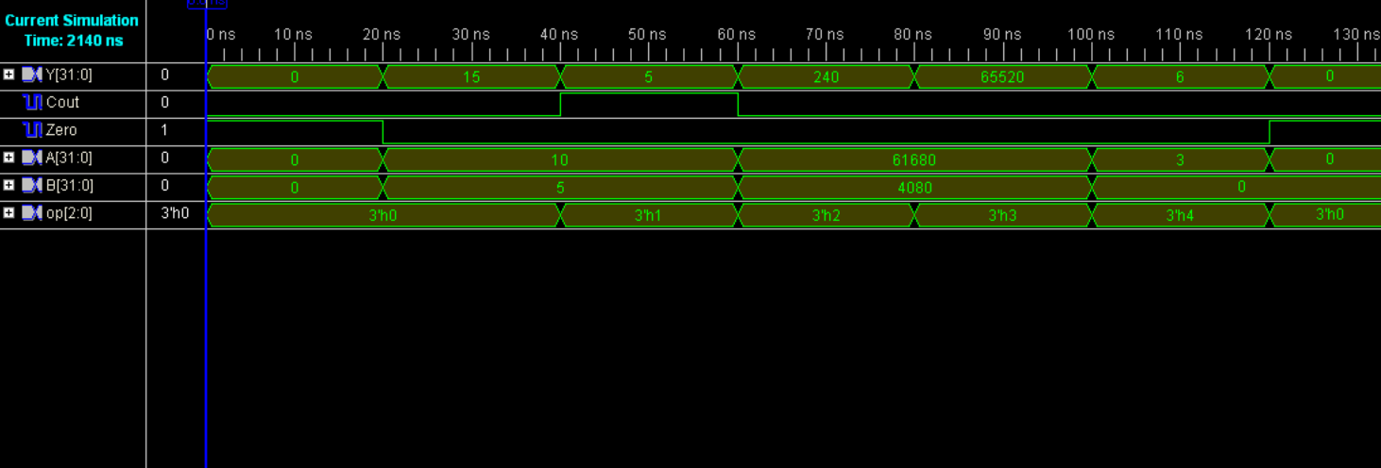

Log file of the mapper
Release 10.1 Map K.31 (nt)
Xilinx Mapping Report File for Design 'alu32'

Design Information
------------------
Command Line : map -ise "C:/Documents and
Settings/student/Desktop/ee533/alu_new/alu_new.ise" -intstyle ise -p
xc2v1000-bg575-6 -cm area -pr off -k 4 -c 100 -tx off -o alu32_map.ncd alu32.ngd
alu32.pcf
Target Device : xc2v1000
Target Package : bg575
Target Speed : -6
Mapper Version : virtex2 -- $Revision: 1.46 $
Mapped Date : Fri Jan 23 20:05:53 2026

Design Summary
--------------
Number of errors: 0
Number of warnings: 0
Logic Utilization:
Number of 4 input LUTs: 106 out of 10,240 1%
Logic Distribution:
Number of occupied Slices: 53 out of 5,120 1%
Number of Slices containing only related logic: 53 out of 53 100%
Number of Slices containing unrelated logic: 0 out of 53 0%
*See NOTES below for an explanation of the effects of unrelated logic.
Total Number of 4 input LUTs: 106 out of 10,240 1%
Number of bonded IOBs: 101 out of 328 30%

Peak Memory Usage: 145 MB
Total REAL time to MAP completion: 0 secs
Total CPU time to MAP completion: 0 secs

NOTES:

Related logic is defined as being logic that shares connectivity - e.g. two
LUTs are "related" if they share common inputs. When assembling slices,
Map gives priority to combine logic that is related. Doing so results in
the best timing performance.

Unrelated logic shares no connectivity. Map will only begin packing
unrelated logic into a slice once 99% of the slices are occupied through
related logic packing.

Note that once logic distribution reaches the 99% level through related
logic packing, this does not mean the device is completely utilized.
Unrelated logic packing will then begin, continuing until all usable LUTs
and FFs are occupied. Depending on your timing budget, increased levels of
unrelated logic packing may adversely affect the overall timing performance
of your design.

Table of Contents
-----------------
Section 1 - Errors
Section 2 - Warnings
Section 3 - Informational
Section 4 - Removed Logic Summary
Section 5 - Removed Logic
Section 6 - IOB Properties
Section 7 - RPMs
Section 8 - Guide Report
Section 9 - Area Group and Partition Summary
Section 10 - Modular Design Summary
Section 11 - Timing Report
Section 12 - Configuration String Information
Section 13 - Control Set Information
Section 14 - Utilization by Hierarchy

Section 1 - Errors
------------------

Section 2 - Warnings
--------------------

Section 3 - Informational
-------------------------
INFO:MapLib:562 - No environment variables are currently set.
INFO:LIT:244 - All of the single ended outputs in this design are using slew
rate limited output drivers. The delay on speed critical single ended outputs
can be dramatically reduced by designating them as fast outputs.

Section 4 - Removed Logic Summary
---------------------------------
2 block(s) optimized away

Section 5 - Removed Logic
-------------------------

Optimized Block(s):
TYPE BLOCK
GND XST_GND
VCC XST_VCC

Section 6 - IOB Properties
--------------------------

+----------------------------------------------------------------------------------------------------------------------------------------+
| IOB Name | Type | Direction | IO Standard | Drive | Slew | Reg (s) | Resistor | IOB |
| | | | | Strength | Rate | | | Delay |
+----------------------------------------------------------------------------------------------------------------------------------------+
| A<0> | IOB | INPUT | LVTTL | | | | | |
| A<1> | IOB | INPUT | LVTTL | | | | | |
| A<2> | IOB | INPUT | LVTTL | | | | | |
| A<3> | IOB | INPUT | LVTTL | | | | | |
| A<4> | IOB | INPUT | LVTTL | | | | | |
| A<5> | IOB | INPUT | LVTTL | | | | | |
| A<6> | IOB | INPUT | LVTTL | | | | | |
| A<7> | IOB | INPUT | LVTTL | | | | | |
| A<8> | IOB | INPUT | LVTTL | | | | | |
| A<9> | IOB | INPUT | LVTTL | | | | | |
| A<10> | IOB | INPUT | LVTTL | | | | | |
| A<11> | IOB | INPUT | LVTTL | | | | | |
| A<12> | IOB | INPUT | LVTTL | | | | | |
| A<13> | IOB | INPUT | LVTTL | | | | | |
| A<14> | IOB | INPUT | LVTTL | | | | | |
| A<15> | IOB | INPUT | LVTTL | | | | | |
| A<16> | IOB | INPUT | LVTTL | | | | | |
| A<17> | IOB | INPUT | LVTTL | | | | | |
| A<18> | IOB | INPUT | LVTTL | | | | | |
| A<19> | IOB | INPUT | LVTTL | | | | | |
| A<20> | IOB | INPUT | LVTTL | | | | | |
| A<21> | IOB | INPUT | LVTTL | | | | | |
| A<22> | IOB | INPUT | LVTTL | | | | | |
| A<23> | IOB | INPUT | LVTTL | | | | | |
| A<24> | IOB | INPUT | LVTTL | | | | | |
| A<25> | IOB | INPUT | LVTTL | | | | | |
| A<26> | IOB | INPUT | LVTTL | | | | | |
| A<27> | IOB | INPUT | LVTTL | | | | | |
| A<28> | IOB | INPUT | LVTTL | | | | | |
| A<29> | IOB | INPUT | LVTTL | | | | | |
| A<30> | IOB | INPUT | LVTTL | | | | | |
| A<31> | IOB | INPUT | LVTTL | | | | | |
| B<0> | IOB | INPUT | LVTTL | | | | | |
| B<1> | IOB | INPUT | LVTTL | | | | | |
| B<2> | IOB | INPUT | LVTTL | | | | | |
| B<3> | IOB | INPUT | LVTTL | | | | | |
| B<4> | IOB | INPUT | LVTTL | | | | | |
| B<5> | IOB | INPUT | LVTTL | | | | | |
| B<6> | IOB | INPUT | LVTTL | | | | | |
| B<7> | IOB | INPUT | LVTTL | | | | | |
| B<8> | IOB | INPUT | LVTTL | | | | | |
| B<9> | IOB | INPUT | LVTTL | | | | | |
| B<10> | IOB | INPUT | LVTTL | | | | | |
| B<11> | IOB | INPUT | LVTTL | | | | | |
| B<12> | IOB | INPUT | LVTTL | | | | | |
| B<13> | IOB | INPUT | LVTTL | | | | | |
| B<14> | IOB | INPUT | LVTTL | | | | | |
| B<15> | IOB | INPUT | LVTTL | | | | | |
| B<16> | IOB | INPUT | LVTTL | | | | | |
| B<17> | IOB | INPUT | LVTTL | | | | | |
| B<18> | IOB | INPUT | LVTTL | | | | | |
| B<19> | IOB | INPUT | LVTTL | | | | | |
| B<20> | IOB | INPUT | LVTTL | | | | | |
| B<21> | IOB | INPUT | LVTTL | | | | | |
| B<22> | IOB | INPUT | LVTTL | | | | | |
| B<23> | IOB | INPUT | LVTTL | | | | | |
| B<24> | IOB | INPUT | LVTTL | | | | | |
| B<25> | IOB | INPUT | LVTTL | | | | | |
| B<26> | IOB | INPUT | LVTTL | | | | | |
| B<27> | IOB | INPUT | LVTTL | | | | | |
| B<28> | IOB | INPUT | LVTTL | | | | | |
| B<29> | IOB | INPUT | LVTTL | | | | | |
| B<30> | IOB | INPUT | LVTTL | | | | | |
| B<31> | IOB | INPUT | LVTTL | | | | | |
| Cout | IOB | OUTPUT | LVTTL | 12 | SLOW | | | |
| Y<0> | IOB | OUTPUT | LVTTL | 12 | SLOW | | | |
| Y<1> | IOB | OUTPUT | LVTTL | 12 | SLOW | | | |
| Y<2> | IOB | OUTPUT | LVTTL | 12 | SLOW | | | |
| Y<3> | IOB | OUTPUT | LVTTL | 12 | SLOW | | | |
| Y<4> | IOB | OUTPUT | LVTTL | 12 | SLOW | | | |
| Y<5> | IOB | OUTPUT | LVTTL | 12 | SLOW | | | |
| Y<6> | IOB | OUTPUT | LVTTL | 12 | SLOW | | | |
| Y<7> | IOB | OUTPUT | LVTTL | 12 | SLOW | | | |
| Y<8> | IOB | OUTPUT | LVTTL | 12 | SLOW | | | |
| Y<9> | IOB | OUTPUT | LVTTL | 12 | SLOW | | | |
| Y<10> | IOB | OUTPUT | LVTTL | 12 | SLOW | | | |
| Y<11> | IOB | OUTPUT | LVTTL | 12 | SLOW | | | |
| Y<12> | IOB | OUTPUT | LVTTL | 12 | SLOW | | | |
| Y<13> | IOB | OUTPUT | LVTTL | 12 | SLOW | | | |
| Y<14> | IOB | OUTPUT | LVTTL | 12 | SLOW | | | |
| Y<15> | IOB | OUTPUT | LVTTL | 12 | SLOW | | | |
| Y<16> | IOB | OUTPUT | LVTTL | 12 | SLOW | | | |
| Y<17> | IOB | OUTPUT | LVTTL | 12 | SLOW | | | |
| Y<18> | IOB | OUTPUT | LVTTL | 12 | SLOW | | | |
| Y<19> | IOB | OUTPUT | LVTTL | 12 | SLOW | | | |
| Y<20> | IOB | OUTPUT | LVTTL | 12 | SLOW | | | |
| Y<21> | IOB | OUTPUT | LVTTL | 12 | SLOW | | | |
| Y<22> | IOB | OUTPUT | LVTTL | 12 | SLOW | | | |
| Y<23> | IOB | OUTPUT | LVTTL | 12 | SLOW | | | |
| Y<24> | IOB | OUTPUT | LVTTL | 12 | SLOW | | | |
| Y<25> | IOB | OUTPUT | LVTTL | 12 | SLOW | | | |
| Y<26> | IOB | OUTPUT | LVTTL | 12 | SLOW | | | |
| Y<27> | IOB | OUTPUT | LVTTL | 12 | SLOW | | | |
| Y<28> | IOB | OUTPUT | LVTTL | 12 | SLOW | | | |
| Y<29> | IOB | OUTPUT | LVTTL | 12 | SLOW | | | |
| Y<30> | IOB | OUTPUT | LVTTL | 12 | SLOW | | | |
| Y<31> | IOB | OUTPUT | LVTTL | 12 | SLOW | | | |
| Zero | IOB | OUTPUT | LVTTL | 12 | SLOW | | | |
| op<0> | IOB | INPUT | LVTTL | | | | | |
| op<1> | IOB | INPUT | LVTTL | | | | | |
| op<2> | IOB | INPUT | LVTTL | | | | | |
+----------------------------------------------------------------------------------------------------------------------------------------+

Section 7 - RPMs
----------------

Section 8 - Guide Report
------------------------
Guide not run on this design.

Section 9 - Area Group and Partition Summary
--------------------------------------------

Partition Implementation Status
-------------------------------

No Partitions were found in this design.

-------------------------------

Area Group Information
----------------------

No area groups were found in this design.

----------------------

Section 10 - Modular Design Summary
-----------------------------------
Modular Design not used for this design.

Section 11 - Timing Report
--------------------------
This design was not run using timing mode.

Section 12 - Configuration String Details
-----------------------------------------
Use the "-detail" map option to print out Configuration Strings

Section 13 - Control Set Information
------------------------------------
No control set information for this architecture.

Section 14 - Utilization by Hierarchy
-------------------------------------

This feature is not supported for this architecture.

Brief comment on the number of gates as compared to the schematic version
The schematic implementation utilized 160 LUTs and 114 slices, while the Verilog implementation required only 106 LUTs and 53 slices. This demonstrates that the Verilog version achieves significantly better logic efficiency. The number of bonded I/O blocks (IOBs) was similar in both designs (102 for schematic and 101 for Verilog), indicating that the interface complexity is nearly identical and that the primary differences arise from internal logic optimization.

