GroundWaterTutor

Example Exercises for Students

Andy Banks, Mos Jirapat Phetheet and Mary Hill

University of Kansas, Department of Geology

Contents

Preface 2

Introduction 2

Software Installation 2

Using The Model 4

Exercise 0: Examine the Initial Heads 13

Exercise 1: Boundary Conditions 13

Exercise 2: Hydraulic gradients under confined conditions with no pumping or recharge 13

Exercise 3: Flow rate under confined conditions with no pumping or recharge 14

Exercise 4: Hydraulic gradients and flow under confined conditions with recharge and no pumping 15

Exercise 5: Hydraulic gradients under confined conditions with pumping and no recharge 16

Exercise 6: Hydraulic gradients under confined conditions with pumping and recharge 16

Exercise 7: Hydraulic gradients under unconfined conditions 16

Exercise 8: Flow rate under unconfined conditions 17

Exercise 9: Particle tracking with heterogeneity in the unconfined system. 17

Exercise 10: Reality check - Investigating the areal recharge rate 18

Applied Exercise A: Consulting a Bean Farmer 19

Complimentary Exercise: Stream-Aquifer Interactions Using a University of Illinois Web Site. 25

# Preface

This document contains a set of example exercises intended to demonstrate the core functionalities of the GroundWaterTutor software. These exercises can be distributed to students as-is or can be individually tailored to fit specific class needs. The answers to some of the questions are included in red font. The remaining questions are more open-ended and require instructor discretion to evaluate.

We readily welcome any feedback regarding the clarity and usability of these exercises. If you would like to share a GroundWaterTutor exercise that you have developed independently for your classroom, we would like to include the exercise in this repository for others to benefit from (being sure to acknowledge your contribution).

This project was supported by the National Science Foundation TRESTLE (Transforming Education, Stimulating Teaching and Learning Excellence) Course Transformation Grant No. 0078642.

# Introduction

In this project you will be managing a hypothetical subsurface hydrologic system with contaminants and a single pumping well. You will be provided some prior knowledge of the hydrologic characteristics of the system. Using this prior knowledge, your objective is to build a simple numerical groundwater model to estimate sustainable withdraw rates from the well under various hydrogeologic conditions.

GroundWaterTutor is developed to introduce users to groundwater modeling using the programs MODFLOW and MODPATH. MODFLOW and MODPATH are free programs distributed by the U.S. Geological Survey that can be used to simulate groundwater flow and particle advection. MODFLOW is a modular finite-difference flow model based on the groundwater flow equation, and MODPATH is a post-processor that simulates particle advection based on models of groundwater flow produced in MODFLOW. Both of these programs are coded in FORTRAN, and do not come with a built-in graphical user interface (GUI) to assist with construction of model input files and displaying model results. GroundWaterTutor provides a very simple graphical user interface for MODFLOW and MODPATH suitable for learning groundwater modeling and being ready to use these programs in more sophisticated GUIs.

# Software Installation

GroundWaterTutor is designed to run on computers with Windows operating systems. You will need administrative access and 1GB of available storage on your computer to install GroundWaterTutor.

The installation files for GroundWaterTutor are hosted on GitHub, which is a file hosting website that allows the software to be distributed for free to anyone. Download the GroundWaterTutor GitHub repository by navigating to the following web address and selecting the “Clone or download” button, then selecting the **Download ZIP** option.

[**https://github.com/andrewtbanks/GroundWaterTutor**](https://github.com/andrewtbanks/GroundWaterTutor)

Extract the contents of the zip file and run GroundWaterTutor_setup.exe to install GroundWaterTutor and MATLAB RUNTIME (9.3). In total this will take approximately 1 GB of space on your computer, most of which is occupied by MATLAB RUNTIME, a free software package that allows MATLAB programs to function as standalone executables (i.e., .exe files).

After installation, place the executables for MODFLOW (mf2005.exe) and MODPATH (MPath7.exe) into a folder anywhere on your computer. Anytime GroundWaterTutor is started, you will be prompted to identify this directory. This directory is where all model files for MODFLOW and MODPATH created by GroundWaterTutor are stored.

Once the Installation is complete, open *GroundWaterTutor.exe*. Be patient, the program may take a few moments to load. If nothing seems to be happening, check to be sure the *MODFLOW and MODPATH Directory Identification Window* is not obscured by other windows on your desktop. The GroundWaterTutor taskbar icon might be flashing if this is the case. Once the software is running properly, you will see a diagram of the model boundary conditions in the GroundWaterTutor input window, as shown in **Figure 1**.



Figure . Diagram of model domain and imposed boundary conditions before any simulation is accomplished. Thus, the constant-head boundaries at the two ends have not affected flow conditions within the model domain. This is the first visualization of the model shown to users and will only load upon successful installation/startup of GroundWaterTutor and specification of directory containing executables for MODFLOW and MODPATH.

# Using The Model

GroundWaterTutor is designed to guide you through the modeling process by simplifying several of the nuanced stages of model development, including delineation of model boundaries, grid discretization, boundary condition specification, and defining spatially varying parameters like hydraulic conductivity, or surface recharge (i.e., surface water infiltration) rates.

As you click the tabs the images of the system appear. Zoom, pan and rotate any model image using the toolbar right above the tabs. The controlling icons are shown in Figure 4.



Figure 2. Images on the toolbar above the five tabs. Click the pointer on the left to select items and click buttons, and, progressing right, to zoom, pan, move, and rotate images. The rotation tool is selected in this image.

The input interface is composed of five tabs, each of which allows you to view or augment a certain aspect of the model. These include:

* **Boundary Conditions** – See **Figure 1.** Boundary conditions are required along all spatial borders of a model. In this model, **constant-head boundary conditions** are assigned on the East and West sides of the model area. The constant head conditions are defined such that there is an overall hydraulic gradient of , decreasing from East to West. in GroundWaterTutor. **No-flow boundary conditions** are assigned on the North and South sides, and on the bottom of the system. The boundary conditions on the sides and bottom cannot be modified. The top boundary condition is a **no-flow or defined-flux boundary condition**, depending on the user-defined areal recharge rate selected under the **Pumping and Recharge** tab (see below).
* **Initial Conditions** – See **Figure 4.** All models (groundwater or otherwise) of systems that change with time require initial conditions to be specified. If no change in time is simulated (that is, the system is steady-state), the initial conditions form the first guess from which the steady-state solution is calculated. GroundWaterTutor starts with a steady-state solution, followed by solution that changes over time. The distribution of hydraulic heads (i.e., our dependent variable, or state variable) defined in the Initial Conditions tab is used as the initial guess of the steady-state solution. A good choice is to make the initial guess close to what a realistic solution, but it also does not have to be physically plausible. For example, the abrupt changes in head at the constant-head boundaries in **Figure 1** is not plausible, but the head level defined throughout the system is between the two values of constant head, which make it easy for the model to adjust the heads to create a valid solution.
* **Define whether the system is confined or unconfined**: In GroundWaterTutor, the Initial Conditions tab is also where the top of the aquifer is defined. Based on the level chosen, the system will be confined (the top of the aquifer is below the hydraulic head throughout the aquifer at all times), unconfined (the top of the aquifer is above the hydraulic head throughout the aquifer at all times), or both (the top of the aquifer is above the hydraulic head some places and times and below hydraulic head in other places at other places and times). During set up, placing the top of the aquifer beneath the lower of the two constant head boundaries will yield a confined aquifer, but applied pumping later may create unconfined conditions. Check for this! adjust the initial elevation of the hydraulic heads relative to the bottom of the aquifer to specify whether the aquifer is confined (the initial head will be beneath both, or unconfined).

**Parameters** – See **Figure 4**. The material properties of the aquifer are hydraulic conductivity, porosity, specific storage and specific yield. Values can be changed by the user. Simple cases of hydraulic conductivity heterogeneity and anisotropy can be introduced.

* **Pumping and Recharge** – See **Figure 5**. A single groundwater well is defined in this model and the rate water is extracted from this well can be modified. The rate of uniform areal groundwater recharge can also be adjusted.
* **Run MODFLOW/MODPATH** – See **Figure 6**. Once all input values have been assigned, navigate to this tab and press the *Modflow2005/Modpath7* button to run the model(s) and display the results. Basic elements of time discretization, like stress-period length and the number of equal-length stress periods can also be modified. Choosing an appropriate temporal discretization scheme requires balancing the need for temporal resolution against the increased model execution times that come with fine temporal resolutions. The initial location of tracer particles (which cannot be modified), the model boundary conditions, and the location of the pumping well can be viewed using the checkboxes on the right side of this tab.

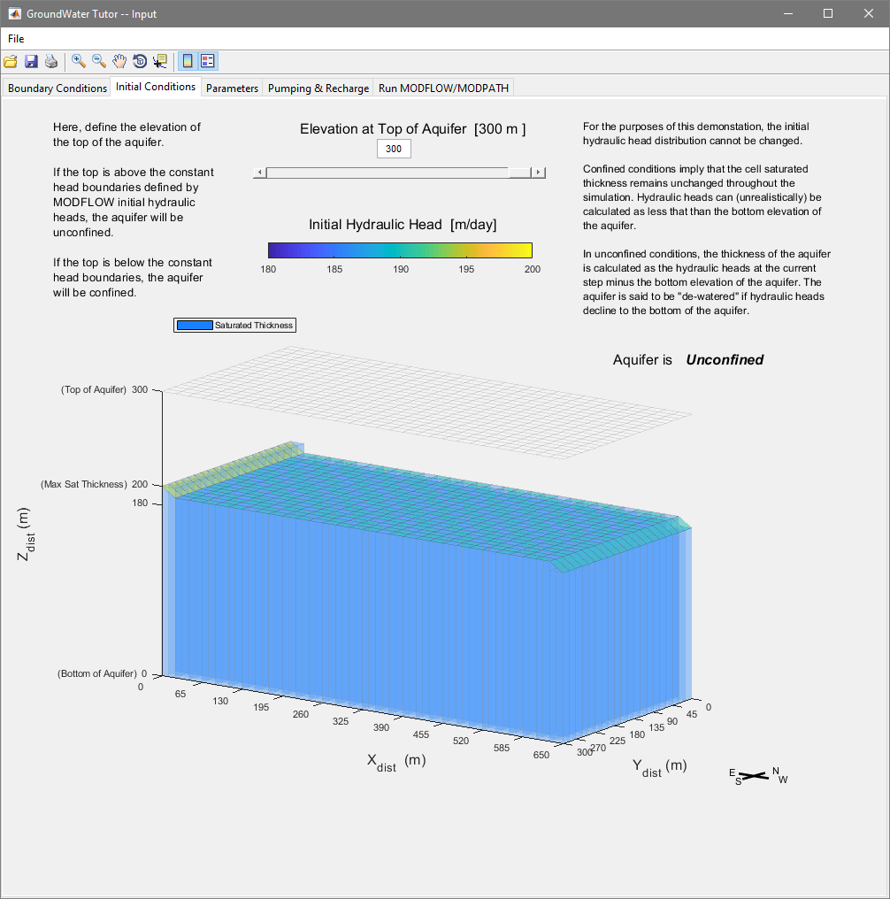

Figure . Parameters tab of the GroundWaterTutor Input Window.

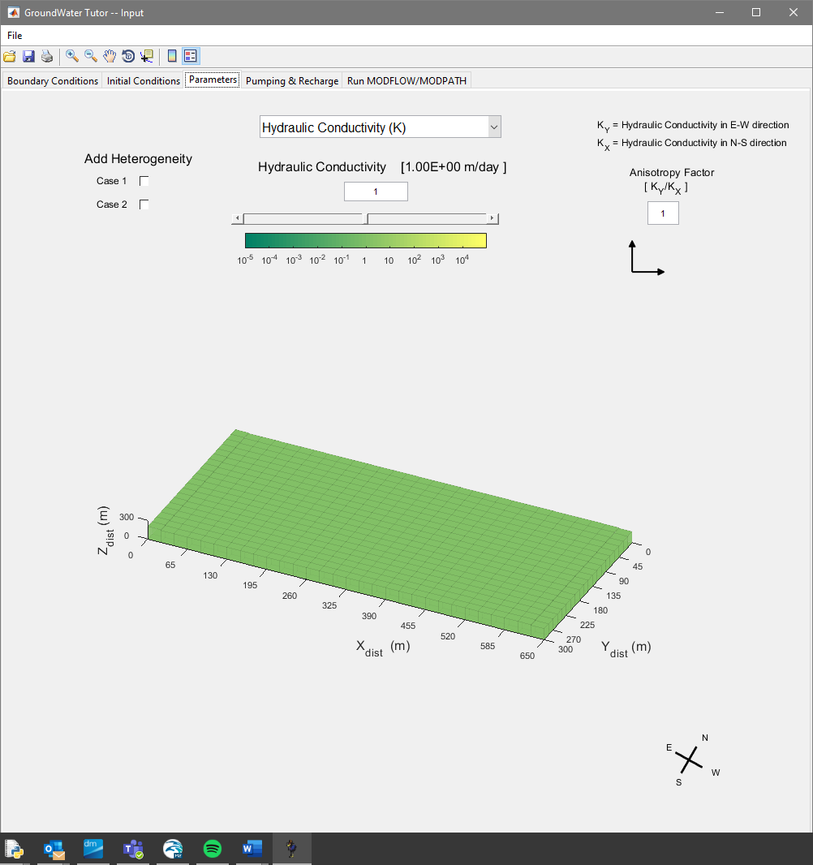

Figure 4 Parameters tab of the GroundWaterTutor Input Window.

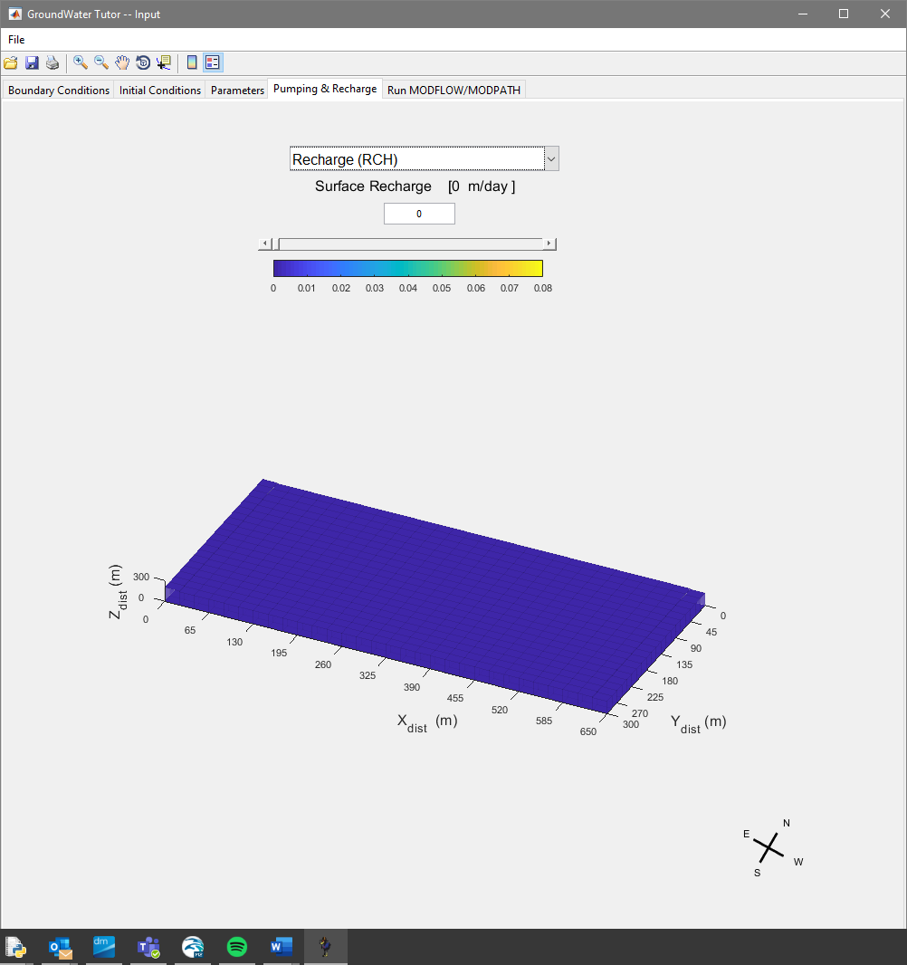

Figure . Pumping and Recharge tab from the GroundWaterTutor Input Window.

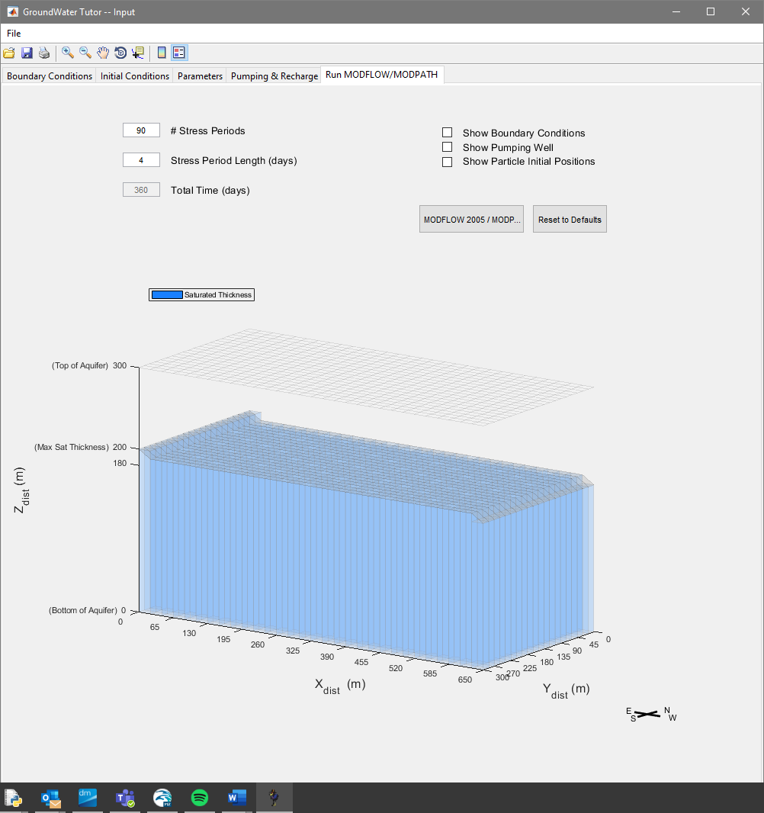

Figure . Run MODFLOW/MODPATH tab from the GroundWaterTutor Input Window.

When you press the Modflow2005/Modpath7 button, two command prompt windows will open sequentially, one for MODFLOW and another for MODPATH. Once both programs have finished running, a new GroundWaterTutor window will open, displaying the results of the simulation. This window has two tabs:

* **Hydraulic Head** - See **Figure 7.** Plots the hydraulic head distribution to be viewed through time.
* **Particle Tracking -** See **Figure 8**. Plots the trajectories of the tracer particles throughout time. Thirty tracer particles (in three groups, 10, 10 and 15) are released from fixed locations on the eastern side of the model domain. The initial location of the particles varies randomly around a fixed centroid point for each location, which does not vary between simulations. This results in three small initial clusters of particles. The spatial distribution of hydraulic heads or hydraulic conductivities can be plotted here as well. As the simulation progresses, the chart in the top corner of this tab indicates the status of tracer particles (i.e., active, terminated at well/sink, or terminated at boundary).

Both results tabs have a slider bar that can be used to select the timestep at which model results are displayed. On both plots, the following are labeled:

* Top elevation of the model aquifer
* Maximum saturated thickness (i.e., highest point in water table) of the model aquifer
* Bottom elevation of the model aquifer

Once you have viewed the model results close the GroundWaterTutor results window. A new model cannot be run while an existing results window is open. However, these results can be saved as images using the toolbar at the top of the window, or a screen capture tool can be used. Additionally, the folder containing MODFLOW and MODPATH input and output files (…\gui_ex1) can be copied and examined manually or plotted using other software. These model files will be deleted at the beginning of a new model run.

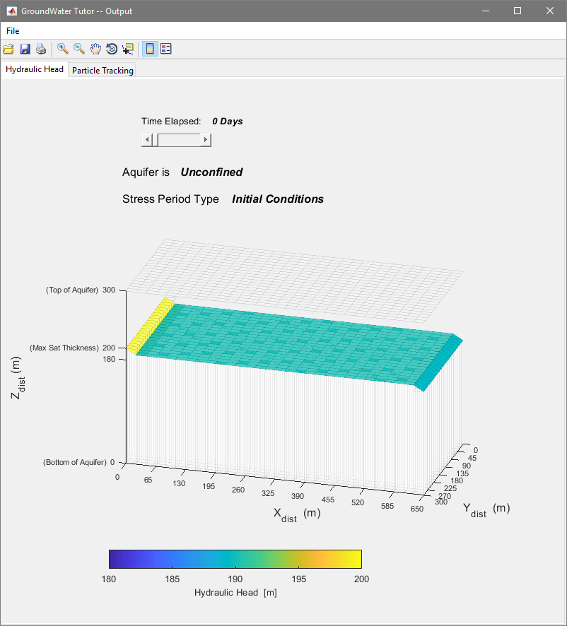

Figure . Hydraulic Heads tab of the GroundWaterTutor Output Window.

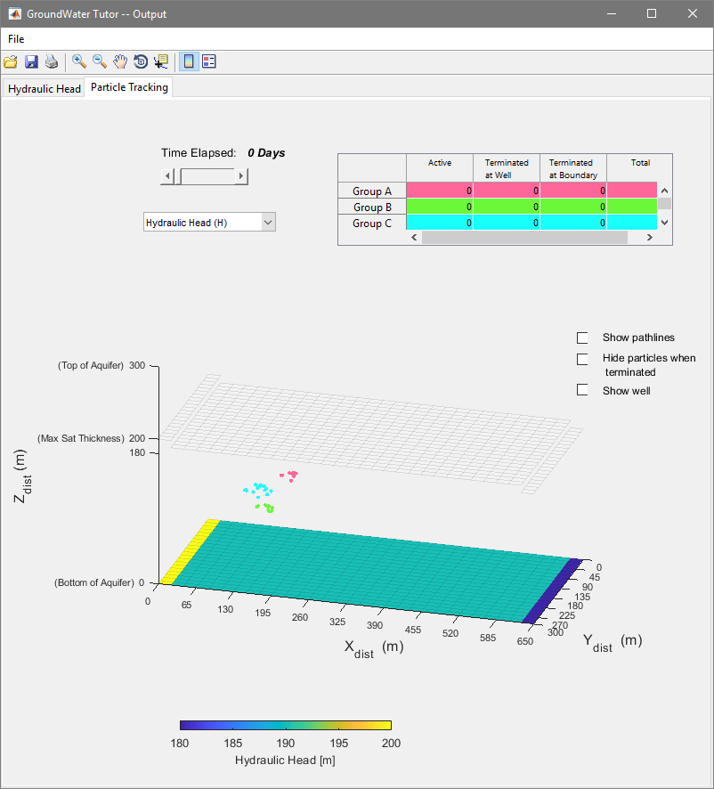

Figure . Particle Tracking tab in the GroundWaterTutor output window.

Example Exercises

# Exercises

The exercises first focus on initial and boundary conditions. This is followed by a series of five exercises on the physics of flow and advective transport in confined aquifers and three exercises that focus on unconfined conditions. Next, one exercise asks users to conduct a reality check on the values of recharge used in previous exercises. Finally, the use of groundwater models in two more realistic examples are pursued. The first of these uses GroundWaterTutor to address an issue in using groundwater for irrigation. The second uses an educational groundwater model developed by Professor Albert Valocchi at the University of Illinois to evaluate stream, wetlands, and aquifer interactions influenced by urbanization and agriculture.

Reference is made to a 2013 textbook by Charles R. Fitts in the exercises.

## Exercise 1: Examine the Initial Heads

The initial heads defined for the GroundWaterTutor MODFLOW model are shown in the **Initial Conditions** tab. Inspect this head distribution. Note the sharp head gradients at the ends and the completely flat head distribution over the rest of the model.

1. Assuming homogenous hydraulic conductivity field, would such a head distribution conserve mass as required by the two-dimensional groundwater flow equation and Darcy’s Law? Why? Be very specific. Comment about the flow implied by this head distribution and whether flow coming in at one point in the system could flow through the rest of the system given the constraints that Darcy’s Law must always be satisfied. If you conclude that the initial heads do not satisfy Darcy’s Law, do not worry. These heads are used only as an initial guess from which a physics-based solution is conducted when the model is run.

## Exercise 2: Boundary Conditions

The system represented in GroundWaterTutor is a simple box model with constant-head boundaries on two sides, no flow boundaries on two sides and the bottom, and a defined-flux boundary on the top. The defined flux can be defined as no flux or as a non-zero constant to represent areal recharge or discharge. In general, there are three types of boundary conditions used commonly in groundwater models: constant head, defined flux (or defined flow; includes no flow), and head-dependent flow boundaries.

1. Copy a screen shot of the system into your exercise document. Identify all boundaries and label what kind of boundary condition is applied. In MODFLOW, no-flow boundaries occur at the edges of the model if no other type of boundary is defined.
2. Once the figure is labeled, use a long arrow to identify the direction of flow you would expect if there was no areal recharge pumping simulated. If you have insight into whether the flows are expected to be greater in some parts of the system than others, add short arrows with different lengths to display the basic pattern of flow velocities you would expect in this system. Adding conceptual flow arrows like this is often extremely useful in practice.
3. How might this change if areal recharge was added?

## Exercise 3a: Confined Conditions: Hydraulic Gradients with No Pumping or Recharge

The same three model runs are used in **Exercise1** and **Exercise2**. It will save time to get the results needed for both exercises from the MODFLOW and MODPATH runs.

1. If the system is confined and there is no pumping or recharge, should the head gradient through this system decline linearly along the direction of groundwater flow? That is, would a graph of head versus distance parallel to the flow direction be a straight line? (yes or no)
2. Clearly support your answer from question **1** using the form of Darcy’s Law that includes the area through which groundwater flows.
3. Clearly support your question1 using results obtained from GroundWaterTutor by the following process:
   1. Set pumping to zero (Pumping & Recharge tab). Although the groundwater model can accept a value of zero, a log scale has been used for pumping in the GroundWaterTutor interface to allow a wide range of pumping values. This means a very small value can be entered, but not zero. The effect with a small value will produce about the same results as using a zero.
   2. Obtain a confined system by setting the top of the aquifer beneath the elevation of the constant head boundaries. Do this in the Initial Conditions tab. Define the aquifer thickness to be 20 m.
   3. Aquifer heads can be much higher than the top of the aquifer in natural settings (Fitts Fig. 5.39). Describe briefly here how this can occur.
   4. Set hydraulic conductivity to 0.025, 1 and 40 (in the **Parameters** tab). For each, run the model and take screen shots of the head distribution in the Hydraulic Heads tab and particle position at early, mid, and late times in the Particle Tracking tab
   5. Submit images of head color maps from the three examples. Comment briefly on how these results support your response to question **1**

## Exercise 3b: Confined Conditions, Flow Rate with No Pumping or Recharge

The same three model runs are used in **Exercise1** and **Exercise2**. It will save time to get the results needed for both exercises from the MODFLOW and MODPATH runs.

1. If a system with constant-head boundary conditions is confined and there is no pumping or recharge, should all cross-sections perpendicular to the direction of flow have the same volume of flow through them? (yes or no)
2. Clearly support your answer in 1 using the form of Darcy’s Law that includes the area through which groundwater flows and a flow budget for the model.
3. Is the Darcy velocity (also called specific discharge) the same throughout any cross-section perpendicular to the direction of flow given homogeneous aquifer properties (K and porosity)? (yes or no)
4. Support your answer to question **3** using the equation for the Darcy velocity.
5. Check results under the **Particle Tracking** tab. How far have the particles traveled in the one-year simulated time frame for each K value? How does this relate to the Darcy velocity? If the particles have exited the system at one year, use a shorter time for the analysis (access earlier times using the time slider in the **Particle Tracking** tab).
   1. Report results in a graph with K on the vertical axis and distance traveled on the horizontal axis. Report results for any particle but use the same particle for all model runs.
   2. Include screen shots of results at the end of one year.
   3. Repeat the runs with a four-year time frame to see how much further the particles get. Include these travel lengths in the graph. Instructions for how to change the simulation time frame are provided above in the section on the **Run MODFLOW/MODPATH** tab.
   4. Relate the distance traveled to the Darcy velocity calculated in question **3**. Would you expect it to be the same? In answering this question, consider the distinction between Darcy velocity and fluid velocity are discussed by Fitts in section 3.2.1. Remember that porosity of the system is defined in the **Parameters** tab.

## Exercise 3c: Confined Conditions, Hydraulic Gradients and Flow With Recharge and No Pumping

1. If the system is confined and there is no pumping but there is recharge, should the head gradient through a simulated system with these boundary conditions be linear under confined conditions? (yes or no)
2. Clearly support your answer to question **1** using the form of Darcy’s Law that includes the area through which groundwater flows. Perform the analysis by considering what the flow would need to be through three cross-sections perpendicular to flow. Locate the cross-sections at the upstream boundary, midway between the upstream and downstream boundaries, and at the downstream boundary. For this analysis assume that all recharge flows toward the lower head boundary. You will be able to check this when you use GroundWaterTutor in question **3**.
3. Use GroundWaterTutor to provide at least three examples that support your answer to question **1**.
   1. Do this by setting pumping to zero, recharge to 0.01 , and setting the hydraulic-conductivity value to 0.025, 1, and 40 (in the **Parameters** tab).
   2. Submit screen shots of the head distributions. Based on these results, address two questions. Specifically identify how the results support the answers you provide.
      1. Is your answer to question **1** supported?
      2. Does the recharge all flow toward the same constant-head boundary?
4. Check results under the tab Particle Tracking. How far have the particles traveled in the one-year simulated time frame for each K value and how is this related to the Darcy velocity?
   1. Report results in a graph with K on the vertical axis and distance traveled on the horizontal axis. Report results for the particle furthest in front.
   2. Include screen shots of results at the end of one year. If the particles have exited the system at one year, use a shorter time for the analysis.
   3. If needed, repeat the runs with a four-year time frame to see how much further the particles get. Include these travel lengths in the graph.
   4. Is the particle velocity the same for any cross-section that extends perpendicularly from one constant-head boundary to the other?

## Exercise 3d: Confined Conditions, Hydraulic Gradients with Pumping and No Recharge

Use the confined system with recharge set to zero, and pumping set to 99 .

1. Do three runs with hydraulic conductivity set to 0.025, 1, and 40 . Provide screen shots for each model run.
2. What happens to the heads at the constant-head boundaries in the three model runs?
3. Repeat the run with K = 0.02 .
   1. Note that the model can produce results that make no sense. In what way are these results obviously impossible? The model can obtain these results because as a confined system MODFLOW is not letting the aquifer thickness be smaller than the defined value of 20 m. A more realistic result can be obtained using more sophisticated method of representing the well.

## Exercise 3e: Confined Conditions, Hydraulic Gradients with Pumping and Recharge

Add a recharge rate of 0.01 (1 ) to the final model from **Exercise 3d**.

1. Do three runs with hydraulic conductivity set to 0.025, 1, and 40 . Provide screen shots for each model run.
2. Confined systems are linear with respect to changes in pumping and recharge because the thickness of the system does not depend on the value of head calculated. Thus, the change in head caused by including recharge (**Exercise 3c**) plus the change in head caused by including pumping (**Exercise 3d**) should equal the change produced by including both recharge and pumping (**Exercise 3e**). This is the principal of superposition.
   1. Use the results from **Exercise 3c** and **Exercise 3d** to see if your results in **Exercise 3e** are consistent with the principle of superposition. Using the numbers on the color bars for the different model run should be useful in answering this question.

## Exercise 4a: Unconfined Conditions, Hydraulic Gradients

Create unconfined condition by raising the top of the aquifer to 300 m in the **Initial Conditions** tab. Often this is thought of as being the land surface level; the water table defines the top of the saturated zone, which is often referred to as the aquifer. Fitts Fig. 5.33 shows an unconfined aquifer with the water table marked by triangles pointing down. This is a common notation used to identify the water table. It is not used to identify the top of a confined aquifer or the potentiometric surface for a confined aquifer.

1. If the system is unconfined and there is no pumping or recharge, should the head gradient through a simulated system with these boundary conditions and geometry decline linearly along the direction of groundwater flow? (yes or no)
2. Clearly support your answer to question **1** using the form of Darcy’s Law that includes the area through which groundwater flows.
3. Use GroundWaterTutor to provide at least three examples that support your answer. Do this by setting pumping and recharge to zero and setting the hydraulic conductivity value to 0.025, 1, and 40 m/day (in the **Parameters** tab). Provide screen shots showing the hydraulic-head distribution for each simulation.

## Exercise 4b: Unconfined Conditions, Flow Rate

1. If the system is unconfined and there is no pumping or recharge, should the Darcy flux (Q) through any simulated system with these boundary conditions and geometry be the same through any cross-section perpendicular to the direction of flow? (yes or no)
2. Clearly support your answer to question **1** using the form of Darcy’s Law that includes the area through which groundwater flows and(or) a flow budget for the model.
3. Is the Darcy velocity (q) the same for any cross-sections perpendicular to the direction of flow? (yes or no)
4. Support your answer to question **3** using the form of Darcy’s Law that produces a Darcy velocity.

## Exercise 4c: Unconfined System, Particle Tracking with Heterogeneity

Under the Parameters tab, two specific variations in the K field can be created. Case 1 introduces a corridor of 10 times higher K material along the length of the system. Case 2 introduces a corridor of 0.1 times lower K material across the system.

1. Briefly describe what effect you would expect case 1 to have on heads and particle tracking.
2. Briefly describe what effect you would expect case 2 to have on heads and particle tracking.

Use GroundWaterTutor to simulate a system with just case 1, just case 2, and then with both case 1 and case 2, as noted below. Set recharge to 0.04 , pumpage to 2,817 , and the base K value to 8 .

1. Produce results with homogeneous K – do not check case 1 and 2. Include images of the heads and particle positions after a year.
2. Produce results with case 1 only. What happened to the heads? What happens to the tracked particles? Include images of heads and particle position after 360 days.
3. Produce results with case 2 only. What happened to the heads? What happens to the tracked particles? Increase the time of the simulation to two years or longer if needed for the particles to travel all the way through the low K material.
4. For the simulation with both case 1 and 2 checked, provide a screen shot of results at 620 days.
5. How do the results compare to the expectations you noted in questions **1** and **2**?

## Exercise 5: Reality Check - Investigating the Areal Recharge Rate

Find the world precipitation map at:

[**http://go.grolier.com/atlas?id=mtlr080**](http://go.grolier.com/atlas?id=mtlr080)

1. Choose 5 areas in the US and 5 internationally and determine the precipitation rate from the map.
2. Use the approximation that, as an annual average, 25% of precipitation infiltrates past surface evaporation and transpiring plants to recharge the groundwater. [This percentage can vary from near zero to about 50%, but here we keep it simple.]
3. Create a table with the recharge rates you calculated.
4. Submit an image of the map with your 10 locations identified and numbered, the table, and what your analysis suggests about whether the recharge rates used in the problems above of 0.01 (1 ) and 0.04 (4 ) are common.

## Exercise 6: Irrigating a bean farm

You are a consultant providing advice to a commercial soybean farmer named Jillie. Jillie manages a 30-acre plot of soybeans, that needs about 25 inches of water over the course of an 8-month growing season. During the growing season, an average of 12 inches of precipitation accumulates and is timed well, leaving a deficit of 13 inches over the 30-acre crop area that Jillie needs to supply through irrigation. There is a single groundwater well on the property that can supply this water, however Jillie knows that there are some nearby sources of contamination and she is concerned about drawing them into the well.

To begin, Jillie needs to know at what average rate water will need to be extracted from the well to keep her crops irrigated.

1. At what rate should water be extracted (in, to match the units used in GroundWaterTutor) to supply the correct amount of water to Jillies 30-acre soybean plot? Show your work (Hint: A computer model is not needed to answer this question).

When Jillie sells her soybean crop, it eventually ends up as animal feed (in fact, virtually all soybeans grown worldwide are used in this manner). Jillie informs you that a feed lot to the east of her farm has started piling excess manure on a ~15-acre pasture which borders her soybean plot. In large quantities, manure can introduce dangerous amounts of nitrogen, phosphorous, and pathogens into the groundwater via surface-water infiltration. This water can potentially end up in groundwater used by nearby homes, towns, and cities that rely on groundwater for freshwater supplies. In appropriate quantities, the nitrogen and phosphorous can actually fertilize Jillies crops, improving her yield. Conversely, excess nitrogen and phosphorous can cause eutrophication of nearby aquatic ecosystems (due to increased oxygen consumption from algae blooms thriving on the abundant nutrients) as the groundwater flows naturally into surficial hydrologic features (e.g., spring ponds, lakes, or rivers).

Your main task is to use a simple groundwater model of Jillies farm to assess whether her groundwater extraction rates (for irrigation) will result in contaminants from the nearby feed lot entering her well.

Open up GroundWaterTutor. Use the **Boundary Conditions** and **Initial Conditions** tab to examine the model domain.

1. In your own words, describe each type of boundary condition used in the model in terms of how it might affect the model results (i.e., general characteristics of the hydraulic head distributions, and where water flows).

This model has one layer of cells. In the **Initial Conditions** tab, you can change the thickness of this layer. As you adjust the thickness of the model cell relative to the initial hydraulic heads in the system, you will see that the aquifer switches between unconfined and confined conditions.

1. In your own words, describe the difference between a confined and an unconfined aquifer in terms of how they are represented in the model (i.e., potentiometric surface verses model cell thickness).

In the **Initial Conditions** tab, you can also see the hydraulic heads defined at constant head boundary conditions.

Without running the model, what direction do you expect water to flow?

The Aquifer in this region is known to have a saturated thickness between 180 and 200 m, with a surface elevation of 300 m. Use the **Initial Conditions** tab to set the top of the model layer to 300 m.

Using freely available data from the USGS, you estimate that the specific yield of the aquifer is 15% and the porosity is 18%. Use the dropdown menu on the **Parameters** tab to specify these parameters in the model.

1. Does specific storage need to be defined for this model? Justify your answer.
2. In your own words, what is the difference between specific yield and porosity?
3. For a given model cell, can the porosity be less than the specific yield?

The USGS dataset suggests that the hydraulic conductivity at the site ranges between 1 m/day and 10 m/day. The anisotropy factor is 1. The hydraulic conductivity is set by default to 1 m/day. Keep it set to this value for now. It can be changed later in the **Parameters** tab.

From the same USGS dataset, you determine that the area receives on average 0.01 m/day of precipitation and approximately 10% of that precipitation infiltrates back into the groundwater system.

1. What is the surface recharge rate (RCH)?

In the **Pumping and Recharge** tab, use the dropdown menu to specify the surface recharge based on your answer to **8**. Similarly, specify the pumping rate to be equal to your answer to question **1**.

Navigate to the **Run MODFLOW/MODPATH** tab and modify the time discretization settings to reflect an 8-month simulation period (240 days). Use a stress period length of 3 days. The initial location of three groups of tracer particles, representing the newly deposited manure piles in the lot adjacent to Jillies farm, can be viewed here by selecting the “Show Particle Initial Positions” checkbox. Similarly, the location of Jillies irrigation well, and the boundary conditions on the model can be viewed by selecting the corresponding checkboxes.

Run the model by pressing the *MODFLOW 2005/MODPATH* button on the left side of the tab.



You will see MODFLOW 2005 and MODPATH 7 running in command line windows. MODFLOW will run first, then MODPATH. These windows will close automatically when the respective models are done executing, and a new GroundWaterTutor window will open up (See **Figure 9**). The hydraulic heads and particle trajectories throughout time can be viewed using the sliders on the **Hydraulic Head** or the **Particle Tracking** tabs, respectively.

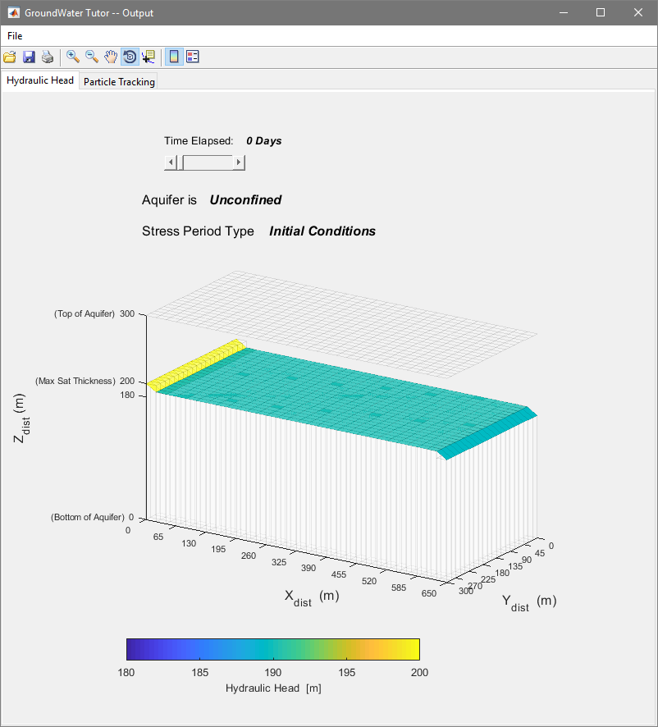

Figure . GroundWaterTutor results window. The Hydraulic heads tab is shown initially.

1. At her current extraction rate of 124 , after the entire duration of the growing season (240 days), would you advise Jillie that she is at risk of extracting contaminated groundwater from her irrigation well? Justify your answer. (Hint: What does a single tracer particle represent?)

In this simulation, you assumed the hydraulic conductivity was 1 , however you know that this value may be as high as 10 . Close the GroundWaterTutor results window. Navigate back to the **Parameters** tab in the main GroundWaterTutor window and change the hydraulic conductivity to 10 . Run the model again and view the results. The results window from the last simulation must be closed before a new simulation can be run.

1. Over the entire range of plausible hydraulic conductivities (i.e., 1-10 ), would you advise Jillie that she is at risk of extracting contaminated groundwater from her irrigation well? Justify your answer.

Now that Jillie knows that your model can be used to help analyze the viability of her current irrigation practices, she asks you to help her plan an expansion to her farm. First, she needs more income. Jillie wants to export her water to nearby farms via a system of irrigation canals and wants to increase here extraction rate to somewhere between 5,000 and 15,000 to supply the water. She knows that some contaminant will enter her well at these rates but wants to mitigate her overall risk – It is bad for business to sell contaminated water.

1. Use the model to determine the maximal pumping rate, such that no more than 50% of the contaminant particles are extracted from Jillies well. Assume the hydraulic conductivity is 10 m/day. (Hint: use the chart in the top left of the **Particle Tracking** tab to determine how many particles were terminated at the well. There were initially 30 particles released).

Use the checkboxes on the left side of the **Particle Tracking** tab to show the particle pathlines, the location of the well, and to hide particles when they are terminated. You can also use the toggle box to adjust whether the spatial distribution of hydraulic heads or the hydraulic conductivities are underlain below the particle trajectories. See **Figure 10**.

. 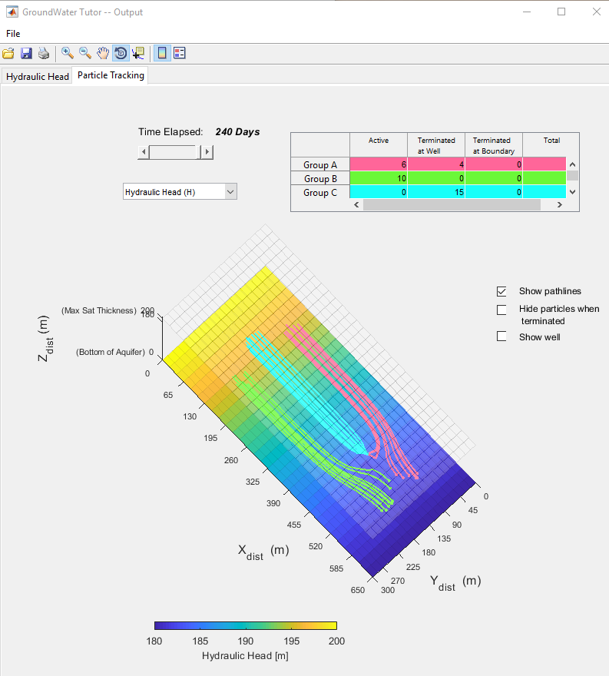

Figure . GroundWaterTutor results window. The Particle Tracking tab is shown, and the “Show pathlines” checkbox is selected. In this example, slightly over 50% (19/30) of the contaminant particles were extracted from the well.

Now that you have helped Jillie, feel free to explore the rest of the features in the model yourself.

Try adding heterogeneity to the hydraulic conductivities but using the “case 1” and “case 2” checkboxes in the **Parameters** tab. The “case 1” checkbox adds a stripe of high-K cells (10x higher than the rest), and the “case 2” checkbox adds a perpendicular stripe of low-K cells.

Try running the model with either “case 1” or “case 2” checked, then with both checked. In particular, you should notice that the scenario where both are checked produces very interesting patterns in particle trajectories. Particles seem to “refract” at the boundary between high-K and low-K cells. See **Figure 11**.

1. **BONUS QUESTION**: Are there any other physical laws that describe refraction at the interface between two distinct media? Name one and try to explain why it is analogous to the groundwater flow equation.

## Exercise 7: Stream, Wetlands, and Aquifer Interactions Influenced by Urbanization and Irrigation

The web site <http://groundwater.cee.illinois.edu/> provides the opportunity to consider a simple MODFLOW model that represents groundwater interactions with a river and a wetland. Access this on-line model and proceed as follows. Much like GroundWaterTutor, MODFLOW is used to simulate groundwater physics. However, instead of running the MODFLOW model on your computer, this tool runs MODFLOW remotely from server computer somewhere at the University of Illinois! This is a very convenient way to distribute the tool, because anyone can use it at any time, even from their cell phones! However, because a single computer is handling all model run requests, an entire classroom likely cannot use this tool simultaneously without potentially significant delays from the server – which makes this a great exercise to distribute for homework.

1. Review the quick start document which is a separate document on the web site where this exercise document was found.
2. Choose the *No Development* scenario. Check *Begin*. Click *Animation*, Plot Streamflow, and pick *Wetlands* at the top. Unclick *Animation* and provide several screen shots in your homework document that display the range of wetland extents produced by the conditions simulated. Click the timeline to get the map at that time. Click *End* to go back to the first page.
3. Choose the scenario *City and Farm*. Check Begin. Click *Animation*, Plot *Streamflow*, and pick *Wetlands* at the top. Unclick *Animation* and provide several screen shots in your homework document that display the range of wetland extents produced by the conditions simulated. Click the timeline to get the map at that time. Click End to go back to the first page.
4. Choose the Scenario *City and Farm* and choose *drought*. Check *Begin*. Click *Animation*, *Plot Streamflow*, and pick *Wetlands* at the top. Unclick *Animation* and provide several screen shots in your homework document that display the range of wetland extents produced by the conditions simulated. Click the timeline to get the map at that time. Click *End* to go back to the first page.
5. Compare the three results and briefly discuss how these simulations show the impact of pumpage and drought. Which has the greatest impact on the wetland?

# References

Fitts, C.R., 2013 Groundwater Science, second edition. Academic Press. 672p.