1. **Documentation of Functional and Non-Functional Requirements**

1. Functional:
2. The web app must implement a **Login/Sign-up Page:**
   1. The Login page must have the fields for:
      1. Username
         1. The username must be a valid e-mail address
      2. Password
         1. The app uses an OTP-based system for user authentication.
   2. The Signup page must have the fields for:
      1. Username
         1. The username must be a valid e-mail address
         2. An authentication e-mail will be sent to verify the user
      2. Nickname/Display Name
3. Users are to set up their profile after account creation with the following details:
   1. Avatar
      1. The user can choose to upload a profile picture or to remain as the default avatar
   2. Interested Genres
      1. A drop down list will appear on the screen.
      2. The user will select from a list of genres and tick the options that apply.
   3. Animes Watched
      1. The user will type in the anime they have watched
      2. The webapp will search for the anime from the database
      3. Once a match has been found, the user will select the anime to add to the list.
   4. Watchlist
      1. The user will type in the anime they wish to watch
      2. The webapp will search for the anime from the database
      3. Once a match has been found, the user will select the anime to add to the list.
   5. Preferred Duration
      1. The user would select the number of seasons that they prefer.
   6. Interested Animation Studios
      1. The user will type in the animation studio
      2. The webapp will search for the animation studio from the API
      3. Once a match has been found, the user will select the animation studio to add to the list.
   7. After the user has created their account, the user will be taken to the Main page.
4. On every page, there will be a hamburger menu:
   1. The following selections will be present in the menu:
      1. Trending
      2. Recommended
      3. Reviews
      4. Write a review!
5. Under the “Home page”, brand new animes will be displayed as a slideshow.
   1. Below the slideshow, the app will have a column-like scrollable view which separates shows currently airing by day. They are also ranked according to the time (UTC) that the show would be aired.
   2. On the top right hand corner there will be a search icon that will expand into a search view that helps you search and filter the anime you would like to watch.
   3. On the top left corner will be a clickable icon that takes you to the homepage regardless of the page the user is currently in.
   4. The hamburger menu icon exists to the right beside the search icon as a floating menu which is clickable.
6. Under the “Trending” page, the most popular anime of the month will be shown to the user.
   1. Users are able to filter the results using the provided filter icon according to the following:
      1. Default
         1. Shows the most popular anime of the month
      2. Genre
         1. Shows the most popular anime of the selected genre
      3. Year
         1. Shows the most popular anime of the selected year
7. Under the “Recommended” page, animes that match the users’ profile will be shown to the user.
   1. The following details of the recommended animes will be shown:
      1. Title
      2. Year
      3. Number of episodes
      4. Date of airing
      5. Genre
      6. Description
      7. Duration
      8. Links to watch the anime (Legal channels)
   2. Users have the ability to add the anime to their watchlist with the “Add to watchlist” or by swiping right button
      1. Another anime will be recommended when these actions are taken
   3. Users have the ability to dismiss the anime with the “Not interested” button or by swiping left
      1. This following anime will not be shown to the user anymore if this button is clicked
      2. Another anime will be presented to the user after this button is clicked
8. Under the “Review” page, a search bar will be provided for the user
   1. Animes will be presented to the user based on the search query
   2. Upon clicking one of the animes, a page listing all the reviews for that anime will be showcased
   3. “Write a review!” button to write a review for an anime
      1. There will be a search bar where entries in the search bar will be matched with the system’s database of anime names
      2. After clicking “enter”, the possible anime titles will be shown in a list
      3. The webapp will verify writer’s watch history.
      4. The writer will only be allowed to write a review for the particular anime if the account is verified to have watched it
      5. The user must then provide a star rating (out of 5) for the particular anime
9. Provide legal links to the recommended animes:
   1. The following links presented can be filtered based on:
      1. Popularity
      2. Free

1. Non-Functional:
2. A one-time password (OTP) will be used to improve security and secrecy of the user.
3. A user must be able to click the buttons and access the page within
4. Arrows that indicate swiping features
5. A user must be able to add to watchlist and remove their favourite animes with a single button
6. A home icon must be present in every page
7. A user must indicate that they have watched the anime before they can leave a review
8. Users must be able to sort their anime searches by the following categories:
   1. Genres
   2. Reviews, sorting from highest to lowest
9. Users must be able to search for reviews by the following categories:
   1. Matching word search
   2. Username
   3. Anime

1. **Data Dictionary**

|  |  |
| --- | --- |
| Term | Definition |
| Anime | An animated show, usually from Japan, has a unique artstyle and contain different genres that cater to a wide audience for entertainment. |
| Genre | The type of anime. Offers a plethora of varieties such as Psychological, Horror, Romance, to name a few. |
| Action | The action genre in anime depicts extremely high levels of intense action, showing thrilling battles and action-packed fight scenes |
| Adventure | The adventure genre is about traveling and undertaking an adventure in a certain place or around the world (which may sometimes escalate to the whole universe or even to the other dimensions |
| Comedy | The comedy genre is about humor, providing funny and humorous scenes and jokes |
| Drama | The drama genre of anime which features stories with high stakes and many conflicts. They're plot-driven and demand that every character and scene move the story forward. |
| Slice of Life | The slice of life genre feature mundane stories realistically set in the domain of real-life |
| Fantasy | The fantasy genre primarily deals with fantasy worlds and surreal events and locations with dazzling and dreamlike environment and atmosphere. |
| Magic | The magic genre in all its essence, is about magical stuff like spells and incantations. It can also include magical sources, beings that grants wishes, and sleeve tricks |
| Supernatural | The supernatural genre refers to something mythical, mystical, bizarre, or something outside the bounds of accepted reality. There’s a shadow of mystery often found in shows involved with this genre. |
| Horror | The horror genre holds disturbing themes that scare or creep one out, with common components like blood, gore, ghosts and monsters |
| Mystery | The mystery genre contains plots whereby some sort of mystery surrounds the narrative. |
| Psychological | The psychological genre of anime is one whereby writers delve into the interiority of a character’s mind and motivation rather than focusing on external actions or motivators |
| Romance | The romance genre typically revolves around a central love story and has an emotionally satisfying and optimistic ending. |
| Sci-Fi | Sci-fi is a genre that showcases scientific and technological elements in its story. Machines and various kinds of technologies are staples of this genre. Most of the time, its focus is on the advancement and development of science and technology. |
| Trending | Refers to the anime that has a high popularity. This means anime that is currently watched by many people |
| Avatar | The profile picture associated with the user account. The profile picture must be in JPG, GIF or PNG format. |
| Watchlist | List of all the animes that the user wishes to watch. Contains information on the name, number of seasons, user ratings and the genre |
| Season | A batch of episodes in a run |
| Duration | The length of time for an episode |
| Nickname/Display Name | The name displayed that is visible to you and everyone on the app. The name can consist of letters, numbers, and a few special characters. |
| Hamburger Menu | A specialised clickable floating context menu that has an icon shaped like a hamburger. The icon is represented by 3 parallel horizontal lines. |
| Animation Studio | The company or group of individuals that produces the anime. |
| Recommended | These are animes which are showcased to the user based on their user profile |
| Episode | A part of a season. Each episode usually has about 20 minutes worth of content with 2 pop songs i.e. the theme song at the beginning and an ending song. An episode usually airs once weekly. |
| Season | A season lasts for about anywhere between 1 month to three months. It contains anywhere between 10 - 26 episodes depending on a story arc. |
| Review | These are user-generated opinions about an anime which are visible to other users. A star rating will also be integrated with the opinion. Each review contains the username, the star rating given by the user, and their opinions shown in text. |
| Star rating | The score of the reviews for a particular anime. The maximum possible score is 5. |
| Watch History | List of all the animes which are watched by the user. |

1. **Initial Use Case Model ( Use Case Diagram +  Use Case Description)**

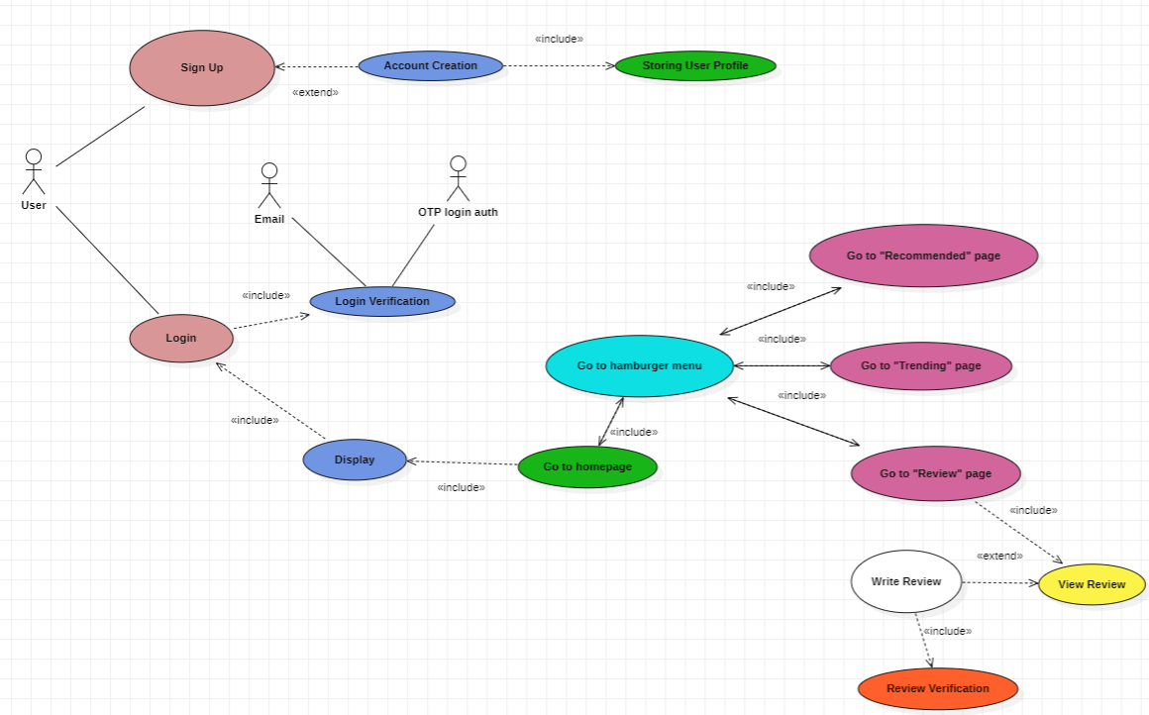

**Use Case Description 1**

|  |  |  |  |
| --- | --- | --- | --- |
| Use Case ID: | Case_1 _SU | | |
| Use Case Name: | Sign Up | | |
| Created By: | Hill Seah | Last Updated By: | Hill Seah |
| Date Created: | 30/8/2022 | Date Last Updated: | 30/8/2022 |

|  |  |
| --- | --- |
| Actor: | User (Participating) |
| Description: | A new user signs up on the web application to use it. |
| Preconditions: | A new user that desires to sign up |
| Postconditions: | User successfully signs up |
| Priority: | 1 |
| Frequency of Use: | 1 |
| Flow of Events: | 1. The User selects SignUp on the login/sign up page 2. Goes to an account creation page whereby the creation of the account is done by the extend use case AccountCreation |
| Alternative Flow: | NIL |
| Exceptions: | NIL |
| Includes: | Nil |
| Extended by: | Account Creation |
| Special Requirements: | Nil |
| Assumptions: | Nil |

**Use Case Description 2**

|  |  |  |  |
| --- | --- | --- | --- |
| Use Case ID: | Case_2_AC | | |
| Use Case Name: | Account Creation | | |
| Created By: | Hill Seah | Last Updated By: | Hill Seah |
| Date Created: | 30/8/2022 | Date Last Updated: | 30/8/2022 |

|  |  |
| --- | --- |
| Actor: | User (Participating) |
| Description: | Creates an account for the user after account field requests are fulfilled correctly by the user (Ie: Email Address for username and display name) |
| Preconditions: | User clicks sign up in the login/signup page |
| Postconditions: | An account is created successfully for the user |
| Priority: | 2 |
| Frequency of Use: | 1 |
| Flow of Events: | 1. Web app request user to enter his/her email address for the account’s username. 2. Web app will send an authentication security code to the email specified by the user for verification. 3. If the security code is entered correctly and the email address is verified to be valid, the web app will request the user to enter the desired display name for the account. 4. If the display name entered is verified to not be a duplicate of any other account’s display name in the database, the account will be successfully created 5. The created account and its details will be stored in the database by StoringUserProfile. |
| Alternative Flows: | AF-S3: If a wrong authentication security code is entered:   1. The web app displays “Invalid Authentication Security Code” below the entry box to inform the user 2. The web app displays a clickable prompt “Wrong email? Re-Enter email”    1. If this prompt is clicked, the web app returns to step 1 3. The web app displays a clickable prompt “Resend Authentication Security Code” below the entry box    1. If this prompt is clicked, the web app returns to step 2   AF-S4: If a duplicate account display name is entered:   1. The web app displays “Display name already exist” below the entry box to inform the user. 2. The web app returns to step 3 |
| Exceptions: | EX1: The user repeatedly enters the wrong authentication security code and clicks “Resends Authentication Security Code” more than 3 times in 1 minute   1. The web app displays “Too many resend requests, wait for 5 minutes” 2. Makes the resend prompt unclickable for 5 minutes 3. A countdown from 5 minutes is shown below the prompt |
| Includes: | Storing User Profile |
| Extended by: | NIL |
| Special Requirements: | NIL |
| Assumptions: | NIL |

**Use Case Description 3**

|  |  |  |  |
| --- | --- | --- | --- |
| Use Case ID: | Case_3_SUP | | |
| Use Case Name: | Storing User Profile | | |
| Created By: | Hill Seah | Last Updated By: | Hill Seah |
| Date Created: | 30/8/2022 | Date Last Updated: | 30/8/2022 |

|  |  |
| --- | --- |
| Actor: | User (Participating) |
| Description: | Stores created account and its details in database |
| Preconditions: | Account was just successfully created |
| Postconditions: | Created account and its details are successfully stored in database |
| Priority: | 3 |
| Frequency of Use: | 1 |
| Flow of Events: | 1. Stores account’s username in the database 2. Stores account’s display name in the database |
| Alternative Flows: | NIL |
| Exceptions: | NIL |
| Includes: | NIL |
| Extended by: | NIL |
| Special Requirements: | NIL |
| Assumptions: | Database is not full |

**Use Case Description 4**

|  |  |  |  |
| --- | --- | --- | --- |
| Use Case ID: | Case_1_L | | |
| Use Case Name: | Login | | |
| Created By: | Bhat Sachin | Last Updated By: | Bhat Sachin |
| Date Created: | 6/9/2022 | Date Last Updated: | 6/9/2022 |

|  |  |
| --- | --- |
| Actor: | User(Participating) |
| Description: | An existing user logs in on the web application to use it. |
| Preconditions: | User wants to login. |
| Postconditions: | Successful login |
| Priority: | 1 |
| Frequency of Use: | 1 |
| Flow of Events: | 1. The User selects Login on the login/sign up page 2. Keys in their username(email in this case) and clicks authenticate to enter password (an OTP in this case). |
| Alternative Flows: | NIL |
| Exceptions: | NIL |
| Includes: | Display |
| Special Requirements: | NIL |
| Assumptions: | User exists. |

**Use Case Description 5**

|  |  |  |  |
| --- | --- | --- | --- |
| Use Case ID: | Case_2_LV | | |
| Use Case Name: | Login Verification | | |
| Created By: | Bhat Sachin | Last Updated By: | Bhat Sachin |
| Date Created: | 6/9/2022 | Date Last Updated: | 6/9/2022 |

|  |  |
| --- | --- |
| Actor: | OTP Login Auth(Initiating), User(Participating), Email System(Receiving) |
| Description: | Verifies the login details. |
| Preconditions: | The username is entered and the ‘authenticate’ button is triggered. |
| Postconditions: | Sends OTP on user verification. |
| Priority: | 2 |
| Frequency of Use: | On every login. |
| Flow of Events: | 1. The user presses the authenticate button. 2. There is an internal querying done, matching the username with an existing database of emails. 3. On successful match, the OTP Login Auth generates an OTP of 6 digits and sends it to the external email system. 4. User then enters the OTP provided which is matched by the OTP Login Auth. 5. User logs in successfully. |
| Alternative Flows: | AF-S3: On failed match   1. The message “User does not exist or is incorrect!” is displayed. 2. The user re-enters the username. 3. Go to 1.   AF-S4: On failed match   1. The message “Incorrect password!” is displayed. 2. User re-enters OTP. 3. Go to 4. |
| Exceptions: | NIL |
| Includes: | Login |
| Special Requirements: | The OTP is valid for 10 minutes after generation, following which a new OTP is to be generated. |
| Assumptions: | NIL |

**Use Case Description 6**

|  |  |  |  |
| --- | --- | --- | --- |
| Use Case ID: | Case_2_D | | |
| Use Case Name: | Display | | |
| Created By: | Bhat Sachin | Last Updated By: | Bhat Sachin |
| Date Created: | 6/9/2022 | Date Last Updated: | 6/9/2022 |

|  |  |
| --- | --- |
| Actor: | User(Receiving) |
| Description: | A container for all viewable or interactive elements in the webapp. |
| Preconditions: | Successful Login |
| Postconditions: | Open the display. |
| Priority: | 2 |
| Frequency of Use: | On every login. |
| Flow of Events: | 1. On successful login, the user is greeted with a container populated by elements such as the homepage, hamburger menu and icons. |
| Alternative Flows: | NIL |
| Exceptions: | NIL |
| Includes: | Go to homepage |
| Special Requirements: | NIL |
| Assumptions: | NIL |

**Use Case Description 7**

|  |  |  |  |
| --- | --- | --- | --- |
| Use Case ID: | Case_3_GTH | | |
| Use Case Name: | Go to homepage | | |
| Created By: | Seah Jun Sheng | Last Updated By: | Seah Jun Sheng |
| Date Created: | 6/9/22 | Date Last Updated: | 6/9/22 |

|  |  |
| --- | --- |
| Actor: | User (Participating) |
| Description: | Brings user to the homepage from whichever page the user is on |
| Preconditions: | 1. User has an account with the webapp 2. User is logged in |
| Postconditions: | Homepage is displayed |
| Priority: | 2 |
| Frequency of Use: | Whenever user wants to go back to homepage |
| Flow of Events: | 1. User clicks on the hamburger menu icon which will initiate the “Go to Hamburger Menu” use case 2. User selects the “Homepage” option 3. System displays the homepage |
| Alternative Flows: | NIL |
| Exceptions: | NIL |
| Includes: | Go to hamburger menu  Display |
| Special Requirements: | NIL |
| Assumptions: | NIL |

**Use Case Description 8**

|  |  |  |  |
| --- | --- | --- | --- |
| Use Case ID: | Case_4_GTHM | | |
| Use Case Name: | Go to Hamburger Menu | | |
| Created By: | Seah Jun Sheng | Last Updated By: | Seah Jun Sheng |
| Date Created: | 6/9/22 | Date Last Updated: | 6/9/22 |

|  |  |
| --- | --- |
| Actor: | User (Participating) |
| Description: | Provides a dropdown box with possible options for the user to navigate the web app |
| Preconditions: | 1. User has an account with the web app 2. User is logged in |
| Postconditions: | Open the hamburger menu |
| Priority: | 2 |
| Frequency of Use: | Whenever the user wants to navigate the web app |
| Flow of Events: | 1. User clicks on the hamburger menu icon 2. A drop down list will appear with options including “Homepage”, “Recommended”, “Trending”, “Review” |
| Alternative Flows: | NIL |
| Exceptions: | NIL |
| Includes: | Go to “Recommended” Page  Go to “Trending” Page  Go to “Review” Page  Go to homepage |
| Special Requirements: | NIL |
| Assumptions: | NIL |

**Use Case Description 9**

|  |  |  |  |
| --- | --- | --- | --- |
| Use Case ID: | Case_5_GTRP1 | | |
| Use Case Name: | Go to “Recommended” Page | | |
| Created By: | Seah Jun Sheng | Last Updated By: | Seah Jun Sheng |
| Date Created: | 6/9/22 | Date Last Updated: | 6/9/22 |

|  |  |
| --- | --- |
| Actor: | User (Participating) |
| Description: | Brings the user to the “Recommended” subpage of the web app |
| Preconditions: | 1. User has an account with the web app 2. User is logged in |
| Postconditions: | “Recommended” subpage is displayed |
| Priority: | 2 |
| Frequency of Use: | Whenever the user wants to go to the “recommended” subpage |
| Flow of Events: | 1. User clicks on the hamburger menu which initiates the “Go to Hamburger Menu” use case 2. User selects “Recommended” 3. System displays the “Recommended” page |
| Alternative Flows: | Nil |
| Exceptions: | Nil |
| Includes: | Go to Hamburger Menu |
| Special Requirements: | Nil |
| Assumptions: | Nil |

**Use Case Description 10**

|  |  |  |  |
| --- | --- | --- | --- |
| Use Case ID: | Case_5_GTTP | | |
| Use Case Name: | Go to “Trending” Page | | |
| Created By: | Loke Kah Hou | Last Updated By: | Loke Kah Hou |
| Date Created: | 6/9/2022 | Date Last Updated: | 6/9/2022 |

|  |  |
| --- | --- |
| Actor: | User (Participating) |
| Description: | Brings User to the “Trending” page |
| Preconditions: | 1. User must have a valid account 2. User must be signed in to their account 3. User must be on the Homepage, “Recommended” page or “Review” page |
| Postconditions: | 1. “Trending” page is displayed by the System |
| Priority: | 2 |
| Frequency of Use: | When the User decides to go to the “Trending” page |
| Flow of Events: | 1. User will click on the Hamburger Menu 2. User will be given a list of pages to choose from 3. User will click on the “Trending” page 4. System will redirect User to the “Trending” page |
| Alternative Flows: | NIL |
| Exceptions: | NIL |
| Includes: | Go To Hamburger Menu |
| Special Requirements: | NIL |
| Assumptions: | NIL |

**Use Case Description 11**

|  |  |  |  |
| --- | --- | --- | --- |
| Use Case ID: | Case_5_GTRP2 | | |
| Use Case Name: | Go to “Review” Page | | |
| Created By: | Loke Kah Hou | Last Updated By: | Loke Kah Hou |
| Date Created: | 6/9/2022 | Date Last Updated: | 6/9/2022 |

|  |  |
| --- | --- |
| Actor: | User (Participating) |
| Description: | Brings User to the “Review” page |
| Preconditions: | 1. User must have a valid account 2. User must be signed in to their account 3. User must be on the Homepage, “Recommended” page or “Review” page |
| Postconditions: | 1. System displays the “Review” page |
| Priority: | 2 |
| Frequency of Use: | When the User chooses to go to the “Review” page to read reviews or write a review |
| Flow of Events: | 1. User will click on the Hamburger Menu 2. User will be given a list of pages to choose from 3. User will click on the “Review” page 4. System will redirect User to the “Review” page |
| Alternative Flows: | NIL |
| Exceptions: | NIL |
| Includes: | Go To Hamburger Menu |
| Special Requirements: | NIL |
| Assumptions: | NIL |

**Use Case Description 12**

|  |  |  |  |
| --- | --- | --- | --- |
| Use Case ID: | Case_6_VR | | |
| Use Case Name: | View Review | | |
| Created By: | Loke Kah Hou | Last Updated By: | Loke Kah Hou |
| Date Created: | 6/9/2022 | Date Last Updated: | 6/9/2022 |

|  |  |
| --- | --- |
| Actor: | User (Participating) |
| Description: | Brings User to the Review page of an Anime that they have searched for |
| Preconditions: | 1. User must have a valid account 2. User must be signed in to their account 3. User must be on the “Review” page |
| Postconditions: | 1. System displays the Reviews for the Anime the User has searched for |
| Priority: | 2 |
| Frequency of Use: | When the User wants to look up Reviews of a particular Anime |
| Flow of Events: | 1. User clicks the Search Bar 2. User types in the Anime name 3. If the queried name matches with Animes in the database, the System will display the Animes matching the search query 4. User selects the Anime they want to see Reviews of 5. System will display the Reviews of the Anime they have chosen |
| Alternative Flows: | AF-S3: If the queried name does not match with any Anime in the database:   1. System will display “Based on your search query, there are no Animes found” as an Error Message 2. User will try again to type in the Search Bar to search for their Anime.   AF-S4: If there are no Reviews present for the Anime they have queried:   1. System will display “There are no Reviews available for this Anime” as a clickable prompt 2. User will be prompted to click the “Write A Review” button to Review the Anime. |
| Exceptions: | NIL |
| Includes: | Go To “Review” page |
| Special Requirements: | NIL |
| Assumptions: | NIL |

**Use Case Description 13**

|  |  |  |  |
| --- | --- | --- | --- |
| Use Case ID: | Case_7_WR | | |
| Use Case Name: | Write Review | | |
| Created By: | Keerthana Jayaraman Karthikeyan | Last Updated By: | Keerthana Jayaraman Karthikeyan |
| Date Created: | 6/9/2022 | Date Last Updated: | 6/9/2022 |

|  |  |
| --- | --- |
| Actor: | User(Participating) |
| Description: | Allows the user to write a review about a particular anime |
| Preconditions: | 1. User must have a valid account 2. User must be logged in 3. User must be on the Review page 4. The user wishes to leave a review. |
| Postconditions: | The user has successfully submitted a review. |
| Priority: | 3 |
| Frequency of Use: | Whenever the user wishes to write a review. |
| Flow of Events: | 1. The user searches and selects the anime they want to review. 2. Tap “Write a Review” and post 3. The user must then provide a star rating for the particular anime |
| Alternative Flows: | NIL |
| Exceptions: | NIL |
| Includes: | “Review Verification” page |
| Special Requirements: | The user must have watched the anime to write a review. |
| Assumptions: | NIL |

**Use Case Description 14**

|  |  |  |  |
| --- | --- | --- | --- |
| Use Case ID: | Case_8_RV | | |
| Use Case Name: | Review Verification | | |
| Created By: | Keerthana Jayaraman Karthikeyan | Last Updated By: | Keerthana Jayaraman Karthikeyan |
| Date Created: | 6/9/2022 | Date Last Updated: | 6/9/2022 |

|  |  |
| --- | --- |
| Actor: | Web App (participating) |
| Description: | Verification to write a review . |
| Preconditions: | 1. User must have a valid account 2. User must be logged in 3. The user must select the anime they want to write a review for. |
| Postconditions: | The user is permitted to post a review. |
| Priority: | 3 |
| Frequency of Use: | When the user wants to write a review. |
| Flow of Events: | 1. The web app verifies the user’s watch history 2. Once verified as having watched the particular anime, the user is allowed to review it. 3. The web app directs the user to “Write a review” |
| Alternative Flows: | AF-S2: The user has not watched the anime yet   1. The Web app displays the message “The user is not permitted to post a review” 2. The web app returns “Review” page |
| Exceptions: | NIL |
| Includes: | NIL |
| Special Requirements: | NIL |
| Assumptions: | NIL |

1. **UI Mock-ups**

Sign up/Login page

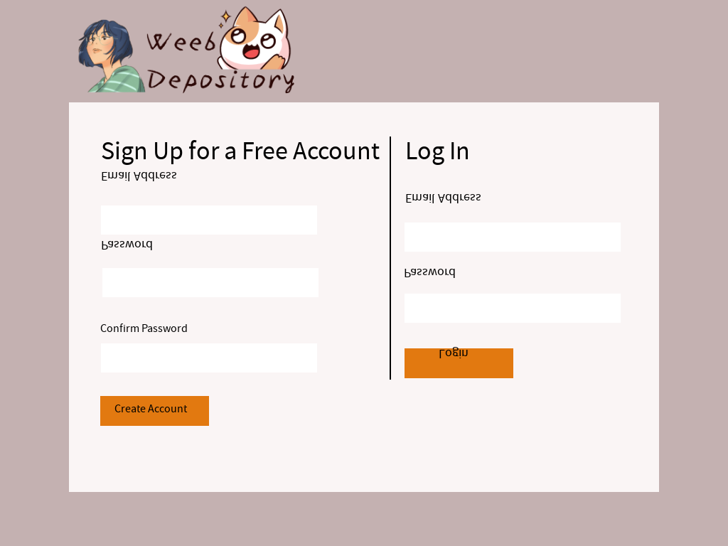

Homepage



Trending page



Review Page

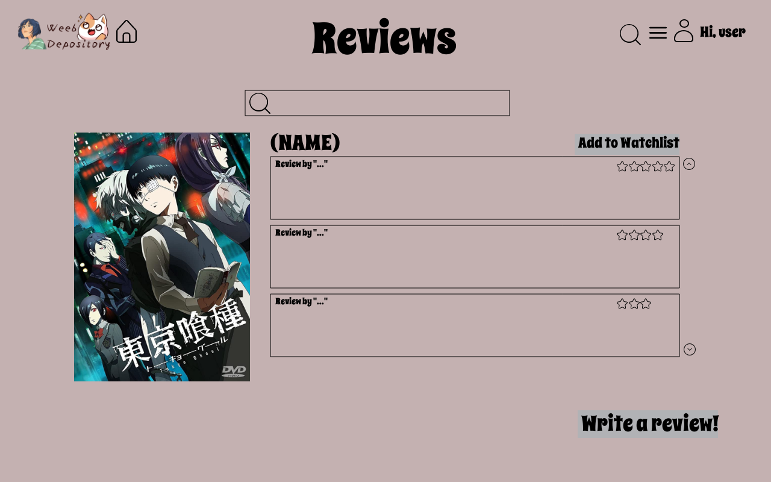

Write a Review page

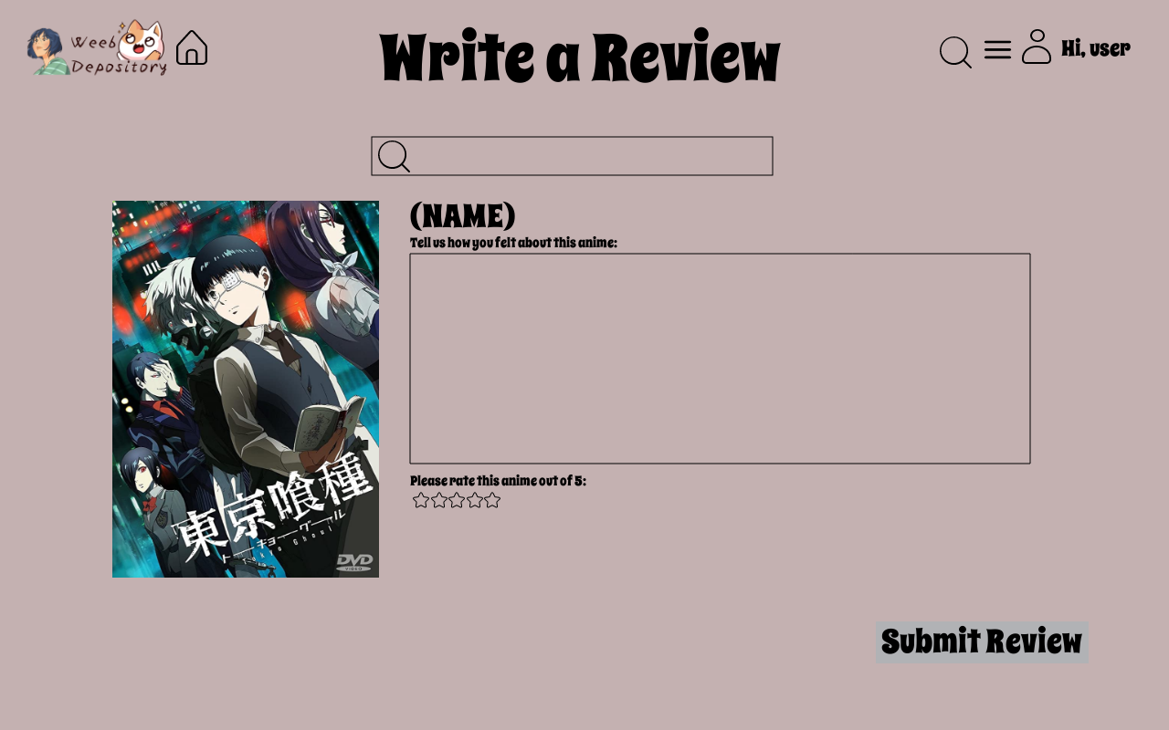

Write a Review page (Not in watch history)

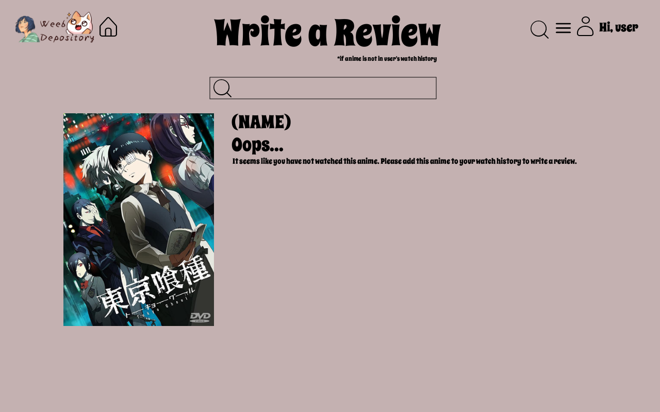

Recommended page

