Name: G.SANTHOSH Roll No: 19UITE004

Date: 15/10/22 Register No: 920419205037

**EXERCISE-10 –WORD COUNT PROGRAM USING MAPREDUCE**

**Step 1:** Create a text file “D:/data.txt”

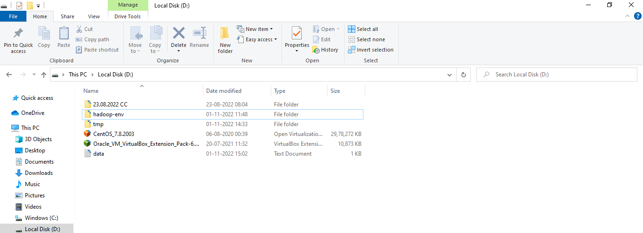

**Step 2:** Create a directory in HDFS, where to kept text file. hdfs dfs -mkdir /user

**Step 3:** Upload the data.txt file on HDFS in the specific directory

hdfs dfs -put D:/data.txt /user

**Step 4:** List the files or directories in hdfs

hdfs dfs -ls /user/

**Step 5:** To view the content of the file “/user/data.txt” hdfs dfs -cat /user/data.t

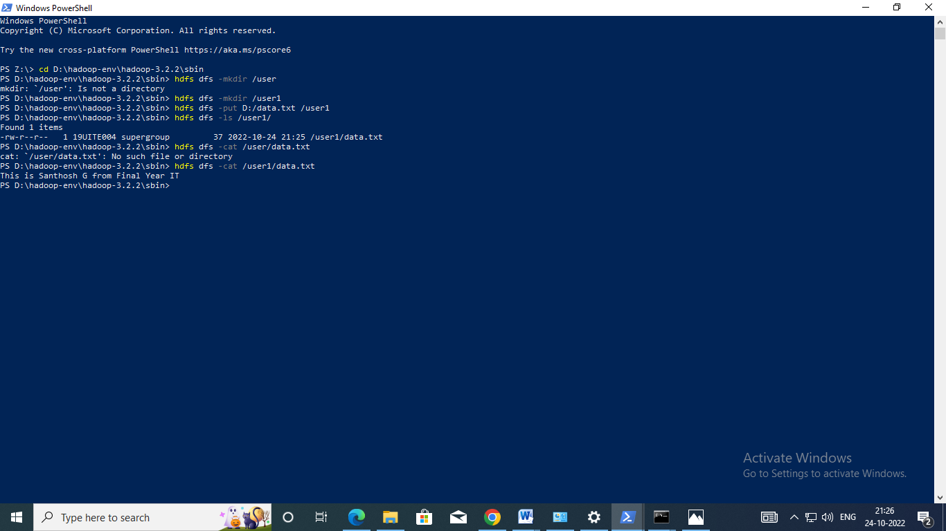

**Step 6:** Run the jar file

hadoop jar D:/hadoop-env/hadoop-3.2.2/share/hadoop/mapreduce/hadoop-mapreduce-examples- 3.2.2.jar wordcount /user /ou

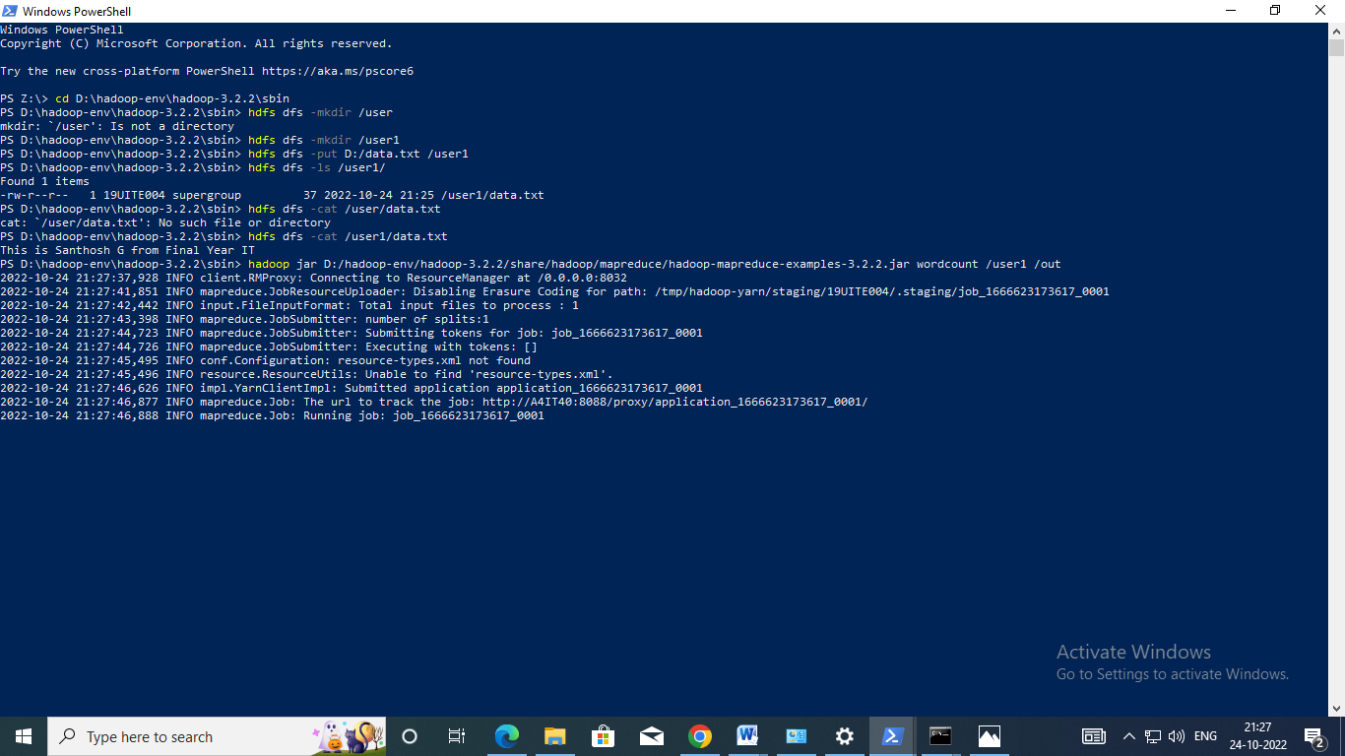

**Step 7:** To view the output in “/out/*” hadoop fs

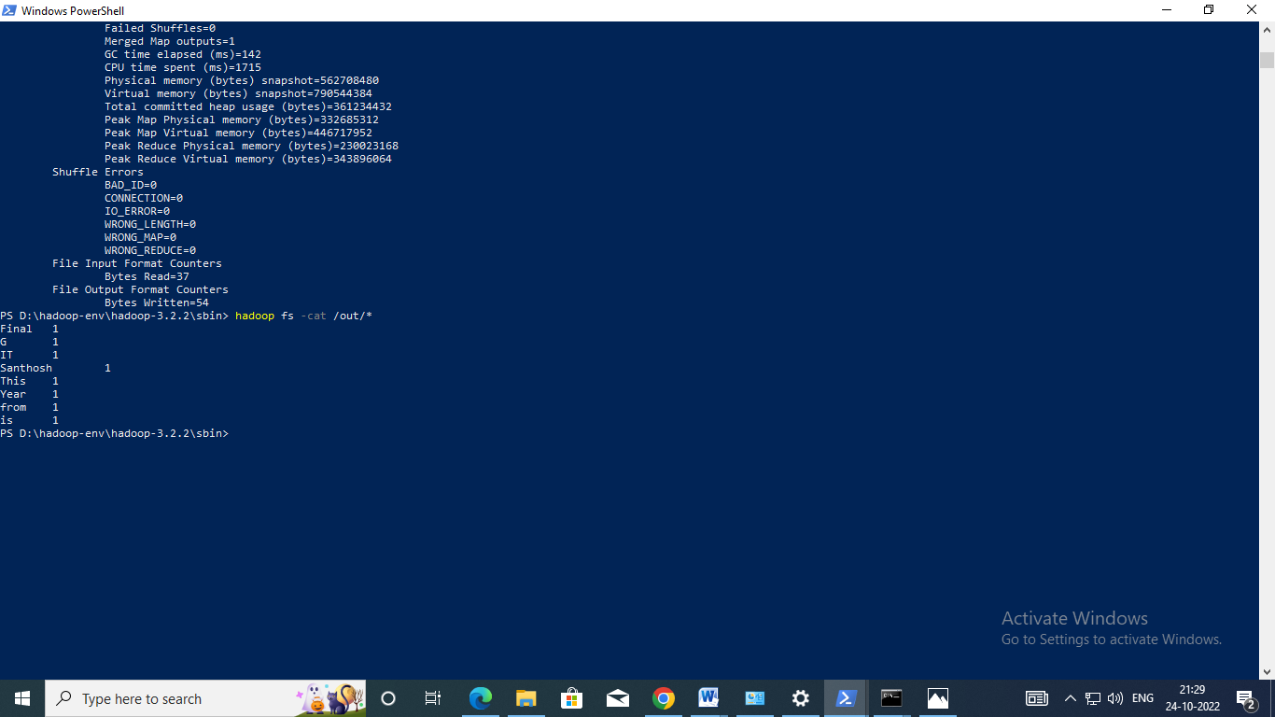

**Output:**

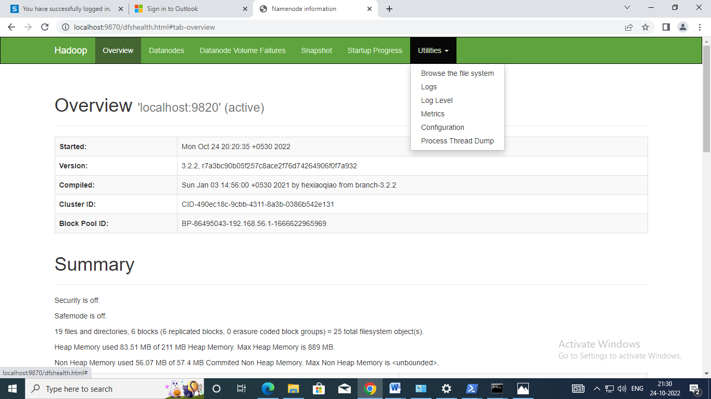

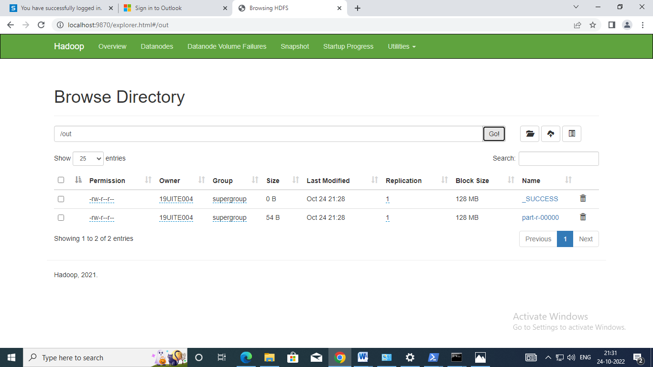

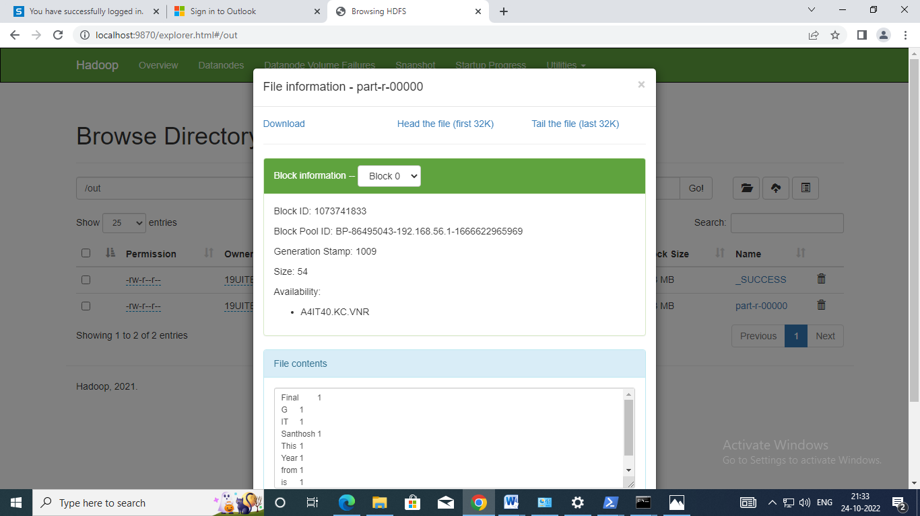

s