**COLLEGE OF BUSINESS EDUCATION**



**DODOMA CAMPUS**

*Student’s Name:* **HILLARIUS JOHN MKAMA**

Reg no: **03.3819.01.02.2022**

***Course* : BIT**

***Lecturer*:madam ATUPELE CAIRO MWAITETE**

***Subject:* PROGRAMMING IN JAVA**

***Nature of Work:* INDIVIDUAL ASSIGNMENT**

**Question.**

You are required to create a small Java application that addresses an everyday challenge faced by individuals or communities in Tanzania with a theme of **"Digital Solutions for Everyday Challenges in Tanzania"**. Each student should select a specific challenge and provide a software-based solution.

**Report on Vending Machine Project**

**1. Introduction**

The Vending Machine project is designed to simulate a real-world vending machine experience, where users can browse products, select quantities, and make payments. This project aims to provide a realistic approach to understanding how vending machines operate, offering a detailed explanation of its features, functionalities, challenges faced during development, and visual representations of the user interface through screenshots. The system not only focuses on product selection and payment but also incorporates a login system to enhance security and personalization.

**2. Project Overview**

This vending machine application offers a comprehensive and user-friendly experience by enabling users to:

* Browse a variety of products with accompanying images and prices.
* Add selected products to their cart with an intuitive selection process.
* View the total cost of selected products in real time.
* Make payments and receive detailed receipts after transactions.
* Securely access the system through a user login and registration process.

The application focuses on simplicity and efficiency, ensuring users can easily navigate through the system. By incorporating a graphical user interface (GUI) with clearly defined panels and options, the project prioritizes user experience.

**3. Features Implemented**

**A. User Login System:**

* The application includes a login system where users can register, log in, and access the vending machine’s functionalities. This feature ensures that only authenticated users can make purchases, adding a layer of security and personalization.

**B. Product Display:**

* The application displays a variety of products, each represented with an image, name, and price. These products are presented as interactive buttons, allowing users to make selections effortlessly.

**C. Product Selection and Quantity Input:**

* When a user selects a product, they are prompted to input the desired quantity. This dynamic feature allows for multiple product selections, ensuring flexibility in creating an order.

**D. Cost Calculation:**

* The system calculates the total cost of selected products based on their quantities and prices. The total cost is updated dynamically, giving users a clear understanding of their order cost in real time.

**E. Payment System:**

* After confirming their order, users are prompted to enter the amount they wish to pay. The system validates the payment amount, ensuring it is sufficient to cover the total cost. If successful, the transaction proceeds, and a receipt is displayed.

**F. Receipt Generation:**

* Upon completing the payment, a detailed receipt is generated. This includes the product names, quantities, individual costs, total cost, amount paid, and change (if applicable). The receipt serves as a clear record of the transaction.

**G. Logout Option:**

* To ensure proper session management, users are prompted to log out after completing their transactions. This prevents unauthorized access and ensures user data remains secure.

**4. User Interface (UI) Design**

The system’s user interface is designed for clarity and ease of use, consisting of the following components:

* **Product Panel:** Displays products as buttons, each with an image, name, and price.
* **Cost Panel:** Updates in real time to show the total cost of selected products.
* **Payment Panel:** Prompts users to make payments and ensures the transaction is seamless.
* **Header Panel:** Welcomes the user and provides navigation options.
* **Receipt Display:** Provides a clear breakdown of the transaction details after payment.

**5. Screenshots of the Interface**

To enhance understanding of the project’s layout and flow, the following screenshots are included:

* **Login Screen:** Displays options for users to log in or register a new account.

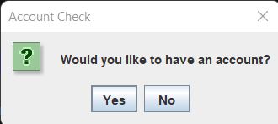

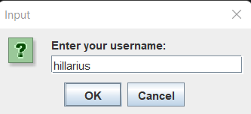

* **Product Display Screen:** Showcases available products with images and prices.

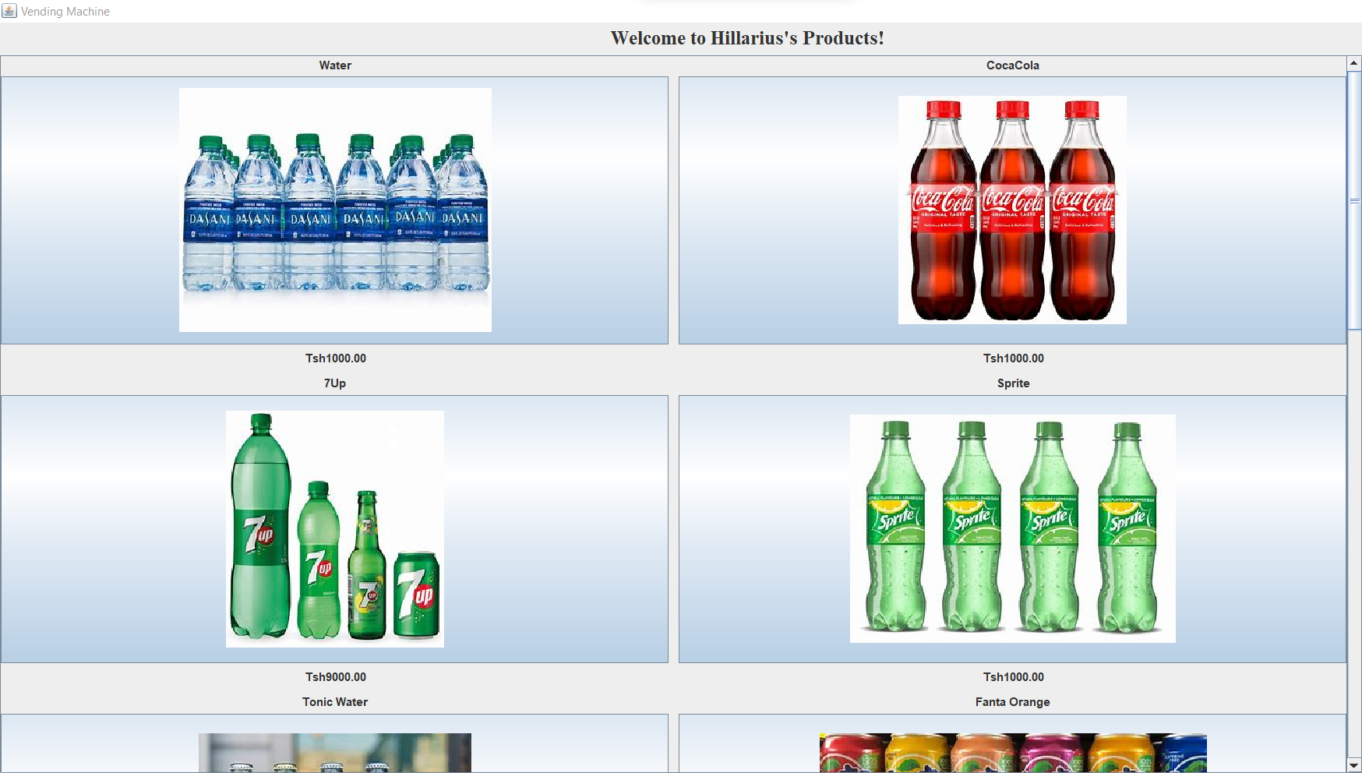

* **Payment Prompt:** Demonstrates the payment process after product selection.

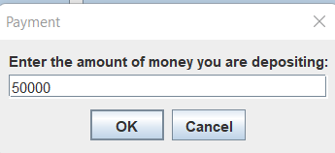

* **Receipt Screen:** Provides a detailed receipt, including purchased items and change.

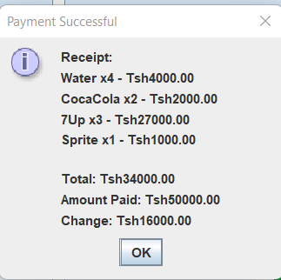

**6. Code Implementation**

The project’s functionality is driven by well-structured code, with key components explained below:

* **Product Class:** Manages product details such as name, price, and image path, ensuring scalability when adding new products.
* **VendingMachine Class:** Serves as the core system, handling product selection, cost calculation, and payment processing.
* **Login System:** Implements basic user authentication and registration for secure access.
* **GUI Components:** Utilizes Java Swing components like JFrame, JButton, JLabel, and JOptionPane to build an intuitive and interactive user interface.

**7. Challenges Faced During Development**

**A. Product Image Handling:**

* Loading and displaying images dynamically within the GUI required accurate file path management and resizing to fit the interface seamlessly.

**B. User Input Validation:**

* Handling user inputs, such as quantities and payment amounts, presented challenges. Invalid inputs, such as non-numeric values or empty fields, needed robust validation to prevent system errors.

**C. Dynamic Updates:**

* Ensuring the total cost updated dynamically as users selected or modified their product choices required precise event handling and UI synchronization.

**D. Payment Calculation:**

* Implementing accurate calculations for payments, including handling insufficient amounts and providing correct change, required careful logic.

**E. Account Management:**

* Developing a secure and simple login system that stored user credentials and managed session states posed challenges in terms of implementation and data handling.

**8. Future Improvements**

**A. Enhanced User Interface:**

* Future versions could include a more sophisticated GUI with detailed product descriptions and improved visuals.

**B. Database Integration:**

* Integrating a database (e.g., MySQL) would enable dynamic storage of products, user data, and transaction history, enhancing scalability and data management.

**C. Improved Payment Gateway:**

* Adding support for online payment systems would increase transaction flexibility and appeal to a broader audience.

**D. Advanced Analytics:**

* Implementing analytics features could help track user activity, popular products, and sales trends for better system insights.

**9. Conclusion**

The Vending Machine project successfully simulates a functional vending system, combining user authentication, product selection, and payment processing into an intuitive interface. This project serves as a practical application of programming concepts such as GUI design, event handling, and validation. Despite challenges faced during development, the system achieves its objectives and provides a foundation for future enhancements, including advanced features like database integration and enhanced payment methods.

**10. References**

* **Java Documentation:** For information about the Java language and libraries used.
* **Swing Tutorials:** To help understand the use of Swing components.
* **JOptionPane Documentation:** To learn about how to use dialog boxes in Java.