|  |  |  |
| --- | --- | --- |
| Group | : | Fong’s Group |
| Names | : | Hillary Fong, Paulina Tee, Jose Valle, JP Flores, Franco David, Rod Arceo III, Royce Ocampo, Thomas Lim, Wayenard Sey, Dane Mendoza |
| Section | : | S22 |

|  |  |  |  |
| --- | --- | --- | --- |
| **Description**  What’s the problem? | **Cause**  What causes the problem? | **Symptoms**  How do we know the problem exists? | **Impact**  Why is this important? What are the consequences? |
| Upon monthly warehouse check there are items unaccounted for. | There are different databases for many information or records the company keeps | The user manually checks and balances the databases | Productivity is not maximized and time is wasted. |
| Secretary is confused about the products and orders. | Manual inventory by using different excel files for orders, meats, and seafoods | The secretary have different excel files for orders, meat, and seafood inventories. | This can lead to waste of time, mix ups, or confusions especially when large volumes of orders are made. |
| The company cannot instantly see the total quantity of products to be delivered per day. | There is no function that will count the total count per day in their excel sheet. | The user gets confused when counting the orders. | This might confuse the users especially when counting a large volume of orders. Also, there is a possibility that they can miscount orders thus, may affect credibility and customer relation of the company. |

**Visualize the process**

Draw a flowchart or simple diagram that illustrates the business process of the client.

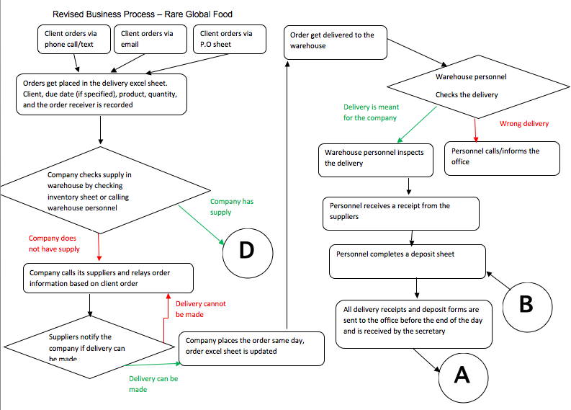

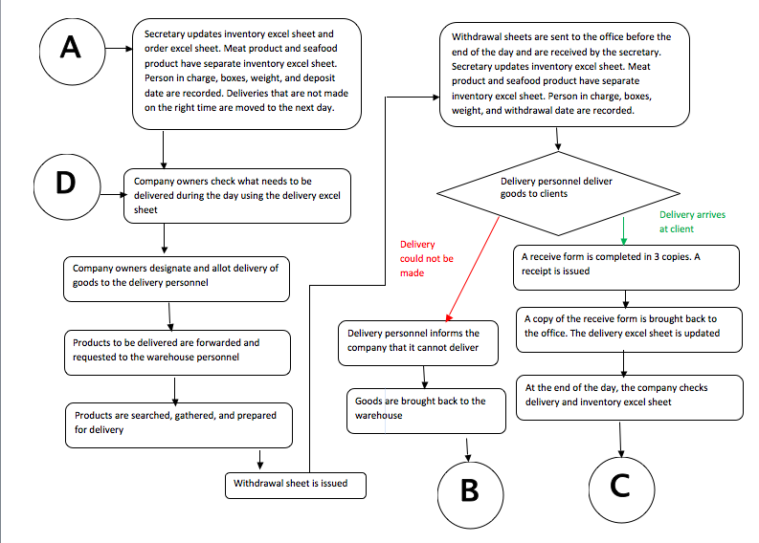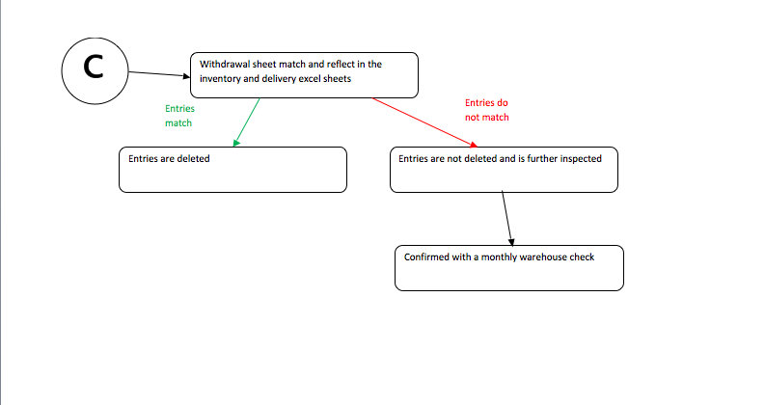

**What is the business goal? Why do they need a computing solution?**

The business goal is to deliver the products efficiently to the clients. They need a computing solution to make it easier for the users to check and track their inventories and orders instead of using different excel files. This will help them save a lot of time and avoid confusions in counting the orders per day.

**What characteristics should the solution have? (Non-functional requirements)**

The solution should have:

**Reliability**

The program perform all its functions reliably.

**Usability**

It should be easy to use and understand.

**Availability**

It must be available all the time.

**Integrity**

Data must be preserved especially when failure occurs.