

**Sri Lanka Institute of Information Technology**

**Data Warehouse and Business Intelligence**

**IT3021**

3rdYear, 1stSemester

Assignment 1

**Weekday Batch**

**Y3S1.15(DS)**

IT19021430

Hillary J.R.

# Contents

Contents

Contents 2

Data Set Selection 3

Preparation Of Data Sources 4

Source table details 4

Class Diagram using Source tables 6

High-Level BI Solution Architecture 7

Data warehouse design & development 9

ETL Development 13

Data Extraction from Source tables to staging tables 13

Transform and Load to Data Ware House 18

# Data Set Selection

The selected data source is a collection of transactional data. The link to the source data set is mentioned below:

Link to chosen data set

<https://www.kaggle.com/ghoshsaptarshi/av-genpact-hack-dec2018>

The select data set is based on a meal delivery company which operates in multiple cities. The data set consists of various fulfillment centers in these cities for dispatching meal orders to their customers. Through the data set can be used to help these centers with demand forecasting for upcoming weeks so that these centers will plan the stock of raw materials accordingly.

Aim of the data set

The source data set is been provided to predict the demand for the next 10 weeks based on the history of 145 weeks for the center meal combinations.

Staffing of centers based on demand

Procurement planning – Raw materials (raw materials are perishable)

The source data set consists

* Historical data of demand for a product-center combination (Weeks: 1 to 145)
* Product (Meal) features such as category, sub-category, current price and discount
* Information for fulfillment center like center area, city information etc.

1. **train.csv**

Weekly Demand data: Contains the historical demand data for all centers.

|  |  |
| --- | --- |
| **Variable** | **Definition** |
| id | Unique ID |
| week | Week number |
| center_id | Unique ID for fulfillment center |
| meal_id | Unique ID for meal |
| checkout__price | Final price including discount, taxes & delivery charges |
| base_price | Base price of the meal – this includes profit margin |
| emailer_for_promotion | E-Mailer sent for promotion |
| homepage_featured | Meal featured at homepage |
| num_orders | Number of orders sold per meal per center |

1. **fulfilment_center_info.csv​**

Contains information for each fulfilment center

|  |  |
| --- | --- |
| **Variable** | **Definition** |
| center_id | Unique ID for fulfillment center |
| city_code | Unique code for city |
| region_code | Unique code for region |
| center_type | Anonymized center type |
| op_area | Area of operation (in km^2) |

1. **meal_info.csv​**

Contains information for each meal being served

|  |  |
| --- | --- |
| **Variable** | **Definition** |
| meal_id | Unique ID for the meal |
| category | Type of meal (beverages/snacks/soups...) |
| cuisine | Meal cuisine (Indian/Italian/...) |

# Preparation Of Data Sources

Modifications were done accordingly to the data set derived from the source. Although the source contains only .csv files I have made some changes to the source files and to match the assignment specifications. According to the changes I made my data source contains of three types such .csv files, .txt files and .bak

Assumptions

Week number was changed into a date considering the week 1 as first week of the year 2018 and the 7th day of that week was considered to be the day data was loaded to the source tables. This assumption was taken to reduce the complexity and to make it easier to look up the DimDate table when loading to the data ware house.

Each unique Meal ID was additionally given a Meal Name which was part from the source data to understand the variations easily when analyzing rather than analyzing using numeric meal ID values.

SrcCenterDetails, SrcCenterManager, SrcCenterManagerDetails were additionally taken(derived) data apart from the source to match the assignment specifications and increase the complexity of the scenario.

## Source table details

* SrcMeal.CSV
* SrcMealBeverage.CSV
* SrcMealCuisine.CSV
* MealDemand_SourceDB.bak – SrcCenter, SrcCenterDetails
* SrcCity.txt
* SrcRegion.txt
* SrcCenterManager.txt
* SrcCenterManagerDetails.csv

Further details about the tables, attributes and datatypes of each attribute are given in the table below.

|  |  |  |  |  |  |  |  |  |  |  |  |  |
| --- | --- | --- | --- | --- | --- | --- | --- | --- | --- | --- | --- | --- |
| Source: SrcMeal.CSV | | Source Type: CSV File | | | | | | Table Name: SrcMeal | | | | |
| **Column Name** | **Data Type** | | | **Link Table** | | | **Link Column** | | | | **Description** | |
| MealID | Int | | |  | | |  | | | | Unique ID. | |
| MealName | Nvarchar(50) | | |  | | |  | | | | Meal Name | |
| MealCuisineID | Int | | | SrcMealCuisine | | | MealCuisineID | | | | Meal Cuisine | |
| MealBeverageID | Int | | | SrcMealBeverage | | | MealBeverageID | | | | Meal Beverage | |
| ModifiedDate | DateTime | | |  | | |  | | | | Modified Date of the Meal | |
|  | | | | | | | | | | | | |
| Source: SrcMealBeverage.CSV | | Source Type: CSV File | | | | | | Table Name: SrcMealBeverage | | | | |
| **Column Name** | **Data Type** | | | **Link Table** | | | **Link Column** | | | | **Description** | |
| MealBeverageID | Int | | |  | | |  | | | | Unique ID. | |
| MealBeverageName | Nvarchar(50) | | |  | | |  | | | | Name of the Meal Beverage | |
| ModifiedDate | DateTime | | |  | | |  | | | | Modified Date of the Meal Beverage | |
|  | | | | | | | | | | | | |
| Source: SrcMealCuisine.CSV | | | Source Type: CSV File | | | | | | | Table Name: SrcMealCuisine | | |
| **Column Name** | **Data Type** | | | **Link Table** | | | **Link Column** | | | | **Description** | |
| MealCuisineID | Int | | |  | | |  | | | | Unique ID. | |
| MealCuisineName | Nvarchar(50) | | |  | | |  | | | | Name of the Meal Cuisine | |
| ModifiedDate | DateTime | | |  | | |  | | | | ModifiedDate of the Meal Cuisine | |
|  | | | | | | | | | | | | |
| Source: MealDemand_SourceDB | | | Source Type: SQL Database | | | | | | | Table Name: SrcCenter | | |
| **Column Name** | **Data Type** | | | **Link Table** | | | **Link Column** | | | | **Description** | |
| CenterID | Int | | |  | | |  | | | | Center Unique ID. | |
| CityID | Int | | | SrcCity | | | CityID | | | | ID of the city | |
| CenterManagerID | Int | | | SrcCenterManager | | | CenterManagerID | | | | ID of the Center Manager | |
| CenterType | Nvarchar(50) | | |  | | |  | | | | Anonymized center type | |
| OpperationaArea | Nvarchar(50) | | |  | | |  | | | | Area of operation(km^2) | |
|  | | | | | | | | | | | | |
| Source: MealDemand_SourceDB | | | | | Source Type: SQL Database | | | | Table Name: SrcCenterDetails | | | |
| **Column Name** | **Data Type** | | | **Link Table** | | | **Link Column** | | | | **Description** | |
| CenterID | Int | | |  | | |  | | | | Center Unique ID. | |
| PhoneNumber | Nvarchar(25) | | |  | | |  | | | | Phone number of the Center | |
| PhoneNumberType | Nvarchar(50) | | |  | | |  | | | | Phone type of the Center | |
| NumberOfEmployees | Int | | |  | | |  | | | | Number of employees working in a particular center | |
|  | | | | | | | | | | | | |
| Source: SrcCity.txt | | | | | | Source Type: Text File | | | | | | Table Name: SrcCity |
| **Column Name** | **Data Type** | | | **Link Table** | | | **Link Column** | | | | **Description** | |
| CityID | Int | | |  | | |  | | | | Unique ID. | |
| CityCode | Int | | |  | | |  | | | | Unique Code of the region | |
| RegionID | Int | | | SrcRegion | | | RegionID | | | | ID of the region | |
| ModifiedDate | DateTime | | |  | | |  | | | | ModifiedDate of the City | |
|  | | | | | | | | | | | | |
| Source: SrcRegion.txt | | | | | | Source Type: Text File | | | | | | Table Name: SrcRegion |
| **Column Name** | **Data Type** | | | **Link Table** | | | **Link Column** | | | | **Description** | |
| RegionID | Int | | |  | | |  | | | | Unique ID. | |
| RegionCode | Int | | |  | | |  | | | | Unique Code of the region | |
| ModifiedDate | DateTime | | |  | | |  | | | | ModifiedDate of the Region | |
|  | | | | | | | | | | | | |
| Source: SrcCenterManager.txt | | | | | | Source Type: Text File | | | | | | Table Name: SrcCenterManager |
| **Column Name** | **Data Type** | | | **Link Table** | | | **Link Column** | | | | **Description** | |
| CenterManagerID | Int | | |  | | |  | | | | Unique ID. | |
| Title | Nvarchar(8) | | |  | | |  | | | | Center Manager Title (Mr., Mrs etc.) | |
| FirstName | Nvarchar(50) | | |  | | |  | | | | First name of the Center Manager | |
| LastName | Nvarchar(50) | | |  | | |  | | | | Last name of the Center Manager | |
| Gender | Nvarchar(1) | | |  | | |  | | | | Center Manager Gender (M, F) | |
|  | | | | | | | | | | | | |
| Source: SrcCenterManagerDetails.csv | | | | | | Source Type: CSV File | | | | | | Table Name: SrcCenterManagerDetails |
| **Column Name** | **Data Type** | | | **Link Table** | | | **Link Column** | | | | **Description** | |
| CenterManagerID | Int | | |  | | |  | | | | Unique ID. | |
| PhoneNumber | Nvarchar(25) | | |  | | |  | | | | Phone number of the Center Manager | |
| PhoneNumberType | Nvarchar(50) | | |  | | |  | | | | Phone type of the Center Manager | |
| Address | Nvarchar(50) | | |  | | |  | | | | Address of the Center Manager | |
| AddressType | Nvarchar(50) | | |  | | |  | | | | Address type of the Center Manager | |
| PostalCode | Nvarchar(50) | | |  | | |  | | | | Postal code of the Center Manager | |
| EmailAddress | Nvarchar(50) | | |  | | |  | | | | Email address of the Center Manager | |
| Country | Nvarchar(50) | | |  | | |  | | | | Country name of the Center Manager | |
|  | | | | | | | | | | | | |
| Source: MealDemand_SourceDB | | | | | | Source Type: SQL Database | | | | | | Table Name: SrcWeeklyDemand |
| **Column Name** | **Data Type** | | | **Link Table** | | | **Link Column** | | | | **Description** | |
| DealID | Int | | |  | | |  | | | | Unique ID. | |
| DealDate | DateTime | | |  | | |  | | | | 7th Day date of week | |
| CenterID | Int | | | SrcCenter | | | CenterID | | | | ID of the Center Manager | |
| MealID | int | | | SrcMeal | | | MealID | | | | ID of the Meal | |
| CheckoutPrice | Money | | |  | | |  | | | | Final price inlcuding discount, taxes & delivery charges | |
| BasePrice | Money | | |  | | |  | | | | Base price of the meal | |
| EmailerForPromotion | Int | | |  | | |  | | | | Emailer sent for promotion of the meal | |
| HomepageFeatured | Int | | |  | | |  | | | | Meal featured at home page | |
| NumOrders | Int | | |  | | |  | | | | Target(Orders Count) | |

## Class Diagram using Source tables

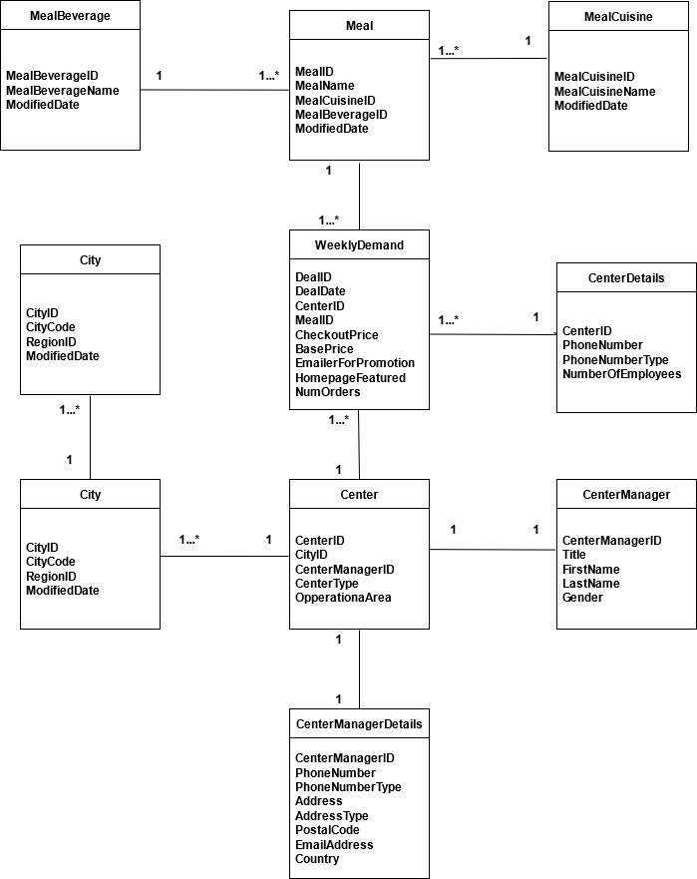

# High-Level BI Solution Architecture

The basic concept of a Data Warehouse is to facilitate a single version of truth for a company for decision making and forecasting. A Data warehouse is an information system that contains historical and commutative data from single or multiple sources. Data Warehouse Concepts simplify the reporting and analysis process of organizations.

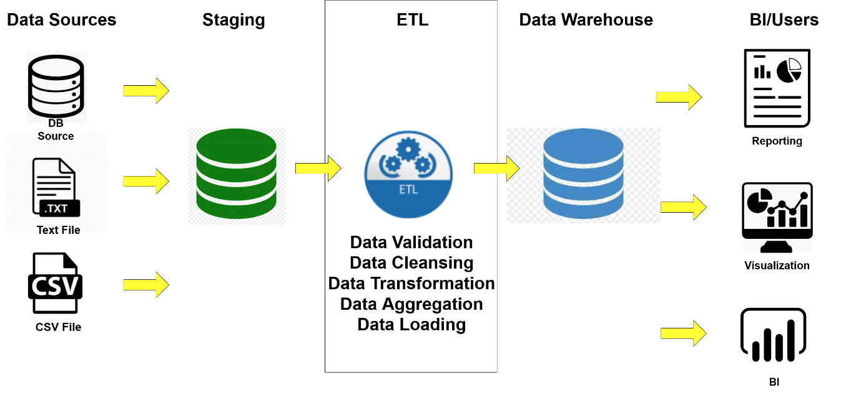

**Data Sources**

This represents the different data sources that feed data into the data warehouse. The data source can be of any format plain text file, relational database, other types of database, Excel file, etc., can all act as a data source. Data sources are the locations where data is being used come from.

For the given scenario, primary data source is a database and secondary data sources are, a flat file and a csv file.

**Data Extraction Layer**

Data gets pulled from the data source into the data staging layer. There is likely some minimal data cleansing, but there is unlikely any major data transformation.

**Staging Area**

This is where data will be gathered prior to being taken and transformed into a data warehouse. Having one common area makes it easier for subsequent data processing further for the data warehouse.

**ETL**

ETL stands for Extract, Transform and Load. This is where data gains its importance, as logic is applied to transform the data from a transactional nature to an analytical nature. It is a process in which an ETL tool extracts the data from various data source systems, transforms it in the staging area and then finally, loads it into the Data Warehouse system.

1. Extraction – reading of source data/ In this case staging layer data which is something similar to the source data but only difference is everything is taken into a common format and common place
2. Transformation -preparing data to be inserted to the target model, this includes cleansing, integrating, de-duplication, enriching, aggregation and loading.
3. Loading - The third and final step of the ETL process is loading. In this step, the transformed data is finally loaded into the data warehouse. Sometimes the data is updated by loading into the data warehouse very frequently and sometimes it is done after longer but regular intervals.

**Data Warehouse**

This is where the transformed and cleansed data sit. Based on scope and functionality, 3 types of entities can be found here: data warehouse, data mart, and operational data store (ODS). In any given system, you may have just one of the three, two of the three, or all three types. In our scenarios we have loaded the data into facts and dimensional tables. DWs are central repositories of integrated data from one or more sources.

**BI Layer**

In business intelligence, data warehouses serve as [the backbone of data storage](https://chartio.com/learn/data-warehouses/the-data-storage-hierarchy-lakes-warehouses-and-marts/). Business intelligence relies on complex queries and comparing multiple sets of data to inform everything from everyday decisions to organization-wide shifts in focus.

This layer includes

BI Applications - web applications, mobile applications, self-service BI tools, other data mining and modelling tools.

# Data warehouse design & development

Snow Flake Schema was the chosen schema for the data ware house development based on the data set

In this schema, it shows the final structure of the data warehousing for the scenario Meal Demand Forecast data set. Here, redundancy will not occur, so the efficiency of storage is improved.

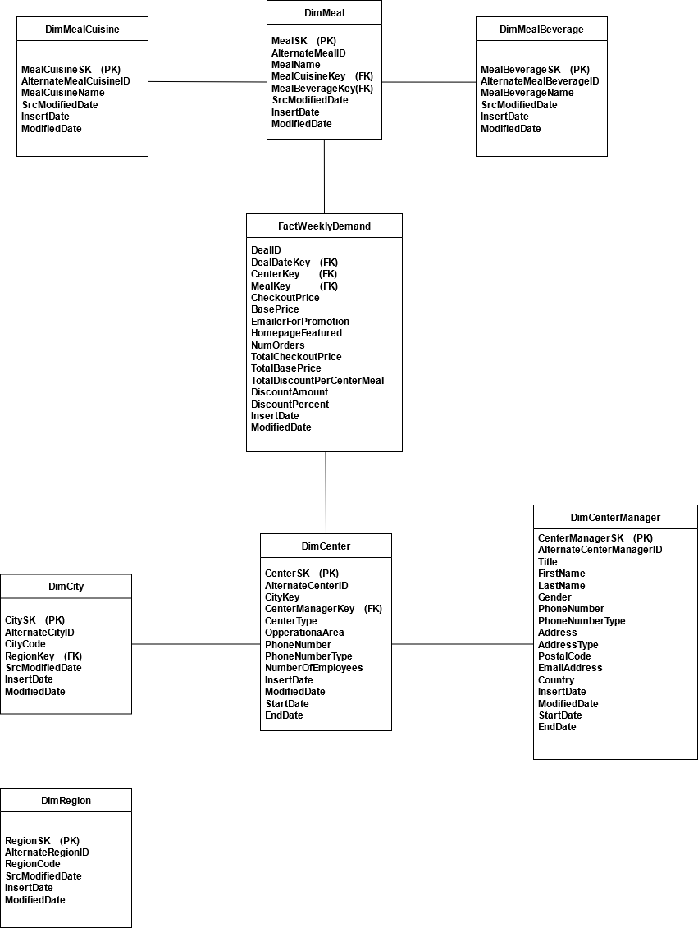

|  |  |  |  |  |  |  |
| --- | --- | --- | --- | --- | --- | --- |
| **Dimension Name** | **Dimension Attributes** | **Derived** | **DataType** |  | **Key** | **Derived Logic** |
| DimMeal | **MealSK** | Y |  | Not Null | PK | Auto incrementing |
|  | AlternateMealID | N | Int | Not Null |  |  |
|  | MealName | N | Nvarchar(50) | |  |  |
|  | MealCuisineKey | N | Int |  | FK |  |
|  | MealBeverageKey | N | Int |  | FK |  |
|  | SrcModifiedDate | N | DateTime | |  |  |
|  | InsertDate | Y | datetime |  |  | SysDateTime |
|  | ModifiedDate | Y | datetime |  |  | SysDateTime |
|  |  |  |  |  |  |  |
|  |  |  |  |  |  |  |
| DimMealCuisine | **MealCuisineSK** | Y | Int | Not Null | PK | Auto incrementing |
|  | AlternateMealCuisineID | N | Int | Not Null |  |  |
|  | MealCuisineName | N | Nvarchar(50) | |  |  |
|  | SrcModifiedDate | N | DateTime | |  |  |
|  | InsertDate | Y | datetime |  |  | SysDateTime |
|  | ModifiedDate | Y | datetime |  |  | SysDateTime |
|  |  |  |  |  |  |  |
| DimMealBeverage | **MealBeverageSK** | Y | Int | Not Null | PK | Auto incrementing |
|  | AlternateMealBeverageID | N | Int | Not Null |  |  |
|  | MealBeverageName | N | Nvarchar(50) | |  |  |
|  | SrcModifiedDate | N | DateTime | |  |  |
|  | InsertDate | Y | datetime |  |  | SysDateTime |
|  | ModifiedDate | Y | datetime |  |  | SysDateTime |
|  |  |  |  |  |  |  |
| DimCenterManager | **CenterManagerSK** | Y | Int | Not Null | PK | Auto incrementing |
|  | AlternateCenterManagerID | N | Int | Not Null |  |  |
|  | Title | N | Nvarchar(8) | |  |  |
|  | FirstName | N | Nvarchar(50) | |  |  |
|  | LastName | N | Nvarchar(50) | |  |  |
|  | Gender | N | Nvarchar(1) | |  |  |
|  | PhoneNumber | N | Nvarchar(25) | |  |  |
|  | PhoneNumberType | N | Nvarchar(50) | |  |  |
|  | Address | N | Nvarchar(50) | |  |  |
|  | AddressType | N | Nvarchar(50) | |  |  |
|  | PostalCode | N | Nvarchar(50) | |  |  |
|  | EmailAddress | N | Nvarchar(50) | |  |  |
|  | Country | N | Nvarchar(50) | |  |  |
|  | InsertDate | Y | datetime |  |  | SysDateTime |
|  | ModifiedDate | Y | datetime |  |  | SysDateTime |
|  | StartDate | Y | datetime |  |  | SysDateTime |
|  | EndDate | Y | datetime |  |  | SysDateTime |
|  |  |  |  |  |  |  |
|  |  |  |  |  |  |  |
| DimCity | **CitySK** | Y | Int | Not Null | PK | Auto incrementing |
|  | AlternateCityID | N | Int | Not Null |  |  |
|  | CityCode | N | Int |  |  |  |
|  | RegionKey | N | Int |  | FK |  |
|  | SrcModifiedDate | N | DateTime | |  |  |
|  | InsertDate | Y | datetime |  |  | SysDateTime |
|  | ModifiedDate | Y | datetime |  |  | SysDateTime |
|  |  |  |  |  |  |  |
| DimRegion | **RegionSK** | Y | Int | Not Null | PK | Auto incrementing |
|  | AlternateRegionID | N | Int | Not Null |  |  |
|  | RegionCode | N | Int |  |  |  |
|  | SrcModifiedDate | N | DateTime | |  |  |
|  | InsertDate | Y | datetime |  |  | SysDateTime |
|  | ModifiedDate | Y | datetime |  |  | SysDateTime |
|  |  |  |  |  |  |  |
|  |  |  |  |  |  |  |
| DimCenter | **CenterSK** | Y | Int | Not Null | PK | Auto incrementing |
|  | AlternateCenterID | N | Int | Not Null |  |  |
|  | CityKey | N | Int |  | FK |  |
|  | CenterManagerKey | N | Int |  | FK |  |
|  | CenterType | N | Nvarchar(50) | |  |  |
|  | OpperationaArea | N | Nvarchar(50) | |  |  |
|  | PhoneNumber | N | Nvarchar(25) | |  |  |
|  | PhoneNumberType | N | Nvarchar(50) | |  |  |
|  | NumberOfEmployees | N | Int |  |  |  |
|  | InsertDate | Y | datetime |  |  | SysDateTime |
|  | ModifiedDate | Y | datetime |  |  | SysDateTime |
|  | StartDate | Y | datetime |  |  | SysDateTime |
|  | EndDate | Y | datetime |  |  | SysDateTime |
|  |  |  |  |  |  |  |
|  |  |  |  |  |  |  |
| FactWeeklyDemand | **DealID** | N | Int | Not Null |  |  |
|  | DealDateKey | N | int |  | FK |  |
|  | CenterKey | N | Int |  | FK |  |
|  | MealKey | N | int |  | FK |  |
|  | CheckoutPrice | N | Money |  |  |  |
|  | BasePrice | N | Money |  |  |  |
|  | EmailerForPromotion | N | Int |  |  |  |
|  | HomepageFeatured | N | Int |  |  |  |
|  | NumOrders | N | Int |  |  |  |
|  | TotalCheckoutPrice | Y | Money |  |  | ([CheckoutPrice]*[NumOrders]) |
|  | TotalBasePrice | Y | Money |  |  | ([BasePrice]*[NumOrders]) |
|  | TotalDiscountPerCenterMeal | Y | Money |  |  | (([BasePrice]*[NumOrders]) - ([CheckoutPrice]*[NumOrders])) |
|  | DiscountAmount | Y | Money |  |  | ([BasePrice] – [CheckoutPrice]) |
|  | DiscountPercent | Y | Money |  |  | ((([BasePrice] – [CheckoutPrice])/[BasePrice])*100) |
|  | InsertDate | Y | datetime |  |  | SysDateTime |
|  | ModifiedDate | Y | datetime |  |  | SysDateTime |

# ETL Development

## Data Extraction from Source tables to staging tables

Staging of each table was made in order as given below

1. Extract Meal Cuisine Data to Staging
2. Extract Meal Beverage Data to Staging
3. Extract Meal Data to Staging
4. Extract Region Data to Staging
5. Extract City Data to Staging
6. Extract CenterManager Data to Staging
7. Extract CenterManagerDetails Data to Staging
8. Extract Center Data to Staging
9. Extract CenterDetails Data to Staging
10. Extract WeeklyDemand to Staging

Derived columns in the Fact table

TotalCheckoutPrice = ([CheckoutPrice]*[NumOrders])

TotalBasePrice = ([BasePrice]*[NumOrders])

TotalDiscountPerCenterMeal = (([BasePrice]*[NumOrders]) - ([CheckoutPrice]*[NumOrders]))

DiscountAmount = ([BasePrice] – [CheckoutPrice])

DiscountPercent = ((([BasePrice] – [CheckoutPrice])/[BasePrice])*100)

Staging package name – MealDemand_Load_Staging.dtsx

Durring the staging process all data from sources will be extracted and loaded into the **MealDemand_Staging** Database.

Following are the names of the table to which the data was loaded.

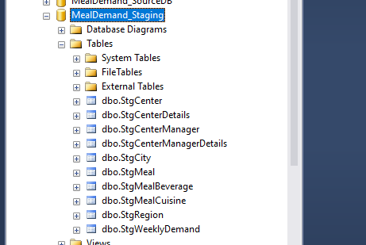

Figure 1: Staging Tables and Database

**Staging of all tables.**

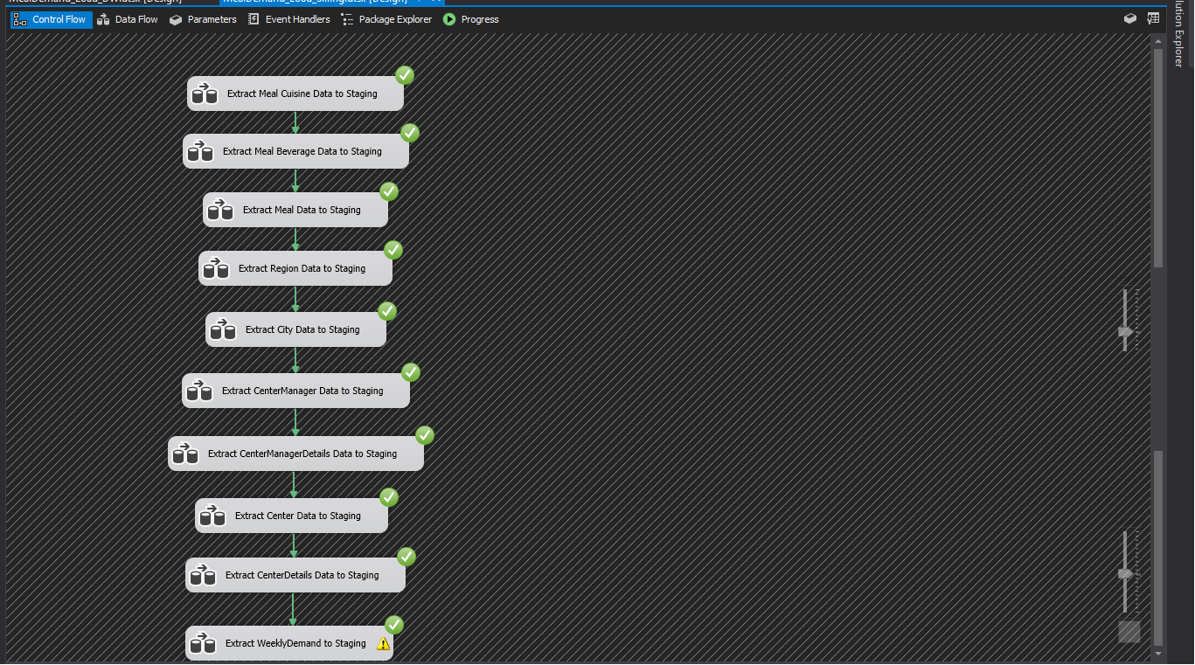

Figure 2: MealDemand_Load_Staging

1. Extract Meal Cuisine Data to Staging



Figure 3: Extract Meal Cuisine Data to Staging

1. Extract Meal Beverage Data to Staging

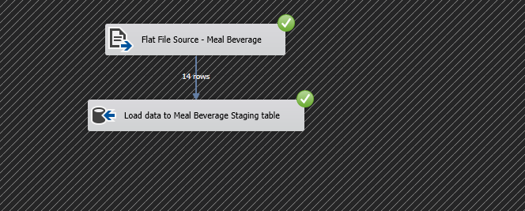

Figure 4:Extract Meal Beverage Data to Staging

1. Extract Meal Data to Staging



Figure 5: Extract Meal Data to Staging

1. Extract Region Data to Staging

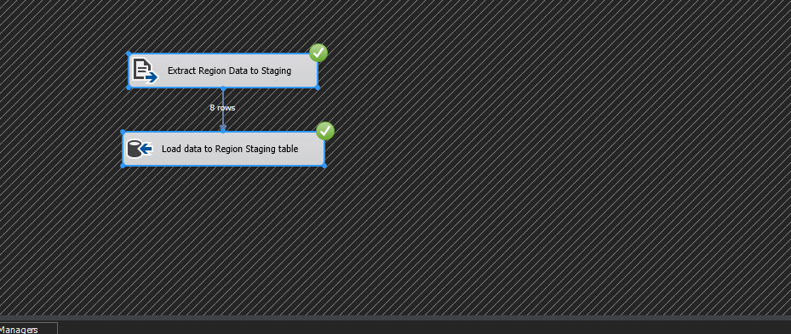

Figure 6: Extract Region Data to Staging

1. Extract City Data to Staging



Figure 7: Extract City Data to Staging

1. Extract CenterManager Data to Staging



Figure 8: Extract CenterManager Data to Staging

1. Extract CenterManagerDetails Data to Staging

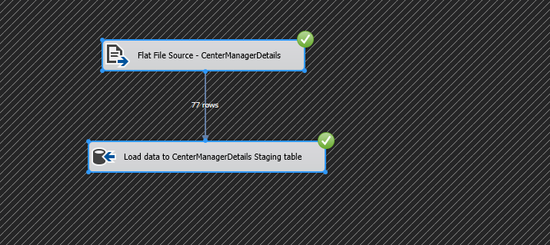

Figure 9: Extract CenterManagerDetails Data to Staging

1. Extract Center Data to Staging



Figure 10: Extract Center Data to Staging

1. Extract CenterDetails Data to Staging

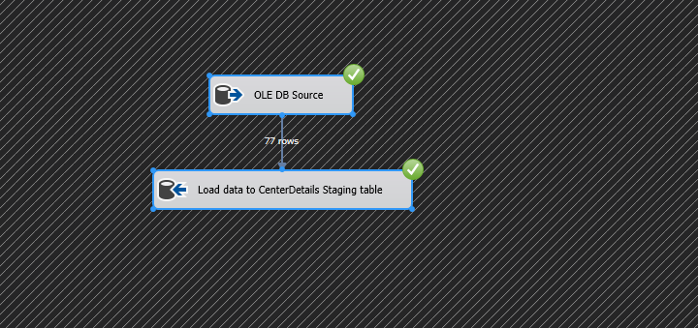

Figure 11: Extract CenterDetails Data to Staging

1. Extract WeeklyDemand to Staging

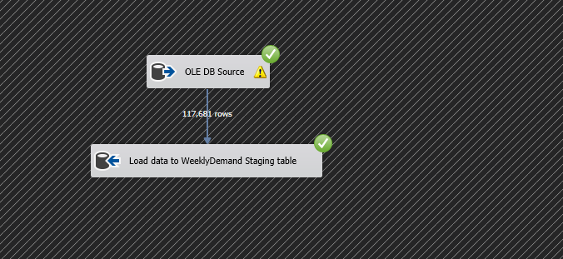

Figure 12: Extract WeeklyDemand to Staging

**Data Profiling**

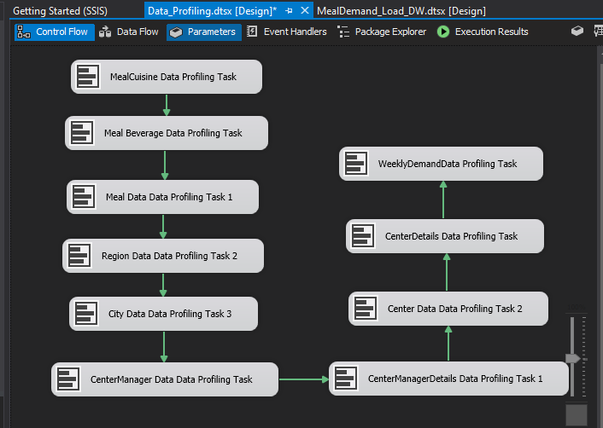

## Transform and Load to Data Ware House

Dimension tables were loaded to the data ware house based on the following order

1. DimMealCuisine - Transform and Load MealCuisine Data to Data Warehouse
2. DimMealBeverage - Transform and Load MealBeverage Data to Data Warehouse
3. DimMeal - Transform and Load Meal Data to Data Warehouse
4. DimCenterManager - Transform and Load CenterManager Data to Data Warehouse
5. DimRegion - Transform and Load Region Data to Data Warehouse
6. DimCity - Transform and Load City Data to Data Warehouse
7. DimCenter - Transform and Load Center Data to Data Warehouse
8. WeeklyDemand Fact - Transform and WeeklyDemand Fact Table to Data Warehouse

Slowly Changing Dimension - DimCenterManager

Slowly Changing Dimension – DimCenter

Durring the process of loading the Staging layer data will be loaded to the **MealDemand_DW** database

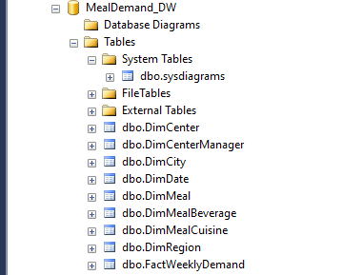

Name of package: **MealDemand_Load_DW.dtsx**

1. DimMealCuisine - Transform and Load MealCuisine Data

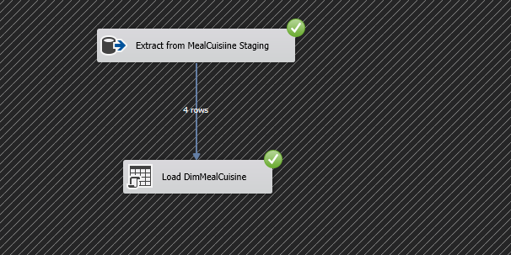

1. DimMealBeverage - Transform and Load MealBeverage Data

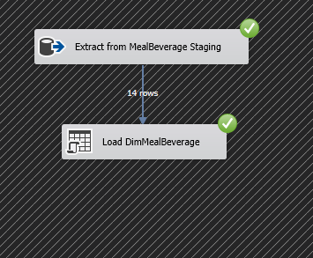

1. DimMeal - Transform and Load Meal Data

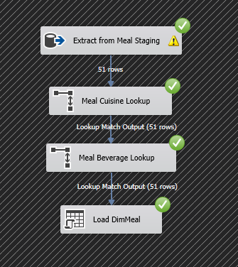

1. DimCenterManager - Transform and Load CenterManager Data

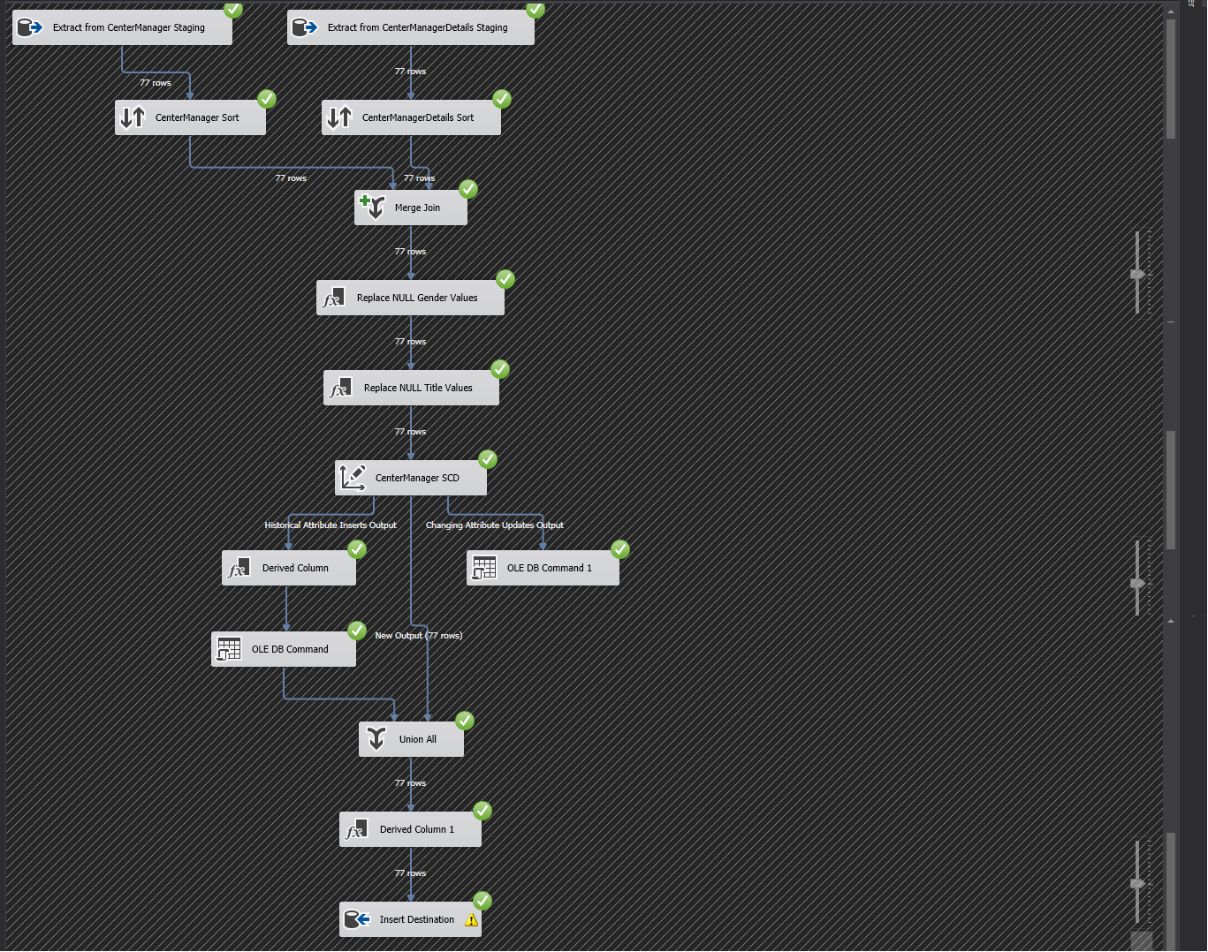

1. DimRegion - Transform and Load Region Data

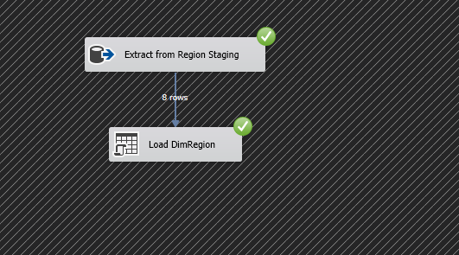

1. DimCity - Transform and Load City Data

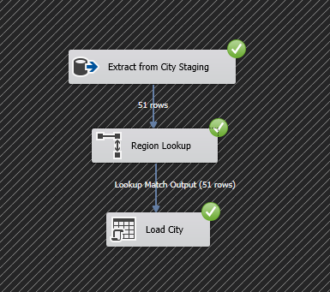

1. DimCenter - Transform and Load Center Data

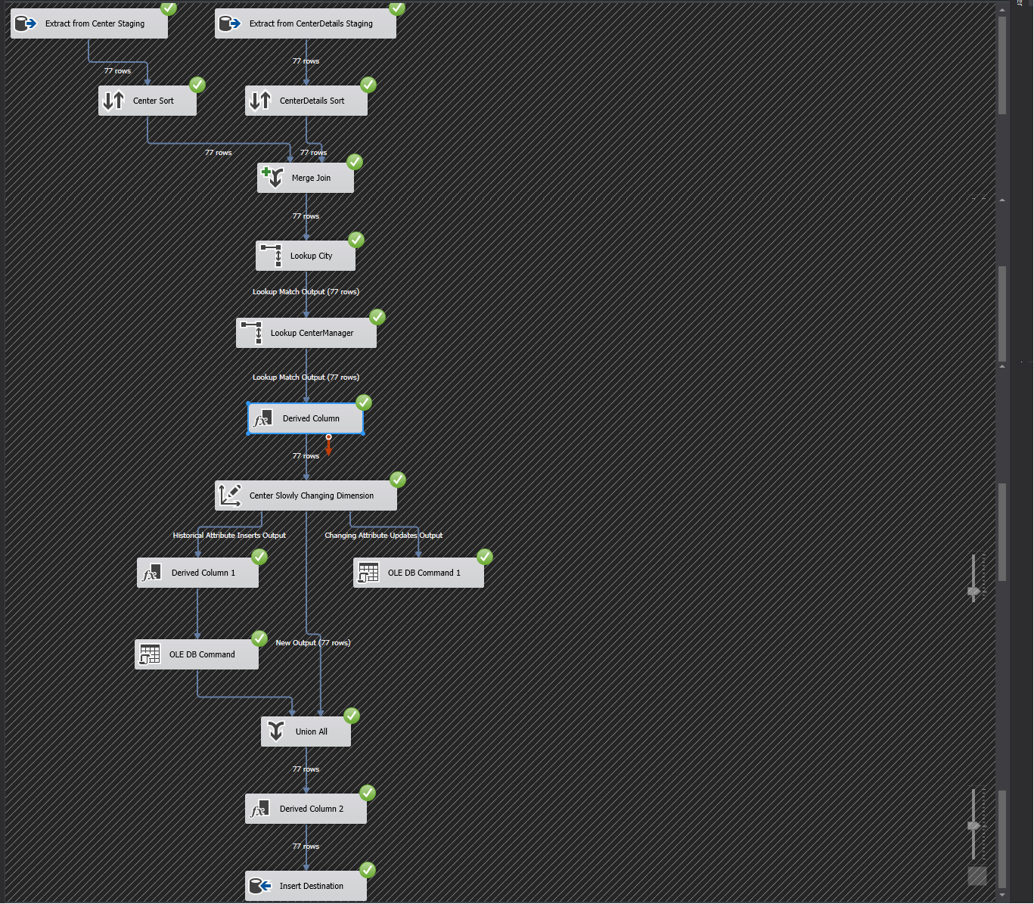

1. WeeklyDemand **Fact** - Transform and WeeklyDemand Fact Table

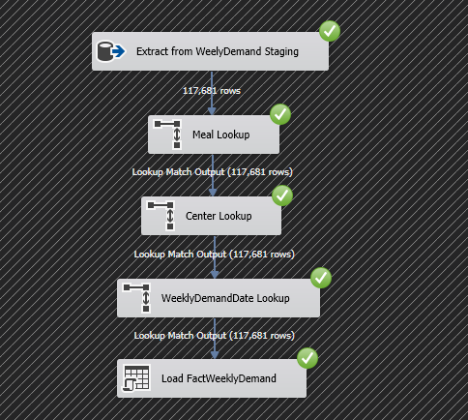

Meal Demand Load Progress

