How to Fill Out & Submit the Package Agency Monthly Sales Detail Report

- Click into the month/year box in the top right corner of the form to populate the dropdown menu, then select the appropriate month.
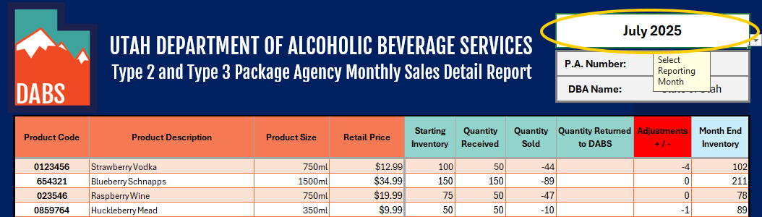

- Enter your Package Agency Number and DBA Name into the following fields. (Entries should match details submitted in your Type 2/3 Package Agency online record and package agency agreement)
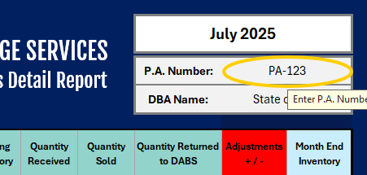 | 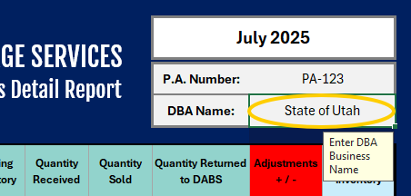

- Enter your item information (Product Code, Product Description, Product Size, and Retail Price) into the orange columns.
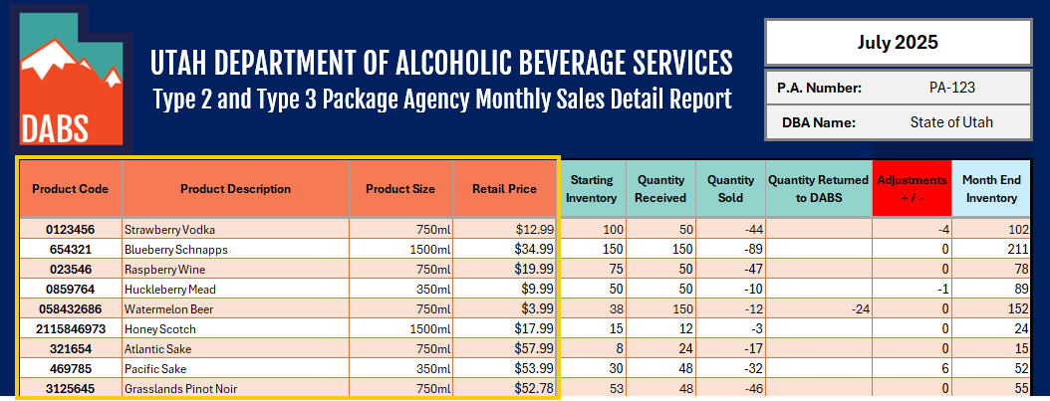

- Fill out the inventory-related columns:
  - Starting Inventory: Values should match the previous month’s “Month End Inventory”.
  - Quantity Received: Values should be the total number of bottles received during the reporting month.
  - Quantity Sold: Values should be the total number of bottles sold during the reporting month.
  - Quantity Returned to DABS: Number of bottles returned to a DABS State Liquor & Wine Store.
  - Adjustment +/-: Values should be total number of bottles for in-store shrink (damage/theft).
*Ensure values in the “Adjustment +/-“ column are entered as negative or positive for record accuracy.*
  - Month End Inventory: Values should be the total number of bottles remaining in stock after calculating the other inventory-related columns at the end of the month.
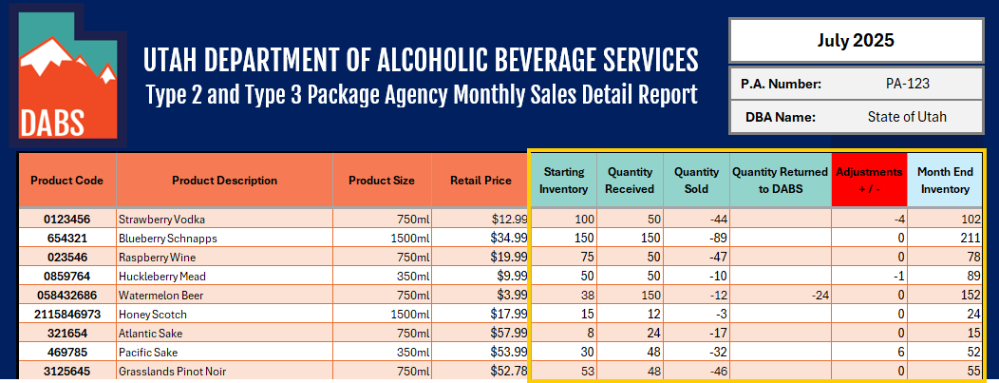

- Save file as “(PA Number) - (MSDR) - (Submission Month) - (Submission Year)”.
EXAMPLE: PA123 - MSDR - July - 2025

- Submit your report.
  - Log into your Licensing & Permitting System account.
  - Go to “Applications”.
  - Click on your current package agency record.
  - Click on “Attachments”.
  - Scroll to the bottom of the list and click on “Add Attachment”.
  - Follow the prompts on your computer.
Your Monthly Sales Detail Report is now submitted.
*CLICK HERE TO DOWNLOAD AN MSDR REPORT TEMPLATE*

