Smart Parking using IoT

|  |
| --- |
| **PHASE 5** |

|  |  |
| --- | --- |
| **Team ID** | 223989 |
| **Team Leader** | Hilstiene M |
| **Team Members** | Bharathi R  Harsha Dhaarani D  Indhuja M  Kumaresan J |
| **Date of Submission** | 01.11.2023 |

**Introduction:**

"Smart Parking System" aims to solve the common urban problem of parking congestion by implementing a system that uses IoT technology. This project utilizes ultrasonic sensors, Raspberry Pi, Python scripts, and a user-friendly MIT App Inventor app with Google Maps integration to provide real-time parking availability information. The goal is to reduce the time and fuel wasted in searching for parking spots, thus making urban life more efficient and environment friendly.

**Project Objective:**

* The primary objective of our project is to create a smart parking system that leverages IoT technology to provide real-time information about parking spot availability.
* By deploying ultrasonic sensors, Raspberry Pi, Python scripts, and a user-friendly MIT App Inventor application integrated with Google Maps.
* Efficiently monitor parking spaces in real-time
* Provide users with live updates on available parking spots
* Reduce the environmental impact of unnecessary vehicle emissions due to prolonged searching.
* Enhance user convenience and optimize parking space utilization.

**Hardware components:**

**Ultrasonic Sensor:**

* An ultrasonic sensor is a device that measures distances using high-frequency sound waves. It emits these sound waves, which bounce off objects and return to the sensor. By calculating the time taken for this round trip and knowing the speed of sound, the sensor accurately determines the distance to the object.
* In a Smart Parking System, ultrasonic sensors are strategically placed within parking spaces. Their primary role is to:
* **Detect Vehicle Presence:** When a vehicle enters or exits a parking space, the ultrasonic sensor emits sound waves. These waves bounce off the vehicle and return to the sensor, allowing it to detect the presence or absence of a vehicle in the space.
* **Data Collection:** The sensor continuously collects distance data, helping the system monitor parking space occupancy.
* **Real-time Information:** The data from the ultrasonic sensors is processed by a central unit (e.g., Raspberry Pi) to determine parking space status (occupied or vacant). This real-time information is then made available to drivers through a mobile app or digital displays.

**Raspberry Pi Pico:**

* The Raspberry Pi, a compact and affordable single-board computer, plays a vital role in our Smart Parking System. It serves as the central processing unit and facilitates the efficient functioning of the system. Here's a brief overview of how it's used:
* **Data Processing:** Raspberry Pi is connected to the ultrasonic sensors deployed in parking spaces. It processes the data collected by these sensors, determining whether a space is vacant or occupied.
* **Decision Making:** Based on the sensor data, the Raspberry Pi runs Python scripts that make real-time decisions about parking space status. It uses this information to keep track of available parking spots.
* **Communication**: The Raspberry Pi communicates the parking status information to a central system or a user-friendly mobile application. This data is then made accessible to drivers, enabling them to locate available parking spaces quickly.

**Software Components:**

* **Required libraries like import machine, time in Python script**
* **Simulation: Wokwi**
* **Server\cloud: Thingspeak**
* **MIT app inventor**

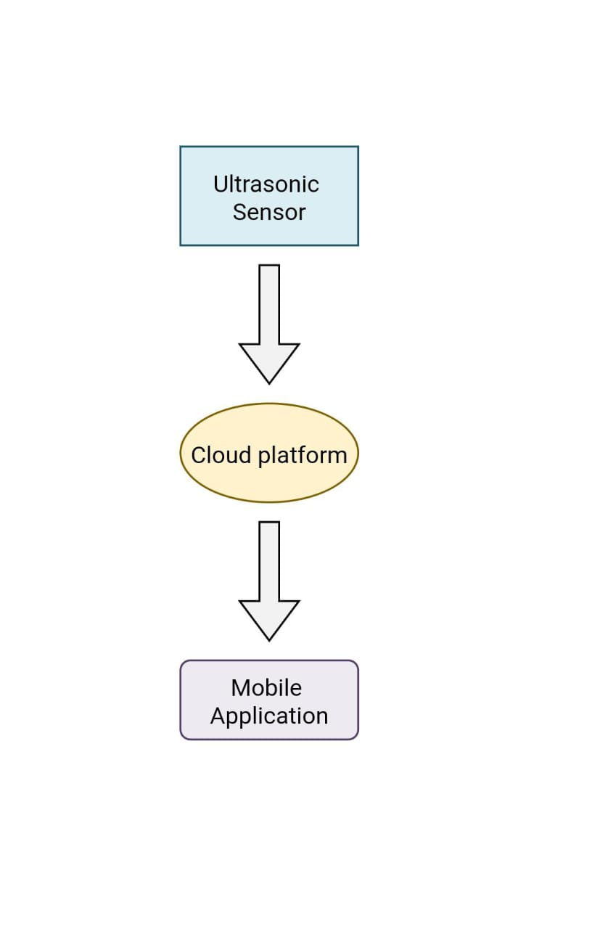**Implementation of IOT Sensor:**

**1.Sensor Installation:**

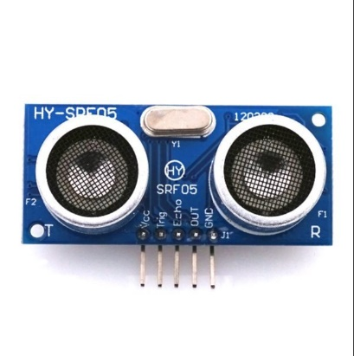

Install Ultrasonic sensors in each parking space and wire the sensors to the microcontroller, ensuring power and data connections.

**2.Microcontroller Setup:**

* **Hardware Selection:** Raspberry Pi

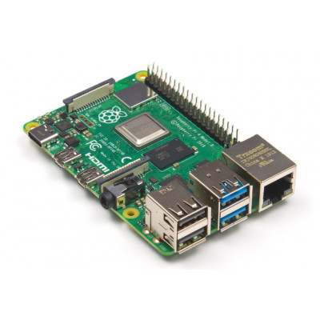

* **Communication:** Implement a communication module (e.g., Wi-Fi, Bluetooth, or LoRa) to transmit sensor data to a central server or cloud platform for processing and storage.
* **Data Processing:** Develop software on the microcontroller to process sensor data, determine parking space occupancy, and make decisions based on that information.

**Simulation Circuit:**

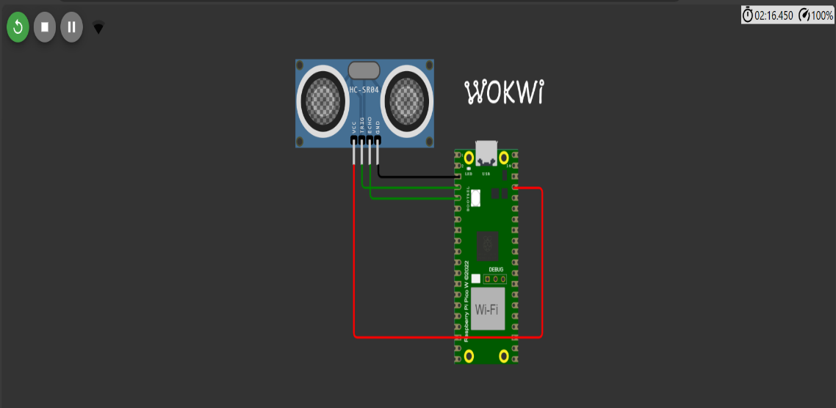

**Mobile Application Development:**

* **Design UI:** Plan the app's features and create a user-friendly interface using MIT App Inventor.
* **Connect IoT Devices:** Set up Raspberry Pi Pico with virtual sensors in Wokwi for parking detection.
* **Cloud Data:** Write Python code to send data to ThingSpeak from Raspberry Pi Pico.
* **IoT Simulation:** Test the IoT components in Wokwi and monitor data on ThingSpeak.
* **Create App:** Build the app's UI and logic in MIT App Inventor, including data retrieval from ThingSpeak.
* **App-ThingSpeak Connection:** Connect the app to ThingSpeak using MIT App Inventor's Web component.
* **Test and Deploy:** Ensure app functionality, and distribute it for testing and deployment, possibly on the Google Play Store.

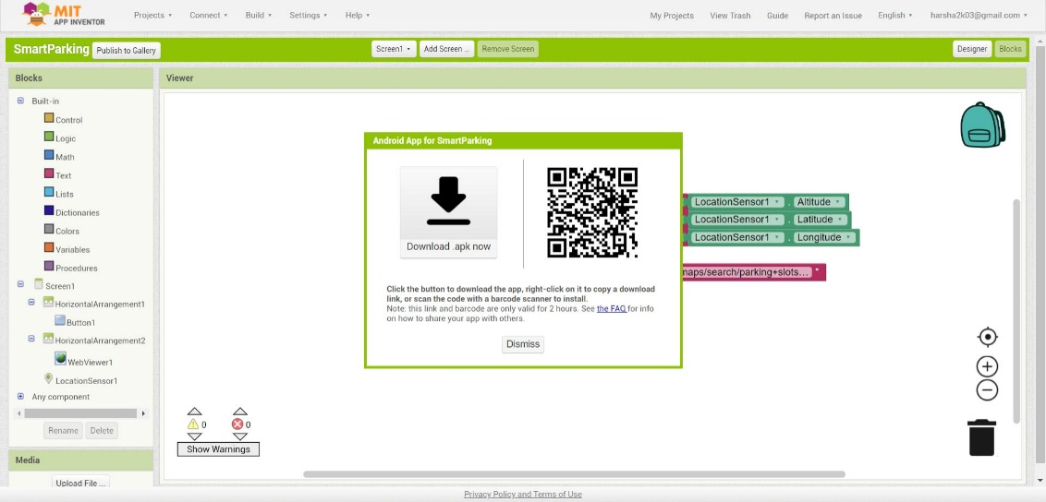

**Homepage:**

**Map view (Google Maps):**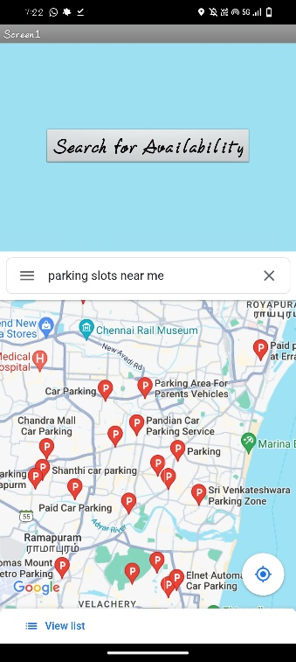

**Raspberry Pi Integration:**

**Coding:**

**import machine**

**import time**

**import urequests**

**import network**

**# WiFi credentials**

**WIFI_SSID = "Wokwi-GUEST"**

**WIFI_PASSWORD = ""**

**# ThingSpeak API settings**

**THINGSPEAK_API_KEY = "J9U2H9SP2QM95J1G"**

**THINGSPEAK_CHANNEL_ID = 2319272**

**# Define the GPIO pins for the sensor**

**TRIG_PIN = machine.Pin(2, machine.Pin.OUT)**

**ECHO_PIN = machine.Pin(3, machine.Pin.IN)**

**# Set the occupancy threshold in centimeters**

**OCCUPANCY_THRESHOLD = 30.0 # Adjust this value as needed**

**# Connect to WiFi**

**wifi = network.WLAN(network.STA_IF)**

**if not wifi.isconnected():**

**print("Connecting to WiFi...")**

**wifi.active(True)**

**wifi.connect(WIFI_SSID, WIFI_PASSWORD)**

**while not wifi.isconnected():**

**pass**

**print("Connected to WiFi")**

**def send_to_thingspeak(occupancy):**

**url = "https://api.thingspeak.com/update?api_key={}&field1={}".format(THINGSPEAK_API_KEY, occupancy)**

**response = urequests.get(url)**

**response.close()**

**try:**

**while True:**

**# Trigger the ultrasonic sensor**

**TRIG_PIN.on()**

**time.sleep_us(10)**

**TRIG_PIN.off()**

**pulse_start = time.ticks_us()**

**pulse_end = time.ticks_us()**

**# Wait for the echo signal**

**while ECHO_PIN.value() == 0:**

**pulse_start = time.ticks_us()**

**while ECHO_PIN.value() == 1:**

**pulse_end = time.ticks_us()**

**# Calculate the distance**

**pulse_duration = time.ticks_diff(pulse_end, pulse_start)**

**distance = (pulse_duration / 1000000) * 17150 # Speed of sound in cm/s**

**# Check for occupancy**

**if distance < OCCUPANCY_THRESHOLD:**

**indhu = "Occupied"**

**print(indhu)**

**send_to_thingspeak(1) # Send 1 to indicate occupancy to ThingSpeak**

**else:**

**indhu1 = "Not Occupied"**

**print(indhu1)**

**send_to_thingspeak(0) # Send 0 to indicate no occupancy to ThingSpeak**

**time.sleep(5) # Delay for 15 seconds (ThingSpeak allows up to 15-second updates)**

**except KeyboardInterrupt:**

**Pass**

**References:**

**WOKWI Source: (**[Pi Pico W - Micropython Copy - Wokwi ESP32, STM32, Arduino Simulator](https://wokwi.com/projects/379637703078118401)**)**

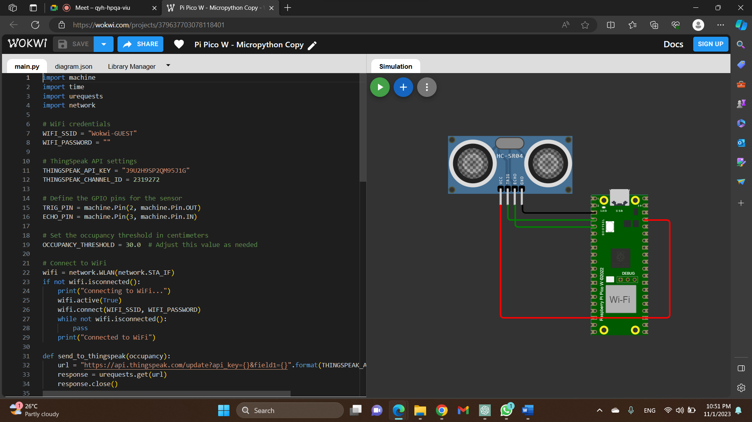

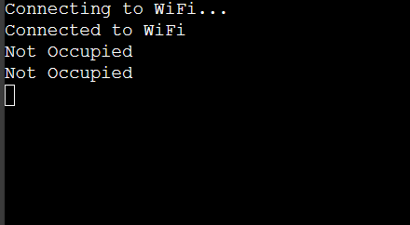**Output:**

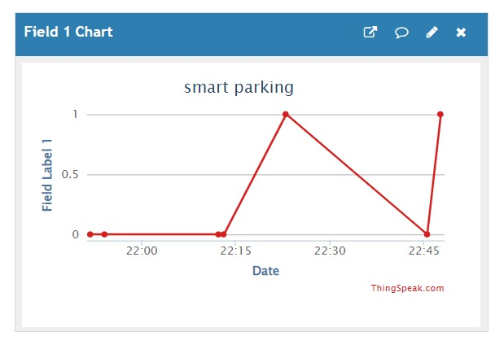**ThingSpeak(cloud platform):** (https://thingspeak.com/channels/2319272/api_keys)

**Benefits:**

* A real-time parking availability system offers several benefits to drivers and helps alleviate common parking issues:
* **Time and Fuel Savings:** Drivers can quickly find available parking spaces, reducing the time and fuel wasted on circling around in search of a spot. This efficiency leads to cost savings and reduces traffic congestion.
* **Reduced Stress:** Searching for parking can be stressful. Real-time availability information helps drivers plan their parking ahead of time, reducing stress and frustration.
* **Environmental Impact:** Decreasing the time spent searching for parking spaces reduces vehicle emissions, contributing to a cleaner environment.
* **Cost Savings:** Real-time parking data can help users find the most cost-effective parking options, whether it's free or lower-priced spots, or by providing information on discounts or promotions.
* **Improved Accessibility:** Parking availability systems can also provide information on accessible parking spots for individuals with disabilities, enhancing inclusivity and compliance with accessibility regulations.
* **Safety:** Drivers are less likely to engage in risky behavior, such as sudden stops or illegal parking, when they have information on available spaces. This improves overall road safety.
* **Optimized Urban Planning:** The data collected from these systems can be used by city planners to make informed decisions about parking infrastructure and allocation, leading to more efficient and sustainable urban development.
* **Convenience:** Drivers can reserve parking spots in advance or navigate directly to available spots, making the parking experience more convenient.
* **Real-time Updates:** The system can offer real-time updates, informing drivers of spot availability changes due to factors like someone leaving or new spots opening up.
* **App Integration:** Integrating the system with mobile apps allows drivers to access real-time parking data, reserve spots, and receive alerts, making the overall parking experience more user-friendly.

**Conclusion:**

In conclusion, promoting smart parking using IoT technology is a transformative step toward addressing the growing challenges of urban congestion, traffic inefficiency, and environmental concerns. IoT-enabled smart parking solutions offer numerous benefits, including real-time availability information, reduced search times, lower emissions, and enhanced convenience for both drivers and city planners. By implementing such systems, cities can optimize their parking infrastructure, reduce environmental impact, and make urban life more efficient and enjoyable. The future of urban mobility and sustainable living is closely tied to the adoption of IoT-based smart parking solutions, which promise a brighter, more accessible, and eco-friendly urban landscape for all.