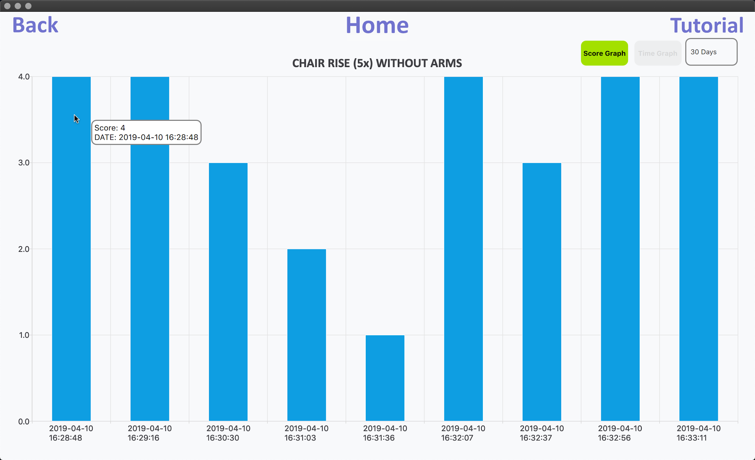

Hello this is a demo test for git to check if tit updated word document.

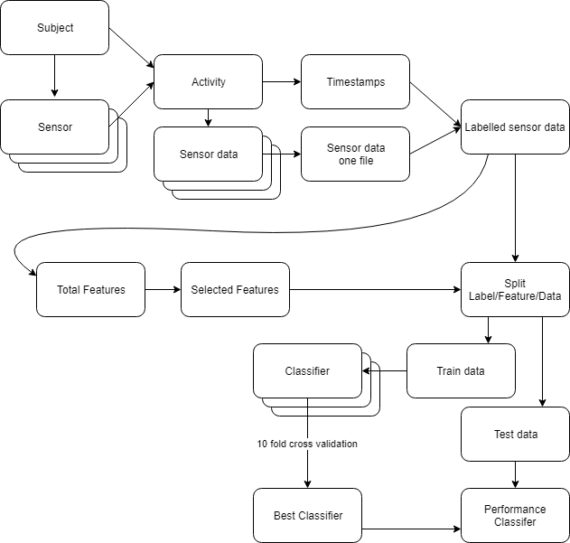

More specifically the selections were made as follows. First the sensor data was limited to only use the data of one accelerometer and do the classification. This was done with all five sensors separately and the sensor with the highest weighted average F1-score on the test data set was kept. Then the data of this first sensor and a second sensor was selected. Again all different sensors were being used in combination with the first to find the highest weighted average F1-score on the test data set. This procedure is continued so that finally all 5 sensors were used. Then a final comparison was done between the five options to see the difference in F1-score. The performance of the different setups is compared in section 3.1.1.

2.8 Impact of using gyroscope
The byteflies sensor dot IMU contains a triaxial accelerometer which was previously used. It also contains a gyroscope. This gyroscope can provide extra information on the orientation of the sensor. An example of application for gyroscope is detecting device orientation in smartphones.
The process to find the impact on classification when including gyroscope data is the same as the general process explained in section 2.4. In this case for the data selection the acceleration and gyroscope data from the optimal setup of sensors found in 2.8 was used.
The same features were calculated on the gyroscope data as on the accelerometer data. Different classifiers were trained and the one with the highest 10 fold cross validation accuracy was tested on test data set. Then the weighted average test set F1-score was compared between using acceleration data only and including gyroscope data. In section 3.1.2 the results are shown.

2.9 Single activity classification and grading
Most activities can be graded easily starting from the start and stop timestamps. By subtracting start from stop you get the duration of the activity. The corresponding grade is then looked up in Table 2.2 and 4.
However there are some activities with other grading criteria. These are the 360° turn and taking stairs. For 360° turn the activity is graded not on time but on whether it was performed continuously and steadily. Unsteady here means if the person staggers or has to grab something to

