*Sacred Heart Convent sr. Sc. School*

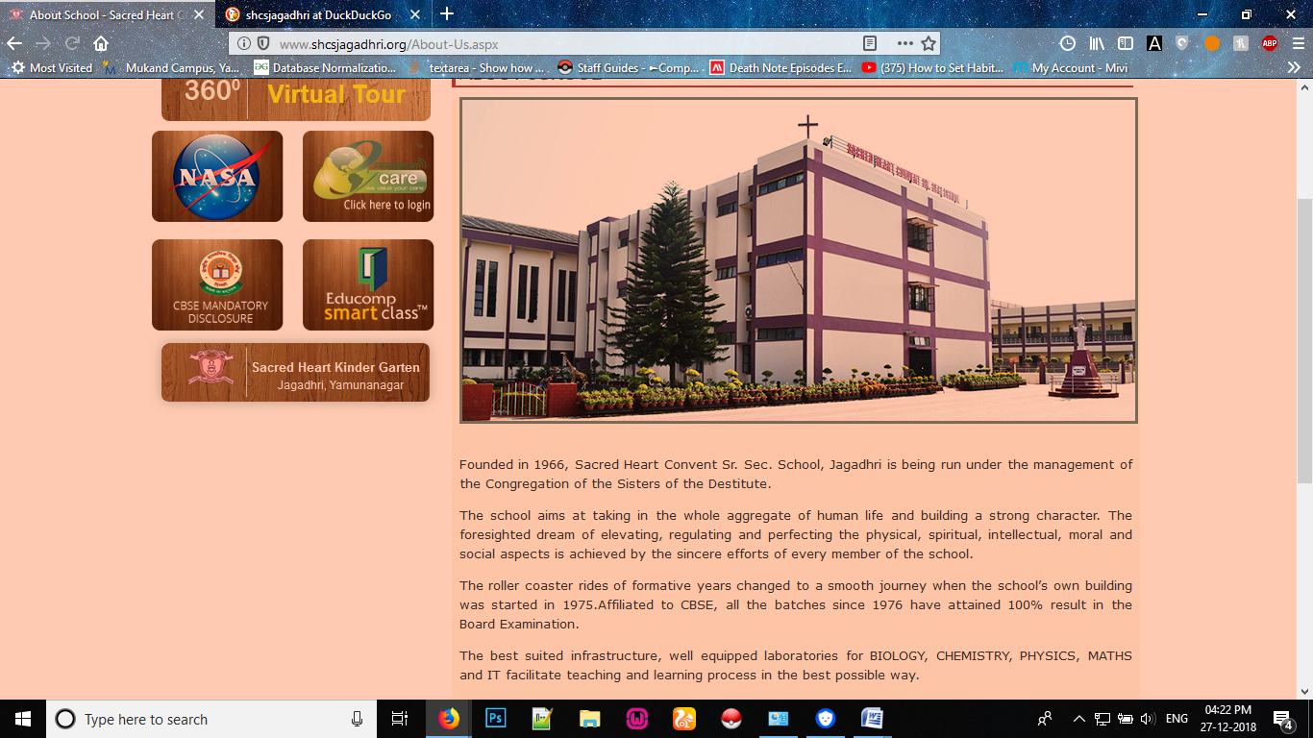

* Project topic: Hybridization
* Submitted to: Central board of secondary education, session-2018-19 in the partial fulfilment of AISSCE.

Under the supervision of:

MRS. MAMTA KAKKAR

(Chemistry lecturer)

Submitted by:

MANSI SHARMA

CLASS: X11-A

ROLLNO: BOARD ROLLNO:

INDEX

1. Bonafide certificate........................ 1
2. ACKNOWLEDGEMENT............................. 2
3. Hybridization....................................... 3
4. Types of hybridization...................... 4
5. Result..................................................... 10
6. Bibliography......................................... 11

Bonafide certificate

*CERTIFIED THAT THIS PROJECT REPORT TITLED Hybridization is the bonafide work of mansi Sharma who carried out the research under my supervision. Certified further ,that to the best of my knowledge the work reported here in does not part of any other project report degree or award was conferred on an earlier occasion on this or any other candidate.*

Acknowledgement

I would like to express my special thanks of gratitude to my teacher Mrs.Mamta Kakkar as well as our principal SR.JESINA S.D. who gave me golden opportunity to do this wonderful project on the topic HYBRIDIZATION, which also helped me in doing a lot of Research and I came to know about so many new things ,I am really thankful to them.

Secondly I would also like to thank my parents and friends who helped me a lot in finalizing this project within the limited time frame.

Hybridization

***Hybridization*** *is a**Term used to describe the mixing of atomic orbitals to generate a set of new hybrid orbitals that are**equivalent.*

* *It is a mathematical tool that allows us to relate the bonding in a molecule to its symmetry.*
* *A* ***hybrid orbital*** *results from the mixing of different types of atomic orbital on the same atom.*
* *The hybridization type can be determined from the number of electron domains around the central atom.*
* *The sublevels of the atom’s valence shell recombine into new orbitals with different shapes and angles:*
* **sp hybridization**
* **sp2 hybridization**
* **sp3 hybridization**
* **sp3d hybridization**
* **sp3d2 hybridization**

**sp hybridization**:

*▪▪ mixture of ****one**** s orbital and ****one**** p orbital*

*▪▪ results in ****two**** degenerate (equivalent – same energy) orbitals *

*▪▪ are at an angle of 180° from each other*

*▪▪ have a ****linear**** shape, with ****two**** unhybridized p orbitals*

**sp2 hybridization**:

*▪▪ mixture of ****one**** s orbital and ****two**** p orbitals *

*▪▪ results in ****three**** degenerate orbitals*

*▪▪ are at angles of 120° from each other*

*▪▪ have a ****trigonal planar**** shape, with ****one**** unhybridized p orbital*

**sp3 hybridization**:

*▪▪ mixture of ****one**** s orbital and ****three**** p orbitals *

*▪▪ results in ****four**** degenerate orbitals*

*▪▪ are at angles of 109.5° from each other*

*▪▪ have a ****tetrahedral**** shape*

**sp3d hybridization**:

*▪▪ mixture of ****one**** s orbital, ****three**** p orbitals, and ****one**** d orbital*

*▪▪ results in ****five**** degenerate orbitals*

*▪▪ ****three**** are at 120° from each other on the equatorial plane, and ****two***

*are 90° to the plane (axial) but 180° from each other ▪▪ have a ****trigonal bipyramidal**** shape*

**sp3d2 hybridization**:

*▪▪ mixture of ****one**** s orbital, ****three**** p orbitals, and ****two**** d orbitals *

*▪▪ results in ****six**** degenerate orbitals*

*▪▪ are at angles of 90° from each other*

*▪▪ have an ****octahedral**** shape.*

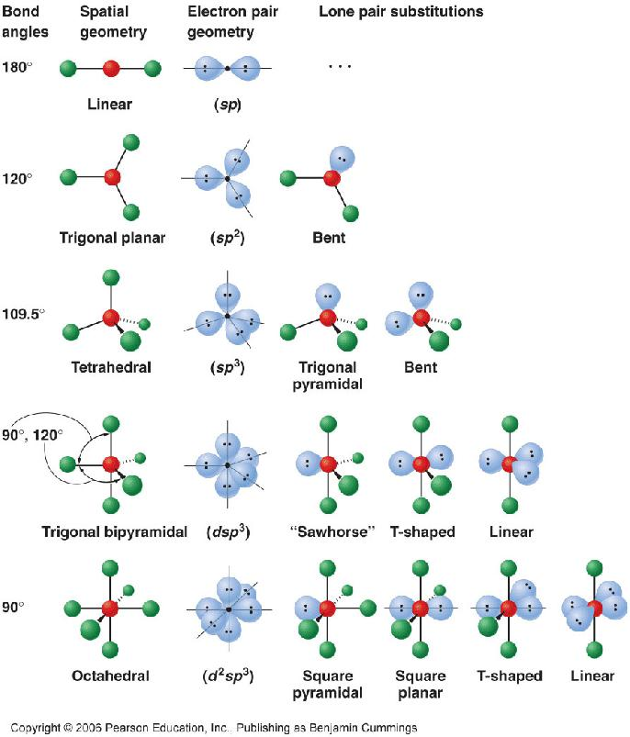

*Result*

*from there we conclude that there are different type of hybridization.*

*Bibliography*

* [***https://en.wikipedia.org/wiki/Orbital_hybridisation***](https://en.wikipedia.org/wiki/Orbital_hybridisation)
* [***http://dl.clackamas.edu/ch106-02/typesof.htm***](http://dl.clackamas.edu/ch106-02/typesof.htm)
* [***http://www.chemistry-assignment.com/types-of-hybridization***](http://www.chemistry-assignment.com/types-of-hybridization)