**Spam Ham Classifier**

***Wireframe Documentation***

Homepage

Spam Ham Classifier is a single page web app so it will have only a single section on the page.

Here is a sample view of the web page:

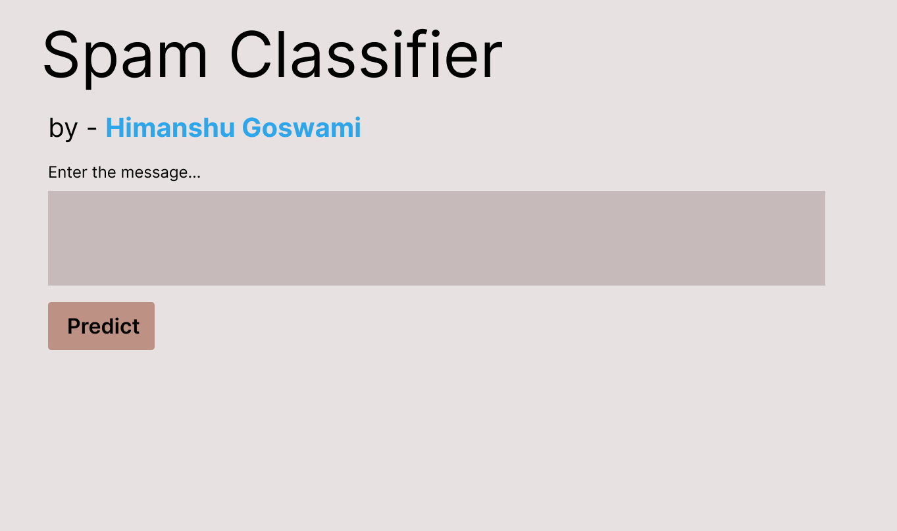

The user will enter the text in the given **text area**.

After entering the text, user will be required to click on the Predict **Button**.

After clicking on the button, process will start and almost instantly user will get the result right at the bottom of Predict Button:

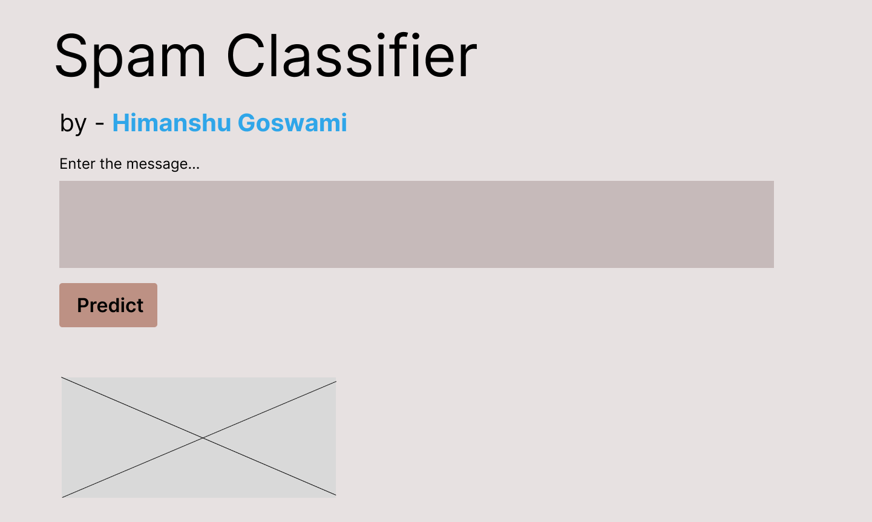

The **Crossed Section** in the above sample shows where pic of “SPAM” or “NOT SPAM” will appear.