Safe AI Adoption Checklist: Standard Operating Procedure
Prepared by SafeAlign AI · info@safealignai.io
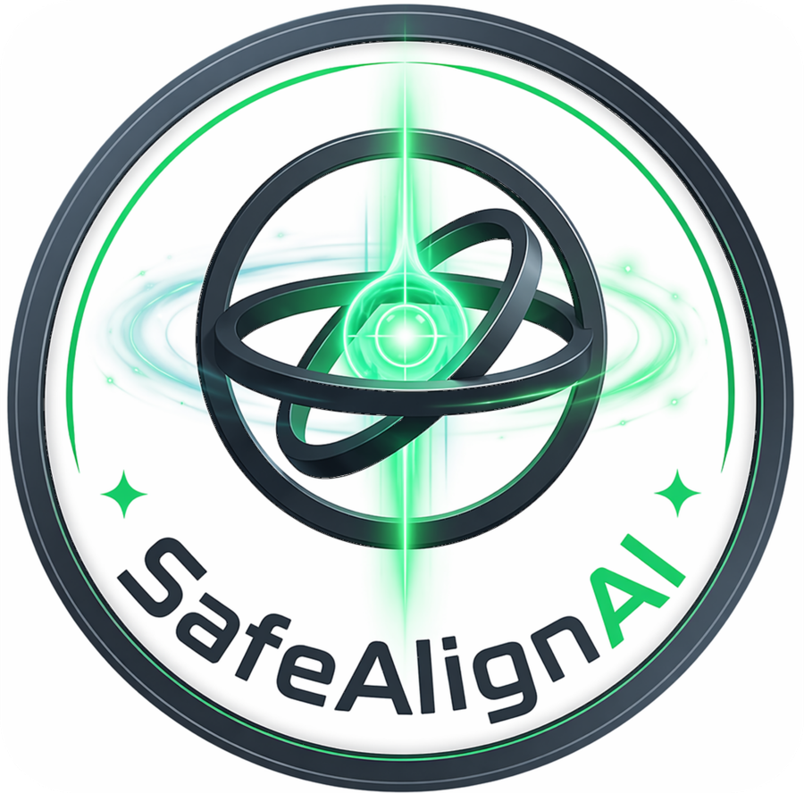
SafeAlign AI

1. Purpose
This procedure explains how to use the Safe AI Adoption Checklist skill (SKILL.md) with any AI assistant to review one AI use case for safety, privacy, IP, staff and customer risk before and after adoption. It is written for small and medium businesses and is platform-neutral.

2. Scope
- Applies to any AI tool or workflow the business is planning, has adopted, or is reviewing.
- Works with Claude, ChatGPT, Gemini and other assistants that accept instructions or skill files.
- Covers one use case per session. Repeat for each use case.
- Produces a readiness record. It does not approve a use case; the business owner signs it.

3. Roles
Role | Responsibility
Use-case owner | Day-to-day owner of the AI tool; answers the intake questions and works through the checklist.
Approver | Business owner or manager who signs the sign-off block and accepts the to-do list.
Reviewer (optional) | Second person who spot-checks answers; recommended for any high-risk use.

4. Before you begin
- Have the following to hand: the tool name and plan, what data it will touch, and who will own it.
- Confirm that any customer, staff, payroll, client, health or financial data will only go into a business-grade tool that does not train on your data.
- Decide the date of your first review (default: 90 days from go-live).

5. Setting up the skill in your AI assistant
Use whichever method your platform supports. If none is available, use method C.
A. Skill file (where supported). Upload SKILL.md as a skill or custom skill in the platform’s skill or project settings, then start a new conversation and ask for the Safe AI Adoption checklist.
B. Project or custom instructions. Create a project, custom GPT or Gem. Paste the body of SKILL.md (everything below the front matter) into its instructions. Name it “Safe AI Adoption Checklist”.
C. One-off conversation. Start a new chat and paste the full contents of SKILL.md, then write: “Run the Safe AI Adoption checklist for the use case below.”
Check that the assistant starts by asking the four intake questions. If it does not, the instructions were not loaded; repeat step A, B or C.

6. Running a review
- Intake (5 minutes). Answer the four questions: use case, tool and plan, data involved, owner.
- Walkthrough (one session, about 45 to 60 minutes). Go through sections 0 to 6 in batches of three to five items. Answer yes, partly, no or not yet for each item, with one line of evidence (for example, “Terms page, section 4, confirms no training on customer data”).
- Follow-ups. For each “no” or “not yet”, record what it would take and by when.
- Output. Ask for the status line, red flags, to-do list and sign-off block.
- Save. Copy the output into a document and store it with the use case. The Word checklist template can be used for the same record.
Do not let the assistant tick items on your behalf. Items must reflect what you have actually verified.

7. Decision rules
Outcome | Action
Any red flag (a “no” in sections 1, 2 or 5 where data, money or people are affected) | Do not go live. Resolve the item, then re-run the affected section.
Only “partly” or “not yet” items remain | May go live with a dated to-do list and an owner for each item.
Use involves health data, children, or automated decisions about employment, credit, housing or benefits | Stop. Obtain a specialist review before proceeding.
Legal or contract question raised | Record it, pause that item, and consult a qualified professional.

8. Records and review
- Keep the completed record for each use case with the sign-off block.
- Review at 90 days, then quarterly, and re-run the checklist whenever the tool, vendor terms, data types or use case change.
- Retire the record and re-assess if the use case is discontinued.

9. Limits and disclaimers
- The checklist is practical guidance, not legal advice. PIPEDA, Ontario human-rights, AODA and contract obligations should be confirmed with a qualified professional.
- The assistant’s answers depend on the information you give it. Verify vendor claims against the vendor’s written terms.
- Do not enter client secrets, account numbers or personal identifiers into the assistant while running the review. Use placeholders such as [CLIENT].

10. Feedback and support
Questions, suggested changes or support: info@safealignai.io
Prepared by SafeAlign AI.

