Analysis and design of high-speed transimpedance amplifier circuits
Ivailo M. Pandiev

The paper presents the structure and the principle of operation of the transimpedance amplifier (TIA) circuits (or current-controlled voltage sources – CCVSs), employing voltage-feedback operational amplifier (VFOA). In particular, under review are the basic circuit of TIA and the modified circuit with additional voltage divider (TIA employing T network). Based on analysis of the operational principle, the equations for the complex transfer functions of both circuits and formulas for the related dynamic electrical parameters are obtained. Moreover, using these formulas a design procedure is developed and recommendations for simulation modeling are given. The efficiency of the proposed procedure is verified by simulation modeling of sample circuits of TIAs.
Анализ и проектиране на високочестотни преобразуватели на ток в напрежение (Ивайло Пандиев). В доклада е представена структурата и принципа на работа на базовите електронни схеми на преобразуватели на ток в напрежение (current-controlled voltage sources – CCVSs или transimpedance amplifiers – TIAs) с операционен усилвател на напрежение (VFOA), като активен елемент. По-конкретно обект на изследване е основната и модифицираната схема на преобразувател на ток в напрежение с допълнителен резисторен делител (трансимпедансен преобразувател с Т – звено във веригата на отрицателната обратна връзка). Въз основа на теоретичен анализ на двете електронни схеми са изведени формулите за комплексните предавателни функции и свързаните с тях електрически параметри. При това използвайки получените резултати е създадена методика за схемотехнично проектиране и са дефинирани препоръки за симулационно изследване. Правилността на предложената методика е потвърдена чрез проектиране и изследване на примерни схеми.

Introduction
The high-speed (with bandwidth 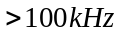) transimpedance amplifiers (TIAs) employing voltage-feedback operational amplifier (VFOA) have been found useful in many applications, such as communications, control systems and measurement systems. The analysis of existing literature showed a wide variety of publications and technical documents [1-7], which discuss various aspects of the analysis, design and simulation modeling of the TIAs. In [1], [2] and [3] the attention of the authors is focused primarily on the principles of operation of the basic circuits of TIAs. Unlike of them in [4], [5], [6] and [7] in addition of analyzing the principle of operation of the basic TIAs the authors proposes some design recommendations for selection of the passive components. To the author’s knowledge, a design procedure for the VFOA-based high-speed TIAs has not yet been reported in the literature. In this paper on the basis of theoretical analysis of the VFOA-based high-speed TIAs a systematic design procedure, valid up to 100MHz, is proposed.
VFOA-based transimpedance amplifier circuits
A basic TIA circuit
The structure of the basic TIA employing VFOA is shown on Fig. 1a. Since VFOA has very high input impedance and thus a small input bias currents inverting input is a virtual ground of the circuit, a current flows through the feedback resistor 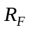 is equal to the input current . Then the output voltage is
(1) 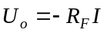,
where 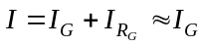 for 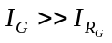.
The input resistance of the circuit according to the Miller theorem [1] is
(2) 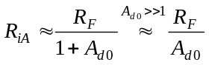.
The value of the resistance 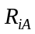 is very small and can be neglected compared to the internal differential resistance 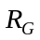 of the input current source.
The output resistance is also very small and can be determined from the formula for a circuit with parallel negative feedback [1]:
(3) 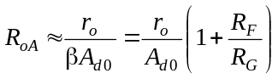,
where is the output resistance of the VFOA and 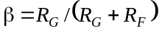.
When 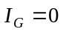 for the real VFOA the output voltage is different from zero. This voltage is determined by the input offset voltage 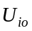 and the input bias current 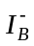 of the VFOA. The value of the total output offset voltage 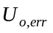 for room temperature (usually in data-sheets the input offset voltage and input bias current of the VFOA is defined at 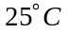) is
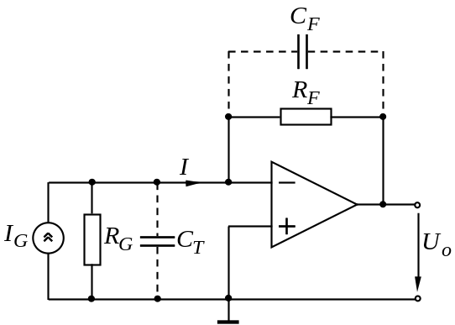  Fig. 1a. A transimpedance amplifier circuit using VFOA. | 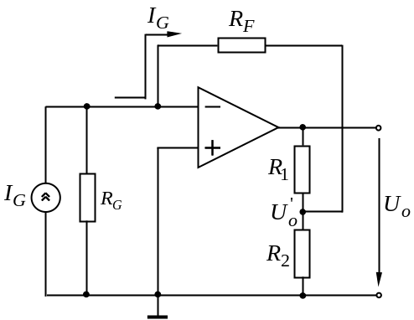  Fig. 1b. A TIA with additional voltage divider.

(4) 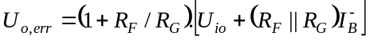.
To reduce the high frequency noises, that may occur in the output of the circuit in parallel of the resistor is connected a capacitor 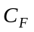. The tranimpedance transfer function for the circuit employing ideal VFOA is defined as
(5) 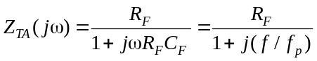,
where 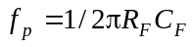 is the pole frequency.
For the real VFOA with an input capacitance 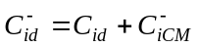 (where 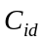 is differential input capacitance and 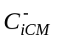 is common-mode input capacitance for the inverting terminal of the VFOA) and for the given equivalent capacitance 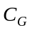 of the input source and mounting parasitic capacitance 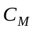 (with typical values ​​from 1 to 3pF) the inverse value of the feedback coefficient (or Noise Gain – NG function) is
(6) 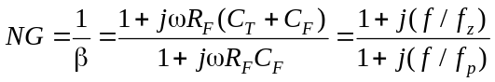,
where is the pole frequency, 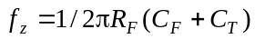 is the zero frequency and 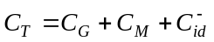 is the total input capacitance.
The module and phase versus frequency of the  coefficient are defined by
(7) 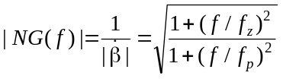 and
(8) 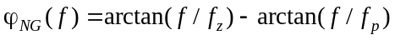.
Since 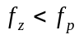 after the zero frequency 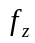 the noise gain function 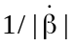 starts to increase at a rate 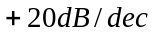. If the 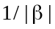 intersect the frequency response 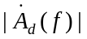 of the VFOA in an area with a slope 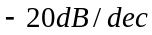 the rate of change will be approximately equal to 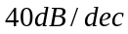. The total phase shift at the intersection point of and is equal to 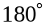. The circuit could become inherently unstable as there will be excess phase shift around the loop.
In order to maintain the stability is necessary the slope of the function to be reduced to a value 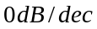, before the – function intersect the frequency response of the VFOA. For this purpose in the circuit on Fig. 1a the capacitance have to be increases so, that for the frequency equal to or less than 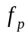 to get intersection between 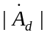 and , i.e. 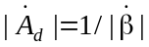 or
(9) 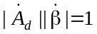.
For the one-pole approximation the amplitude-frequency response of the VFOA is
(10a) 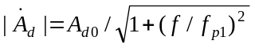,
where 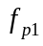 is the linear frequency of the dominant pole.
If 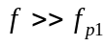 Eq. (10a) yields the type
(10b) 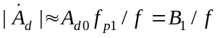,
where 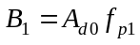 is the unity-gain bandwidth of the VFOA.
After substituting Eq. (10b) and Eq. (7) in Eq. (9) is obtained
(11) 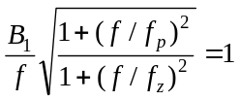.
If the value of the frequency f is equal to and 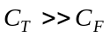, according to Eq. (11), for the optimum value of the is found
(12) 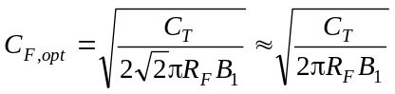.
If the value calculated for gives too much ringing in the circuit, then some overcomepensation can be used to reduce the ringing. Overcompensation will, of course, reduce the bandwidth of the circuit. The formula for the cutoff frequency of the circuit at an optimal value of is
(13) 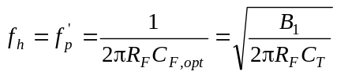.
A TIA with an additional voltage divider
When its needed to obtain higher value of the amplitude of the output voltage 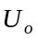 without changing the resistance , at the output of the VFOA its includes an additional voltage divider formed by 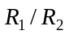, as shown on Fig. 1b.
For an ideal VFOA the output voltage of the circuit shown on Fig. 1b is
(14a) 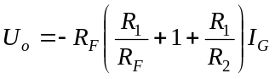.
If 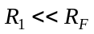 Eq. (14a) is simplifies and for the output voltage is obtained
(14b) 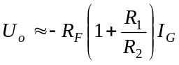.
If and 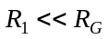 the output offset voltage of the circuit is
(15) 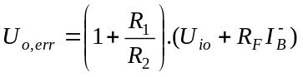.
Design procedure
“A good decision is based on knowledge and not on numbers.”
Plato.
The analytical formulas for the transfer functions and the related dynamic parameters are the base of the design procedure for the high-speed transimpedance amplifier circuits employing VFOAs. The schematic design of the circuits on Fig. 1a and Fig. 1b begins by definition of the following requirements: amplitude of the input current 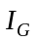 with internal resistance and internal capacitance 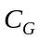; input resistance 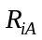; mounting parasitic capacitance 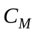; amplitude of the output voltage 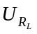 at load resistance 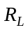; output resistance 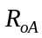; cutoff frequency 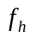 at maximum acceptable attenuation coefficient 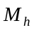; relative error 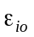 [%] defined by the input offset current and voltage; minimum value of a signal-to-noise ratio 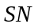. Then an electronic circuit is chosen. The basic circuit, shown on Fig. 1a, provides small input and output impedance, typically 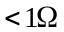. For 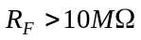 the output offset voltage caused by the input bias currents increases. For the circuit shown on Fig. 1b the output offset voltage caused by the input bias currents is less, but the offset defined by the input offset voltage is higher.
For the chosen circuit the calculations proceed according to the following formulas:
1) The VFOA is selected. The VFOA is usually precision with small input bias current (such as LF356, AD549 and ICL7611 − JFET or TLC271 and TLC272 − CMOS), high-speed VFOA (such as OPA111, LF442 or AD8605) or high-speed CFOA (for example OPA648, OPA658 or AD8001) with bandwidth higher than 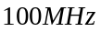. The VFOA is selected according to the following conditions:
− Maximum output voltage 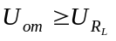 (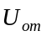 is the maximum output voltage of the VFOA);
− The power supply voltage 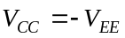 is selected higher than the maximum output voltage , as keeping the condition 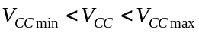;
− Maximum output current 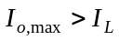, where 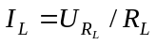;
− Small-signal bandwidth 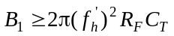, where 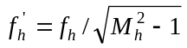, 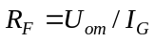 and ;
− Slew rate 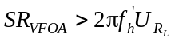.
2) The value of the feedback resistor is calculated: 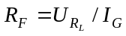.
If the resistance is more than several mega-ohms instead the circuit on Fig. 1a commonly used is the circuit on Fig. 1b. For the TIA on Fig. 1b the resistors 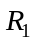 and 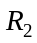 are calculated as follows: 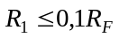, where 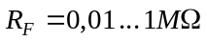 and 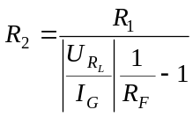.
3) The optimal value of the feedback capacitor is calculated according to Eq. (12). If the value of 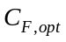 gives too much ringing in the circuit, then some overcompensation (C_{F} > C_{F,opt}) can be used to reduce the ringing. Overcompensation will, of course, reduce the bandwidth of the circuit. The formula for the cutoff frequency is calculated in step 5.
4) The input and output resistance is calculated:
;
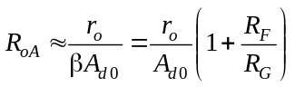,
where 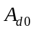 is the open-loop voltage gain, is the output resistance of the VFOA and 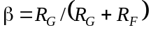.
5) The cutoff frequency at 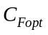 is calculated:
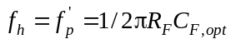.
The resulting value is compared with the value 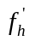 (from step 1). To meet the technical specification, the calculated value should be equal to or greater than .
6) The phase margin (PM) is calculated:
For a stable operation of the designed circuit is needed 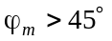.
7) The output offset voltage of the circuit is calculated: First the output offset voltage for room temperature (usually ) is calculated:
− 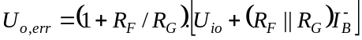 for Fig. 1a;
− for Fig. 1b.
The relative error 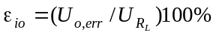 is compared with the value, given in the beginning of the procedure.
8) The signal-to-noise ratio (SN) is calculated. First the resulting noise voltage density at the TIA’s output is calculated: 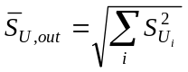for 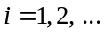,
where 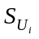 are the individual noise components.
Then the signal-to-noise ratio is 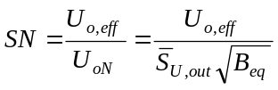, where 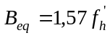 is the noise bandwidth and 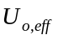 is the effective value of the output voltage.
The design procedure of the TIAs is finishing with verification check by simulations. The computer simulations by using Cadence OrCAD® covers the following steps: 1) Selection of a macro-model for an VFOA and identification of the modeled parameters; 2) Creation of a schematic for simulations by using OrCAD Capture; 3) Setting up parameters for standard and statistical analyses; 4) Performance of simulation testing; 5) Displaying and analyzing simulation results; 6) Comparison of the simulation results with the technical specification given in the beginning of the procedure; 7) Preparing of a final technical characteristic of the designed electronic circuit.
Simulation testing and analyses
To verify the theoretical analysis and the proposed procedure a high-speed TIA (Fig. 1a) was implemented with the following pre-defined parameters:
– Input source is a flux 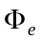, which is converted into a current by PIN photodiode BPV10 (from Vishay Semiconductors) with the following parameters: reverse dark current 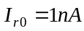 with 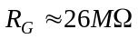; reverse light current range 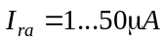; absolute spectral sensitivity 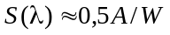 at voltage drop 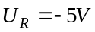 and 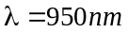; bandwidth 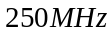; barrier capacitance 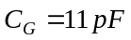 at voltage drop 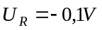, as 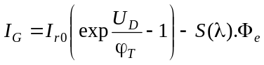, where the thermal voltage is 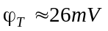 for 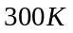;
– Electrical parameters of the TIA circuit are: 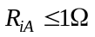; 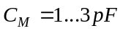; transmission coefficient – 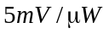; 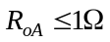; 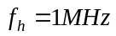 at 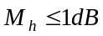; 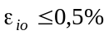 and 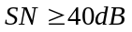;
– Electrical parameters of the load: 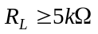.
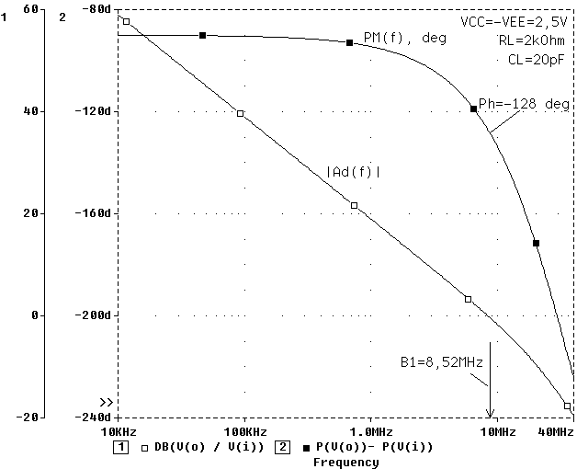
Fig. 2. Open-loop gain and phase versus frequency for the AD8605 SPICE macro-model.
The circuit is designed using VFOA AD8605 (from Analog Dev.), biased with 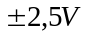 supplies. The verification check of the circuit was performed within Cadence OrCAD, using AD8605 SPICE macro-model, version 1.0 (05/2002). The modeled parameters of the AD8605 SPICE macro-model are: 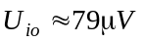, 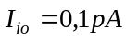, 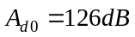, 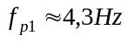, 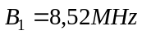, 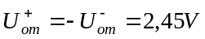, 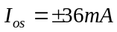, 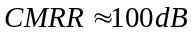, 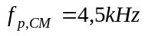, 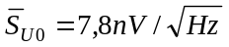, 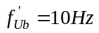, 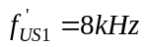, 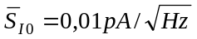, 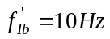, 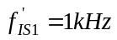, 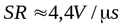, 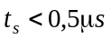 (at 0,01% peaking of the input signal) and 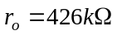 (an output impedance 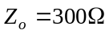 within the range from 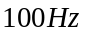 to 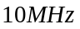). The open-loop gain and phase versus frequency of the AD8605 SPICE macro-model are shown on Fig. 2. The test circuit for simulation is created following the test conditions given in the semiconductor data books. In the frequency range up to 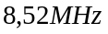 the slope of the frequency response is approximately equal to 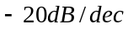 and the phase margin is larger than 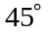. At the phase margin is 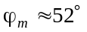. For frequencies higher than the slope of the frequency response increases and the phase shift between the input and the output signal becomes equal to at frequency approximately equal to 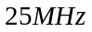. For the working frequency range up to 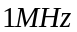 the slope is and the phase margin is 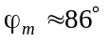, which defines a stable operation of the designed electronic circuit.
The AD8605 SPICE macro-model is not capable of simulating the temperature effects and some of the other second-order parasitic effects.
The equivalent circuit of the chosen photodiode type BPV10, used for simulations includes: ideal current source with internal differential resistance (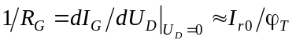) and internal capacitance . Moreover, in parallel of the capacitance is added parasitic mounting capacitance and parasitic input capacitance 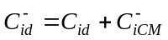 to the inverting input of the VFOA.
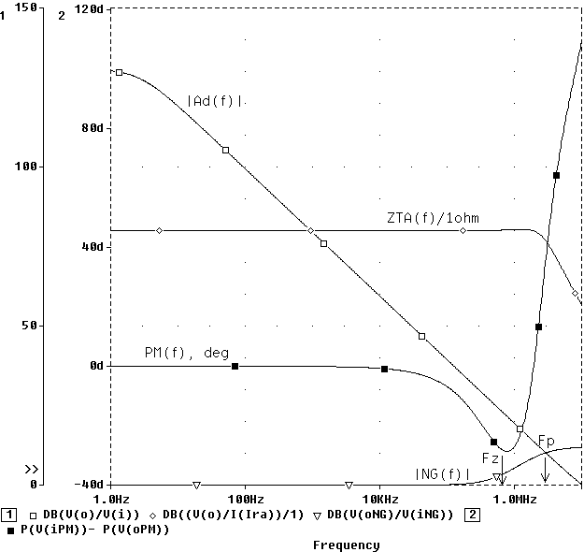
Fig. 3. Simulation results for the designed TIA at 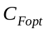.
The values of the calculated passive circuit components for the circuit shown on Fig. 1a are: 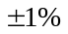 and 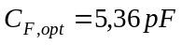 (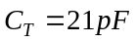, where 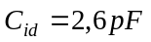 and 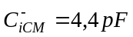 according to the data-sheet of the chosen VFOA).
For the verification check of the designed TIA DC bias point, AC analysis and Monte Carlo analysis are preformed. The AC analysis sweeps 100 points per decade from 1Hz to 10MHz and the Monte Carlo analysis is set to make a series of 100 AC analyses, while randomly varying resistor and capacitor values for each run. The simulation results within frequency range from 1Hz to 10MHz for the open-loop gain vs. frequency for the AD8605, the feedback coefficient, the phase vs. frequency and the normalized transimpedance transfer function 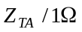 at are given on Fig. 3. The analysis of the frequency characteristics shows, that for the working frequency range up to 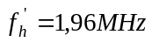 the maximum acceptable attenuation is not greater than 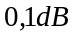. Accordingly, the phase shift is significantly larger than . At 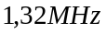 is obtained a spike (ripple) with value equal to 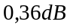 (in comparison with the normalized transimpedance equal to 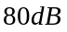), but this value is less than the specified frequency attenuation (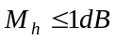). At frequency 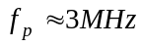, where the – function intersect the frequency response of the VFOA the phase margin of the circuit is equal to 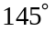, which guarantee the stable operation of the designed TIA.
Based on analysis of the obtained results in Table 1 the calculated parameters and the simulation results for the designed circuit are presented. The maximum error between calculated values of the electrical parameters and simulation results is not higher than 5…6%. Moreover, an error of 5…6% is quite acceptable considering the tolerances of the technological parameters.
Table 1
Comparison between calculated parameters and simulation results.
Parameter | Calculated results | Simulation results
Z_{TIA} | 10kΩ | 10kΩ
f_{h} | 2,54MHz | 2,47MHz_{(min)} … 2,52MHz_{(max)}
U_{om} | 10mV_{(min)} … 500mV_{(max)} | 10mV_{(min)} … 500mV_{(max)}
f’_{h} | ≈ 2MHz at M_{h}=1dB | 2,06MHz_{(min)} … 2,09MHz_{(max)} at M_{h}=0,1dB
Ripple | - | 0,36dB at 1,32MHz
R_{iA} / R_{oA} | ≈ 5mΩ / 200mΩ | ≈ 5mΩ / 210mΩ
ϕ_{m} | ≈ 147º | ≈ 145º
U_{o,err} / ε_{io} | 78,94μV / 0,15% | 78,94μV / 0,15%
U_{oN} | 24,9μV | 25,1μV
U_{o,eff} / SN | ≈ 7mV / 49,07dB | ≈ 7mV / 49,02dB

Conclusion
A design procedure of high-speed TIA circuits using VFOAs have been presented. The efficiency of the procedure is demonstrated by design and verifycation of concrete electronic circuits using VFOA AD8605. The created approach can be useful for analysis and design of various electronic circuits and systems, such as photodiode amplifiers, luxmeters and I/V converters for digital-to-analog converters.
REFERENCES
- Tietze, V., Ch. Schenk. Electronic circuits. 2nd Edition. New York. Springer-Verlag, 2008.
- Texas I. Photodiode monitoring with op amps. SBOA035, http://www.ti.com /lit/an/sboa035/sboa035.pdf, last accessed March 10, 2013.
- Transimpedance Photodiode Amplifier, http://www.jensign.com/trans-impedanceamp/index.html, last accessed March 10, 2013.
- Pachchigar, M. Design considerations for transimpedance amplifier, AN-1803, National Semi., 2008.
- Westerman, D. Understanding and apply the transimpedance amplifier, EE Times-India, 2007.
- Asparuhova, K., T. Djamiykov. Design of transimpedance amplifiers. Annual Journal of Electronics, vol. 5, No 1, pp. 55-58, 2011.
- Aznar, F., W. Gaber, H. Zimmermann. A 0.18 mm CMOS transimpedance amplifier with 26dB dynamic range at 2.5Gb/s. Microelectronics Journal, vol. 42, pp. 1136–1142, 2011.

Ivailo Pandiev received his M.Sc and Ph.D. degrees in Electronic Engineering from Technical University of Sofia, Bulgaria, in 1996 and 2000, respectively. He is currently an associate professor in the Department of Electronics at the TU-Sofia. His research interests include analysis and design of analog and mixed-signal circuits and systems.
tel.: 02 965 3027. е-mail: ipandiev@tu-sofia.bg.

