NLP-Based Sentiment Analysis of Product Reviews Using TF-IDF and Machine Learning
Mini NLP Project Report

Submitted by:
Name: Hima Joy
Register No.:24UBC231
Class: III BCA B
Course: Natural Language Processing
Academic Year:2024-2028

- Introduction
Sentiment analysis is an important application of Natural Language Processing (NLP) that is used to identify the emotional tone or opinion expressed in textual data. It is commonly used to classify text into categories such as positive, negative, or neutral.
With the rapid growth of online shopping, customers provide a large number of product reviews describing their experiences with products. These reviews contain valuable information about customer satisfaction, product quality, and user opinions. However, manually analyzing a large number of reviews can be time-consuming and difficult.
This project develops an NLP-based sentiment analysis system for product reviews. The system automatically classifies product reviews into Positive and Negative sentiment categories. The project uses text preprocessing to clean the reviews, TF-IDF (Term Frequency-Inverse Document Frequency) to convert textual data into numerical features, and Logistic Regression as the machine-learning classification algorithm.
A simple Streamlit web application was also developed to allow users to enter a product review and receive a predicted sentiment.
The selected problem is directly relevant to NLP because the input is unstructured human language and the system needs to process and classify the meaning expressed in the text. Sentiment analysis of product reviews is also one of the example project areas listed in the assignment.

- Problem Statement
Online shopping platforms contain thousands of product reviews written by customers. These reviews provide useful information about customer experiences, but manually reading and analyzing every review is inefficient and time-consuming.
The problem addressed in this project is to develop an automated system that can analyze the text of product reviews and classify them into Positive or Negative sentiment categories.
The proposed system uses NLP techniques to preprocess the review text, extract meaningful numerical features using TF-IDF, and classify the reviews using a machine-learning model.
The main problem can therefore be stated as:
To develop an NLP-based machine-learning system that automatically classifies product reviews as Positive or Negative based on the textual content of the reviews.
The assignment requires the selected project to clearly identify the NLP problem, explain its relevance, identify the data, describe the NLP techniques used, and specify the output generated by the system.

- Objectives
The main objectives of this project are:
- To develop a sentiment analysis system for product reviews using Natural Language Processing.
- To collect and prepare a suitable product-review dataset.
- To analyze the structure and distribution of the review dataset.
- To clean and preprocess the textual reviews by removing unnecessary information.
- To convert textual reviews into numerical features using the TF-IDF technique.
- To divide the dataset into training and testing data.
- To train a Logistic Regression machine-learning model for sentiment classification.
- To predict whether new product reviews are Positive or Negative.
- To evaluate the performance of the classification model using accuracy, precision, recall, and F1-score.
- To visualize the classification performance using a confusion matrix.
- To develop a simple Streamlit-based application for real-time sentiment prediction.
- To analyze the limitations of the developed system and identify possible future improvements.

- Dataset
- Dataset Name
Indian Products on Amazon
- Dataset Source
The dataset was obtained from Kaggle and contains customer reviews of products available on Amazon.
- Dataset Description
The dataset consists of product-review information, including customer ratings and textual reviews. The rating values range from 1 to 5, where lower ratings generally indicate dissatisfaction and higher ratings indicate satisfaction.
For this project, the rating information was used to create the sentiment classes.
The data preparation process classified:
- 1 and 2-star ratings → Negative
- 4 and 5-star ratings → Positive
- 3-star ratings → Removed, because they represent a neutral or mixed opinion and the project focuses on binary sentiment classification.
- Original Dataset Size
    - The original dataset contained:
    - 2,782 reviews
    - The rating distribution obtained during dataset analysis was:

Rating | Number of Reviews
1 | 546
2 | 130
3 | 198
4 | 464
5 | 1,444

- Data Cleaning
Several cleaning operations were performed before model training.
- Missing Values
There were 6 missing values in the review column.

These missing reviews were removed because text is required for sentiment analysis.
- Duplicate Reviews
The dataset contained 1,522 duplicate reviews. Duplicate entries were removed to reduce repetition and prevent duplicated text from affecting the model.
- Neutral Reviews
The 198 three-star reviews were removed because the project performs binary sentiment classification rather than positive/neutral/negative classification.
- Empty Reviews
After text preprocessing, 5 reviews became empty because all their usable content was removed during cleaning. These reviews were also removed.

- Final Dataset
After all the cleaning and preprocessing operations, the final dataset contained:
1,051 reviews
The final sentiment distribution was:
Sentiment | Number of Reviews
Positive | 763
Negative | 288
Total | 1,051

The final dataset contains more positive reviews than negative reviews. Therefore, the dataset is somewhat imbalanced toward the Positive class.

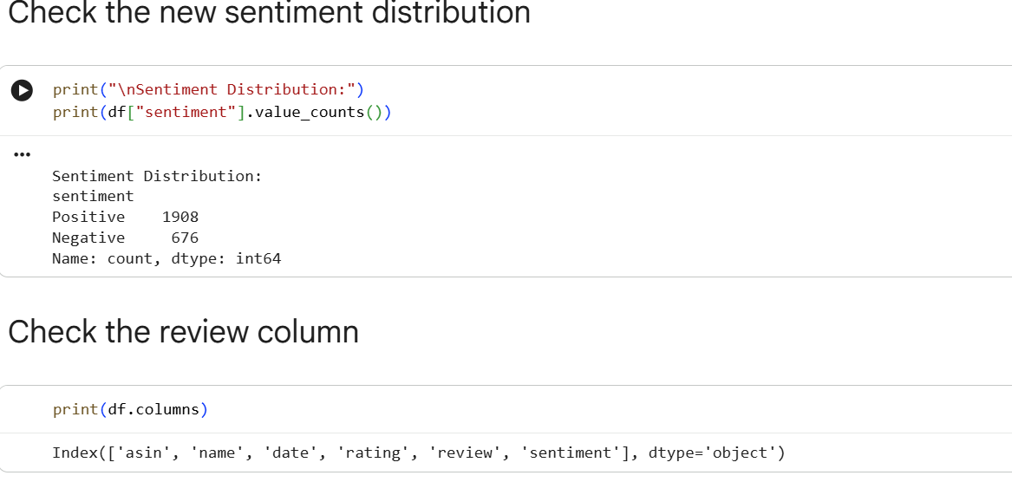

- Methodology
The overall methodology used in the project is:
Product Review Dataset
↓
Data Understanding
↓
Data Cleaning
↓
Text Preprocessing
↓
Train-Test Split
↓
TF-IDF Feature Extraction
↓
Logistic Regression
↓
Sentiment Prediction
↓
Model Evaluation
↓
Streamlit Application

- Data Preprocessing
Text preprocessing is an important step in NLP because raw text often contains unnecessary characters, inconsistent capitalization, URLs, punctuation, and common words.
The following preprocessing operations were performed.
- Convert Text to Lowercase
All review text was converted to lowercase.
For example:
"This Product Is GOOD"
becomes:
"this product is good"
This ensures that words with different capitalization are treated consistently.
- Remove URLs
URLs and web links were removed because they are generally not useful for determining the sentiment of the review.
- Remove Punctuation and Special Characters
Punctuation marks and unnecessary special characters were removed from the reviews.
For example:
"Very good!!! Product @ Amazon"
is cleaned into text containing only relevant words.
- Remove Extra Spaces
Extra spaces were removed to produce clean and consistent text.
- Stopword Removal
Common English stopwords were removed using the NLTK stopword list.
However, important negative words such as:
- not
- no
- nor
- never
were retained because they can significantly affect sentiment.
For example:
"not good"
has a different sentiment from:
"good"
Therefore, removing important negative words could reduce sentiment classification quality.
- Remove Empty Reviews
After preprocessing, 5 reviews contained no usable text. These records were removed.

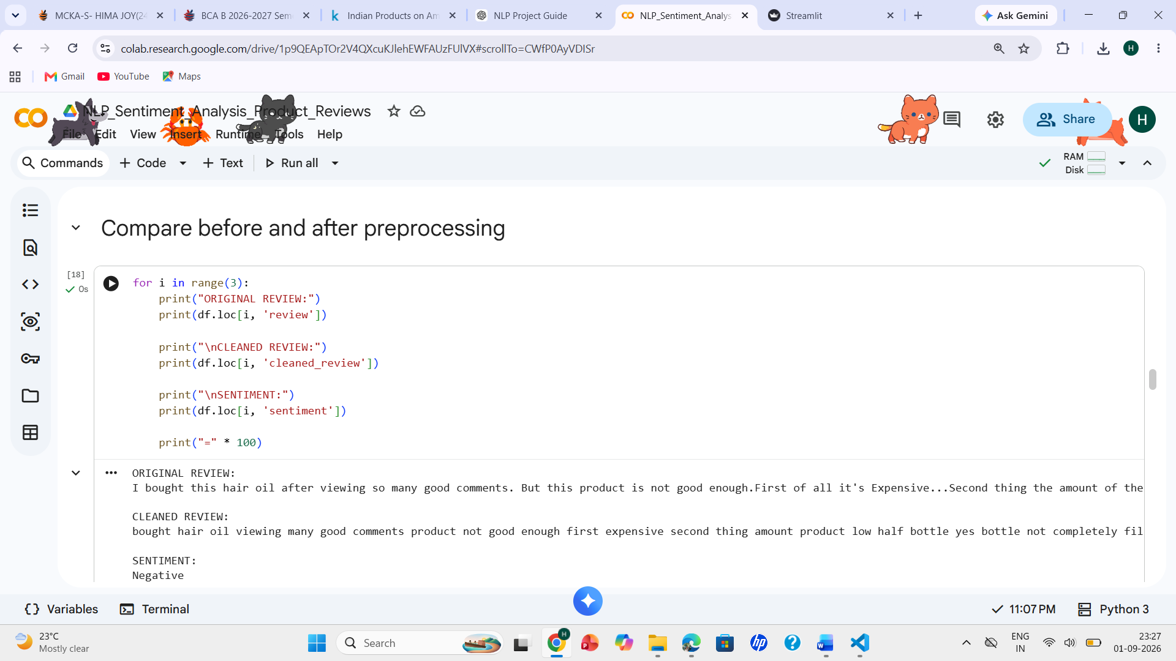

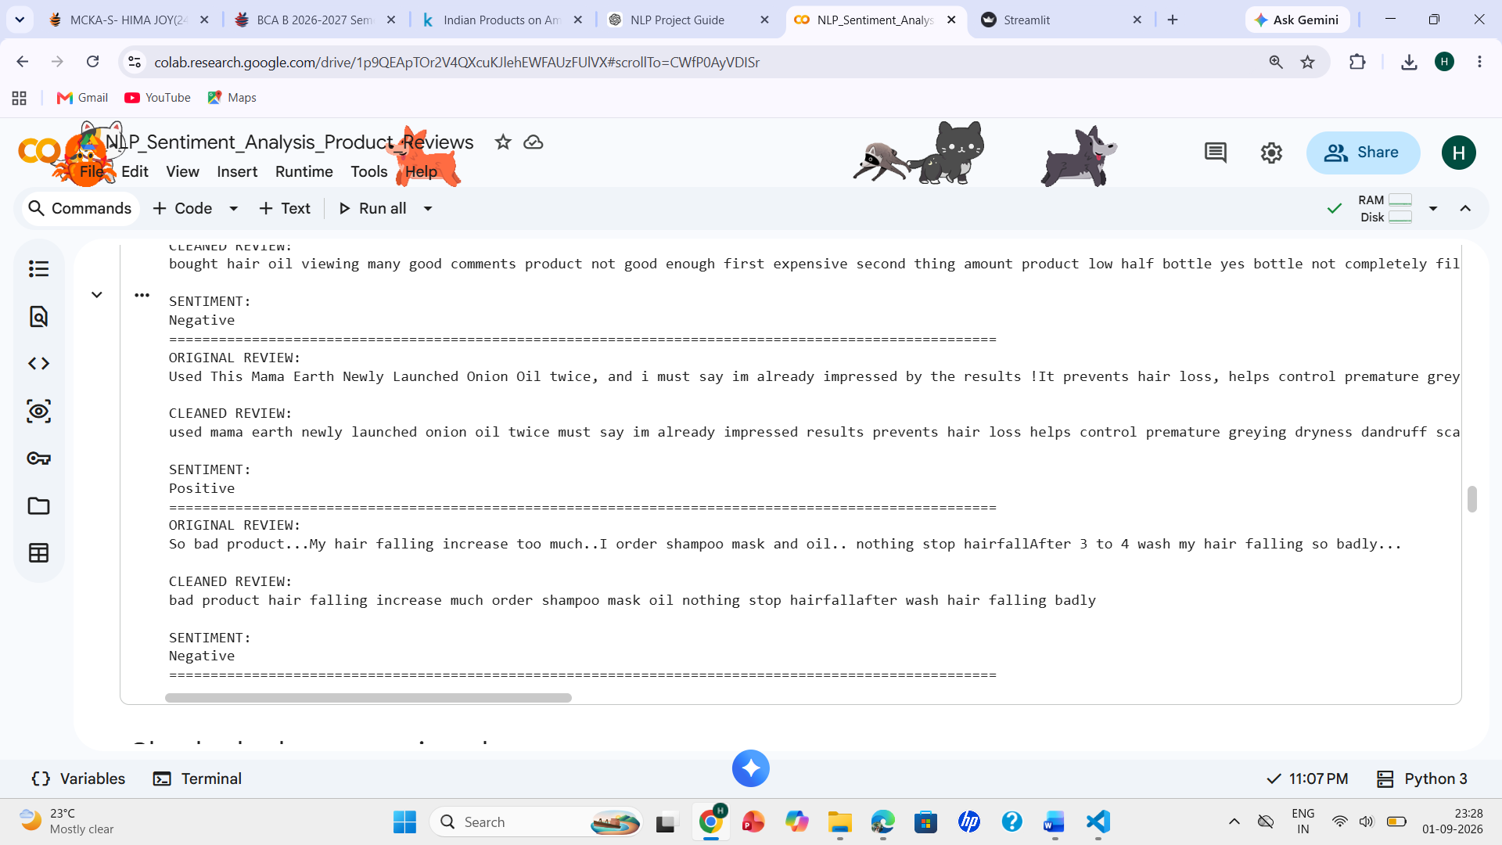

- Train-Test Split
After preprocessing, the dataset contained 1,051 reviews.
The dataset was divided into:
- 80% training data
- 20% testing data
The resulting split was:
Dataset | Number of Reviews
Training | 840
Testing | 211
Total | 1,051

The train_test_split() function from Scikit-learn was used.
A random_state value of 42 was used to make the experiment reproducible.
The stratify=y parameter was used so that the Positive and Negative class proportions were maintained approximately in both training and testing sets.
- TF-IDF Feature Extraction
- What is TF-IDF?
TF-IDF stands for Term Frequency-Inverse Document Frequency.
Machine-learning algorithms cannot directly process raw text. Therefore, the textual reviews must be converted into numerical features.
TF-IDF assigns a numerical importance value to words based on their occurrence in a document and their frequency across the collection of documents.
The basic idea is:
- A word occurring frequently in a particular review can be important to that review.
- A word occurring in almost every review is less useful for distinguishing between reviews.
Therefore, TF-IDF helps identify words and phrases that are more informative for classification.
- TF-IDF Configuration
The project used:
TfidfVectorizer( max_features=5000, ngram_range=(1, 2))
The maximum number of features was set to:
5,000
The ngram_range=(1,2) means that both:
- Unigrams — individual words
- Bigrams — two-word combinations
were considered.

Examples:
good
excellent
product
are unigrams.

Examples:
good product
very good
waste money
are bigrams.

Using bigrams can help the model understand useful combinations of words in sentiment analysis.

- TF-IDF Results
The resulting feature matrices were:

Training TF-IDF shape: (840, 5000)
Testing TF-IDF shape: (211, 5000)

This means each of the 840 training reviews was represented using 5,000 numerical features, and each of the 211 testing reviews was represented using the same 5,000-feature representation.
The TF-IDF vectorizer was fitted only on the training data and then used to transform the testing data. This prevents information from the test set from influencing the feature-learning process.

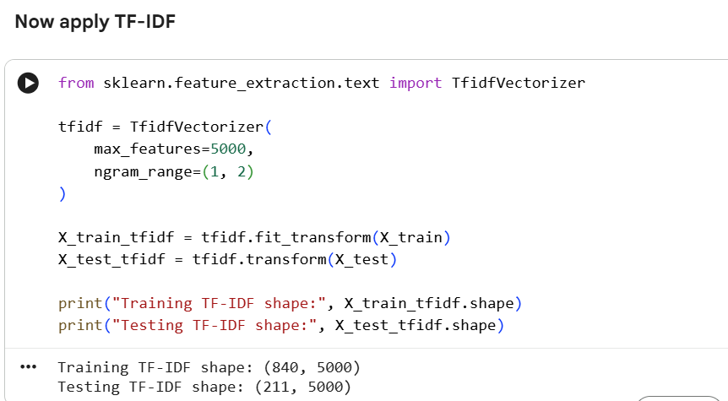

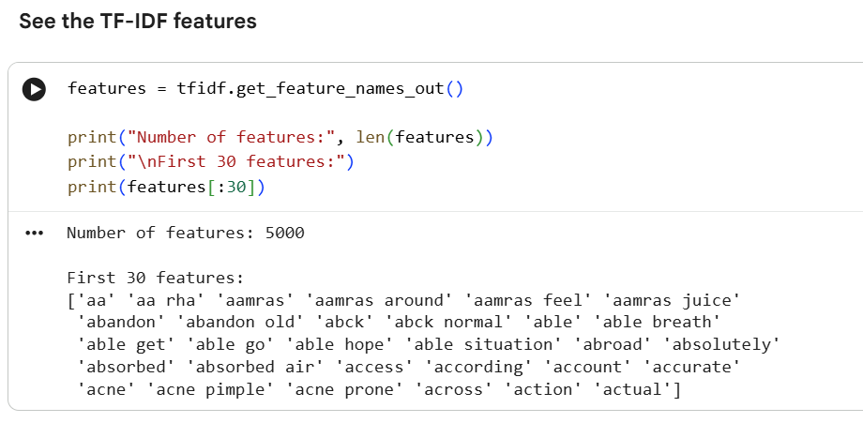

- Machine Learning Model

- Logistic Regression
The machine-learning algorithm selected for this project is Logistic Regression.
Logistic Regression is a supervised machine-learning classification algorithm that can be used to predict the class of an input based on its features.
In this project, the input features are the numerical TF-IDF representations of product reviews, and the output classes are:
Positive
Negative

- Why Logistic Regression?
Logistic Regression was selected because:
- It is suitable for binary classification.
- It works well with high-dimensional numerical features such as TF-IDF.
- It is computationally efficient.
- It is relatively simple to understand and explain.
- It provides a strong baseline for text classification.
- It is suitable for the size of the dataset used in this project.
The assignment specifically lists Logistic Regression among the suitable machine-learning algorithms for NLP projects and emphasizes that a simple, well-understood model is preferable to a complex model that the student cannot explain.

- Model Training
The Logistic Regression model was trained using the TF-IDF features of the training reviews.

The model was configured using:
LogisticRegression(max_iter=1000)

The training process can be represented as:

Training Reviews
↓
TF-IDF Transformation
↓
5,000 Numerical Features
↓
Logistic Regression
↓
Trained Classification Model

After training, the model was used to predict the sentiment of the 211 unseen testing reviews.

- Sentiment Prediction
The trained model predicts one of two classes:
Positive
Negative
For a new review, the application first performs the same preprocessing used during training.

The cleaned review is then transformed using the saved TF-IDF vectorizer.
Finally, the trained Logistic Regression model predicts the sentiment.

The process is:
New Product Review
↓
Preprocessing
↓
TF-IDF Transformation
↓
Logistic Regression
↓
Positive / Negative

- Model Evaluation
The model was evaluated using:
- Accuracy
- Precision
- Recall
- F1-score
- Confusion Matrix

These are appropriate evaluation measures for a binary classification problem, and the assignment specifically recommends these measures for classification projects.

- Accuracy
The model achieved:
Accuracy = 85.31%

The decimal value obtained was:
0.8530805687203792

Accuracy represents the proportion of test reviews that were classified correctly.

Therefore, the model correctly classified approximately 85.31% of the 211 test reviews.

- Classification Report
The classification report obtained from the model is:

Class | Precision | Recall | F1-score | Support
Negative | 0.97 | 0.48 | 0.64 | 58
Positive | 0.84 | 0.99 | 0.91 | 153
Accuracy |  |  | 0.85 | 211
Macro Average | 0.90 | 0.74 | 0.78 | 211
Weighted Average | 0.87 | 0.85 | 0.83 | 211

Precision
Precision indicates how many of the reviews predicted as a particular class actually belonged to that class.
For Negative reviews, the precision was 0.97, meaning that predictions classified as Negative were highly reliable.
For Positive reviews, the precision was 0.84.

Recall
Recall indicates how many of the actual reviews belonging to a class were correctly identified.
The Negative recall was 0.48, while the Positive recall was 0.99.
Therefore, the model identified almost all of the actual Positive reviews but missed a number of actual Negative reviews.

F1-score
F1-score combines precision and recall into a single measure.
The Positive class achieved an F1-score of 0.91, while the Negative class achieved an F1-score of 0.64.

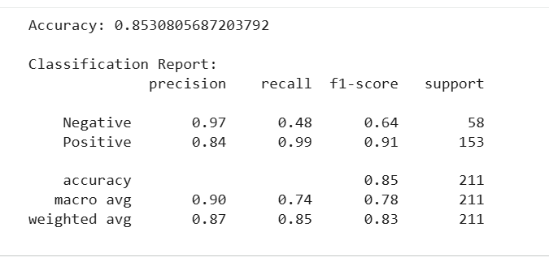

- Confusion Matrix
A confusion matrix was used to visualize the model's classification performance.

The confusion matrix compares:
- Actual sentiment
- Predicted sentiment

It shows how many reviews were correctly classified and how many were misclassified.

The confusion matrix is particularly useful for this project because the classification performance differs between Positive and Negative reviews.
Interpretation

The model performs strongly on Positive reviews, which is consistent with the 99% recall for the Positive class.
However, the lower 48% recall for Negative reviews indicates that several actual Negative reviews were classified as Positive.
This result is likely influenced by the imbalance in the final dataset, where there are:
- 763 Positive reviews
- 288 Negative reviews

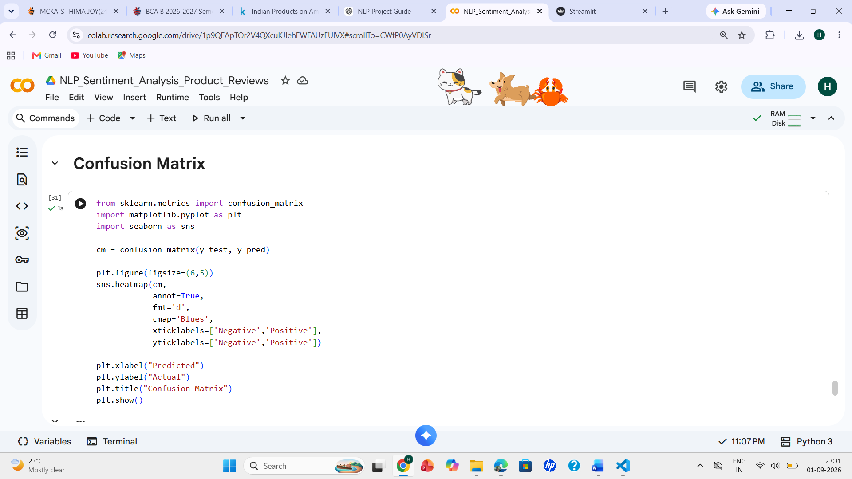

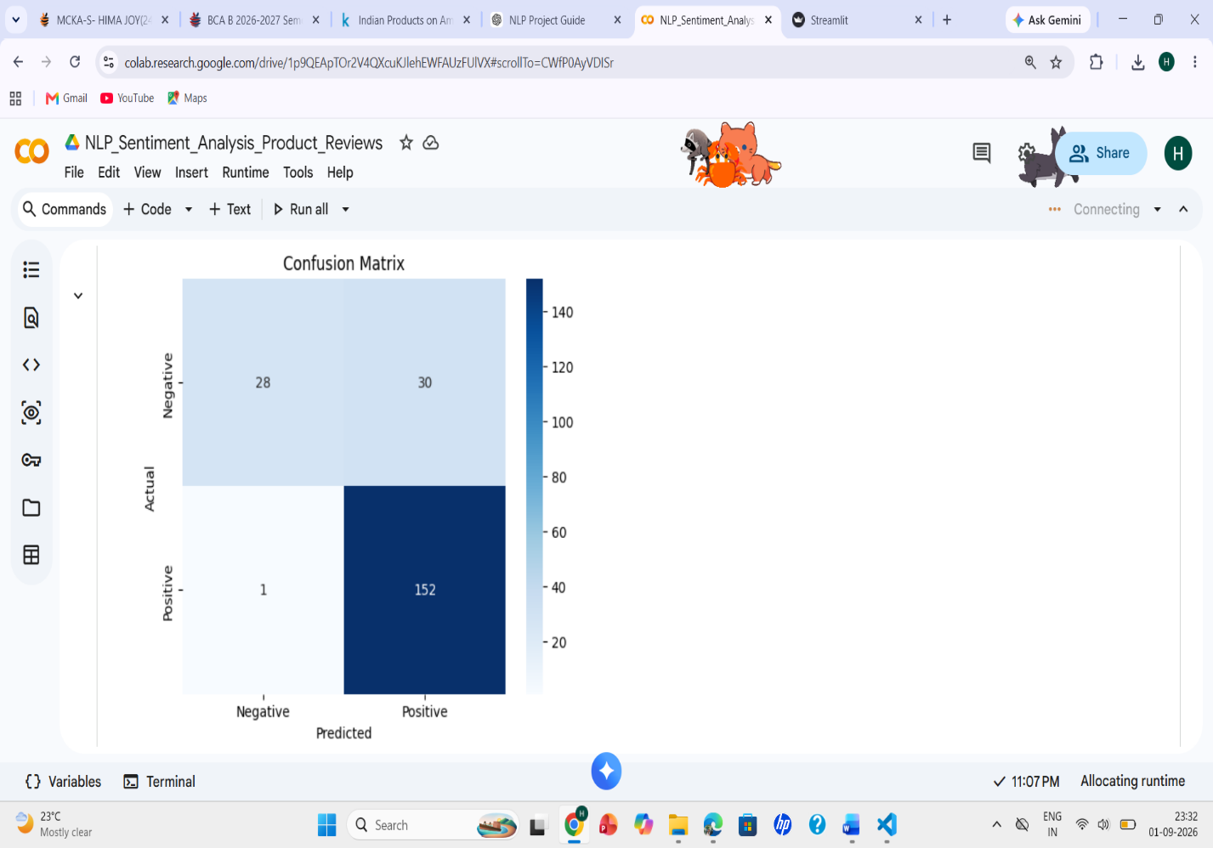
- Results and Discussion
The developed sentiment analysis model achieved an overall accuracy of 85.31% on the test dataset.

The results show that the model performs particularly well in identifying Positive reviews. The Positive class achieved:

- Precision: 84%
- Recall: 99%
- F1-score: 91%
The Negative class achieved:

- Precision: 97%
- Recall: 48%
- F1-score: 64%

The high Negative precision means that when the model predicts a review as Negative, the prediction is usually correct. However, the lower Negative recall means that the model fails to identify some reviews that are actually Negative.

The model's strong Positive recall is useful because it can identify almost all positive reviews in the test set. However, improving the detection of negative reviews would be an important area for future improvement.

Overall, the result of 85.31% accuracy demonstrates that TF-IDF combined with Logistic Regression can be used as an effective baseline approach for product-review sentiment classification.

- Working Application
A simple web-based application was developed using Streamlit.
The application allows a user to enter a product review into a text box.

The application then:
- Receives the user's review.
- Converts the review to lowercase.
- Removes unnecessary characters and URLs.
- Removes stopwords while retaining important negative words.
- Converts the cleaned review into TF-IDF features.
- Passes the features to the trained Logistic Regression model.
- Displays the predicted sentiment.

The output is displayed as either:

POSITIVE
or
NEGATIVE

The trained Logistic Regression model and TF-IDF vectorizer were saved using joblib so that they could be loaded by the application.

- Application Screenshots
- Streamlit Application

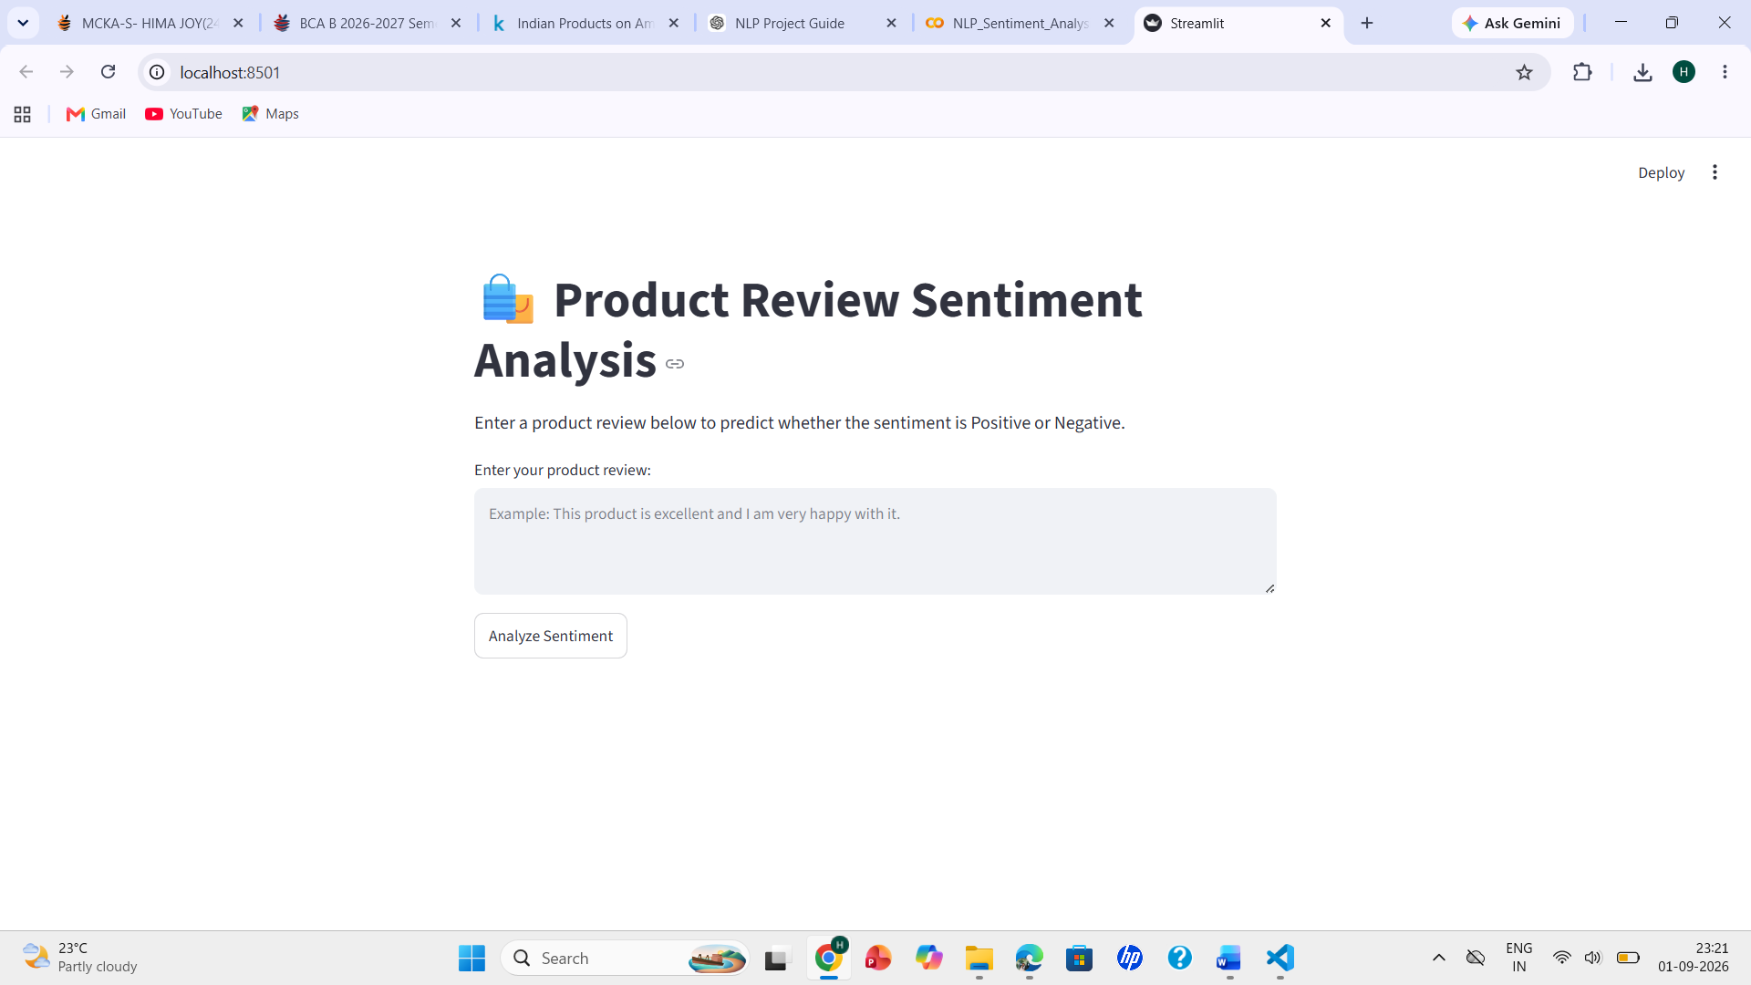

- Positive Prediction
A sample positive review was entered into the application.
Example:
"This product is excellent. The quality is very good and I am extremely happy with my purchase."
The application predicts:
Sentiment: POSITIVE
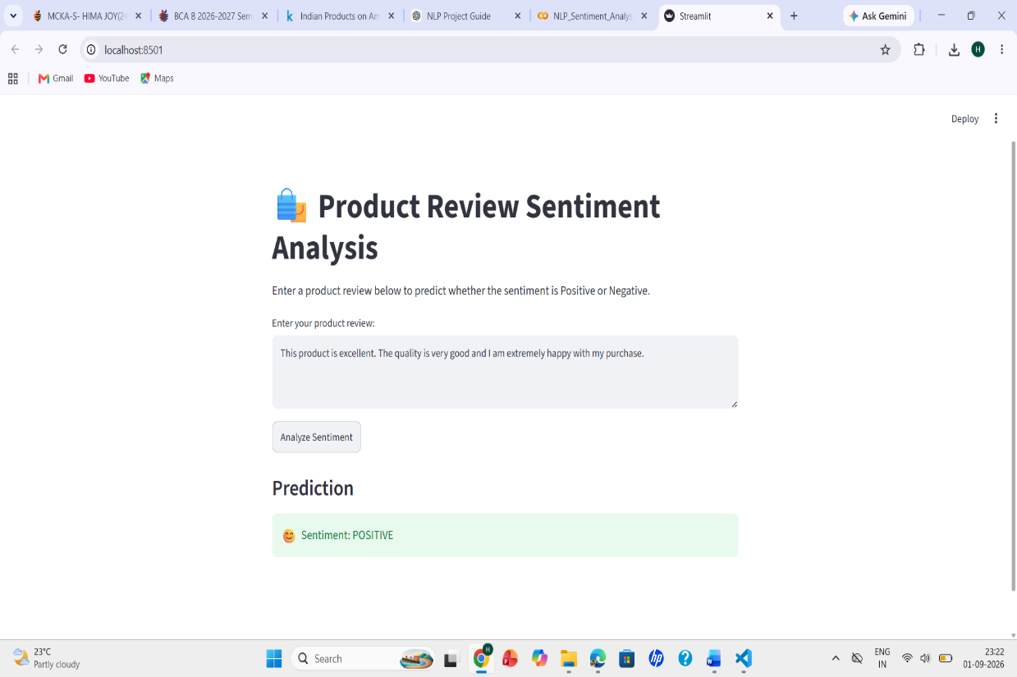
- Negative Prediction
A sample negative review was entered into the application.
Example:
"This product is very bad. The quality is poor and I am not satisfied with my purchase."
The application predicts:
Sentiment: NEGATIVE
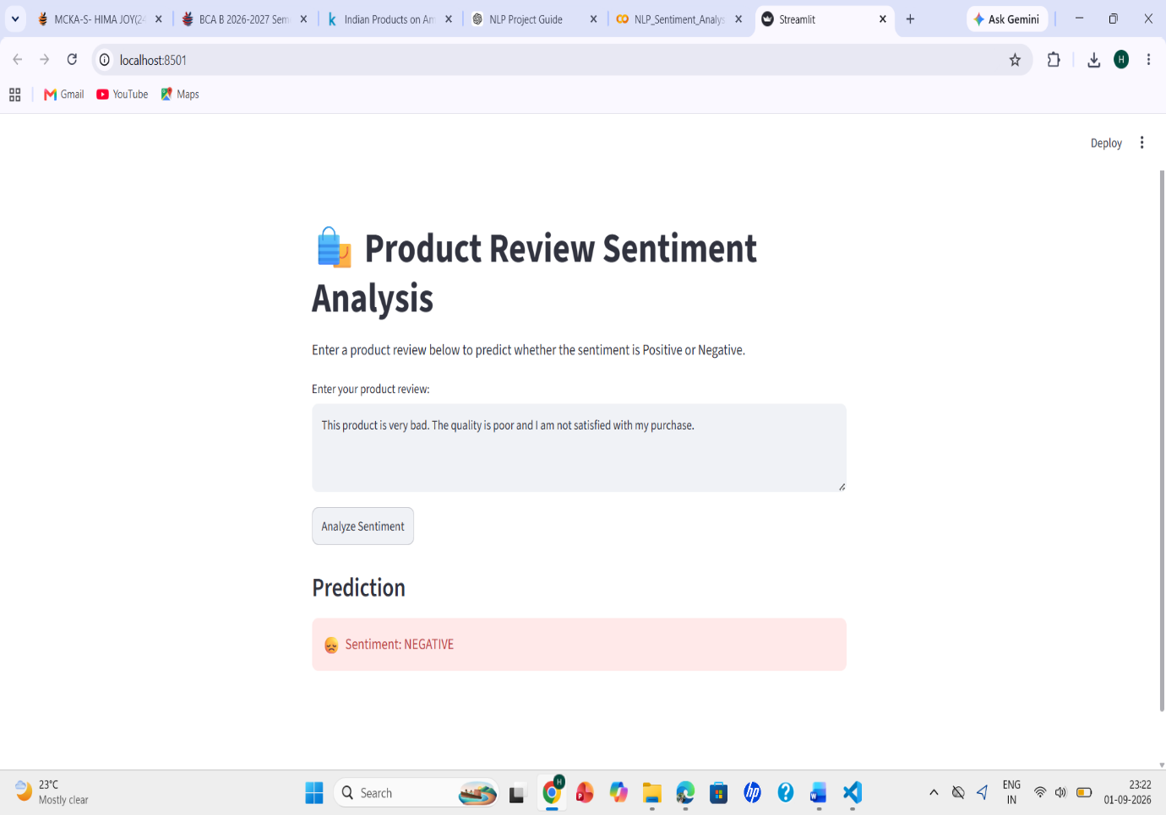

- Technologies Used
The following technologies and libraries were used:

Technology/Library | Purpose
Python | Programming language
Pandas | Dataset handling and analysis
NumPy | Numerical operations
NLTK | Natural Language Processing and stopword processing
Scikit-learn | TF-IDF, train-test split, Logistic Regression and evaluation
Matplotlib | Visualization
Seaborn | Confusion matrix visualization
Joblib | Saving and loading trained model/vectorizer
Streamlit | Development of the web application
Google Colab | Model development and experimentation
VS Code | Application development

- System Requirements
Hardware Requirements
- Computer or laptop
- Minimum 4 GB RAM
- Internet connection for dataset download and library installation
- Basic processor capable of running Python and Streamlit

Software Requirements
- Python 3.x
  - Google Colab or Jupyter Notebook
  - VS Code or another Python IDE
  - Required Python libraries
  - Web browser
  - Streamlit

- Limitations
Although the developed system provides good overall performance, it has some limitations.
- Dataset Imbalance
The final dataset contains significantly more Positive reviews than Negative reviews.
There are:
763 Positive reviews
and:
288 Negative reviews
This imbalance may cause the model to favor the Positive class.
This can be seen from the evaluation results, where Positive recall is 99%, while Negative recall is only 48%.
- Limited Dataset Size
The final dataset contains 1,051 reviews, which is relatively small for a general-purpose sentiment analysis system.
A larger dataset could provide more examples and potentially improve generalization.
- Difficulty with Sarcasm
Traditional TF-IDF-based models may have difficulty understanding sarcasm, irony, humor, or indirect expressions.
For example, a sentence may contain positive words but actually express a negative opinion.
- Context Understanding
TF-IDF mainly represents words and short word combinations as numerical features. It does not fully understand the deeper context or meaning of a sentence.
- Domain Specificity
The dataset is based on product reviews, so the model may not perform equally well on other types of text such as news articles, social-media posts, or formal documents.
- Incorrect Predictions
Like any machine-learning classifier, the system can produce incorrect predictions, especially for reviews containing unusual wording, mixed opinions, sarcasm, or vocabulary that was not sufficiently represented in the training data.

- Future Scope
The project can be improved in several ways.
- Larger Dataset
A larger and more balanced dataset can be used to improve the reliability and generalization of the model.
- Better Class Balance
Techniques such as class weighting, oversampling, or collecting additional Negative reviews could be explored to improve Negative sentiment recall.
- Comparison of Multiple Models
Future work can compare Logistic Regression with:
- Naive Bayes
- Support Vector Machine
- Random Forest
- Other suitable classification algorithms
This could help identify the best-performing model.
- Advanced NLP Models
More advanced NLP and deep-learning approaches such as:
- LSTM
- GRU
- CNN for text
- Transformer-based models
- BERT
could be explored for better contextual understanding.
The assignment also lists RNN, LSTM, GRU, CNN, Transformers and BERT among possible advanced approaches.
- Multilingual Sentiment Analysis
The system could be extended to support multiple languages, allowing reviews written in languages other than English to be analyzed.
- Real-Time Deployment
The Streamlit application could be deployed online so that users can access the sentiment analysis system through a web browser.
- Improved User Interface
The application could be enhanced by displaying:
- Prediction probability
- Confidence score
- Review history
- Sentiment charts
- Positive/negative word analysis
- Aspect-Based Sentiment Analysis
Future versions could identify sentiment about specific product aspects such as:
- Price
- Quality
- Packaging
- Delivery
- Customer service
For example, a review could be classified as:
Quality → Positive
Price → Negative
Delivery → Positive
This would provide more detailed information than simple Positive/Negative classification.

- Conclusion
This project successfully developed an NLP-Based Sentiment Analysis System for Product Reviews using TF-IDF and Logistic Regression.
The project began with a product-review dataset containing 2,782 reviews. Data cleaning and preprocessing were performed by removing three-star reviews, missing reviews, duplicate reviews, and empty reviews generated after preprocessing. After cleaning, 1,051 reviews remained, consisting of 763 Positive and 288 Negative reviews.
The dataset was divided into 840 training reviews and 211 testing reviews. TF-IDF was then used to convert the textual reviews into numerical features using a maximum of 5,000 features with unigram and bigram representation.
A Logistic Regression classifier was trained using the TF-IDF features. The model achieved an overall accuracy of 85.31% on the testing dataset.
The evaluation showed that the model performed particularly well for Positive reviews, achieving a 99% recall and 91% F1-score. However, the Negative class had a lower recall of 48%, indicating that improving the detection of negative reviews is an important area for future work.
Finally, a Streamlit web application was developed to demonstrate the practical use of the trained model. The application accepts a product review from the user and predicts whether the review expresses a Positive or Negative sentiment.
Overall, the project demonstrates how NLP and machine-learning techniques can be combined to automatically analyze customer opinions from product reviews. It also provides a practical foundation for developing more advanced sentiment analysis systems in the future.

