

Lecture Name : Mr.pramudya Thilakarathne

Module Code : CS107.3

**Group Members**

|  |  |
| --- | --- |
| Member Name | Member index |
| W.H.P.Fernando | 24032 |
| M.V.D.Rajakaruna | 24712 |
| G.M.D.H.V.Gamlath | 24536 |
| P.S.M.Niranjana | 24581 |
| P.K.P.Sandamal | 24479 |
| H.P.A.Gunarathna | 20985 |

**Introduction**

Care + is a virtual pharmacy. It is a little bit larger, and several workers work there. Currently all the data such as medicines, employee details are stored in a manual database. As the result of this the employees who work care+ have to face so many difficulties. Such as, Difficult to update current stock, difficult to find medicine information, need more physical space for store data, has to protect books from insects . Because of these reasons employees request for purchase an automated system to do these works more efficiency. So, owner of care+ Mr.David hand over this project for us. Still, we are undergraduate students of NSBM Green University and our group members accepted to do this with 1 month time period. To do this we choose C# language under C#.Net framework. At the same time we choose Microsoft SQL for attaching backend database with this application. The main Purpose of this application is increasing the efficiency of pharmacy and save time. The application which is made by us can handling all the transaction, getting details about stock in, stockout and expired drugs and manipulate entire process until sold something for customer. This application helps to handle all the things which are related to the Care+ Pharmacy. We hope all problems will be sorted because of this application.

**Planning**

Before beginning the project, our team discuss with the owner of Care+ and some of employees of Care+. Here we follow data gathering techniques such as interviews and questionnaires. Mainly we gather data using interviews. Here we interview two employees individually and collect data. According to requirements of Care+ we built ER-Diagram. In the beginning we don’t have completed idea about flow of this application. Since time by time all the members of our team gave their suggestion to complete diagram.

In here mainly we focused about starting forms of application. So, we add login form for accessing application. Once the user enters correct credential then he/she redirects into dashboard form. In there user can add account, remover account, do transactions, check stock, handle stock and more. Further all the things which are related to the Care+ stored in backend database. Once user do some changes then those things will appear on related database.

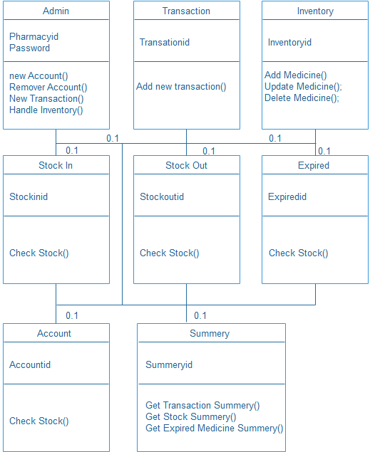

**Class Diagram**

**Er-Diagram**

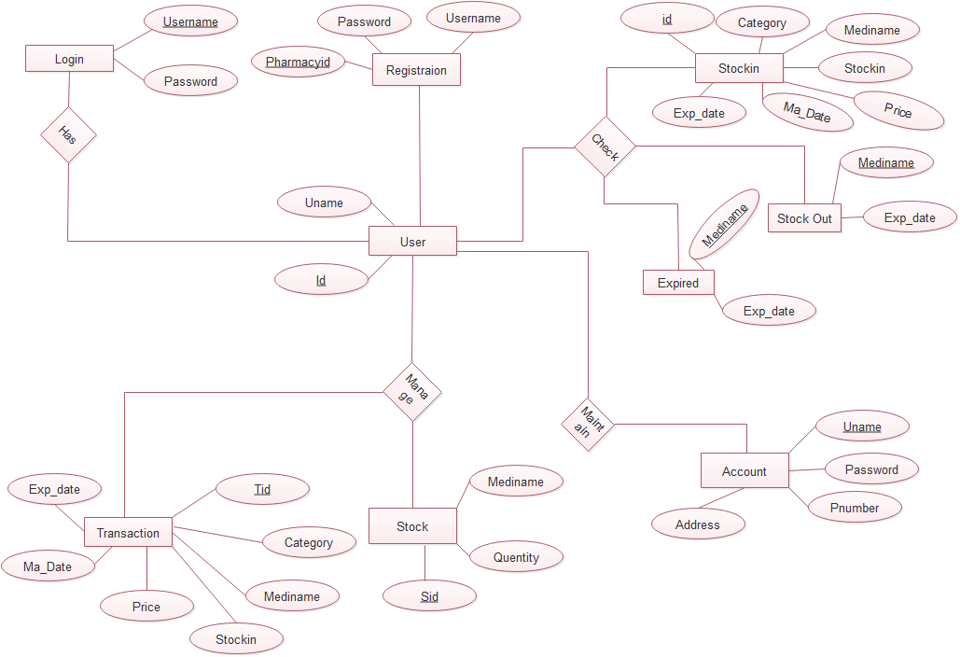

**Use-Case Diagram**

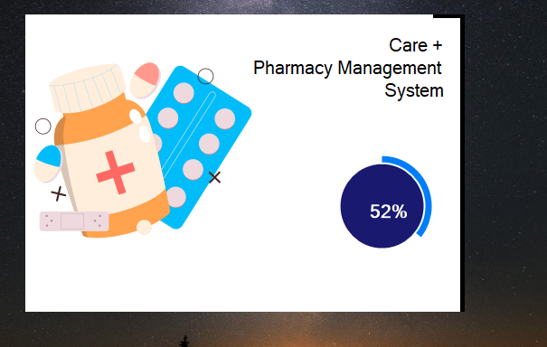

**Loading Form**

* Above Form is the loading form of Care+ Pharmacy Management System.
* Here We used Guna Framework for adding circle progress bar.
* Once the completed progress bar it redirects into login form.

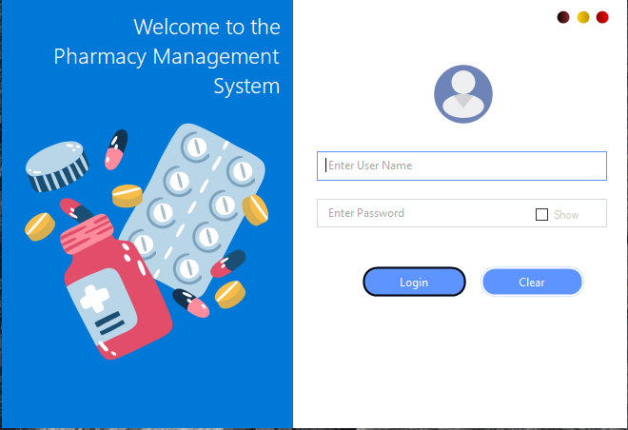

**Login Form**

* Once user enters the username and password then system check whether it matches with database credentials.
* If it is match with database table credentials, login form redirects into dashboard. Otherwise, it will Show Error message.

**Dashboard** Form

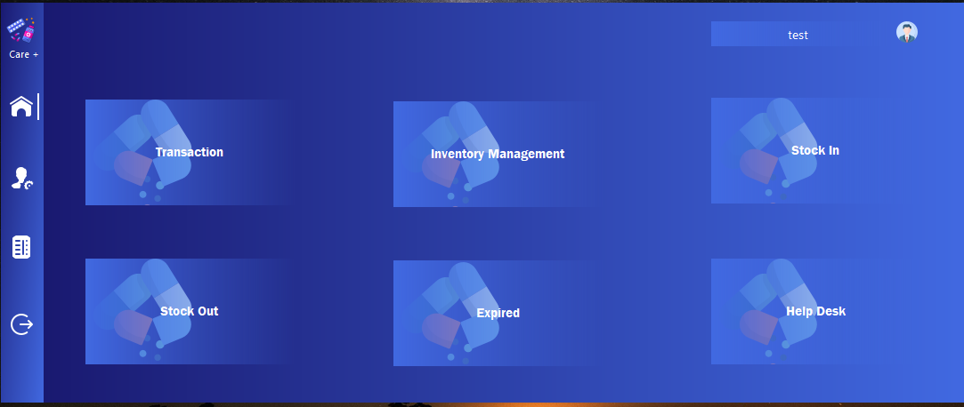

* This is dashboard form of Care+ pharmacy Management System. Here user can handle entire system.
* Transaction is the button which helps to do all the transaction.
* Inventory Management is button which helps to add, update, delete stock.
* Stock in uses to check all the stock which is currently use.
* Stock out uses to check all the stock which is out from stock.
* Expired uses to check all the stock which is already expired.
* Help desk helps to contact who develop the system.
* In side panel there is home button, account button, summery button and exit button

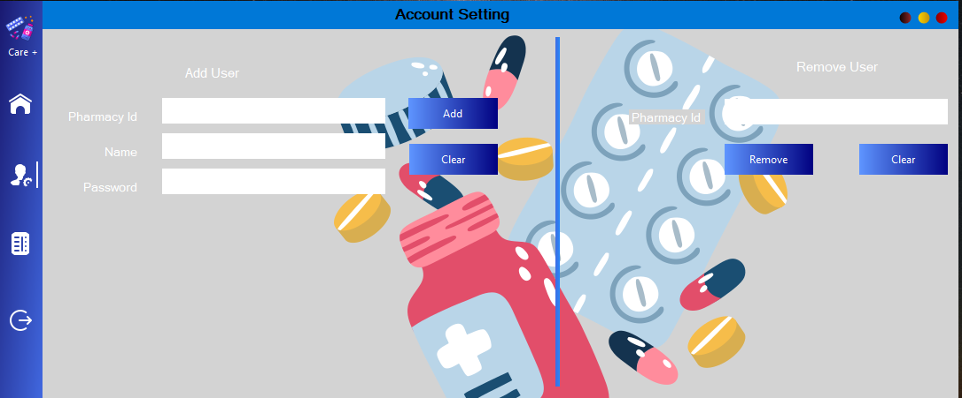

**Account Setting Form**

* This form helps to create new user account and removed unused accounts.

**Summery Form**

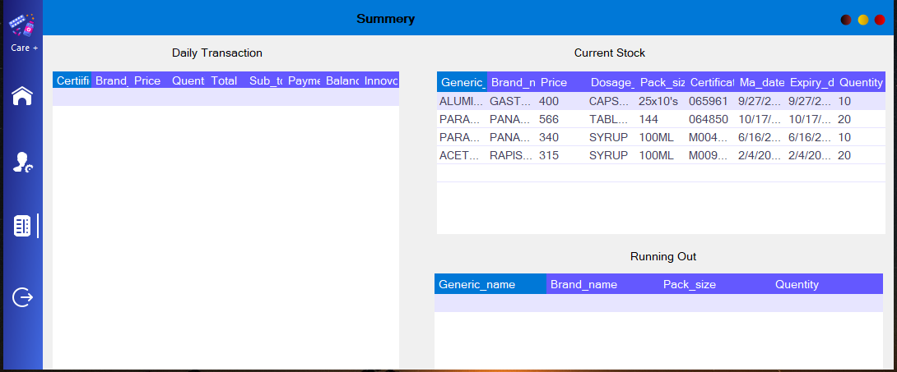

* This form provides all the details of transaction, current stock, stock which is currently running out.

**Inventory Form**

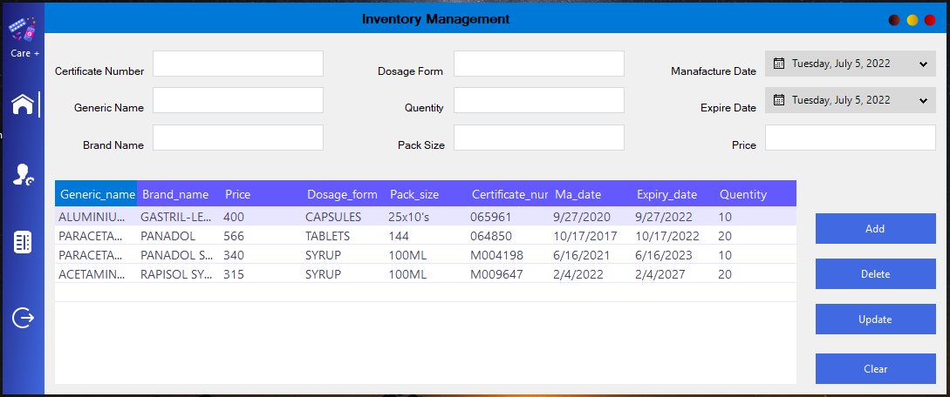

* This form helps to add, delete, update medicines. Once user do some changes in here it will appear below table.

**Stock In Form**

* This Form Provides all the details about medicines which are currently in stock.

**Stock Out Form**

* This Form provides all the details about medicines which are running out from stock.

**Expired Medicine Form**

* Above Form provides remain days for expiring of medicines which are available in stock.

**Help Desk Form**

* This form helps to contact the team who developed the system.

**Database and Tables**

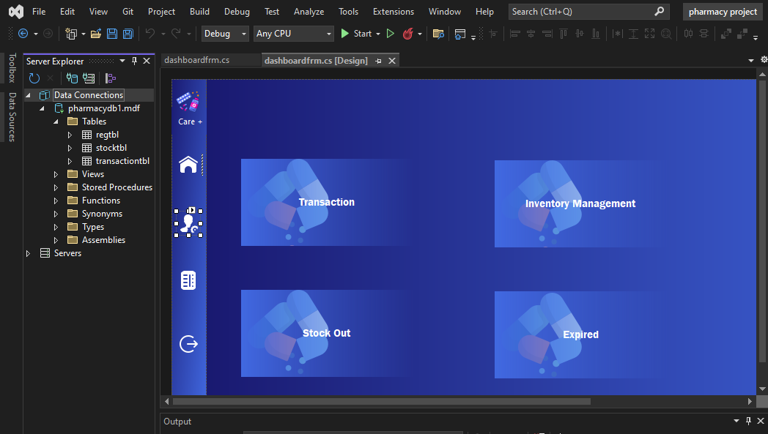

* Here are the database and tables which are connecting with Care+ Pharmacy Management System.

|  |  |
| --- | --- |
| Name | Workload Category |
| W.H.P.Fernando | Both Login Form and Expired Form |
| M.V.D.Rajakaruna | Both Dashboard Form Help Desk Form |
| G.M.D.H.V.Gamlath | Transaction Form |
| P.S.M.Niranjana | Both Stock In and Stock Out Form |
| P.K.P.Sandamal | Inventory Management Form |
| H.P.A.Gunarathna | Both Account Setting and Summery Form |

**Workload of Group Members**

**Conclusion**

Here we built software application using C# Language. Previously the employees who used manual system. All the data stored in books. Because of this they had to face several problems such as security problems, spend more time for update those things. Because of these reasons we built application and hand over them. Result of this they can do their work easily and no need to worry about security. All the data stored in database automatically.