WEEK 2: PL/SQL programming

**Exercise 1: Control Structures**

**INIT**

CREATE TABLE customers (

customer_id INT GENERATED ALWAYS AS IDENTITY (START WITH 1 INCREMENT BY 1),

Name VARCHAR2(100),

age Int,

isVip NUMBER(1), -- 1 for TRUE, 0 for FALSE

balance int

);

CREATE TABLE loans (

loan_id INT GENERATED ALWAYS AS IDENTITY,

customer_id INT,

interest_rate NUMBER(5,2),

due_date DATE

);

INSERT INTO customers (Name, age, isVip, balance) VALUES ('Alice Johnson', 65, 0, 12000);

INSERT INTO customers (Name, age, isVip, balance) VALUES ('Bob Smith', 45, 0, 8000);

INSERT INTO customers (Name, age, isVip, balance) VALUES ('Carol Lee', 70, 0, 15000);

INSERT INTO customers (Name, age, isVip, balance) VALUES ('David Kim', 30, 0, 9500);

INSERT INTO customers (Name, age, isVip, balance) VALUES ('Eva Green', 55, 0, 11000);

INSERT INTO loans (customer_id, interest_rate, due_date) VALUES (1, 5.00, SYSDATE + 10);

INSERT INTO loans (customer_id, interest_rate, due_date) VALUES (2, 6.50, SYSDATE + 40);

INSERT INTO loans (customer_id, interest_rate, due_date) VALUES (3, 4.75, SYSDATE + 25);

INSERT INTO loans (customer_id, interest_rate, due_date) VALUES (4, 7.00, SYSDATE + 5);

INSERT INTO loans (customer_id, interest_rate, due_date) VALUES (5, 5.50, SYSDATE + 60);

1. **Question:** Write a PL/SQL block that loops through all customers, checks their age, and if they are above 60, apply a 1% discount to their current loan interest rates.

**PL/SQL CODE:**

BEGIN

FOR cust_rec IN (SELECT CUSTOMER_ID, AGE FROM CUSTOMERS) LOOP

IF cust_rec.AGE > 60 THEN

UPDATE LOANS

SET INTEREST_RATE = INTEREST_RATE - 0.01

WHERE CUSTOMER_ID = cust_rec.CUSTOMER_ID;

END IF;

END LOOP;

COMMIT;

END;

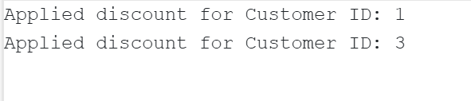

1. **Question:** Write a PL/SQL block that iterates through all customers and sets a flag IsVIP to TRUE for those with a balance over $10,000.

**PL/SQL CODE:**

BEGIN

FOR cust_rec IN (SELECT customer_id, balance FROM customers) LOOP

IF cust_rec.balance > 10000 THEN

UPDATE customers

SET isVip = 1

WHERE customer_id = cust_rec.customer_id;

END IF;

END LOOP;

COMMIT;

END;

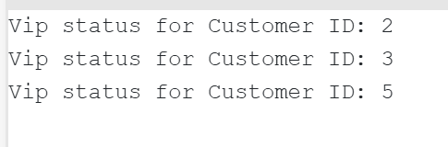

1. **Question:** Write a PL/SQL block that fetches all loans due in the next 30 days and prints a reminder message for each customer.

**PL/SQL CODE:**

BEGIN

FOR rec IN (

SELECT c.name, l.customer_id, l.due_date

FROM loans l

JOIN customers c ON l.customer_id = c.customer_id

WHERE l.due_date BETWEEN SYSDATE AND SYSDATE + 30

) LOOP

DBMS_OUTPUT.PUT_LINE('Reminder: Loan for ' || rec.name ||

' (Customer ID: ' || rec.customer_id ||

') is due on ' || TO_CHAR(rec.due_date, 'DD-MON-YYYY'));

END LOOP;

END;

/

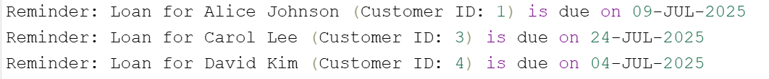

**Exercise 3: Stored Procedures**

**INIT**

-- Create and Insert Data into Tables

CREATE TABLE savings_accounts (

account_id INT GENERATED ALWAYS AS IDENTITY PRIMARY KEY,

customer_id INT,

balance NUMBER(12, 2) CHECK (balance >= 0)

);

INSERT INTO savings_accounts (customer_id, balance) VALUES (1, 1200.00);

INSERT INTO savings_accounts (customer_id, balance) VALUES (2, 2500.00);

INSERT INTO savings_accounts (customer_id, balance) VALUES (3, 3400.00);

INSERT INTO savings_accounts (customer_id, balance) VALUES (4, 1800.00);

INSERT INTO savings_accounts (customer_id, balance) VALUES (5, 2750.00);

CREATE TABLE employees (

employee_id INT GENERATED ALWAYS AS IDENTITY PRIMARY KEY,

name VARCHAR2(100),

department_id INT,

salary NUMBER(10, 2) CHECK (salary >= 0)

);

INSERT INTO employees (name, department_id, salary) VALUES ('Alice Manager', 101, 5000);

INSERT INTO employees (name, department_id, salary) VALUES ('Bob Analyst', 101, 4000);

INSERT INTO employees (name, department_id, salary) VALUES ('Carol Developer', 102, 4500);

CREATE TABLE accounts (

account_id INT GENERATED ALWAYS AS IDENTITY PRIMARY KEY,

customer_id INT,

balance NUMBER(12, 2) CHECK (balance >= 0)

);

INSERT INTO accounts (customer_id, balance) VALUES (1, 5000.00);

INSERT INTO accounts (customer_id, balance) VALUES (2, 3000.00);

INSERT INTO accounts (customer_id, balance) VALUES (3, 7000.00);

INSERT INTO accounts (customer_id, balance) VALUES (4, 2000.00);

INSERT INTO accounts (customer_id, balance) VALUES (5, 1000.00);

1. **Question:** Write a stored procedure **ProcessMonthlyInterest** that calculates and updates the balance of all savings accounts by applying an interest rate of 1% to the current balance.

**PL/SQL CODE:**

CREATE OR REPLACE PROCEDURE ProcessMonthlyInterest AS

BEGIN

UPDATE savings_accounts

SET balance = balance + (balance * 0.01); -- Apply 1% interest to each account

COMMIT;

END;

/

EXEC ProcessMonthlyInterest;



Post execution: -

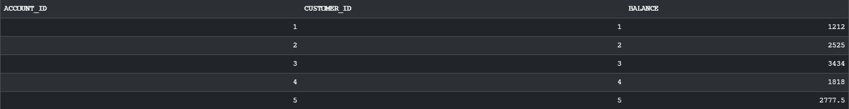

1. **Question:** Write a stored procedure **UpdateEmployeeBonus** that updates the salary of employees in a given department by adding a bonus percentage passed as a parameter.

**PL/SQL CODE:**

CREATE OR REPLACE PROCEDURE UpdateEmployeeBonus(

p_department_id IN NUMBER,

p_bonus_percent IN NUMBER

) AS

BEGIN

UPDATE employees

SET salary = salary + (salary * p_bonus_percent / 100)

WHERE department_id = p_department_id;

COMMIT;

END;

/

EXEC UpdateEmployeeBonus(101, 10);

SELECT * FROM employees;

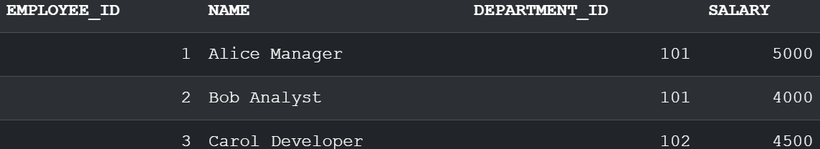

Post execution:-

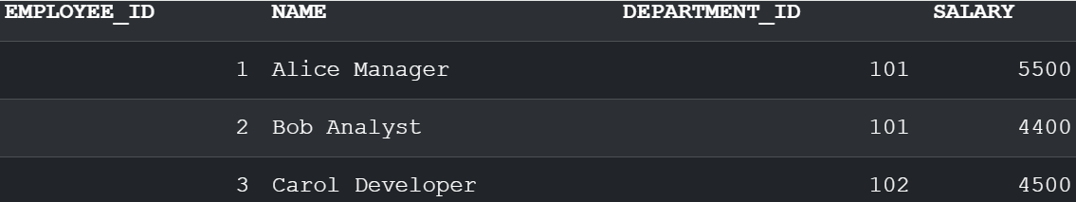

1. **Question:** Write a stored procedure **TransferFunds** that transfers a specified amount from one account to another, checking that the source account has sufficient balance before making the transfer.

**PL/SQL CODE:**

CREATE OR REPLACE PROCEDURE TransferFunds(

p_from_account_id IN NUMBER,

p_to_account_id IN NUMBER,

p_amount IN NUMBER

) AS

v_from_balance NUMBER;

BEGIN

-- Check if source account has enough balance

SELECT balance INTO v_from_balance

FROM accounts

WHERE account_id = p_from_account_id

FOR UPDATE;

IF v_from_balance < p_amount THEN

RAISE_APPLICATION_ERROR(-20001, 'Insufficient funds in source account.');

END IF;

-- Deduct the amount from source account

UPDATE accounts

SET balance = balance - p_amount

WHERE account_id = p_from_account_id;

-- Add the amount to destination account

UPDATE accounts

SET balance = balance + p_amount

WHERE account_id = p_to_account_id;

COMMIT;

END;

/

EXEC TransferFunds(1, 2, 500);

SELECT * FROM accounts;



Post execution:-

