WEEK 3: Spring Core and Maven

**Exercise 1: Configuring a Basic Spring Application**

**App.java**

package com.mypackage.LibraryManagement;

import org.springframework.context.support.ClassPathXmlApplicationContext;

import org.springframework.context.ApplicationContext;

public class App

{

public static void main( String[] args )

{

ApplicationContext context = new ClassPathXmlApplicationContext("applicationContext.xml");

BookService bookService = context.getBean("bookService", BookService.class);

bookService.addBook();

}

}

**BookRepository.java**

package com.mypackage.LibraryManagement;

public class BookRepository {

public void saveBook() {

System.***out***.println("Book saved to the repository.");

}

}

**BookService.java**

package com.mypackage.LibraryManagement;

public class BookService {

public void addBook() {

System.***out***.println("Book added in service.");

}

}

**applicationContext.xml**

<?**xml** version=*"1.0"* encoding=*"UTF-8"*?>

<**beans** xmlns=*"http://www.springframework.org/schema/beans"*

xmlns:xsi=*"http://www.w3.org/2001/XMLSchema-instance"*

xsi:schemaLocation=*"http://www.springframework.org/schema/beans*

*http://www.springframework.org/schema/beans/spring-beans.xsd"*>

<**bean** id=*"bookRepository"* class=*"com.mypackage.LibraryManagement.BookRepository"*/>

<**bean** id=*"bookService"* class=*"com.mypackage.LibraryManagement.BookService"*/>

</**beans**>

**Output:-**

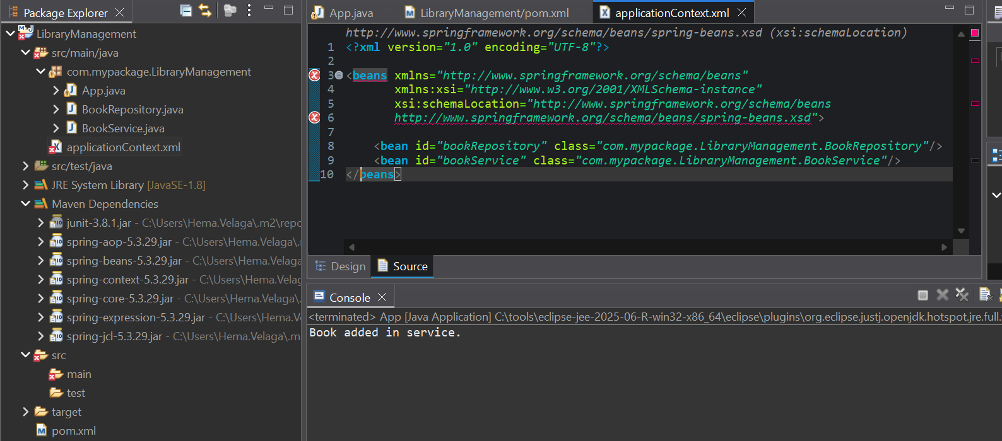

**Exercise 2: Implementing Dependency Injection**

**applicationContext.xml**

<?**xml** version=*"1.0"* encoding=*"UTF-8"*?>

<**beans** xmlns=*"http://www.springframework.org/schema/beans"*

xmlns:xsi=*"http://www.w3.org/2001/XMLSchema-instance"*

xsi:schemaLocation=*"http://www.springframework.org/schema/beans*

*http://www.springframework.org/schema/beans/spring-beans.xsd"*>

<**bean** id=*"bookRepository"* class=*"com.mypackage.LibraryManagement.BookRepository"*/>

<**bean** id=*"bookService"* class=*"com.mypackage.LibraryManagement.BookService"*>

<**property** name=*"bookRep"* ref=*"bookRepository"*/>

</**bean**>

</**beans**>

**BookService.java**

package com.mypackage.LibraryManagement;

public class BookService {

private BookRepository bookRep;

public void setBookRep(BookRepository bookRep) {

this.bookRep = bookRep;

}

public void addBook() {

bookRep.saveBook();

System.***out***.println("Book added in service.");

}

}

**Output:-**

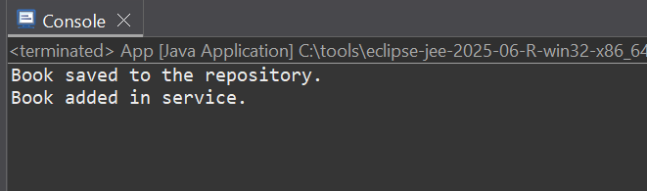

**Exercise 4: Creating and Configuring a Maven Project**

**Steps:**

1. **Create a New Maven Project:** Create a new Maven project named **LibraryManagement**.

**Output:-**

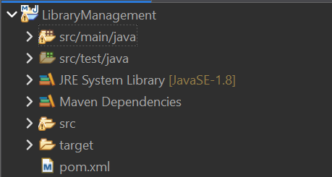

1. **Add Spring Dependencies in pom.xml:** Include dependencies for Spring Context, Spring AOP, and Spring WebMVC.

**Output:-**

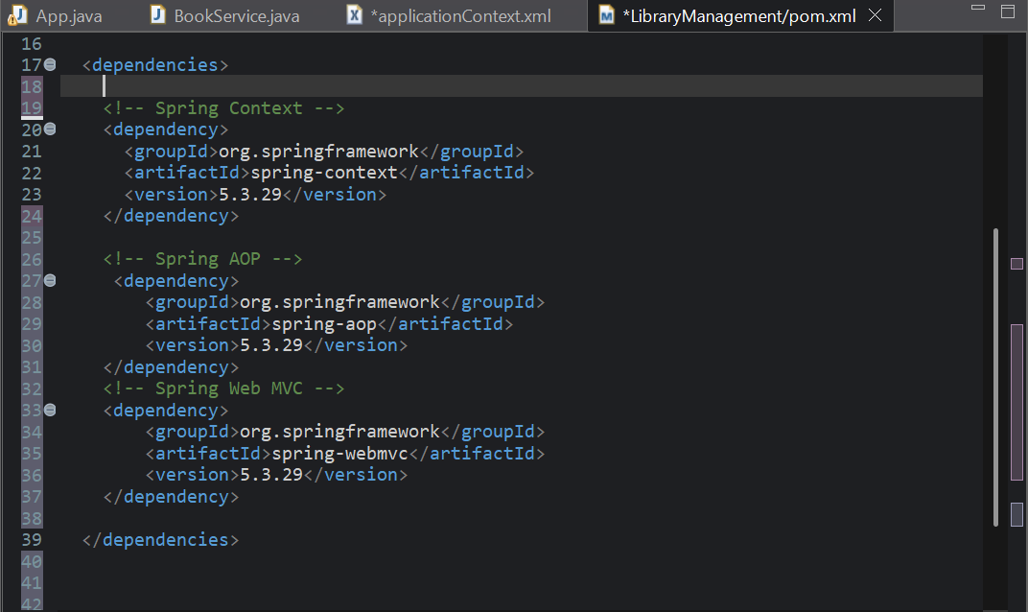

1. **Configure Maven Plugins:** Configure the Maven Compiler Plugin for Java version 1.8 in the pom.xml file.

