Week -7 React

**9. ReactJS-HOL**

**index.js**

import React from 'react';

import ReactDOM from 'react-dom/client';

import App from './App';

const root = ReactDOM.createRoot(document.getElementById('root'));

root.render(<App />);

**App.js**

import React from 'react';

import ListofPlayers from './components/ListofPlayers';

import Scorebelow70 from './components/Scorebelow70';

import { OddPlayers } from './components/OddPlayers';

import { EvenPlayers } from './components/EvenPlayers';

import ListofIndianPlayers from './components/ListofIndianPlayers';

import { players } from './data/players';

import { IndianPlayers } from './data/IndianPlayers';

function App() {

var flag = true;

if (flag === true) {

return (

<div>

<h1>List of Players</h1>

<ListofPlayers players={players} />

<hr />

<h1>List of Players having Scores Less than 70</h1>

<Scorebelow70 players={players} />

</div>

);

} else {

return (

<div>

<div>

<h1>Indian Team</h1>

<h1>Odd Players</h1>

<OddPlayers {...[IndianPlayers]} />

<hr />

<h1>Even Players</h1>

<EvenPlayers {...[IndianPlayers]} />

</div>

<hr />

<div>

<h1>List of Indian Players Merged:</h1>

<ListofIndianPlayers IndianPlayers={IndianPlayers} />

</div>

</div>

);

}

}

export default App;

**components/ListofIndianPlayers.js**

import React from 'react';

function ListofIndianPlayers({ IndianPlayers }) {

return (

<ul>

{IndianPlayers.map((player, index) => (

<li key={index}>{player}</li>

))}

</ul>

);

}

export default ListofIndianPlayers;

**components/EvenPlayers.js**

import React from 'react';

export function EvenPlayers([, second,, fourth,, sixth]) {

return (

<div>

<li> Second: {second} </li>

<li> Fourth: {fourth} </li>

<li> Sixth: {sixth} </li>

</div>

);

}

**components/OddPlayers.js**

import React from 'react';

export function OddPlayers([first,, third,, fifth]) {

return (

<div>

<li> First: {first} </li>

<li> Third: {third} </li>

<li> Fifth: {fifth} </li>

</div>

);

}

**components/Scorebelow70.js**

import React from 'react';

function Scorebelow70({ players }) {

const players70 = players.filter(item => item.score <= 70);

return (

<ul>

{players70.map((player, index) => (

<li key={index}>{player.name} - {player.score}</li>

))}

</ul>

);

}

export default Scorebelow70;

**components/ListofPlayers.js**

import React from 'react';

function ListofPlayers({ players }) {

return (

<div>

{players.map((item, index) => (

<li key={index}>

Mr. {item.name} <span>{item.score}</span>

</li>

))}

</div>

);

}

export default ListofPlayers;

**data/IndianPlayers.js**

const T20Players = ['First Player', 'Second Player', 'Third Player'];

const RanjiTrophyPlayers = ['Fourth Player', 'Fifth Player', 'Sixth Player'];

export const IndianPlayers = [...T20Players, ...RanjiTrophyPlayers];

**data/players.js**

export const players = [

{ name: "Rohit", score: 85 },

{ name: "Virat", score: 65 },

{ name: "Dhawan", score: 55 },

{ name: "Rahul", score: 92 },

{ name: "Pandya", score: 48 },

];

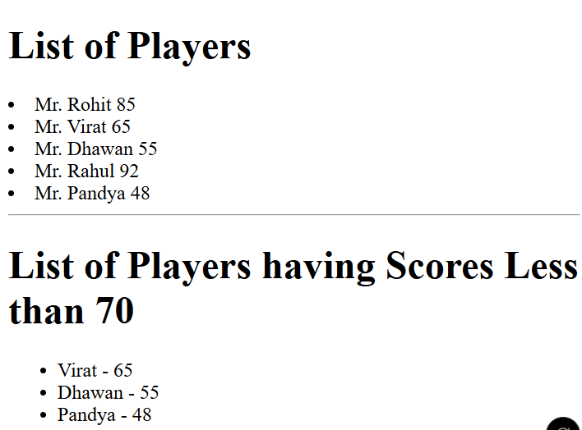

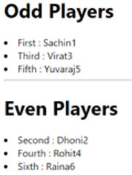

**10. ReactJS-HOL**

**App.js**

import React from 'react';

import './styles.css';

function App() {

const element = "Office Space";

const offices = [

{ Name: "WeWork", Rent: 45000, Address: "Hyderabad" }

];

return (

<div>

<h1>{element} , at Affordable Range</h1>

{offices.map((item, index) => {

const rentColor = item.Rent <= 60000 ? "textRed" : "textGreen";

return (

<div key={index}>

<h1>Name: {item.Name}</h1>

<h3 className={rentColor}>Rent: Rs. {item.Rent}</h3>

<h3>Address: {item.Address}</h3>

<hr />

</div>

);

})}

</div>

);

}

export default App;

**index.js**

import React from 'react';

import ReactDOM from 'react-dom/client';

import './index.css';

import App from './App';

const root = ReactDOM.createRoot(document.getElementById('root'));

root.render(<App />);

**styles.css**

.textRed {

color: red;

}

.textGreen {

color: green;

}

h1 {

font-weight: bold;

}



**11. ReactJS-HOL**

**App.js**

import React, { Component } from 'react';

import CurrencyConverter from './CurrencyConverter';

import './App.css';

class App extends Component {

constructor(props) {

super(props);

this.state = {

count: 5

};

}

increment = () => {

this.setState({ count: this.state.count + 1 });

this.sayHello();

};

decrement = () => {

this.setState({ count: this.state.count - 1 });

};

sayHello = () => {

alert("Hello! Member1");

};

sayWelcome = (msg) => {

alert(msg);

};

handleClick = (e) => {

alert("I was clicked");

};

render() {

return (

<div style={{ padding: '20px' }}>

<div>{this.state.count}</div>

<button onClick={this.increment}>Increment</button>

<button onClick={this.decrement}>Decrement</button>

<br /><br />

<button onClick={() => this.sayWelcome("welcome")}>Say welcome</button>

<br /><br />

<button onClick={this.handleClick}>Click on me</button>

<hr />

<CurrencyConverter />

</div>

);

}

}

export default App;

**index.js**

import React from 'react';

import ReactDOM from 'react-dom/client';

import App from './App';

const root = ReactDOM.createRoot(document.getElementById('root'));

root.render(<App />);

**CurrencyConverter.js**

import React, { Component } from 'react';

class CurrencyConverter extends Component {

constructor(props) {

super(props);

this.state = {

amount: '',

currency: '',

};

}

handleAmountChange = (e) => {

this.setState({ amount: e.target.value });

};

handleCurrencyChange = (e) => {

this.setState({ currency: e.target.value });

};

handleSubmit = (e) => {

e.preventDefault();

const rate = 80; // Assuming 1 Euro = 80 INR

const converted = this.state.amount * rate;

alert(`Converting to ${this.state.currency} Amount is ${converted}`);

};

render() {

return (

<div>

<h1 style={{ color: 'green' }}>Currency Convertor!!!</h1>

<form onSubmit={this.handleSubmit}>

<label>

Amount:

<input

type="text"

value={this.state.amount}

onChange={this.handleAmountChange}

/>

</label>

<br /><br />

<label>

Currency:

<textarea

value={this.state.currency}

onChange={this.handleCurrencyChange}

/>

</label>

<br /><br />

<button type="submit">Submit</button>

</form>

</div>

);

}

}

export default CurrencyConverter;

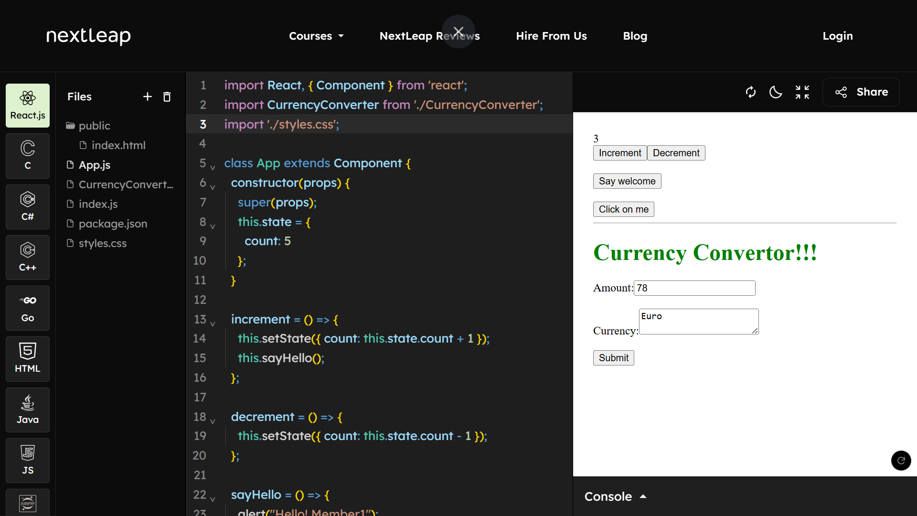

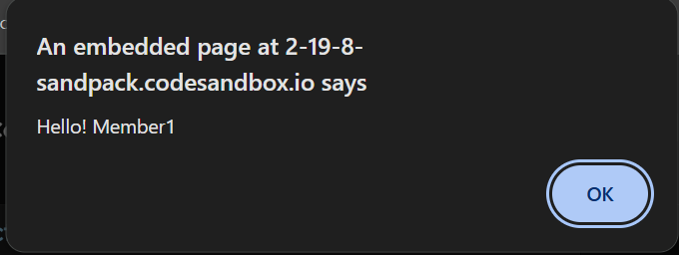

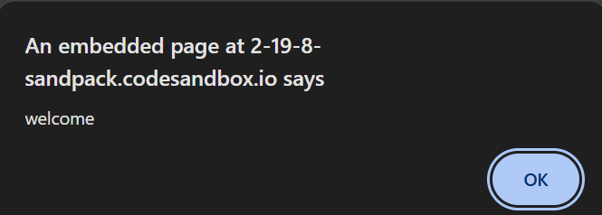

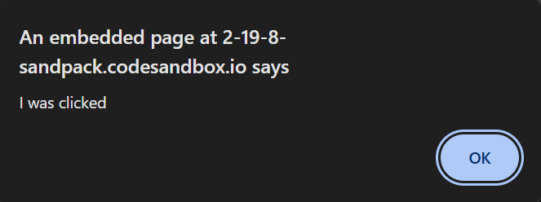

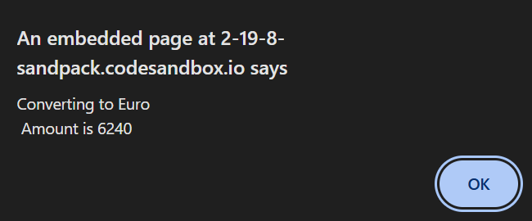

**12. ReactJS-HOL**

**App.js**

import React, { useState } from 'react';

import Greeting from './Greeting';

import LoginButton from './LoginButton';

import LogoutButton from './LogoutButton';

function App() {

const [isLoggedIn, setIsLoggedIn] = useState(false);

const handleLoginClick = () => setIsLoggedIn(true);

const handleLogoutClick = () => setIsLoggedIn(false);

let button;

if (isLoggedIn) {

button = <LogoutButton onClick={handleLogoutClick} />;

} else {

button = <LoginButton onClick={handleLoginClick} />;

}

return (

<div style={{ textAlign: 'center', marginTop: '50px' }}>

<Greeting isLoggedIn={isLoggedIn} />

{button}

</div>

);

}

export default App;

**Greeting.js**

import React from 'react';

import UserGreeting from './UserGreeting';

import GuestGreeting from './GuestGreeting';

function Greeting(props) {

const isLoggedIn = props.isLoggedIn;

if (isLoggedIn) {

return <UserGreeting />;

}

return <GuestGreeting />;

}

export default Greeting;

**GuestGreeting.js**

import React from 'react';

function GuestGreeting() {

return <h1>Please sign up.</h1>;

}

export default GuestGreeting;

**LoginButton.js**

import React from 'react';

function LoginButton(props) {

return (

<button onClick={props.onClick}>

Login

</button>

);

}

export default LoginButton;

**LogoutButton.js**

import React from 'react';

function LogoutButton(props) {

return (

<button onClick={props.onClick}>

Logout

</button>

);

}

export default LogoutButton;

**UserGreeting.js**

import React from 'react';

function UserGreeting() {

return <h1>Welcome back</h1>;

}

export default UserGreeting;

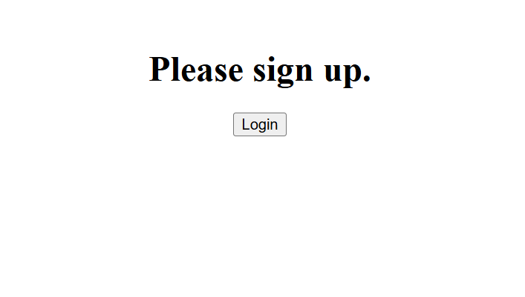

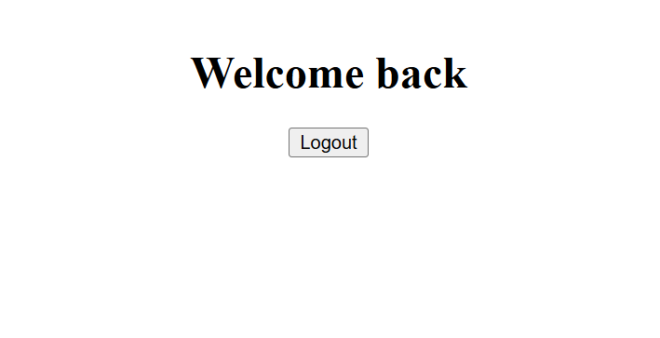

**13. ReactJS-HOL**

**App.js**

import React from 'react';

function App() {

const books = [

{ id: 101, bname: 'Master React', price: 670 },

{ id: 102, bname: 'Deep Dive into Angular 11', price: 800 },

{ id: 103, bname: 'Mongo Essentials', price: 450 }

];

const bookdet = (

<ul>

{books.map((book) => (

<div key={book.id}>

<h3>{book.bname}</h3>

<h4>{book.price}</h4>

</div>

))}

</ul>

);

const content = (

<div>

<h3>Blog Title</h3>

<p>This is a sample blog content.</p>

</div>

);

const coursedet = (

<div>

<h3>React Course</h3>

<p>Learn React step by step.</p>

</div>

);

return (

<div>

<div>

<div className="st2">

<h1>Book Details</h1>

{bookdet}

</div>

<div className="v1">

<h1>Blog Details</h1>

{content}

</div>

<div className="mystyle1">

<h1>Course Details</h1>

{coursedet}

</div>

</div>

</div>

);

}

export default App;

**index.js**

import React from 'react';

import { createRoot } from 'react-dom/client';

import App from './App';

const root = createRoot(document.getElementById('root'));

root.render(<App />);

