**Week- 8**

**1 HOL**

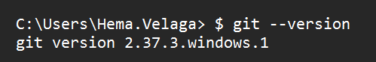

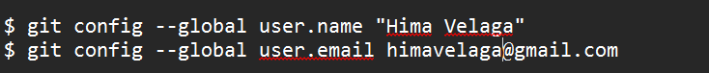

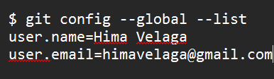

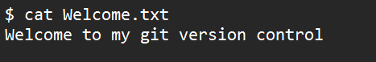









**2 HOL**

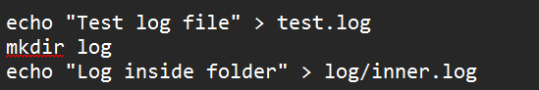

**$ git status**

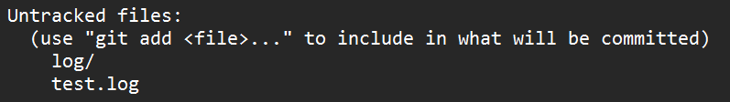

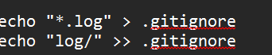



**$ git status**

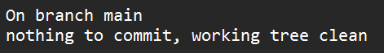

**3 HOL**

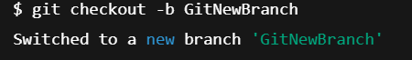

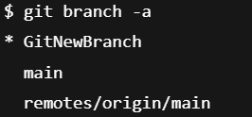





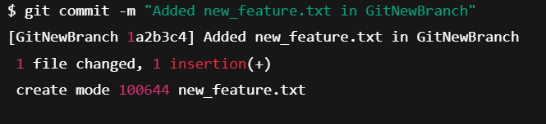

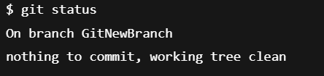

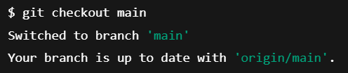

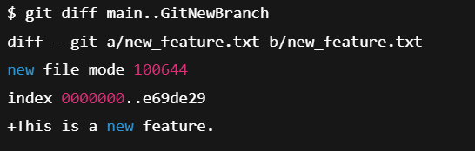

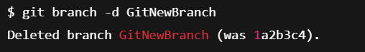

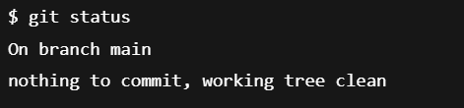

**4 HOL**

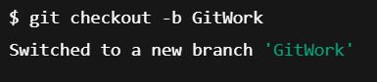

$ echo "<note>This is GitWork branch update</note>" >> hello.xml

$ git add hello.xml

$ git commit -m "GitWork: Added hello.xml with custom message"

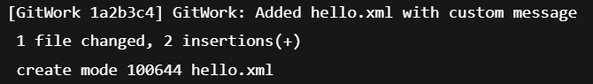

$ git checkout master

$ echo "<message>Hello from master branch</message>" > hello.xml

$ echo "<note>This is master branch update</note>" >> hello.xml

$ git add hello.xml

$ git commit -m "Master: Added hello.xml with different message"

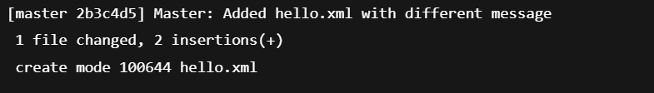

$ git log --oneline --graph --decorate –all

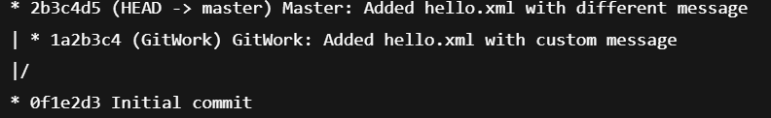

$ git diff GitWork hello.xml

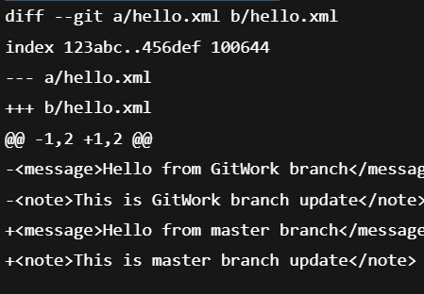

$ cat hello.xml

o/p

<<<<<<< HEAD

<message>Hello from master branch</message>

<note>This is master branch update</note>

=======

<message>Hello from GitWork branch</message>

<note>This is GitWork branch update</note>

>>>>>>> GitWork

o/p

<message>Hello from master branch</message>

<note>This is master branch update</note>

<message>Hello from GitWork branch</message>

<note>This is GitWork branch update</note>

$ git add hello.xml

$ git commit -m "Resolved conflict in hello.xml between master and GitWork"

**5 HOL**

$ git status

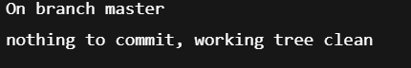

$ git branch



$ git pull origin master

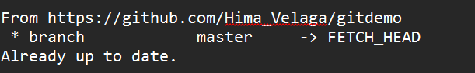

$ git push origin master