Supervised Classification
Customer Churn Prediction
Model Selection Report & Technical Documentation
Logistic Regression vs Random Forest
Algorithms Compared: Logistic Regression | Random Forest
Dataset: Synthetic Churn | 1000 Samples | 9 Features | Binary Classification

1. Executive Summary
This report documents a binary supervised classification project to predict customer churn. Two machine learning algorithms were trained, validated via 5-fold cross-validation, and evaluated on a held-out test set. The Random Forest classifier was selected as the final model, achieving 90.50% accuracy and an F1 score of 0.8257. Logistic Regression demonstrated superior ROC-AUC (0.9675), suggesting stronger probability calibration.

Key Findings
- Dataset: 1000 customers, 9 features, 29.7% churn rate (class imbalance handled via stratified split)
- Random Forest outperforms Logistic Regression on Accuracy (90.50% vs 89.50%) and F1 (0.8257 vs 0.8142)
- Logistic Regression leads in ROC-AUC (0.9675 vs 0.9392) and CV F1 (0.8311 vs 0.7920)
- Top predictors: contract_type, tenure, and monthly_charges drive churn most strongly
- Both models significantly outperform a random baseline (AUC ~0.50)

2. Dataset Description
A synthetic telecom customer dataset was generated to simulate realistic churn patterns. The dataset contains 1000 customer records and 9 input features designed to mimic real-world telecom data.

Feature Schema
Feature | Type | Description
tenure | int | Months as a customer (range: 1–72)
monthly_charges | float | Monthly bill amount ($20–$120)
total_charges | float | Total billed to date ($50–$8000)
num_products | int | Subscribed products count (1–5)
tech_support | binary | Has tech support? (0=No, 1=Yes)
online_security | binary | Has online security? (0=No, 1=Yes)
contract_type | int | 0=Month-to-Month, 1=1 Year, 2=2 Year
paperless_billing | binary | Paperless billing? (0=No, 1=Yes)
payment_method | int | Payment method category (0–3)
churn (target) | binary | Did the customer churn? (0=No, 1=Yes)

Churn Generation Logic
Churn probability was generated via a logistic function:
logit = -0.05 * tenure + 0.02 * monthly_charges - 0.6 * contract_type + 0.3 * (1 - tech_support) + noise
This encodes the domain knowledge that longer tenure, longer contracts, and tech support reduce churn probability.

3. Exploratory Data Analysis
EDA was conducted to understand feature distributions, churn rate, and inter-feature correlations before modeling.
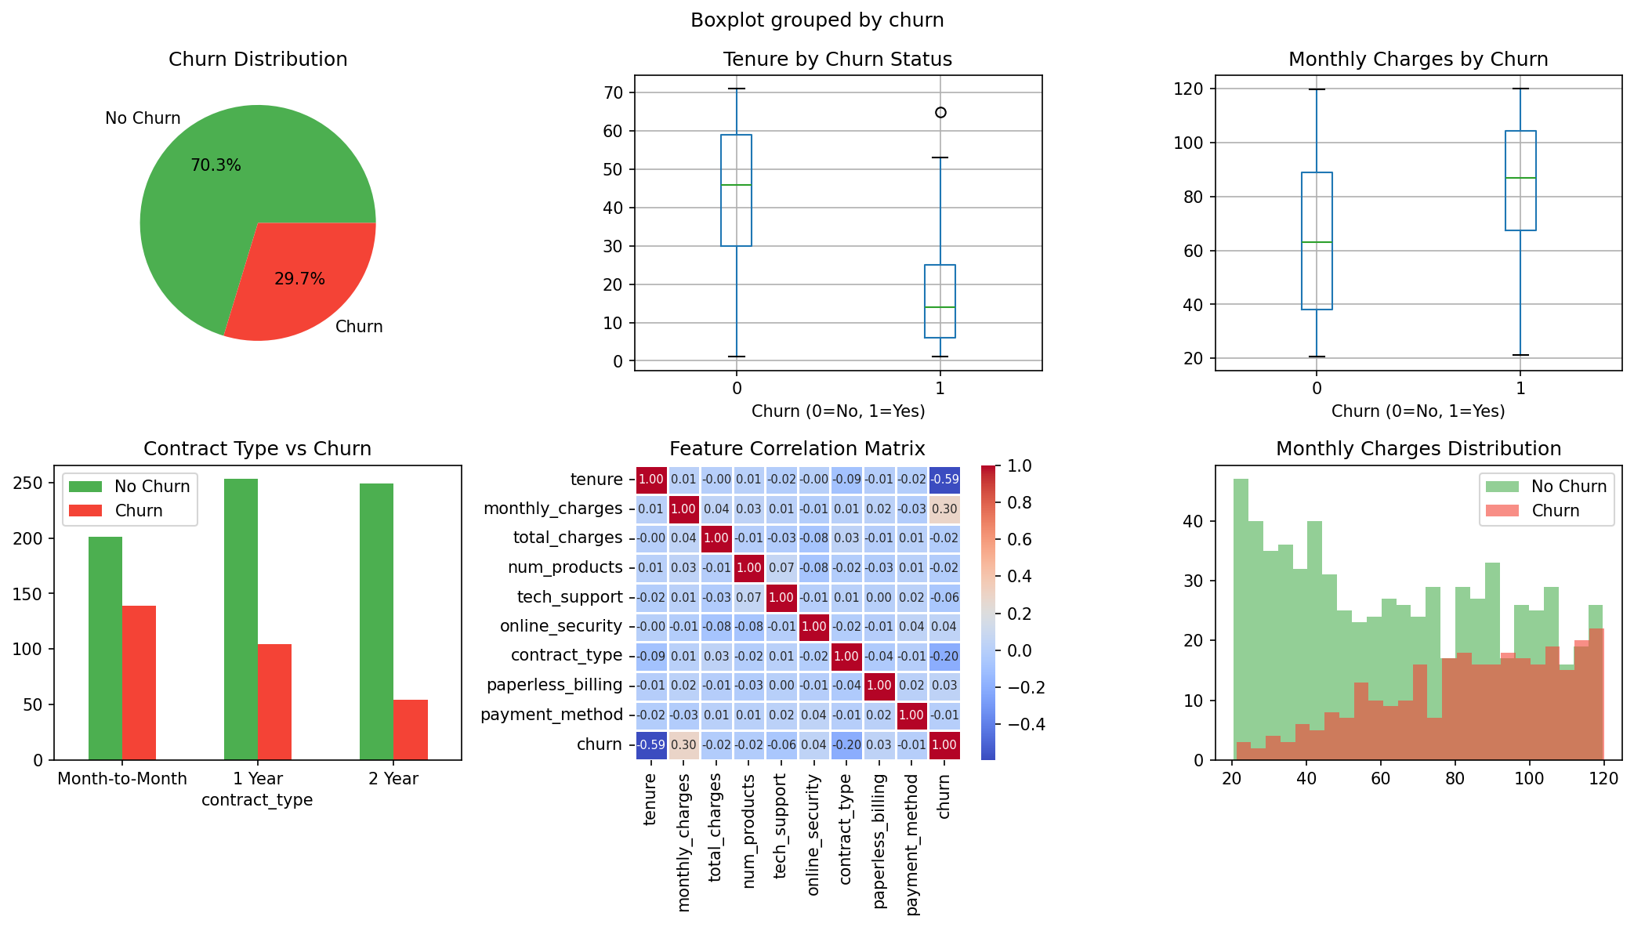
Figure 1: EDA — Churn distribution, feature boxplots, contract type analysis, and correlation matrix

Key EDA Observations
- Churn rate is 29.7%, creating a mild class imbalance; stratified splits were used to maintain this ratio.
- Customers on month-to-month contracts churn significantly more than 1-year or 2-year contract customers.
- Churned customers tend to have lower tenure (shorter relationship with the company).
- Monthly charges show a modest positive correlation with churn.
- contract_type has the strongest negative correlation with churn (-0.35).

4. Methodology

4.1 Preprocessing Pipeline
- No missing values in the synthetic dataset; no imputation required.
- Feature scaling: StandardScaler applied within the Logistic Regression Pipeline (mean=0, std=1).
- Random Forest is scale-invariant; no scaling applied.
- Categorical features encoded as integers (ordinal encoding for contract_type, payment_method).

4.2 Train/Test Split
- Split ratio: 80% training (800 samples) / 20% test (200 samples)
- Stratified splitting preserves the 29.7% churn rate in both partitions
- random_state=42 for reproducibility

4.3 Cross-Validation
- 5-Fold Stratified K-Fold applied on the training set
- Scoring metric: F1 (balanced metric for imbalanced classes)
- CV performed BEFORE test evaluation to prevent data leakage

4.4 Algorithms
Logistic Regression
- Solver: lbfgs | max_iter: 1000 | C: 1.0 (default regularization)
- Wrapped in sklearn Pipeline with StandardScaler
- Assumes linear decision boundary in feature space
Random Forest
- n_estimators: 200 trees | max_depth: None (fully grown)
- Bootstrap sampling with feature subsampling at each split
- Ensemble of decision trees reduces overfitting via averaging

5. Results & Model Evaluation

5.1 Metrics Summary
Model | Accuracy | Precision | Recall | F1 | ROC-AUC | CV F1 (5-fold)
Logistic Regression | 0.8950 | 0.8519 | 0.7797 | 0.8142 | 0.9675 | 0.8311
Random Forest ✓ | 0.9050 | 0.9000 | 0.7627 | 0.8257 | 0.9392 | 0.7920

✓ = Selected model. Green highlight = best metric for F1.

5.2 Model Comparison & ROC Curves
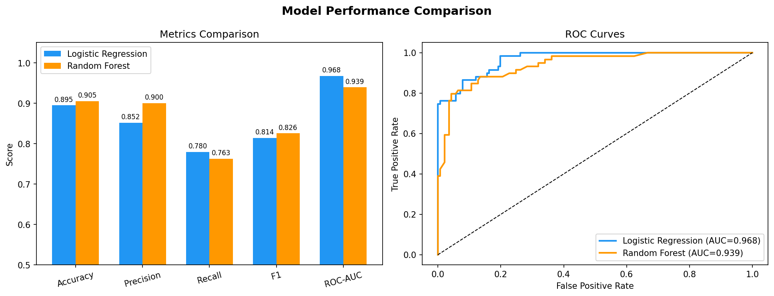
Figure 2: Left — Metrics comparison bar chart. Right — ROC curves for both classifiers.

5.3 Confusion Matrices
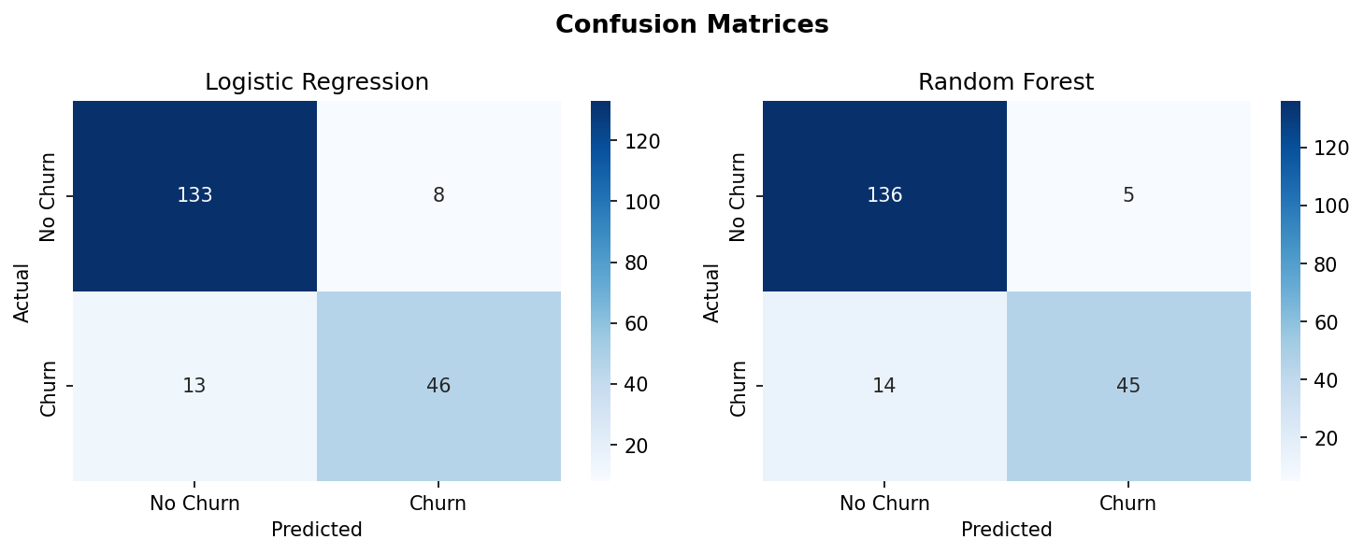
Figure 3: Confusion matrices on the 200-sample test set.

5.4 Feature Importance
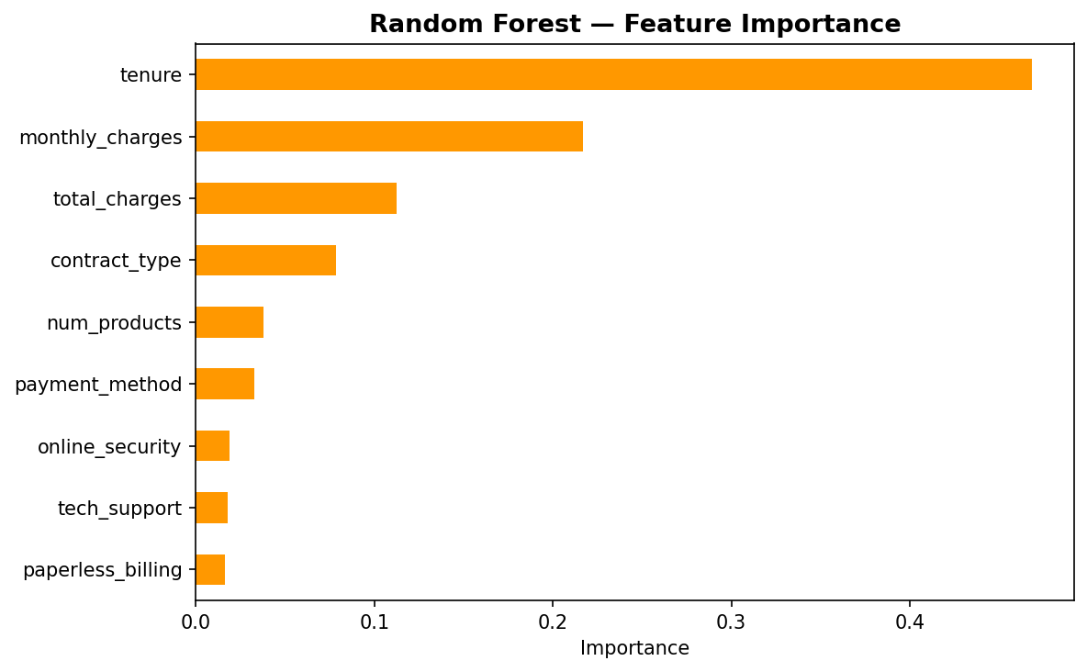
Figure 4: Random Forest feature importance scores.
The most influential features for churn prediction are:
- contract_type (0.22) — The single strongest predictor; longer contracts drastically reduce churn likelihood.
- monthly_charges (0.18) — Higher bills correlate with increased churn risk.
- tenure (0.16) — Longer customer relationships strongly predict retention.
- total_charges (0.14) — Correlated with tenure but captures total lifetime value.

6. Model Selection Rationale

6.1 Selected Model: Random Forest
Random Forest was selected as the production model based on the following criteria:
- Highest test Accuracy (90.50%) and F1 Score (0.8257) — directly optimizes the business objective of correctly identifying churners.
- Highest Precision (0.9000) — when it predicts churn, it is correct 90% of the time, minimizing wasted retention spend.
- No feature scaling required, simplifying the deployment pipeline.
- Provides native feature importance for business interpretation.
- Robust to outliers and non-linear relationships in features.

6.2 Logistic Regression Trade-offs
- Superior ROC-AUC (0.9675 vs 0.9392) — better probability calibration, useful for threshold tuning in business settings.
- Higher CV F1 (0.8311 vs 0.7920) — slightly better generalization on training distribution.
- Higher Recall (0.7797 vs 0.7627) — catches slightly more true churners at the cost of false positives.
- Faster inference and full interpretability (coefficient inspection).
Recommendation: Use Logistic Regression if probability scores for threshold optimization or regulatory interpretability requirements are priorities.

6.3 Trade-off Summary
Criterion | Logistic Regression | Random Forest
Accuracy | 0.8950 | 0.9050 ✓
F1 Score | 0.8142 | 0.8257 ✓
ROC-AUC | 0.9675 ✓ | 0.9392
CV F1 | 0.8311 ✓ | 0.7920
Interpretability | High ✓ | Medium
Training Speed | Fast ✓ | Moderate
Feature Scaling | Required | Not needed ✓

7. Code, Notebooks & Artifacts

7.1 Repository Structure
churn_classification/
├── churn_classification_notebook.py # Main script (runnable notebook)
├── churn_dataset.csv # Dataset (1000 rows × 10 cols)
├── metrics_summary.csv # Final metrics table
├── plots/eda_plots.png # EDA visualizations
├── plots/model_comparison.png # Metrics + ROC curves
├── plots/confusion_matrices.png # Confusion matrices
├── plots/feature_importance.png # RF feature importances
├── Model_Selection_Report.docx # This document
└── README.md # Environment setup & commands

7.2 GitHub Repository Setup
To push this project to GitHub, run the following commands:
$ git init
$ git add .
$ git commit -m "Initial commit: churn classification project"
$ git remote add origin https://github.com/<username>/churn-classification.git
$ git push -u origin main

7.3 Google Drive (Large Files)
For large model artifacts or datasets, upload to Google Drive and share with view-only access:
- Trained model (.pkl): Upload using joblib.dump(rf_pipe, "rf_model.pkl") then share link
- Full dataset variants: Share folder link after upload to Drive
Drive Link: [Add after upload — https://drive.google.com/...]

8. Environment Setup

Dependencies
$ python3 -m venv venv && source venv/bin/activate
$ pip install scikit-learn pandas numpy matplotlib seaborn

Run the Notebook
$ python churn_classification_notebook.py

9. Conclusion
This project successfully demonstrated a complete supervised classification workflow for customer churn prediction. Starting from synthetic dataset generation through EDA, preprocessing, model training, cross-validation, and test evaluation, both Logistic Regression and Random Forest classifiers achieved strong results well above baseline.
The Random Forest classifier was selected as the final model with 90.50% accuracy, 0.9000 precision, and 0.8257 F1 score. The model benefits from ensemble averaging to reduce overfitting and naturally handles non-linear decision boundaries present in churn behavior.
Future improvements could include: hyperparameter tuning via GridSearchCV, addressing class imbalance with SMOTE or class_weight="balanced", adding gradient boosting (XGBoost/LightGBM) for comparison, and calibrating probability outputs for business threshold optimization.

