Build (Execute) Jenkins Job



This section will guide you on:

* How to build Jenkins job with Cucumber

**Development Environment:**

* JRE: OpenJDK Runtime Environment 11.0.2
* Maven path setup
* Eclipse IDE for Enterprise Java Developers v2019-03 (4.11.0)
* Jenkin war file

Executing through Jenkins

* Login into Jenkins

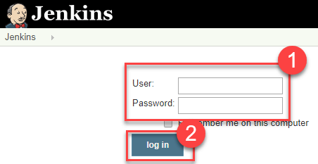

* Create a new job as Maven Project

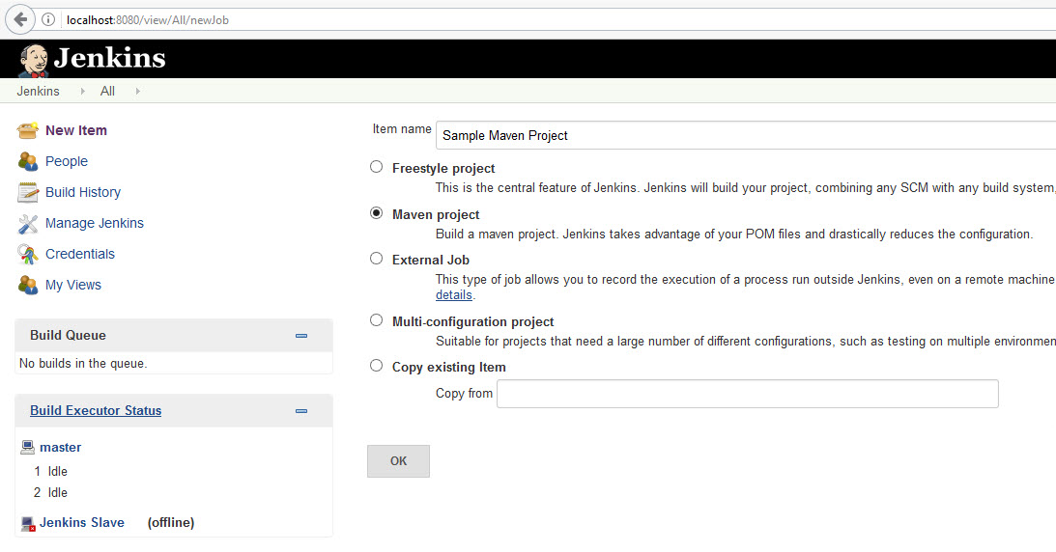

* After then click on the created projected from the Jenkins Dashboard and click on “Configure”.
* In Job Configuration, go to the “Build” section and provide the path of pom.xml which has to be executed.
* And click on “Save” and click on “Build Now” to start the execution on Jenkins.

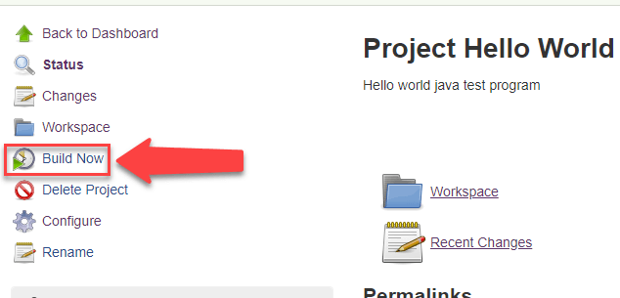

* After Executing the build, you can review the result as below:

