Jenkins Integration with Extent Report

****

This section will guide you to:

* Integrate extent report in Jenkins

Jenkins Integration with Extent Report

To setup an extent report in Jenkins Dashboard:

* Login into Jenkins-->Manage Jenkins and Install HTML Publisher Plugin. Please make sure to restart Jenkins after the plugin installation.
* Now go to Jenkins Home Page create New Jenkins Job and in Post-Build Action select publish Selenium HTML report plugin.

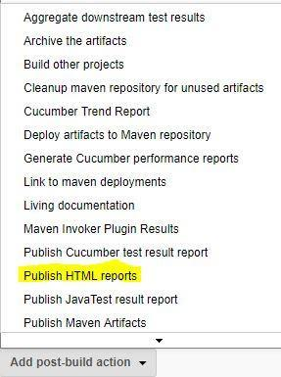

* Now Give Path of your Extent Report, Name and Title.

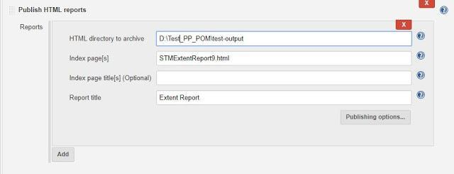

* Execute your Jenkins Job and now, Extent Report would be visible in your Jenkins Dashboard.

