Step Definition****

This section will guide you to understand:

* What is cucumber step definition
* Implementation of Cucumber in Selenium

**Development Environment:**

* JRE: OpenJDK Runtime Environment 11.0.2
* Eclipse IDE for Enterprise Java Developers v2019-03 (4.11.0)
* TestNG
* Selenium jars
* Cucumber jars

Adding a step definition file.

* Create a new Class file in the “stepDefinition” package and name it as “Test_Steps”
* When we run the Feature file as Cucumber feature, the following message will be displayed in the console window:

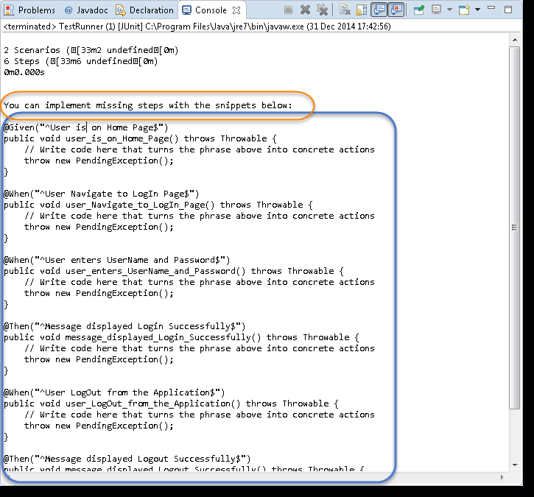

* Copy the complete text marked in a blue box and paste it into the above created Test_Steps class.
* The test will show many errors on “@” annotations. At the annotations, import the “cucumber.api.java.en” for all the annotations.

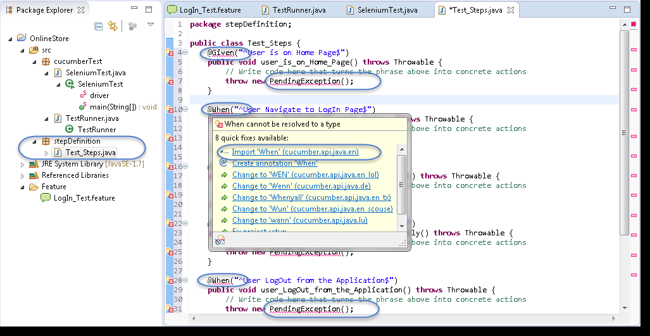

## 

## Providing implementations using Selenium Java for the Step Definition methods.

* Using Selenium Java, provide the implementation to the first method “@Given (“^User is on Home Page$”)”
* Launch the Browser
* Navigate to Home Page

Method will look like this now:

|  |
| --- |
| **@Given("^User is on Home Page$")**  **public void user_is_on_Home_Page() throws Throwable**  **{**  **driver = new FirefoxDriver();**  **driver.manage().timeouts().implicitlyWait(10, TimeUnit.SECONDS); driver.get("http://www.store.demoqa.com");**  **}** |

## 

* Using Selenium Java, provide the implementation to the second method “@When (“^User Navigate to Login Page$”)”
* Click on the Login link

Method will look like this now:

|  |
| --- |
| @When("^User Navigate to Login Page$")  public void user_Navigate_to_Login_Page() throws Throwable  {  driver.findElement(By.xpath(".//*[@id='account']/a")).click();  } |

* Using Selenium Java, provide the implementation to the second method.

“@When (“^User enters UserName and Password$”)”

* Enter UserName and Password
* Click on Submit button

Method will look like this now:

|  |
| --- |
| @When("^User enters Username and Password$")  public **void** user_enters_Username_and_Password() throws Throwable  {  driver.findElement(By.id("log")).sendKeys("testuser_1");  driver.findElement(By.id("pwd")).sendKeys("Test@123");  driver.findElement(By.id("login")).click();  } |

* Do the same steps for the rest of the methods and the complete Test_Steps class will look like this:
* **public** **class** Test_Steps
* { **public** **static** WebDriver driver;
* @Given("^User is on Home Page$")
* **public** **void** user_is_on_Home_Page() **throws** Throwable{
* driver = **new** FirefoxDriver();
* driver.manage().timeouts().implicitlyWait(10, TimeUnit.SECONDS);
* driver.get("http://www.store.demoqa.com"); }
* @When("^User Navigate to LogIn Page$")
* **public** **void** user_Navigate_to_LogIn_Page() **throws** Throwable {
* driver.findElement(By.xpath(".//*[@id='account']/a")).click(); }
* @When("^User enters UserName and Password$")
* **public** **void** user_enters_UserName_and_Password() **throws** Throwable {
* driver.findElement(By.id("log")).sendKeys("testuser_1");
* driver.findElement(By.id("pwd")).sendKeys("Test@123");
* driver.findElement(By.id("login")).click(); }
* @Then("^Message displayed Login Successfully$")
* **public** **void** message_displayed_Login_Successfully() **throws** Throwable{
* System.out.println("Login Successfully"); }
* @When("^User LogOut from the Application$")
* **public** **void** user_LogOut_from_the_Application() **throws** Throwable{
* driver.findElement (By.xpath(".//*[@id='account_logout']/a")).click(); }
* @Then("^Message displayed Logout Successfully$")
* **public** **void** message_displayed_Logout_Successfully() **throws** Throwable {
* System.out.println("LogOut Successfully"); }}