Tagged Scenarios



This section will guide you through :

* Cucumber Step Definition
* Implementation of Tagged Scenarios in Selenium

How to add a tag to a feature file and scenario

* Syntax to add tag for feature file

Type “@<tag_name>” at the top of Feature or Scenario

* Tag a feature

The tag applies automatically to all the scenarios on the feature file

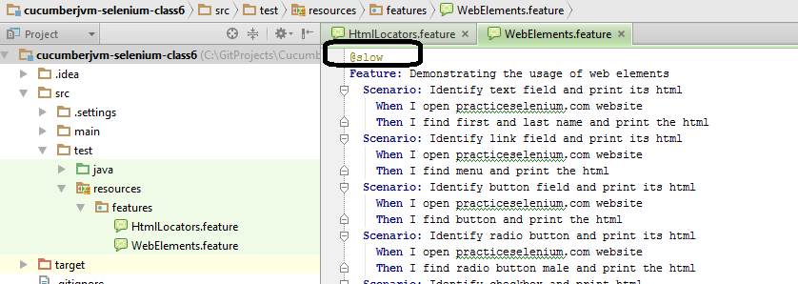

* Tag a scenario

Place the tag at the line exactly above the Scenario.

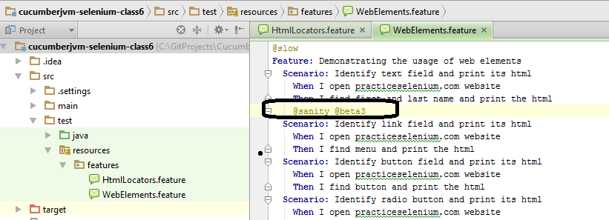

Methods to run the tagged file

* Method1 (Run all @slow in features directory)

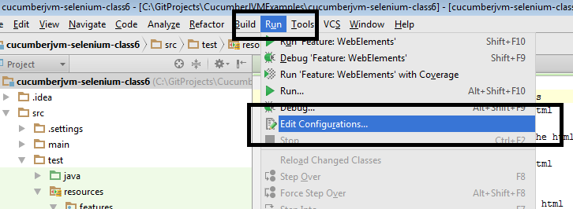

* Paste the path to **feature** folder in your project and write the following in Program arguments:

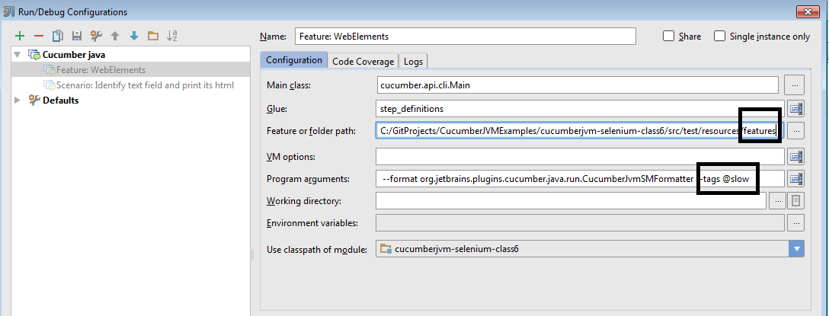

* Method2 (Run all @slow scenarios in a particular feature)

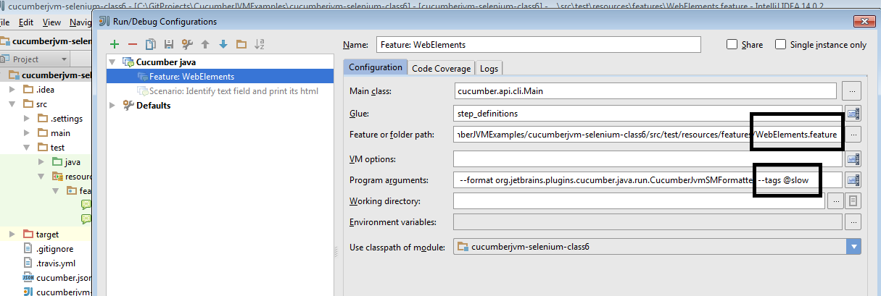

* Method3 (Run from the command line)

