Argument Sources



* To understand @ValueSource annotation
* To understand @CsvSource annotation
* To understand @EnumSource annotation
* To understand @ArgumentsSource annotation

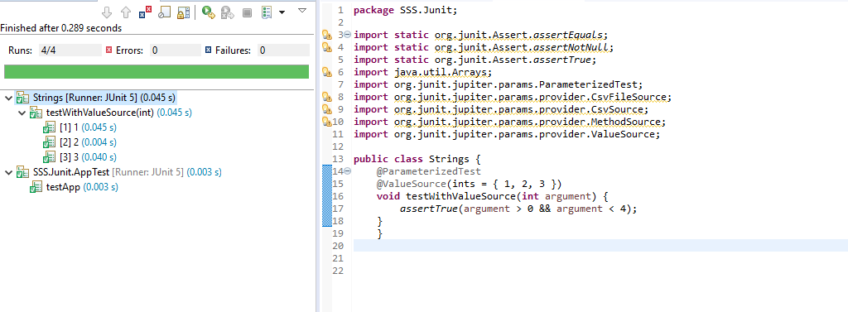

@CsvSource annotation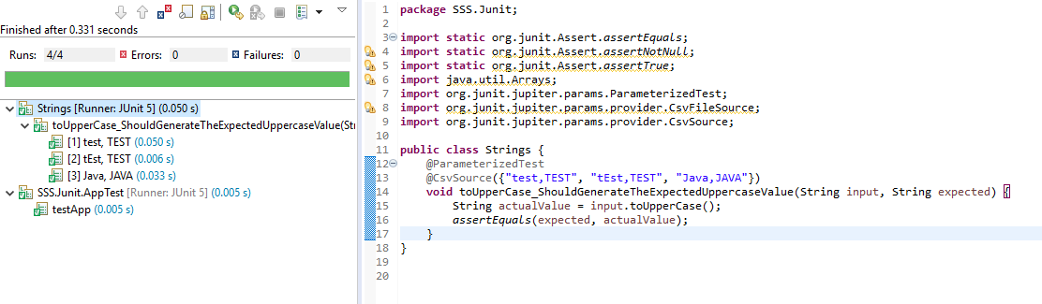

@EnumSource annotation

In order to run a test with different values from an enumeration, we can use the @EnumSource annotation.

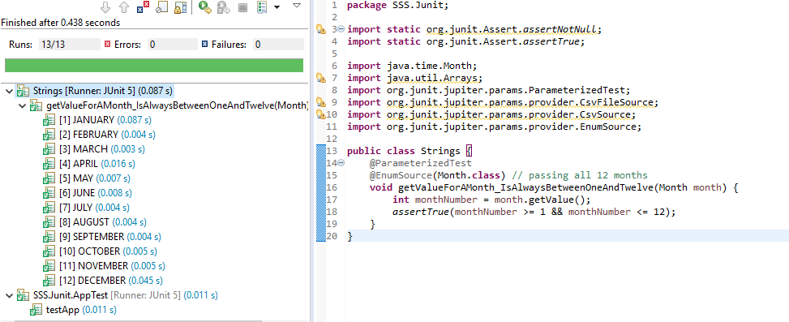

@ArgumentsSource annotation

@ArgumentsSource can be used to specify a custom, reusable ArgumentsProvider. Note that an implementation of ArgumentsProvider must be declared as either a top-level class or as a static nested class.

