Assumptions



* assumeTrue()

We can use assumeTrue() to skip the test if the input number is negative. Below is the updated code:

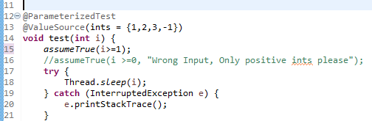

* JUnit will skip when the input number is negative. When we run the test, we will get the following output:

* assumeFalse()

assumeFalse() validates the given assumption to false and if the assumption is false then the test proceeds, otherwise, the test execution is aborted. It works just opposite to assumeTrue().

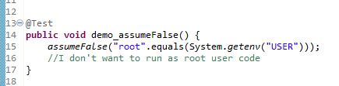

* assumingThat()

This method executes the supplied Executable if the assumption is valid. If the assumption is invalid, this method does nothing. We can use this for logging or notifications when our assumptions are valid.

