
Software requirement specification document for project Software system
Name | ID
Ibrahim Mohamed | 255116
Omar Ahmed | 253374
Omar Emad | 255424
Yassin Bedir | 254287
Ziad Hany | 253278

Supervised by: Dr.Reem kadry
April 14, 2026

1 Introduction
1.1 Purpose of this document
This document outlines the requirements of Clogs, Slippers & Bags regarding the Retail Management System for online sales. This document provides a clear description of system requirements, defines the system scope and boundaries, and serves as a reference for design, implementation, testing, and validation. It also helps reduce misunderstandings between stakeholders, supports project planning and cost estimation, and acts as a baseline for future maintenance and system evolution.

1.2 Scope of this document
The software engineering team conducted meetings with the customer (Tretto.eg for Clogs, Slippers & Bags) to understand their exact business needs and requirements. During these sessions, the customer requested the development of an online Retail Management System. The requirements collected from these meetings will be discussed and specified in detail in Section 3 (Functional Requirements).
Schedule: The requirements elicitation process was held through a series of meetings. The first meeting was held with the customer to identify and collect the functional requirements of the system. A second meeting is planned to discuss and finalize the system design. A final meeting will take place at the end of the project to review and validate the delivered system.
Environment: All meetings were held offline, face-to-face with the customer to ensure clear communication and better understanding.
Cost: This project is non-profit.

1.3 Overview
The product defined as a result of the requirements elicitation process is an online Retail Management System developed for Clogs, Slippers & Bags. The system is designed to manage online sales operations. It aims to improve customer experience and provide management with better control over sales activities.

1.4 Business Context
TRETTO.EG is an Egyptian retail business specializing in selling clogs, slippers, and bags. The company’s mission is to bring the trendiest styles, colors, and prints to customers with comfort and style in mind. Its main objective is to expand sales through online channels and to improve the overall customer shopping experience.

2 General Description

2.1 Product Functions
The online Retail Management System provides many functions to support both customers and administrators of Clogs, Slippers & Bags. The system allows users to browse and search for products, manage their shopping cart, complete purchases online, and track their orders. It also supports user authentication, product reviews, Wishlist, and personalized recommendations. On the administrative side, the system enables product collections, store locations, inventory management, order monitoring, and sales reporting. These functions will be discussed in further detail in Section 3.

2.2 Similar System Information
The Retail Management System is not a fully stand-alone product. It is integrated with an external banking payment system to support online Visa payments during the checkout process. The system is otherwise intended to be stand-alone in managing all online retail operations.

2.3 User Characteristics
The system serves two types of users: customers who shop online with basic digital experience, and admins who manage the entire system and are expected to have moderate technical knowledge.

2.4 User Problem Statement
TRETTO.EG currently manages retail operations manually, which leads to inefficiency and errors in tracking inventory. TRETTO.EG lacks an online system, limiting its ability to reach a wider customer base. Additionally, manual inventory tracking makes it difficult to monitor stock levels accurately. These challenges highlighted the need for an automated online Retail Management System to simplify operations and expand the business online.

2.5 User Objectives
Customers expect the system to provide a simple online shopping experience, along with easy inventory and order management. The overall objective is to replace manual processes with an automated solution that supports the growth of TRETTO.EG online.

2.6 General Constraints
The system must deliver high-speed performance and operate on standard hardware. It must ensure secure handling of user data and online payment transactions, covering a website for online sales operations.

3 Functional Requirements
Function Requirement 1: Register
Function Name | Register
Description | System shall allow new users to create an account by entering required information such as name, email, phone number, and password.
Critically | High because users must register to access most system features.
Technical issues | Secure password hashing and email validation.
Cost and schedule | It can be implemented in the early stages of development.
Risks | Invalid email or duplicate email registration.
Dependencies with other requirements | None because Register is the first step in the system and doesn’t depend on any other function.
Pre-Condition | User doesn’t have account in the system.
Post-Condition | A new user account is successfully created.
Function Requirement 2: Login
Function Name | Login
Description | The system shall allow registered users and admins to log in using their email and password to access their accounts and system services.
Critically | High because Login is essential for both users and admins to access all system features and services.
Technical issues | Password verification and secure authentication process.
Cost and schedule | Implemented in the early stages of development.
Risks | Incorrect login or authentication failures.
Dependencies with other requirements | (register) User must have a registered account to log in.
Pre-Condition | Person already has an account in the system.
Post-Condition | Users are redirected to the homepage. Admin is redirected to the Admin Dashboard.
Function Requirement 3: Logout
Function Name | Log Out
Description | The system shall allow logged-in users and admins to log out from their accounts securely.
Critically | Medium Logout is essential for both users and admins to maintain account security.
Technical issues | Session finishes and secure logout handling.
Cost and schedule | usually done early in development.
Risks | Session may not finish correctly, which can cause security issues.
Dependencies with other requirements | login
Pre-Condition | People are currently logged into the system.
Post-Condition | Person's sessions are terminated and they are redirected to the Login page.
Function Requirement 4: View Products
Function Name | View Products
Description | system shall allow users to view clogs, slippers, and bags with full details including price, description, available sizes, stock status, and multiple images.
Critically | High because essential requirement as customers need to view products before making any purchase decision.
Technical issues | must display real-time stock status.
Cost and schedule | requires product database setup and image storage management..
Risks | database errors may cause incorrect stock status to be displayed.
Dependencies with other requirements | (None) Any user can view products without needing any other function.
Pre-Condition | user is on the website and has access to the product page.
Post-Condition | users can view full product details including price, sizes, stock status, and images.
Function Requirement 5: Search Products
Function Name | Search Products
Description | system shall provide a search bar that allows users to find products by entering keywords, product names, or descriptions.
Critically | High because users must be able to quickly locate specific products without browsing on website.
Technical issues | support real-time search suggestions and handle partial keyword matches
Cost and schedule | Requires integration with the product database.
Risks | Incorrect search results may occur due to incomplete product data or poor indexing.
Dependencies with other requirements | (View Products) Search results depend on product data.
Pre-Condition | Users are on the website and products are available in the database.
Post-Condition | Users receive a list of products that match the entered search keyword.
Function Requirement 6: Filter Products
Function Name | Filter Products
Description | System shall allow users to filter products by one or more criteria, including collections, size, price range, and color.
Critically | High because Filtering helps users narrow down large products to find items matching their specific needs.
Technical issues | Filters must update the product list dynamically without a full page reload.
Cost and schedule | Requires filter logic to be integrated with the product database.
Risks | Applying multiple filters may return zero results or cause performance issues if queries are not optimized.
Dependencies with other requirements | (View Products) Filter results depend on available product data.
Pre-Condition | User is on the product page and at least one product category or attribute exists in the database.
Post-Condition | User receives a refined product list that matches all selected filter criteria.
Function Requirement 7: Sort Products
Function Name | Sort product
Description | system shall allow users to sort the product listing by price (low to high / high to low), newest arrivals, or best-selling items.
Critically | Medium because Sorting improves browsing experience by presenting products in a preferred order.
Technical issues | Sorting must be applied on the current filtered/searched results without reloading the page.
Cost and schedule | Requires sort logic to be implemented on the product listing and connected to the database.
Risks | Incorrect sort product in the database.
Dependencies with other requirements | (View Products) Products must be displayed before sorting can be applied.
Pre-Condition | User is on the product page and at least one product is displayed.
Post-Condition | User sees the product list reordered according to the selected sort option.
Function Requirement 8: Add to cart
Function Name | Add to cart
Description | System shall allow logged-in users to add a product to the shopping cart. Users must select an available size before adding a product to the cart.
Critically | High because shopping carts are a core feature that directly enables the purchasing process.
Technical issues | System must validate size availability before adding to cart and update the total price in real time.
Cost and schedule | Requires cart management logic and real-time database updates.
Risks | Items added to the cart may go out of stock before checkout.
Dependencies with other requirements | (Login , View Products).
Pre-Condition | User is logged in and has selected a product with an available size.
Post-Condition | Selected products are added to the cart, and the total price is updated automatically.
Function Requirement 9: Remove from cart
Function Name | Remove from Cart
Description | System shall allow logged-in users to remove one or more products from their shopping cart, with the total price updating automatically.
Critically | Medium because users need the ability to modify their cart before processing to checkout.
Technical issues | System must update the cart and recalculate the total price immediately after remove without requiring a page reload.
Cost and schedule | Implemented alongside the Add to Cart feature as part of the cart management module.
Risks | A prompt will appear for confirmation on deletion.
Dependencies with other requirements | (Add to Cart) A product must already be in the cart before it can be removed.
Pre-Condition | User is logged in and has at least one product in the shopping cart.
Post-Condition | Selected products are removed from the cart, and the total price is recalculated and updated.
Function Requirement 10: Process Checkout
Function Name | Process Checkout
Description | system shall allow users to enter shipping details and review their order before proceeding to payment.
Critically | High because Checkout is a critical step that bridges the shopping cart and the payment process.
Technical issues | system must validate shipping details and ensure cart contents are accurate and up to date before order confirmation.
Cost and schedule | Requires development of the checkout flow and integration with cart and order management systems.
Risks | Items in the cart may go out of stock during the checkout process before payment is completed.
Dependencies with other requirements | (login, Add to Cart) Checkout depends on user login and cart contents.
Pre-Condition | User is logged in and has products in the shopping cart.
Post-Condition | User has reviewed the order and shipping details and is redirected to the payment step.
Functional Requirement 11: Process Payment-cash
Function Name | Process Payment - Cash on Delivery
Description | system shall allow users to complete their order by paying cash upon delivery.
Critically | High because provides an essential alternative for users without a Visa card.
Technical issues | Requires order recording and admin notification system.
Cost and schedule | No payment gateway required.
Risks | Customer may refuse delivery or be unavailable.
Dependencies with other requirements | (Process Checkout)
Pre-Condition | User has selected Cash on Delivery as the payment method.
Post-Condition | Payment is processed successfully and the user is redirected to Place Order to confirm and finalize the order.
Functional Requirement 12: Process Payment-Visa
Function Name | Process Payment - Visa
Description | system shall allow users to complete payment using Visa through a secure banking payment gateway.
Critically | High because Visa payment directly handles the financial transaction securely.
Technical issues | Requires secure banking gateway integration and data encryption.
Cost and schedule | requires payment security standards compliance.
Risks | Payment may fail due to invalid card details or gateway downtime.
Dependencies with other requirements | (Process Checkout)
Pre-Condition | User has selected Visa as the payment method.
Post-Condition | Payment is processed successfully and the user is redirected to Place Order to confirm and finalize the order.
Function Requirement 13: Add to Favorites
Function Name | Add to Favorites
Description | system shall allow users to add products to a favorites list for future purchase.
Critically | Medium because requirement enhances user experience by allowing customers to save products they are interested in for later.
Technical issues | system must store Wishlist data per user and sync it.
Cost and schedule | requires simple database table to store user favorites and display them on a page.
Risks | Wishlist items may go out of stock
Dependencies with other requirements | (View Products, login) Wishlist depends on available products.
Pre-Condition | user is logged in and is viewing a product.
Post-Condition | selected product is saved to the user's favorites list and can be accessed later.
Function Requirement 14: Browse Collections
Function Name | Browse Collections
Description | system shall allow users to browse products organized into collections or categories such as new arrivals, seasonal items, or featured groups.
Critically | medium because Collections improve navigation and help users discover products grouped by themes or category.
Technical issues | system must dynamically load collection data from the database and display products under each collection efficiently.
Cost and schedule | Requires collection management logic and a display page linked to the product database and admin management module.
Risks | Collections may display outdated or incorrect products if the database is not regularly updated by the admin.
Dependencies with other requirements | None
Pre-Condition | User is on the website and at least one collection exists in the system
Post-Condition | Users can view all available collections and browse the products within each one
Function Requirement 15:View Popular Products
Function Name | View Popular Products
Description | system shall display popular products based on sales or views and recommend products based on user browsing and most purchases. Recommendations appear as "You may also like" on product pages and "Recommended for you" on the homepage.
Critically | Medium because requirement enhances shopping experience by helping users discover relevant products and increases sales opportunities.
Technical issues | system must track user browsing and purchase history and implement a recommendation based on collected data.
Cost and schedule | requires data tracking and recommendation logic integrated with the product database.
Risks | Inaccurate recommendations may occur if insufficient user data is available.
Dependencies with other requirements | (view order) recommendations depend most purchases.
Pre-Condition | user is on the website and product sales and browsing data are available in the system.
Post-Condition | system displays popular and personalized product recommendations on the homepage and product pages.
Function Requirement 16: Track order
Function Name | Track order
Description | system shall allow users to track their order status including Pending, Shipped, and Delivered.
Critically | high because Order tracking is essential for maintaining customer trust and ensuring transparency in the delivery process.
Technical issues | system must update order status in real-time and reflect changes accurately on the user's tracking page.
Cost and schedule | Requires an order tracking system integrated with the order management and shipping modules.
Risks | Delays in order status updates may cause customer dissatisfaction and loss of trust.
Dependencies with other requirements | (Login, Place Order)
Pre-Condition | User has successfully placed an order and payment has been completed.
Post-Condition | Users can view the current order status (Pending, Shipped, or Delivered) as updated by the admin..
Function Requirement 17: Request Refund
Function Name | Request Refund
Description | The system shall allow users to submit a refund request for their order according to store policy.
Critically | High Refund handling is essential for customer satisfaction and trust in the store.
Technical issues | The system must handle refund requests efficiently and notify the admin for review and approval.
Cost and schedule | Requires development of a refund request module linked to the order management system.
Risks | Requests may be delayed if the admin does not review them.
Dependencies with other requirements | (login , track order) refund or exchange request depends on a completed order.
Pre-Condition | User has successfully placed an order, and the order is for refund according to store policy.
Post-Condition | Refund request is successfully submitted and forwarded to the admin for processing.
Function Requirement 18: Request Exchange
Function Name | Request Exchange
Description | The system shall allow users to submit an exchange request for their order according to store policy.
Critically | High Refund handling is essential for customer satisfaction and trust in the store.
Technical issues | The system must handle refund requests efficiently and notify the admin for review and approval.
Cost and schedule | Requires development of a refund exchange module linked to the order management system.
Risks | Requests may be delayed if the admin does not review them.
Dependencies with other requirements | (login , track order) refund or exchange request depends on a completed order.
Pre-Condition | User has successfully placed an order, and the order is for exchange according to store policy.
Post-Condition | exchange requests are successfully submitted and forwarded to the admin for processing.
Function Requirement 19: Submit Review
Function Name | Submit Review
Description | The system shall allow users to submit a written review for products they have purchased and received.
Critically | Medium Reviews build customer trust and help other users make informed purchase decisions.
Technical issues | System must verify that only users whose order status has been marked as Delivered can submit a review, and store reviews securely in the database.
Cost and schedule | Requires a review submission form linked to the product page.
Risks | Users may submit fake reviews.
Dependencies with other requirements | (login , track order)reviews depend on user login and completed purchases.
Pre-Condition | user is logged in and has successfully received a purchased product.
Post-Condition | review are submitted and displayed on the product page for other users to view.
Function Requirement 20: Place Order
Function Name | Place Order
Description | The system allow logged-in users to place an order after completing the checkout and payment process.
Critically | High Placing an order is the final step in the purchasing process and directly confirms the customer's purchase.
Technical issues | The system must generate a unique order ID, save order details to the database, and confirm stock availability before finalizing the order.
Cost and schedule | Requires order creation logic integrated with the checkout, payment, and inventory modules.
Risks | Order may fail if stock runs out during the payment process.
Dependencies with other requirements | (Login User , Process Checkout , Process Payment) placing an order depends on a completed checkout and successful payment.
Pre-Condition | User is logged in, has completed the checkout step, and payment has been successfully processed.
Post-Condition | Order is successfully placed, saved in the database, and the user receives an order confirmation.
Function Requirement 21: Request Support
Function Name | Request Support
Description | system shall provide a Support section displaying store contact details including phone numbers
Critically | Medium because This requirement ensures customers can easily reach the store for support.
Technical issues | system must provide an easy-to-manage contact information section in the admin dashboard.
Cost and schedule | requires a simple contact page and admin management interface for updating contact details.
Risks | Outdated contact information may mislead customers.
Dependencies with other requirements | (manage support) contact information is managed and updated by the admin.
Pre-Condition | Admin has entered contact details via the admin dashboard and user is on the website.
Post-Condition | Support section displays up-to-date store contact details for users to view.
Function Requirement 22: View Store Location
Function Name | View Store Location
Description | system shall display store locations on a specific page, including address, phone number, working hours, and an integrated map.
Critically | Medium because This requirement helps customers locate the physical store.
Technical issues | system must integrate with an external map service such as Google Maps to display store locations accurately.
Cost and schedule | requires a specific store location page and Google Maps API integration.
Risks | Map service downtime may prevent store location from being displayed
Dependencies with other requirements | (Manage Store Location) store location information is managed and updated by the admin.
Pre-Condition | Admin has entered store location details and user is on the website.
Post-Condition | Store location page displays the address, phone number, working hours, and an integrated map for users to view.
Function Requirement 23: Apply Refund
Function Name | Apply Refund
Description | The system shall allow the admin to approve a refund request submitted by a user.
Critically | High Approving refunds is essential for maintaining customer trust and store policy compliance.
Technical issues | The system must notify the admin of new refund requests and provide a clear interface to approve them.
Cost and schedule | Requires admin refund management interface linked to the order management system.
Risks | Admin may miss requests if notifications are not received.
Dependencies with other requirements | (Request Refund, login) refund approval depends on a submitted refund request.
Pre-Condition | A user has submitted a refund request.
Post-Condition | Refund requests are approved and the user is notified of the decision.
Function Requirement 24: Deny Refund
Function Name | Deny Refund
Description | The system shall allow the admin to reject a refund request submitted by a user.
Critically | High Rejecting invalid refunds is essential for maintaining store policy compliance.
Technical issues | The system must provide a clear interface for the admin to reject refund requests and notify the user.
Cost and schedule | Requires admin refund management interface linked to the order management system.
Risks | Admin may incorrectly reject valid refund requests.
Dependencies with other requirements | (Request Refund, login) refund rejection depends on a submitted refund request.
Pre-Condition | A user has submitted a refund request.
Post-Condition | Refund requests are rejected and the user is notified of the decision with a reason.
Function Requirement 25: Apply Exchange
Function Name | Apply Exchange
Description | The system shall allow the admin to approve an exchange request submitted by a user.
Critically | High Approving exchanges is essential for maintaining customer trust and store policy compliance.
Technical issues | The system must notify the admin of new exchange requests and provide a clear interface to approve them.
Cost and schedule | Requires admin exchange management interface linked to the order management system.
Risks | Admin may miss requests if notifications are not received.
Dependencies with other requirements | (Request Exchange, login) exchange approval depends on a submitted exchange request.
Pre-Condition | A user has submitted an exchange request.
Post-Condition | Exchange requests are approved and the user is notified of the decision.
Function Requirement 26: Deny Exchange
Function Name | Deny Exchange
Description | The system shall allow the admin to reject an exchange request submitted by a user.
Critically | High Rejecting invalid exchanges is essential for maintaining store policy compliance.
Technical issues | The system must provide a clear interface for the admin to reject exchange requests and notify the user.
Cost and schedule | Requires admin exchange management interface linked to the order management system.
Risks | Admin may incorrectly reject valid exchange requests
Dependencies with other requirements | (Request Exchange, login) exchange rejection depends on a submitted exchange request.
Pre-Condition | A user has submitted an exchange request.
Post-Condition | Exchange requests are rejected and the user is notified of the decision with a reason.
Function Requirement 27: Add Product
Function Name | Add Product
Description | System shall allow the admin to add new products including name, image, price, size, color, and stock quantity to the catalog.
Critically | high because adding products is essential for keeping the catalog up to date and available for customers.
Technical issues | system must validate all product fields before saving and ensure the new product is immediately reflected in the database.
Cost and schedule | Requires a product creation form integrated with the admin dashboard and product database.
Risks | Incomplete or incorrect product data entered by the admin may display wrong information to customers.
Dependencies with other requirements | (login) Admin must be logged in.
Pre-Condition | Admin is logged in with full administrative access .
Post-Condition | New product is successfully saved in the database and displayed in the product catalog.
Function Requirement 28: Edit Product
Function Name | Edit Product
Description | system shall allow the admin to edit existing product details such as name, image, price, size, color, and description.
Critically | high because editing products ensures that product information remains accurate and up to date for customers.
Technical issues | system must load existing product data correctly into the edit form and save changes without affecting other products.
Cost and schedule | Requires an edit form integrated with the product management module in the admin dashboard.
Risks | Incorrect edits may display wrong product information to customers and affect purchasing decisions.
Dependencies with other requirements | (login, add product) Admin must be logged in and the product must already exist in the database.
Pre-Condition | Admin is logged in and the product to be edited exists in the system.
Post-Condition | Product details are successfully updated, and changes are immediately reflected in the products.
Function Requirement 29: Update Stock
Function Name | Update Stock
Description | system shall allow the admin to update stock quantities for existing products to reflect current inventory levels.
Critically | high because Accurate stock updates are essential to prevent overselling and ensure product availability is correctly displayed.
Technical issues | system must update stock quantities in real time and sync changes immediately with the product availability display.
Cost and schedule | Requires stock management logic integrated with the inventory and product database.
Risks | Incorrect stock updates may cause overselling or show products as unavailable when stock exists.
Dependencies with other requirements | (login, add product) Admin must be logged in and the product must exist before stock can be updated.
Pre-Condition | Admin is logged in and the product exists in the system with a current stock value.
Post-Condition | Stock quantity is successfully updated, and the new availability is reflected immediately across the system.
Function Requirement 30: Delete Product
Function Name | Delete Product
Description | system shall allow the admin to permanently remove a product from the catalog and database.
Critically | High because deleting discontinued or unavailable products keeps the catalog clean and prevents customers from viewing outdated items.
Technical issues | system must confirm deletion before proceeding and ensure the product is fully removed from all related records.
Cost and schedule | Requires a delete function with a confirmation step integrated into the admin dashboard.
Risks | deletion of an active product may remove it from the products and disable customer experience.
Dependencies with other requirements | (Login, Add Product) Admin must be logged in and the product must exist before it can be deleted.
Pre-Condition | Admin is logged in and the product to be deleted exists in the system.
Post-Condition | Products are permanently removed from the database and no longer appears in the products.
Function Requirement 31: View Orders
Function Name | View Orders
Description | system shall allow the admin to view all previous and current orders placed by customers, including order details, status, and payment information.
Critically | high because Viewing orders is essential for monitoring and managing the overall purchasing process.
Technical issues | system must display all order records accurately and efficiently from the database.
Cost and schedule | Requires an order listing view integrated within the admin dashboard connected to the order database.
Risks | Inaccurate or missing order data may cause the admin to overlook unprocessed or pending orders.
Dependencies with other requirements | (Login ,Place Order) order data depends on completed customer transactions.
Pre-Condition | Admin is logged in with full administrative access and at least one order exists in the system.
Post-Condition | Admin can view a complete and update list of all customer orders and their current status.
Function Requirement 32: Modify Orders
Function Name | Modify Orders
Description | The system shall allow the admin to update the status of existing orders including Pending, Shipped, and Delivered.
Critically | High Updating order status is essential for processing and fulfilling customer orders accurately.
Technical issues | The system must provide the admin with a clear order management dashboard to update and monitor all orders in real-time.
Cost and schedule | Requires an admin order management interface integrated with the order tracking system.
Risks | Incorrect status updates by admin may mislead customers.
Dependencies with other requirements | (login, view orders) admin must view orders before modifying them.
Pre-Condition | Admin is logged in and at least one order exists in the system.
Post-Condition | Order status is updated and reflected immediately on the user's tracking page.
Function Requirement 33: Delete Orders
Function Name | Delete Orders
Description | The system shall allow the admin to permanently delete an order from the system when necessary.
Critically | High Deleting invalid or duplicate orders is essential for maintaining accurate order records.
Technical issues | The system must confirm deletion before proceeding and ensure the order is fully removed from all related records.
Cost and schedule | Requires a delete function with a confirmation step integrated into the admin order management dashboard.
Risks | Accidental deletion of a valid order may cause customer dissatisfaction.
Dependencies with other requirements | (login, view orders) admin must view orders before deleting them.
Pre-Condition | Admin is logged in and the order to be deleted exists in the system.
Post-Condition | Order is permanently deleted from the database and no longer appears in the order management system.
Function Requirement 34: Add Collection
Function Name | Add Collection
Description | The system shall allow the admin to create a new collection and assign products to it.
Critically | Medium Adding collections is essential for organizing products and improving user browsing experience.
Technical issues | The system must support many-to-many relationships between products and collections in the database and reflect the new collection immediately on the website.
Cost and schedule | Requires a collection creation interface in the admin dashboard linked to the product database.
Risks | Incorrect product assignments may display wrong products in the collection.
Dependencies with other requirements | (Login, Add Product) admin must be logged in and products must exist before creating a collection.
Pre-Condition | Admin is logged in and products are available in the system.
Post-Condition | New collections are successfully created and displayed immediately on the website for users to browse.
Function Requirement 35: Modify Collection
Function Name | Modify Collection
Description | The system shall allow the admin to edit an existing collection by updating its name or reassigning products.
Critically | Medium Modifying collections ensures that product groupings remain accurate and up to date.
Technical issues | The system must load existing collection data correctly and reflect updates immediately on the website.
Cost and schedule | Requires a collection editing interface in the admin dashboard linked to the product database.
Risks | Incorrect edits may display wrong products in the collection.
Dependencies with other requirements | (Login, Add Collection) admin must be logged in and the collection must already exist.
Pre-Condition | Admin is logged in and the collection to be modified exists in the system.
Post-Condition | Collection is successfully updated and changes are reflected immediately on the website.
Function Requirement 36: Delete Collection
Function Name | Delete Collection
Description | The system shall allow the admin to permanently delete an existing collection from the system.
Critically | Medium Deleting outdated collections keeps the website organized and prevents customers from viewing irrelevant groupings.
Technical issues | The system must confirm deletion before proceeding and ensure the collection is fully removed from all related records without affecting the products inside it.
Cost and schedule | Requires a delete function with a confirmation step integrated into the admin collection management interface.
Risks | Accidental deletion of a collection may affect product visibility.
Dependencies with other requirements | (Login, Add Collection) admin must be logged in and the collection must exist before it can be deleted.
Pre-Condition | Admin is logged in and the collection to be deleted exists in the system.
Post-Condition | Collection is permanently deleted from the database and no longer appears on the website.
Function Requirement 37: Edit Store Location
Function Name | Edit Store Location
Description | The system shall allow the admin to update existing store location details including address, phone number, working hours, and map coordinates.
Critically | Medium Keeping store location accurate helps customers locate the physical store.
Technical issues | The system must load existing location data correctly and reflect updates immediately on the Store Location page.
Cost and schedule | Requires an edit form in the admin dashboard linked to Google Maps API.
Risks | Incorrect updates may mislead customers.
Dependencies with other requirements | (Login, add store location)
Pre-Condition | Admin is logged in and store location already exists in the system.
Post-Condition | Store location details are updated and reflected immediately on the Store Location page.
Function Requirement 38: Add Store Location
Function Name | add Store Location
Description | The system shall allow the admin to add new store location details including address, phone number, working hours, and map coordinates.
Critically | Medium Adding store location helps customers locate the physical store.
Technical issues | The system must integrate with Google Maps API and reflect the new location immediately on the Store Location page.
Cost and schedule | Requires a store location creation form in the admin dashboard linked to Google Maps API.
Risks | Incorrect location data may mislead customers. This can be mitigated by validating map coordinates before saving.
Dependencies with other requirements | (Login)
Pre-Condition | Admin is logged in with full administrative access.
Post-Condition | New store location is saved and displayed immediately on the Store Location page.
Function Requirement 39: GetTopSellingProducts
Function Name | GetTopSellingProducts
Description | The system shall retrieve and display the top selling products based on total quantity sold within a selected time period, identified by ProductId.
Critically | High Identifying top sellers helps admin make informed decisions on inventory and promotions.
Technical issues | The system must aggregate sales data per product efficiently, especially with large order datasets.
Cost and schedule | Requires query optimization and integration with the sales reporting module and product database.
Risks | Incorrect aggregation or missing order records may produce inaccurate rankings and mislead inventory decisions.
Dependencies with other requirements | (Login, View Orders)depends on completed order and product data.
Pre-Condition | Admin is logged in, order data exists in the system, and products are linked to their respective order records.
Post-Condition | A ranked list of top selling products is displayed to the admin with product names, IDs, and total quantities sold.
Function Requirement 40: CalculateMonthlyRevenue
Function Name | CalculateMonthlyRevenue
Description | The system shall calculate and display the total revenue generated within a specified monthly period based on completed and paid orders.
Critically | High Monthly revenue figures are a core metric for evaluating financial performance and business growth.
Technical issues | The system must accurately sum payment data per period and handle edge cases such as refunds, cancellations, and partial payments.
Cost and schedule | Requires development of revenue calculation logic integrated with payment and order records, along with a period selector in the dashboard.
Risks | Including cancelled or refunded orders in the calculation may result in incorrect financial reporting.
Dependencies with other requirements | (Login, View Orders)depends on confirmed payment records.
Pre-Condition | Admin is logged in a valid time period is selected and completed payment records exist in the system for that period.
Post-Condition | Total monthly revenue is calculated and displayed accurately to the admin, with a breakdown by period if applicable.
Function Requirement 41: GetLowStockAlerts
Function Name | GetLowStockAlerts
Description | The system should monitor product stock levels and generate alerts for products whose available quantity falls below a defined minimum level.
Critically | Medium Low stock alerts prevent stockouts and ensure product availability is maintained for customers.
Technical issues | The system must continuously or periodically check stock levels
Cost and schedule | Requires integration with inventory management and an alert mechanism within the admin dashboard.
Risks | delayed stock updates may result in missed alerts or false positives that affect buying decisions
Dependencies with other requirements | (Login, Add Product) depends on confirmed payment records.
Pre-Condition | Admin is logged in, products exist in the system, and minimum stock levels have been configured for each product.
Post-Condition | A list of products with stock below the threshold is displayed to the admin with product names, current quantities, and recommended restock actions.
Function Requirement 42: Delete Review
Function Name | Delete Review
Description | The system shall allow the admin to delete inappropriate or fake reviews submitted by users from product pages.
Critically | Medium Deleting inappropriate reviews is essential to maintain the quality and integrity of product content.
Technical issues | The system must provide the admin with a review management interface to view and delete reviews instantly from the database.
Cost and schedule | Requires admin review moderation interface linked to the product pages.
Risks | Inappropriate reviews may appear if admin does not moderate in a timely manner.
Dependencies with other requirements | (Login ,Submit Review) admin can only delete reviews that have been submitted by users.
Pre-Condition | A user has submitted a review, and it exists in the system.
Post-Condition | Review is permanently deleted from the database and no longer appears on the product page.
Function Requirement 43: Add Support
Function Name | Add Support
Description | The system should allow the admin to add new store contact details including phone numbers to the Support page.
Critically | Medium Adding contact information ensures customers can reach the store for support.
Technical issues | The system must save new contact details immediately and reflect them on the Support page.
Cost and schedule | Requires a contact addition interface in the admin dashboard linked to the Support page.
Risks | Incorrect contact details may mislead customers.
Dependencies with other requirements | (Login) admin must be logged in and Support page must exist.
Pre-Condition | Admin is logged in with full administrative access.
Post-Condition | New contact details are successfully saved and displayed on the Support page.
Function Requirement 44: Edit Support
Function Name | Edit Support
Description | The system shall allow the admin to update existing store contact details including phone numbers displayed on the Support page.
Critically | Medium Keeping contact information up to date ensures customers can always reach the store.
Technical issues | The system must load existing contact details correctly and reflect updates immediately on the Support page.
Cost and schedule | Requires a contact editing interface in the admin dashboard linked to the Support page.
Risks | Incorrect updates may mislead customers.
Dependencies with other requirements | (Login, add Support) admin must be logged in and Support page must exist.
Pre-Condition | Admin is logged in and contact details already exist in the system.
Post-Condition | Contact details are successfully updated and reflected immediately on the Support page.
Function Requirement 45: Manage popular products
Function Name | Manage Popular Products
Description | The system shall allow the admin to manage and update the list of popular and recommended products displayed on the homepage and product pages.
Critically | Medium Managing popular products enhances the shopping experience by helping users discover relevant and trending products.
Technical issues | The system must allow the admin to manually select or update popular products and reflect changes immediately on the homepage and product pages.
Cost and schedule | Requires a popular products management interface in the admin dashboard linked to the product database.
Risks | Outdated or incorrect popular products may reduce customer engagement.
Dependencies with other requirements | (Login, add product ) admin must be logged in and products must exist in the system.
Pre-Condition | Admin is logged in with full administrative access and products are available in the system.
Post-Condition | Popular products list is successfully updated and reflected immediately on the homepage and product pages.

4 Interface Requirements
This section describes how the software interfaces with other software products or users for input or output. Examples of such interfaces include library routines, token streams, shared memory, data streams, and so forth.

4.1 User Interfaces
Customer-facing screens allow users to register and log in, browse the main homepage, view product listings, check product details, and manage favorites and shopping carts. Customers can proceed through checkout and payment to place orders, track their order status, and leave reviews after delivery. Additional pages provide store location information and customer support contact details. On the other hand, admin-facing screens allow administrators to log in to an admin dashboard where they can manage products, monitor and update customer orders, generate sales reports, and control store information such as location and contact details. Together, these screens support the full process of browsing, purchasing, and managing products within the system.
4.1.1 GUI
1-user interface
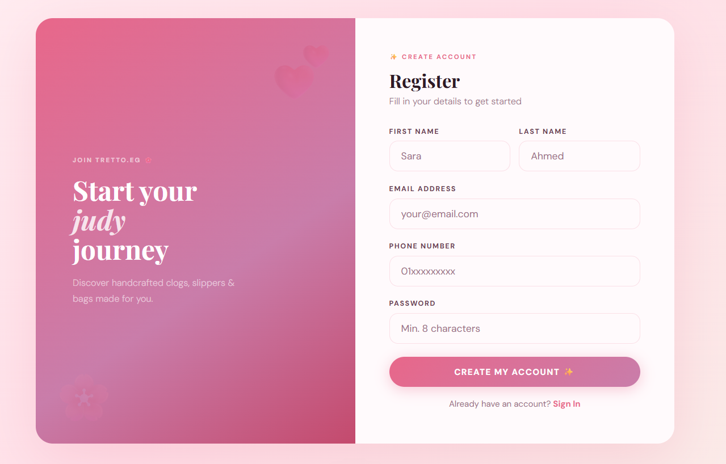
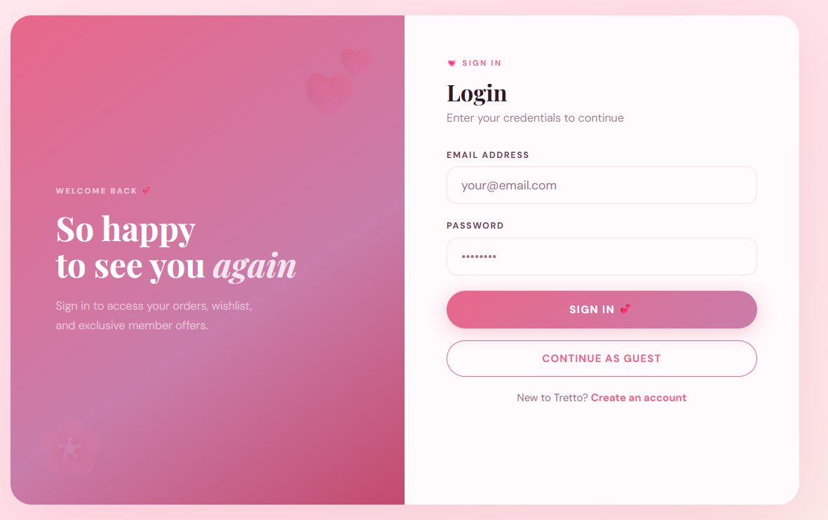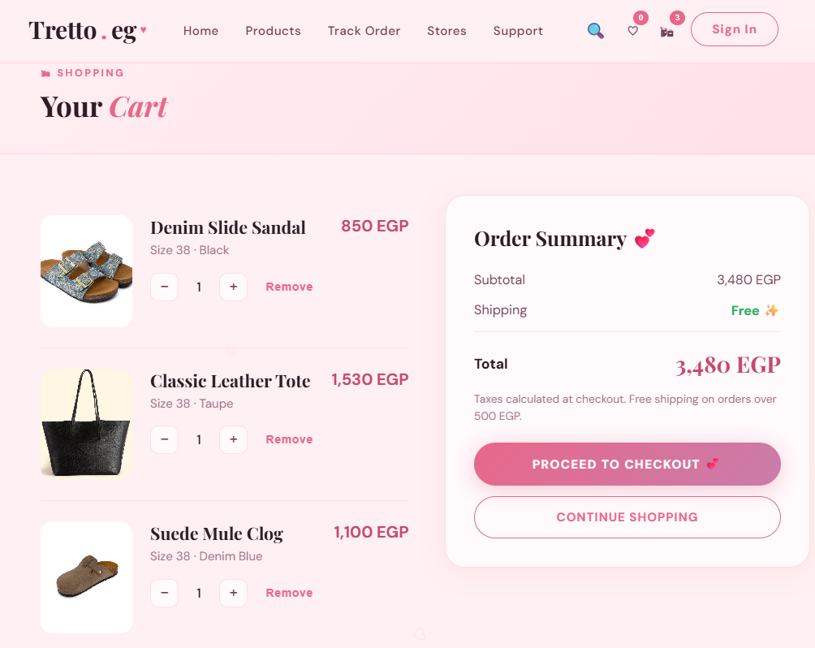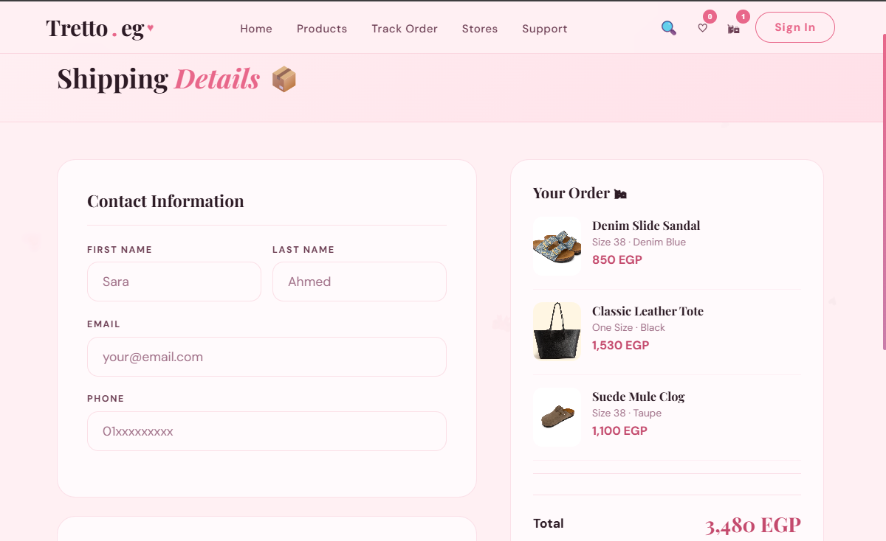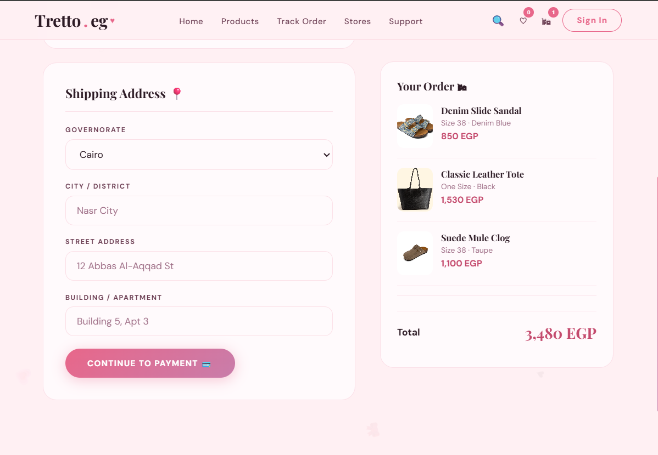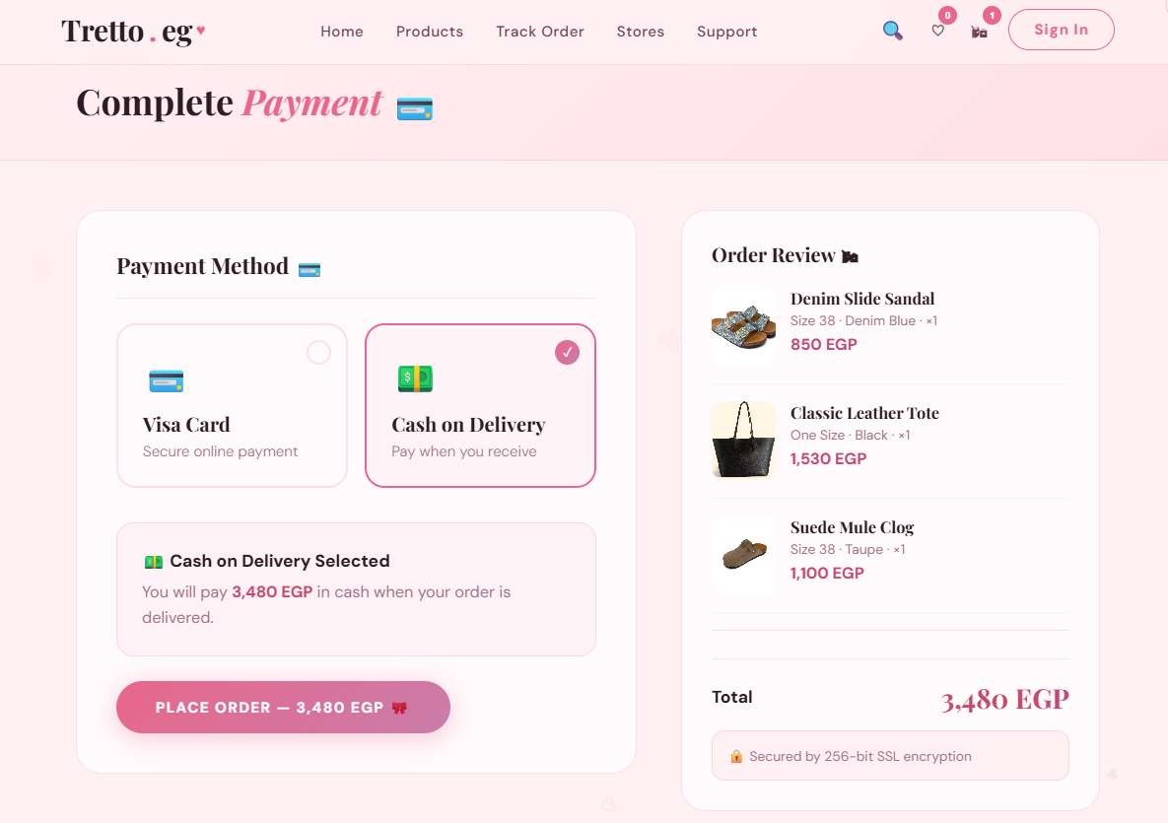

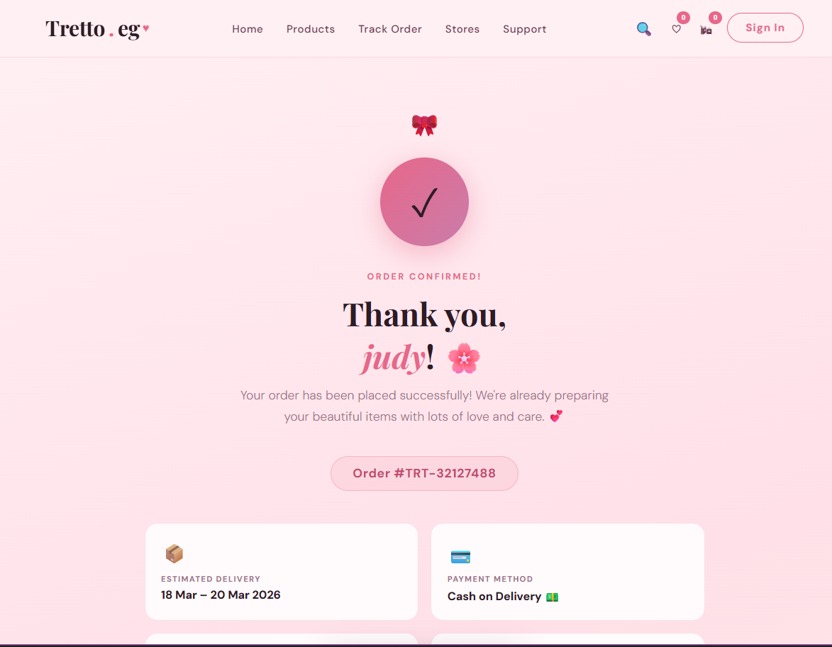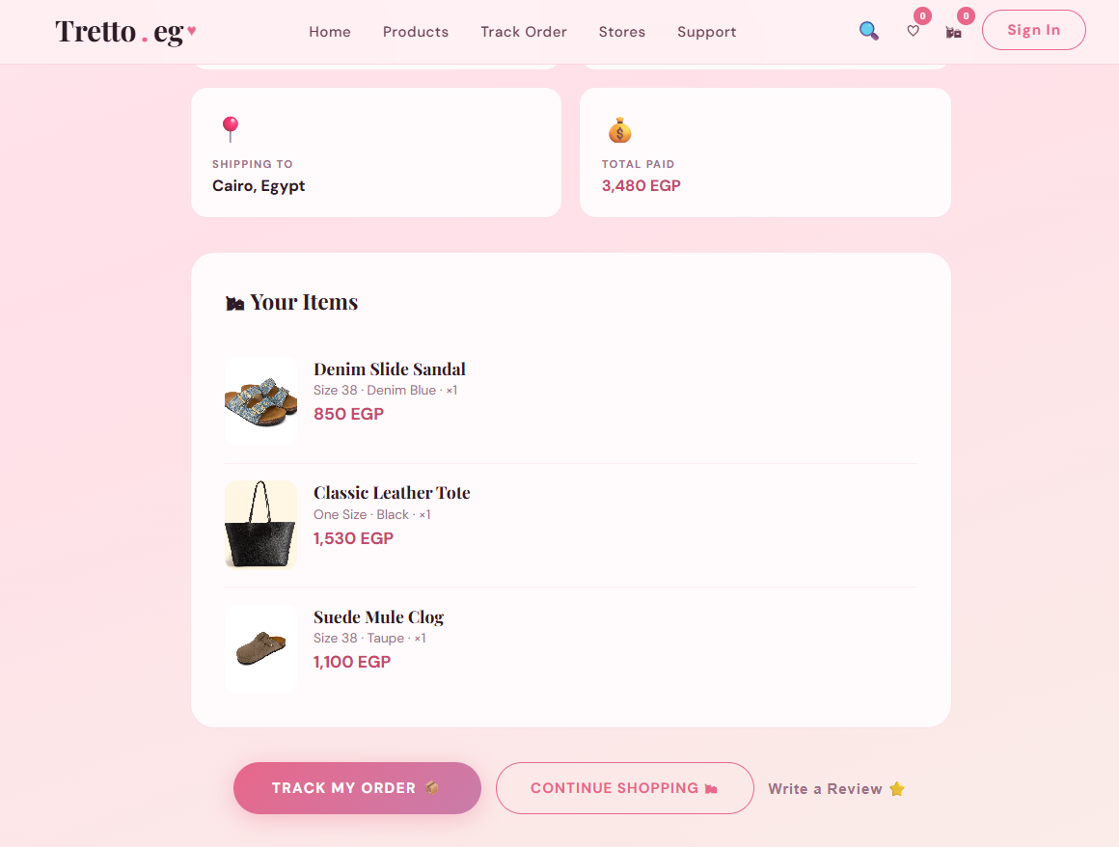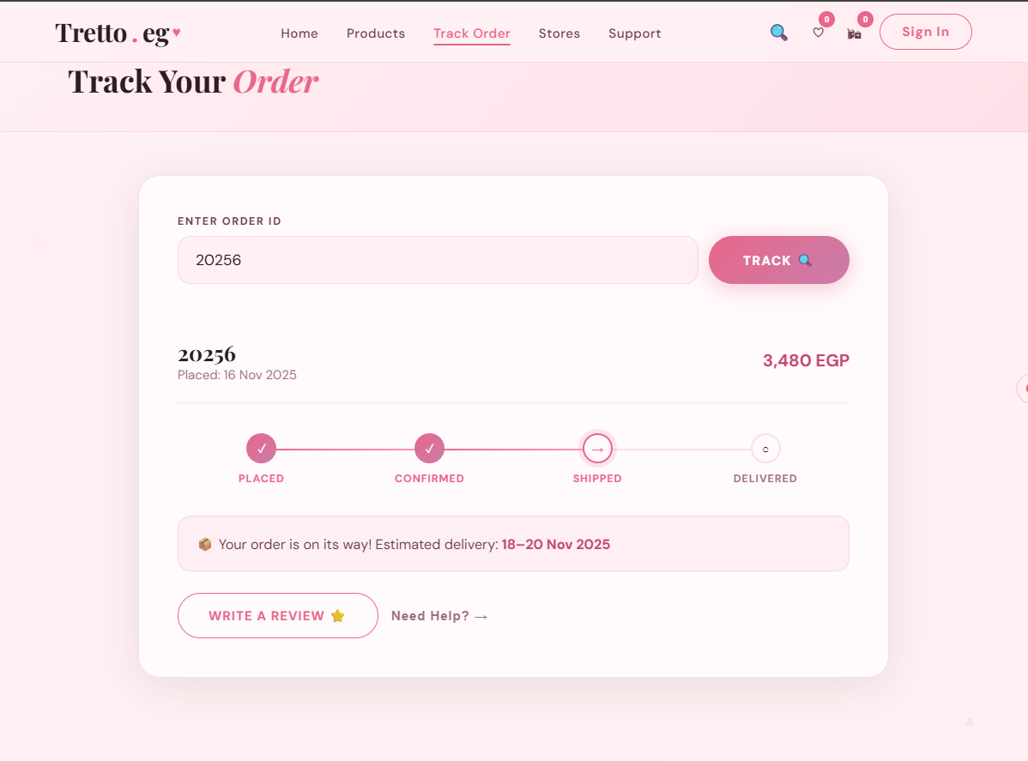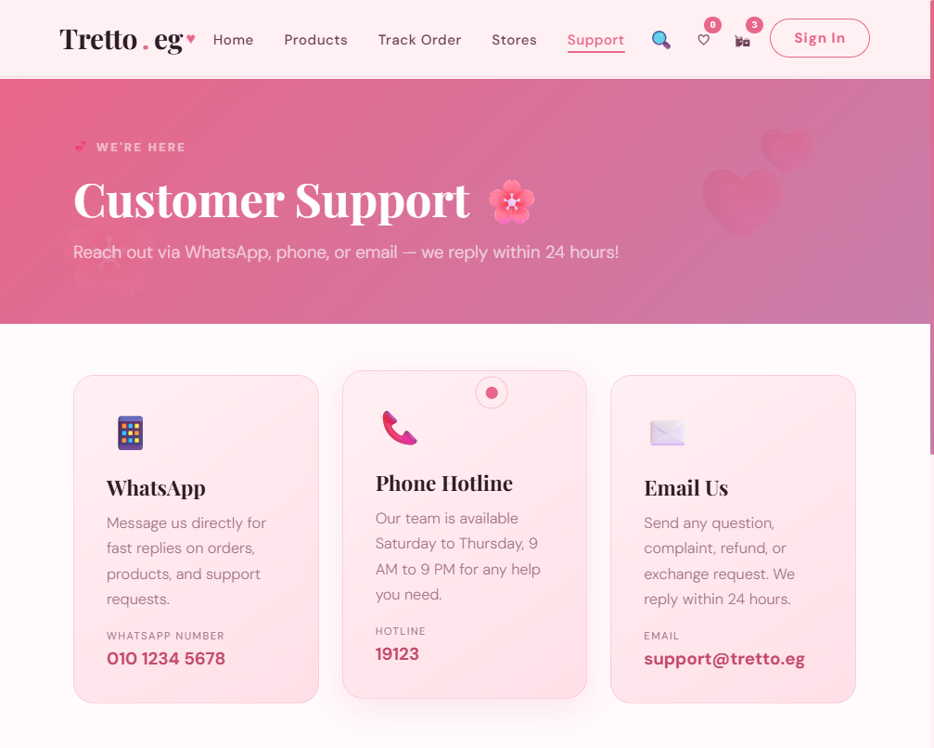

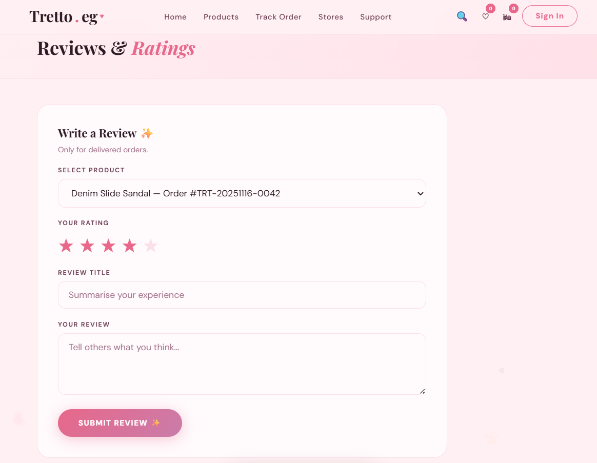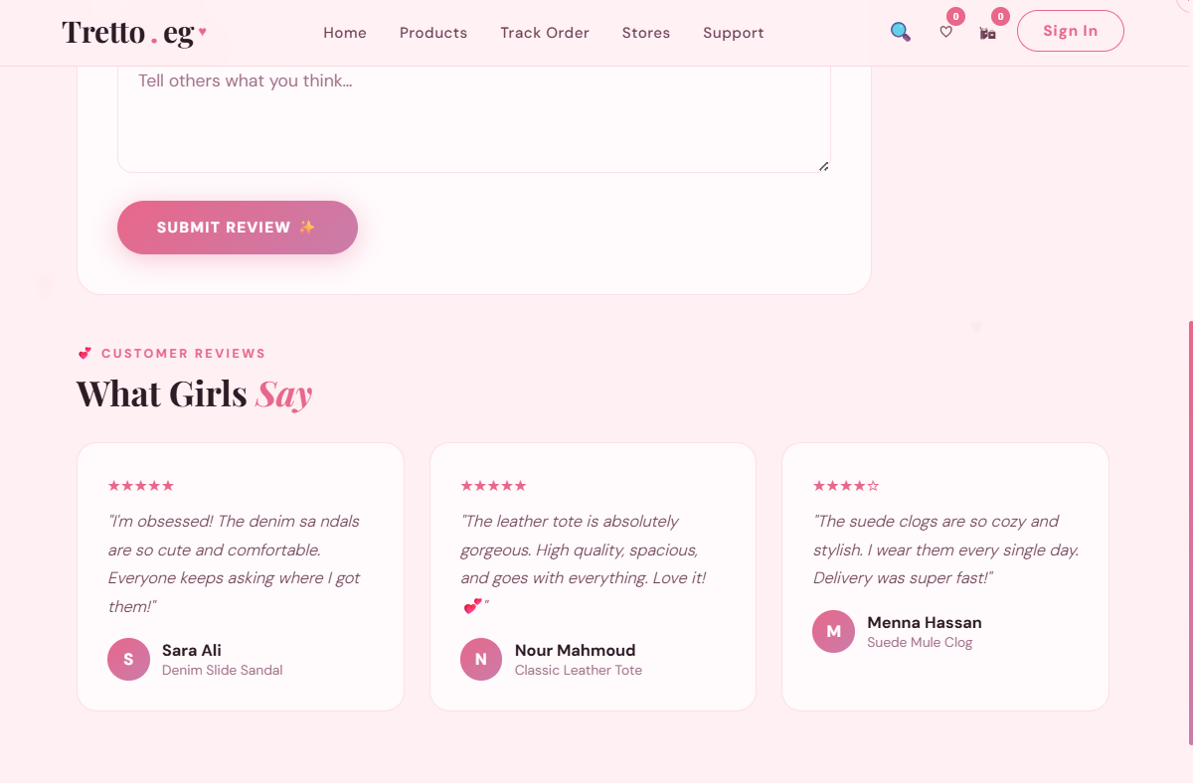
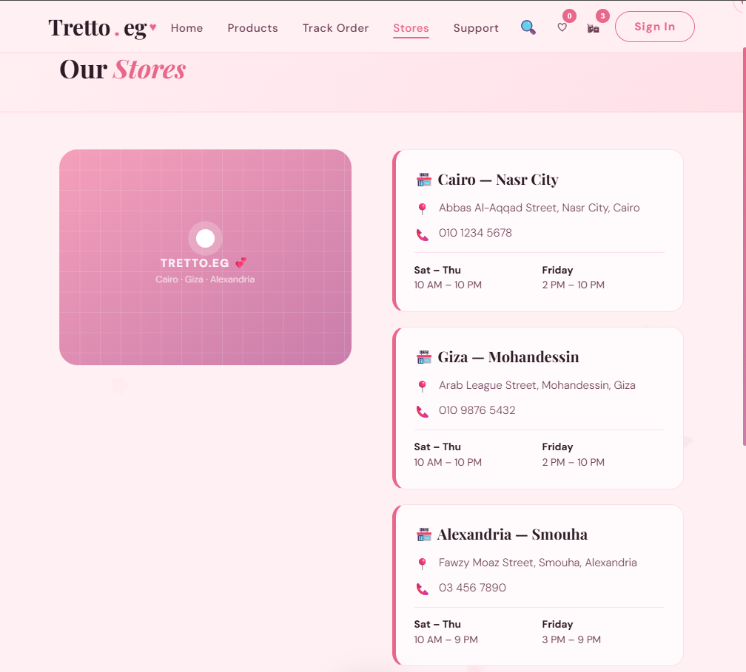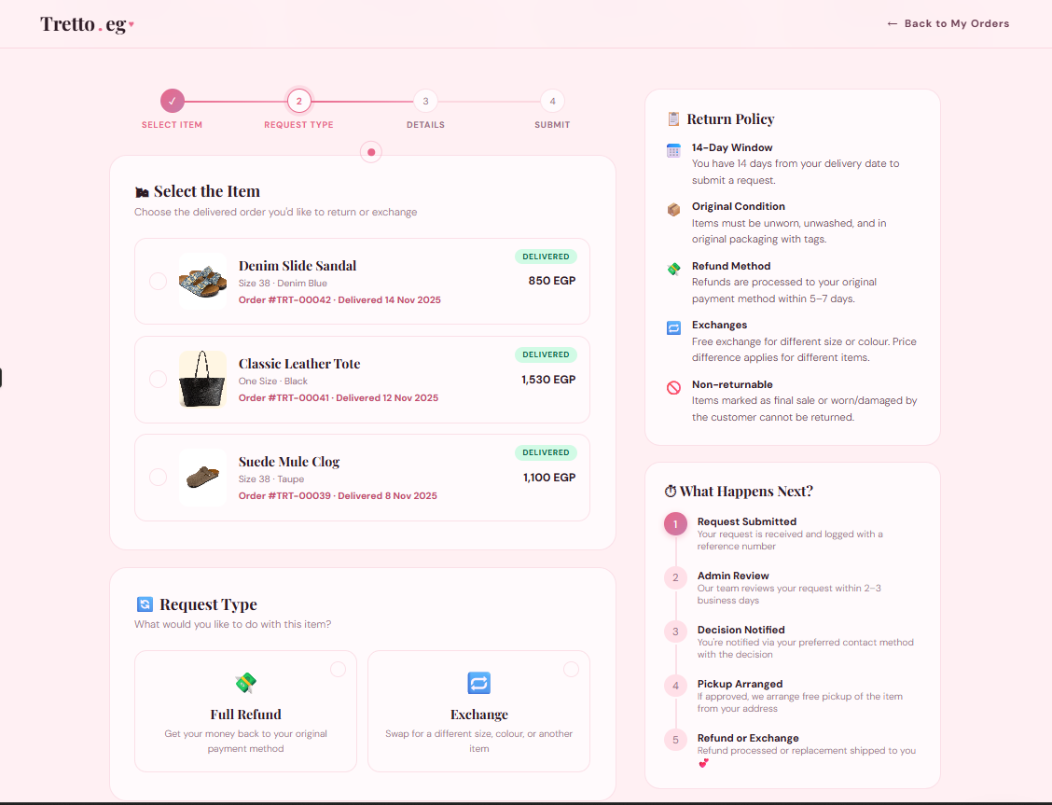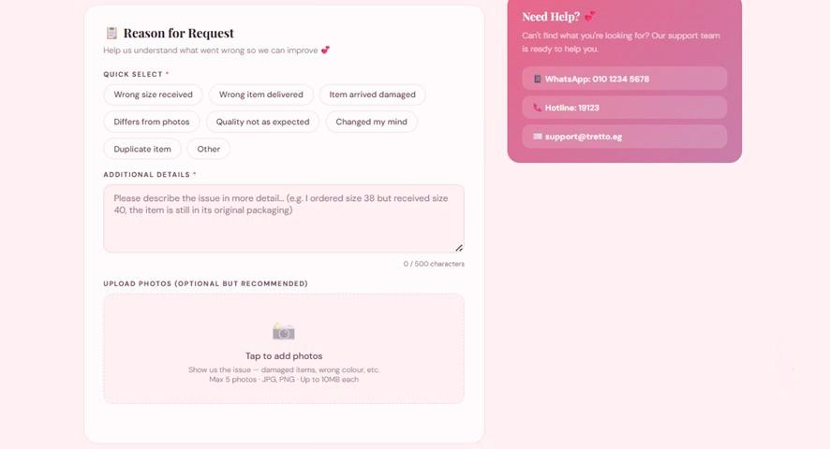

2-Admin interface
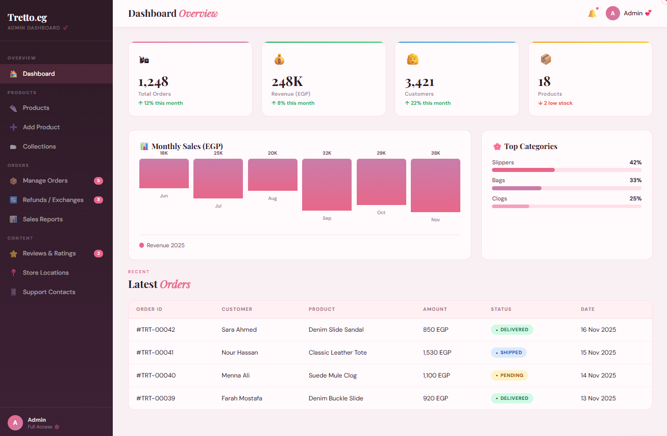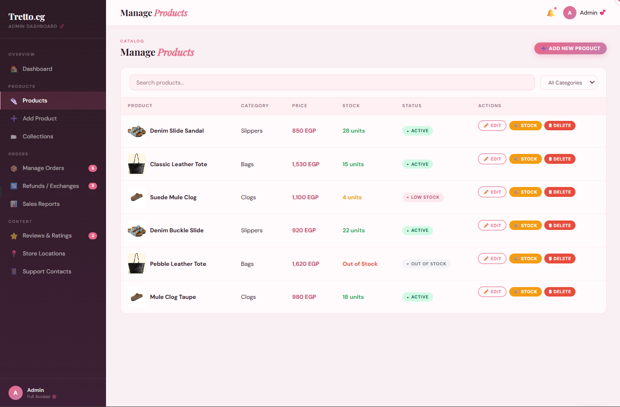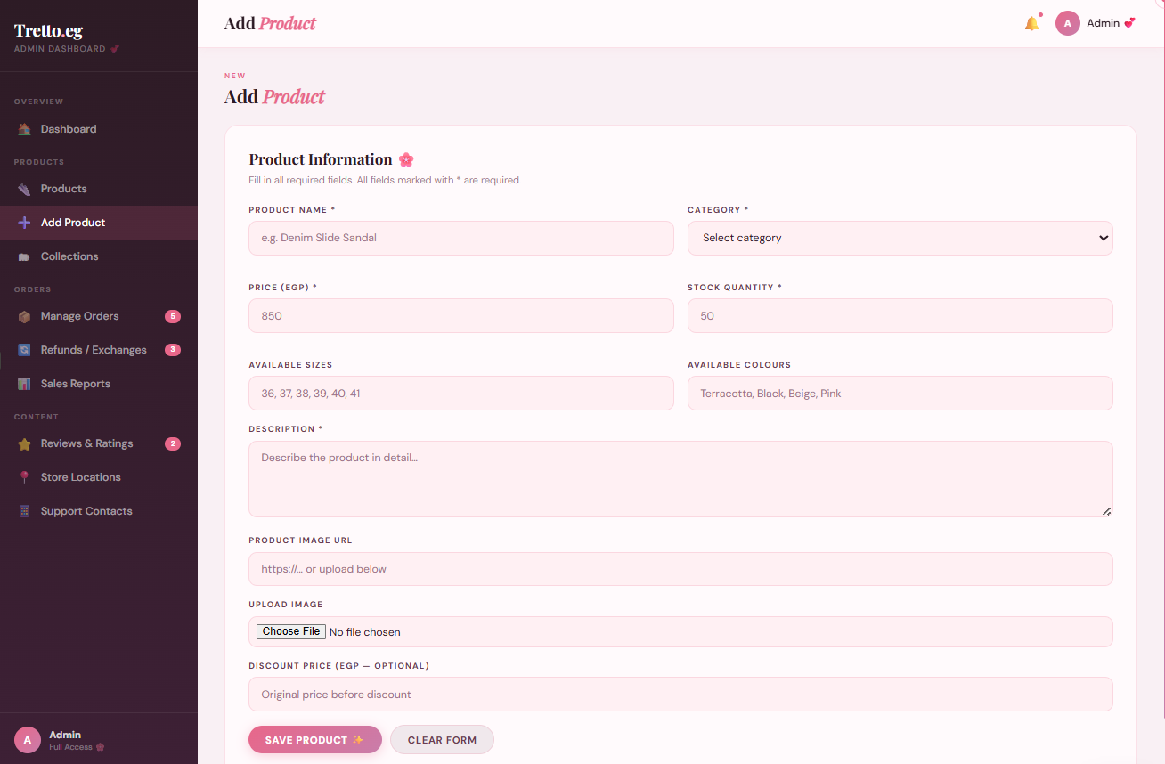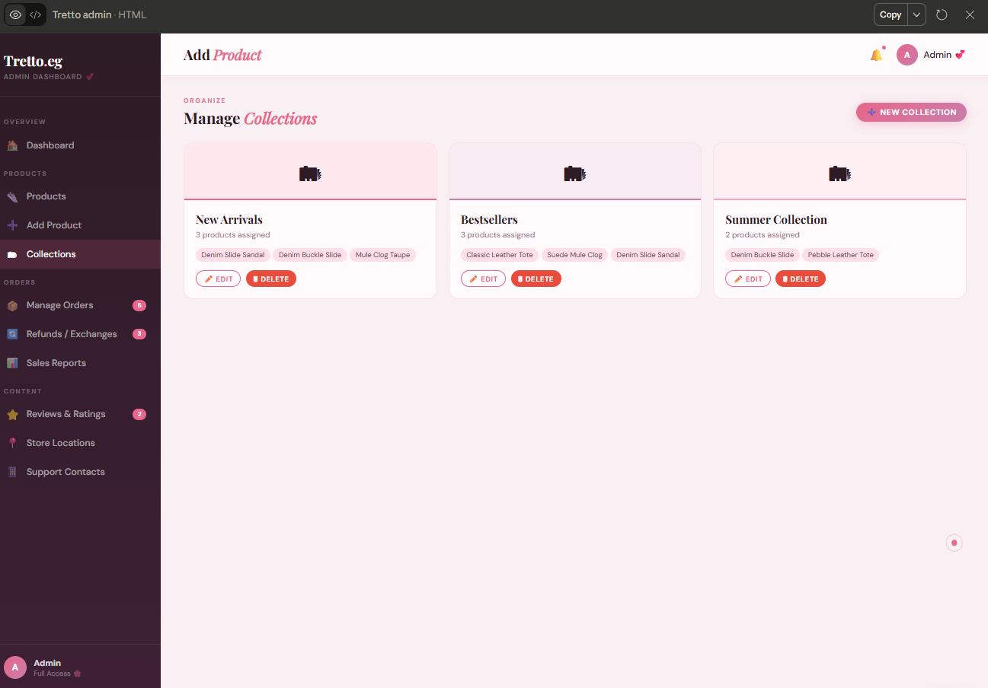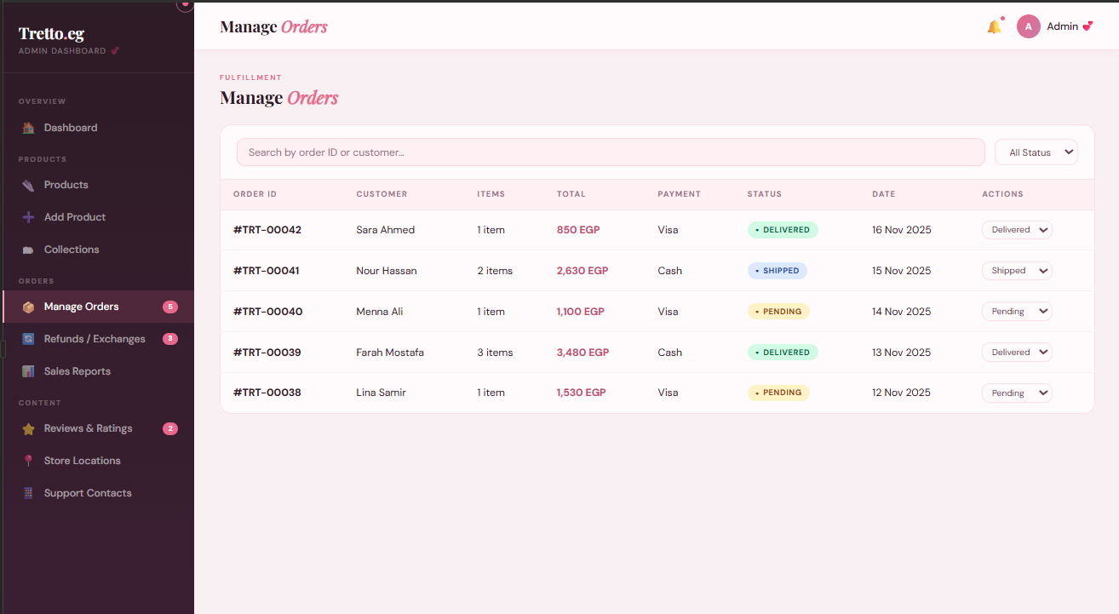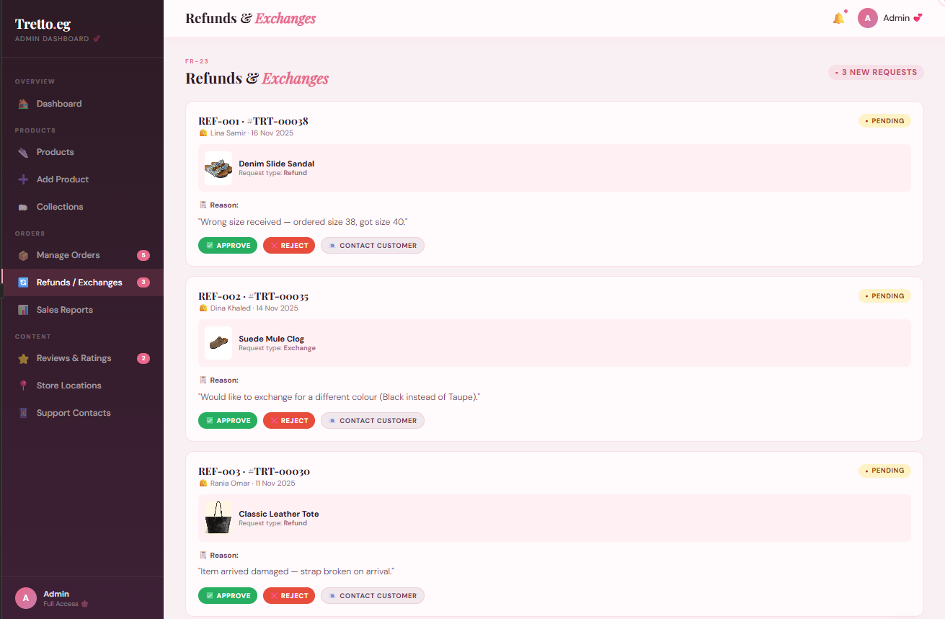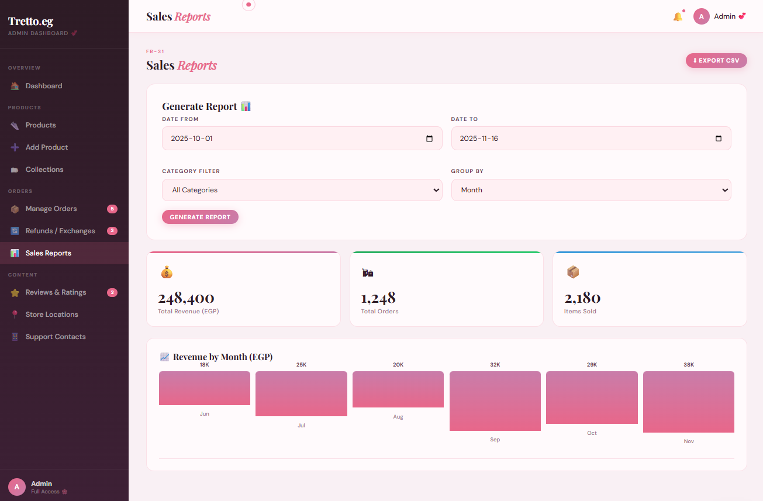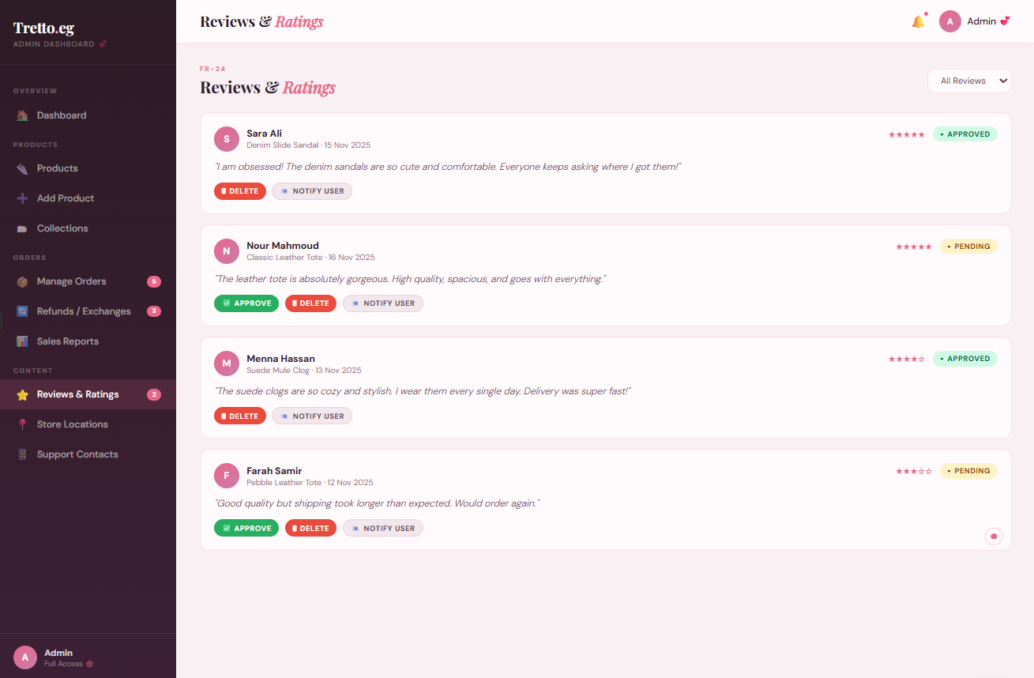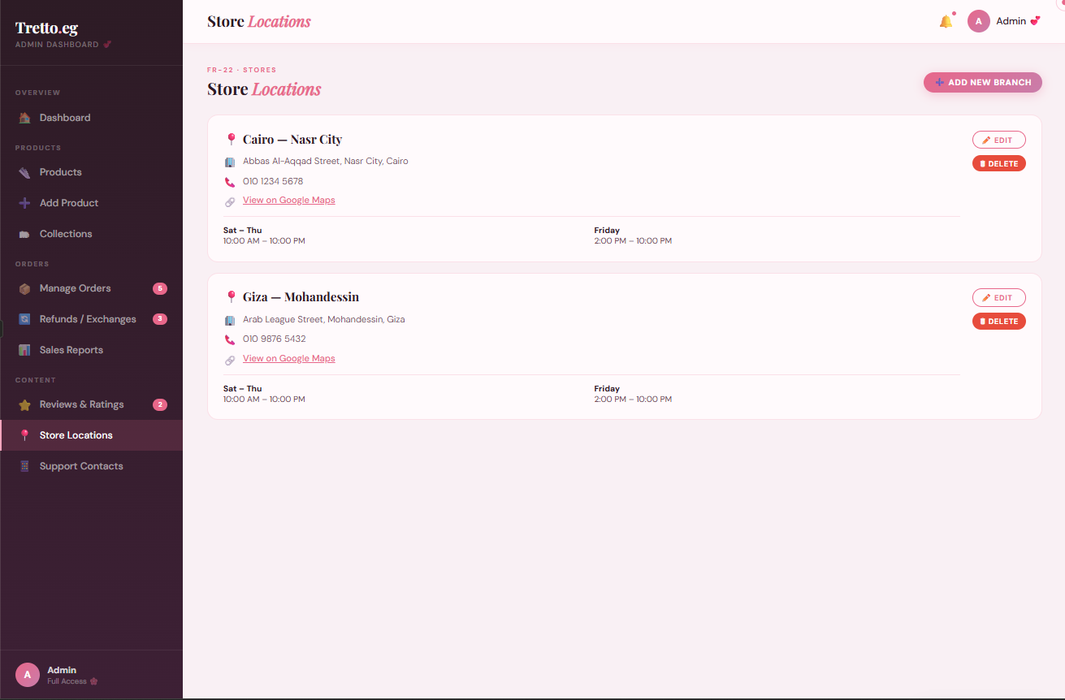
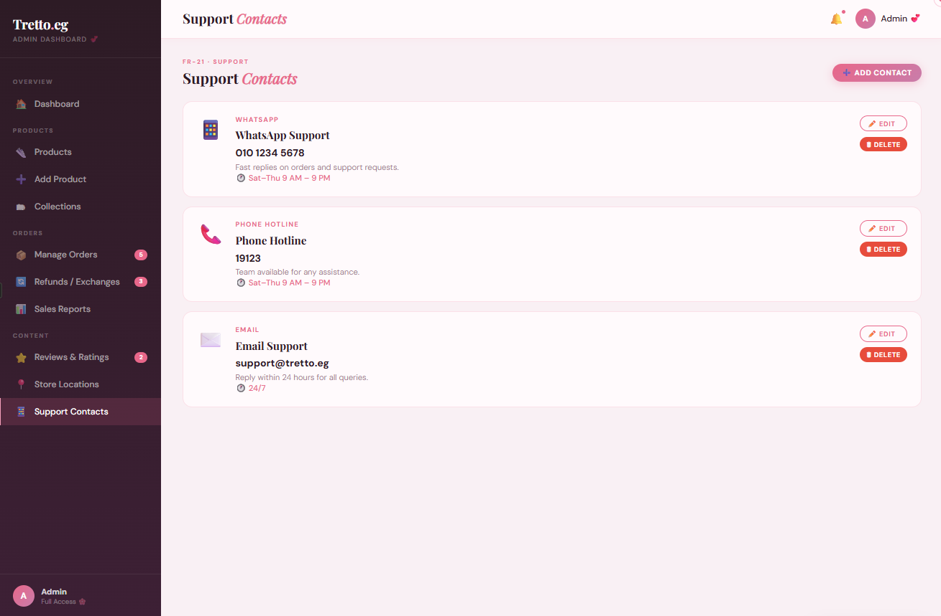
4.1.2 CLI
The system is designed as a web-based application and does not provide a command-line interface. All functionalities are accessible through the graphical user interface (GUI).

4.1.3 API
Payment Gateway API | Google Maps API
Used during the checkout process to handle Visa card transactions securely. The system sends the order amount and card details to the external banking payment gateway. The gateway returns a success or failure response, which the system uses to confirm or reject the order. | Used on the Store Location page to display the physical store location on an interactive map. The system passes the store coordinates to the Google Maps API and embeds the map view on the page.
4.1.4 Diagnostics or ROM
Describes how to obtain debugging information or other diagnostic data.
4.2 Hardware Interfaces
No direct hardware interfaces required.
4.3 Communications Interfaces
Describes network interfaces.
4.4 Software Interfaces
1) Payment Gateway: The system connects to a payment gateway to process Visa card payments during checkout.
2) Google Maps API: The system uses Google Maps API to display the store location on the map
5 Performance Requirements
Speed: The system must load pages within 3 seconds under normal usage conditions. Search, filter, and sort operations must return results in real time without delay.
Memory: The system must operate efficiently on simple, low-end hardware without requiring high memory capacity or processing power.

6 Design Constraints
This section specifies the constraints that the design team must consider when designing and implementing the Retail Management System for TRETTO.EG.
6.1 Standards Compliance
The system must resemble well-known systems and avoid any innovations to ensure ease of use for employees and managers. The database must maintain data integrity, and the code must be simple and clear.
6.2 Hardware Limitations
The system must be designed to work on all mid-range and low-end devices; it doesn't need a powerful machine to run it, nor does it require a certain amount of RAM, processors, or anything like that, to allow all shops and employees to use it easily.
6.3 others as appropriate
The system must run on all modern web browsers without requiring any extra. Both the online and POS systems require a stable internet connection to communicate with the central server. The system must be designed to support future growth such as new products and store locations without major changes. Both systems must share the same central database to ensure data consistency across all operations.

7 Other non-functional attributes
Specifies any other particular non-functional attributes required by the system. Examples are provided below.
7.1 Security
Only administrators, such as managers or senior staff, should be authorized to access and modify product data and information. It's important to note that even these individuals will be prohibited from viewing confidential customer data, which is often banking information related to payments.
7.2 Binary Compatibility
7.3 Reliability
The system must be able to withstand the pressure on it without server crashes, for example, and it must be able to handle the large number of orders and the current number of people using it, without any malfunctions that disrupt sales, and it must constantly monitor the database and inventory.
7.4 Maintainability
The system needs to be able to handle maintenance and updates continuously, and it shouldn't have to shut down completely, restructure the work from scratch, or damage anything within the system to update it.
7.5 Portability
The system needs to be seamlessly switchable between devices, like mobile phones, home computers, and laptops, so that everyone can use it without needing major technological changes.
7.6 Extensibility
7.7 Re-usability
7.8 Application Affinity/Compatibility
7.9 Resource Utilization
7.10 Serviceability
7.11 others as appropriate

8 Preliminary Object-Oriented Domain
This section presents a list of the fundamental objects that must be modeled within the system to satisfy its requirements. The purpose is to provide an alternative, ”structural” view on the requirements stated above and how they might be satisfied in the system. A primitive class diagram to be delivered.

8.1 Inheritance Relationships
This section should contain a set of graphs that illustrate the primary inheritance hierarchy (is-kind-of) for the system. For example:
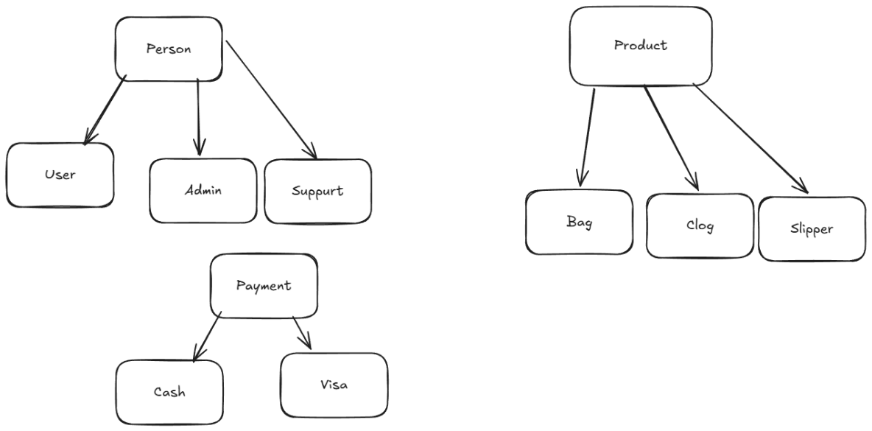
Figure 1: Inheritance Relations

8.2 Class descriptions
This section presents a more detailed description of each class identified during the OO Domain Analysis. For more details on the process giving rise to these descriptions, see Lecture 5.3: OO Domain Analysis and/or texts on object-oriented software development. Each class description should conform to the following structure:
    - Class Name: Person
- Abstract or Concrete: Abstract
- List of Superclasses:None
- List of Subclasses: User ,Admin
- Purpose: To serve as a base class that defines the common identity and contact information for all individuals interacting with the system, whether they are customers or staff.
- Collaborations:
- Store Location: Associates a person with a specific physical branch or regional location.
- User: Inherits attributes to facilitate shopping and profile management.
- Admin: Inherits attributes to facilitate system management and oversight.
- Product: To get Details of products.
- Attributes:
- ID: int (e.g.,”101”)
- name: String (e.g., "John Doe")
- email: String (e.g., "john@example.com")
- password: String (e.g., “Avasds21!.2” )
- Operations:
- Login(email, password)
- Arguments: None
- Return Value: String
- Side Effects: None.
- Logout()
- Arguments: None
- Return Value: void
- Side Effects: Invalidates the current session token and changes the system state to "Logged Out."
- viewProducts()
- Arguments: None
- Return Value: List<Product>
- Side Effects: None. This is a query operation that retrieves data from the Product database.
- SearchProducts()
- Arguments: keyword: String
- Return Value: List<Product>
- Side Effects: None. Filters the product list based on the string provided.
- Filter Products()
- Arguments: category: String, price Range: Double
- Return Value: List<Product>
- Side Effects: None. Narrows the visible product set based on specific attributes like "Bag" or "Clogs."
- Sort Products()
- Arguments: criteria: String (e.g., "Price Low to High")
- Return Value: List<Product>
- Side Effects: Reorders the current view of the product list; does not change actual product data.
- viewStoreLocation()
- Arguments: None
- Return Value: Store Location (Object or String)
- Side Effects: None. Retrieves the address and details of the associated physical store.
- View Popular()
- Arguments: none
- Return Value: void
- Side Effects: Shows The popular products on the website
- Browse Collection()
- Arguments: target Collection: Collection
- Return Value: List<Product>
- Side Effects: None. Returns the list of products stored within a specific Collection.
- Constraints:
- password must be hard to identify.
- Email must follow a standard electronic mail format.
    - Class Name: User
- Abstract or Concrete: Concrete
- List of Super classes: Person
- List of Subclasses: None
- Purpose: To represent the customer entity within the system. This class handles the personal shopping experience, allowing the individual to manage their own cart, save favorites, and provide feedback on products.
- Collaborations:
- Cart: Interacts to add, remove, and view items intended for purchase.
- Review: Interacts to create and submit feedback/ratings for products.
- Favorite: Interacts to save specific products for later viewing.
- Collection: Interacts to organize favorite items into specific groups.
- Order: Interacts to convert a cart into a finalized purchase record.
- Payment Send the request to Pay
- Refund: Request Refund for product
- Exchange: Request Exchange for product
- Attributes:
- ShippingAddres: String (e.g., "Street Ahmed fath")
- PhoneNumber: String (e.g., "012234567")
- Operations:
- register()
- Arguments: newName: String, newEmail: String
- Return Value: voidSide
- Effects: Changes the state of the name and email variables
- addToCart()
- Arguments: productID: String, quantity: Integer
- Return Value: void
- Side Effects: Updates the state of the Cart by adding the specified product and quantity.
- removeFromCart()
- Arguments: productID: String
- Return Value: void
- Side Effects: Removes the specified item from the Cart state variables.
- addToFavorite()
- Arguments: productID: String
- Return Value: void
- Side Effects: Adds the specific Product reference to the User's persistent Favorite list.
- SubmitReview()
- Arguments: productID: String, rating: Integer, comment: String
- Return Value: Boolean
- Side Effects: Creates a new Review entry in the database associated with both the User and the Product.
- ProcessCheckOut()
- Arguments: None
- Return Value: Order
- Side Effects: Converts the current Cart contents into a finalized Order and clears the Cart state.
- Request_Refund()
- Arguments: orderID: String, reason: String
- Return Value: Boolean
- Side Effects: Creates a new Refund record in the system and notifies the admin for approval.
- TrackOrder()
- Arguments: current Order: Order
- Return Value: String (e.g., "In Transit" or "Delivered")
- Side Effects: None. Retrieves the current status from the Order object.
- Place_Order()
- Arguments: current Order: Order
- Return Value: void
- Side Effects: Changes the state of the Order from "Pending" to "Placed" and updates inventory levels.
- RequestSupport()
- Arguments: subject: String, message: String
- Return Value: void
- Side Effects: Generates a support ticket linked to the User profile.
- ProcessPayment()
- Arguments: payment Details: Visa, target Order: Order
- Return Value: Boolean
- Side Effects: Connects to the Payment interface; updates the Order state to "Paid" upon success.
- RequestExChange ()
- Arguments: None
- Return Value: void
- Side Effects: Request A Exchange for a product in database
- SubmitReview()
- Arguments: ReviewID: int : Integer, comment: String
- Return Value: void
- Side Effects: Submit the Review entry in the database associated with both the User and the Product.
- Constraints:
- Login Status: Must be authenticated to use Process Checkout, Submit Review, or Request Refund.
- Unique Email: No two Users can share the same email address.
- Review Rule: Rating must be between 1 and 5; User must have purchased the product first.
- Order Status: Process Checkout is only allowed if the Cart is not empty.
- Refund Limit: Request Refund must be initiated within 14 days of delivery.
- Payment Validation: Visa payments must receive external bank authorization to proceed.
- Collection Limit: Maximum of 10 Collections per User.
    - Class Name: admin
- Abstract or Concrete: Concrete
- List of Superclasses:Person
- List of Subclasses: None
- Purpose: To manage the system’s backend operations, including inventory control, processing customer refunds, and maintaining store location data.
- Collaborations:
- Product: To add, update, or remove inventory.
- Refund: To review and approve/deny customer refund requests.
- Store Location: To manage physical branch details.
- Order: To monitor sales and manage order statuses.
- Review: Edit the reviews or delete it
- Collection: Manage it
- Exchange: Get Request For exchange product
- Attributes: None
- Operations:
- Add Products()
- Arguments: None
- Return Value: void
- Side Effects: Add a new Product To database
- Modify Products()
- Arguments: p: Product
- Return Value: void
- Side Effects: Modifies the Product.
- Delete Products()
  - Arguments: productID: int
  - Return Value: void
  - Side Effects: Delete Product from the list
- Update Stock()
    - Arguments: Number: int, p: Product
    - Return Value: void
    - Side Effects: Update the product Stock easily
- View_Orders()
    - Arguments: Orders: Order
    - Return Value: List<Order >
    - Side Effects: Get List of orders to show up to Admin.
- Modify_Order()
- Arguments: OrderID: Order
- Return Value: void
- Side Effects: Modify Order Status or anything inside it.
- Delete_Order()
- Arguments: OrderID: Order
- Return Value: void
- Side Effects: Delete the Order from user.
- DeleteReview()
- Arguments: reviewID: String
- Return Value: void
- Side Effects: Removes a specific Review entry from the database and updates the product's average rating.
- Apply Refund()
- Arguments: target Refund: Refund
- Return Value: void
- Side Effects: Executes the financial transfer back to the user and marks the Refund as "Completed."
- Deny_Refund()
- Arguments: target Refund: Refund
- Return Value: void
- Side Effects: Marks the Refund request as "Rejected" and notifies the user with a reason.
- Add_Store_Location()
- Arguments: new Location: Store Location
- Return Value: void
- Side Effects: Adds a new physical branch entry to the system's Store Location list.
- Edit_Store_Location()
- Arguments: existing Location: StoreLocation,Name: String
- Return Value: void
- Side Effects: Updates the address, hours, or contact info of an existing Store Location.
- Add Support()
- Arguments: support Ticket: String
- Return Value: void
- Side Effects: Creates a support response or a new knowledge base entry for users to access.
- Modify Support()
- Arguments: support Ticket: String
- Return Value: void
- Side Effects: Modify a support response or a new knowledge base entry for users to access.
- Add_Collection()
- Arguments: None
- Return Value: void
- Side Effects: Add Collection to List
- Modify Collection()
- Arguments: Collection: Object
- Return Value: void
- Side Effects: Edit the collection
- Delete Collection()
- Arguments: target Collection: Collection
- Return Value: void
- Side Effects: Delete the selected Collection
- GetTopSellingProducts()
  - Arguments: Product
  - Return Value: List<Product>
  - Side Effects: Queries the Order history to count sales per item and sorts them.
- CalculateMonthlyRevenue()
  - Arguments: Product
  - Return Value: float
  - Side Effects: Scans all "Completed" orders for that time period and sums the totals.
- GetLowStockAlerts()
- Arguments: Product
- Return Value: List<Product>
- Side Effects: None.
- Apply_Exchange ()
- Arguments: Person
- Return Value: void
- Side Effects: None.
- Deny_Exchange()
- Arguments: Person
- Return Value: void
- Side Effects: None.
- Manage_popular_products()
- Arguments: none
- Return Value: void
- Side Effects: Edit Popular products to appear.
- Constraints for Admin
- High Security: Admins must use Two-Factor Authentication (2FA) to log in.
- Permission Level: The Process Refund operation can only be performed by Admins with an access Level of 2 or higher.
- Audit Trail: Every Manage Products action must be logged with a timestamp and the adminEmployeeID.
- Conflict of Interest: An Admin cannot approve a refund for an order they placed themselves as a User.
    - Class Name: support
- Abstract or Concrete: Concrete
- List of Superclasses:Person
- List of Subclasses: None
- Purpose: To Add Support Person to help Users
- Collaborations: None
- Attributes: Number: String, Email: String
- Operations:(As requested, no operations listed for this class.)
- Constraints: None
    - Class Name : product
- Abstract or Concrete: Concrete
- List of Superclasses:None
- List of Subclasses:Bag,Clogs, Slipper
- Purpose: To represent the physical items available for purchase in the store. This class stores the essential details, physical characteristics, and inventory levels of each item.
- Collaborations:
- User: Interacts via search, viewing, and adding to favorites.
- Review: Holds a collection of feedback and ratings linked to the product.
- Cart: Is added as an item within a cart for the checkout process.
- Admin: Managed and updated by administrative staff (price changes, stock updates).
- Collection: Hold the product in category’s and filters
- Refund: Hold the products that will Refund
- Exchange: Make Exchange for the product
- Attributes:
- PID: int
- Name: String (e.g., "Classic Leather Bag")
- Price: Double (e.g., 120.00)
- StockQuantity: Integer (Range: 0 to 5000)
- Color: String (e.g., "Midnight Black")
- Size: String (e.g., "Large" or "42 EU")
- Number_of_Selling: int (e.g.,”102”)
- Operations:(As requested, no operations listed for this class.)
- Constraints:
- Unique Identity: Each PID must be unique within the global catalog.
- Positive Value: The Price attribute must always be greater than 0.00.
- Inventory Control: Stock Quantity cannot be a negative number.
- Subclass Specifics: If the product is a Slipper or Clog, the Size attribute must follow standard footwear scaling.
    - Class Name : bag
- Abstract or Concrete: Concrete
- List of Superclasses:Product
- List of Subclasses: None
- Purpose: To represent a specific type of product designed for carrying items, categorized by its volume and storage organization.
- Collaborations: Product: Inherits core attributes like PID, Price, and Name.
- Attributes: capacity Liters: Double (e.g., 15.5 or 25.0) , Num Packets: Integer (e.g., 3 or 5)
- Operations:(No operations listed.)
- Constraints:
- capacity Liters must be a positive value.
- Num Packets must be at least 1 (main compartment).
    - Class Name: clogs
- Abstract or Concrete: Concrete
- List of Superclasses:Product
- List of Subclasses: None
- Purpose: To represent a specialized type of footwear characterized by specific heel dimensions and security features (straps).
- Collaborations:Product: Inherits core attributes like PID and Size.
- Attributes: heel Height: Double (e.g., 2.5 or 5.0), StrapType:String (e.g., "Adjustable", "Fixed", "Pivoting")
- Operations:(No operations listed.)
- Constraints:heelHeight must be measured in centimeters and cannot be negative.
    - Class Name: Slipper
- Abstract or Concrete: Concrete
- List of Superclasses:Product
- List of Subclasses: None
- Purpose: To represent indoor or comfort-focused footwear defined by the tactile quality of its build material.
- Collaborations:Product: Inherits core attributes like Color and Price.
- Attributes: material Softness: String (e.g., "Extra Soft", "Firm", "Memory Foam")
- Operations:(No operations listed.)
- Constraints: material Softness must be chosen from a predefined list of comfort ratings
    - Class Name: review
- Abstract or Concrete: Concrete
- List of Super classes: None
- List of Subclasses: None
- Purpose: To capture and store customer feedback, allowing users to rate and comment on their purchases.
- Collaborations:
- User: The author of the review who provides the data.
- Product: The subject being reviewed.
- Admin: Monitors and manages reviews (can delete if inappropriate).
  - Attributes:
- ReviewID: int (“101”)
- Rating: Integer (Range: 1 to 5)
- Review Comment: String (e.g., "Very comfortable and durable!")
- Operations: (No operations listed.)
- Constraints:
- Rating must be an integer between 1 and 5.
- A Review must be linked to both a valid User and a valid Product
    - Class Name : favorite
- Abstract or Concrete: Concrete
- List of Super classes: None
- List of Subclasses: None
- Purpose: To allow users to bookmark specific products they are interested in for quick access later.
- Collaborations:
- User: The owner of the favorites list.
- Product: The item being "favorited."
- Attributes: FavID: int , item List: List<Product>
- Operations: (No operations listed.)
- Constraints:
- FavID must be unique.
- A Product can only be added once to a specific User’s Favorite list.
    - Class Name : Collection
- Abstract or Concrete: Concrete
- List of Superclasses: None
- List of Subclasses: None
- Purpose: To provide a way for users to organize their favorite products into themed groups (e.g., "Summer Essentials").
- Collaborations:
- User: The individual who creates and manages the collection.
- Product: To Add product into the collection
- Admin: To Modify it
- Attributes:
- CollectionID: int
- Collection Name: String (e.g., "Winter Picks")
- item List: List<Product>
- Operations:(No operations listed.)
- Constraints:
- CollectionName cannot be empty.
- A Collection must belong to exactly one User.
    - Class Name : Store location
- Abstract or Concrete: Concrete
- List of Superclasses: None
- List of Subclasses: None
- Purpose: To represent the physical retail branches where products are stocked and staff are assigned.
- Collaborations:
- Person: Provides the general identity link for anyone visiting or worki22qang at the store.
- Admin: Manages the store's operational details and inventory.
- Product: Represents the inventory physically located at this specific branch.
- Attributes:
- BrandID: int
- City: String (e.g., "New York")
- Address: String (e.g., "5th Avenue, Suite 10")
- Operations: (No operations listed.)
- Constraints:
- Each BrandID must be unique to a specific physical location.
- The city must be selected from a pre-validated list of operating regions.
    - Class Name: Track Order
- Abstract or Concrete: Concrete
- List of Superclasses: None
- List of Subclasses: None
- Purpose: To manage the digital fulfillment details for purchases made through the web or mobile interface.
- Collaborations: Order Provides the logistics data (shipping and tracking) for a specific transaction.
- Attributes:
- ShippingAddress: String (e.g., "123 Maple St, Springfield")
- TrackingNumber: String (e.g., "1Z999AA10123456784")
- Shipping fee: float (e.g.,”1.2*100)
- Order_Current_Location: String (“St: Cairo”)
- Delivery_Name: String(“Ahmed”)
- Delivery_Number: String(“010101”)
- Operations: (No operations listed.)
- Constraints: TrackingNumber must be generated only after the Order status is "Shipped."
    - Class Name: Order
- Abstract or Concrete: Concrete
- List of Superclasses: None
- List of Subclasses: None
- Purpose: To act as the central record for a completed transaction, linking the customer, their items, and their payment.
- Collaborations:
- User: The customer who placed the order.
- Cart: The source of the products and quantities for the order.
- Online: Provides shipping details if the order is handled digitally.
- Payment: Links to the financial transaction (Visa or Cash).
- Admin: Allows staff to monitor and update the order's progress.
- Refund: Get Order Data to Refund
- Exchange: Get Order Data to Exchange
- Attributes:
- OrderID: int
- Order Date: Date (e.g., "2024-05-20")
- total Amount: Double (e.g., 250.75)
- Order Status: String (e.g., "Pending", "Paid", "Cancelled")
- Operations: (No operations listed.).
- Constraints:
- OrderID must be unique and non-modifiable once created.
- Total Amount must equal the sum of items in the Cart plus shipping fees
    - Class Name : Cart
- Abstract or Concrete: Concrete
- List of Superclasses: None
- List of Subclasses: None
- Purpose: To serve as a temporary holding area for products a user intends to buy before finalizing an order.
- Collaborations:
- Person: The individual currently shopping.
- Order: Transfers its contents to an Order object upon successful checkout.
- Product: Get products data to show in cart and checkout
- Attributes:
- CartID: int
- total Amount: Double (Sum of all item prices in the cart)
- item List: List<Product>
- Operations: None
- Constraints: total Amount must update automatically whenever a Product is added or removed.
    - Class Name: Refund
- Abstract or Concrete: Concrete
- List of Superclasses: None
- List of Subclasses: None
- Purpose: To manage the process of returning funds to a customer for a returned or cancelled order.
- Collaborations:
- User: The person requesting the money back.
- Admin: The staff member who must review and authorize the refund.
- Attributes:
- RefundID: int
- reason: String (e.g., "Defective Product", "Wrong Size")
- Refund_Amount: Double (The specific amount being returned)
- Status: String (e.g.”Deny”)
- Operations: (No operations listed.)
- Constraints:
- Refund_Amount cannot exceed the total Amount of the original Order.
- A Refund cannot be processed without a valid reason
    - Class Name: Payment (Interface)
- Abstract or Concrete: Abstract (Interface)
- List of Superclasses: None
- List of Subclasses: Cash , Visa
- Purpose: To define a standard contract for processing financial transactions, ensuring that different payment methods (Cash or Visa) follow the same basic rules for authorization and processing.
- Collaborations:
- Order: Provides the total amount required for the transaction.
- User: The individual providing the funds or card details.
- Cash / Visa: Concrete implementations that fulfill this interface.
- Attributes: None
- Operations:
- authorizePayment()
  - Arguments: None
  - Return Value: Boolean
  - Side Effects: None. Check if the payment method is valid or if sufficient funds exist.
- Constraints:
- amount must match the total Amount in the associated Order.
- transactionID must be unique for every payment attempt.
    - Class Name : Cash
- Abstract or Concrete: Concrete
- List of Superclasses: Payment
- List of Subclasses: None
- Purpose: To handle physical currency transactions, typically used for in-store purchases or cash-on-delivery.
- Collaborations:
- User: The person handing over the physical cash.
- Admin: Often the one verifying the cash received.
- Attributes:
- CashReceived: Double (e.g., 200.00)
- ChangeDate: Date (The timestamp when the change was calculated)
- Operations:
- calculate Change()
  - Arguments: None
  - Return Value: Double
  - Side Effects: Calculates the difference between CashReceived and the amount.
- authorizePayment()
  - Arguments: None
  - Return Value: Boolean
  - Side Effects: Returns true if CashReceived is greater than or equal to amount.
- Constraints: CashReceived cannot be less than the amount of the payment.
    - Class Name : Visa
- Abstract or Concrete: Concrete
- List of Superclasses: Payment
- List of Subclasses: None
- Purpose: To handle digital credit or debit card transactions through an external payment gateway.
- Collaborations: User The Cardholder performing the transaction.
- Attributes:
- card Number: String (e.g., "4111 XXXX XXXX 1111")
- Cardholder Name: String (e.g., "John A. Smith")
- Expiry Date: String (e.g., "12/28")
- Operations:
- authorizePayment()
  - Arguments: None
  - Return Value: Boolean
  - Side Effects: Contacts the external bank API to verify card validity and available credit.
- Constraints:
  - ExpiryDate must be in the future relative to the OrderDate.
  - cardNumber must pass a standard Luhn algorithm check for validity.

9 Operational Scenarios
A new customer visits the TRETTO.EG website and registers by entering their name, email, phone number, and password. After registration, they log in and are redirected to the homepage where they can see popular and recommended products. The customer browses products and uses the search bar to find a specific item, applies filters by size and color, and sorts results by price. They can also browse products organized by collections such as "New Arrivals" or "Summer Collection". After selecting a product and choosing an available size, they add it to the cart. If they change their mind, they can remove the product from the cart. When ready, they proceed to checkout, enter their shipping details, and complete payment using either Visa through the secure banking gateway or Cash on Delivery. After the payment is processed, the order is placed and the customer receives an order confirmation. The customer can then track their order status from Pending to Shipped to Delivered. If there is an issue with the product, they can submit a Refund or Exchange request which is forwarded to the admin for review. Once the order is marked as Delivered, the customer can submit a written review and a numerical rating for the purchased product. The customer can also save products to their favorites list for future purchases, view the store location on an integrated map, and contact the store through the Support page.
The admin logs into the Admin Dashboard using their credentials and is redirected to the control panel. From the dashboard, the admin manages products by adding new items with full details including name, images, price, size, color, and stock quantity. The admin can also edit existing product details, update stock quantities to reflect current inventory levels, and permanently delete discontinued products. The admin creates and manages collections such as "Summer Collection" by adding, modifying, or deleting them and assigning products accordingly. The admin manages popular products by manually selecting and updating the list displayed on the homepage. The admin monitors all customer orders through the View Orders section, updates order statuses from Pending to Shipped to Delivered, and deletes invalid or duplicate orders when necessary. The system automatically calculates monthly revenue, retrieves top selling products, and generates low stock alerts which the admin can view at any time to monitor business performance and make informed decisions. The admin handles refund and exchange requests by approving or rejecting them and notifying the customer of the decision. The admin moderates customer reviews by deleting inappropriate or fake content to maintain product page quality. Finally, the admin manages store location details and contact information on the Support page by adding or editing entries to ensure customers always have accurate and up-to-date information.

10 Preliminary Schedule Adjusted
https://trello.com/b/UGCfbB6R/my-trello-board
11 Preliminary Budget Adjusted
This project is a non-profit academic project. No financial budget has been allocated for the development of the Retail Management System..

12 Appendices
Specifies other useful information for understanding the requirements. All SRS documents should include at least the following two appendices:
12.1 Definitions, Acronyms, Abbreviations
Provides definitions of unfamiliar definitions, terms, and acronyms.
12.2 Collected material
13 References

References
[1] M. Rehm, N. Bee, and E. Andre, “Wave like an egyptian: accelerometer based gesture recognition for culture specific interactions,” in Proceedings of the 22nd British HCI Group Annual Conference on People and Computers: Culture, Creativity, Interaction - Volume 1, ser. BCS-HCI ’08. Swinton, UK, UK: British Computer Society, 2008, pp. 13–22.

