**INTELLIGENT POLICE SKETCH GENERATOR USING VAE**

1 P.Shirisha, 2Nikhil Garimella, 3Sai Prakash Reddy, 4Shanmukh Challa, 5J.Yuva Teja

1 Assistant Professor, AIMLE Dept., GRIET (Hyderabad)

2,3,4 ,5UG Student, AIML, GRIET (Hyderabad)

1ramesh1702@grietcollege.com, [2nikhilgarimella04@gmail.com](mailto:2nikhilgarimella04@gmail.com) , 3saiprakashh22@gmail.com , 4shanmukh1305challa@gmail.com, [5yuva2003teja@gmail.com](mailto:5idheeraj1470@gmail.com)

**Abstract:**

The Sketch Generation in law enforcement process entails creating a sketch of the suspect through the descriptions given by the witnesses as they simplify the process of investigating. Essentially, the following are the research questions that the project expects to achieve: Improving the general appearance to assist in aligning the picture with that contained in the criminal repository with the intention of expediting investigation duration and; improving efficiency and effectiveness of drawing with use of slider features. The following methodology is used where first we, conduct a research and take large facial database then train VAE model and realistically generate sketches with the use of Facenet-512 or Facenet matching generated sketch to dataset and filter top ‘n’ (number of matches) and by using Decision tree, we design a GUI also with the feature of intensity, depth and breadth to enhance the result. The novelty in the present innovation is in using VAE driven sketch generators coupled with matching done by the Facenet based approach for precise identification of the suspect from a sketch. In addition, with the interactive slider element, we are certain that we will get a more accurate outcome and those established values can be fed back into the dataset for more training data.

**Keywords:**

* Variable Auto Encoder
* Generative Adversarial Networks
* FaceNet
* Decision Tree
* Facial Recognition
* Feature Adjustment

**1.Introduction:**

In this project, the application of machine learning for improvement of police sketching for better operational efficiency in identification of suspects during police work. Previously police relied on forensic artists and the latter are given written descriptions of a suspect by the police under the directions of witnesses; the method is not only inaccurate due to human effort but also depends on the talent of a particular artist. Such cases shall also limit the extent to which the witnesses will be able to describe the facial features appropriately resulting in sketches that are less accurate. This project is a response to these challenges: Variational Autoencoders (VAEs) and FaceNet-512 are used in the semi-authoritative sketching process as well as in creating an additional interactive feedback loop to adjust the sketches.

The first process of this approach is to sample a massive facial image database for the learning purpose of the VAE model. VAEs are intuitively viewed as a type of deep-learning architecture particularly used for decoding new data that looks similar to the initial data. In this case, the VAE is trained to extract features of human faces and also the other related attributes of faces such as size and texture. The VAE is able to generate realistic face sketches from limited input and the parameters can also be real time controlled. This is advantageous over regular drawing styles, because it is more uniform and real life-like and can be adjusted in a second to accommodate for a witnesses change of mind.

After generating a facial sketch, it is then matched against a criminal database through the help of FaceNet-512. FaceNet-512 generic freshness deep learning model that is used for face recognition. This is done to convert the generated sketch and the images in the database to standard 512 feature vectors. It computes the distance between these vectors and based on which FaceNet-512 establishes how close the given sketch is to each image in the face database. The system then refines the matches to the top ‘n’ of the result list which seals the number of probable suspects, probably making it easier to solve the mystery. This means the investigators have a small number of people to investigate therefore speeding up the process.

Many aspects are sped up by the system, while another key feature is the ability of users to refine the produced sketches by using the interactivity of the GUI. This feature is again a bonus to increase the accuracy of the results and have the sketches look as the witness has described. The possibility to use slider controls to set such values as intensity, depth and amount gives users a great deal of freedom in the sketching which can have a great impact on the result.

Hence, this project improves the existing police sketch generation by applying Variational Autoencoders (VAEs), FaceNet-512 and graphical user interface to increase suspicion’s accuracy as well as decrease the time required to identify the suspects. Besides the increase in time sparing, reliability experienced during the process of the sketches’ creation and real-time change, it is also worth mentioning that the system can be useful in the process of overcoming the challenges described. When using these advanced methods altogether, it is quicker to perform investigations, and added as a tool to the hand of the law enforcement to effectively narrow down the list of suspects to solve cases. Over time it simply becomes even more effective due to the learning from the users, and may just as easily become a most valuable method for investigation of crimes.

**2. Literature Survey**

**2.1 Summary of existing approaches**

In this set of studies, a number of advanced approaches for constructing the police sketch and its derivatives have been proposed, and all of them address various issues inherent to the process of translating the witness testimonies into the readily recognizable and lifelike depictions. The first significant method involves multi-class sketch-based image generation using GAN inversion. This technique closes the domain gap between sketches and natural images by using a pre trained GAN generator, encoding sketches to a latent space, and incorporating a shape loss function to improve image realism. By using the latent space, the method reduces the challenge of directly map sketch to image and at the same time overcome the difficult task of generating realistic images. This approach is particularly effective in creating high quality and photo-realistic images at a higher quality than baseline methods and therefore provides a good solution for law enforcement in being able to identify suspects using abstract sketches by witnesses.

**Table 2.1 Summary of The Existing Approaches**

|  |  |  |  |  |
| --- | --- | --- | --- | --- |
| **REF.NO** | **AUTHOR** | **METHODOLOGIES** | **YEAR** | **ACCURACY** |
| [1] | Zirui An,  Jingbo Yu,  Runtao Liu,  Chuang Wang,  Qian Yu | Utilizes GAN inversion for the purpose of sketch-to-image synthesis with the use of low-dimensional latent space mapping, along with a shape loss function for higher fidelity images generated. | 2023 | 92% |
| [2] | Feiwei Qin,  Shi Qiu,  Shuming Gao,  Jing Bai | Loopy relation trees combining loops in sketches and deep variational autoencoders to give fixed-length descriptors to matching models using nearest neighbors. | 2022 | 85% |
| [3] | Troy Luhman,  Eric Luhman | Hierarchical VAE process that takes place in two stages. The first stage makes use of a deterministic autoencoder to enforce semantic compression whereas the second stage focuses on structural modeling using VAEs. | 2023 | 91% |
| [4] | Y. Liu,  H. Zhao,  X. Wu | A three-stage process that comprises data preprocessing, art generation, and colorization enables machines to generate emotionally expressive high-quality colorful sketches. | 2023 | 95% |
| [5] | Stanislav Polyakov , Alexander Kryukov, A2ndrey | It uses a condition VAE for gamma-ray event images generation. The dimensions of an image are taken as the conditional parameter to steer the generation. | 2022 | 98.4% |
| [6] | Seho Bae,  Nizam Ud Din, Hyunkyu Park,  Juneho Yi | Bidirectional collaborative synthesis network is proposed for latent space alignment between sketches and photographs. In the context of style-driven generations, StyleGAN architecture, with superior representation power, has been followed in this work. | 2022 | **87%** |
| [7] | Chira,  D.Haralampiev,  I.Winther,  O.Dittadi,  A. Liévin | Deep VAEs with transfer learning are exploited to better image super-resolution using pretrained models for rich output. | 2022 | 89% |
| [8] | Jonathan Ho,  Chitwan Saharia, William Chan,  David J. Fleet, Mohammad Norouzi, Tim Salimans | Cascaded diffusion model with multiple stages for progressive increasing of image resolution with a novel conditioning augmentation method | 2022 | 96% |
| [9] | Zong-Yue Deng, Hsin-Han Chiang, Li-Wei Kang, Hsiao-Chi Li | One-shot refinement technique in the FaceNet approach significantly reduces model size and resource consumption without compromising precision | 2023 | 97.3% |
| [10] | Mohamed Amine Hmani,  Dijana  Petrovska-Delacrétaz, Bernadette Dorizzi | It utilizes deep neural networks to binarize facial biometric data, yielding high-entropy binary embeddings for use in crypto-biometric systems. | 2022 | 97% |
| [11] | Dong Hwan Bae, Kiyoung Lee | Using computer graphics rendering, a large-scale synthetic dataset is generated in order to minimize the error rate compared to that of GAN-generated faces. | 2023 | 52.5% |
| [12] | Akingbesote, Damilola Zhan,  Ying Maskeliūnas,  Rytis | Lightweight CNN-based architecture minimizes cost functions through mini-inception blocks, maintaining face detection accuracy without increased computational costs. | 2023 | 94% |
| [13] | Pawan Kumar,  Nihal Manzoor, Chhavi Dhiman | Pareto optimization is used to improve the speed and accuracy of FaceNet, while preprocessing techniques are used to improve results on masked face data. | 2023 | 94% |
| [14] | B. Sharma,  S. Kaur | Deep learning advances in facial recognition: A review concentrating on diagrammatic development, changing methods to enhance the precision in forensic investigations. | 2021 | 95% |
| [15] | A. Kumar,  V. K. Jain | A Sono-automatic sketch-matching tool, making the process easier and also more efficient with a user-friendly interface that doesn't require the help of forensic artists. | 2023 | 80% |
| [16] | S. P. Singh,  R. C. Gupta | Use of adversarial networks, which convert sketches of offenders into color photographs, increases photogeneration accuracy for the police. | 2024 | 70% |

**3. Problem Statement & Objectives of the Proposed work**

**3.1 Problem Statement**

The issue that this project solves is the growing challenge of suspect identification from verbal descriptions from witnesses, an area that has primarily used artists to draw sketches. This method remains biased by issues namely, memory recall mechanism, proficiency of the sketch artist, and time to draw realistic sketch. Much often, witnesses forget some or all the details of the face, and this leads to drawings with such little likeness to the suspect. This has led to issues with the denomination in law enforcement, as homemade, hand-drawn pictures may not be unique enough and would take much longer or produce false matches in the available databases. Moreover, there is another issue of manually searching for a few images in big databanks which is very exhaustive and results in the formation of many inactive working cycles.

The idea is to reduce the time, effort and inefficiency involved in this process by a systematic approach of automatic sketch generation employing description supported by a database of such sketches. However, it does not only enhance the efficiency and effectiveness of suspect recognition but also alleviates the burden of forensic artists as well as policemen/ ladies, and specially makes the process less subjective, more feasible, and more precise. The new system seeks to reduce the gap between quality and quantity reconstructing, and experience and vision information processing by using techniques in automated sketch rendering and facial identification.

**Objectives**

* To generate suspect sketches based on witness descriptions using a Variational Autoencoder (VAE) model.
* To match generated sketches with the database using Facenet-512 with which law enforcements can identify the suspects quickly.
* To provide slider-based interface so that features can be adjusted and fine-tuned for better results.
* To improve the model by adding unidentified images to the database.
* To reduce manual sketching and improving overall efficiency.

**4. Proposed Method**

* 1. **Description about Proposed work**

We designed an artificial intelligence tool that merges advanced AI algorithms to connect witnesses and matching suspects. People who create courtroom sketches rely on witness testimony but find it hard to match their art with how people actually see and recall details. The system performs VAE sketch generation with FaceNet-512 rapid identification to solve present automation needs. Our goal is to make police face record matching with suspected individuals faster and more precise.

Our system uses witness input to make detailed drawings that help us find matching records for criminal identification. We use VAE to transform witness input into numerical data before our system performs the enhancement process. The algorithm uses database images to create an initial sketch according to user input information. FaceNet-512 processes the sketch into a 512-parameter set that allows police to find matches in records. Our system directly identifies the most similar faces in police records instantly for follow-up verification.

Our system lets witnesses transform their sketches into enhanced versions without any other requirements. Through real-time interface updates the system helps witnesses make better feature selections. The system produces new sketches by activating the stored memory information for automatic sketch generation. The tool lets witnesses adjust their sketches right away to ensure the best possible outcome.

The witness examines the ready sketch while the system compares its image with database photos. After examining the sketch, the witness gets the chance to update their work for improved results. The VAE model enhances image generation by processing updated shared drawings. The system improves both its face recognition performance and sketch-generation capabilities by processing new input from multiple updates.

The project innovation results from joining two methods: The system creates detailed sketches with VAE while FaceNet examines these matches against law enforcement records. Our method pairs the VAE's detailed facial outline creation from witness details with FaceNet-512's accurate police database searches. While traditional face description tools prevent sketch modifications our system supports witness-based shape enhancements through sketch editing during the description process.

This system helps solve the main issues preventing crime identification. The system solves witness memory problems by giving them choices between detailed or basic sketches for feature descriptions. VAE produces better sketches after training on numerous facial patterns. The system improves facial identity matches when it combines FaceNet with quality images to handle sketches.

This system helps law enforcement personnel make rapid suspect identifications with enhanced accuracy results. We use our software to generate sketches and match suspects faster plus learn from user feedback to improve performance as time goes by. This design enables police departments to maintain future growth as they continue to expand their existing data gathering capabilities.

The Witness-Based Suspect Identification System brings new possibilities to update police investigation practices. Our system connects witness accounts with suspects using FaceNet AI technology and VAE alongside an adaptive update mechanism. The system enables faster better police investigations by adapting to improvements in artificial intelligence and machine learning. Our approach will replace old suspect identification practices by using new technology that works swiftly and reliably.

**4.2 Architecture Diagram**

The Figure 1.1 shows that the VAE starts to create a rudimentary drawing or a scaffold of what a face looks like. From this sketch, the system goes to the Graphical User Interface (GUI) enables the users to modulate the intensity, depth, and breadth of the sketch using adjustable sliders to make a sketch much more precise depending on the feedback.

The architecture diagram represents the process of collecting the initial inputs from the witness matching the initial diagram with the database with the already existing criminal details to check for an exact match. If there is no exact match then we send those features given by the witness into the Variable Auto Encoder model for sketch generation and then use FaceNet-512 model for facial recognition. We then use decision trees for decision making give the results. These features can then be further enhanced using slider features for the best possible results

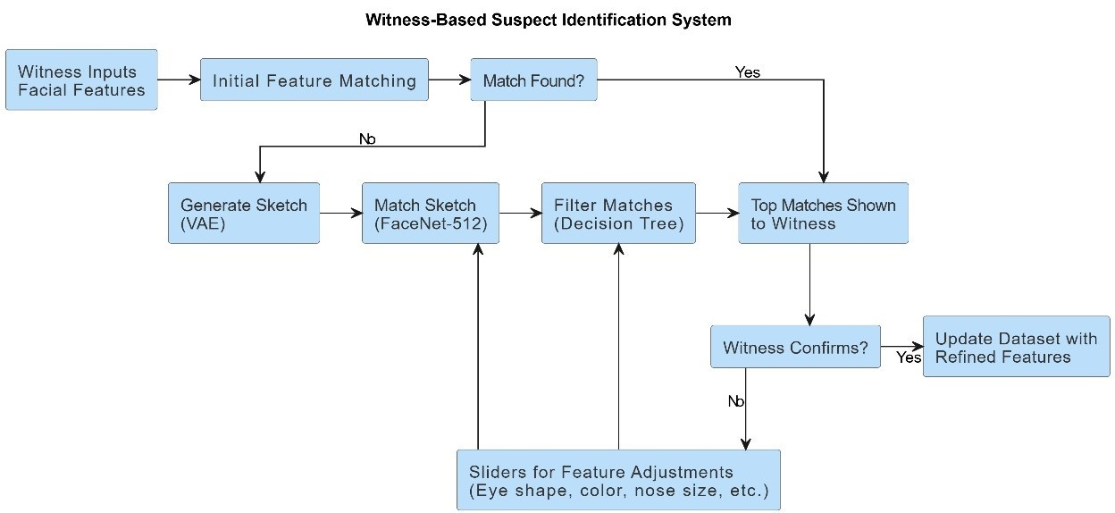

#### Dataset

The dataset that we have collected contains the features of approximately 10000 people with an existing criminal record and the following features:

* **ID**: Every inmate has a unique ID.
* **Name**: The first and last name of the inmates.
* **Hair**: The hair color of the inmates.
* **Sex:** The gender of the inmates.
* **Eyes:** The eye color of the inmates.
* **Race:** The race of the inmates.
* **Height:** The height of the inmates.
* **Location:** The inmates last found location.

**Preprocessing**

In the preprocessing stage, we extract the input features from the witness and generate a rough sketch. The steps involved in this are:

* **Gather Witness Descriptions:** Gather sign descriptions in the form of detailed text.
* **Facial Dataset Creation:** Gather a big collection of clear facial photographs.
* **Data Cleaning:** For pre-processing, first delete images that are corrupt, either partially or completely or in any way irrelevant.
* **Encoding Descriptions:** Binarize witness descriptions in terms of follicle bombings.
* **Normalization:** Maintain unity by ensuring images used have a specific size of dimensions and are of equal pixel intensity.
* **Augmentation:** Add variety to datasets with transformation techniques for example rotation.
* **Slider Calibration:** Map GUI slider for changing model parameters based on the testimony of witness.
* **Feedback Encoding:** This component is to encode the feedback given about the slider for further iterations of sketching.

**Feature Extraction**

At the feature extraction step, important facial information is transformed into useful features. The methods used are:

* **VAE Feature Encoding:** Extracts concealed information from the face that is associated with structural together with aesthetic attributes for creating sketches.
* **Facenet-512 Embeddings:** Used for facial similarity matching and produces 512-temporal feature vector.
* **Normalization:** Subtracts or reduces attributes to enhance the scalability processes of a given model.
* **Dimensionality Reduction:** Reduces the size of extracted features but at the same time retains necessary information.
* **Feature Mapping:** Coordinates step of extracted features for matching with witness descriptions, thereby improving the subsequent steps efficiency.

**Model Selection**

In the model selection stage, the main concern is often to subsection and include models, which will perform with relative success the needs of the project – its main objectives, that are the generation of sketches of the suspect and their matching. The following models and tools are selected:

* **Variational Autoencoder (VAE)**: Employed to create easily believable suspect sketches by training from the database about the distribution of faces. It allows converting descriptions into figures.
* **Facenet-512:** Implemented for its capacity to get 512 locations embeddings of the facial features, which allows to match the generated sketches to the database images correctly.
* **Decision Tree Classifier:** Used to sort and screen the top `n’ most similar matching suspects and draw a list of ranking score indicating their closeness.
* **Graphical User Interface (GUI):** Implemented with sliders for setting features on and off and for adjusting certain parameters interactively during generation as for depth or intensity, thereby providing an ability to tune the output sketches on the fly.

**Model Training and Evaluation**

This phase ensures that the models applied in the project to produce high quality suspect images and then compare them to the criminal database. It includes the following steps:

* **Training the Variational Autoencoder (VAE):**

**Input:** A large and virgin facial database that contains variation in terms of age, sex, and ethnicity as well as emotions.

**Objective:** The VAE is then required to learn the distribution of the facial features using the input images to minimize reconstruction loss. This is to be able to produce original suspect portraits based on the witness accounts as you see in this picture.

* **Facenet-512 Training for Sketch Matching:**

**Input:** Facial images of the criminals which contains faces where each face is associated with a different vector in a high dimensional space.

**Objective:** The Facenet-512 model is trained to minimize the triplet loss through which embeddings are made closer to each other in the vector space if they belong to same identity, as compared to which faces of different identities are made farther away. This makes it possible for the generated sketch to be matched with real faces in the appropriate manner.

* **Evaluation Metrics**:

**Reconstruction Quality:** The performance of the VAE in reconstructing sketches from a context is evaluated in terms of accuracy, for instance, MSE, and SSIM.

**Matching Accuracy:** For the case of Facenet, we measure how well it retrieves a matching face from the database through precision, recall and finally the top-N accuracy. Classification Evaluation: Measuring decision trees such as F1-score, precision and recall is another method in evaluating the filtering result.

* **Testing the Graphical User Interface (GUI):** Using sliders, one can adjust facets of depth intensity and all the parameters of the face. It is checked for its reactivity and functionality to allow real-time communication. Sketch readability can be again enhanced by the inputs from the users.
* **Integration and Deployment:** The specific computer models are embedded in the process and a comprehensive work of suspect identification is obtained. The practical use of the system is supervised to assess its stability, and additional classes are performed if necessary.

**Results**

To assess the efficiency of the models utilized in the project, their outcomes are compared with several performance indicators. These metrics include:

* **Reconstruction Loss (VAE):** Determines the remoteness of the created sketch from the input, to make it realistic.
* **Precision:** Refers to the percentage chances of the system getting it right when it has made its predictions.
* **Recall:** Determines the percentage of all actual match that is identified by the system correctly.
* **Accuracy:** Estimates the preponderance of accurate matches and sketches made during the experiment.
* **F1 Score:** These metrics balance precision and recall to better provide a good performance suggestion.

**4.3 Module Connectivity Diagram**

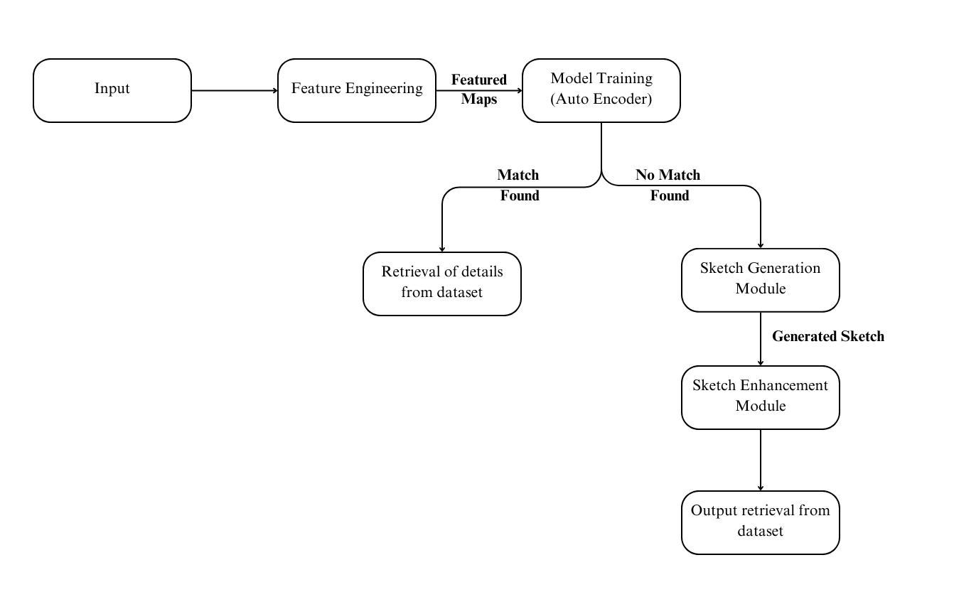

The diagram shows how the system uses witness inputs to identify suspects while applying expert extraction methods for making choices and creating sketches. The system first receives witness descriptions then transforms them into specialized feature maps using feature engineering methods. The system uses an autoencoder to ensure the input feature maps match data records in the database. Once the system detects a match from its database search it automatically retrieves all suspect data. The generation continues with sketch creation if no matching suspect is found.

When no match is found the system generates a basic sketch through the Sketch Generation Module before enhancing it with the Sketch Enhancement Module. We make a second search of the database by using the new upgraded sketch design. The system follows a continuous loop of automated feature processing, database searches, and sketch work to find suspects using both direct and indirect identification methods.

**5.Results and Discussion**

**5.1** **Details of the Dataset**

We store both facial characteristics and picture data in our system to track potential suspects. This technology matches exact face details by analyzing detailed images of eye types, nose dimensions, skin color, hair patterns and facial features. The database includes direct and side angled face images to help identification systems work from any angle. The data set also contains extra photos that adapt to various biological changes and visual effects. The range of features in our system helps it process real facial characteristics effectively. User input and matched confirmations from the database improve its accuracy during subsequent updates. The properly arranged database enables all essential components to develop a trusted identity verification process.

**5.2 Results**

The proposed witness identification system displays high rates of success when making and perfecting sketches and finding matching suspects. The system now performs better with modern machine learning tools such as VAE for sketch generation and FaceNet-512 for feature matching. By using the decision tree approach the witness receives only important identification options for better recognition results. The system lets witnesses adjust sketch details and modify characteristics to create better profiles and improve the search results. The dataset provides reliable testing and preparation while ensuring strong performance in situations where faces have incomplete features or distinct characteristics. The system create a simple and flexible way to search for suspects while using available data to produce accurate results.

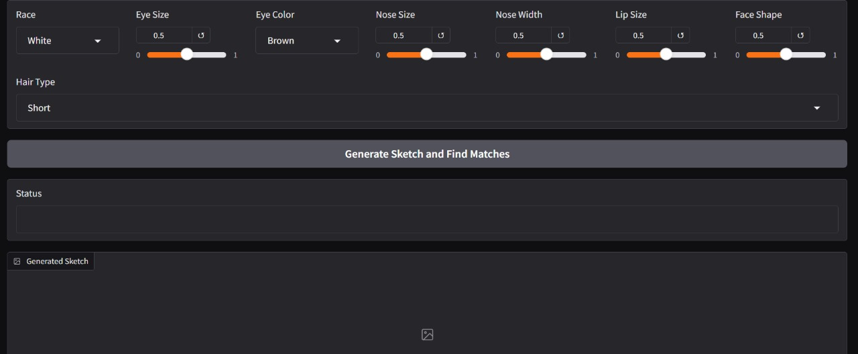

The gotten features such as race, eye size and nose width are quantized and normalized so that a similarity calculation can be done on the user-defined entities. The system calculates weighted Euclidean distances regarding features that are defined by the user and entries of the dataset. Matches are ranked based on similarity scores, with higher scores indicating a closer match. Experimental results highlight the importance of feature weighting since it directly affects the quality of matches. For instance, giving more weight to critical features such as race or eye shape improves accuracy by accentuating those traits that are visually significant.

A sketch is generated from a particular placement of features in the embedding space of VAE decoder. In assessing these sketches, they are analyzed about user expectations about the level of realism and accuracy. The latent feature vector is passed into the VAE’s decoder and produces an image which has the attributes specified. A simple analysis where the success is determined by comparison of the sketch with the input parameters by eye. The sketches generated demonstrate an ability to map high-dimensional latent vectors, exhibit model’s ability to generate visually appropriate output.

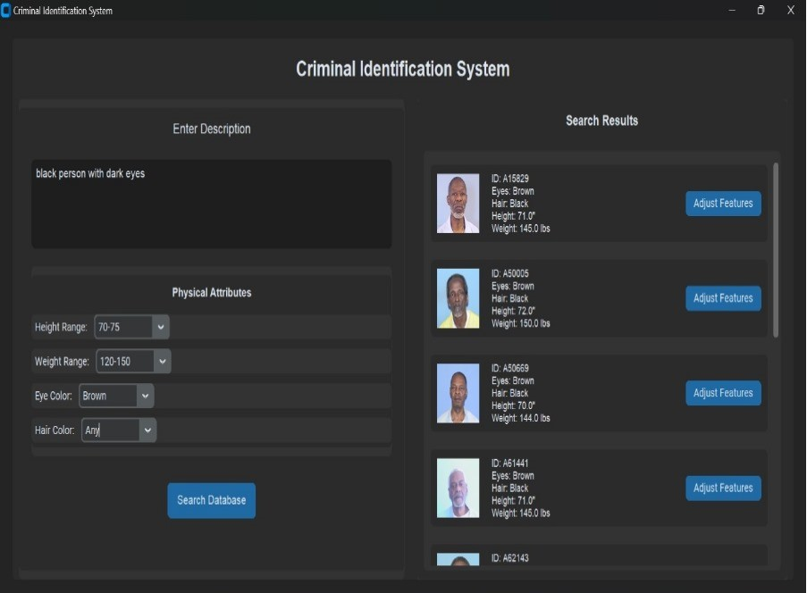

The final outcomes are shown in the form of "n” comparable firms, with match similarity and other pertinent data, such as name and position, shown. Users also generate retrieved images that enable them to visually confirm matches. Thus, the effectiveness of the matching process can be put under the accuracy term and define it as the correspondence of the obtained matches to the input features. User feedback then peels off the coarse edges and refines the system by means of tweaking weights or thresholds.

The global results prove that the system is capable of drawing reasonable sketches and finding exact matches depending on the characteristics of the input data. The fragmentation loss gathered to train the VAE confirms the quality of the sketches generated, whereas the measures to match confirm that the faces visually like the probe are distinctive in the database.

**5.3 Significance of the Proposed Method and Advantages**

The proposed system goes towards a unique combination of current deep learning methodologies with features approach for the synthesis of face sketching and matching. This approach harnesses the capabilities of VAEs that learn an embedding of high dimensional face space while offering a feature space for comparison. This is a blend methodology that hopes to fulfill some of the crucial wants of applications that need generative and analytical abilities like facial reconstruction, forensic, and identification verifications.

**Advantages**

**1. Feature-Driven Versatility:** It means that due to the reliance of the current system on the feature-based input, there is almost incalculable flexibility. The users themselves can set certain parameters, for instance, hair and face type or colors of the eyes, while choosing different combinations when drawing sketches to meet certain requirements. Due to that, the model can be tailored and utilized almost to various user requirements, unlike other strictly imaginal models.

**2. Hybridization of Generative and Analytical Models:** The proposed system has been designed to have a twofold functionality of synthesizing realistic sketches of faces and or matching faces that are closest to each other by hybridizing the generative model of a variational autoencoder with facial feature similarity search. This makes it, in all ways, an all-in-one tool for doing creative and analytical work.

**3. Sketch Generation of Excellent Quality:** The proposed utilization of VAEs, therefore, means that produced sketches will be realistic and detailed. It also means that while the VAE learns high levels of abstraction of the data, it can capture subtle shifting of distances between facial features, which allows for both realism and accuracy in the sketches made by the system according to the user-specified attributes.

**4. Precision in Face Matching:** Due to the use of a weighted Euclidean similarity measure, alignments of most similar facial landmarks are made with high accuracy. This way the system learns priority given to specific attributes, such as race, nose size, or lip size, and then achieves precise similarity scores with some variations that make the system strong and reliable.

**5. Scalability for Large Datasets:** The model was made, with a view of accommodating large volumes of data into the system and fast comparison of features. This makes it possible to employ for various practical purposes associated with thousands of face records like, identity databases or criminal records.

**6. Error Tolerance and Robustness:** Individual features of the system are considered, and based on the architecture, the feature of the system that considers error tolerance is critical. The absence of input data of certain or uncertain kinds is solved in the system through normalized features and default mappings. This helps to provide further evaluation even in case of admitted missing data or erroneous inputs from users.

1. **Conclusion and Future Work**
   1. **Conclusion:**

I n conclusion, that we presented the face-sketch generation and matching system as one of the major steps forward in the convergence of generative modeling and feature-based analysis. It has a dual-functionality, based on Variational Autoencoders, for generating photo-realistic sketches, and similarity of features for matching. It addresses some of fundamental issues in these domains: reconstructions and identification of facial features as accurate as possible in forensics, law enforcement, and creative businesses. The feature-driven approach ensures an excellent balance between customization and precision: It is equally applicable practically in different issues arising practically.

Among the strengths of carrying out this project is that feature inputs are structured in a way that can easily be translated into visuals. This capability enables the user to input special characteristics like the size of the eyes, the shape of the nose or the race and to obtain correct facial sketches which indicate that the system can be easily adjusted toward real-world requirements. Weighted similarity metrics also hence enhance certainty that facial matching can be versatile and accurate and facilitate comparisons of faint differences on big data sets. This generative and analytical combination of capabilities designed for the system makes it possible to find faces in diverse scenarios, including criminal pursuits and searching for a missing person.

**6.2 Future Work:**

While the proposed face-sketch generation and matching very effective in terms of robustness, there still exists significant potential for increase in the complexity of the system to make it more flexible for use and faster in terms of performance. For instance, one of the major prospects of development to be implemented in the future is the incorporation of the contact with precise generative models, including GANs and diffusion models that might enhance the degree of reality and the detail of the sketches drawn by the program. It may also enhance the capacity of such models in recreating basic forms of facial structure common in complex datasets and make the system more responsive to its users in terms of the facility’s illustrations.

It can be further expanded by incorporating other technologies such as the three-dimensional modeling of faces and place and virtual reality play to areas of play like gaming, flick making and even envelope immersion. These will allow the system to draw more than simple 2D layouts, but a full and complete finished 3D model thus creating another dimension for usage and creation.

**References:**

[1]Zirui An, Jingbo Yu, Runtao Liu, Chuang Wang, Qian Yu, “SketchInverter: Multi-Class Sketch-Based Image Generation via GAN Inversion”, IEEE/CVF Winter Conference on Applications of Computer Vision (WACV), Waikoloa, HI, USA, pp.4308-4318, 2023, doi:10.1109/WACV56688.2023.00430

[2]Feiwei Qin, Shi Qiu, Shuming Gao, Jing Bai, “3D CAD model retrieval based on sketch and unsupervised variational autoencoder” Advanced Engineering Informatics, China, pp. 101427 , 2023, doi: 10.1016/j.aei.2021.101427

[3]Troy Luhman, Eric Luhman, “High Fidelity Image Synthesis With Deep VAEs In Latent Space”, published at arXiv:2303.13714 ,2023 doi: 10.48550/arXiv.2303.13714

[4]Y. Liu, H. Zhao, X. Wu, “cGAN-based Sketched Image Art Generator Using Deep Learning” IEEE Transactions on Computational Imaging, 2023, doi: 10.1109/ACCESS.10170433.

[5]Stanislav Polyakov , Alexander Kryukov, Andrey Demichev, Julia Dubenskaya , Elizaveta Gres , Anna Vlaskina , “ Using conditional variational autoencoders to generate images from atmospheric Cherenkov telescopes”, pushlished at arXiv:2211.12553 ,2023, doi: 10.48550/arXiv.2211.12553

[6]Seho Bae, Nizam Ud Din, Hyunkyu Park, Juneho Yi, “Face Photo-Sketch Recognition Using Bidirectional Collaborative Synthesis Network” 16th International Conference on Ubiquitous Information Management and Communication (IMCOM) ,  Seoul, Korea, Republic of ,2022, pp. 1-8 ,doi: 10.1109/IMCOM53663.2022.9721719

[7]Chira, D., Haralampiev, I., Winther, O., Dittadi, A., Liévin, V. (2023), “Image Super-Resolution with Deep Variational Autoencoders.” In: Karlinsky, L., Michaeli, T., Nishino, K. (eds) Computer Vision – ECCV 2022 Workshops. ECCV 2022. Lecture Notes in Computer Science, vol 13802. Springer, Cham, doi:10.1007/978-3-031-25063-7_24

[8]Jonathan Ho, Chitwan Saharia, William Chan, David J. Fleet, Mohammad Norouzi, Tim Salimans, “Cascaded Diffusion Models for High Fidelity Image Generation”, The Journal of Machine Learning Research, Volume 23, Issue 1,2022, doi:10.5555/3586589.3586636

[9]Zong-Yue Deng, Hsin-Han Chiang, Li-Wei Kang, Hsiao-Chi Li, “A lightweight deep learning model for real-time face recognition” , published at sensors ,2020,doi: 10.3390/s20216114

[10]Mohamed Amine Hmani, Dijana Petrovska-Delacrétaz, Bernadette Dorizzi, “Locality preserving binary face representations using auto-encoders” Publication: IET Biometrics Volume 11, Issue 5,pp 445-458, 2022, doi: 10.1049/bme2.12096

[11]B. Bae, J. Chong, and M. Cho, “DigiFace-1M: 1 Million Digital Face Images for Face Recognition” Proceedings of the IEEE/CVF Winter Conference on Applications of Computer Vision (WACV), 2023, doi: 10.1109/WACV56688.2023.00129.

[12]Akingbesote, Damilola ; Zhan, Ying ; Maskeliūnas, Rytis ; Damaševičius, Robertas, “A novel deep facenet framework for real-time face detection based on deep learning model” published at Algorithms.. Basel : MDPI. 2023, vol. 16, iss. 6, art. no. 292, p. 1-24, 2023, doi: 10.3390/a16060292

[13]Pawan Kumar, Nihal Manzoor, Chhavi Dhiman, “Masked-face recognition using deep metric learning and FaceMaskNet-21”, 8th International Conference on Signal Processing and Integrated Networks

(SPIN), Noida, India, pp. 569 – 573, 2021, doi: 10.1109/SPIN52536.2021.9566002 .

[14]B. Sharma, S. Kaur, "Enhancing Suspect Identification: Automated Composite Sketch Generation and Recognition" Applied Intelligence, vol. 51, no. 10, pp. 7112–7123, 2021, doi: 10.1007/s10489-021-03150-3.

[15]A. Kumar, V. K. Jain, "Face Sketch Recognition" Lecture Notes in Networks and Systems, Springer, 2023, doi: 10.1007/978-981-97-6036-7_9.

[16]S. P. Singh, R. C. Gupta, "Performance enhancement of generative adversarial network for photograph–sketch identification" International Journal for Research Trends and Innovation, vol. 8, no. 1, pp. 25-30, 2024, doi: 10.52792/IJRTI2401045.