ECG SIMULATOR

PROJECT REPORT

FOR- STREBEN HEALTHCARE PVT. LTD.

BY- HIMANSHU SAVARGAONKAR

**INTRODUCTION**

ECG(Electro-CardioGram) is one of the most vital measurement techniques when it comes to quantizing the health. It is used in many cases ranging from diagnosing heart diseases, critical surgeries to detecting of stress levels. Though ECG is one of the primary tools acquiring ECG data from a patent is a painstaking process, in which the patient has to be connected with 10 connectors on various parts of the body. These are then connected with the device to acquire the graph. This is very uncomfortable for testing reasons and for demonstrations. Thus, normally the human is replaced by an ECG Simulator for demonstration and development. The simulator is designed in a manner that mimics the human data helping software developers test their applications without physically connecting the leads to a human. Another advantage of a simulator is that the incoming ECG signal can be changed to different types as desired by the user, along with this it is normally quite compact and easy to store. ECG simulators are also used for the endurance test of software’s were the program runs for a long time at a time.

**OBJECTIVES**

* Development of an ECG simulator which is compatible with the current software.
* The ECG should be wireless and should be able to connect to the software via bluetooth connection.
* The device should give the user option to select from the various sample ECG’s stored on the device.
* The device should be concise with independent battery for easy transport.

**SYTEM DESIGN /BLOCK DIAGRAM**

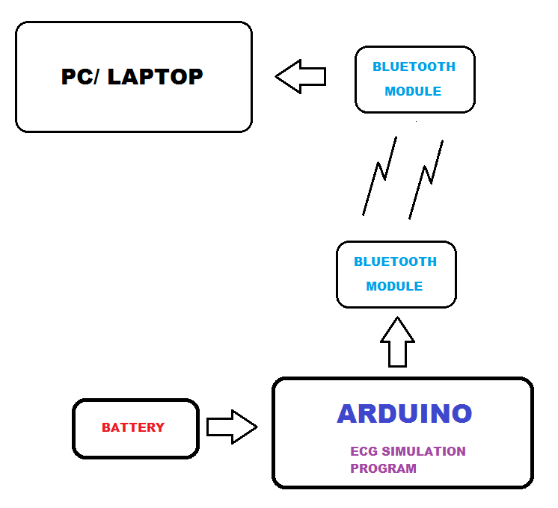

**HARDWARE SUB SYSTEM**

The project is based around main two hardware components. Arduino Uno microcontroller board and a HC-05 bluetooth module. The Uno board with AT Mega microcontroller houses the main code and the data of the ECG wave form. It is also responsible for proper compression and packetization of the data. The packetized data then is sent to the bluetooth module via SESRIAL COMMUNICARION PORT WITH Rx and Tx USING RS232 PROTOCOL. The bluetooth module then is connected to the computer running the software where it receives the data.

The device was provided with a dip switch which lets the user manually decide the ECG waveform from the multiple options on board. The device was also given a separate power-bank connection which made the independent AND PORTABLE. An on-board LED was added for visualization of the heart rate of the simulated patient.

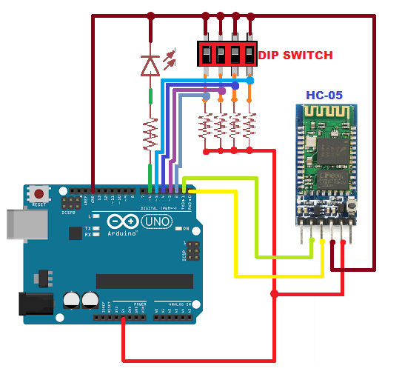

CIRCUIT DIAGRAM

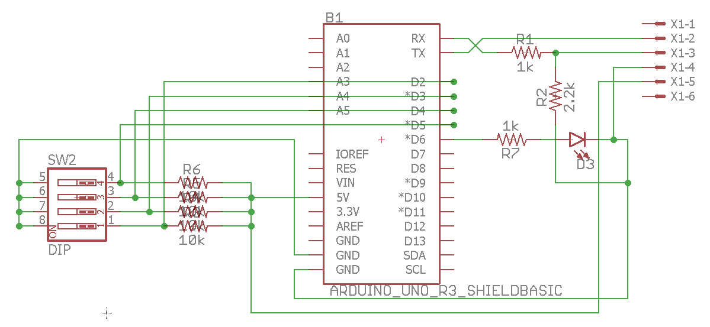

PCB SCHEMATIC

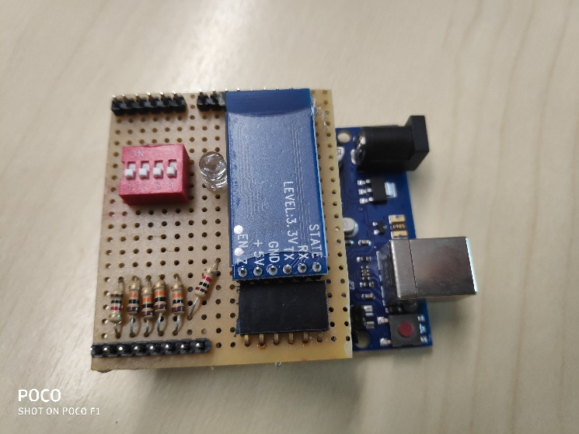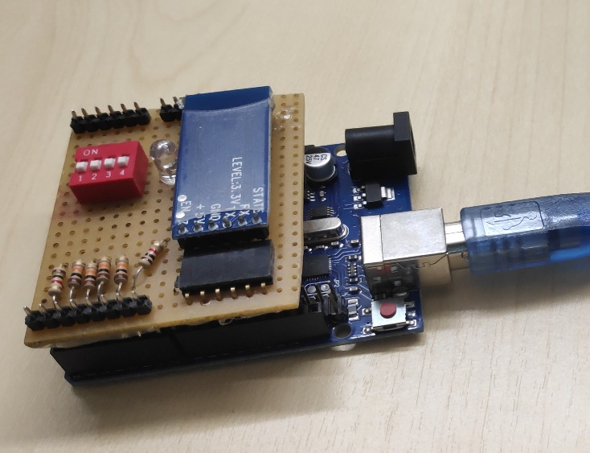

THE DEVICE

**SOFTWARE SUB SYSTEM**

There are two main software components to the project.

1. The Arduino Code: This comprises of the code uploaded to the device which outputs the ECG data. Various ECG data is stored in arrays which can then be selected by the switches provided to the user. Once the data array is selected, it undergoes compression and packetization to mimic the ECG data received from the existing device. Once packetized, the data is sent to the computer THROUGH BLUETOOTH MODULE. The transfer of THE data follows the RS232 protocol.
2. The Test App: The main aim of the test app was to have a platform on the computer end to troubleshoot any problems faced in the data transfer process. It comprised of a simple console application that could connect to the bluetooth module and accept and decompress the data. This was used as an intermediate step before integrating the new simulator with the existing software.

**FUTURE PLAN**

* A custom PCB can be manufactured as an Arduino Uno shield to house all the components. An Arduino Shield is a PCB designed to fit perfectly over the arduino pin outs.
* An enclosure could be designed to house the arduino, the pcb and the battery, making the set up more portable and less delicate.

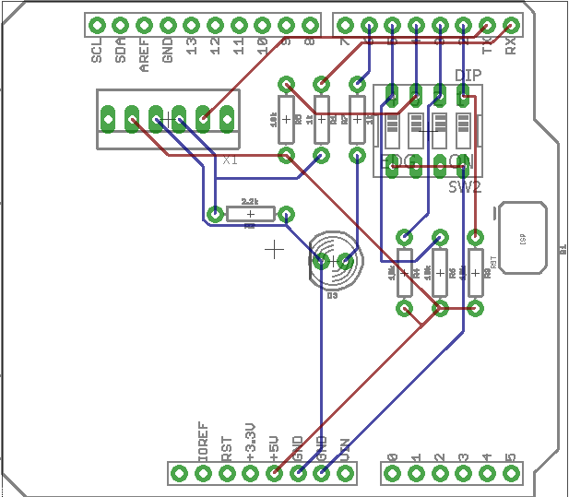

PCB ARDUINO SHIELD PROTOTYPE