**1. INTRODUCTION**

**1.1 PREFACE:**

With the rise in infectious diseases and health concerns, vaccines play one of the most important roles in aiding in the prevention and protection against diseases of various kinds. They are designed in such a way that they stimulate the immune system to recognize and fight off specific pathogens at a later stage.

The advantages of using vaccines include:

1. Providing immunity without having to be affected by a pathogen
2. Promote individual and herd immunity
3. Cost effective way of health protection
4. Help in the eradication of diseases like smallpox
5. They provide long term protection with a few shots
6. They come in different forms such as injections, oral and nasal sprays
7. Can be utilized by people of all age groups

Despite the merits, vaccines also have certain limitations which are as follows:

1. Lack of 100% efficiency in certain cases
2. Minor side effects might be prevalent after taking the vaccine
3. They require refrigeration and have to be maintained at a certain temperature
4. Limited protection against evolving pathogen strains
5. Accessibility issues in places due to geographic, economic and political situations

**1.2 PROBLEM STATEMENT**

Vaccines are transported through cold chain systems, and hence the storage of vaccines is a crucial key in determining their stability. Vaccines should be maintained at a colder temperature, failing to do so results in deeming the vaccine ineffective to use and causes spoilage. Hence a working model to monitor the temperature changes in the vaccine storage box during transportation is needed. This project aims to resolve this issue by monitoring the temperature of vaccine boxes at specific time intervals and sending alerts when the temperature exceeds the range.  The following graphs show the statistics of vaccine wastage in the global and state level:

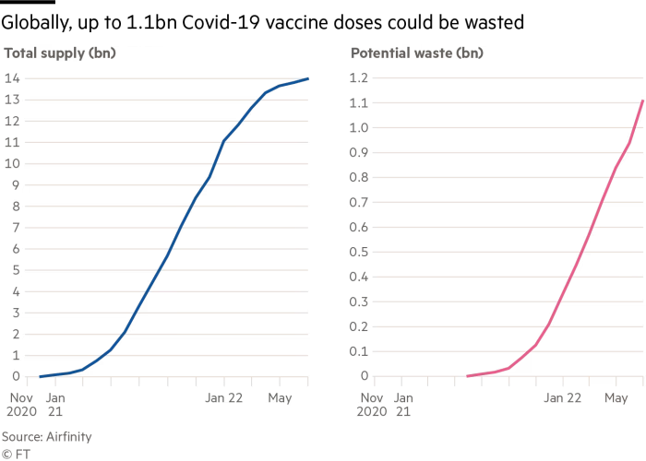

                                                 Fig 1.1 Global statistics on vaccine wastage

Source:https://www.ft.com/content/b2267d3a-ef24-4f96-9c02-7a057d80b3e6

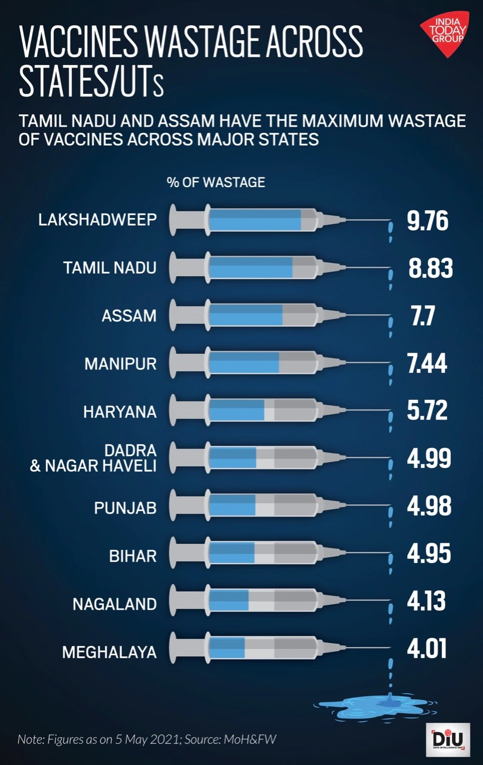

                                                     Fig 1.2 Statewise vaccine wastage

Source:https://www.indiatoday.in/diu/story/wastage-shortages-slow-down-india-s-vaccine-drive-at-first-shot-1799235-2021-05-05

**1.3 MOTIVATION**

1. WHO estimates that around 50% vaccines are rendered ineffective and hence wasted.
2. Traditional methods of temperature monitoring such as manual checks are time consuming and prone to errors.
3. Automated temperature checks help to avoid spoilage and hence increase the efficiency of the vaccines.

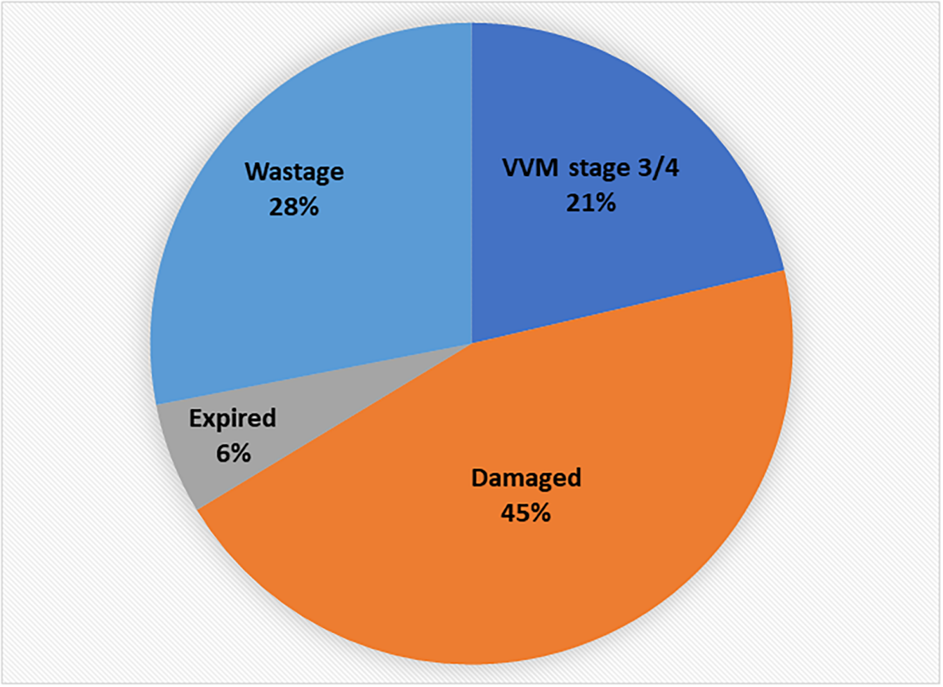

Fig 1.3 Assessment on vaccine wastage

Source: https://journals.plos.org/globalpublichealth/article?id=10.1371/journal.pgph.0000572

**1.4 OBJECTIVE**

The objective of the project is to ensure that the vaccines are transported and stored under appropriate temperature conditions by implementing a suitable temperature sensor to monitor the storage temperature at frequent intervals. The identification of the vaccine box is facilitated by the usage of RFID tags attached to the vaccine container.

The data is then stored in a real time cloud platform and alerts the concerned authorities through email and push notification if the temperature of the vaccine box is not within the stipulated range.

**2. LITERATURE SURVEY**

A literature survey aims to critically evaluate the current state of  and research on a problem statement.In addition to academic publications and conference proceedings, it pulls from a wide range of sources. By  analyzing this information, the survey aims to provide a comprehensive up-to-date understanding of the current state of temperature sensing systems and IoT modules in the healthcare industry, while helping to identify gaps and areas for future research.

Relevant research papers were studied and the following were inferred to develop a working plan for this project:

[1] Continuous temperature monitoring using new technologies has reduced the risk of accidental vaccine freezing. [2] A system to monitor the temperature, humidity, and location of a vaccine carrier which is then sent to an SD card. [3] To preserve a temperature time history, most commercial wireless temperature sensors include transceivers, memory, and batteries, but this is expensive. In this study, we present a paradigm for sensing that is based on passive RFID tag antennas. [4]This essay tries to address issues with temperature monitoring in the cold chain of medicine. [5] Internet of Things based cold storage model integrating temperature sensing technology, RFID technology, network communication and other technologies. [6]An IOT system and an RFID tag with a temperature sensor will be inserted in the cold box. The reader will be used to collect data before sending it to the cloud server. [7] To track the state of frozen goods while they are being transported, a planar antenna design is created for connection with a temperature sensor. [8] The stability features of vaccines can be precisely put into electronic time-temperature indicator (eTTI) monitors with a high level of realism. [9] Intervention sites used Fridge-tag, while control sites continued with thermometers. While there were large differences in temperature readings, all Fridge-tag alerts were confirmed in the intervention group. [10] In addition to outlining a programme for cold chain temperature monitoring and tracking cold chain product moving through the supply chain, the article covers the use of RFID in cold chain temperature monitoring systems. [11] Detection of facial features and recording body temperature during attendance. [12] Integrating a 13.6MHz RFID with low power CMOS circuitry to obtain temperature details. [13] Using IOT, thermal imaging and related technologies to monitor trends in food supply [14] Food quality monitoring using IOT, Zigbee and WiFi. [15] The use of IoT technology, specifically cognitive radio-based IoT, in healthcare systems has promising potential for dynamic monitoring and controlling of pandemics like COVID-19. [16] Implementation of a wireless IOT system to monitor the temperature of workers using scraping and model prediction. [17] Integrating block chain with IOT to optimize vaccine distributions in India [18] Touchless mask and temperature detection system [19] Implementing RFID of various types and frequencies in agri sector for identification, quality control and traceability. [20] Using IOT and a camera module to detect changes in the health of students and faculty.[21]Combining blockchain technologies with IOT infrastructure to maintain temperature. [22]Maintaining cold storage facilities and distribution of vaccines on time. [23]The investigation shows how using IoT has a beneficial impact on the effectiveness of the VSC in dispersing the COVID vaccination.[24]To assist businesses in enhancing vaccine quality, the system forecasts vaccine demand and performs sentiment analysis on vaccine evaluations. [25]To find solutions based on the Internet of Things (IoT) for the biggest problems in the Indian healthcare sector. [26]Survey on the application of RFID systems in preventing future pandemic breakouts by the use of personal protective equipment, social isolation, and early symptom detection. [27]Analyzing various sensors and their usage to implement in smart IOT systems. [28]Measurement of the stability of vaccines using an electronic time temperature indicator. [29]RFID based real time monitoring of temperature, humidity and troubleshoot issues in cold chain supply. [30]Usage of a passive RFID tag as a cost effective way to monitor environmental temperatures.

**3. COMPONENTS DESCRIPTION**

**3.1 NODE MCU ESP8266​**

* The ESP8266 is a highly integrated System-on-a-Chip (SoC) microcontroller with built-in Wi-Fi capabilities. It was designed and produced by Espressif Systems, a Chinese company specializing in low-cost, low-power Wi-Fi chips.
* The ESP8266 has gained significant popularity in the maker community due to its low cost, ease of use, and powerful features. It is commonly used in Internet of Things (IoT) projects, such as home automation, weather stations, and remote monitoring systems.
* The ESP8266 is based on the Xtensa LX106 microcontroller, which runs at a clock speed of 80 MHz. It comes with 64KB of instruction RAM and 96 KB of data RAM. The chip also has 1MB of built-in flash memory, which can be used to store firmware and other data.
* The ESP8266 supports both STA (Station) and AP (Access Point) modes, which allows it to connect to an existing Wi-Fi network or create its own network. It supports 802.11 b/g/n wireless standards and can operate in 2.4 GHz frequency band.
* Programming the ESP8266 is relatively easy, as it supports several programming languages including C and MicroPython. The chip can be programmed using the Arduino IDE, which simplifies the process of writing code for the chip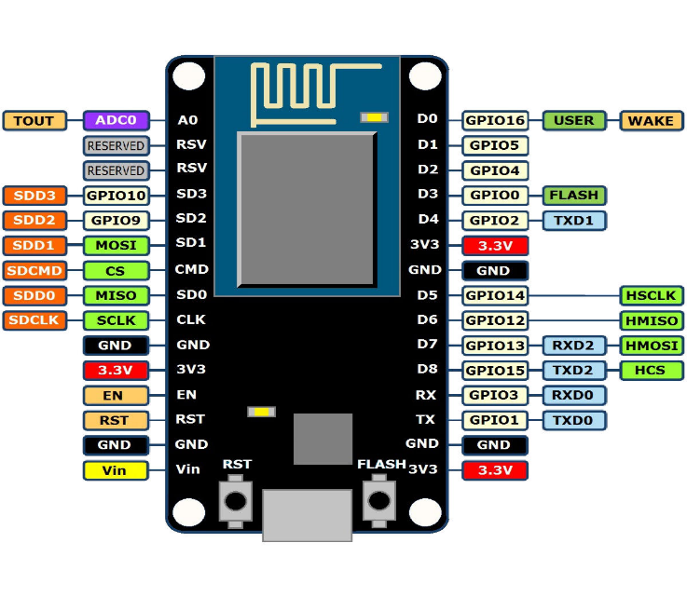

Fig 3.1 Pin diagram of ESP 8266

**3.2 MLX90614:​**

1. The MLX90614 is a non-contact infrared thermometer sensor that is used to measure temperature from a distance without any physical contact. It is a popular sensor that is widely used in various applications, such as industrial temperature control, medical equipment, automotive, and home appliances.
2. The sensor uses advanced MEMS technology to measure infrared radiation emitted by the object and converts it into temperature values. It has a measuring range of -70°C to +380°C with an accuracy of ±0.5°C. The sensor comes with a small thermopile detector chip that can detect even small changes in infrared radiation emitted by the object.
3. The MLX90614 sensor has a small form factor and can be easily integrated into any system. It communicates with the microcontroller through an I2C interface, which makes it easy to interface with any microcontroller. It also has a built-in EEPROM memory that can store calibration data, making it easy to calibrate the sensor without any external components.
4. Overall, the MLX90614 is a reliable and accurate non-contact infrared thermometer sensor that can be used in a wide range of applications.

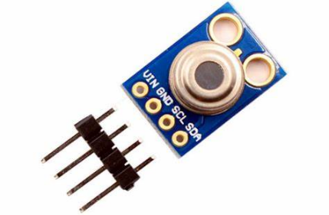

Fig 3.2 MLX 90614

**3.3 EM-18 RFID Module​:**

1. The EM-18 RFID module is a low-cost RFID reader module that operates at a frequency of 125kHz. It is designed to read the data stored on RFID tags or cards that are within its range. This module is widely used in various applications, such as access control systems, attendance systems, inventory management, and security systems.
2. The EM-18 RFID module is a compact module that can be easily integrated into any system. It has a built-in antenna, and the range of the module is approximately 10 cm. The module operates at a voltage range of 5V to 12V DC and consumes very low power, making it ideal for battery-powered applications.
3. The EM-18 RFID module communicates with the microcontroller through a UART interface, which makes it easy to interface with any microcontroller. The module sends the data in the form of ASCII characters, which can be easily decoded by the microcontroller. The module can read the data from EM4100 compatible RFID tags or cards.
4. Overall, the EM-18 RFID module is a reliable and easy-to-use RFID reader module that is widely used in various applications. It is a low-cost solution for RFID-based systems and provides a convenient and secure method for identification and tracking.

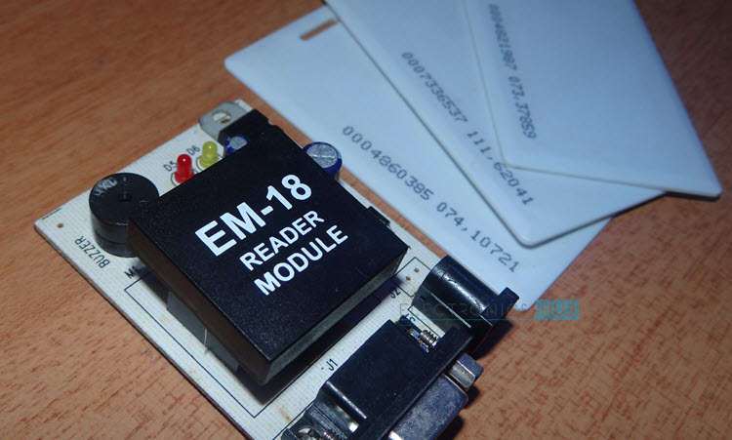

Fig 3.3 EM 18 Reader module with RFID tags

**3.4 BLYNK​​:**

1. Blynk is a platform for building mobile and web-based Internet of Things (IoT) applications. It provides a user-friendly way to connect and control various hardware devices using a mobile app or a web interface. Blynk is designed to make it easy for anyone to build IoT applications without requiring any prior knowledge of programming or electronics.
2. Blynk provides a mobile app that is available for both iOS and Android platforms. The app allows users to create custom interfaces that can control and monitor various hardware devices. Blynk also provides a library of widgets, including buttons, sliders, gauges, and graphs, that can be easily added to the app interface.
3. Blynk supports a wide range of hardware devices and communication protocols, including Arduino, Raspberry Pi, ESP8266, and Bluetooth. The platform provides a library of pre-built code examples that make it easy to connect and control these devices. Blynk also provides a cloud-based server that manages the communication between the app and the hardware device.
4. One of the key features of Blynk is its ability to create alerts and notifications. Users can set up alerts that will be triggered when a specific condition is met, such as when a sensor reading exceeds a certain value. Blynk also supports push notifications, which can be sent to the user's mobile device when a specific event occurs.
5. Overall, Blynk is a powerful and user-friendly platform that makes it easy to build IoT applications. It provides a wide range of features and supports a variety of hardware devices and communication protocols. Blynk is suitable for both hobbyists and professionals who want to build IoT applications without requiring extensive knowledge of programming or electronics.

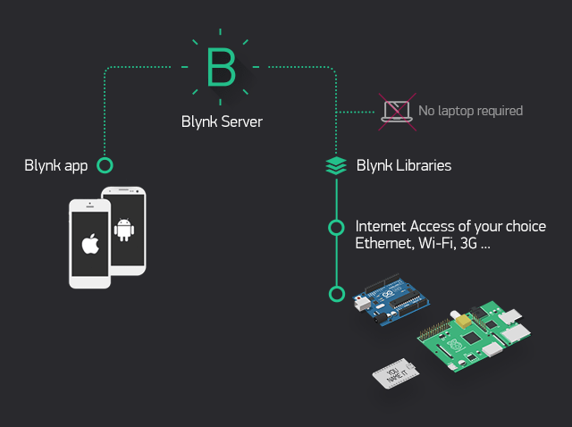

Fig 3.4 Blynk workflow

**4. EXPERIMENTAL WORK & METHODOLOGY**

1. **Design and development of the temperature sensing system:**

To gather and process data, the system should have an RFID reader, RFID tags, temperature sensors, and a microprocessor.

1. **Selection of RFID tags:**

Tags that can withstand the temperature range of the vaccines and can be detected at a near distance should be preferred.



Fig 4.1 RFID Tags

1. **Calibration of temperature sensors:**

The temperature sensors should be calibrated to ensure accuracy and dependability by  contrasting the sensor results with a standard thermometer.

1. **Integration of RFID tags and temperature sensors:**

Include temperature sensors and RFID tags in the vaccine storage containers. The temperature sensors should be positioned so they can take an accurate temperature reading of the vaccinations, and the tags should be positioned so the RFID reader can read them easily.

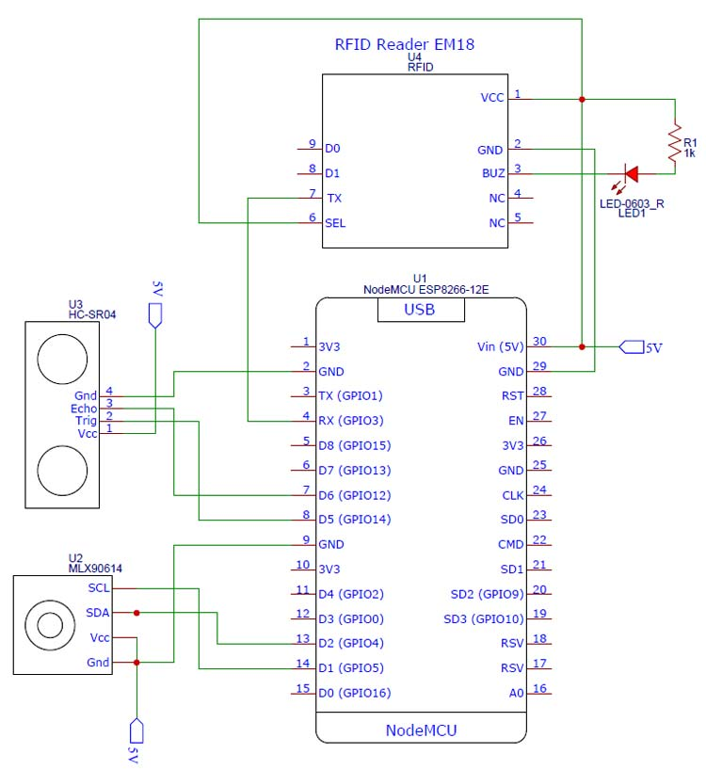

Fig 4.2 Circuit diagram

1. **Testing of the system:**

Test the system by exposing vaccine storage containers to a range of temperatures and circumstances including any that might come up during handling, storing, and transportation.

1. **Data analysis:**

To find any patterns or unusual temperature readings, analyze the data gathered.

1. **Comparison with existing systems:**

Performance should be compared to that of the current temperature monitoring systems. This will make it easier to weigh the benefits and drawbacks of utilizing RFID-based technology for the distribution of vaccines.

1. **Evaluation of the system:**

Based on factors including accuracy, dependability, usability, and cost-effectiveness, evaluate the system. Any areas that need improvement in order to improve the system's performance should be identified by the review.

1. **Conclusion:**

Summarize the study's findings and optimize the model.

**5. SETUP**

The system containing the temperature sensor and RFID reader module is placed inside the vaccine box containing coolants and the required vaccines. The data from the box is collected and sent to the Blynk console via the Wi-Fi on the ESP8266 NodeMCU model.

The device is registered on Blynk web and the NodeMCU is registered, following which the sensors used in the model are initialized as virtual pins in the Datastreams section.  A unique authorization id is generated which is to be added into the Arduino code.

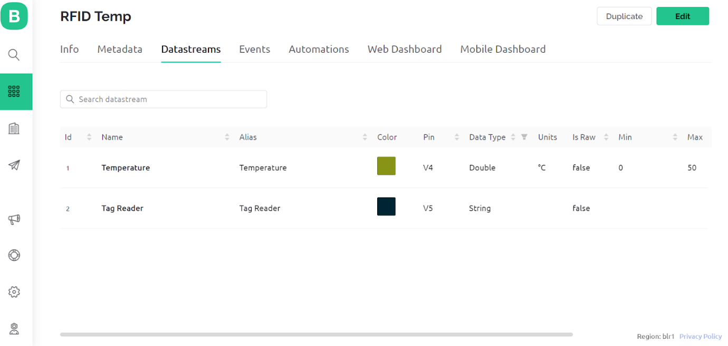

Fig 5.1 Datastream initialization in Blynk

Now the project should raise alerts when the temperature exceeds the limit (e.g. 30 degrees Celsius). This can be done by creating a warning event in the Events tab.

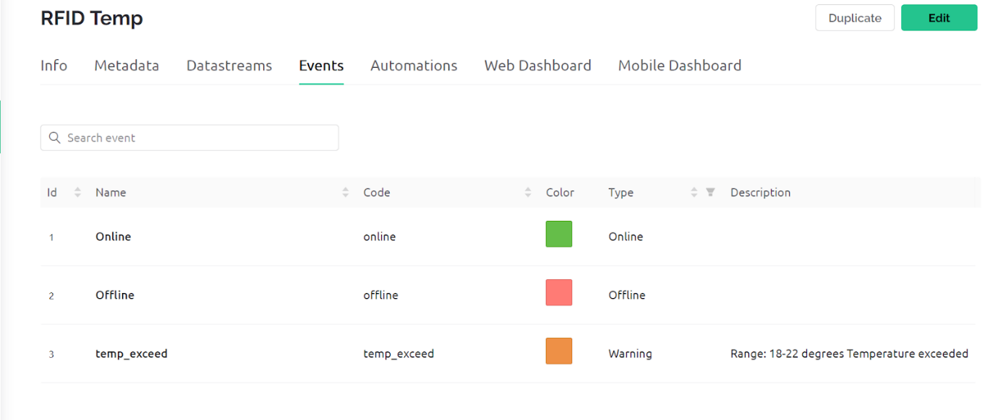

                                                     Fig 5.2 Event setup in Blynk

Settings are changed to alert the user via email and in-app push notifications along with the warning message and the ID of the vaccine box which raises the alert.

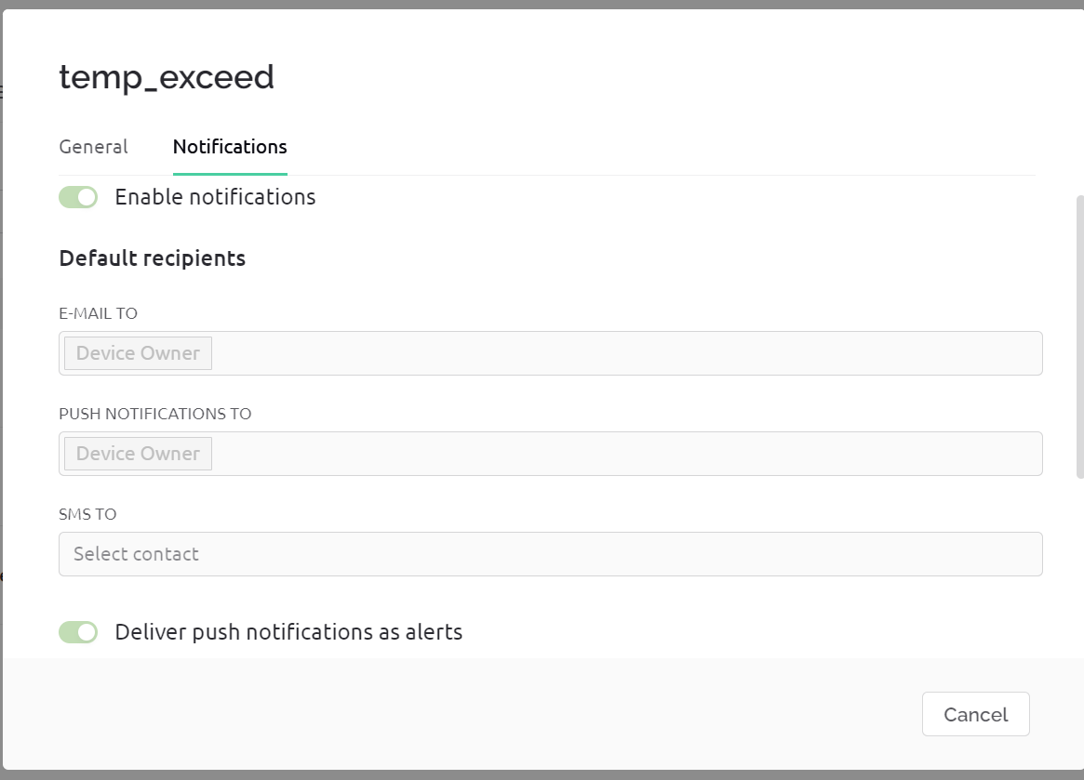

Fig 5.3 Enabling notifications

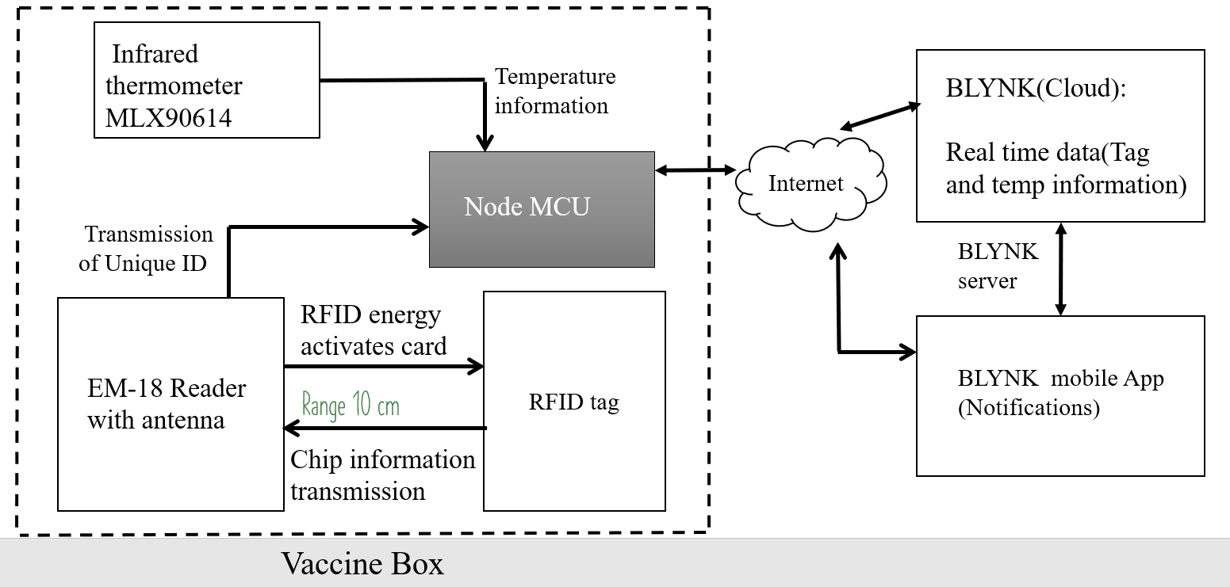

Fig 5.4 Flow Chart

**6.RESULTS AND DISCUSSION**

The arduino code is executed and uploaded to the NodeMCU. The Blynk console turns active.

The below snapshot shows the raw data as viewed in the serial monitor of the Arduino IDE, where the timestamp, tag id and temperature in Celsius is seen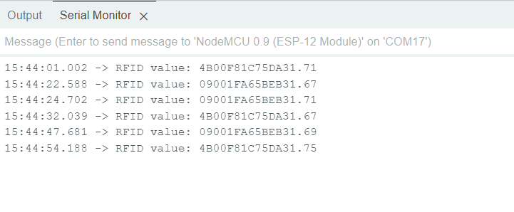

                                                             Fig 6.1 Serial Monitor Output

Widgets are used to visualize the data in real time, and in this model the tag id is shown in a display widget, temperature in a gauge format in the web dashboard:

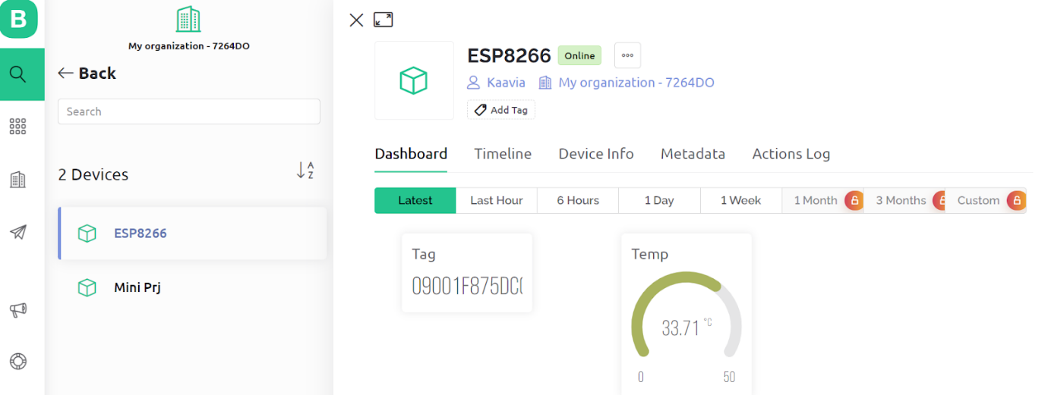Fig 6.2 Blynk web dashboard

The Blynk console is also visualized in the mobile app, where the past temperature data is also shown, making it easier to visualize past trends and store data in a database.

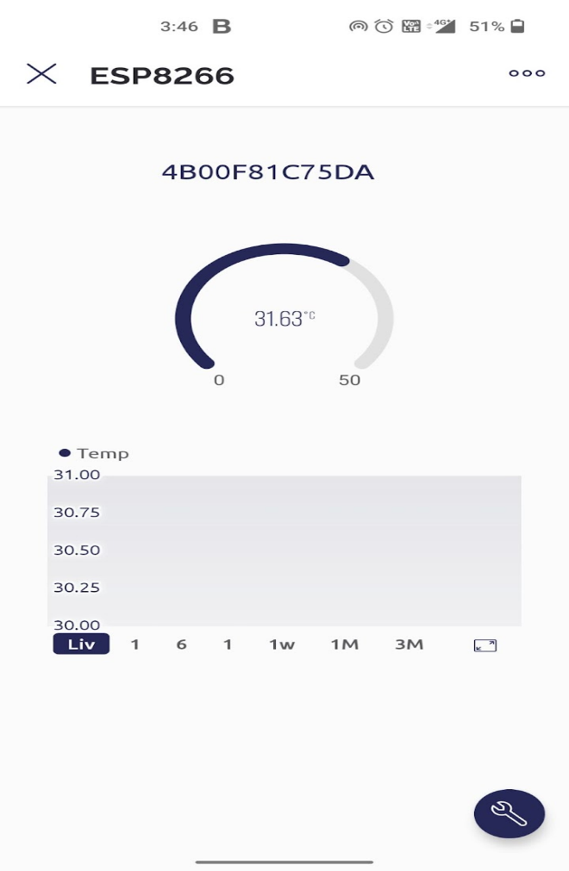

Fig 6.3 Blynk App dashboard

Below are the alerts as seen from the push notification and email alert:

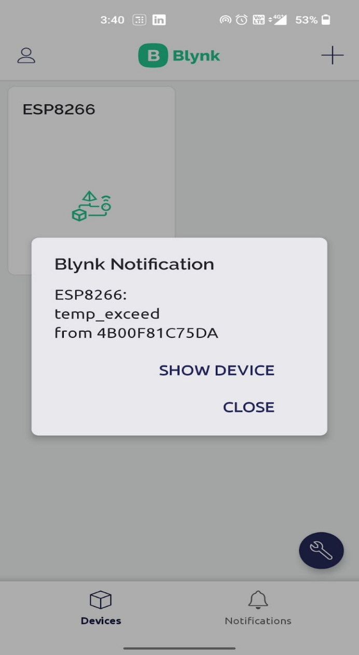

Fig 6.4 Blynk in App push notification

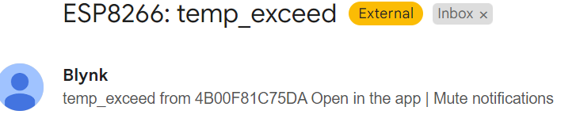

                                                      Fig 6.5 Email notification

**7. CONCLUSIONS AND FURTHER WORK**

**7.1 CONCLUSION:**

In conclusion, this model has proved to be reliable for monitoring the temperature of vaccines during delivery. The system uses RFID tags with integrated temperature sensors that can be attached to vaccine containers and read remotely using an RFID reader. It also provides an auditable record of temperature data, which can be useful for regulatory compliance and quality control purposes. Another important benefit is the ability to send notifications when the temperature crosses a threshold,  allowing for prompt corrective action to be taken.

Overall, the use of RFID technology for temperature sensing in vaccine delivery has great potential for improving the safety and efficacy of vaccine delivery, and further research and development in this area could lead to even more innovative solutions.

**7.2 FURTHER WORK:**

The integration of a GPS system to suggest nearby cold storage facilities can be added to additionally develop the existing model. GPS helps to track real time location and one can effectively narrow down the time taken for the vaccines to reach their destination.

The route to be taken can be fed into the model, along with the nearest cold storage facilities along the path. When the temperature alert goes off the GPS springs into action and shows the distance to the nearest facility in the shortest possible route, thus optimizing the vaccine delivery process and reducing delivery times.