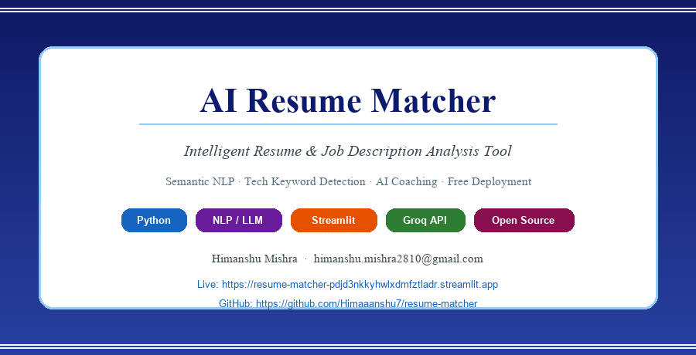

Table of Contents
1. Project Overview
2. Key Features
3. System Architecture
4. Tech Stack
5. How the Match Score Works
6. Tech Keyword Gap Analysis
7. Per-Bullet Scoring
8. AI Features — Feedback & Bullet Rewriter
9. Project File Structure
10. Deployment
11. How to Run Locally
12. How to Use the App
13. Limitations & Future Improvements

1. Project Overview
AI Resume Matcher is a free, fully open-source web application that helps job seekers objectively measure how well their resume aligns with a specific job description. The tool solves a common problem: candidates apply to jobs without knowing which skills, tools, or keywords are missing from their resume — leading to rejections that could have been avoided with targeted improvements.

The application combines two complementary AI techniques: a semantic embedding model (sentence-transformers) for understanding meaning and context, and a large language model (Groq's llama-3.1-8b) for generating human-quality coaching advice. Both run efficiently at zero cost to the user.

Item | Details
Live Application | https://resume-matcher-pdjd3nkkyhwlxdmfztladr.streamlit.app/
Source Code | https://github.com/Himaaanshu7/resume-matcher
Author | Himanshu Mishra
Stack | Python, Streamlit, sentence-transformers, Groq API
Cost | 100% free — no subscriptions, no hidden charges
Deployment | Streamlit Community Cloud

2. Key Features
- Semantic Match Score (0–100%): Converts both the resume and job description into 384-dimensional semantic vectors using the all-MiniLM-L6-v2 sentence-transformer model, then computes cosine similarity between them. Unlike simple keyword counting, this approach understands meaning — so 'built REST APIs' and 'developed web services' are recognized as related. The result is displayed on a colour-coded gauge: green (≥60%), amber (40–60%), red (<40%).

- Tech Keyword Gap Analysis: Scans the job description against a hand-curated vocabulary of 150+ real technologies across 8 categories: programming languages, web frameworks, cloud/DevOps, databases, ML/data tools, testing tools, APIs/protocols, and architecture patterns. A secondary semantic similarity check (threshold 0.55) ensures that aliases like 'sklearn' vs 'scikit-learn' or 'Postgres' vs 'PostgreSQL' are not double-counted. No soft-skill jargon is ever shown.

- Per-Bullet Scoring: Every bullet point extracted from the resume is individually scored against the job description using the same sentence-transformer model. Results are shown in a sortable table with three strength tiers: Strong (≥45%), OK (30–45%), Weak (<30%). This pinpoints exactly which experience statements need improvement.

- AI Bullet Rewriter: The three weakest bullets are surfaced with an expandable panel and a one-click 'Rewrite with LLM' button. Groq's llama-3.1-8b-instant model rewrites each bullet using strong action verbs, JD-aligned terminology, and specific language — keeping it under 20 words. Results persist on screen via Streamlit session state.

- AI Coach Feedback: A single button generates a structured coaching report by sending the resume, job description, and missing keywords to Groq's LLM. The report contains: a 2-sentence match summary, 3 specific bullets to add or rewrite with examples, and 2 critical skills completely absent from the resume. The result is stored in session state so it doesn't disappear on rerender.

- Resume Section Detection: Automatically identifies standard resume sections (Experience, Education, Skills, Projects, Summary, Certifications, etc.) using regex pattern matching on section headers. Detected sections are displayed in the results panel.

- Multi-Format Resume Upload: Accepts PDF files (via pdfplumber), Microsoft Word DOCX files (via python-docx), and plain text. Users can also paste resume text directly without uploading a file.

- Zero-Friction AI Access: The Groq API key is stored as a Streamlit server secret — users never need to create an account or enter any credentials. AI features work out of the box for all visitors.

3. System Architecture
The application is built as four cooperating Python modules, each with a single responsibility. Streamlit manages the UI and session state, ensuring results persist across user interactions without page reloads.

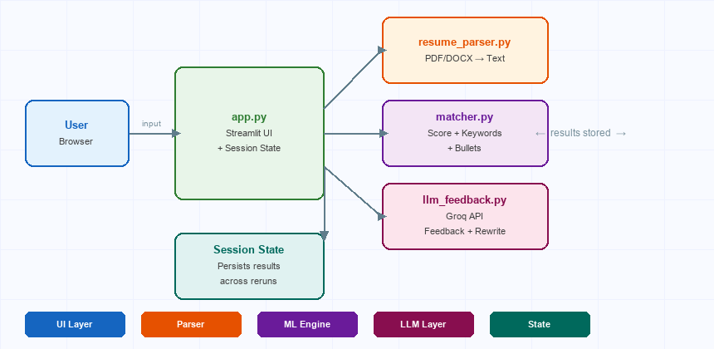

Figure 1: System architecture showing the four Python modules and how data flows from user input through parsing, scoring, and LLM feedback back to the Streamlit UI.

4. Tech Stack
All libraries used are free and open-source. No paid API is baked into the cost of running the app for visitors — the Groq free tier provides 14,400 requests per day, which is more than sufficient for a demo/portfolio application.

Component | Library / Service | Version | Purpose
Semantic Similarity | sentence-transformers | ≥2.7 | Encode text to vectors, cosine similarity
Embedding Model | all-MiniLM-L6-v2 | — | 80MB model, runs on CPU, 384-dim embeddings
Resume Parsing (PDF) | pdfplumber | ≥0.11 | Extract text from PDF files page by page
Resume Parsing (DOCX) | python-docx | ≥1.1 | Extract paragraphs from Word documents
LLM Feedback | Groq API | ≥0.9 | llama-3.1-8b-instant for coaching & rewrites
UI Framework | Streamlit | ≥1.32 | Web UI, session state, file uploader
Visualisation | Plotly | ≥5.20 | Interactive gauge chart for match score
Data Display | Pandas | ≥2.2 | Bullet score table rendering
ML Utilities | PyTorch | ≥2.2 | Tensor operations for embedding similarity
Deployment | Streamlit Community Cloud | — | Free hosting with secrets management

5. How the Match Score Works
The overall match score measures the semantic similarity between the full resume text and the full job description. It does not rely on keyword counting — instead it uses deep language understanding so that different words expressing the same concept score highly.

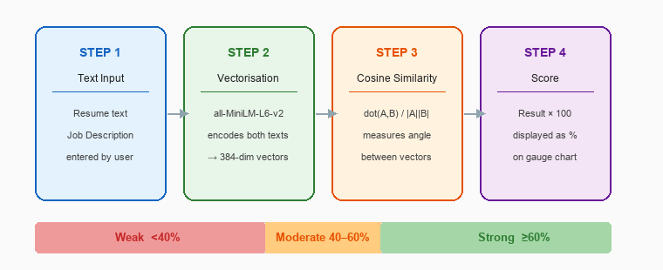

Figure 2: Four-step pipeline for computing the match score.

Score Interpretation
Score Range | Label | Meaning | Recommended Action
60% – 100% | Strong Match | Resume language closely mirrors the JD | Minor tweaks; apply confidently
40% – 59% | Moderate Match | Some overlap but key areas are missing | Use AI feedback to identify gaps
0% – 39% | Weak Match | Resume and JD are semantically misaligned | Significant rewrite recommended

6. Tech Keyword Gap Analysis
The keyword engine was redesigned to show only real technologies and tools — never soft skills, generic adjectives, or business jargon. It operates in two passes:

- Pass 1 — Exact matching: The JD is scanned against a vocabulary of 150+ known technologies. Any term present in the JD but absent from the resume is flagged as a candidate.

- Pass 2 — Semantic deduplication: Each candidate is encoded and compared against every sentence in the resume. If the semantic similarity exceeds 0.55, the term is removed — this handles synonyms and abbreviations (e.g. Postgres ↔ PostgreSQL, sklearn ↔ scikit-learn).

The vocabulary covers 8 technology categories:

Category | Examples from Vocabulary
Programming Languages | Python, JavaScript, TypeScript, Go, Rust, Java, C++, C#, R, SQL, Kotlin, Swift
Web Frameworks | React, Angular, Vue.js, Next.js, Django, FastAPI, Flask, Spring Boot, Node.js, Rails
Cloud & DevOps | AWS, Azure, GCP, Docker, Kubernetes, Terraform, Ansible, Jenkins, GitHub Actions, Helm
Databases | PostgreSQL, MySQL, MongoDB, Redis, Snowflake, BigQuery, Elasticsearch, DynamoDB, Cassandra
ML & Data Engineering | PyTorch, TensorFlow, scikit-learn, Spark, Airflow, dbt, MLflow, LangChain, Hugging Face
Testing & QA | Pytest, Selenium, Cypress, Jest, JUnit, TDD, BDD, Unit Testing, Integration Testing
APIs & Protocols | REST API, GraphQL, gRPC, WebSocket, OAuth, JWT, OpenAPI, Swagger
Architecture & Patterns | Microservices, Serverless, ETL, Data Pipeline, Message Queue, Kafka, RabbitMQ, CI/CD

7. Per-Bullet Scoring
While the overall score gives a high-level view, per-bullet scoring shows exactly which experience statements are strong and which need improvement. This is often more actionable than the overall score.

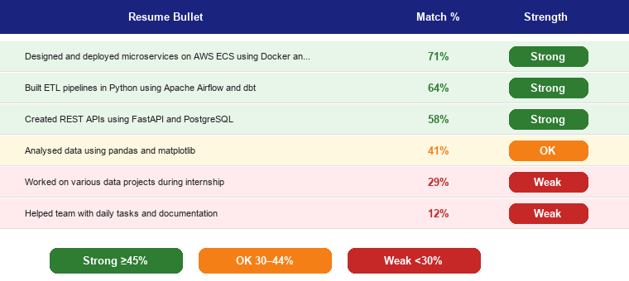

Figure 3: Example bullet scoring table showing Strong, OK, and Weak ratings.

The parser extracts bullets using regex patterns that detect •, -, *, and numbered lists. It also captures long descriptive lines (>40 characters) that are not formally bulleted. Each extracted bullet is then encoded and compared against the full JD vector using cosine similarity.

8. AI Features
Both AI features are powered by Groq's free API using the llama-3.1-8b-instant model. Groq runs inference on custom LPU (Language Processing Unit) hardware, making responses significantly faster than typical cloud LLM APIs. The free tier provides 14,400 requests/day.

8.1 AI Coach Feedback
Clicking 'Generate AI Feedback' constructs a structured prompt containing the job description (first 1,200 characters), the resume (first 1,200 characters), and the list of missing tech keywords. The model is instructed to respond in a fixed format:

- Match summary — 2 sentences explaining how well the resume fits the role
- 3 specific bullets to add or rewrite, with concrete examples
- 2 critical skills from the JD that are completely absent from the resume

8.2 AI Bullet Rewriter
The three weakest-scoring bullets are displayed in expandable panels. Each has a 'Rewrite with LLM' button that sends the original bullet and a JD excerpt to the model with instructions to: start with a strong action verb, be specific and quantified where possible, and keep the result under 20 words.

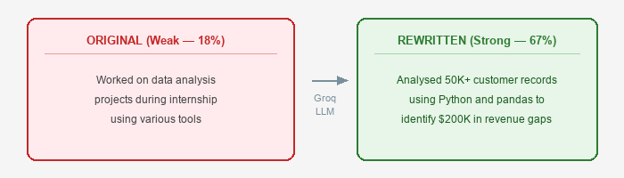

Figure 4: Example of a weak bullet being rewritten by the LLM.

8.3 Session State Persistence
A key technical detail: in Streamlit, every button click triggers a full page rerun. Early versions of the app lost AI results immediately after generation. The fix was to store all results (match score, bullet scores, AI feedback, rewrites) in st.session_state — a dictionary that survives reruns. Results now persist until the user clicks 'Analyze Match' again.

9. Project File Structure
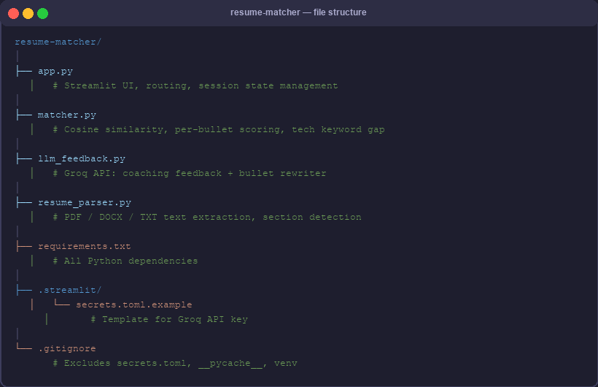

Figure 5: Project file structure with annotations for each file's responsibility.

10. Deployment
The application is deployed on Streamlit Community Cloud, which provides free hosting for public Streamlit apps connected to a GitHub repository. Deployments update automatically whenever code is pushed to the main branch.

Item | Details
Platform | Streamlit Community Cloud (free tier)
Live URL | https://resume-matcher-pdjd3nkkyhwlxdmfztladr.streamlit.app/
GitHub Repository | https://github.com/Himaaanshu7/resume-matcher
Branch | main
Entry Point | resume-matcher/app.py
Secret Managed | GROQ_API_KEY — stored in Streamlit dashboard, never in code
Auto-deploy | Yes — every push to main triggers a redeploy
Cost | Free

Secret Management
The Groq API key is stored as a Streamlit secret in the deployment dashboard — it is never committed to the GitHub repository. The app reads it at runtime via st.secrets['GROQ_API_KEY']. If the secret is absent (e.g. local development), the app falls back to a sidebar input field where users can enter their own key.

11. How to Run Locally
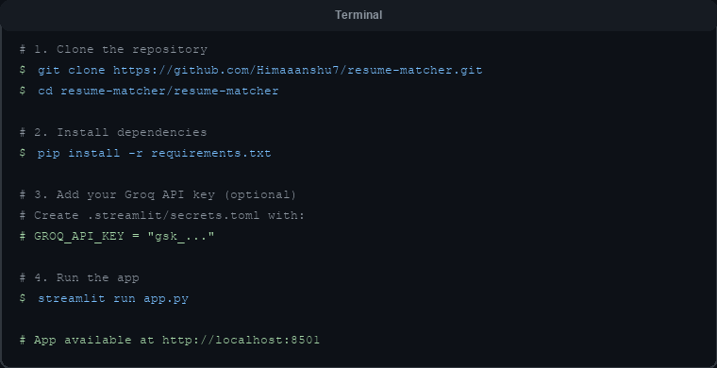

Figure 6: Terminal commands to clone, install, and run the app locally.

12. How to Use the App
- Step 1 — Open the App: Visit the live URL or run locally. The app loads with an empty two-column layout.

- Step 2 — Upload or Paste Resume: Use the left panel to upload a PDF or DOCX file, or paste resume text directly into the text area. Both options produce identical results.

- Step 3 — Paste the Job Description: Copy the full job description from LinkedIn, Indeed, or any job board and paste it into the right panel text area.

- Step 4 — Click 'Analyze Match': The button activates once both inputs are filled. The semantic model runs locally and results appear within 2–5 seconds (longer on first run while the model loads).

- Step 5 — Review the Gauge Chart: The match score is shown as a percentage on a colour-coded gauge. Read the summary line below it for a quick verdict.

- Step 6 — Check Missing Tech Keywords: The left column shows technology terms from the JD not found in the resume. These are high-priority additions to consider.

- Step 7 — Review Bullet Scores: The bullet score table shows every resume bullet ranked by JD relevance. Sort mentally by Weak → OK → Strong to find the most impactful items to fix.

- Step 8 — Rewrite Weak Bullets: Expand any weak bullet panel and click 'Rewrite with LLM'. The AI produces an improved version in under 3 seconds. The result stays on screen persistently.

- Step 9 — Generate AI Feedback: Click 'Generate AI Feedback' at the bottom for a full coaching report. This gives a holistic view with specific, actionable recommendations.

13. Limitations & Future Improvements

Current Limitations
- Score reflects text similarity, not skill matching: A resume full of general tech language can score higher than one with the exact right skills written differently. The keyword gap and bullet scores provide better signal.

- Groq free tier rate limits: 14,400 requests/day is generous for a demo app, but a high-traffic deployment would need a paid Groq plan or fallback model.

- Tech vocabulary is static: New frameworks and tools require manual additions to the vocabulary list in matcher.py.

- No user accounts or history: Sessions are stateless — analysis results are lost when the browser tab closes.

Potential Future Improvements
- Dynamic tech vocabulary using live job market data APIs
- User accounts with analysis history and progress tracking
- Side-by-side diff view showing exactly which resume words align with which JD phrases
- Export analysis report as a formatted PDF
- ATS (Applicant Tracking System) simulation mode
- Resume score trend tracking across multiple JD comparisons
- Multi-language support for non-English resumes and JDs

— End of Document —

