DECS Project Description

System: Customer feedback form for any company

Semantics of the form:

The form will contain following fields:
- Name: name of user
- Company: name of the company
- Rating: rating given to that company by user
- Comments: any comments that user wishes to leave for that company

Components:

1. Client: Can send following requests to HTTP server:
- fill: fill a customer feedback form
- view_usecompany: view feedback forms for given company
- view_usename: view feedback forms for given user name
- delete_feedback: delete a feedback form for given company and user name parameters.

2. HTTP Server:
- accepts client connections over HTTP protocol
- communicates with database server, using HTTP protocol, and forwards client’s queries to insert/select/delete the data

3. Database Server:
- accepts connections from HTTP server, and accepts its requests to insert/select/delete the data
- communicates with MySQL database to fulfill these requests
- contains in-memory cache to improve performance of the system

4. In-memory cache:
- created using hash-map
- accepts select request from database server and fulfills them if it contains the data
- Upon delete request, the concerned entry is deleted from the server
- Keys can be: user name or company name
- implements LRU policy of eviction, based on timestamp

5. Database: MySQL database that stores a table called feedback_form, with 5 fields:
- id
- user_name
- company_name
- rating
- comments
- submitted_at

Diagram:
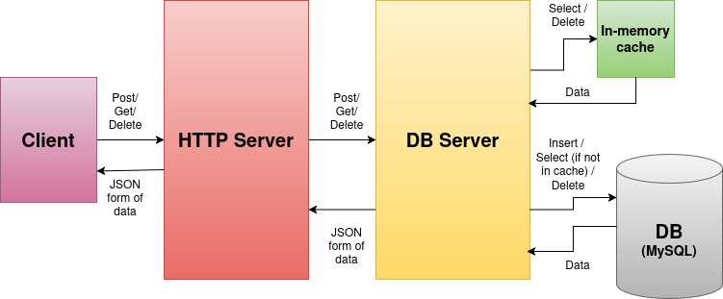
Note: Upon insertion of a feedback for a given user and company, in DB, database server will remove any entry corresponding to that user or company from in-memory cache

Technology used:

Client, HTTP server and DB server : C++
Database: MySQL
HTTP library: cpp-httplib
JSON library: nlohmann json.hpp
Database connector: MySQL Connector/C++ X DevAPI
Link of Github Repo:
https://github.com/Himadri-Mukadam/CS744_DECS_Project.git

