ENHANCING DECISION-MAKING THROUGH DATA VISUALIZATION: EXPLORING CANADA'S QUALITY OF LIFE FRAMEWORK

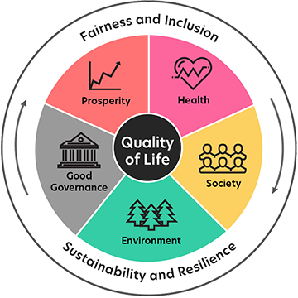

**GROUP 2**

***GROUP MEMBERS -***

Edwin Jacob – N01579447

Divya Jain – N01535424

Suryansh Gupta – N01579410

Himadri Patel – N01579857

Daegan Pimenta - N01536800

DASHBOARD LINK: [Quality of Life - Group 2.pbix](https://humberital-my.sharepoint.com/:u:/r/personal/n01579857_humber_ca/Documents/PowerBI/video/Quality%20of%20Life%20-%20Group%202.pbix?csf=1&web=1&e=I26K1v)

GROUP PRESENTATION LINK: [Quality of Life - Group 2.mp4](https://humberital-my.sharepoint.com/personal/n01579857_humber_ca/_layouts/15/onedrive.aspx?id=%2Fpersonal%2Fn01579857%5Fhumber%5Fca%2FDocuments%2FPowerBI%2Fvideo&ga=1)

# **Gantt Chart:**

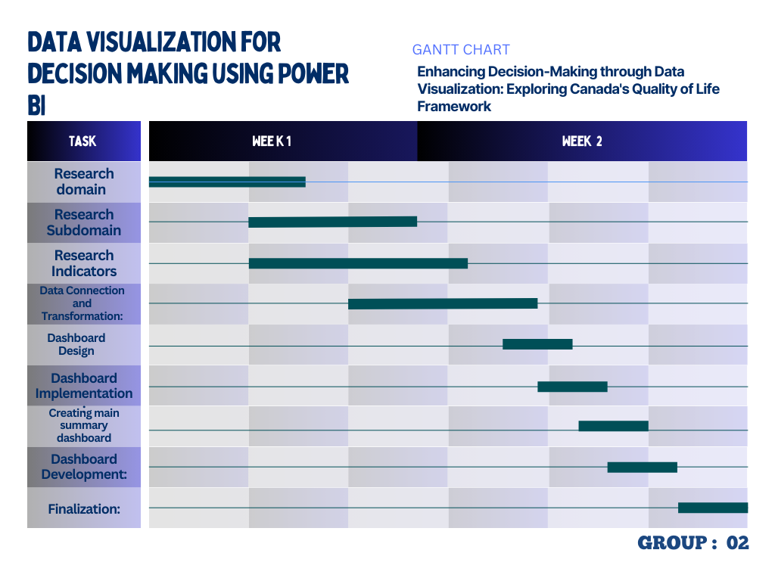**2. DAX Codes and Screenshots of the boards:**

***Prosperity***

Housing needs

= Table.TransformColumnTypes(#"Promoted Headers",{{"REF_DATE", Int64.Type}, {"GEO", type text}, {"DGUID", type text}, {"Tenure including first-time homebuyer and social and affordable housing status", type text}, {"Acceptable housing", type text}, {"Statistics", type text}, {"UOM", type text}, {"UOM_ID", Int64.Type}, {"SCALAR_FACTOR", type text}, {"SCALAR_ID", Int64.Type}, {"VECTOR", type text}, {"COORDINATE", type text}, {"VALUE", type number}, {"STATUS", type any}, {"SYMBOL", type any}, {"TERMINATED", type any}, {"DECIMALS", Int64.Type}})

Employment

= Table.TransformColumnTypes(#"Promoted Headers",{{"REF_DATE", type date}, {"GEO", type text}, {"DGUID", type text}, {"Labour force characteristics", type text}, {"Sex", type text}, {"Age group", type text}, {"Statistics", type text}, {"Data type", type text}, {"UOM", type text}, {"UOM_ID", Int64.Type}, {"SCALAR_FACTOR", type text}, {"SCALAR_ID", Int64.Type}, {"VECTOR", type text}, {"COORDINATE", type text}, {"VALUE", type number}, {"STATUS", type any}, {"SYMBOL", type any}, {"TERMINATED", type any}, {"DECIMALS", Int64.Type}})

Youth

= Table.TransformColumnTypes(#"Promoted Headers",{{"REF_DATE", Int64.Type}, {"GEO", type text}, {"DGUID", type text}, {"Educational attainment level", type text}, {"Labour force and education status", type text}, {"Age group", type text}, {"Sex", type text}, {"Statistics", type text}, {"UOM", type text}, {"UOM_ID", Int64.Type}, {"SCALAR_FACTOR", type text}, {"SCALAR_ID", Int64.Type}, {"VECTOR", type text}, {"COORDINATE", type text}, {"VALUE", Int64.Type}, {"STATUS", type any}, {"SYMBOL", type any}, {"TERMINATED", type any}, {"DECIMALS", Int64.Type}})

***Health***

Hale

= Table.TransformColumnTypes(#"Promoted Headers",{{"REF_DATE", type text}, {"GEO", type text}, {"DGUID", type text}, {"Age group", type text}, {"Sex", type text}, {"Income group", type text}, {"Characteristics", type text}, {"UOM", type text}, {"SCALAR_FACTOR", type text}, {"VALUE", type number}})

SRMH:

= Table.TransformColumnTypes(#"Promoted Headers",{{"REF_DATE", Int64.Type}, {"GEO", type text}, {"DGUID", type any}, {"Age group", type text}, {"Indicators", type text}, {"Characteristics", type text}, {"VALUE", type number}})

= Table.SelectRows(#"Changed Type", each ([REF_DATE] <> 2016))

= Table.SelectRows(#"Filtered Rows1", each ([Characteristics] = "Number of persons"))

= Table.RemoveColumns(#"Filtered Rows",{"DGUID"})

UnmentHealthcare:

= Table.TransformColumnTypes(#"Promoted Headers",{{"REF_DATE", Int64.Type}, {"GEO", type text}, {"DGUID", type text}, {"Sex", type text}, {"Statistics", type text}, {"UOM", type text}, {"UOM_ID", Int64.Type}, {"SCALAR_FACTOR", type text}, {"SCALAR_ID", Int64.Type}, {"VECTOR", type text}, {"COORDINATE", type date}, {"VALUE", type number}})

= Table.RemoveColumns(#"Changed Type",{"DGUID"})

= Table.RemoveColumns(#"Changed Type",{"DGUID", "UOM", "UOM_ID", "SCALAR_FACTOR", "SCALAR_ID", "VECTOR"})

= Table.SelectRows(#"Removed Columns", each ([GEO] <> "Canada"))

Fruits and Vegetable consumption:

= Table.TransformColumnTypes(#"Promoted Headers",{{"REF_DATE", Int64.Type}, {"GEO", type text}, {"DGUID", type text}, {"Age group", type text}, {"Sex", type text}, {"Indicators", type text}, {"Characteristics", type text}, {"VALUE", type number}})

= Table.SelectRows(#"Changed Type", each ([REF_DATE] <> 2016) and ([Age group] <> "Total, 12 years and over") and ([Characteristics] = "Percent"))

***Environment***

Drinking Water

= Table.TransformColumnTypes(#"Promoted Headers",{{"REF_DATE", Int64.Type}, {"GEO", type text}, {"DGUID", type text}, {"Type of supply", type text}, {"Treatment of drinking water", type text}, {"UOM", type text}, {"UOM_ID", Int64.Type}, {"SCALAR_FACTOR", type text}, {"SCALAR_ID", Int64.Type}, {"VECTOR", type text}, {"COORDINATE", type text}, {"VALUE", Int64.Type}, {"STATUS", type text}, {"SYMBOL", type text}, {"TERMINATED", type text}, {"DECIMALS", Int64.Type}})

= Table.RemoveColumns(#"Changed Type",{"STATUS", "SYMBOL", "TERMINATED", "DECIMALS", "DGUID", "UOM", "UOM_ID", "SCALAR_FACTOR", "SCALAR_ID", "VECTOR", "COORDINATE"})

Climate Change

= Table.TransformColumnTypes(#"Promoted Headers",{{"Year", Int64.Type}, {"Geography", type text}, {"Core public infrastructure assets", type text}, {"Type of municipality by population size", type text}, {"GeoCode", Int64.Type}, {"Value", type number}})

= Table.RemoveColumns(#"Changed Type",{"GeoCode"})

***Good Governance***

Crime severity index

= Table.TransformColumnTypes(#"Promoted Headers",{{"REF_DATE", Int64.Type}, {"GEO", type text}, {"DGUID", type text}, {"Statistics", type text}, {"UOM", type text}, {"UOM_ID", Int64.Type}, {"SCALAR_FACTOR", type text}, {"SCALAR_ID", Int64.Type}, {"VECTOR", type text}, {"COORDINATE", type number}, {"VALUE", type number}, {"STATUS", type text}, {"SYMBOL", type text}, {"TERMINATED", type text}, {"DECIMALS", Int64.Type}})

Discrimination and unfair treatment

= Table.TransformColumnTypes(#"Promoted Headers",{{"REF_DATE", Int64.Type}, {"GEO", type text}, {"DGUID", type text}, {"Visible minority", type text}, {"Selected sociodemographic characteristics", type text}, {"Indicators", type text}, {"Statistics", type text}, {"UOM", type text}, {"UOM_ID", Int64.Type}, {"SCALAR_FACTOR", type text}, {"SCALAR_ID", Int64.Type}, {"VECTOR", type text}, {"COORDINATE", type text}, {"VALUE", type number}, {"STATUS", type text}, {"SYMBOL", type text}, {"TERMINATED", type text}, {"DECIMALS", Int64.Type}})

Confidence levels in institutions:

= Table.TransformColumnTypes(#"Promoted Headers",{{"REF_DATE", type date}, {"GEO", type text}, {"DGUID", type text}, {"Gender", type text}, {"Sociodemographic characteristics", type text}, {"Indicators", type text}, {"Statistics", type text}, {"UOM", type text}, {"UOM_ID", Int64.Type}, {"SCALAR_FACTOR", type text}, {"SCALAR_ID", Int64.Type}, {"VECTOR", type text}, {"COORDINATE", type text}, {"VALUE", type number}, {"STATUS", type text}, {"SYMBOL", type text}, {"TERMINATED", type text}, {"DECIMALS", Int64.Type}})

***Society***

= Table.TransformColumnTypes(#"Promoted Headers",{{"REF_DATE", type date}, {"GEO", type text}, {"DGUID", type text}, {"Gender", type text}, {"Sociodemographic characteristics", type text}, {"Indicators", type text}, {"Statistics", type text}, {"UOM", type text}, {"UOM_ID", Int64.Type}, {"SCALAR_FACTOR", type text}, {"SCALAR_ID", Int64.Type}, {"VECTOR", type text}, {"COORDINATE", type text}, {"VALUE", type number}, {"STATUS", type any}, {"SYMBOL", type any}, {"TERMINATED", type any}, {"DECIMALS", Int64.Type}})

Dashboard Screenshots:

Porsperity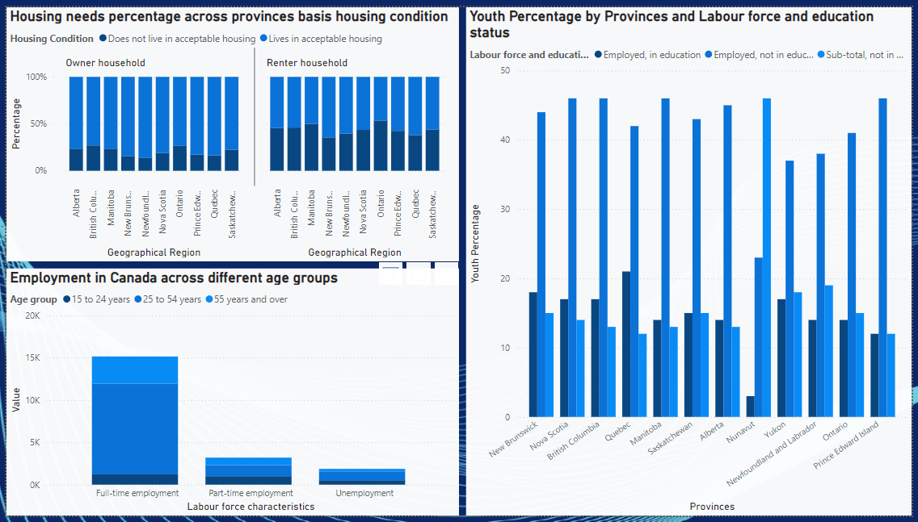

Health

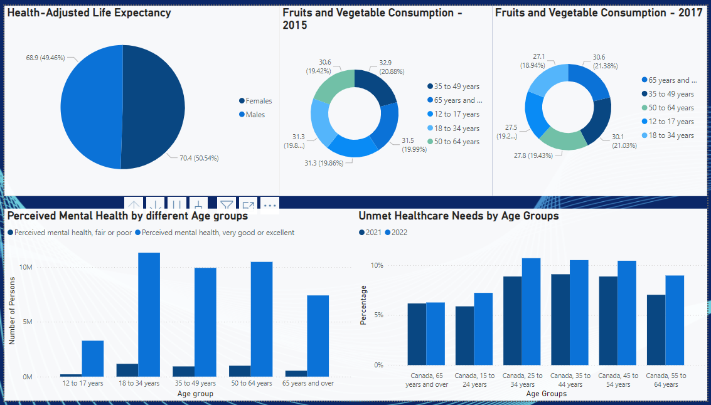

Society

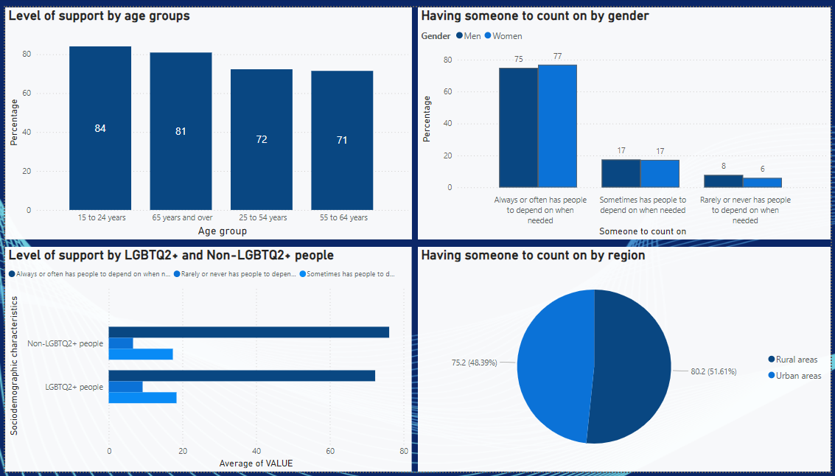

Environment

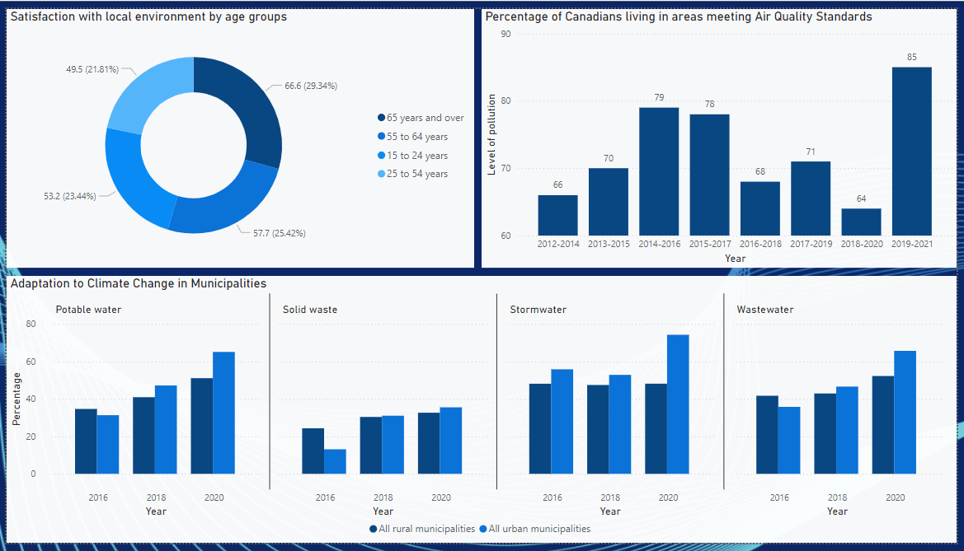

Good governance

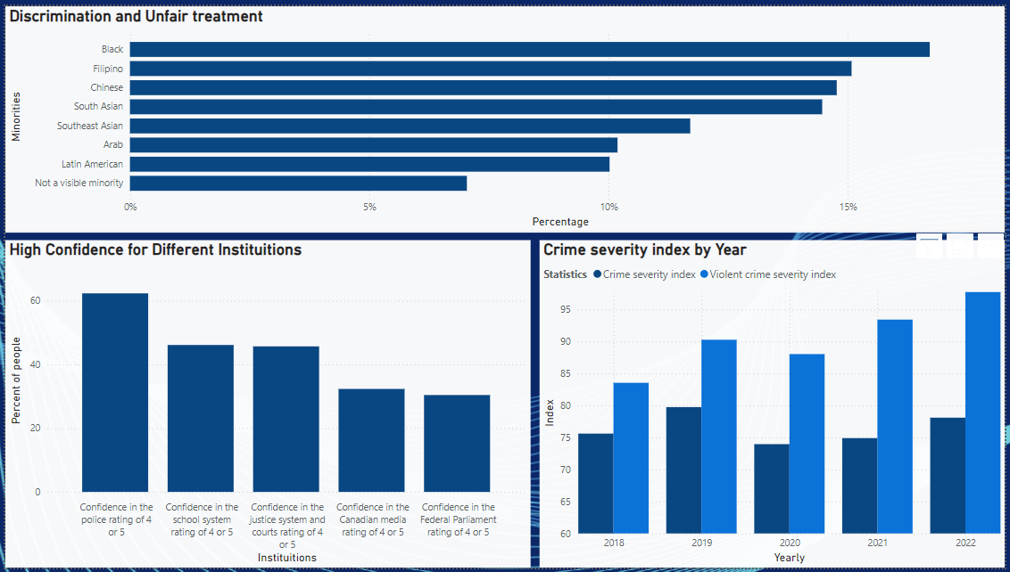

Summary

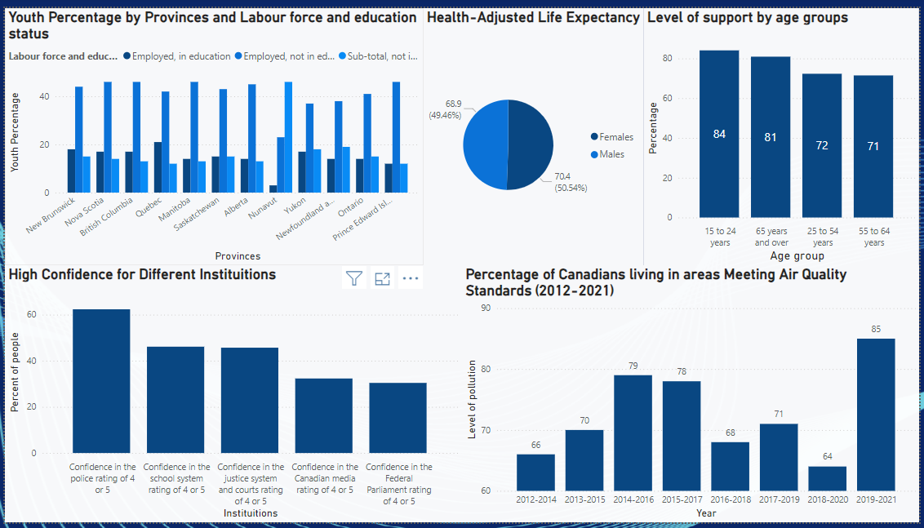

Challenges

During our Power BI project, we encountered several challenges that impacted our workflow and productivity. One significant issue was the limitation of the free version of Power BI, which did not allow us to share dashboards among team members. Consequently, we were forced to coordinate our schedules to work together on a single laptop, which proved to be inefficient and time-consuming. Additionally, we faced difficulties publishing the dashboard to Power BI services due to sign-in issues with our Humber email IDs. These challenges hindered our ability to collaborate effectively and delayed the project’s completion.

Conclusion

In conclusion, our project involved an in-depth analysis of the five domains of Quality of Life in Canada, utilizing data sourced from Statistics Canada. Through Power BI, we built comprehensive reports that provide valuable insights into various aspects of Canadians' well-being. The health domain analysis underscores the importance of healthcare access and its direct impact on the population's overall health. In the education domain, the data highlights areas for improvement in educational outcomes and access, which are crucial for future economic growth and personal development. The income domain analysis sheds light on economic disparities and can inform policies aimed at reducing inequality. Our examination of the social environment domain emphasizes the significance of community support and social networks in enhancing life satisfaction. Finally, the environmental quality domain analysis reveals the relationship between a clean, sustainable environment and the overall quality of life. These insights are not only crucial for current policymakers but also pave the way for future growth and development, ensuring a higher quality of life for all Canadians.

References

Statistics Canada. (2024, June 12). Quality of Life Hub. Government of Canada. <https://www160.statcan.gc.ca/index-eng.htm>