**Assignment: Build a RESTful API with MongoDB using Node.js and Express**

**Node.js server is running on port 5000 and has successfully connected to MongoDB.**

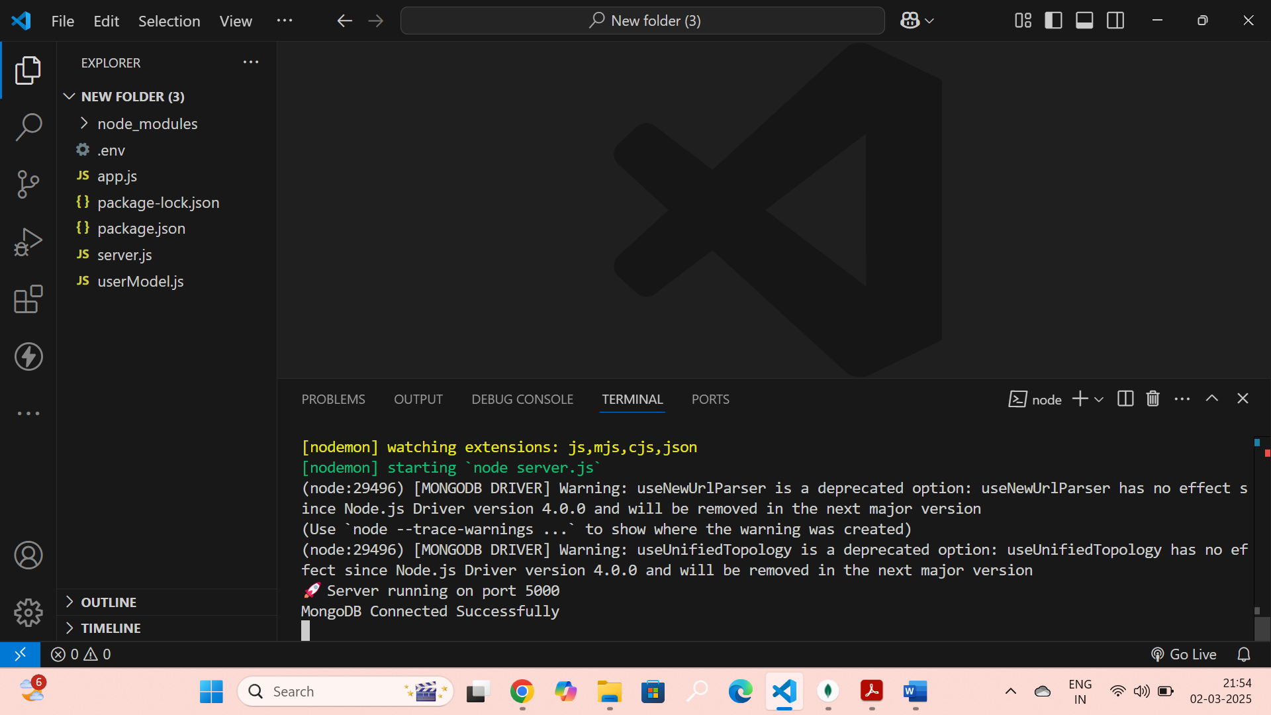

**1. GET /users – Retrieves a list of all users from the MongoDB database.**

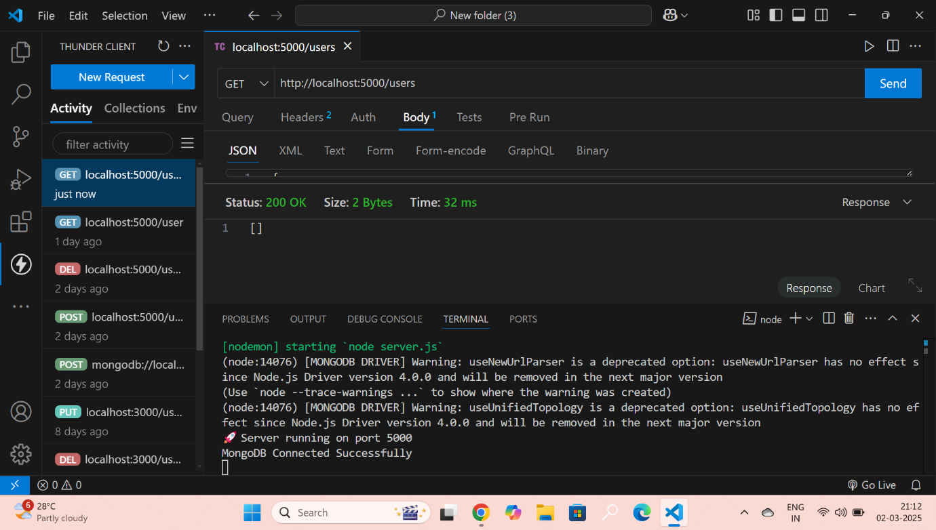

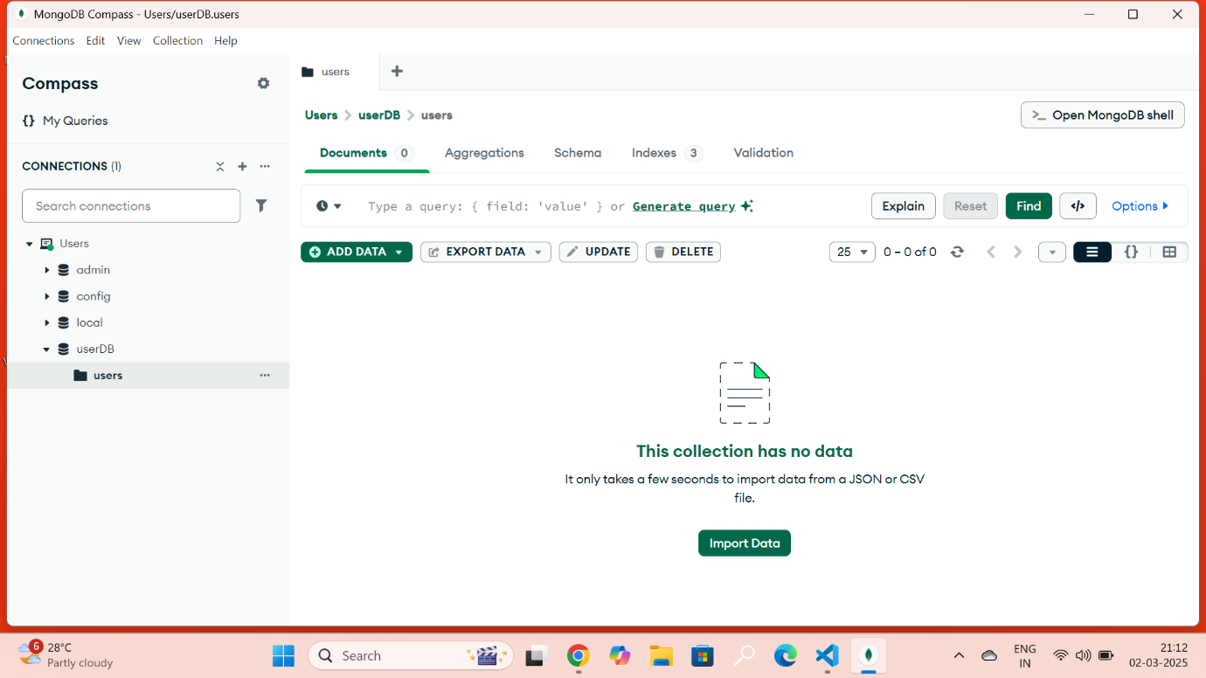

**2. POST /user – Creates a new user, saving their data in MongoDB.**

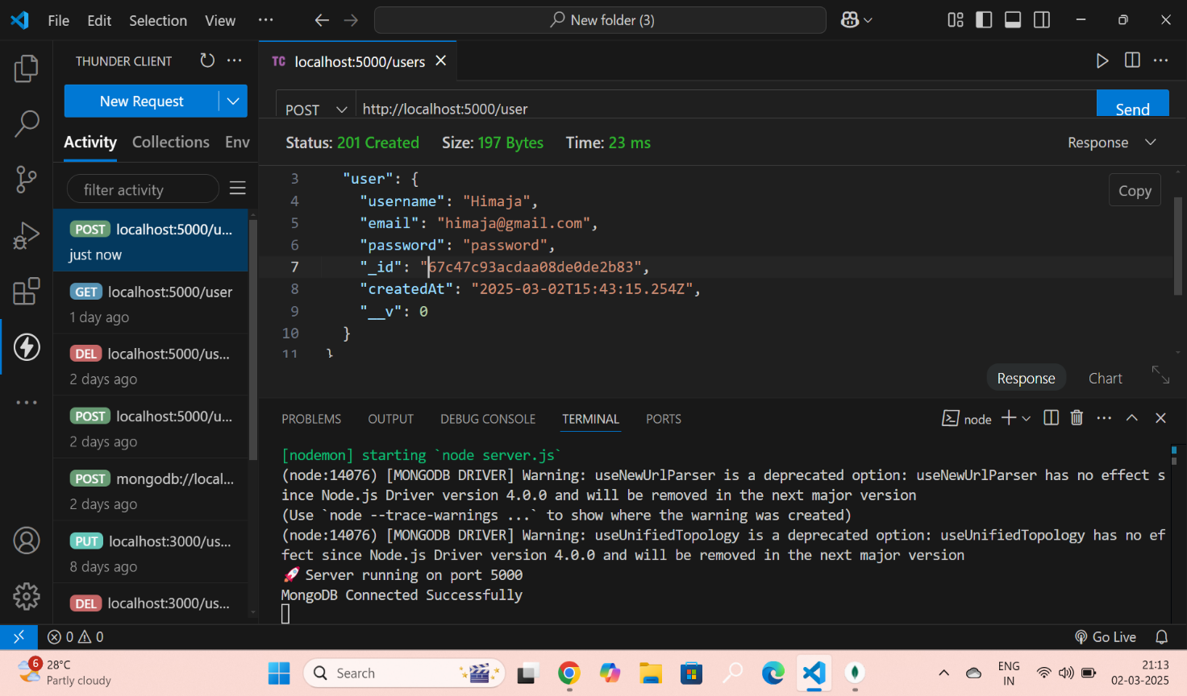

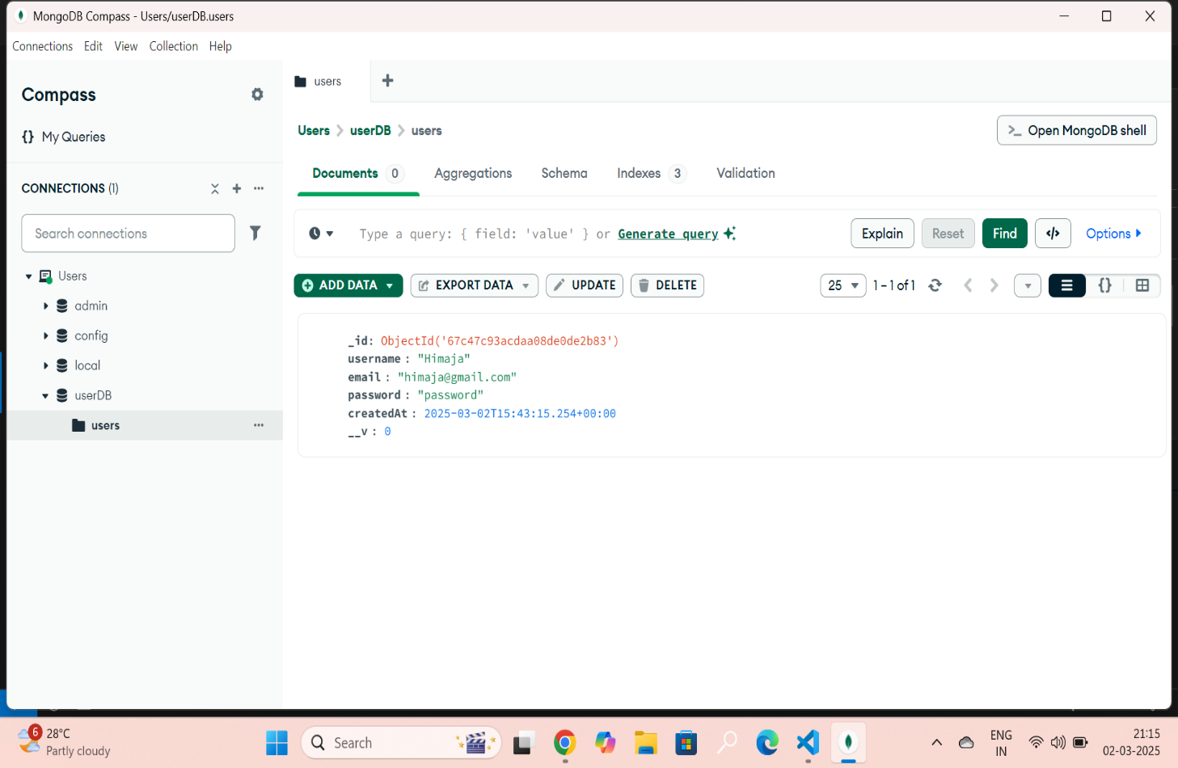

**3. GET /users – Fetches all users from MongoDB, including newly added users after a POST request.**

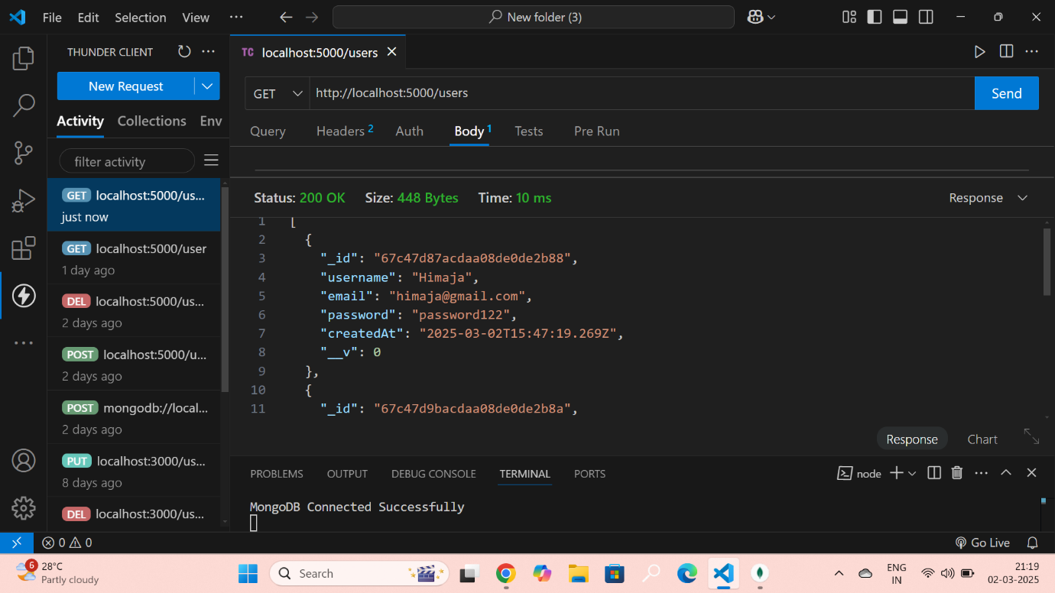

**4. GET /users/{id} – Retrieves details of a specific user using their MongoDB ObjectId.**

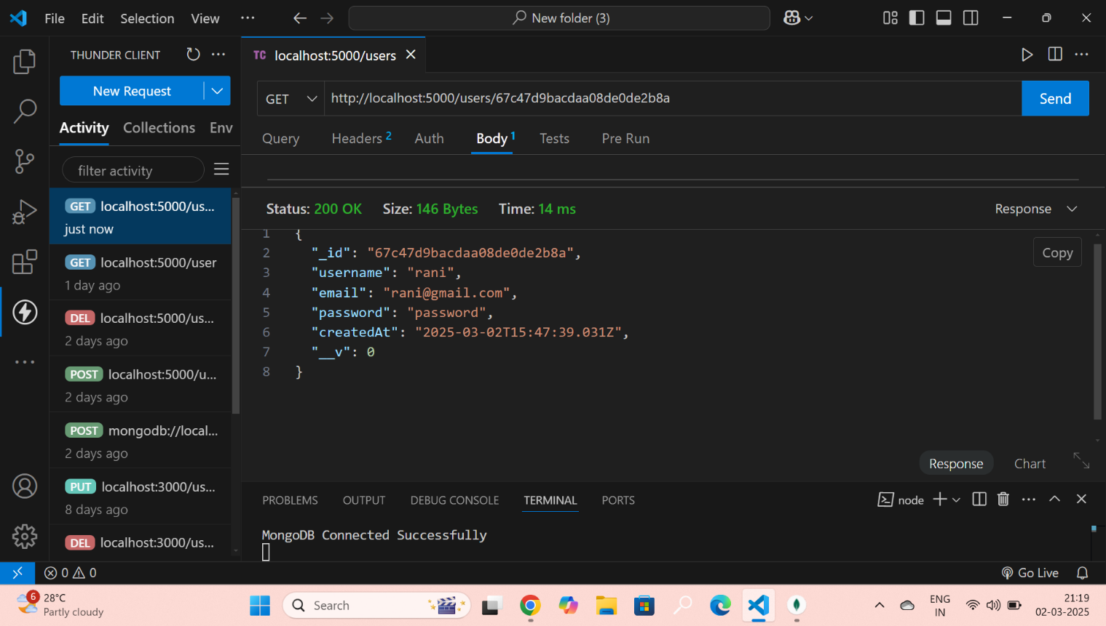

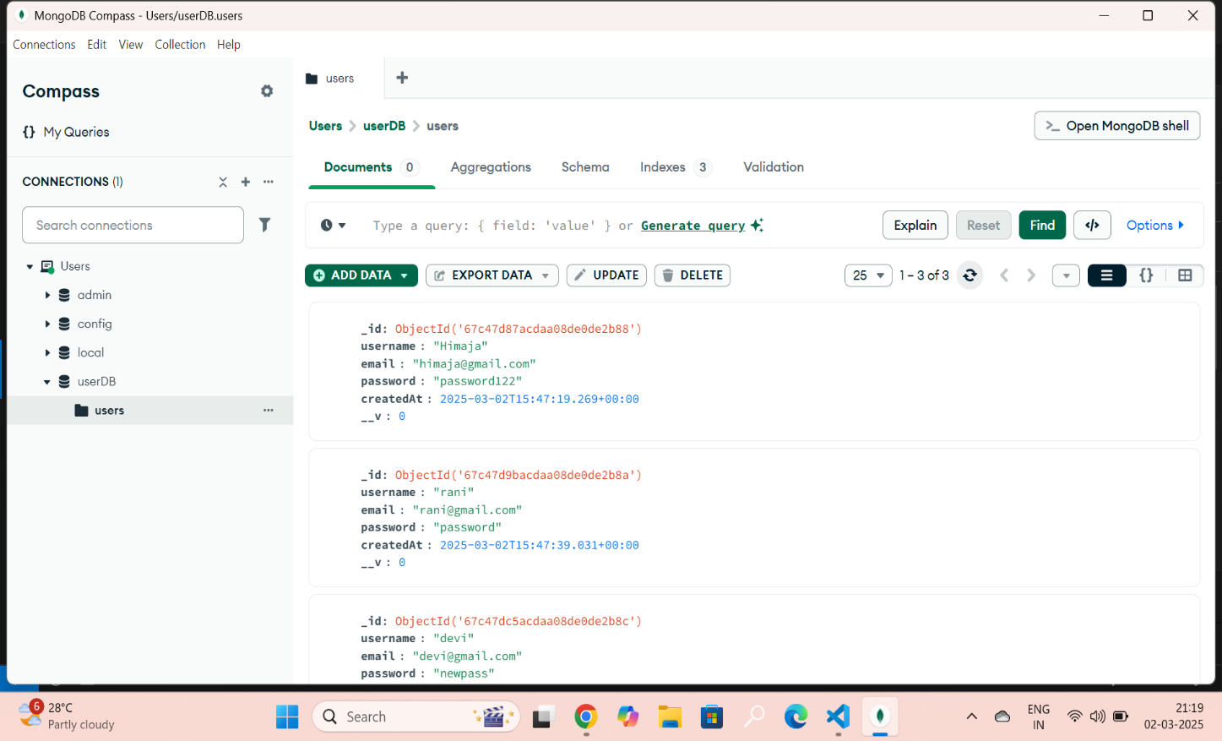

**5. PUT /user/{id} – Updates the information of an existing user.**

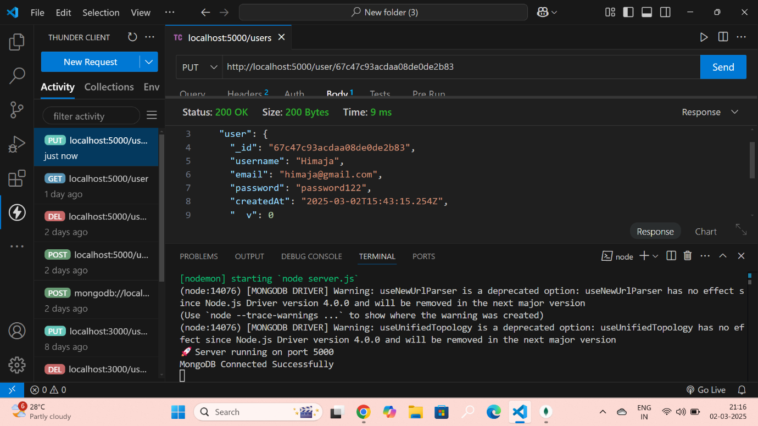

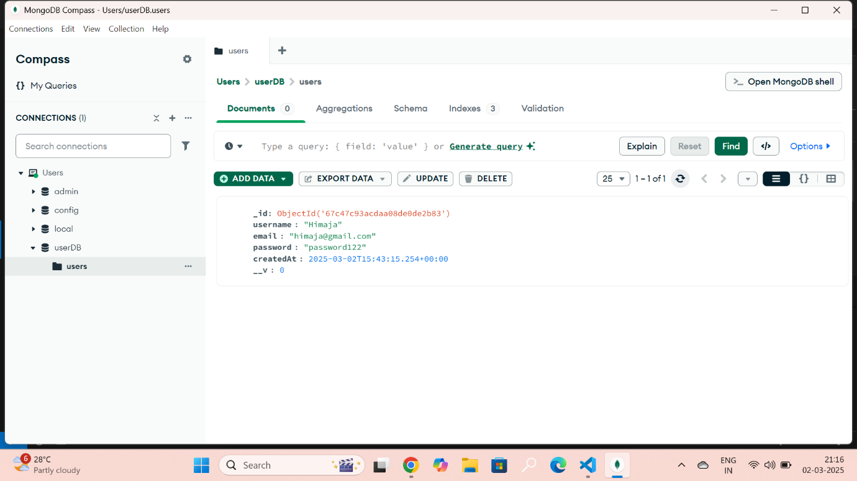

**6. DELETE /user/{id} – Removes a user from the database based on their ObjectId.**

