**Assignment 1: Build a RESTful API using Node.js and Express**

Get :

1) Successfully fetching the list of all users.

Returns 200 OK with an array of users.

**Link: http://localhost:3000/users**

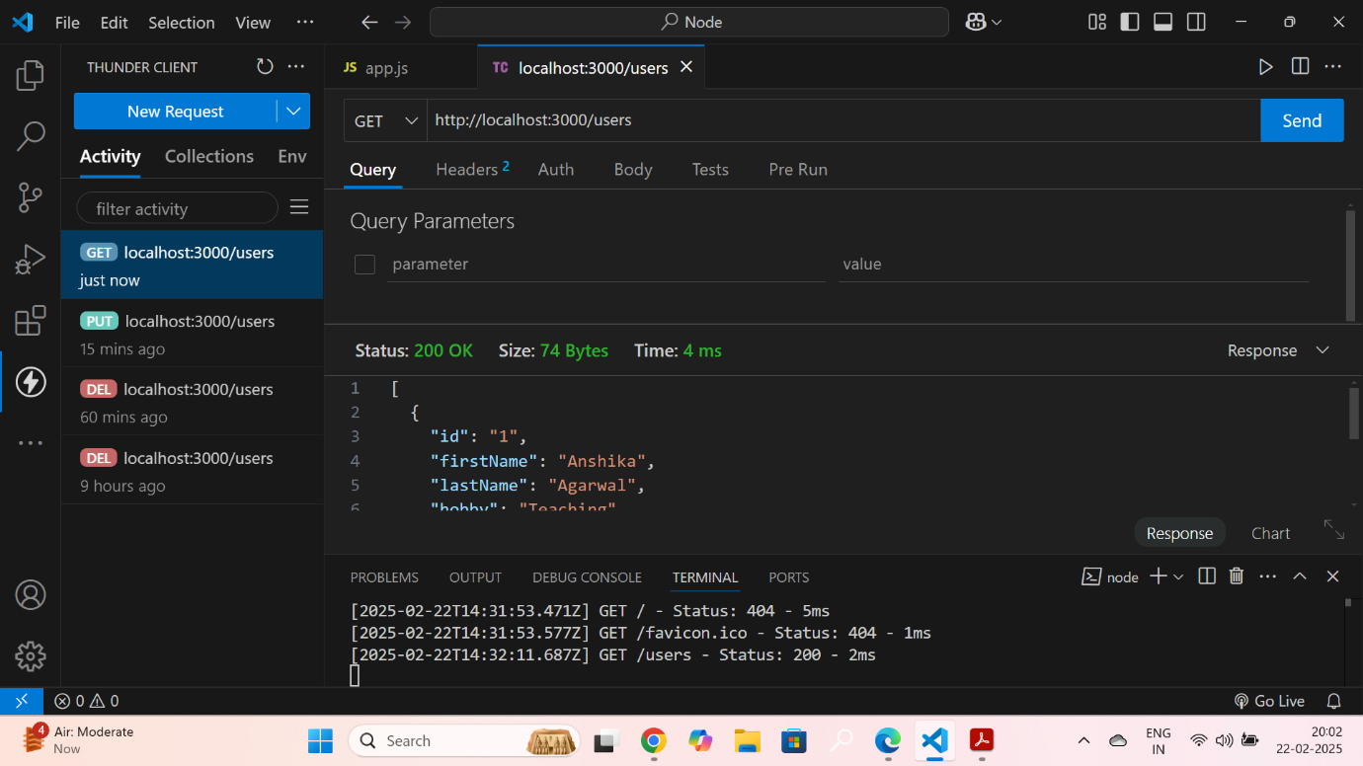

1. Fetching user details with a valid ID.

Returns 200 OK with user details.

**Link: http://localhost:3000/users/:id**

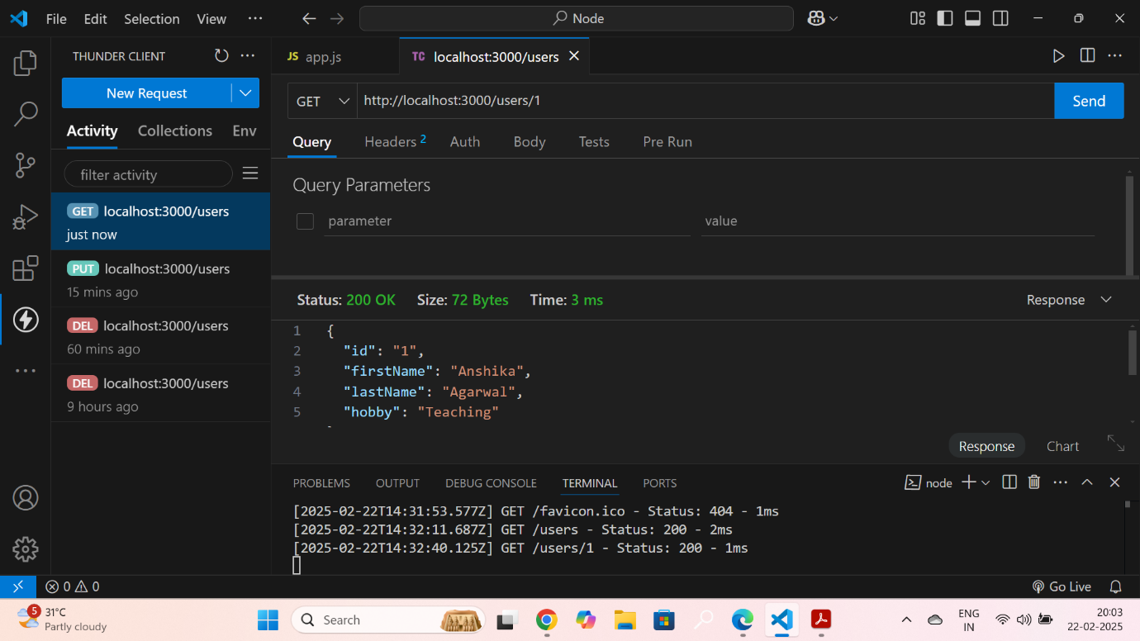

**Post :**

3) Missing firstName, lastName, or hobby field in the request body.

Returns 400 Bad Request with error: "All fields are required."

**Link: http://localhost:3000/user**

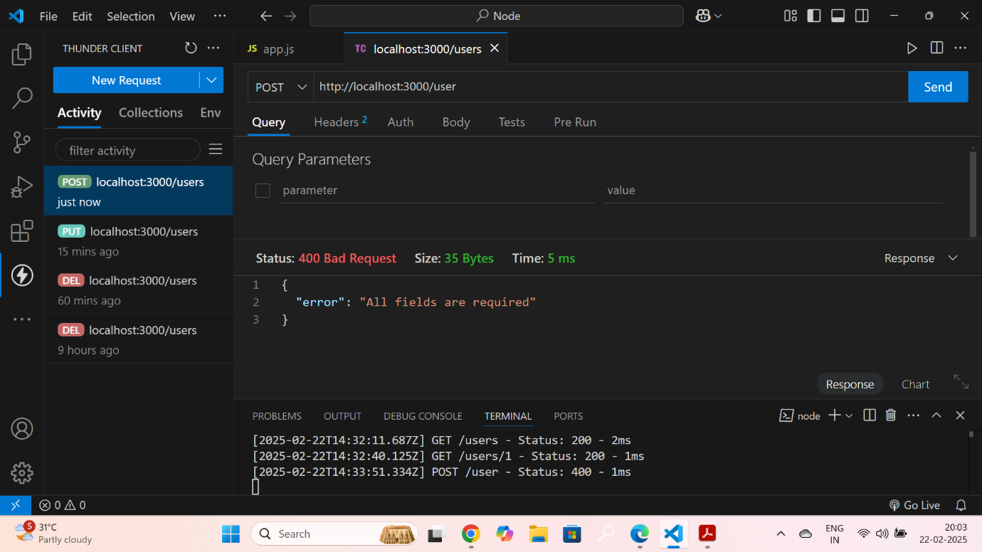

4) FirstName or LastName contains numbers or special characters.

Returns 400 Bad Request with error: "Names must contain only alphabets”.

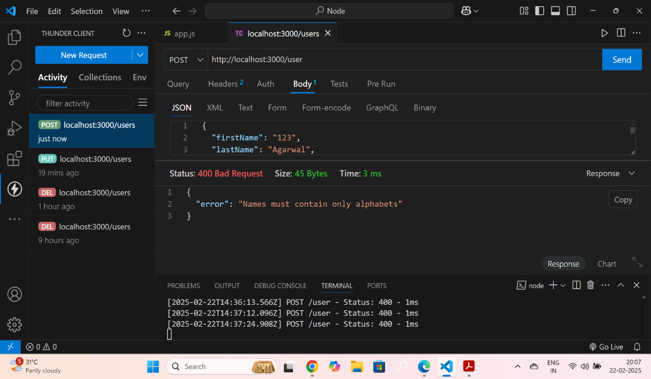

5) FirstName or LastName contains numbers or special characters.

Returns 400 Bad Request with error: "Names must contain only alphabets”.

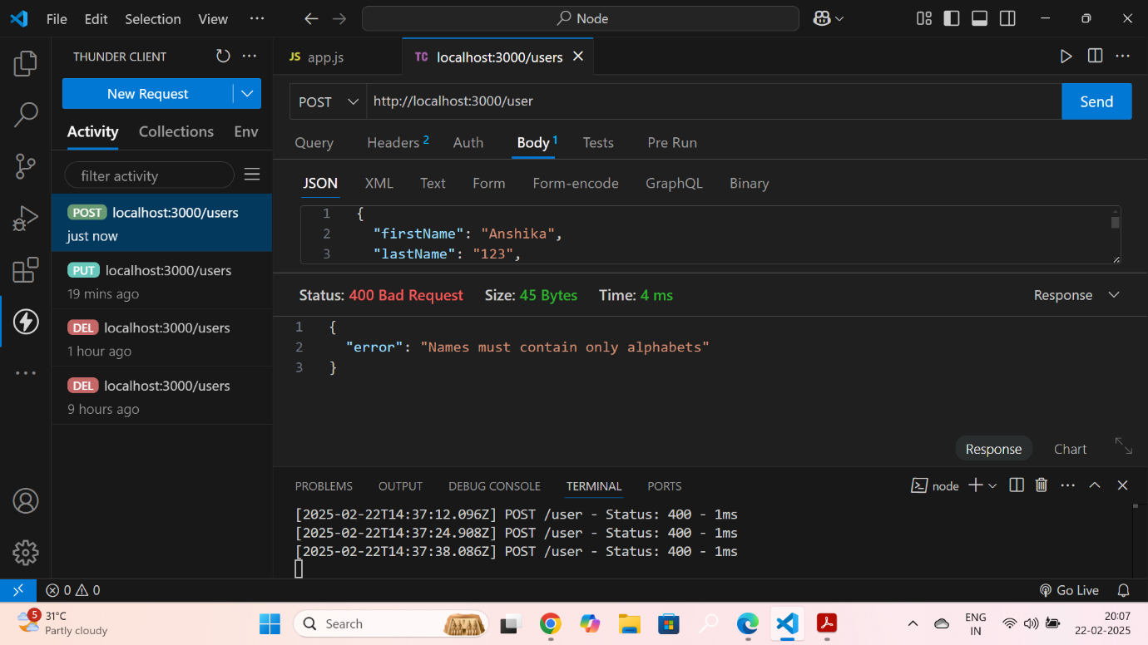

6) hobby length is less than 3 or more than 30 characters.

Returns 400 Bad Request with error: "Hobby must be 3-30 characters long

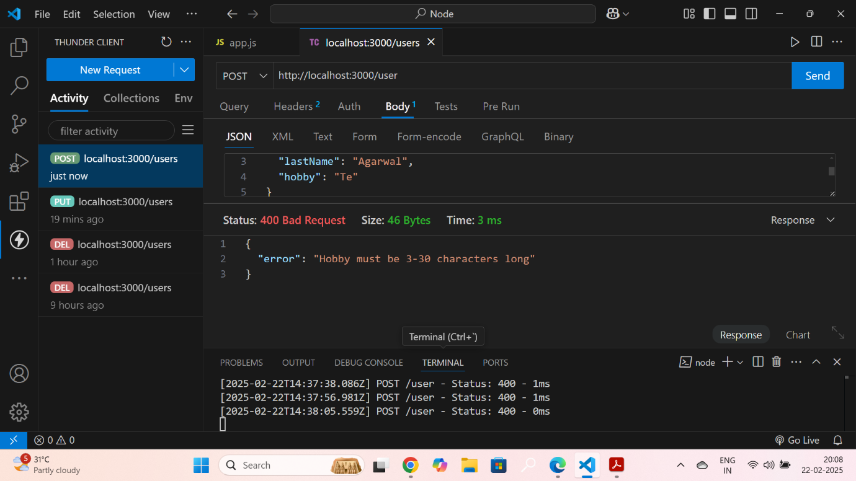

**Delete :**

7) Deleting a user with a valid ID.

Returns 200 OK with message: "User removed successfully."

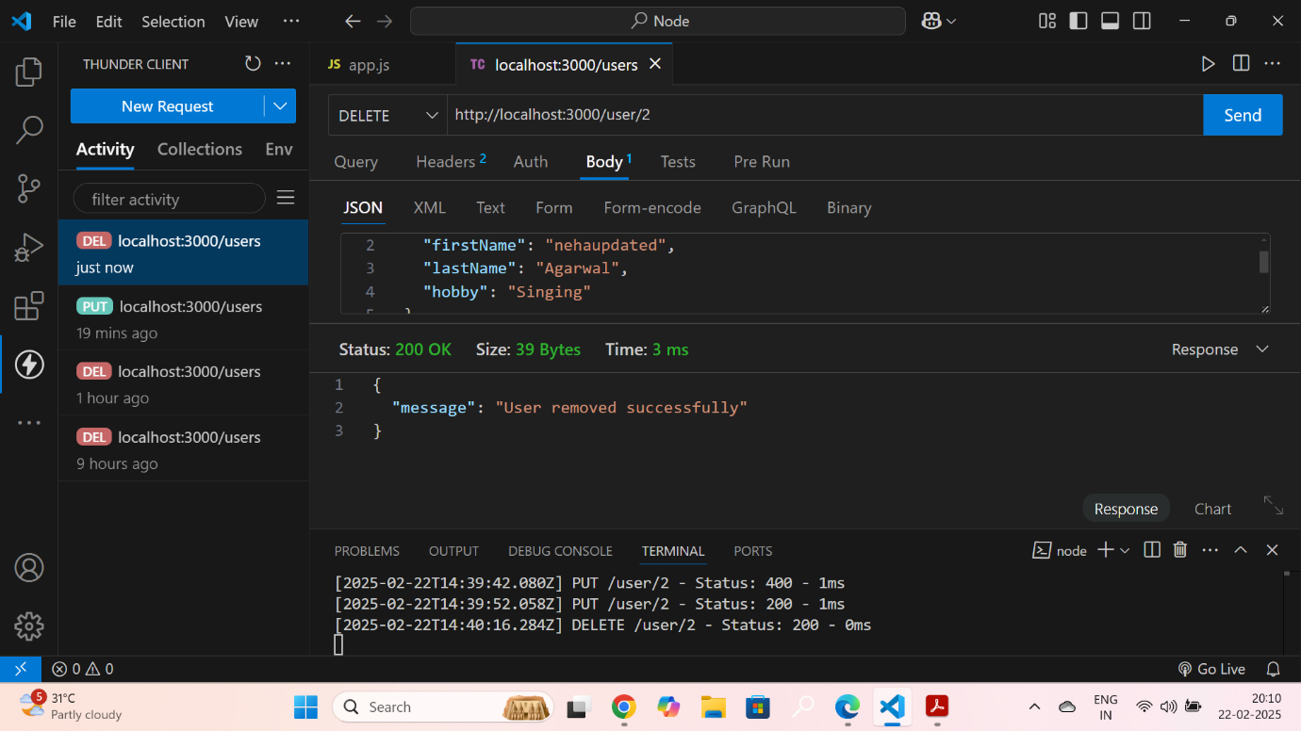

Put:

8) Successful PUT request with valid input.

Returns 200 OK with message: "User updated successfully."

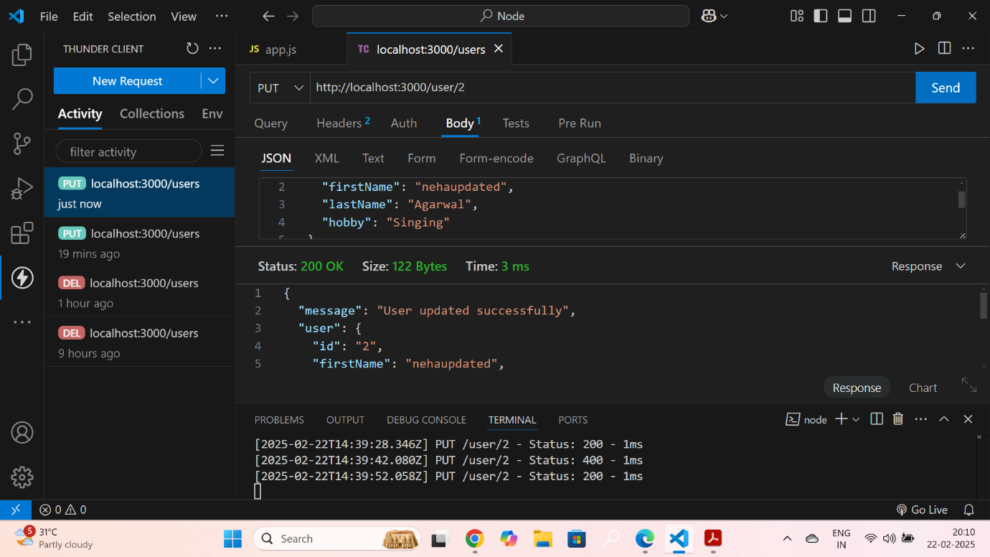

9) For all user-related routes (GET, PUT, DELETE), the application

Returns 404 Not Found

if the user ID is missing, invalid, or not found.

