NERAYA
Agricultural Intelligence for the Farmer

Why Neraya
A farmer can notice that something is wrong with a crop without immediately knowing what the problem is or what should happen next.
A crop image can show visible symptoms. Weather can explain part of the situation. Crop stage, field conditions, previous observations, and the farmer's own experience add more context. The difficulty is that these pieces of information are often separated.
Neraya brings them together in one place. The goal is not simply to return a disease name. The goal is to help the farmer understand what is being seen, what evidence supports an assessment, what is still missing, and what to check next.
Evidence → Context → Reasoning → Action

Project Overview
Neraya is a farmer centered agricultural intelligence platform that brings crop information, field context, farmer observations, weather, field history, AI assisted assessment, and a foundation for real farmer knowledge sharing into one experience.
The farmer remains the decision maker. Neraya is designed to make information easier to understand and to turn scattered evidence into practical next steps.

The Core Idea

Evidence
- Crop image
- Farmer description
- Farmer observations
- Crop type and variety
- Growth stage
- Field information

Context
- Current weather
- Weather forecast
- Field location
- Previous assessments
- Field history
- Environmental conditions

Reasoning
Gemini multimodal analysis is used to produce an AI assisted assessment. Instead of returning only a label, Neraya presents observed indicators, evidence used, missing evidence, assessment confidence, severity, environmental considerations, recommendations, and escalation guidance when appropriate.

Action
The result is turned into practical decision support. The farmer can understand what to inspect, what to monitor, what conditions may matter, and when expert advice may be useful.
Neraya does not predict for the farmer. Neraya helps the farmer decide.

Product Features
Feature | What it does
Crop Assessment | Combines a real crop image with farmer observations, field context, weather, forecast information, and previous assessment context.
Field Pulse | Provides an interactive 3D representation of the selected field and responds to crop type, growth stage, severity, and environmental conditions.
Weather Intelligence | Provides current conditions and forecast information as environmental context.
Field History | Stores assessments against individual fields and provides history and a health timeline.
Neraya Assistant | Provides field aware conversation using the selected field's available context.
Farmer Community | Creates a foundation for real farmer experiences and practical knowledge sharing without fabricated activity.

How Neraya Works
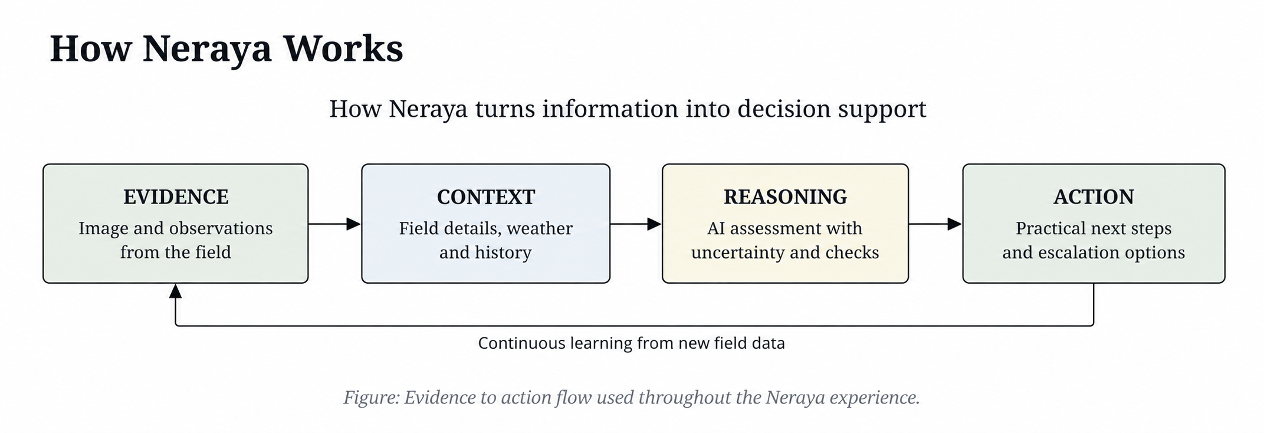
The product follows the same logic across its main workflows. The farmer starts with what is visible and known, adds context, reviews the assessment and uncertainty, and then receives practical next checks or options.

Crop Assessment
The crop assessment flow begins with a real field selected by the farmer. The farmer uploads a crop image and describes what is happening. Neraya then combines the image with available farmer observations, field details, weather, forecast information, and previous assessments.

Assessment information shown to the farmer
- Possible issue or condition
- Observed indicators
- Evidence used
- Missing evidence
- Assessment confidence
- Severity
- Environmental considerations
- Recommendations and next checks
- Escalation guidance when appropriate

Real Use Case: Rice Field 1
A real rice leaf image showing brown lesions was assessed for Rice Field 1. The field used Rice, variety BPT-5204, at flowering stage in Vijayawada, Andhra Pradesh. The farmer described the lesions and noted that symptoms appeared after wet weather, with lower areas of the field staying wetter.
Input | Recorded information
Crop | Rice
Variety | BPT-5204
Growth stage | Flowering
Location | Vijayawada, Andhra Pradesh
Observed situation | Brown lesions appearing after wet weather
Field observation | Lower areas stayed wetter

Neraya returned the assessment: Possible Leaf Blast (Pyricularia oryzae) or Brown Spot.
The assessment showed moderate confidence and moderate severity. It also identified missing evidence and suggested further checks.
- Inspect panicles and leaf collars.
- Examine lower and newer leaves.
- Check nearby plants in drier parts of the field.
- Monitor a set of plants regularly.
- Manage excess standing water where possible.
- Seek KVK or agricultural expert advice if needed.
The value of this result is not the disease label alone. It connects visible evidence with field context, uncertainty, and a practical next step.

Field Pulse
Field Pulse is not a static illustration. The capable device experience uses Three.js and WebGL to create an interactive field representation.
The visualization uses procedural plant geometry and crop archetypes rather than loading a separate heavy model for every crop. The current implementation uses a single instanced mesh approach for the main plant representation, with 144 plant instances in the field view.
Crop family | Examples | Visualization
Fruiting or branching | Tomato, Brinjal, Eggplant, Okra, Bhendi | Fruiting branching
Pepper like | Chili, Chilli, Pepper, Mirchi | Pepper branching
Grass or grain | Rice, Paddy, Wheat, Jowar, Sorghum, Bajra, Barley | Grass grain
Tall stalk | Maize, Corn, Sugarcane, Banana | Tall stalk
Bushy | Cotton, Soybean, Soya | Bushy
Low growing | Potato, Groundnut, Peanut, Onion, Garlic, Ginger, Turmeric | Low growing
Other | Unmapped crops | Generic

Growth stage affects plant scale and development. Assessment severity can affect the visual health state. Weather conditions can affect environmental presentation. An SVG fallback remains available for environments where the full 3D experience is not appropriate.

Weather Intelligence
Weather is retrieved through the protected weather Edge Function and is used as environmental context across Today, Crop Assessment, Field Details, Field Pulse, and the Neraya Assistant.
Weather is not treated as proof of a crop disease. It provides information that may help explain the conditions surrounding the field.
The integrated flow was also checked for stale weather context in the Assistant and corrected so that the current weather response is passed through the relevant application state.

Field History and Persistence
Assessments are stored against the field that was selected when the scan was performed. This keeps different fields' histories separate and allows earlier context to be reused when it is relevant.
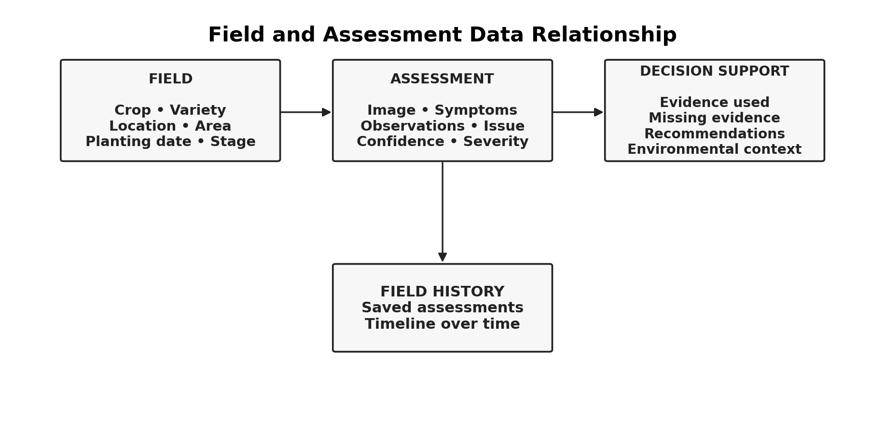
Figure: Relationship between a field, its assessments, and decision support information.
The important relationship is that an assessment belongs to a field. This allows the product to show recent scans, health timelines, and earlier assessments without mixing information from different fields.

Neraya Assistant
The Assistant is designed as field aware conversation rather than a completely generic chatbot. When a field is selected, the Assistant can use the available field context, current weather, and assessment history to make the conversation more relevant to the farmer's situation.

Farmer Community
The community is intended for real farmer experiences. Farmers should eventually be able to share problems they have faced, what they observed, what they tried, and what happened afterwards.
The current experience intentionally avoids fabricated posts, user counts, activity numbers, or engagement statistics. The aim is to let the knowledge layer grow from real people and real experiences.
The human side matters because farming is not only about receiving an answer. A farmer may also want to know whether someone else has faced something similar, what they tried, and what happened.

Technical Architecture
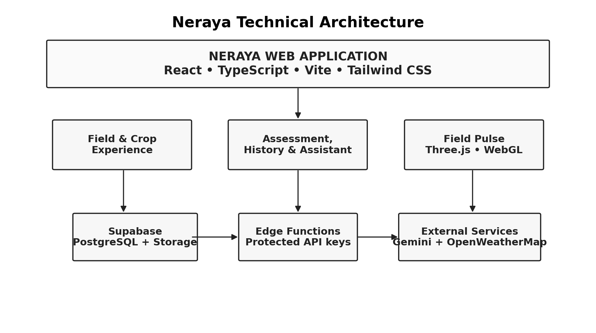
Figure: Neraya technical architecture and main service boundaries.
The browser handles the product experience. Supabase provides persistent data storage and the server side boundary for external service calls. Edge Functions keep external API keys away from the client bundle.

Frontend
- React
- TypeScript
- Vite
- Tailwind CSS
- CSS
- Three.js
- WebGL

Backend and data
- Supabase
- PostgreSQL
- Supabase Storage
- Supabase Edge Functions

AI and external services
- Gemini multimodal analysis
- OpenWeatherMap

Deployment and source control
- Vercel
- GitHub

Security and API Key Handling
External service keys are kept server side through Supabase Edge Functions. The browser calls the application's functions, and those functions access protected secrets when communicating with external services.
The important server side secrets include:
GEMINI_API_KEY
OPENWEATHER_API_KEY
Production keys should never be committed to GitHub or placed directly inside frontend source files.

AI Assessment Structure
Assessment
├── issue / possible condition
├── severity
├── assessment confidence
├── observed indicators
├── evidence used
├── missing evidence
├── symptoms
├── farmer observations
├── recommendations
├── environmental considerations
└── escalation guidance
This structure makes the assessment useful for the immediate decision and for later field history. It also makes uncertainty visible instead of hiding it inside a single generated paragraph.

Responsible AI
Agricultural decisions can have real consequences, so Neraya is designed to make uncertainty visible.

AI assisted, not confirmed
Neraya does not present an image based assessment as a confirmed agricultural diagnosis. The interface uses language such as possible, AI assisted assessment, moderate confidence, what was observed, what evidence was used, and what is still missing.

Evidence and uncertainty
The assessment explains what the system saw and what information contributed to the result. It also identifies missing evidence when the available information is not enough for stronger confidence.

Environmental context
Weather information is presented as context rather than proof. Environmental conditions can support interpretation, but they do not by themselves establish a crop problem.

No fabricated information
- Weather conditions
- Field history
- Previous assessments
- Community posts
- Community activity
- Farmer experiences
- Unsupported certainty

Expert escalation
When an assessment is uncertain or a situation may require closer inspection, Neraya can guide the farmer toward further checks or agricultural expert support.
A failure state is better than a convincing but false answer.

Data Model and Persistence
Field
|
+-- Crop information
+-- Location
+-- Growth stage
+-- Planting date
+-- Notes
|
+-- Assessments
+-- Image
+-- Symptoms
+-- Observations
+-- Issue
+-- Confidence
+-- Severity
+-- Evidence used
+-- Missing evidence
+-- Recommendations
+-- Environmental considerations
+-- Escalation guidance

Main Application Flows

Creating a field
- Open My Fields.
- Create a field.
- Enter crop information.
- Add location, area, planting date, and growth stage.
- Save the field.

Running a crop assessment
- Select a field.
- Upload a real crop image.
- Describe the situation.
- Add observations when available.
- Use weather and forecast context.
- Include previous assessment context where relevant.
- Generate the AI assisted assessment.
- Review evidence, uncertainty, missing evidence, and next steps.
- Save the assessment.

Reviewing field history
- Open Field Details.
- Review current environmental conditions.
- Review forecast information.
- Open the Health Timeline.
- Review Field History and previous assessments.

Failure and Fallback Behavior
A useful agricultural application cannot assume that every external service will always respond successfully. Neraya is designed to fail honestly.
- Weather unavailable state
- AI analysis unavailable state
- Missing evidence state
- General service failure state
When a live service cannot provide a result, the product should show that the information is unavailable rather than replacing it with invented content.

Project Structure
neraya-agricultural-intelligence/
├── src/
│ ├── components/
│ ├── pages/
│ ├── lib/
│ ├── services/
│ └── ...
├── supabase/
│ ├── functions/
│ │ ├── ai-analyze/
│ │ ├── ai-chat/
│ │ └── weather/
│ └── ...
├── public/
│ └── og-image.svg
├── index.html
├── package.json
├── package-lock.json
├── tailwind.config.js
├── vite.config.ts
├── tsconfig*.json
├── eslint.config.js
└── README.md

Local Development

Requirements
- Node.js
- npm
- Git
- A configured Supabase project

Install dependencies
npm install

Start the development server
npm run dev

Production build
npm run build
Kept Gemini and OpenWeatherMap secrets in the server side configuration used by Supabase Edge Functions.

Validation and Testing
The integrated product was tested across the main service, persistence, UI, and failure paths.
- Real weather retrieval through the weather Edge Function.
- Gemini model availability and AI chat.
- Multimodal crop analysis.
- A negative image test using a solid green image to verify that the system does not force a crop diagnosis when visible plant evidence is absent.
- Current weather propagation into the Assistant.
- Assessment persistence in Supabase.
- Previous assessment and weather context.
- Failure and fallback states.
- Verification that mock data was not used in the tested product flows.
- Verification that the main UI remained intact during integration work.
- TypeScript and production build validation.
A real rice crop assessment was also used to verify the end to end experience from field selection through assessment, history, Field Pulse, and Field Details.

User Experience and Design Direction
Neraya uses a calm agricultural editorial direction with cream backgrounds, forest green accents, clear hierarchy, restrained cards, and direct language.
The interface is designed to feel approachable rather than technical. The product experience follows the order in which a real decision is made: notice something, understand the context, consider the assessment, and then decide what to check or do next.

Production Application
Live application:
https://neraya-agricultural-intelligence.vercel.app/
GitHub repository:
https://github.com/Himaja625/neraya-agricultural-intelligence

Deployment
GitHub
|
v
Vercel
|
v
Neraya production application
The production application is deployed through Vercel. The project also includes its own social preview image and metadata so shared links represent Neraya rather than the builder platform.

Current Status
- Field creation and management
- Crop assessment
- Gemini multimodal analysis
- Weather integration
- Assessment persistence
- Field history
- Health timeline
- Field Pulse
- Field aware Assistant
- Farmer community foundation
- Responsible AI messaging
- Failure states
- Responsive interface
- Production deployment
- GitHub source code

Future Direction

Real farmer community
Build a trusted community where farmers can share experiences, observations, outcomes, and practical knowledge.

Crop specific knowledge
Add stronger crop and region-specific agricultural knowledge while keeping the distinction between verified information and community experience.

Longer term field intelligence
Use accumulated field history to help farmers notice meaningful changes over longer periods.

Multilingual and voice interaction
Make the experience easier to use across different languages and support farmers who prefer speaking to typing.

Expert connection
Create clearer pathways for farmers to reach agricultural experts or local agricultural support services when an issue requires human inspection.

What I Learned While Building Neraya
Building Neraya changed the way I think about agricultural AI. The hardest part was not adding another model or another screen. The harder question was what should happen after the prediction.
That led me toward context, uncertainty, history, decision support, and eventually the human side of farming.
I learned that an AI result becomes more useful when the person receiving it can understand why it was produced, what is still unknown, and what they can do next.
I also learned that trust cannot be added at the end of a product. It has to be part of the design from the beginning.

Responsible Use
Neraya is a decision support tool. Its AI assisted assessments should not be treated as confirmed diagnoses or as a substitute for professional agricultural advice. Farmers should use their own observations, field conditions, local knowledge, and appropriate expert guidance when making consequential decisions.

Author
Naga Himaja Ganugapati
Neraya was designed, built, integrated, tested, and prepared for submission as a solo project.

THANK YOU

