**Student Name and Number: [Your Name, Your Student ID]**

**Program: 2425_TMD1**

**Lecturer Name: Paul Laird**

**Module/Subject Title: Programming for Information Systems (B9IS123)**

**Assignment Title: Mathews Coach Hire Bus Booking System**

**Project overview**

Matthews Coach Hire is a leading passenger transport company in Ireland. This company provides a wide range of facilities for the customers, but the company lacks an efficient bus booking system. Therefore, this is implementation to create a comprehensive solution to address the Matthews Coach Hire’s missing bus booking system. This implementation is a web application which is maintained by the backend and frontend.

**Tech stack**

According to the requirements and technical feasibility the implementation’s frontend is implemented using HTML, CSS and JavaScript. This approach will keep the frontend part easy and user friendly for the users. For the backend part express.js and MongoDB integrated approach are used. This approach is easy when the REST APIs are making the connections between frontend and backend. Also, express.js with node.js is widely used approach and it will be helpful for REST APIs.

**Key functionalities**

Passengers – passengers can create accounts and log in to the system. This authentication process is verified using email verification. After passengers log in to the system passengers can select the location and date and search for the available buses. Then passengers can book a bus. If a passenger cancels the booking that task also can be done by using the passenger’s dashboard. Also, the dashboard provides the booking history of the passengers.

Drivers – Bus drivers can sign up to the system using the sign-up form. Then driver’s registration will be sent to the admins dashboard after the admins approval driver’s get verification link to their mails after clicking that link drivers can log in to the system. Drivers can add buses to the system after the admin approval is granted. Also, drivers can request cancel or change the time of a bus ride from the admin using the dashboard. If the admin approves that mail will be sent to the passenger’s mail informing us of the status of the booking.

Admin – Admin login is predefined from the system. Admin can manage all the logins and see all the analytics of the system. Also, bus approvals have also been managed by the admin dashboard. Admin can add the routes to the system and these added locations are visible to the bus driver when he added a bus to the system.

Above are the key functionalities of the system. These functionalities cover the CRUD operations. Additionally, UI is simple and easy to navigate to the users.

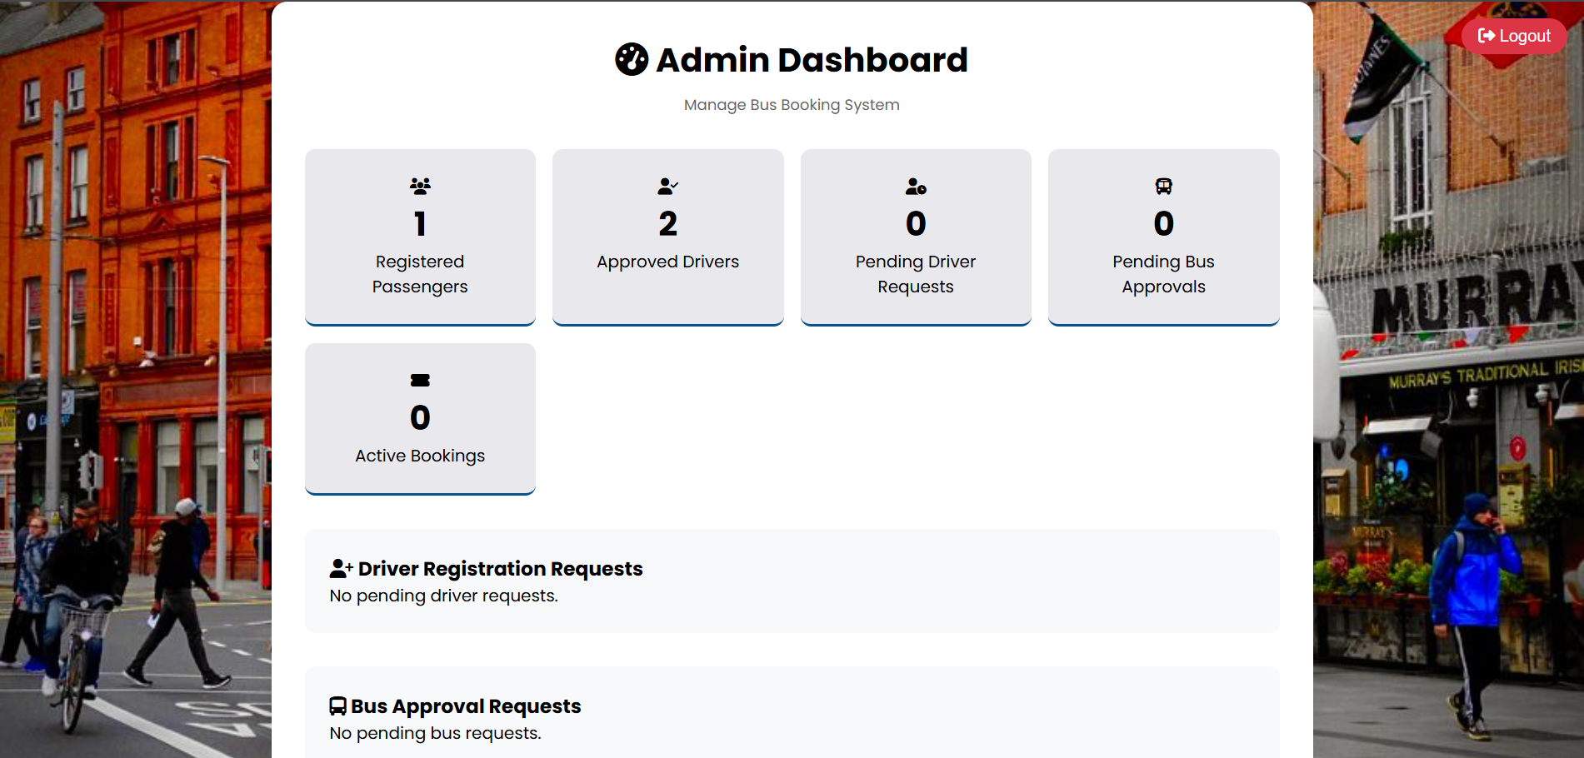

Figure 1: Admin dashboard

Figure 2: Passenger dashboard

Figure 3: Driver dashboard

**Version controlling**

When implementing this system bugs and updates happened frequently. Therefore, consistent and easy way of managing the versions of the implementation. Therefore, GitHub with GitHub desktop is used for regarding this matter. Commits are maintained with proper descriptions and GitHub repository folder structured according to the requirements of the project.

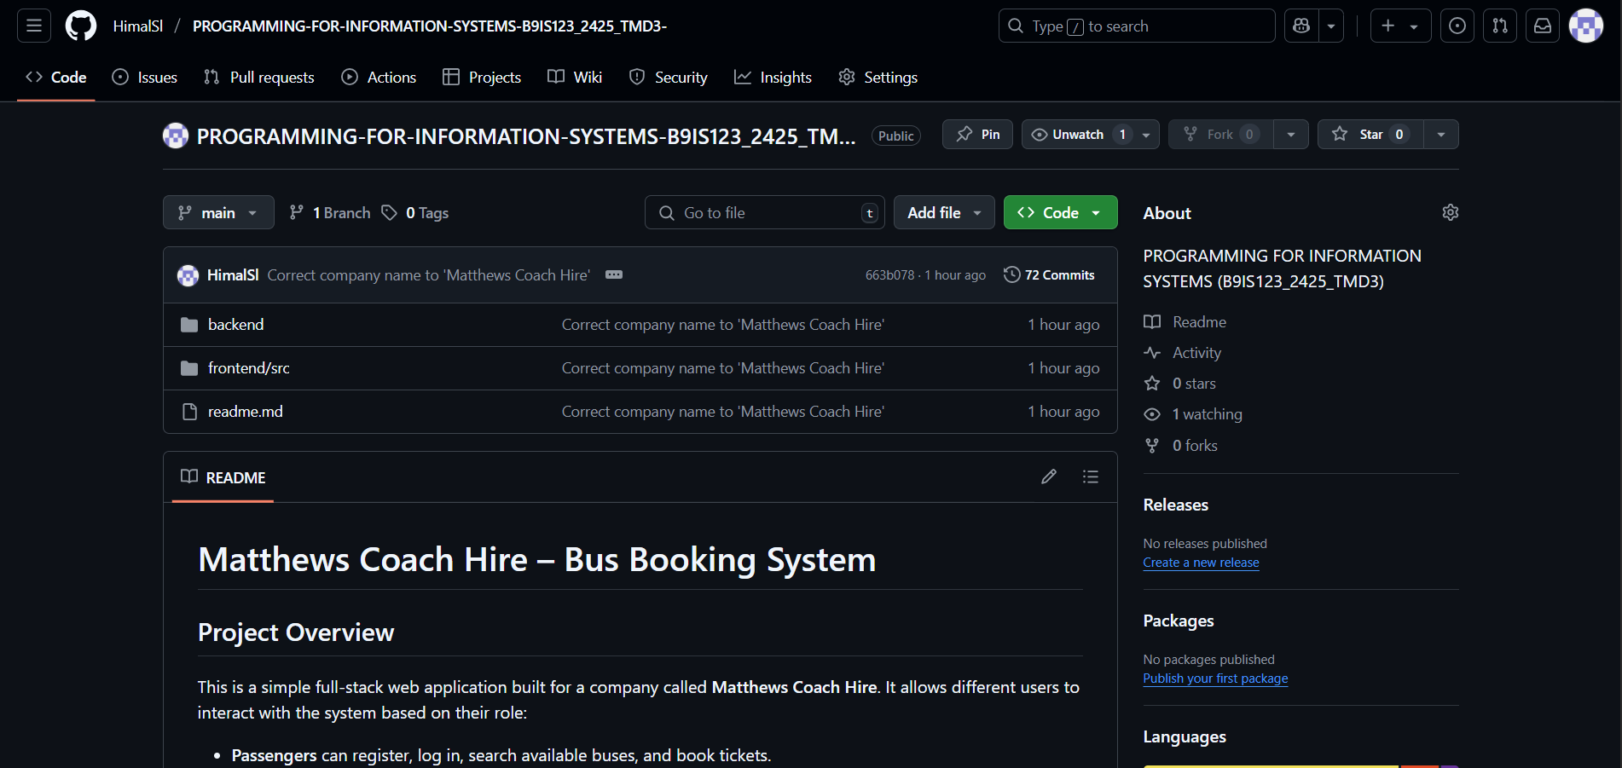

Figure 4: GitHub repository overview

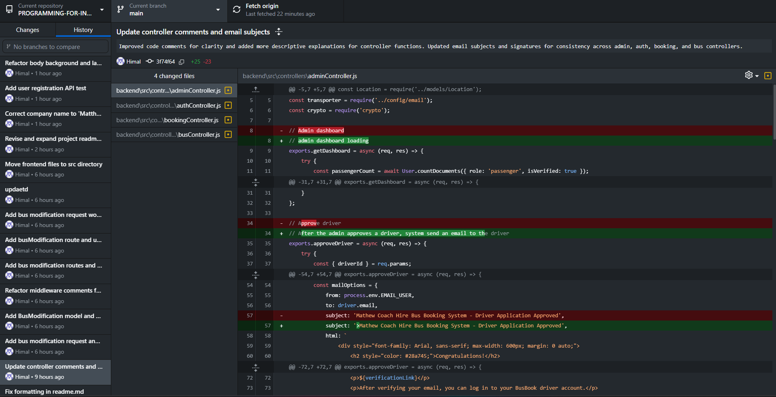

Figure 5: GitHub Desktop Overview

**MongoDB database**

For the backend functionalities used a mongo db. database which is NO-SQL database which is better with the projects requirements. Within a cluster there are four schemas’ were created. They are users,locations,buses,busModifications and bookings.

* users – for user management
* locations – For location management
* buses – for bus management
* busModifications – To manage the bus modifiations (time or cancel)
* bookings – Manages the bookngs of the passengers

Figure 6 : Mongo DB dashboard

**Performance Testing**

To check the website performance conducted a lighthouse testing for the website. Below shows the results of the lighthouse testing.

Figure 7: Lighthouse performance testing results

**Future enhancements**

In the future I hope to expand the system by integrating the payment methods into the system. Also, on the admin side add a Machine Learning part to identify the busiest times of passenger bookings and for that boost up the bus adding ratio. Also using the google maps API passengers’, admins can track the bus routes in an efficient way. I hope to implement these future enhancements to boost the functionalities of the Matthew Coach Hire Bus Booking system.