Dynamic Array
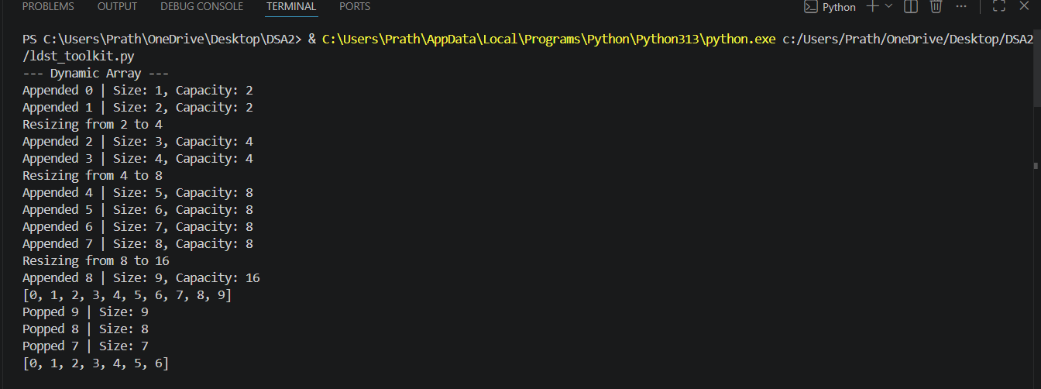Doubly Linked List
Singly Linked List
Stack
Queue

Parenthesis Checker

