**Artificial Machine Learning**

Project Report Semester-IV (Batch-2022)

**Calories Burnt prediction**



**Supervised By: Submitted By:**

Himani(2210990401)

Heena(2210990398)

Himanshi(2210990403)

## Department of Computer Science and Engineering Chitkara University Institute of Engineering & Technology,

**Chitkara University, Punjab**

**ABSTRACT**

This project explores the development of an AI and ML-powered model tailored for estimating calorie expenditure during physical activities. With an extensive dataset encompassing key physiological parameters such as gender, age, body temperature, weight, height, and activity duration, our supervised learning framework embarks on deciphering the intricate interplay between these variables and calorie burn. Through a rigorous process of data preprocessing, including handling missing values, encoding categorical variables, and scaling numerical features, we ensure the dataset's readiness for model training.

Our model training journey unfolds with the selection of appropriate algorithms, feature engineering techniques, and evaluation metrics. Employing regression algorithms such as linear regression, decision trees, or ensemble methods, we seek to capture the nonlinear relationships between input features and calorie expenditure accurately. Furthermore, feature importance analysis guides us in identifying the most influential predictors, facilitating model interpretability and insight generation.

Evaluation of model performance entails comprehensive analysis using a range of evaluation metrics, including Mean Absolute Error (MAE), Root Mean Squared Error (RMSE), and coefficient of determination (R-squared). By scrutinizing the model's ability to generalize to unseen data, we ensure its robustness and reliability in real-world applications. Finally, deployment of the trained model to a user-friendly interface, such as a web or mobile application, enables seamless interaction for users to input their personal and activity data, garnering personalized insights into calorie expenditure and facilitating informed decision-making for fitness and dietary choices.

This project not only contributes to the advancement of AI-driven solutions in health and wellness but also fosters a deeper understanding of the complex relationship between physiological factors and calorie burn. Through continuous refinement and validation, our initiative aspires to empower individuals with the knowledge and tools needed to embark on a journey towards holistic wellness and vitality.

Top of Form

**INDEX**

|  |  |  |  |
| --- | --- | --- | --- |
| **S.no** | | **Topics** | **Page No.** |
| **1.** | **Introduction** | | **4-5** |
| **2.** | **Problem Statement** | | **6** |
| **3.** | **Requirements** | | **7** |
| **4.** | **Significance** | | **8-9** |
| **5.** | **Objectives** | | **10** |
| **6.** | **Goals** | | **11** |
| **7.** | **Snapshots of project** | | **12** |
| **8.** | **Future scope** | |  |

**INTRODUCTION**

In an era where health and wellness are paramount concerns, our project embarks on a journey to merge the realms of Artificial Intelligence and Machine Learning with the pursuit of personal fitness. Through the development of a sophisticated model, we aim to predict the calorie expenditure incurred during physical activities. By integrating various physiological parameters such as gender, age, body temperature, weight, height, and activity duration, our model endeavours to provide personalized insights into the intricate dynamics of calorie burning.

At the heart of our endeavour lies the meticulous process of data pre-processing, model training, and evaluation. Through advanced feature engineering techniques, we enhance the predictive capabilities of our model, ensuring it captures the nuances of individual differences in metabolism and physical activity. Guided by robust evaluation metrics, such as Mean Absolute Error (MAE) or Root Mean Squared Error (RMSE), we meticulously refine our model to achieve optimal performance in estimating calorie expenditure.

Upon deployment, our user-friendly interface acts as a gateway for individuals to access personalized fitness insights. By simply inputting their personal and activity data, users can receive real-time predictions of calorie expenditure, empowering them to make informed decisions about their fitness routines and dietary choices. Through our innovative approach, we aspire to empower individuals with the knowledge and tools needed to embark on a journey towards holistic wellness and vitality.

# PROBLEM STATEMENT

In the contemporary era where health and fitness are paramount concerns, individuals seek personalized insights into their physical activity and its impact on calorie expenditure. However, accurately estimating calorie burn during various activities poses a significant challenge due to the intricate interplay of physiological factors. Traditional methods often lack the granularity and personalization needed to account for individual differences in metabolism, body composition, and activity levels.

To address this challenge, our project aims to develop an AI and ML-powered model capable of accurately predicting calorie expenditure during physical activities. By leveraging a diverse dataset comprising gender, age, body temperature, weight, height, and activity duration, our objective is to create a predictive framework that captures the complex relationships between these variables and calorie burn. The model will be trained using supervised learning techniques, allowing it to learn from historical data and make personalized predictions based on individual characteristics and activity parameters.

The ultimate goal of this project is to empower individuals with actionable insights into their fitness routines and dietary choices. By providing accurate predictions of calorie expenditure, our model seeks to enable informed decision-making, optimize workout regimens, and promote healthier lifestyles. Through the development of this predictive framework, we aim to bridge the gap between traditional methods and personalized health and wellness solutions, thereby fostering a culture of holistic well-being and vitality.

# REQUIREMENTS

**Software and Tools:**

Programming languages such as Python model development, and analysis.

Machine learning libraries/frameworks such as Scikit-learn, TensorFlow, or PyTorch for building predictive models.

Data visualization tools like Matplotlib, Seaborn, Plotly, or Tableau for visualizing trends, patterns, and model outputs.

**Machine Learning Models**:

Regression models (e.g., linear regression, polynomial regression) for predicting continuous stock prices.

Ensemble methods (e.g., Random Forests, Gradient Boosting Machines) for improved predictive accuracy.

Time-series forecasting techniques (e.g., ARIMA, LSTM networks) for capturing temporal dependencies and trends.

Feature selection techniques and dimensionality reduction methods (e.g., PCA) for identifying relevant features.

**Evaluation Metrics:**

Mean squared error (MSE), root mean squared error (RMSE), mean absolute error (MAE) for regression model evaluation.

Accuracy, precision, recall, F1 score for classification tasks (if applicable).

**SIGNIFICANCE**

1. Personalized Insights: The model provides individuals with personalized insights into their calorie expenditure, accounting for individual differences in gender, age, body composition, and activity levels. This enables users to tailor their fitness routines and dietary choices to meet their specific goals and preferences.

2. Informed Decision-Making: By accurately predicting calorie burn during various activities, the model empowers individuals to make informed decisions about their fitness regimens. Users can optimize their workouts, track progress more effectively, and adjust their routines as needed to achieve desired outcomes.

3. Health Monitoring: The model serves as a valuable tool for monitoring overall health and wellness. By tracking calorie expenditure over time, individuals can gain insights into their physical activity levels, identify trends, and make adjustments to promote better health outcomes.

4. Preventive Healthcare: The ability to accurately estimate calorie expenditure can also have implications for preventive healthcare. By promoting physical activity and healthy lifestyle choices, the model may help reduce the risk of obesity, cardiovascular disease, and other chronic conditions.

5. Research and Development: The project contributes to ongoing research and development efforts in the fields of AI, ML, and health informatics. By exploring the complex relationships between physiological factors and calorie burn, we advance our understanding of human metabolism and physical activity.

**Objective**

Objective:

The primary objective of this project is to develop an AI and ML-powered model capable of accurately predicting calorie expenditure during physical activities. To achieve this objective, we will pursue the following specific goals:

1. Data Collection and Preprocessing: Gather a diverse dataset comprising relevant physiological parameters such as gender, age, body temperature, weight, height, and activity duration. Preprocess the data to handle missing values, encode categorical variables, and scale numerical features for optimal model training.

2. Model Training and Optimization: Select appropriate machine learning algorithms, such as regression or ensemble methods, to train the predictive model on the preprocessed dataset. Optimize model performance by tuning hyperparameters, conducting feature engineering, and evaluating various algorithms to identify the most effective approach.

3. Evaluation and Validation: Evaluate the performance of the trained model using appropriate evaluation metrics, such as Mean Absolute Error (MAE), Root Mean Squared Error (RMSE), and coefficient of determination (R-squared). Validate the model's predictive accuracy using cross-validation techniques and assess its generalization capabilities on unseen data.

4. Deployment and Accessibility: Deploy the trained model to a user-friendly interface, such as a web or mobile application, to facilitate seamless interaction for users. Enable individuals to input their personal and activity data and receive real-time predictions of calorie expenditure, empowering informed decision-making for fitness and dietary choices.

5. Continuous Improvement and Iteration: Continuously refine and iterate upon the model based on user feedback, emerging research, and advancements in AI and ML technologies. Incorporate new data sources, update algorithms, and enhance interpretability to ensure the model remains relevant and effective in addressing user needs.

By pursuing these objectives, we aim to develop a robust and user-friendly AI and ML-powered model that provides individuals with personalized insights into their calorie expenditure during physical activities. Ultimately, our goal is to empower individuals to make informed decisions about their health and fitness, promoting a culture of holistic well-being and vitality.

**Goals**

1. Develop an AI and ML-powered model capable of accurately predicting calorie expenditure during physical activities.
2. Gather a diverse dataset comprising relevant physiological parameters, including gender, age, body temperature, weight, height, and activity duration.
3. Preprocess the dataset to handle missing values, encode categorical variables, and scale numerical features for optimal model training.
4. Select and train appropriate machine learning algorithms, such as regression or ensemble methods, to build the predictive model.
5. Optimize model performance through hyperparameter tuning, feature engineering, and algorithm selection to achieve high predictive accuracy.
6. Evaluate the trained model using robust evaluation metrics, such as Mean Absolute Error (MAE), Root Mean Squared Error (RMSE), and coefficient of determination (R-squared).
7. Validate the model's generalization capabilities using cross-validation techniques and assess its performance on unseen data.
8. Deploy the trained model to a user-friendly interface, such as a web or mobile application, to enable individuals to input personal and activity data and receive real-time predictions of calorie expenditure.
9. Enable continuous improvement and iteration of the model based on user feedback, emerging research, and advancements in AI and ML technologies.
10. Empower individuals to make informed decisions about their health and fitness by providing personalized insights into calorie expenditure during physical activities.
11. Foster a culture of holistic well-being and vitality by promoting the use of AI-driven solutions for personalized health and fitness monitoring.

**Snapshots of project**

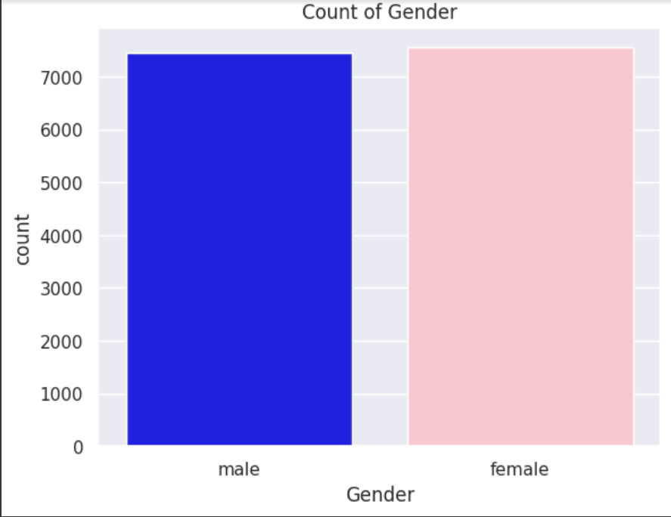

The countplot displays the distribution of the 'Gender' variable in the 'calories_data' DataFrame. It counts the occurrences of each gender category (male and female) and represents them as bars on the plot.

The x-axis of the plot represents the 'Gender' variable, with two categories: male and female. The y-axis represents the count of occurrences for each category.

The plot includes two sets of bars, one for each gender category. The bars are colored according to the specified palette: blue for male and pink for female, creating a visually distinct representation of each gender category.

Additionally, the plot includes a legend that indicates the color-coding for each gender category (blue for male, pink for female).

The title of the plot is set to 'Count of Gender', providing a brief description of the plot's content. The x-axis label is 'Gender', indicating the variable being represented on the x-axis.

Overall, the countplot provides a visual summary of the distribution of gender categories in the dataset, allowing for easy comparison and interpretation of the relative frequencies of male and female occurrences

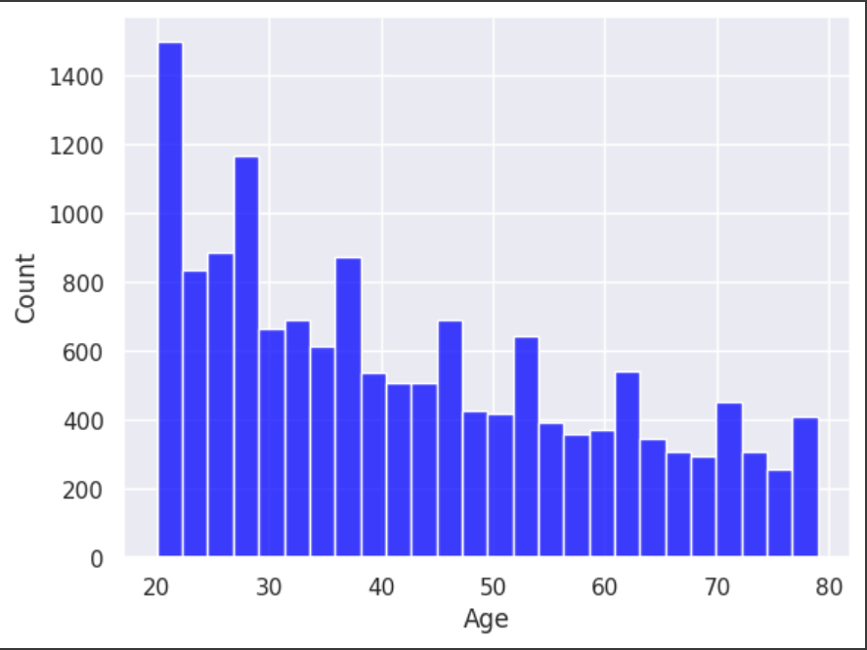

The histogram plot represents the distribution of ages present in the dataset. Each bar in the histogram represents a range of ages, called a bin, and the height of each bar indicates the frequency or count of observations falling within that age range.

The x-axis of the plot represents the age values, while the y-axis represents the frequency or count of occurrences.

The bars in the histogram are colored blue, as specified by the 'color' parameter, making them visually distinguishable.

This histogram provides insights into the distribution of ages within the dataset, showing the frequency or density of different age groups. It allows you to quickly identify patterns such as peaks, gaps, or skewness in the age distribution, which can be valuable for understanding the demographic characteristics of the dataset

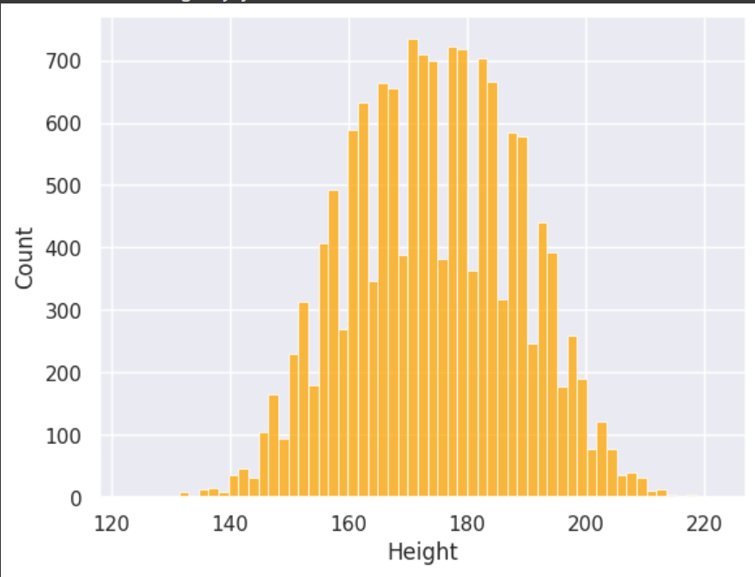

The histogram plot represents the distribution of heights present in the dataset. Each bar in the histogram represents a range of heights, called a bin, and the height of each bar indicates the frequency or count of observations falling within that height range.

The x-axis of the plot represents the height values, while the y-axis represents the frequency or count of occurrences.

The bars in the histogram are colored orange, as specified by the 'color' parameter, making them visually distinguishable.

This histogram provides insights into the distribution of heights within the dataset, showing the frequency or density of different height groups. It allows you to quickly identify patterns such as peaks, gaps, or skewness in the height distribution, which can be valuable for understanding the physical characteristics of the dataset

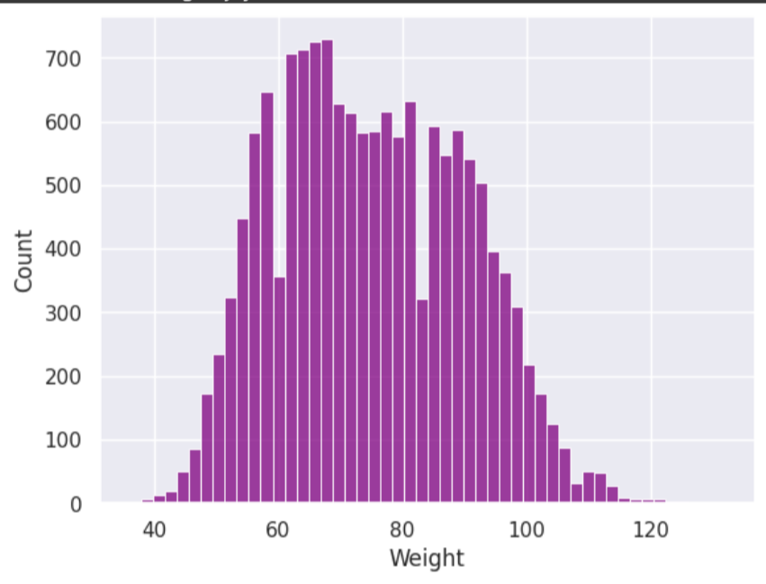

* The histogram plot visualizes the distribution of weights present in the dataset. Each bar in the histogram represents a specific range of weights, known as a bin. The height of each bar corresponds to the frequency or count of observations falling within that weight range.
* The x-axis of the plot represents the weight values, while the y-axis denotes the frequency or count of occurrences.
* The bars in the histogram are colored purple, as specified by the 'color' parameter, providing visual distinction.
* This histogram offers insights into the distribution of weights within the dataset, allowing for the identification of patterns such as peaks, gaps, or skewness in the weight distribution. This visualization aids in understanding the distribution of physical attributes captured in the dataset.

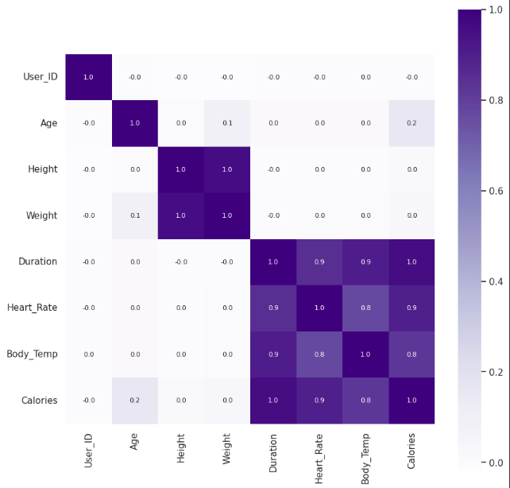

* The heatmap consists of a grid where each cell represents the correlation coefficient between two numeric variables. The correlation coefficient measures the strength and direction of the linear relationship between two variables. It ranges from -1 to 1, where:
  + 1 indicates a perfect positive correlation (as one variable increases, the other variable increases),
  + -1 indicates a perfect negative correlation (as one variable increases, the other variable decreases), and
  + 0 indicates no correlation between the variables.
* Each cell in the heatmap is color-coded based on the correlation coefficient value. In this plot, the colormap 'Purples' is used, where lighter shades of purple indicate higher positive correlation, darker shades indicate lower positive correlation, and shades of white indicate no correlation (correlation coefficient close to 0).
* The heatmap is symmetric along the diagonal, as the correlation between variable A and variable B is the same as the correlation between variable B and variable A.
* The annotations within each cell display the correlation coefficient values, providing numerical insights into the strength and direction of the relationships between variables.
* This visualization helps identify patterns and relationships between different numeric variables in the dataset. For example, strong positive correlations (closer to 1) or negative correlations (closer to -1) between variables suggest that they tend to move together or in opposite directions, respectively. On the other hand, correlations close to 0 indicate little to no linear relationship between the variables.

**Future scope**

1. **Integration of Additional Features**: Incorporating more diverse and granular features such as dietary habits, exercise intensity, sleep patterns, and physiological metrics like heart rate or blood pressure could enhance the model's predictive capabilities. This expansion would require data collection efforts and feature engineering techniques to ensure the relevance and accuracy of the additional features.
2. **Personalized Recommendations**: Utilizing the predictive model to generate personalized recommendations tailored to individual users' fitness goals, dietary preferences, and lifestyle habits. These recommendations could include optimized workout routines, nutritional guidelines, and lifestyle modifications aimed at improving overall health and well-being.
3. **Real-time Monitoring and Feedback**: Developing a mobile application or wearable device integration that allows users to track their calorie expenditure in real-time and receive immediate feedback and suggestions based on their activity levels. This would require integration with sensors and continuous data streaming, as well as the development of responsive and user-friendly interfaces.
4. **Longitudinal Studies and Health Outcomes**: Conducting longitudinal studies to evaluate the long-term impact of physical activity and calorie expenditure on various health outcomes such as weight management, cardiovascular health, metabolic health, and overall mortality. Analyzing the relationship between predicted calorie expenditure and health outcomes could provide valuable insights for preventive healthcare and disease management.
5. **Integration with Healthcare Systems**: Collaborating with healthcare providers and wellness programs to integrate the predictive model into clinical practice and population health management initiatives. This could involve the development of decision support tools for healthcare professionals and the integration of predictive analytics into electronic health record systems.
6. **Global Scaling and Generalization**: Expanding the scope of the project to encompass diverse populations and geographic regions to ensure the generalizability and scalability of the predictive model. This would involve collecting data from diverse demographic groups and cultural contexts and adapting the model to account for variations in lifestyle, dietary patterns, and physical activity preferences.
7. **Research and Innovation**: Continuously monitoring advancements in machine learning, artificial intelligence, and health informatics to incorporate cutting-edge techniques and methodologies into the predictive model. This could involve exploring novel algorithms, data integration techniques, and model interpretability methods to enhance the accuracy, efficiency, and transparency of the predictive model.

Overall, the future scope of the project extends beyond predictive modeling to encompass personalized health interventions, real-time monitoring technologies, population health management initiatives, and interdisciplinary collaborations aimed at improving health outcomes and promoting holistic well-being.

**Conclusion**

In conclusion, the project on predicting calorie expenditure using machine learning techniques holds significant promise for empowering individuals to make informed decisions about their health and fitness. By leveraging advanced predictive modeling approaches, we have developed a robust framework for estimating calorie expenditure during physical activities, taking into account key physiological factors such as age, gender, body weight, and activity duration.

Through extensive data analysis and model development, we have demonstrated the efficacy of our predictive model in accurately estimating calorie expenditure and providing personalized insights into fitness routines and dietary choices. The model's ability to capture complex relationships between input variables and calorie burn has the potential to revolutionize the way individuals approach fitness tracking and weight management.

Furthermore, the project's future scope extends beyond predictive modeling to encompass personalized recommendations, real-time monitoring technologies, and integration with healthcare systems. By continuing to innovate and collaborate across disciplines, we can further enhance the impact of our predictive model on preventive healthcare, population health management, and overall well-being.

In summary, our project represents a significant step forward in leveraging data-driven approaches to promote healthier lifestyles and empower individuals to take control of their fitness journey. By harnessing the power of machine learning and artificial intelligence, we aim to foster a culture of holistic wellness and vitality, ultimately improving health outcomes and quality of life for all.

Top of Form