Investing in Social Media Companies

Social media is all the rage in this century. Since the advent of social media, people’s lives have changed drastically. It has changed everything; from the way people perceive the world around them, to the way people conduct their lives. This level of influence gives the social media companies a huge number of users around the world which translates to huge profits for the company. The four biggest social media sites are Instagram, Facebook, Snapchat, and Twitter.

Investing in one of these social media companies can be a sound decision. However, there are certain factors that need to considered before investing in such companies. Apart from the number of users across the world, and other factors, one of the most important factors that need to be looked at is the downtime of the social media sites. Downtime causes the company shares to drop and thus, sometimes, resulting in losses for the stakeholders. Recently, Instagram had been down which would have caused the Instagram influencers a lot of money. Here, we analyse the trend of how frequently these channels have been down throughout the world in the last five years.

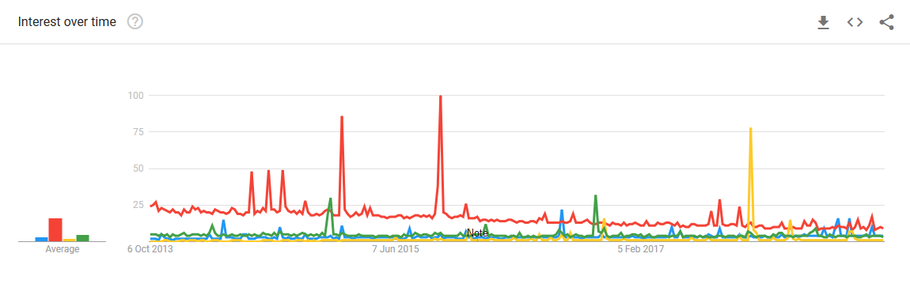

In the above graph, the red line represents Facebook, the blue line represents Instagram, the yellow line represents Snapchat, and the green line represents Twitter. From the graph, we can see that the term ‘Facebook down’ has been searched the most in the last 5 years. The spikes in the graph indicate the instance when Facebook was actually experiencing downtime. For example, the two highest spikes indicate the week in which Facebook was down in September 2015. Due to this, the company shares fell by 4%. The downtime of Facebook has however been decreasing since then.

In the last five years, Snapchat has been down only once which is probably why there is a huge, single, yellow spike in the graph which indicates the time it was down. The huge, yellow spike indicates the time the application was down for almost two hours in November 2017. The graph also shows that there have been relatively less outages of Twitter and Instagram since there are no major spikes in the graph for the two.

The below image shows the top ‘related topics’ and ‘related queries’ to ‘Facebook down’ search term:

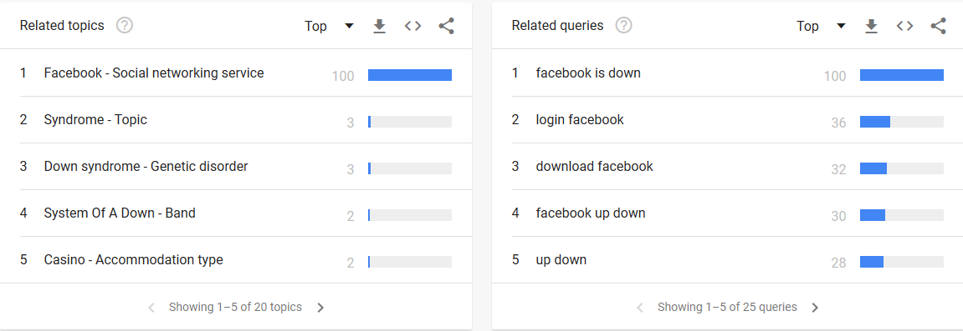

This research can be scaled up by carrying out an analysis of the number of users of all the social media sites in the past years, whether that number is increasing or decreasing, the stock prices of their companies, the overall performance of the companies, and other factors. A decision can then be reached at, as to which social media company should be invested in to gain maximum profits.

CITATION:

* BBC News. (2015, September 28). [*Facebook down for second time in a week.*]

Retrieved from: https://www.bbc.com/news/world-us-canada-34383655

* Heath, Alex. (2017, November 6). [*Snapchat isn’t working for a lot of people.*]

Retrieved from: https://www.businessinsider.com/snapchat-is-down-for-a-lot-of-people-2017-11

* Snelling, David. (2018, October 3). [*Instagram DOWN - Social network app not working as outage hits thousands of users.*]

Retrieved from: https://www.express.co.uk/life-style/science-technology/1026087/Instagram-DOWN-Social-network-app-not-working-outage