United Breaks Guitars: An analysis

The years 2008-10 were very difficult for United Airlines. They faced an unexpected PR situation which subsequently got worse. Dave Carroll, a Canadian musician was travelling on their airlines from Halifax, Canada to Omaha, United States, with a change of flight in Chicago, with his band, Sons of Maxwell. While the baggage was being loaded, he saw that his $3,500 Taylor guitar was being thrown around by the United staff. This horrified him. In order to bring this to the attention of the staff, he informed three of the staff attendants about the scenario, but they turned a deaf ear to him. When they landed in Omaha., he immediately sought his guitar which he feared to be broken. That, indeed was the case.

When he complained about this to the airline, he was shunned from one department to another where he got a final ‘No’ as an answer, saying he won’t get any compensation for his broken guitar. Infuriated by this response, he and his band composed a song, “United Breaks Guitars”, which described his entire experience with the airlines, on YouTube. The song, that was posted on July 6, 2009, quickly gained views and by mid-August, it had been viewed 5 million times. Currently, the song has 18 million views. They also released two more songs about the same in August 2009 and March 2010 respectively, with a humorous and satirical take on the unresponsiveness and denial of claim by the airlines.

Apart from trending on YouTube, the hashtag ‘UnitedBreaksGuitars’ and David Carroll quickly gained momentum on twitter as well. Below are the social media maps for both ‘#UnitedBreaksGuitars’ as well as David Carrol.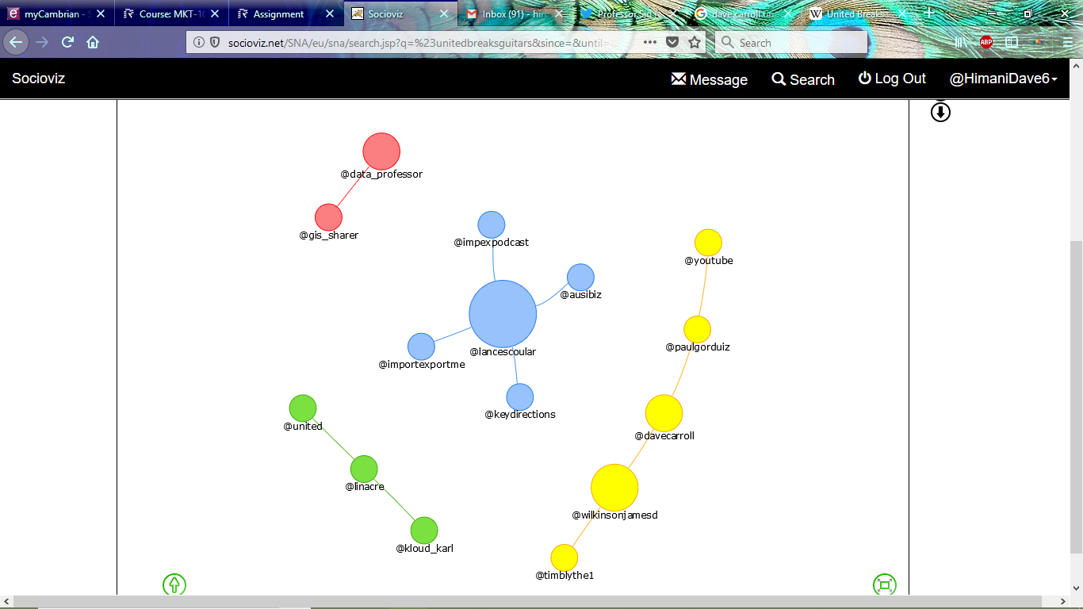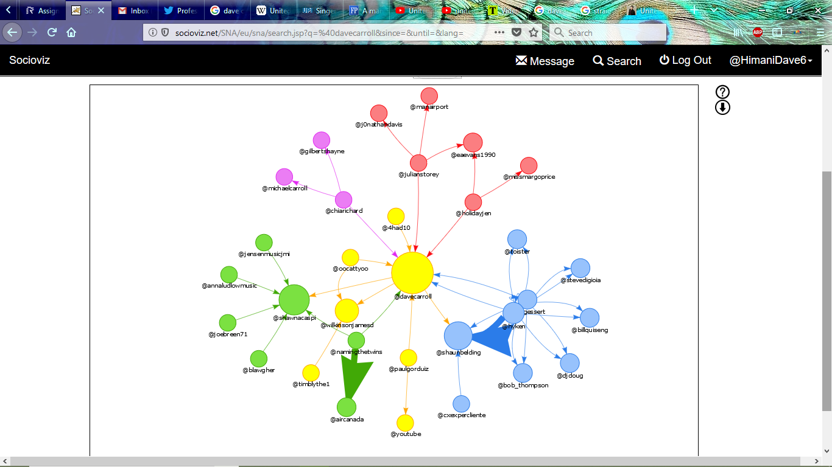

The first map shows how many people used the ‘UnitedBreaksGuitars’ hashtag which includes considerable people. It is, however, less than the retweets and tweets gained by Dave Carroll. The maps suggest it gained a considerable momentum on Twitter as well.

In light of the enormous support gained by Dave, United Airlines had to respond. Trying to mitigate the damage, a spokesperson of the company praised the video as being ‘excellent’ and sought Carroll’s permission to use it for internal training. They offered him a compensation of $3,000, which Dave asked to donate to a charity instead.

This entire situation could have been handled in a much better way by United Airlines. First of all, instead of tweeting their apology, they should have either issued a press release or made a video (like Dave Carroll did). The apology should have come from the CEO of the airlines and not the PR team. He should have promised to fire all that were responsible for mistreating Dave and mishandling his baggage. He should also have promised to create a system to quickly handle customer complaints in the future. This would have shown the customers how seriously United Airlines takes its customers’ complaints and resolves it in a timely manner, thus mitigating the damage done by the entire incident.

The relationship assessment questionnaire that can be used by United Airlines after the incident should contain the following questions from Gruning Relationship Survey. These are agree/disagree statements which need to be answered on a scale of 1 to 7 to indicate their relationship with the organisation:

* This organisation can be relied on to keep its promises.
* This organisation has the ability to accomplish what it says it will do.
* This organisation really listens to what people like me have to say.
* I feel that this organisation is trying to maintain a relationship with people like me.
* I have no desire to have a relationship with this organisation.
* Generally speaking, I am pleased with the relationship this organisation has established with people like me.
* I don’t consider this to be a particularly helpful organisation.
* I feel that this organisation tries to get the upper hand.
* Whenever this organisation gives or offers something to people like me, it generally expects something in return.

CITATIONS:

* Carroll, Dave. (July 7, 2009). “*United Breaks Guitars*”.   
   Retrieved from: https://www.davecarrollmusic.com/songwriting/united-breaks- guitars/?v=3e8d115eb4b3
* Ayers, Chris. (July 22, 2009). “*Revenge is best served cold – on YouTube: How a broken guitar became a smash hit*”. The Times. London.  
   Retrieved from: https://web.archive.org/web/20100531204013/http://www.timesonline.co.uk/tol/c omment/columnists/chris_ayres/article6722407.ece
* Colby, Cosh. (August 21, 2009). “*A man and his guitar*”. The Financial Post.  
   Retrieved from: https://web.archive.org/web/20120305172232/http://www.financialpost.com/scrip ts/story.html?id=f9065720-c55a-4612-84eb-e168fd37ed1f&k=15437
* United Press International. (July 9, 2009). “*Singer’s Revenge on United: A hit song*”.  
   Retrieved from: https://www.upi.com/Odd_News/2009/07/09/Singers-revenge-on- United-A-hit-song/79301247160917/