Enhancing Legal Information Access with Cutting Edge AI & RAG Technology
In propose work we have employed RAG and FAISS AI algorithm to train on Legal Document and whenever user issue any query then algorithm will query RAG and FAISS model to retrieve relevant documents as recommendation.
To implement this we have designed following modules
- New User sign up: using this module user can sign up with the application
- User Login: using this module user can login to application
- Legal Advice: using this module user can enter some query and then AI algorithm will suggest advice as recommendation
- Chatbot: user will send text query to Chatbot and then Chatbot employ AI algorithms to respond to user query
- Summarize the Document: user will upload sample text file and then AI algorithm will generate summary
- Voice Chatbot: user will send some recorded voice as Speech to text and then AI algorithm will employ RAF to retrieve closest document.
SCREEN SHOTS
To run project double click on ‘run.bat’ file to start python server and then will get below page
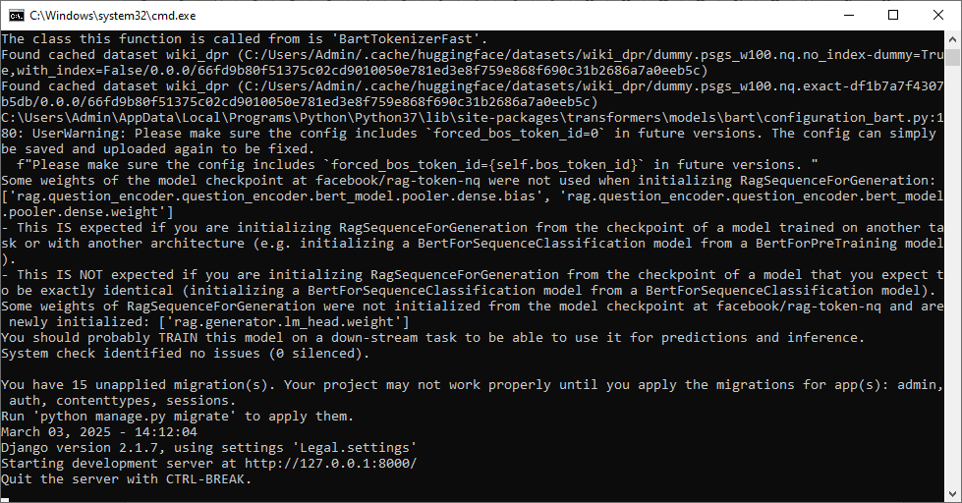
In above screen python server started and now open browser and enter URL as http://127.0.0.1:8000/index.html and then press enter key to get below page
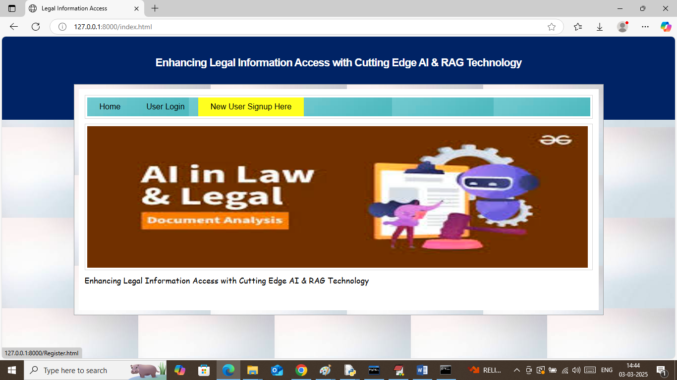
In above screen click on ‘New User Sign up’ link to get below page
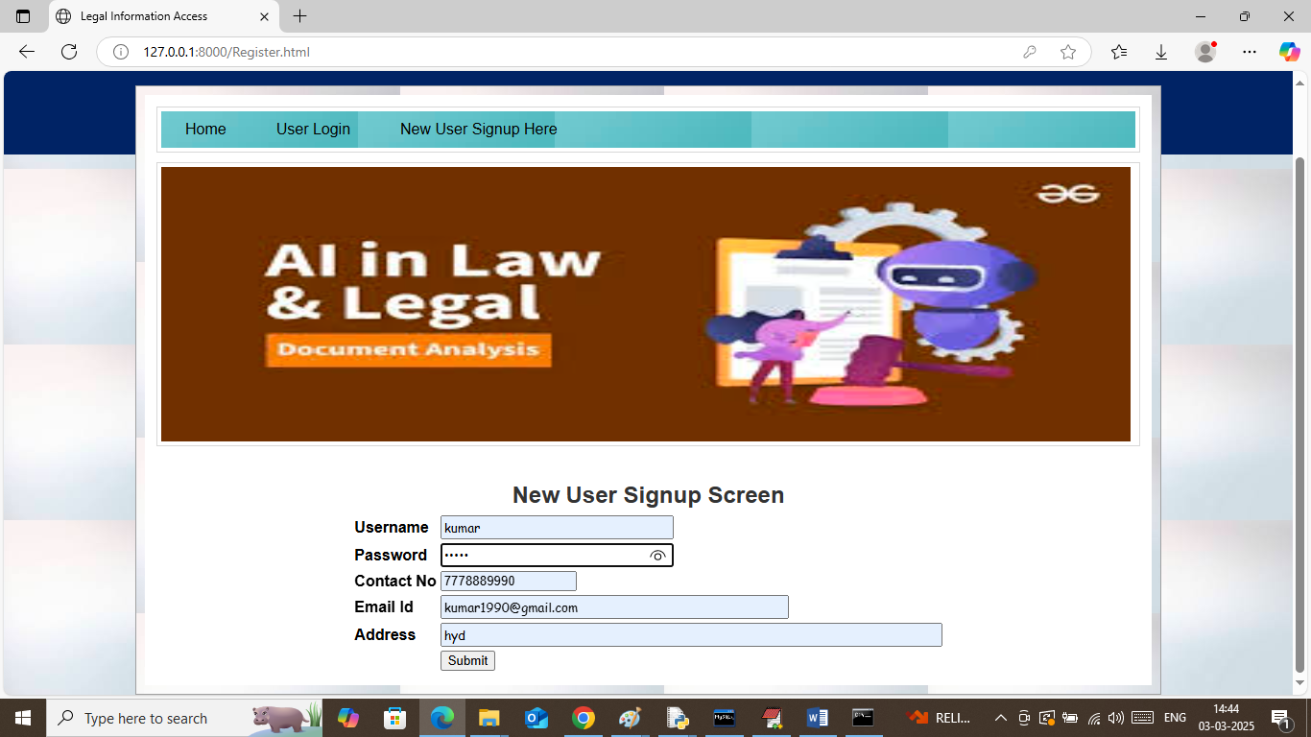
In above screen user is entering sign up details and then press button to get below page
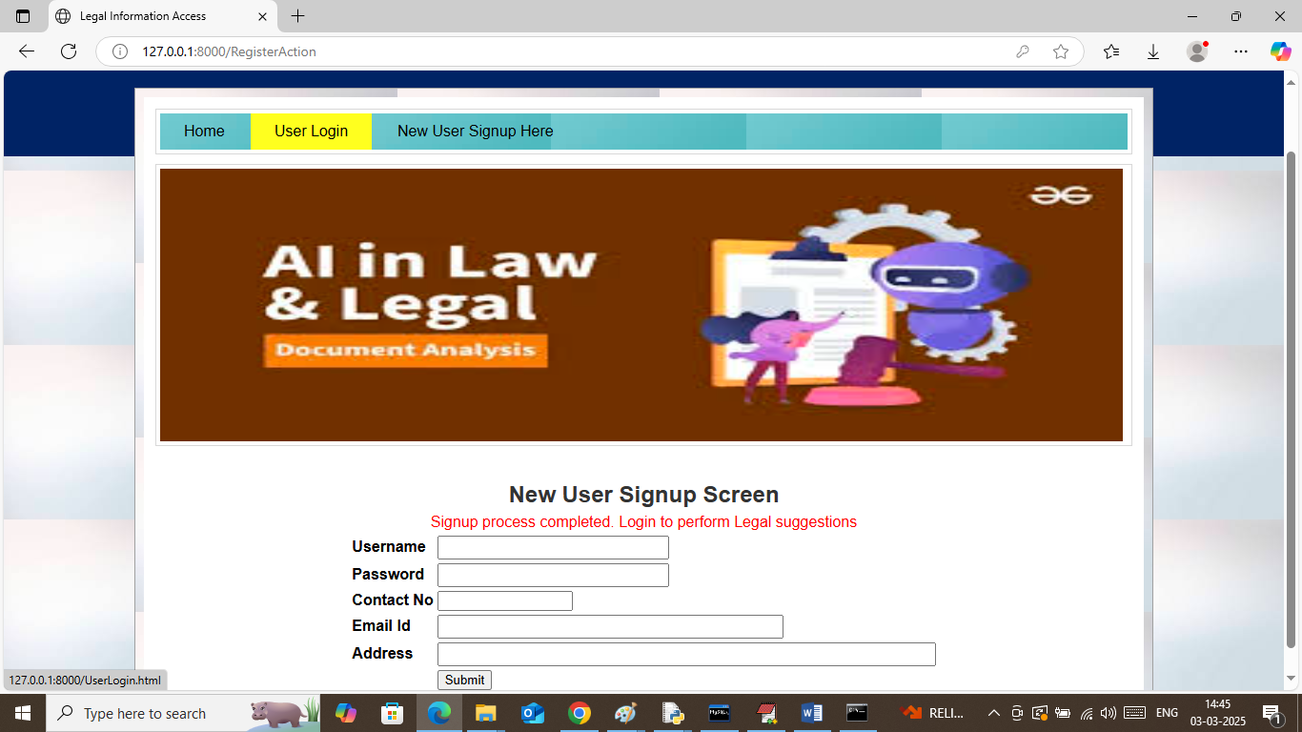
In above screen sign up process completed and now click on ‘User Login’ link to get below page
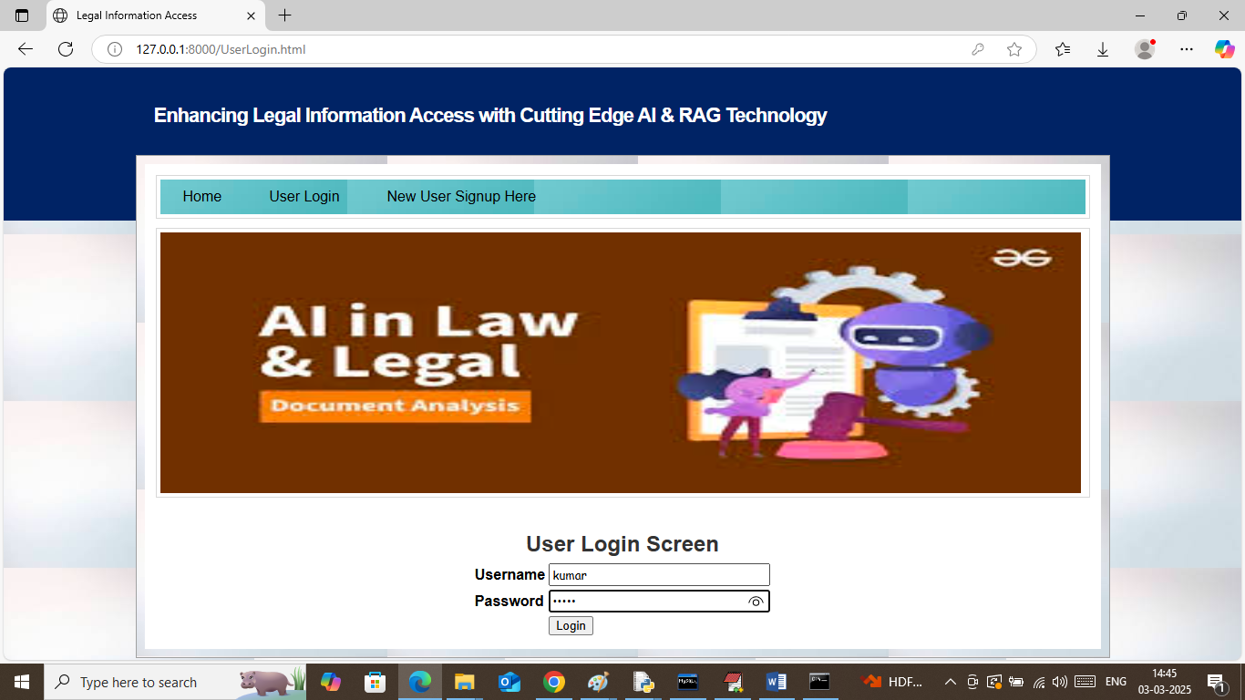
In above screen user is login and after login will get below page
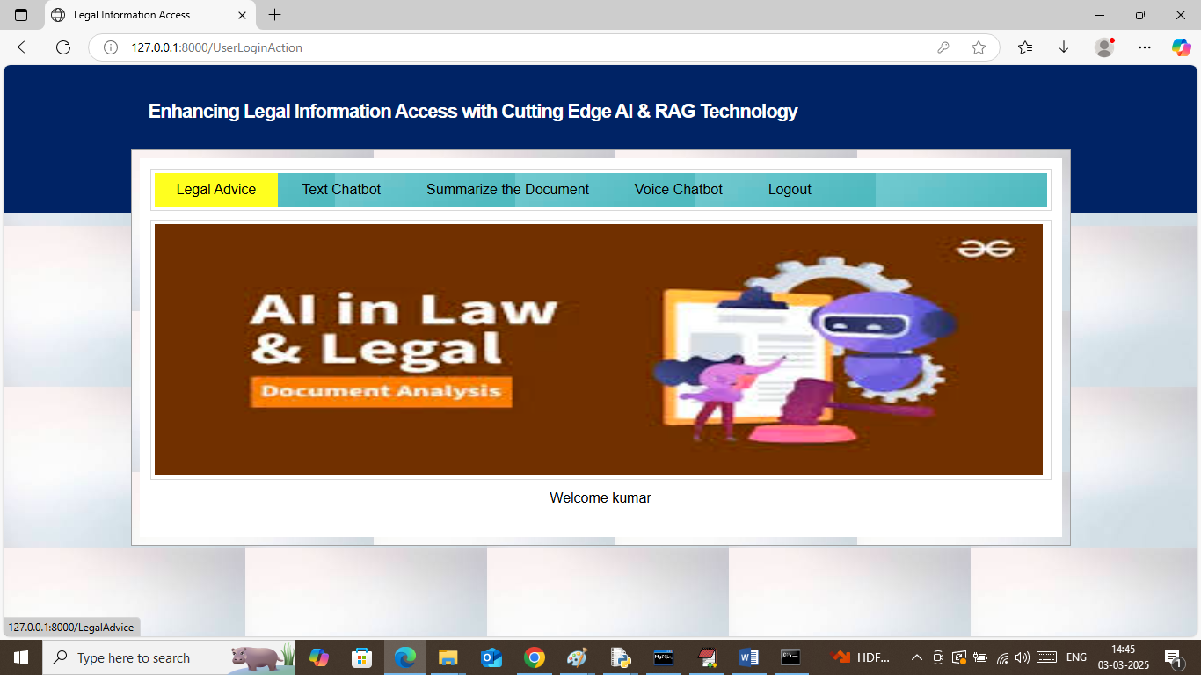
In above screen user can click on ‘Legal Advice’ link to get below page
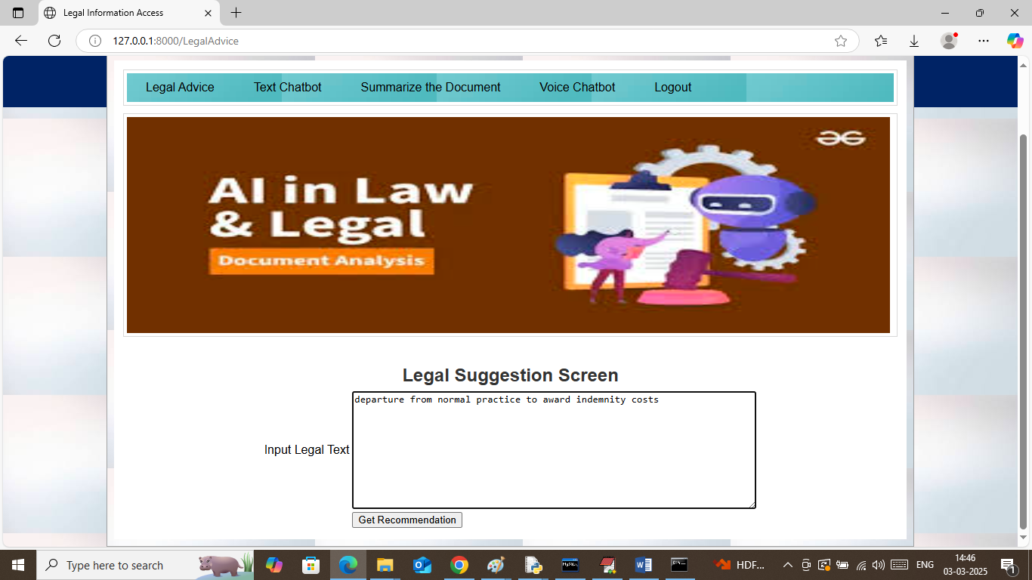
In above screen enter any query related to legal documents and then press button to get below page
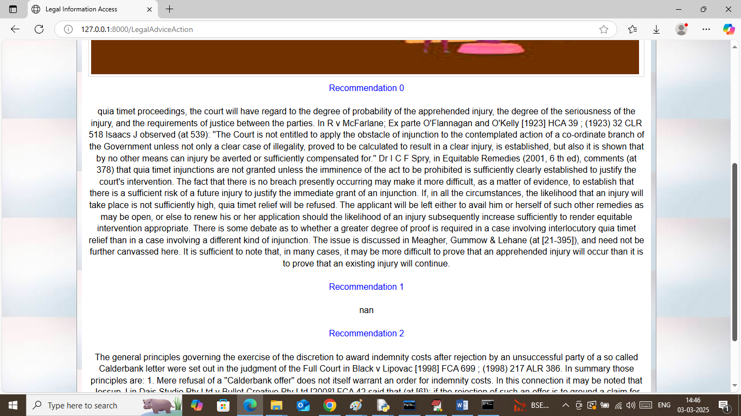
In above screen RAG and FAISS will retrieve relevant documents and then display as recommendation to user. Similarly enter any query and get advice as recommendation. Now click on ‘Text Chatbot’ link to get below page
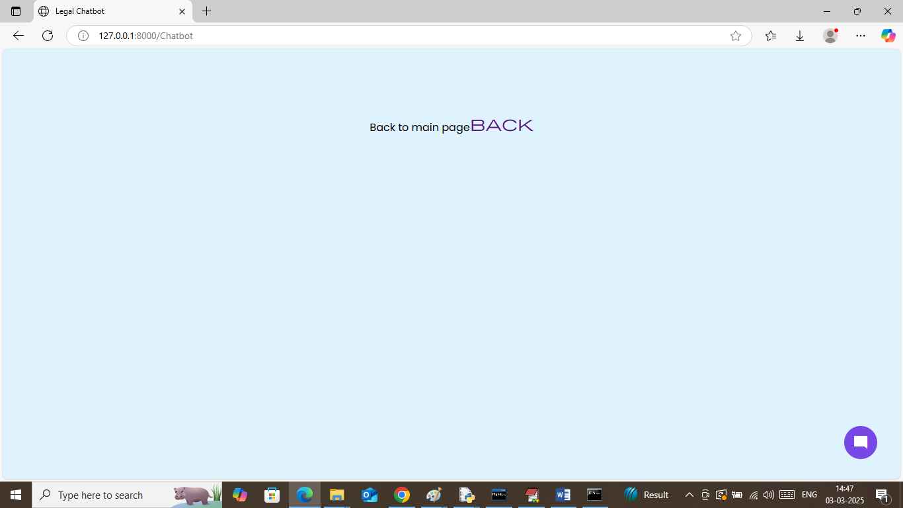
In above screen from bottom click on ‘blue’ icon to get below page
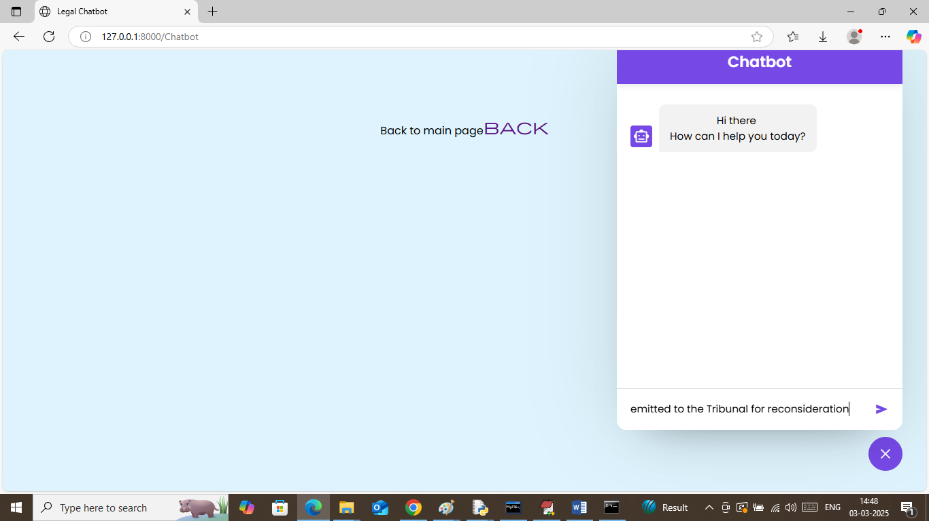
In above screen in last text field I am entering some query and then press enter key to get below Chatbot response
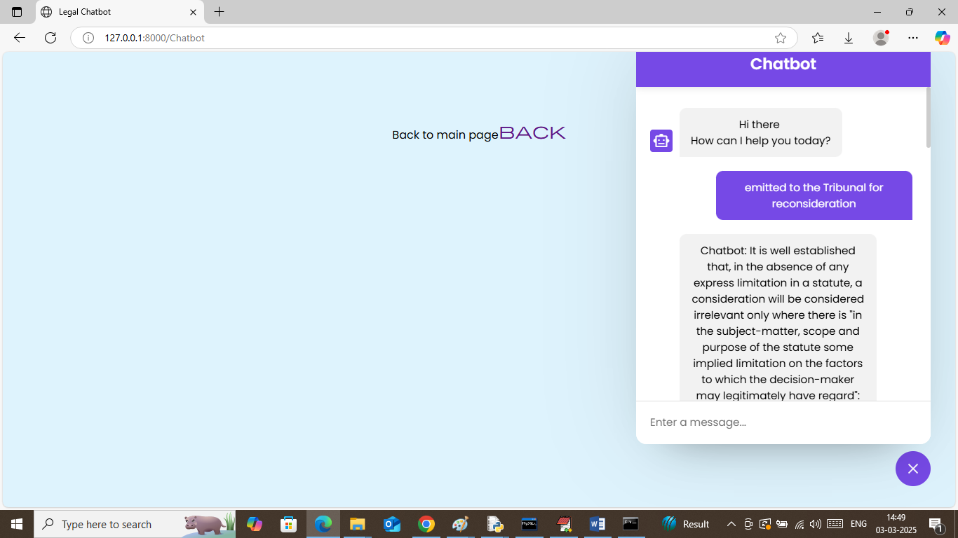
In above screen can see some response sent by Chatbot and similarly enter any query and get response. Now click on ‘Summarize the Document’ link to get below page
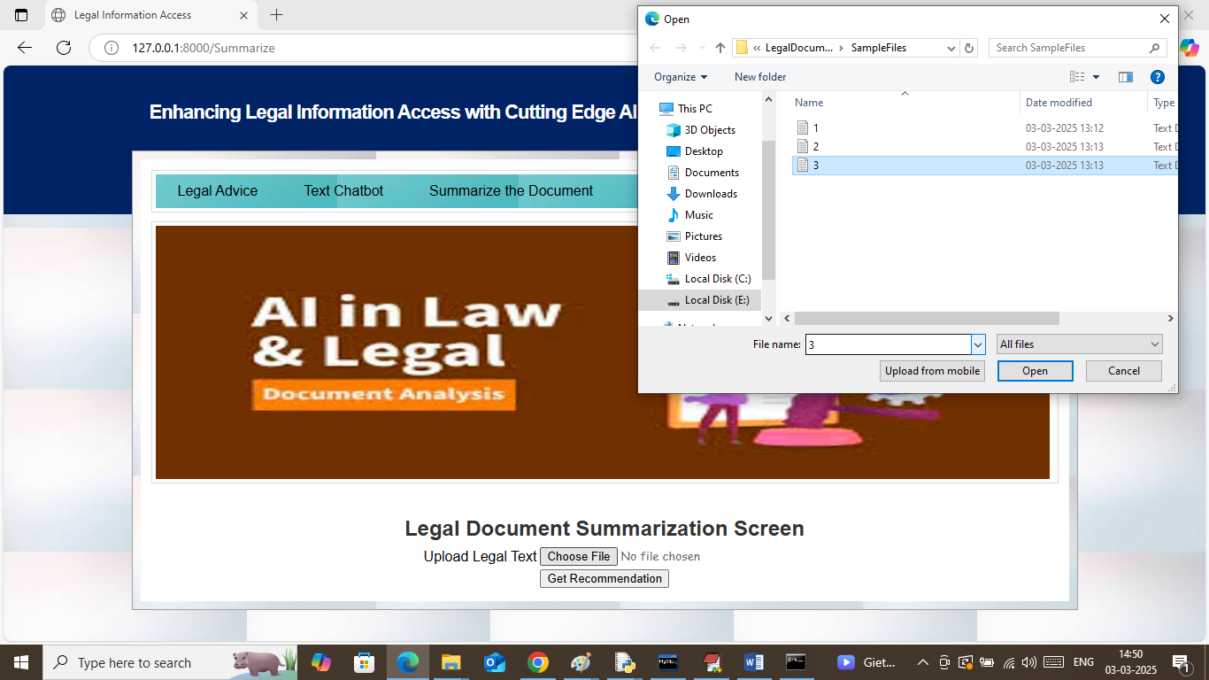
In above screen uploading sample file and then press button to get below page
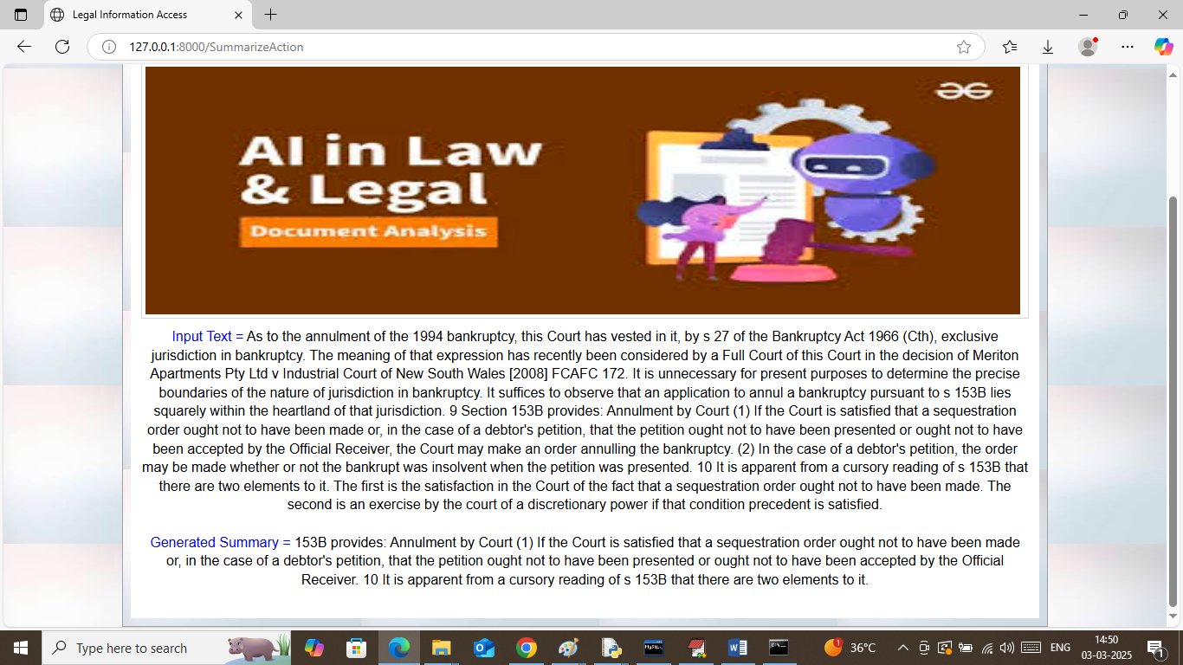
In above screen in first paragraph can see uploaded TEXT data and in second paragraph can see generated ‘Summary’. Similarly you can upload and test any other document. Now click on ‘Voice Chatbot’ link to get below page
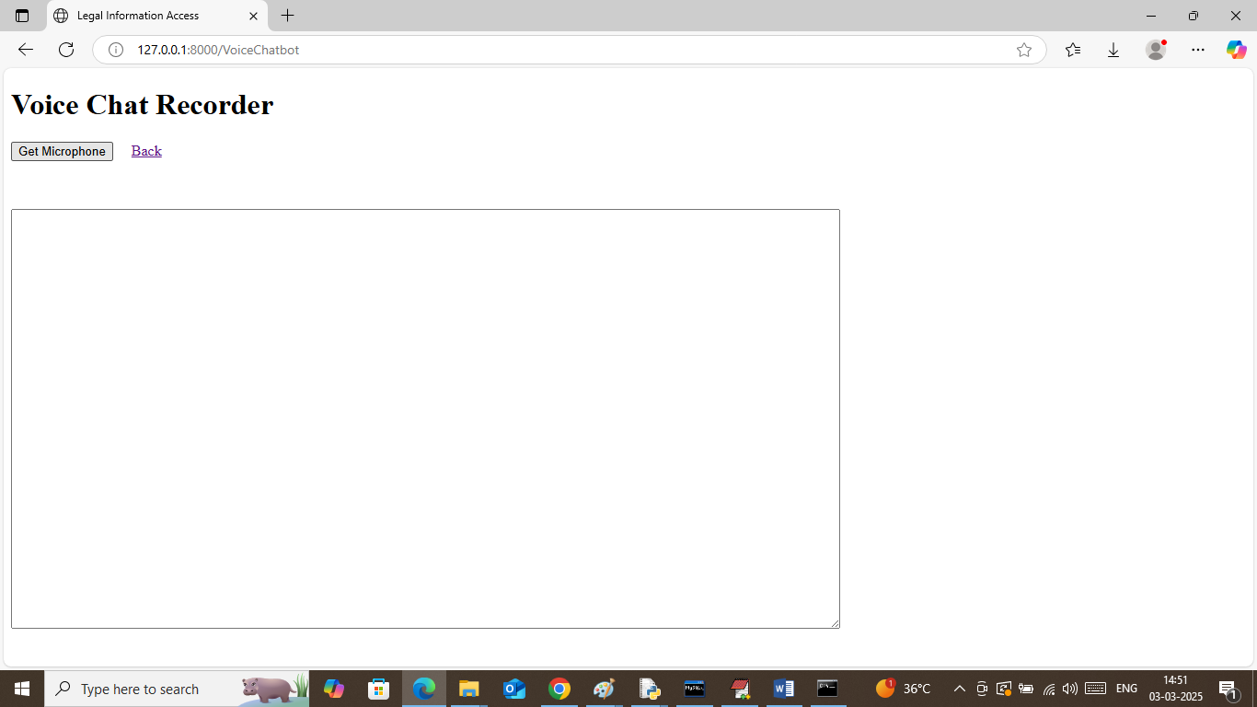
In above screen click on ‘Get Microphone’ link connect to microphone and then will get below page
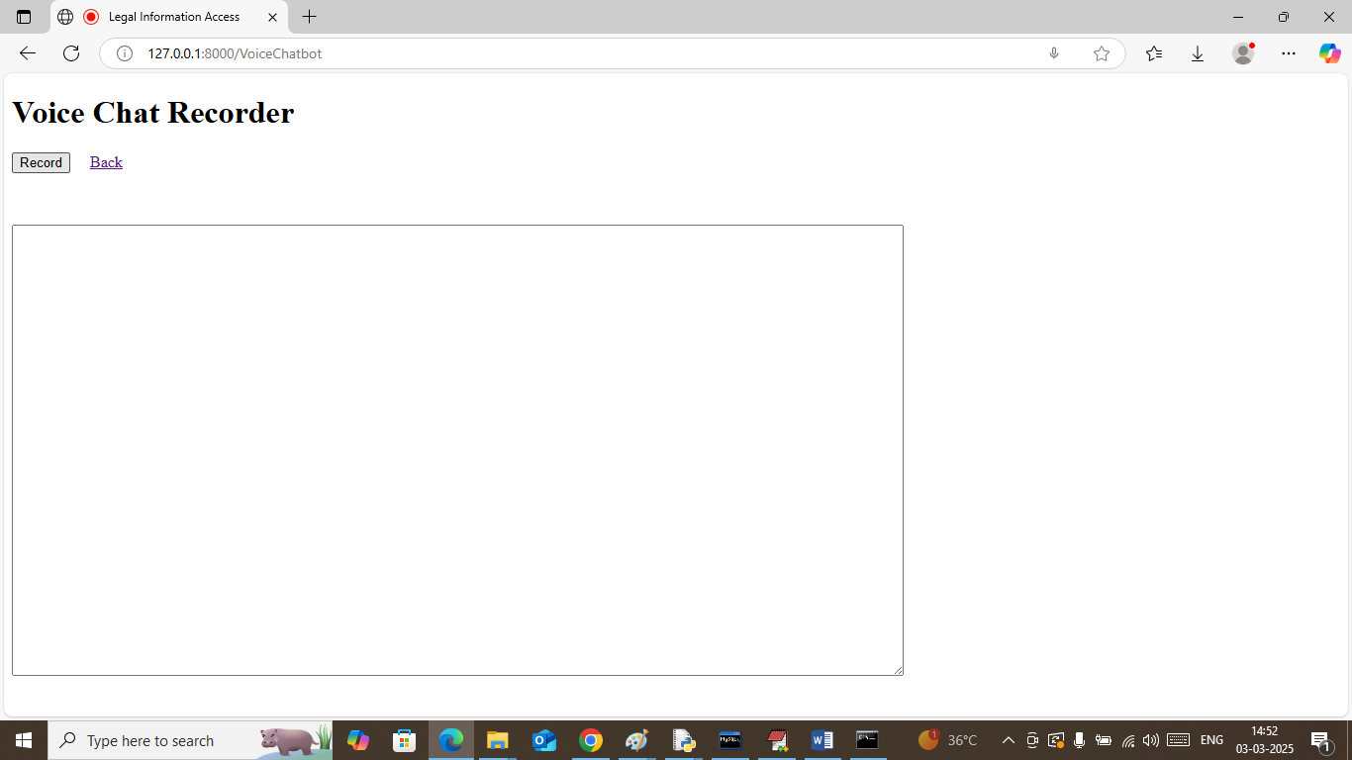
In above screen click on ‘Record’ link and then speak some query and then press ‘Stop’ button to get below page
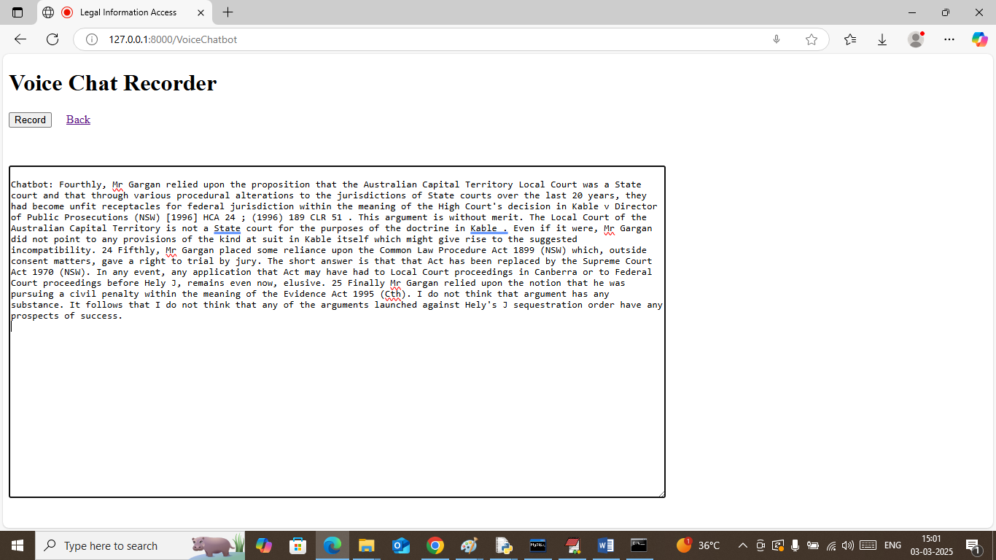
In above screen Chatbot convert speech to text and then response RAG retrieve legal document to user.
Similarly by following above screens you can run complete project

