Airport And Airlines Data

***Wireframe Documentation***

Homepage

# Overview of Project:

# 

# Comparison between Estimate Timestamp and Actual Timestamp taking Base Airlines and Route as base.

# 

# Analyzing Process ending date by Bae Airlines, Actual and Estimated Timestamp

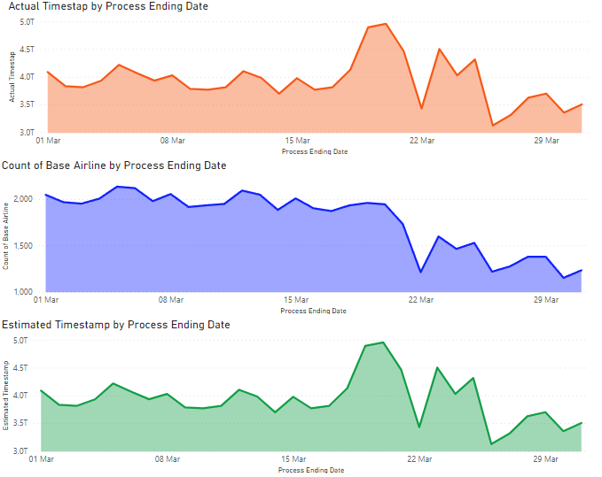

# Relation between Flight number and date.

# Relation between starting point, count of gate and route by process ending date.

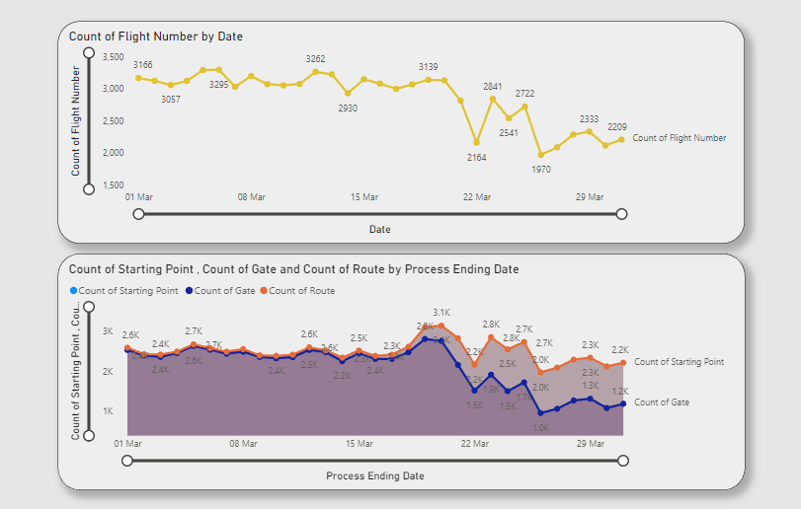

# Influence of Geometry Coordinates.

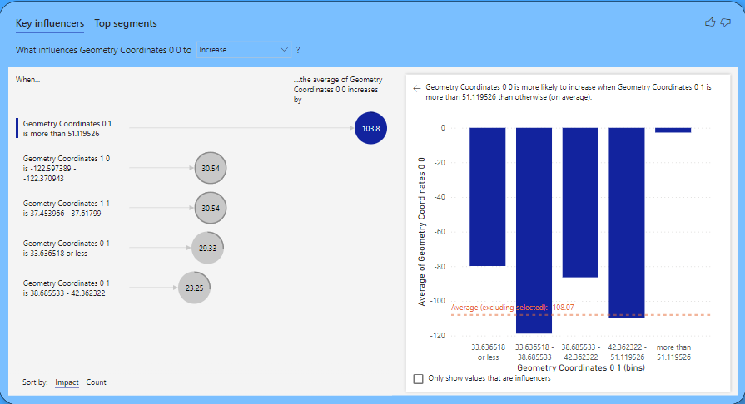

Here, we have our