**Kickstarter Analysis**

1. **Insight 1:** This insight shows the relationship between the project category and its outcome to determine which category had the highest success rate. Top 3 Kickstarter are in Theater, music and film/video categories and lowest 3 performers are in food, games and publishing categories. Overall, kickstarters are likely to be successful than to fail and get canceled. This insight also tells that there are certain categories which did not perform well at all. Backers might have to rethink on supporting those categories.

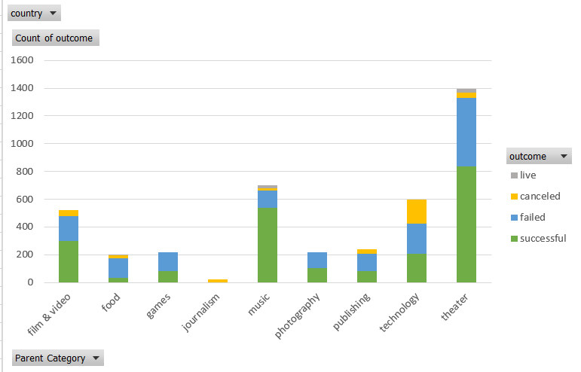

1. **Insight 2:** Second insights is on the relationship between the project sub-category and the outcome to analyze which subcategories were most likely to succeed. Looking into the sub-categories, we can see that some categories has performed great with 100% success rate and are most likely to succeed, they are Rock (Music), Documentary (Film & Video), and Hardware (Technology). Worst performers in sub-categories are animation, drama, jazz and video games. From previous insight as we know theater and music were most successful especially from play and rock sub-categories.

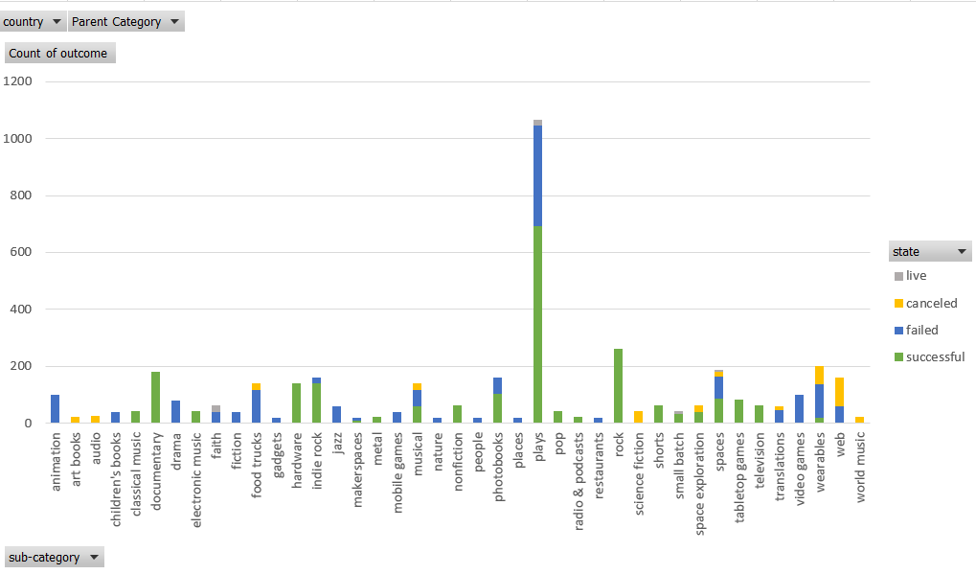

1. **Insight 3:** This insight shows relationship to analyze project based on the time of year (month) in which the project was conducted and the subsequent outcomes. There is a significant increase in successful projects in the month of May and least successful outcomes can be seen occurred in December.

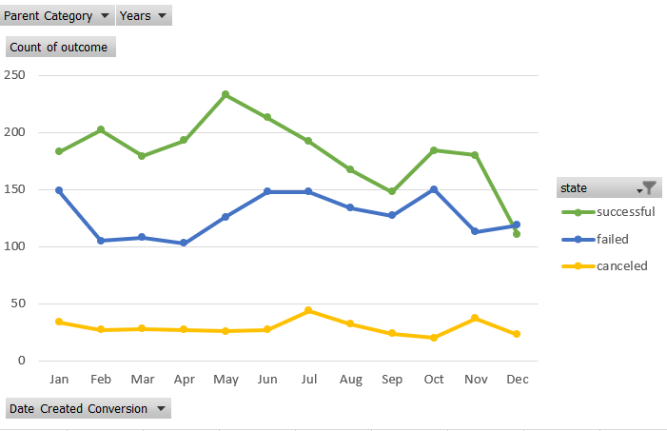

1. **Insight 4:** This line chart is to analyze different outcomes based on the project's goals. It has been concluded that lower the range higher the success rate of the project. Goal range “Less Than 1000” has highest successful percentage with 71%.

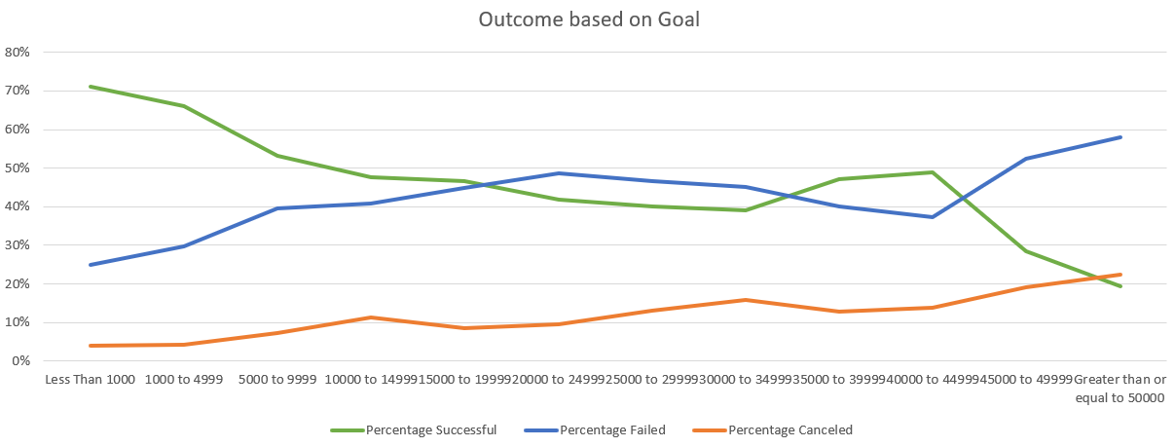

**Limitations**

* Of the over 300,000 projects launched, we only have data for 4,000 projects. This data is not enough to accurately represent the data of all Kickstarter campaigns and find insight.
* Apart from mentioned factors, there can be other factors like geographical area and currency worth considering finding the insights.
* Additional analysis could have been conducted on duration of the campaign.

**What are some other possible tables/graphs that we could create?**

* We could have created graph to analyze the success of projects based on the duration of the project.
* Analysis based on geographical area would have been contributed to make additional conclusions.
* Average donation could have given more insights.