# Chatter

For Remedyforce administrators, Chatter offers your Help Desk staff replacement of long, cumbersome email threads with a private Chatter group where they can get updates, share lessons learned, and keep track of specific records.

## To enable Chatter:

* In Salesforce: Setup > Customize > Chatter > Manage Your Chatter Settings
* In Remedyforce: Remedyforce Administration > Application Settings > Chatter

On the Remedyforce console form, Chatter is shown if you click on record details at the top.

You have the option either to enable Chatter for all users in your organization at the same time or to do a profile-based rollout to select parts of your organization.

## Chatter feed tracking

You can enable Chatter feed tracking for Remedyforce custom objects such as Incident, Change Request, Configuration Items, Broadcast and such. The limit is 20 fields per object and it will allow updates of the enabled fields to appear in the Chatter feeds.

Updates appear in the following format:

[Chatter image 1](http://cloudaction.com/wp-content/uploads/2015/04/Chatter-image-1.png)

Enable feed tracking for the following custom objects and the fields of custom objects:

* Broadcast
* Incident
* FAQ
* Change Request
* Base Element - Enable feed tracking for this object to view posts, comments, and field updates that are made to a configuration item.

## Chatter Listeners

Remedyforce increases Chatter usability by giving you the ability to create incidents from Chatter using hashtags. For example, a user in a private IT Support group or “IT Support” might post #printer replace toner at location to create an incident.

The configuration can be achieved from Remedyforce Administration > Application Settings > Chatter Listeners.

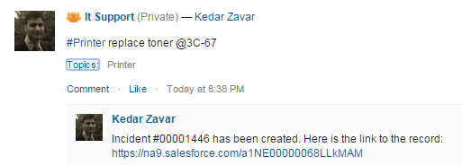

Priority Issues and Chatter  
With Chatter, you can create an automated post to a group when an incident within a specific category is logged. The settings are available under Remedyforce Administration > Enable Incident Chatter Posts. This feature can be very useful for major incidents or P1 issues, and Chatter supports P1 to P5 values.  
[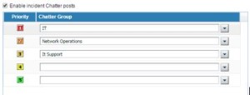](http://cloudaction.com/wp-content/uploads/2015/04/Chatter-image-3-new.jpg)

Global Actions  
Chatter supports global actions so you can create records from Chatter.  
[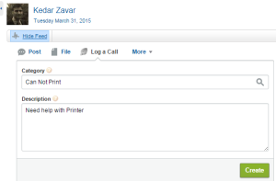](http://cloudaction.com/wp-content/uploads/2015/04/Chatter-image-8.png)

## Chatter Licenses

Chatter is available in Remedyforce for staff and clients based on configuration. Other available licenses include:

* Chatter External – Allows use of Chatter groups
* Chatter Free – Provides access to Chatter
* Chatter Only (Chatter Plus) – Partial access to salesforce objects and Chatter data

NOTE: Please see Salesforce licensing for more details.

CREATE CHATTER LISTENERS AND THEN USE THOSE LISTENER’S HASHTAG IN CHATTER POST; A NEW TICKET WILL BE CREATED.

# Self Service Portal

## Prerequisites for using Self Service

Before you begin to use Self Service, ensure that you meet the following requirements:

* You must have a correct Self Service URL.
* You must have valid credentials to log on to Self Service.

## Features and benefits of Self Service

Using Self Service, you can create and close your own service requests, thus lowering the volume of calls to staff members. You can also report an issue, submit a new request, create a service request, or find a solution to your issue by using the keywords that define it. Additionally, you can access a database of self-help articles and provide feedback on them. You can also access your opened and closed service requests.

## Logging on to Self Service

To log on to Self Service, go to the URL that corresponds to your user type, and enter your user name and password. The following table describes the different URLs to be used based on your user type.

| **Type of user** | **How to access Self Service** |
| --- | --- |
| Salesforce user with any of the following licenses:   * Salesforce * Salesforce Platform * Chatter Only | * Use the Self Service URL provided by the system administrator. * Use the Salesforce URL ( [https://login.salesforce.com](https://login.salesforce.com/) ) and click the **Remedyforce Self Service** tab. |
| Self Service portal user with any of the following licenses:   * Customer Portal Manager * Customer Portal Manager Standard * Customer Portal Manager Custom | Use the Self Service URL provided by the system administrator. You should have received your user name in an automated email message that also contains a temporary password. If you did not receive this email message, contact your system administrator. |
| Salesforce user and you are a system administrator or staff member | * Use the Self Service URL provided by the system administrator. * Use the Salesforce URL ( [https://login.salesforce.com](https://login.salesforce.com/) ) and click the **Remedyforce Self Service** tab. * Use the Self Service URL provided at the Sites page. To access the Sites page, click**Setup > App Setup > Develop > Sites** and click the URL in the **Site URL** column. |

## Licenses

* **Customer Portal Manager *Standard*** is $5 a month.
* **Customer Portal Manger Custom** is $10 a month. The main advantage to the "Custom" flavor of the Customer Portal Manager license is the ability to run reports. Otherwise you get "insufficient privileges" when a "Standard" license tries to access the Reports Tab, even if the Report Folder has been shared out to the Public Group "All Customer Portal Users."