LAB Logbook

Lab 1

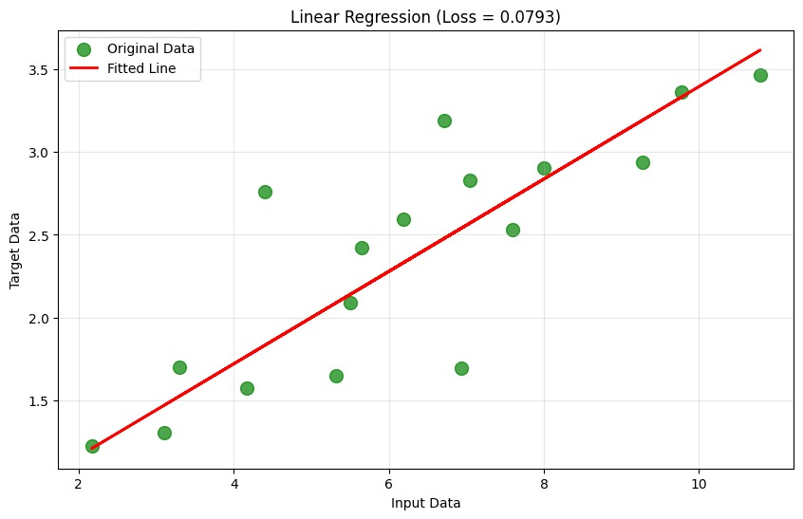

Lab 2

Table

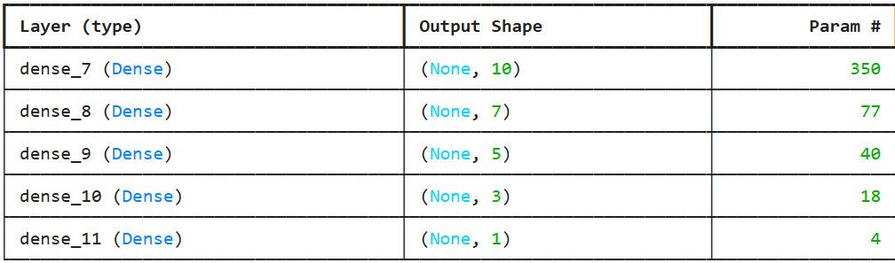

Chart

Lab 3

Test accuracy: 0.8873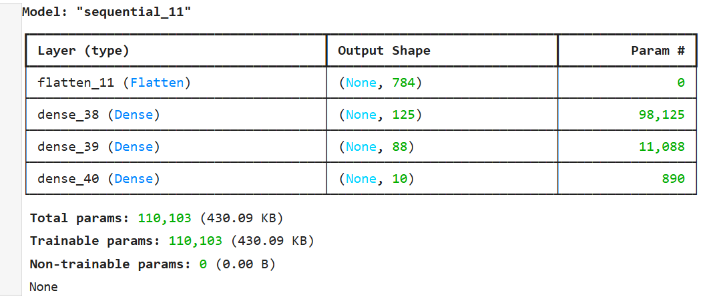

Lab 4

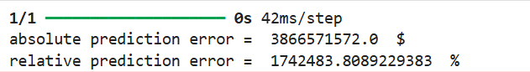

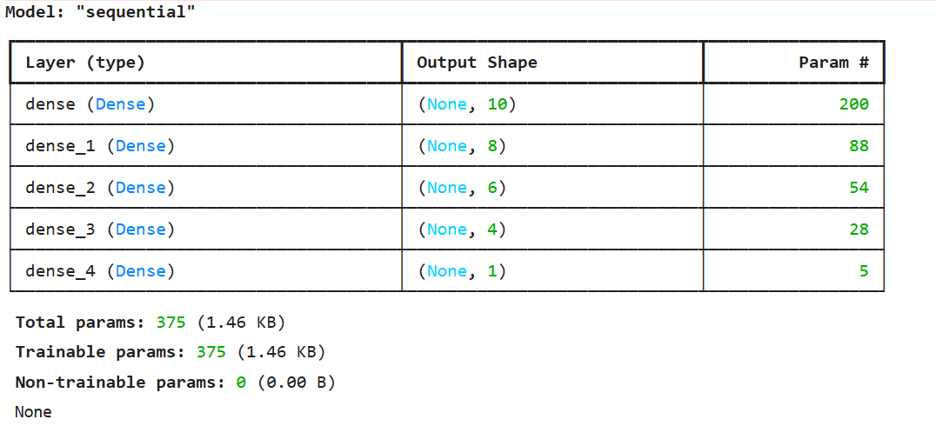

Lab 5

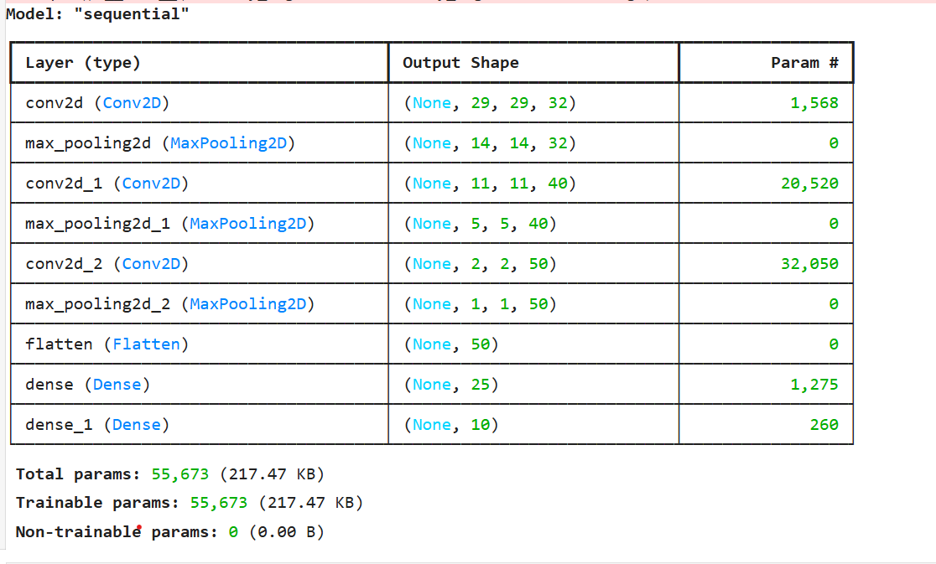

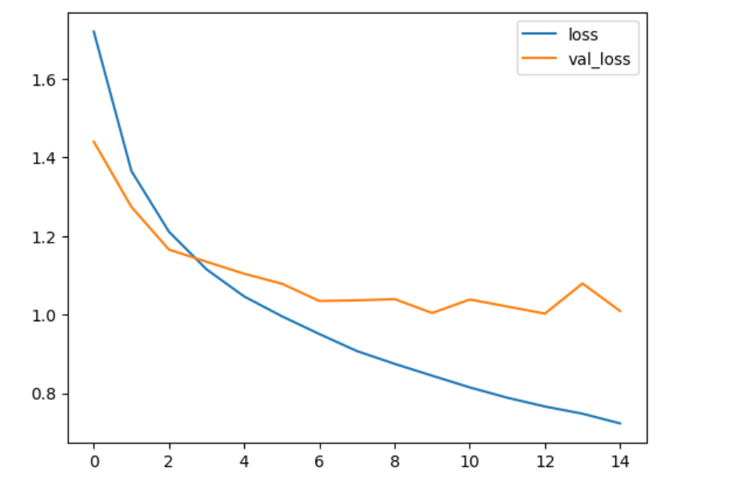

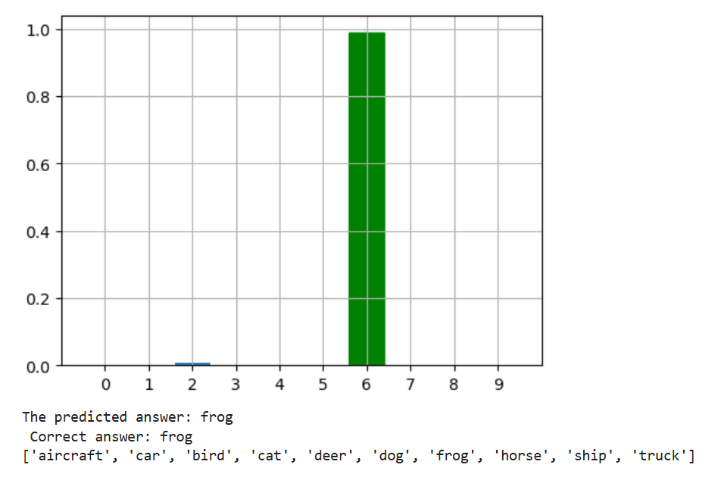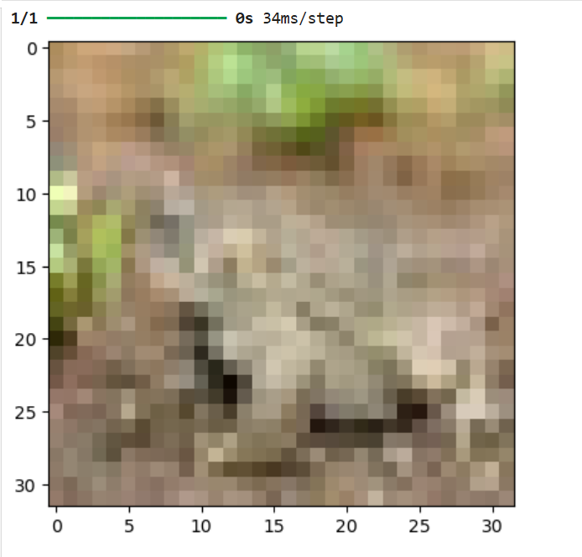

Lab 6

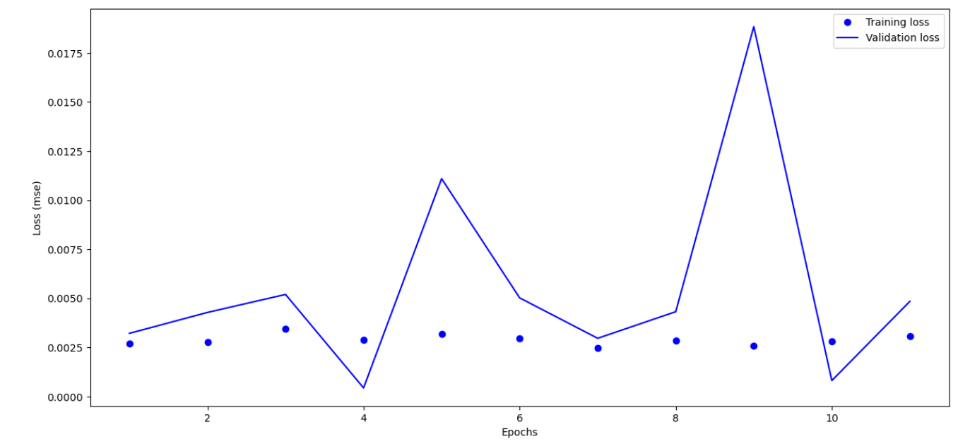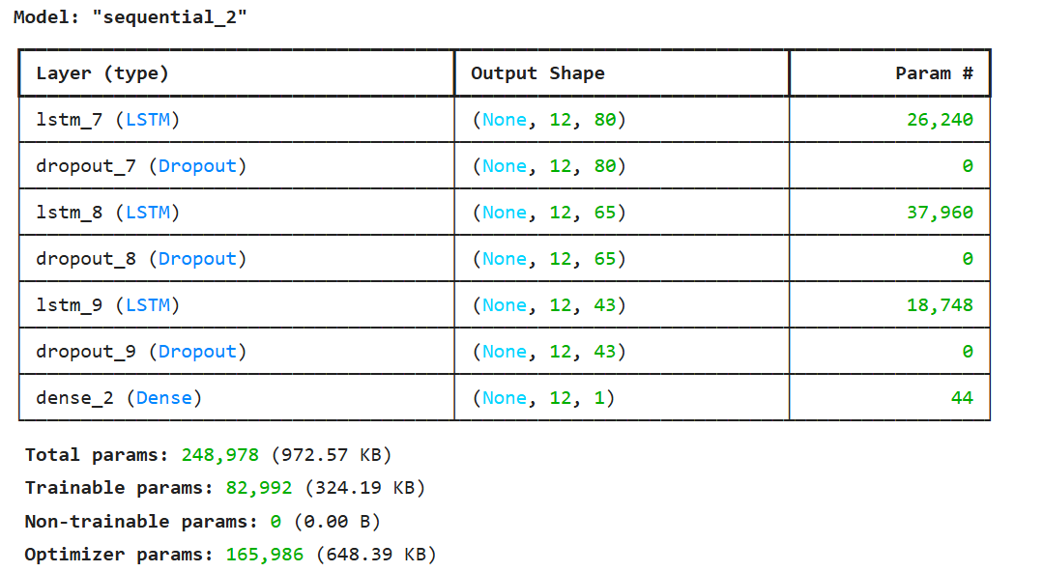

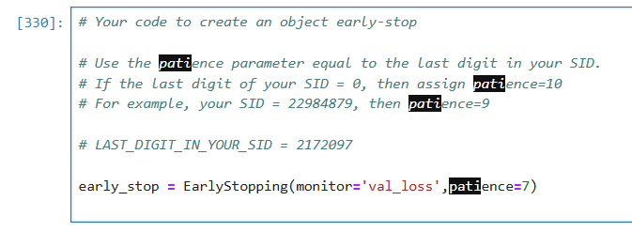

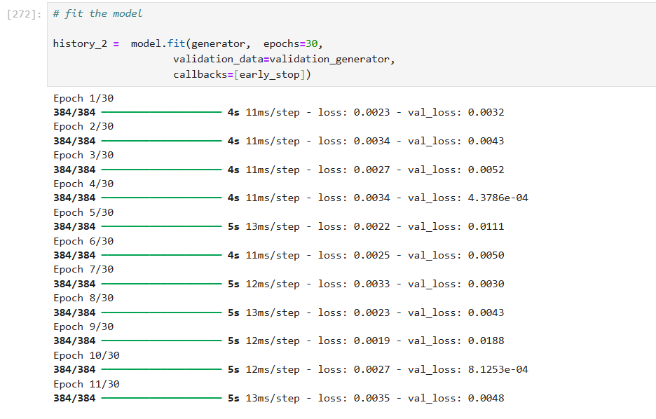

Optimal number of epochs – 4

Lab 7

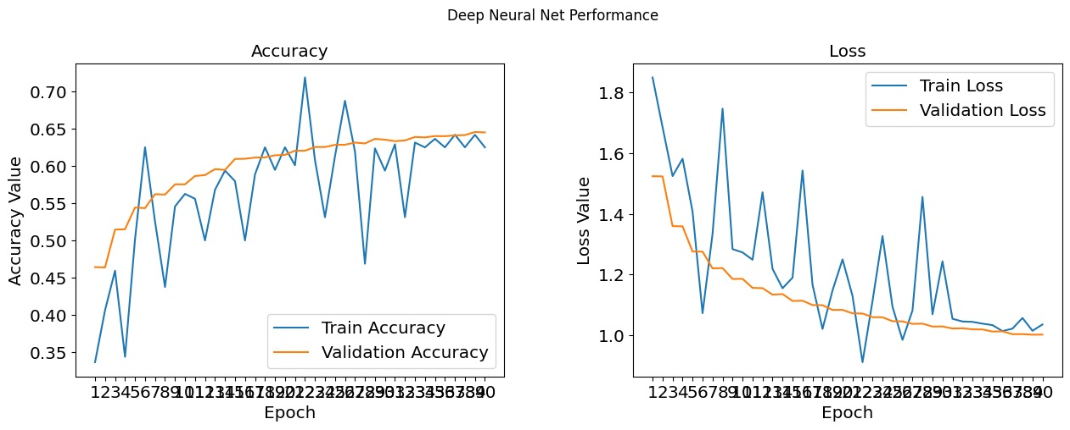

Optimal number of epochs – 38

VGG - 19

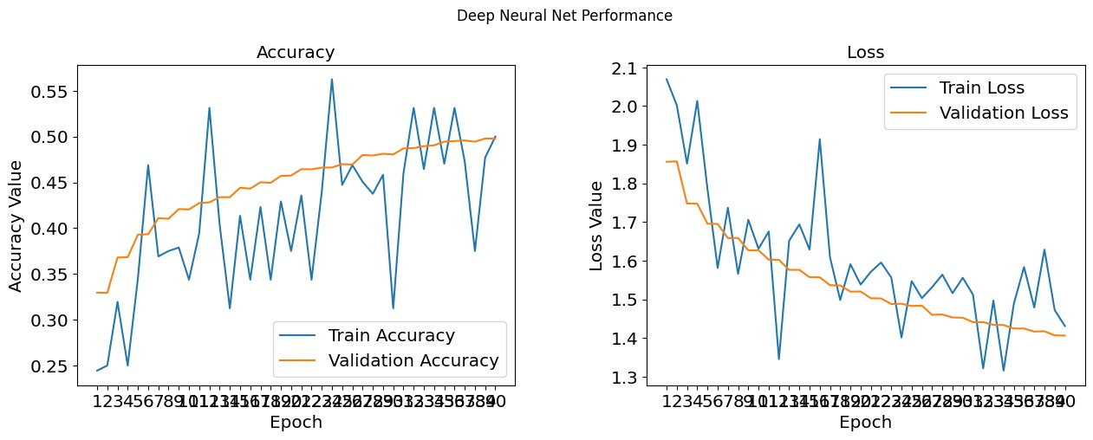

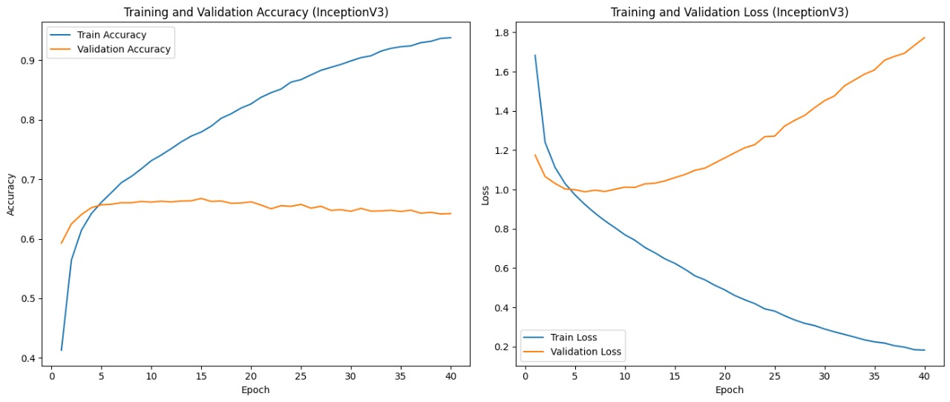Inception V3

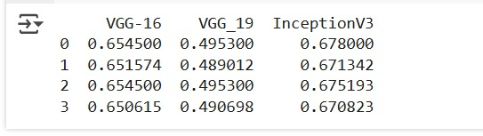

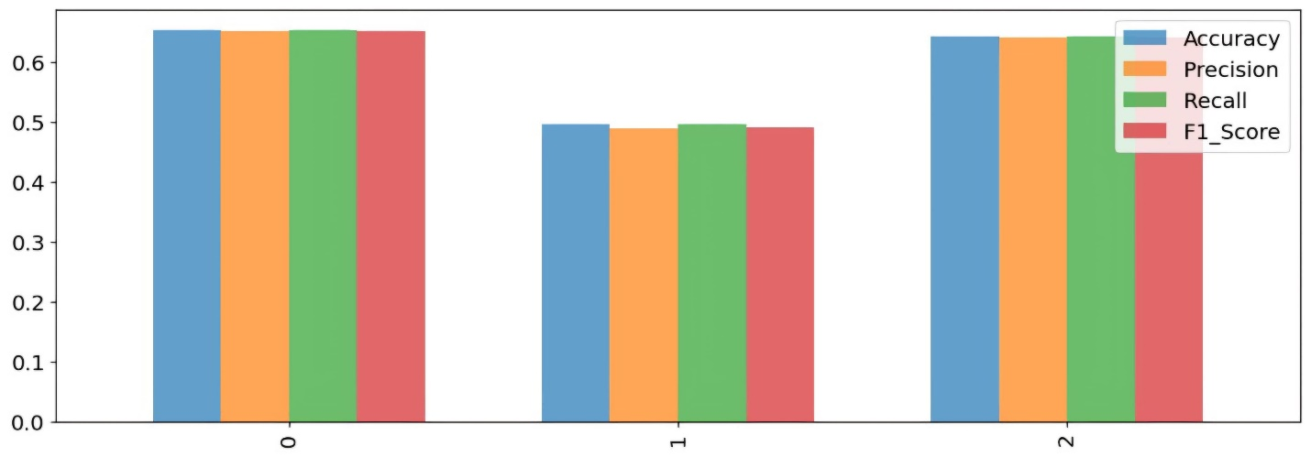

Lab 8

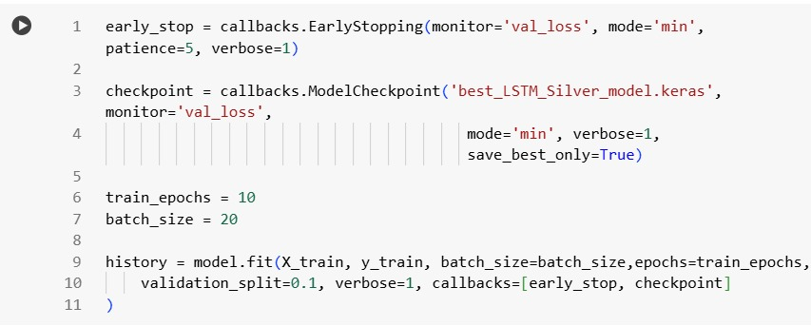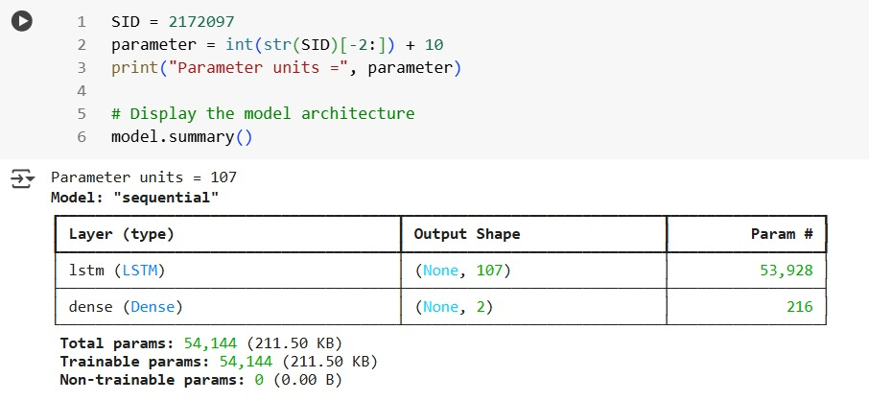

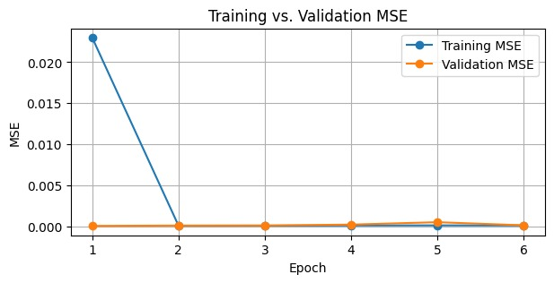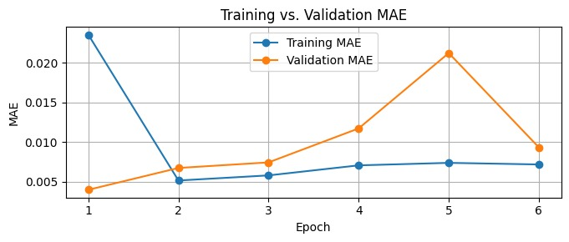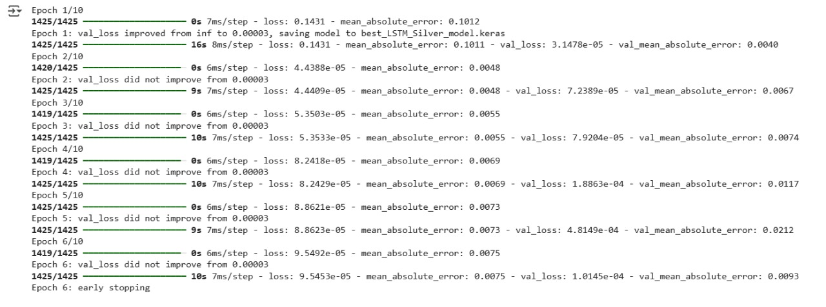

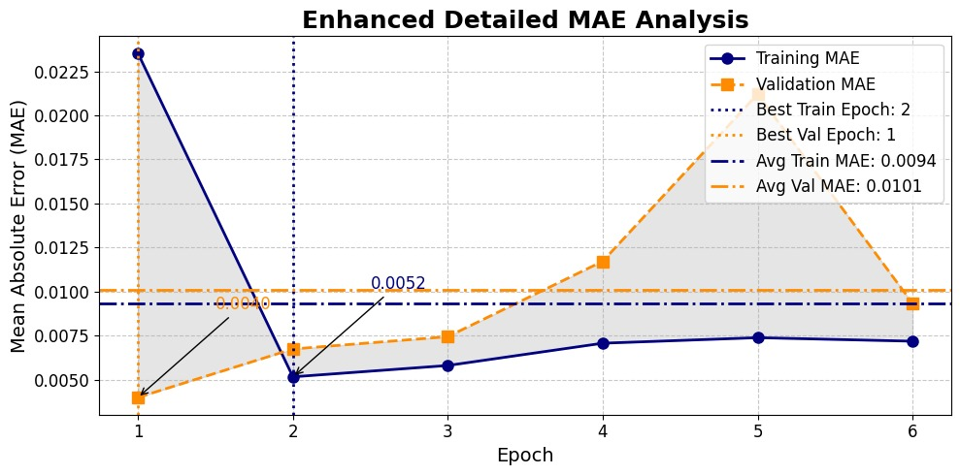

Lab 9

1

2

2.1

2.2

3

4

Lab 10

Task 1

Task 2

Lab 11

Lab 12



