LAB Logbook

Lab 1

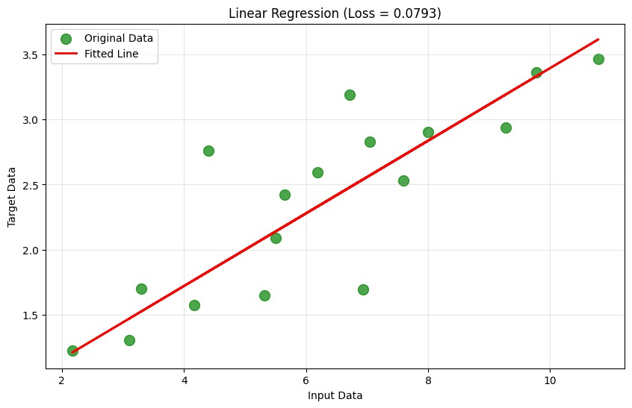

Lab 2

Table

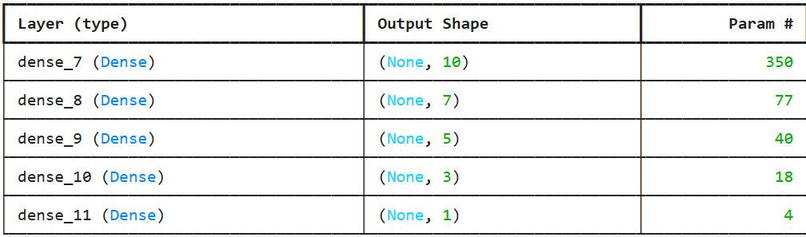

Chart

Lab 3

Test accuracy: 0.8873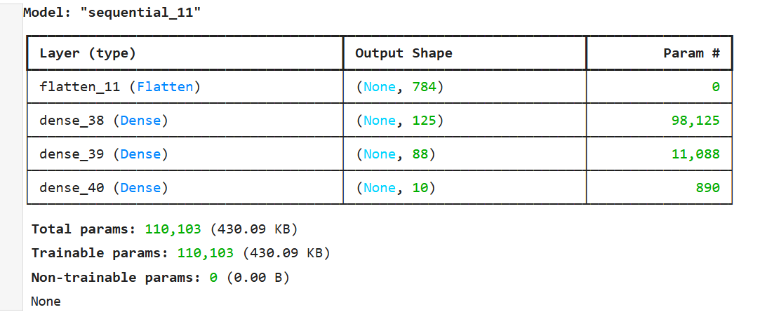

Lab 4

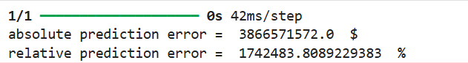

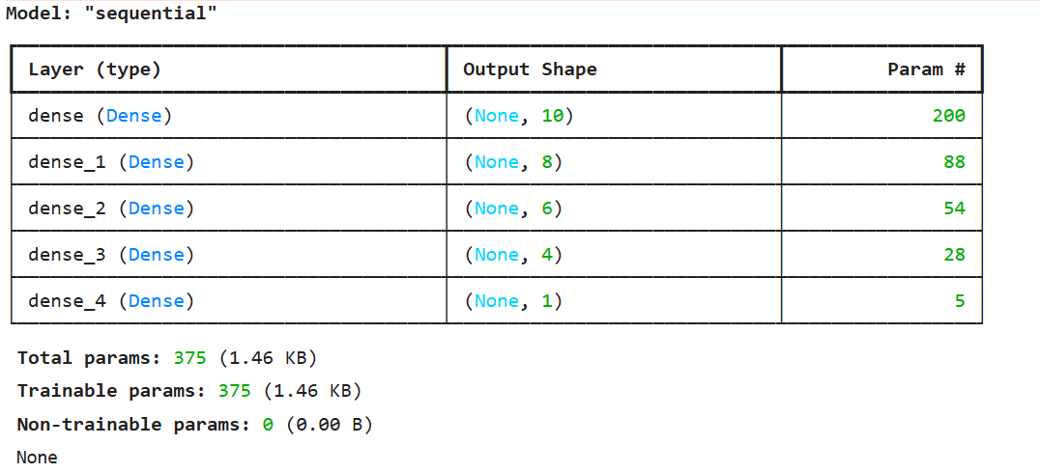

Lab 5

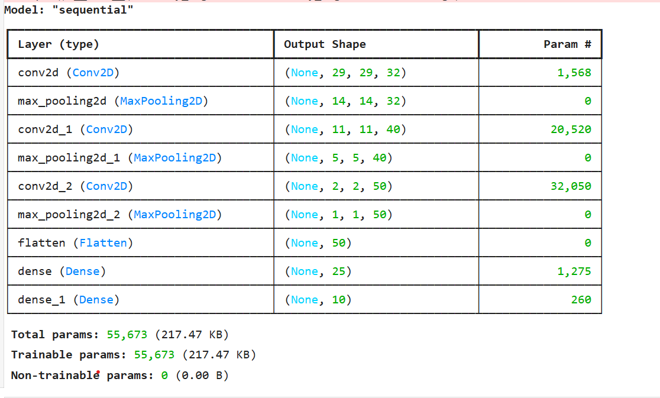

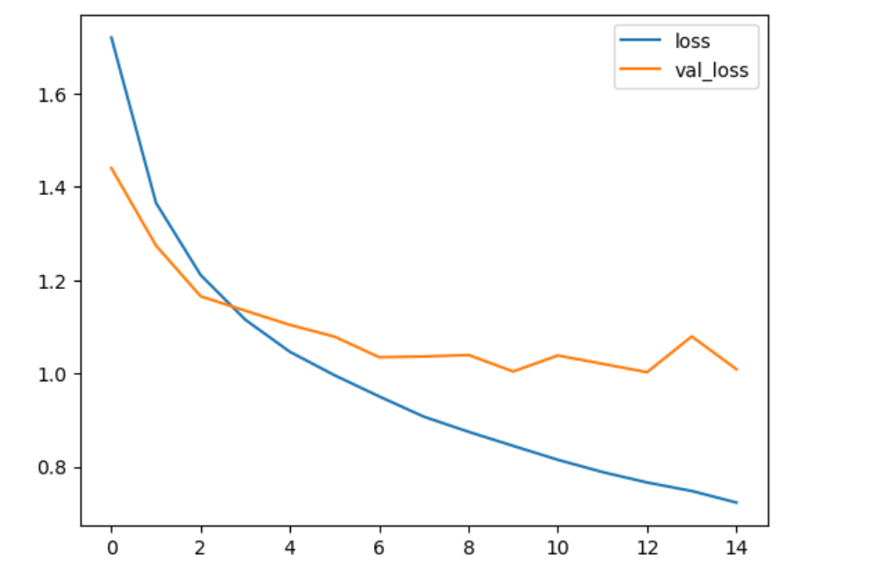

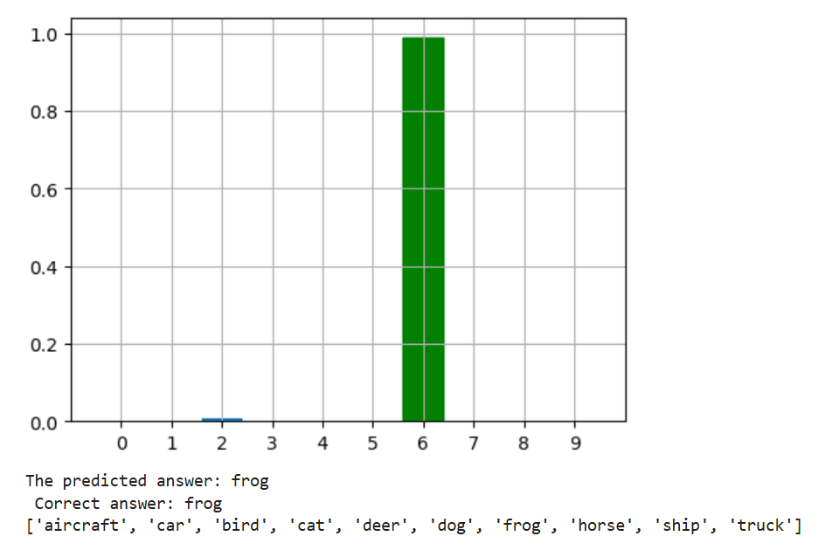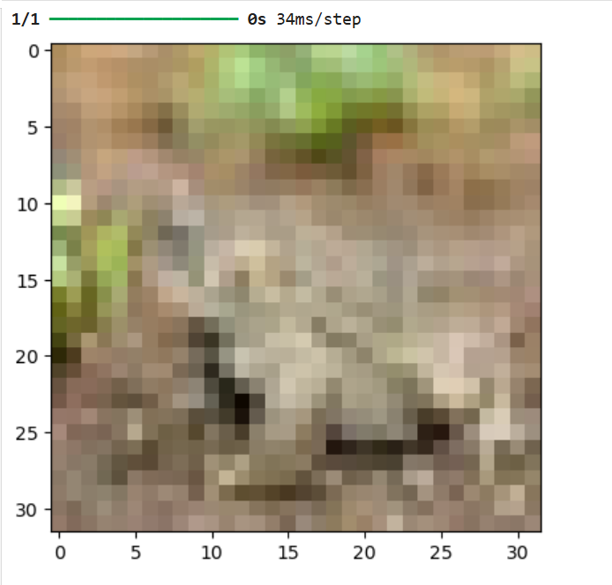

Lab 6

Lab 7

Lab 8

Lab 9

Lab 10

Lab 11

Lab 12